Title: Computer Networking Principles: Introduction to Computer Systems
Author: Michael Davies
ID: 2204766
Date: May 1st, 2023

Table of Contents:

Introduction
Network Topologies
2.1 Bus Topology
2.2 Ring Topology
2.3 Star Topology
2.4 Mesh Topology
2.5 Hybrid Topology
Network Protocols
3.1 Transmission Control Protocol (TCP)
3.2 User Datagram Protocol (UDP)
3.3 Internet Protocol (IP)
3.4 Hypertext Transfer Protocol (HTTP)
Network Devices
4.1 Routers
4.2 Switches
4.3 Hubs
4.4 Firewalls
Virtual Machine
5.1 Introduction
5.2 Setting up a VM.
5.3 Configuring a VM.
5.4 Installing Windows.
Conclusion
References
Introduction
Computer networking principles refer to the set of guidelines, protocols, and technologies used for connecting computers and devices to facilitate communication and data sharing. Network topologies, protocols, and network devices are some of the fundamental principles of computer networking. In this report, we will explore these principles in more detail and their importance in creating efficient and reliable networks.

Network Topologies
2.1 Bus Topology

A bus topology is a network configuration where all devices are connected to a common communication medium, known as the bus. In this topology, devices share the same transmission medium, and data is broadcasted to all devices on the network. However, only the intended recipient processes the data. Bus topologies are simple to implement but can be prone to single-point failures as the failure of the bus can disrupt the entire network.[1][2]

2.2 Ring Topology

A ring topology is a network configuration where devices are connected in a closed loop, forming a ring. Each device in the network is connected to exactly two neighboring devices, and data travels in a circular manner. In this topology, data is passed from one device to the next until it reaches the destination device. Ring topologies provide equal access to all devices and eliminate collisions. However, the failure of a single device or connection can disrupt the entire network.[3][4]

2.3 Star Topology

A star topology is a network configuration where all devices are connected to a central hub or switch. In this topology, each device has a dedicated connection to the central hub, forming a star-like structure. Data is transmitted from the source device to the central hub, which then broadcasts the data to the intended recipient. Star topologies provide high scalability, easy troubleshooting, and the failure of one device does not affect the rest of the network. However, the reliance on the central hub can be a single point of failure.[5][6]

2.4 Mesh Topology

A mesh topology is a network configuration where each device is connected to every other device in the network. In this topology, there are multiple paths for data to travel from the source device to the destination device, creating a highly redundant and fault-tolerant network. Mesh topologies provide excellent reliability and can handle high-traffic loads. However, the high number of connections can make mesh topologies complex and costly to implement.[7][8]

2.5 Hybrid Topology

A hybrid topology is a network configuration that combines two or more different types of topologies. By combining different topologies, organizations can leverage the strengths of each topology and create a network that meets their specific requirements. For example, a hybrid topology could consist of a combination of star and mesh topologies.[9][10]

Network Protocols
3.1 Transmission Control Protocol (TCP)

Transmission Control Protocol (TCP) is a reliable, connection-oriented protocol used for transmitting data over networks. It provides error-checking, flow control, and congestion control mechanisms to ensure the reliable delivery of data packets. TCP is widely used in applications such as web browsing, email, and file transfer.[11][12]

3.2 User Datagram Protocol (UDP)

User Datagram Protocol (UDP) is a connectionless, unreliable protocol used for lightweight and fast data transmission over networks. Unlike TCP, UDP does not provide error-checking, sequencing, or flow control mechanisms. It is commonly used for real-time applications such as streaming media, online gaming, and VoIP, where speed and low latency are prioritized over reliability.[13][14]

3.3 Internet Protocol (IP)

Internet Protocol (IP) is the core protocol of the internet, responsible for addressing and routing packets across networks. It provides a unique IP address to each device connected to the network, allowing data to be transmitted between devices. IP operates at the network layer of the TCP/IP protocol suite and forms the basis for internetworking.[15][16]

3.4 Hypertext Transfer Protocol (HTTP)

Hypertext Transfer Protocol (HTTP) is an application-layer protocol used for the transfer of hypertext, which comprises HTML files, over the internet. It enables communication between web servers and web browsers, allowing users to access websites and retrieve web resources. HTTP operates on top of TCP/IP and follows a request-response model.[17]
Network Devices
4.1 Routers

Routers are networking devices that operate at the network layer of the OSI model. They are responsible for forwarding data packets between different networks based on their destination IP addresses. Routers use routing tables and algorithms to determine the optimal path for packet transmission, enabling interconnectivity between networks.[18][19]

4.2 Switches

Switches are network devices that operate at the data link layer of the OSI model. They provide connectivity within a local area network (LAN) by forwarding data packets between devices based on their MAC (Media Access Control) addresses. Switches create dedicated communication paths between devices, improving network performance and reducing collisions.[20][21]

4.3 Hubs

Hubs are network devices that operate at the physical layer of the OSI model. They are the simplest form of network devices and serve as a central connection point for devices in a LAN. Hubs receive incoming data packets from one port and broadcast them to all other ports, without any intelligence to differentiate or filter the packets.[22][23]

4.4 Firewalls

Firewalls are network security devices that monitor, and control network traffic based on predetermined security rules. They act as a barrier between internal networks (such as LANs) and external networks (such as the Internet) to prevent unauthorized access and protect against malicious activities. Firewalls can be implemented in both hardware and software forms.[24][25]

Installing Windows 7 ISO on a Virtual Machine
5.1 Introduction
Installing a Windows 7 ISO on a virtual machine (VM) allows for testing and experimentation with the operating system without affecting the host machine. This section provides a brief overview of how my experience with it was doing.
5.2 Setting Up the Virtual Machine
To start I installed a virtualization software called VirtualBox on the host machine (my laptop).
Open the virtualization software and click on "New VM" to create a new virtual machine.
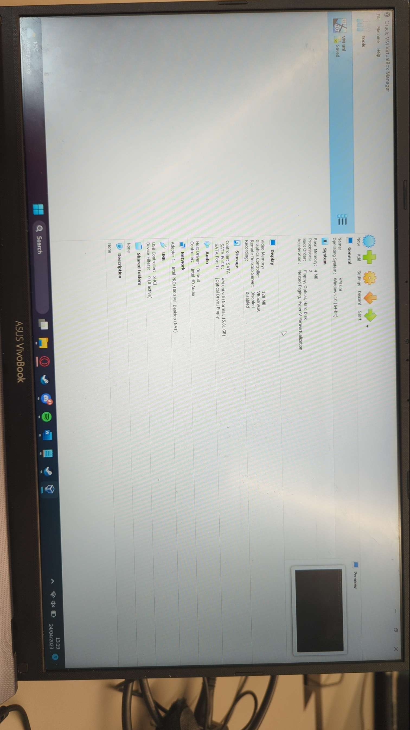

5.3 Configuring the Virtual Machine
In the virtualization software, select the newly created VM and click on "Settings".
Navigate to the "Storage" on settings.
Add the Windows 7 ISO file as the bootable media by selecting the ISO file and attaching it to the VM's virtual CD/DVD drive.
Configure other settings as desired, such as network settings, display resolution, and virtual hardware options.

5.4 Installing Windows 7
Start the VM and it should boot from the Windows 7 ISO.
Follow the on-screen instructions to begin the installation process.
Select the desired language, time zone, and keyboard layout.
Choose the installation type (typically "Custom" for a fresh installation).
Partition the virtual disk as per your requirements.
Select the partition where you want to install Windows 7 and proceed with the installation.
Follow the prompts to complete the installation process, including setting up a username, password, and other preferences.
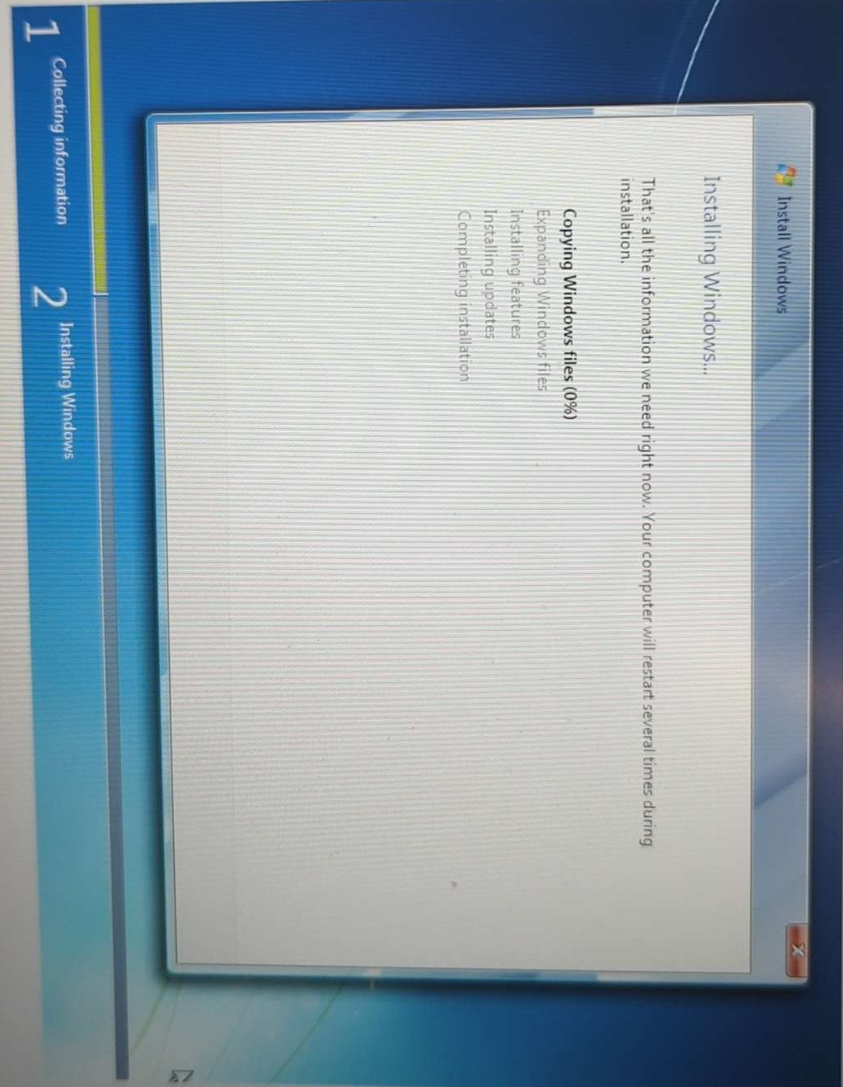

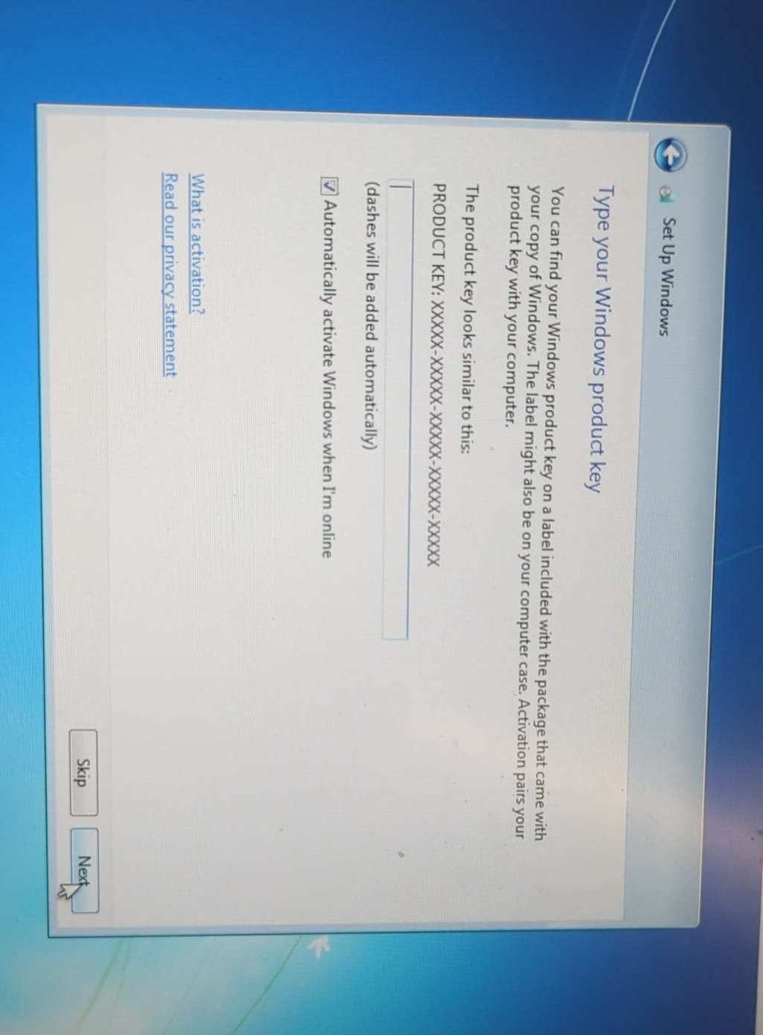

Conclusion
In this report, we have explored the fundamental principles of computer networking, including network topologies, network protocols, and network devices. Network topologies such as bus, ring, star, mesh, and hybrid offer various advantages and considerations in terms of scalability, reliability, and cost. Network protocols such as TCP, UDP, IP, and HTTP play critical roles in ensuring reliable data transmission, addressing, and application-level communication. Network devices such as routers, switches, hubs, and firewalls enable connectivity, traffic management, and network security.

Understanding these principles is essential for designing, implementing, and maintaining efficient and secure computer networks. By considering the specific requirements and goals of a network, organizations can make informed decisions and leverage these principles to create robust and reliable networking infrastructures.

References:

[1] B. A. Forouzan and S. C. Fegan, "Data Communications and Networking," McGraw-Hill Education, 2015.
[2] Cisco, "Bus Topology." [Online]. Available: https://www.cisco.com/c/en/us/support/docs/routers/2900-series-integrated-services-routers/112063-lan-switching-112063.html.
[3] D. Comer, "Computer Networks and Internets," Pearson, 2019.
[4] Techopedia, "Ring Topology." [Online]. Available: https://www.techopedia.com/definition/2684/ring-topology.
[5] J. F. Kurose and K. W. Ross, "Computer Networking: A Top-Down Approach," Pearson, 2017.
[6] TechTarget, "Star Topology." [Online]. Available: https://searchnetworking.techtarget.com/definition/star-topology.
[7] A. S. Tanenbaum and D. J. Wetherall, "Computer Networks," Pearson, 2011.
[8] TechTarget, "Mesh Topology." [Online]. Available: https://searchnetworking.techtarget.com/definition/mesh-topology.
[9] L. L. Peterson and B. S. Davie, "Computer Networks: A Systems Approach," Morgan Kaufmann, 2012.
[10] Technopedia, "Hybrid Topology." [Online]. Available: https://www.techopedia.com/definition/16665/hybrid-topology.
[11] W. Richard Stevens, "TCP/IP Illustrated, Volume 1: The Protocols," Addison-Wesley Professional, 2011.
[12] Forouzan, B. A. (2013). "TCP/IP Protocol Suite," McGraw-Hill Education.
[13] W. Richard Stevens, "TCP/IP Illustrated, Volume 1: The Protocols," Addison-Wesley Professional, 2011.
[14] Kozierok, C. M. (2005). "The TCP/IP Guide: A Comprehensive, Illustrated Internet Protocols Reference," No Starch Press.
[15] D. Comer, "Internetworking with TCP/IP: Principles, Protocols, and Architecture," Pearson, 2014.
[16] Forouzan, B. A. (2013). "TCP/IP Protocol Suite," McGraw-Hill Education.
[17] I. Fette and A. Melnikov, "The Hypertext Transfer Protocol (HTTP/1.1): Semantics and Content," RFC 7231, 2014.
[18] C. S. Plummer,
L. Peterson, and B. S. Davie, "Computer Networks: A Systems Approach," Morgan Kaufmann, 2011.
[19] Cisco, "Understanding How Routers Work." [Online]. Available: https://www.cisco.com/c/en/us/support/docs/routers/10000-series-routers/4936-router-works.html.
[20] A. S. Tanenbaum and D. J. Wetherall, "Computer Networks," Pearson, 2011.
[21] Cisco, "Understanding How Switches Work." [Online]. Available: https://www.cisco.com/c/en/us/support/docs/lan-switching/ethernet/4949-ethernet.html.
[22] D. E. Comer, "Internetworking with TCP/IP: Principles, Protocols, and Architecture," Pearson, 2014.
[23] TechTarget, "Hub." [Online]. Available: https://searchnetworking.techtarget.com/definition/hub.
[24] W. Stallings, "Network Security Essentials: Applications and Standards," Pearson, 2017.
[25] Cisco, "What Is a Firewall?" [Online]. Available: https://www.cisco.com/c/en/us/about/security-center/what-is-a-firewall.html.

