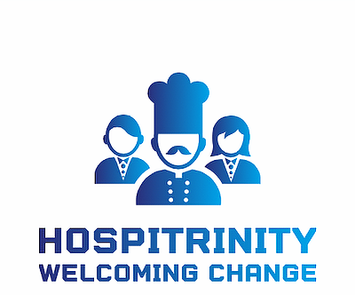

Contemporary Themes

Conference Log

Laurence Blake (1806184)

Student Name: | Laurence Blake (1806184)

Week 1 | Monday April 27th, 2020
Planning:

This week all the team has met up to discuss how the virtual conference is to be arranged. Currently, there has been a lot of positive brainstorming with great contribution from all members of the team.

Setting a theme must be one of the most important parts of the conference, with a theme set it makes it easier to move on to the following processes with the conference. Whilst setting a theme was an ongoing discussion, collectively we allocated roles and responsibilities. The responsibilities were broken down into three areas: Management, Marketing and Technology. The team selection was based upon individual strengths and preferences.

In relation to the meetings, the teams have met to discuss further planning. The management team has documented the meetings for reflection of progress. To the conference the team has selected the topics which will be covered: Abdul; Wellness, Laurence; Terrorism and hotel strategies, Jaliya; Technology & paperless offices, Dan; Mass Tourism, Molly; Food tourism (or Sustainable menus), Mo; Globalisation, Ranad; Political instability and tourism. However, ideas need to be finalised by the next meeting.

From the meetings the teams will have meetings outside of lectures to discuss further strategies and brainstorm, this will create more purpose and focus with executing the conference.

Organising:

As a team we have allocated ourselves into separate teams, this would enable focus in different areas of the conference such as: Management, Marketing and Technical.

Team Selection: Marketing – Katie, Robbie, Abdul, Paval, Jaliya Management – Molly, Laurence, Ranad
Technical – Mo and Dan
The first guest speaker arranged for the conference; it will be Samantha Wilson-Croft from Twr Y Felin.

A practical element has been created by the Management team through a ‘Gantt Chart’, this will act as a checklist. Additionally, this will be used to track progress and can be used to analyse areas which require more concentration and focus.
Managing:

As the Management team our key role is to support and organise the ongoing operations of the conference. The team will record all meetings including individual team meetings and general meetings where all members are present. From this information this will enable the management team to set deadlines and to track and record progress. The use of a ‘Gantt Chart’ has additionally been created to assist with the current progress of objectives. Additionally, as well as the administration points the team will be responsible for supporting all members of the group. Through showing compassion and support to the teams and the team members.

Marketing:

Marketing will be adopting the 7 ps tactic to enable the conference to be advertised to the right market. This will comprise a guest list which will show the attendees and a leaflet design will be created for further depth into the marketing of the conference.

Technical:

One of the first the areas to be covered will be designing a logo, this in effect will assist with branding and the marketing team for their advertising and promotions. Following this a website will be created to enable a platform of which to gain further information on the conference details, also an executive summary on the topics discussed. In addition to the website, links will be created to a YouTube channel of which to watch back the conference at a later stage.

Problems/Resolution Action Plan:

In relation to attendance to the meetings, there have been team members who have been absent during these crucial times of team meets and discussions. In all teamwork one of the most effective tools is communication, without effective communication team members become confused and disorientated during the process of planning. Each member has established effective communication with each other this provides the basis of relaying communication between team members and back briefing where appropriate.

The initial theme for the conference was based upon ‘Sustainability’. However, following the team meetings it was decided that a different theme would broaden the scope of the conference instead of basing it on the one topic. Currently, the theme which has been agreed upon is ‘Current Issues Affecting Global Tourism & The Hospitality Industry. This theme will provide much more depth and wider perspective on the overall issues affecting global tourism and hospitality.

The theme is a very broad and diverse topic ranging from issues such as: Sustainability, Mass Tourism and Terrorism. Unfortunately, not every member of the team has finalised which area to cover. The Management team has currently set a deadline for next Monday for team members to have an area to cover organised. With deadlines implemented into project work it provides structure to go from, and with effective time management and team organisation the project will be a success.

Focus for the Week:

- Finalise individual presentation topics

- Send photos to Mohamed for website

- Teams to create brief overview of objectives

Student Signature:

Laurence Blake
__________________________________

Date:

03/05/20

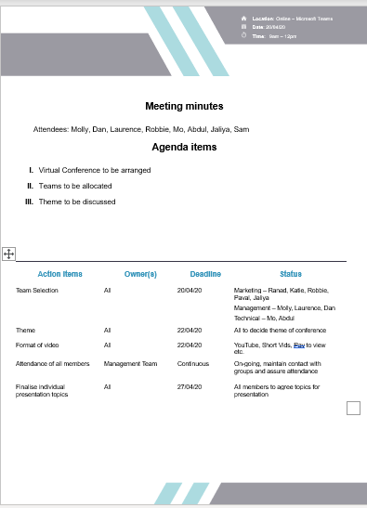

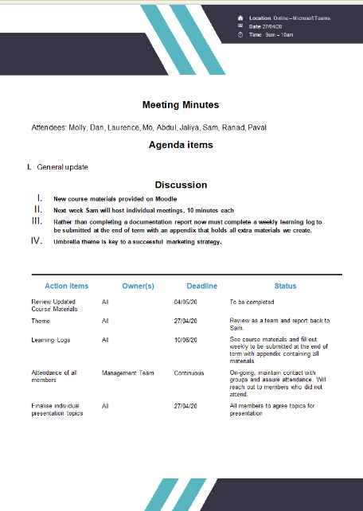

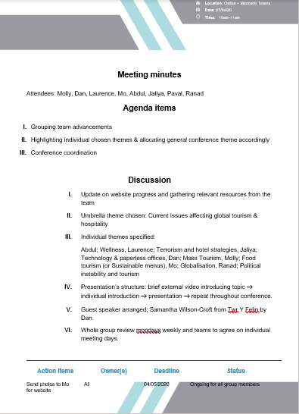
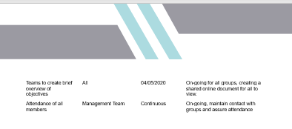

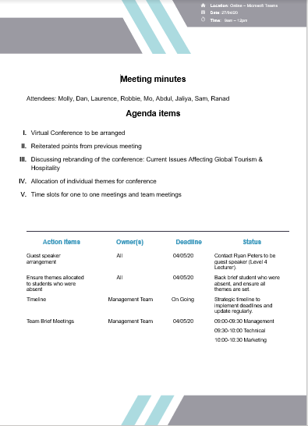

Week 2 | Monday May 4th, 2020
Planning:
The first meeting of the week began with a reflection on a previous meeting where communication had been an issue and the meeting had created problems instead of progress. It was decided that roles would be created to enable guidance and progress for the duration of planning. The roles being: Senior Project Manager and Marketing Manager.
Straight way, it was discussed that there was a need for the finalisation of various topics such as: Company Name, Logo, and Website design. Moving forward it was decided to have a poll system to create a selection of options of which team members opinions are casted to finalised decision making.
It had been stressed the importance of attendance with the team, to maximise contribution and to maximise communication between team members. If this is not carried out team members would struggle to understand what was going on. Teamwork and communication will be essential with the completion and execution of the conference.
Upon selection for guest speakers, one of them had declined the offer due to other commitments. From this other options have been explored with getting more guest speakers.
The team had been given tighter deadlines because we were now playing catch up instead of making progress. It was decided for individuals to confirm their research topics in 48 hours and the polls were to be completed in 24 hours. This would get the team back on track and this would assist all of the team in the long term of events.

Organising:

To speed up the process with the organising the conference, it was decided to make a poll to decide conference ideas. By using polls, this would provide equal contributions from all team members by selecting what they felt was best for the conference. In addition, the results were finalised in 24hrs from the release of the poll. The polls had been broken down into three areas; Company Name, Website Template and Logo Selection.

Company Name

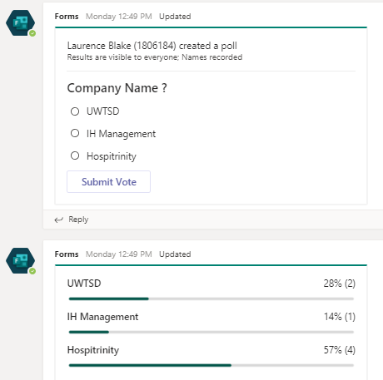
Company Name Poll Chart
The poll chart clearly shows that ”Hospitrinity“ is selected for the company name.

Website Template

Website Template One:

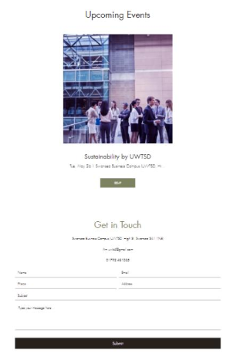
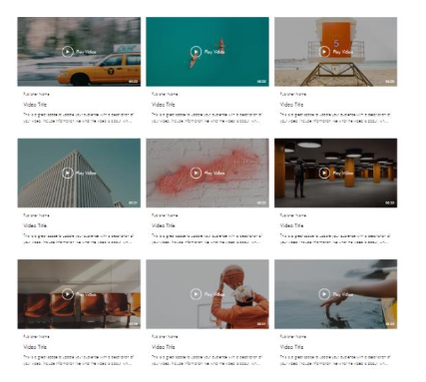
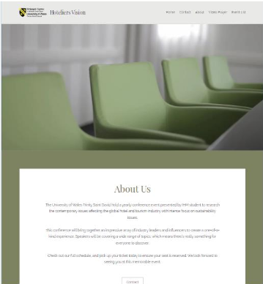

Website Template Two:
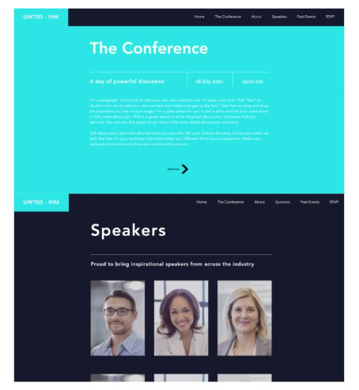
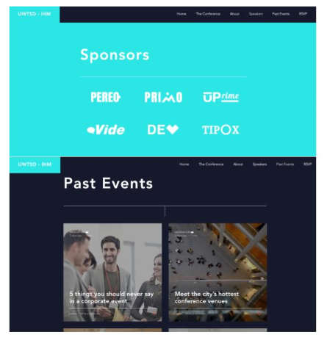
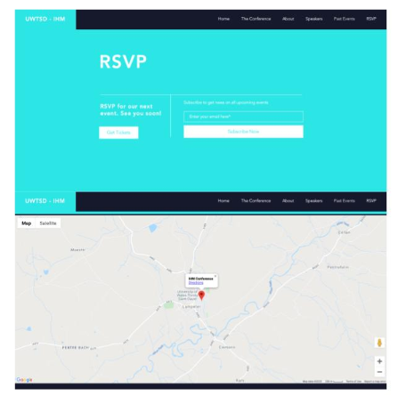
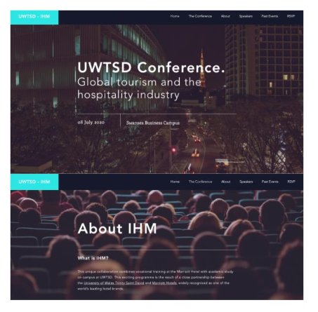

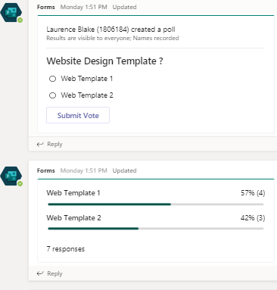
Website Template Poll Chart
The poll chart shows that “Website Template 1” will be used for the conference.

Company Logo

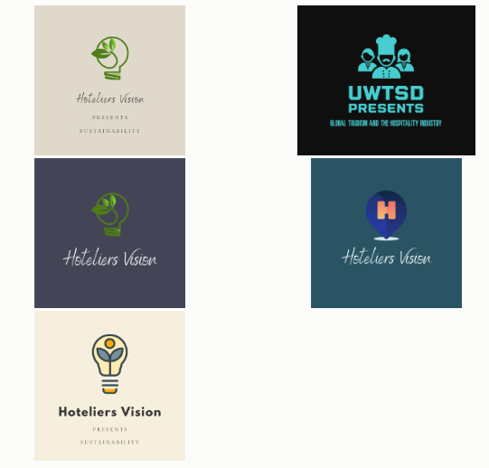
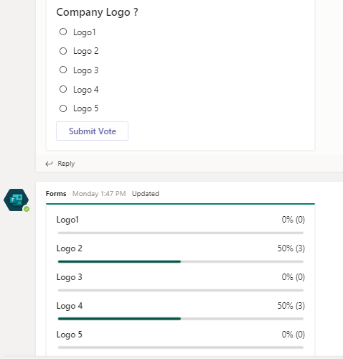
Logo Selection
Logo Poll Chart

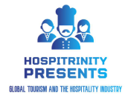
Final Logo Design

The logo decision had come to a tied vote. From the poll it was decided from the management team to select logo 2 over logo 4, so that each person in technical team has equal contribution to the conference.

The information from the polls has now created a structure of which to work from. This can assist all teams with progressing forward to the following stages of organising the conference.

Managing:

Management team have been maintaining track of the deadlines and sticking to them. In addition, the management team have been acting as a ‘Think Tank’ by providing problems to solutions and effective strategies to ensure smooth progress with the planning and the preparation phase of the conference. This team have been stating clear objectives for the conference such as not swapping and changing ideas and topics. This will create strict clarity and ensure that progress is only moving forwards always and will provide support and guidance to teams and team members throughout the preparations phase.

Marketing:

The Marketing Team are currently waiting for people to send headshots, briefing topic, and the reasons for choosing the topic before moving forward to the next phase. Once it has been completed this can be uploaded to the website and can start building up the website at a steady pace.

In the meantime, of this going one Marketing has been responsible for generating public interest to attract viewers. By creating a contact list and a mailing list, this will enable loyalty with clients and keep them up to date with hospitality latest news. This will be done through sending email invitations for schools, colleges and those who are interested in ‘Global Hospitality and The Tourism Industry’. One area to be followed up with will be the use of a slogan or catchphrase. This creates an element of marketing which will be easy to remember and will be used for the purpose of advertisement.

Technical:

Both students were tasked with creating a logo and a website. Following the ideas proposed, these would go onto the Teams page and a poll was created to select options.
The team was also tasked with organising an introduction video, which would be roughly two minutes long. This will set the scene and aim to bring the conference to life. The overall introduction video summarising all chosen topics will be put together as opposed to individual videos for each topic.

Problems/Resolution Action Plan:

During one meeting the communication between team members had been poor. This created elements of tensions with the group, and key points were not discussed in the appropriate detail. It would be seen that the meeting had been a waste of time. I contacted team members to get people, by giving guidance and showing compassion towards them. The team greatly appreciated my efforts to contact them and began to bring the team back together.

Following this meeting it was decided to restructure the teams and regain momentum. It was decided that there would be a Senior Project Manager to oversee all operations of the conference. Additionally, due to the large number of students in the marketing team, they have a marketing manager to arrange and guide the team. This person will lease any points with the other teams in the project.

Focus for the Week:

- Select an introduction video.

- Submit self-photo, background and chosen topic to marketing.

- Mailing list and Contact list

- Catchphrase and Slogan

- Contact more guest speakers.

- Management team to ensure deadlines are adhered to.

Student Signature:

Laurence Blake
__________________________________

Date:
13/05/20
_________________________________

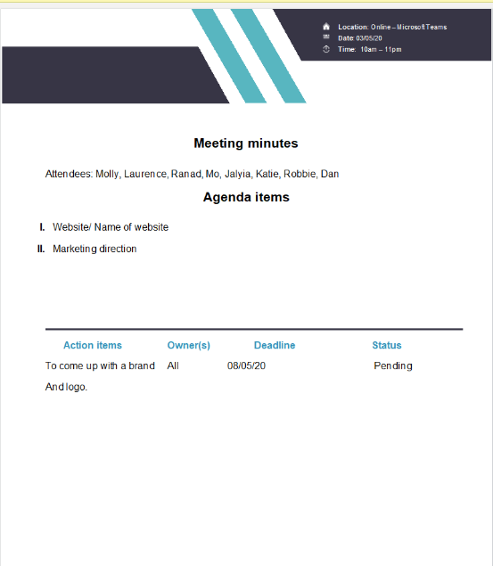

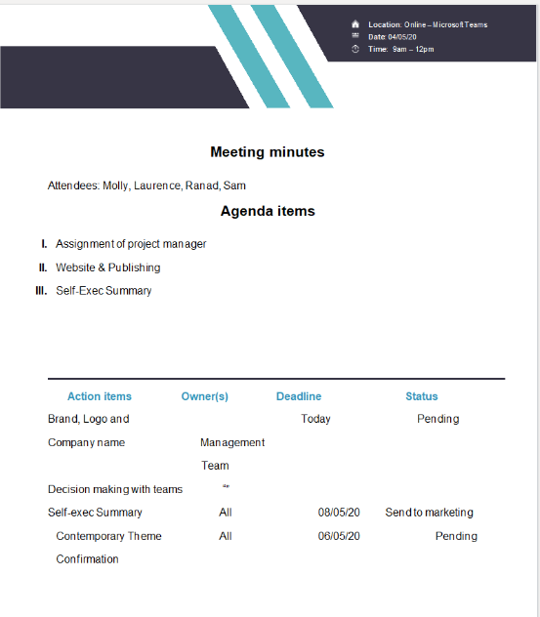
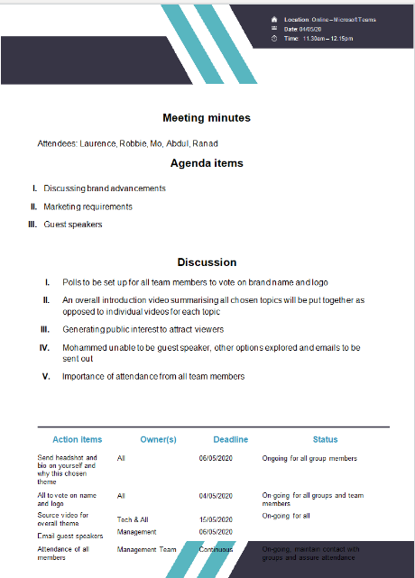
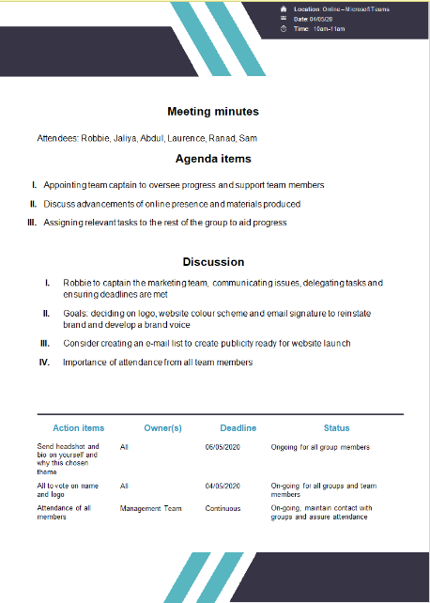

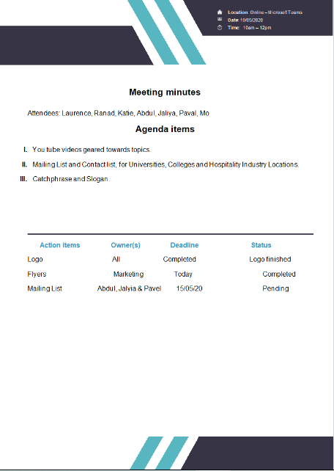
Week 3 | Monday May 11th, 2020
Planning:

Firstly, the teams had a full-scale meeting opposed to individual team meetings. This objective was to make sure that all members from each of the teams had a full understanding about what each department was doing to gain a wider scope about what will be going on. In addition to the full-scale meeting this was to check that each team is meeting their deadlines, which can then assist the organisational process of the conference.
As there had been a lack of potential guest speakers to present at the conference, it was discussed to have spotlight videos to promote the conference, which could be used to encourage donations to relevant charities. However, we have one video from a guest speaker so far so this increases flexibility with planning the conference.
Being the conference is online and it will be edited into one video, it was discussed about the technological capabilities of the presenters. So far, most team members have the technology to record themselves presenting their topics.
The teams began to move forward with planning and preparations by going to the next phase of planning. The slogan creation will bring to life the brand. So far, an idea has been put forward called ‘Welcoming Change’ this will be finalised and discussed next week’s meeting.

Organising:

Unfortunately, some people have been slower to get tasks completed which has had a slight impact to organising the conference. It will be down to team effort to ensure all items are completed by the deadline days.
Bio’s and picture deadline not met, those who have not sent to Robbie need to complete soon. This is now the second week that this has not been completed and needs to be completed.
Even though there have been some deadline issues, the team name, logo, and website design all confirmed now. This shows that in areas there is progress being made.
Videos for the beginning of each person’s presentation can be picked by the individual and sent to marketing or marketing will assign a generic video if needed. This will bring more life to the conference topics by having a short introduction videos.
The Technical team had trailed recording methods, two methods of recording each person’s conference will be via teams and Phone.
The whole group will need to discuss about the website layout holds, this may result in a poll being created to finalise decision making.

Managing:

On a concurrent aspect, the management team have been creating the meeting agendas to create a sense of direction and to create a platform of which to base key meetings from.
Molly has also updated the ‘Gant Chart’ to create a visual aid of conference organisational progress. This will be updated weekly as deadlines are becoming more crucial.
Ranad is going to send a final round of emails to try and acquire another guest speaker, but if there are no available people the team will look into idea of a small promotional/charity video instead.

Marketing:

Marketing are still waiting for a final few people to submit their profile pictures and self-exec summaries, as these are one aspect which needs to be completed for the website.

So far areas which have been completed are: Mailing list that involves educational heads of departments and the flyers, but the flyers still need to uploaded to the teams page. In addition to completed items, the about us section has been completed.

An invitation email will be completed, this will be a template email which will advertise interest for the conference. One member of the Technical team will collaborate with marketing to create promotional content using Canva pro. More emphasis of communication between Marketing and technical will be crucial to the success of the conference.

Technical:

Previously, there had been communication issues with the Technical team as they were both doing the same work and not collaborating. Since then the issues have been resolved and progress ahs been able to push forward.
So far technical team discussed access to the website; this will give access not to just technical but will give access to members of the whole team to assist where needed. In addition, it was discussed how the website will work to decide if we are going to have individual promo videos or just one initial video.
Technical has trialled various ways to record our presentations. So far, two options were decided separate uploads of our mobile phone recording of ourselves and presentation or complete recording of presentation through Microsoft teams. A deadline for the finished presentation will depend on which method of recording is selected; 1) will need to be completed by 25th of May. 2) will need to be completed by 1st of June.
Additionally, technical proposed either a 30 second video about yourself and the topic or Bio and profile picture.

Problems/Resolution Action Plan :

So far there has been a reoccurring issue with team members and meeting deadlines, in the next meeting it will be made clear about the importance of deadlines.
Currently, Marketing has missed the deadlines for production of flyers, even though it has been completed it was required to upload the flyer to the group teams page, which has not been completed. However, we are giving assistance to teams who are struggling with completion. Mo has access to Canva Pro Software, this will create professional quality advertisement for promoting the conference.
A crucial aspect which needs to be addressed in the next meeting will be discussing how each member of the team will record their presentations. Everyone will need to be able to record themselves in order to create a smooth conference.
Focus for the Week:

- Continue to check that deadlines are being met.

- Agree on slogan, Potential Slogan- “Welcoming Change”

- Promotional video, presentation slides and video of yourself presenting all to be sent to the marketing team who will pass onto technical team.

- Completion of presentations, videos of presentation, and selection of promo video 30 second video about yourself

- Deadline for videos and creating 1-1 with tech team, Method of recording and final deadline to be agreed upon.

- 30 second video about yourself and the topic or Bio and Picture poll

- Need a whole group discussion on how the website layout holds our content

- Agree a website layout

- Create promotional content Mo & Marketing Team

- Ranad to contact guest speakers

Student Signature:
Laurence Blake

__________________________________

Date:
17/05/20
_________________________________

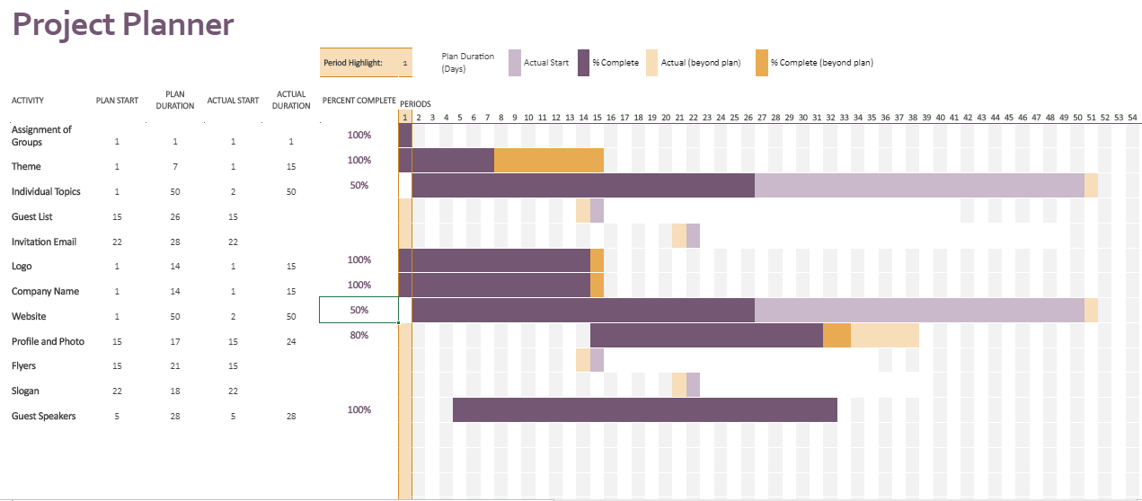
Gantt Chart Update

Contact list for Email Invitation

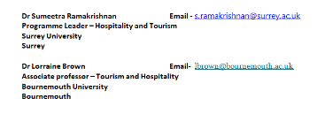
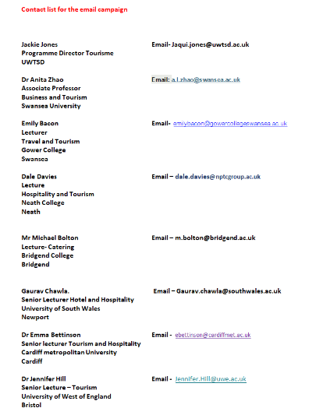

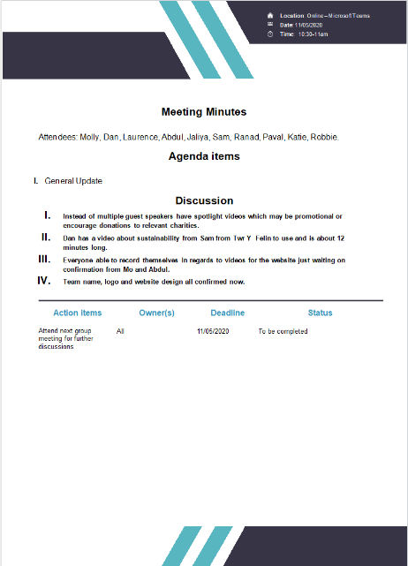
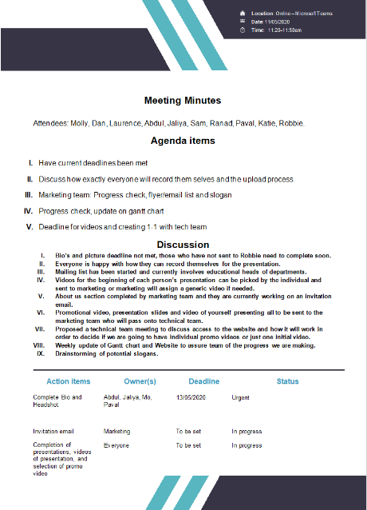
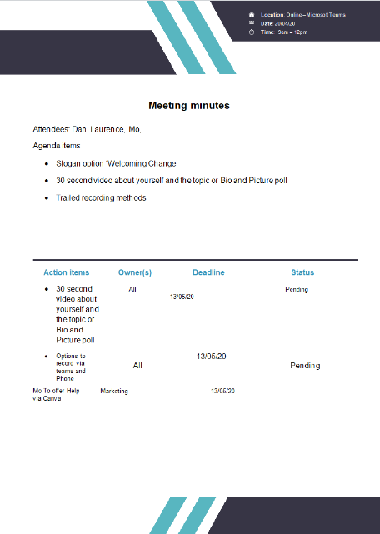
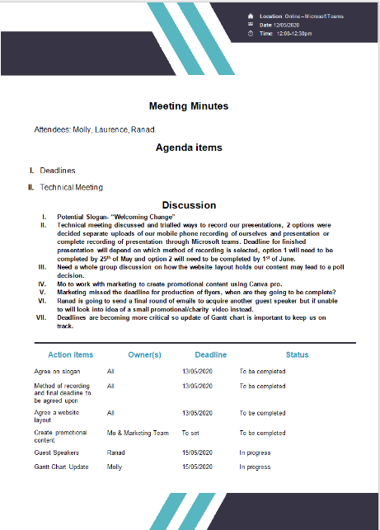
Week 4 | Monday May 18th, 2020
Planning:

This weeks planning phase spring boarded into action, as usual by ensuring all deadlines from the previous weeks have been completed. By having regular meetings, we can communicate across the various teams to ensure that the aims and objectives set by the management team are set.
These objectives include :

- Continue to check that deadlines are being met.
- Promotional video, presentation slides and video of yourself presenting all to be sent to the marketing team who will pass onto technical team.
- 30 second video about yourself and the topic or Bio and Picture.
- Need a whole group discussion on how the website layout holds our content.

Organising:
Some of the areas above were organised through a group consensus, such as the slogan to bring more flair to the conference. In addition, from the taskings set above it was up to the management team to issue out the tasks to be completed to the relevant teams.
We set firm deadlines for the completion of the presentations; this will give the technical team enough time to upload the videos to the website.
As a team, we had to decide how the presentations would be recorded. We decided to have one set way and stick to it to make it easier for the technical team.

Managing:

To bring more focus and meaning to meetings, management have been pre planning the following weeks meetings. Each management team member agrees with the pre-planned agenda and adds points were nessacary.
The Gannt chart continues to be updated to provide the management team with a visual aid to track progress with the project.
In effort to increase our profile, one of the management team will directly call potential guest b
Ranad to contact guest speakers via call; oppose to email. This will make a more direct line of contact between us and them to get a much straight forward answer.

Marketing:

Mo from the technical team has offered his assistance to the Marketing team, as he has access to computer software which can create amazing promotional content for marketing.
One of this weeks taskings for marketing will be to create an overview of the conference, this will give the website viewer a deeper understanding to the conference and the topics covered.
The invitations have been completed which is good, this will enable the team to track how may people participate in the conference.
By word of mouth the flyers have been completed, but the flyers and the newsletters have not been shown. This is simply not good enough, this can have a knock-on effect later during the conference so its crucial the meet the objective deadlines, and to keep moving forward.

Technical:
One of the crucial concepts for the conference is ensuring that the videos can be recorded, uploaded, and viewed on the website.
Technical team suggested in the previous week about having a short video as a self-introduction instead of the current written self-introductions. However, the written self-introductions had more votes for it.
Due to the size of the videos there have been issues uploading test videos to the website. The proposal to have a button under the self-introductions which will link to YouTube.
The website layout has been discussed; however, it has now stuck with the original layout.
So far we have received one guest speaker video to be used on the conference.

Problems/Resolution Action Plan :

As deadlines are continuing to be an occurring issue, the management team will continue to reiterate the importance of setting deadlines and achieving the goals in the time set.

There has been an uncertainty surrounding securing privacy details with publishing rules with YouTube, technical team will investigate this concern on legal and publishing matters with using YouTube. Feedback from technical suggested the copyright is given as soon YouTube has verified the person as real, however this is not needed as we are keeping it private.
As attendance for the meetings has been an issue. It was proposed that everybody should have access to the website so they can see the updates and to make changes if people are not available.

Focus for the Week:

-Ranad to call potential guest speakers.

-Mo to edit website
and have buttons underneath pictures.

-Give everyone
access to the website.

-Put Logo in the
website.

-Overview of the
conference.

-Need a whole group discussion on how the website layout holds our content.

-Discuss the order of where each topic will be placed 1st-9th.

Student Signature:

Laurence Blake
__________________________________

Date:
24/05/20
________________________________

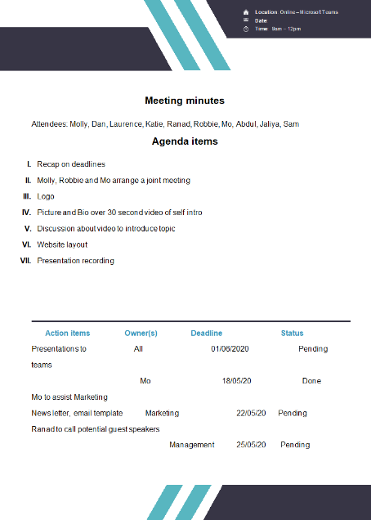
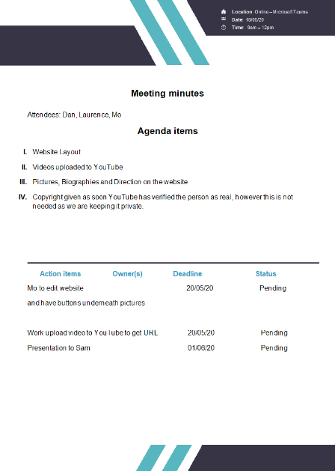

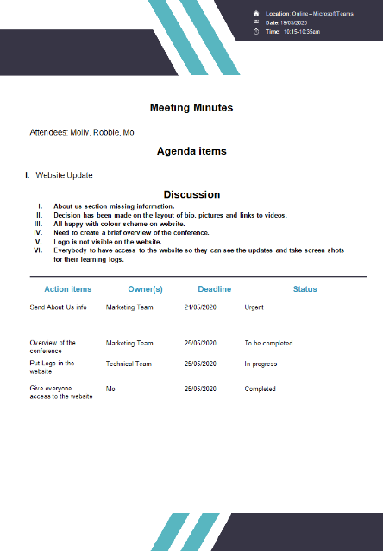

Website features

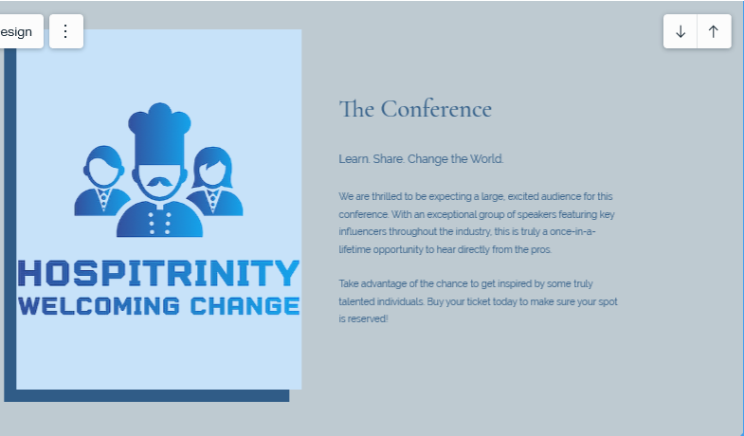

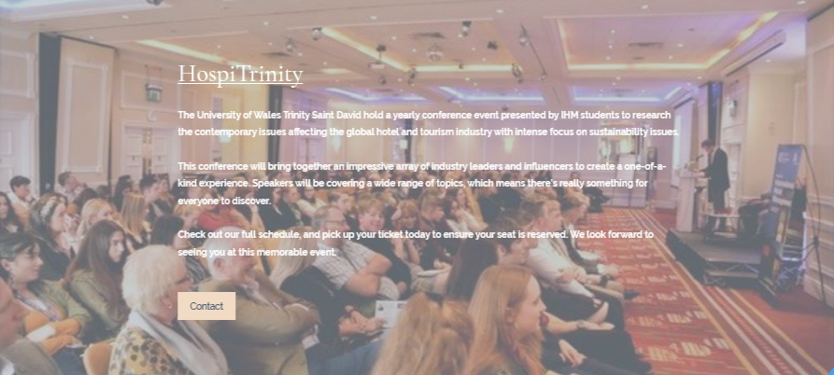

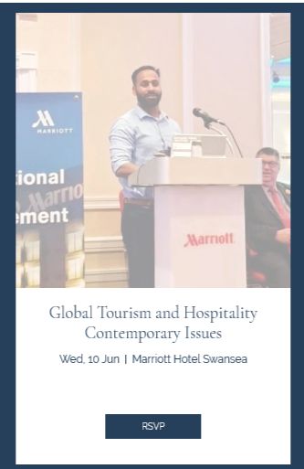
Confirmation of Attendance.

Week 5 | Monday May 25th, 2020
Planning:

To begin with by the management team pre planning the weeks agenda continues to bring all the teams focus onto the conference. Working from the points set from the previous week, this week it was aimed to ensue taskings had been met. These areas of focus included:

-Ranad to call potential guest speakers.

-Mo to edit website
and have buttons underneath pictures.

-Give everyone
access to the website.

-Put Logo in the
website.

-Overview of the
conference.

-Need a whole group discussion on how the website layout holds our content.
Organising:
From the pre-planned items set from management, this gave direct to all team members. In addition, this included recapping on previous weeks items to complete and ensure there completion.
Mo from technical continued to assist Marketing with promotional content.

Managing:

Management will continue to pre-plan meeting objectives before Monday meetings. One of the management team was tasked to call directly to potential guest speakers to speak at the conference. Unfortunately, the people that were contacted will not be guest speakers due to other commitments, and they wish the team all the best.
The project manager and the marketing manager analysed the website and noticed areas which need to be addressed for website maintenance.

Marketing:

In the meetings marketing went through all minimal tasks list to get the conference and website to life. A blurb had been created to bring mor flair to the conference. However, due to absentees it is very difficult to get some taskings completed such as the flyers etc. The idea for the newsletter has dropped and a possible subscription sign up will replace this. In addition, most websites have a PSA (Public Service Announcement) we will mimic this to make the website look more authentic.

Technical:

Technical team had input buttons underneath the pictures which will link them to the videos, this matter has been tried and tested by technical and observed by the management team.

Problems/Resolution Action Plan :

Upon reviewing the website with marketing manager, it was seen that there were several things with the website that needed to be arranged. For instance, only six of the nine bios have been uploaded to the website. Furthermore, the name of the title was not correct. These aspects should have been completed earlier within the creation of the website. Technical team have been made aware of this issue and they will rectify it.

Focus for the Week:

Final finishing checks on the conference

Maintenance checks for the website, ensuring all features are added before the deadline 08/06/20

Presentations to be recorded next week

Ensure all presentations are uploaded to the website.

Student Signature:

Laurence
__________________________________

Date:
28/05/20
_________________________________

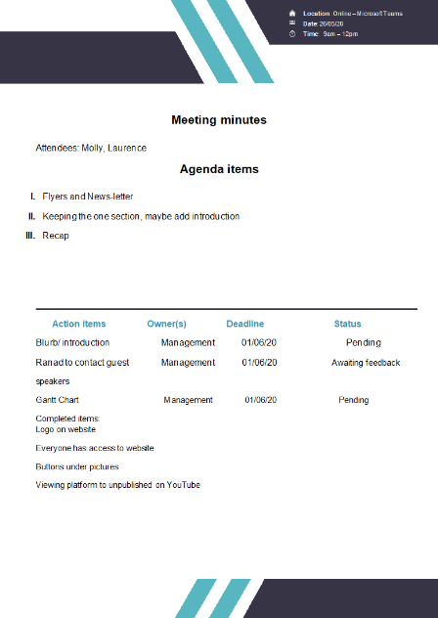
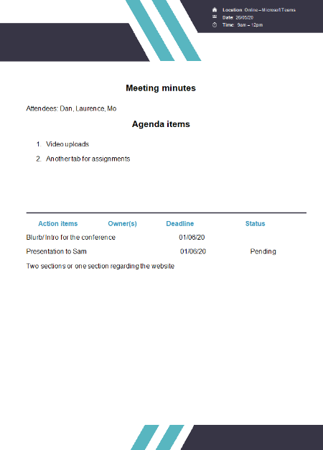
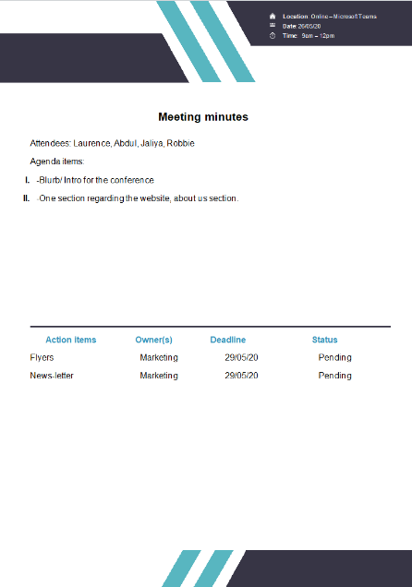
Week 6 – Final Week | Monday June 1st, 2020
Planning:

As the week usually begins by ensuring the previous weeks task have been completed. As the project is now in the final week it is important to ensure all tasks are finished, ready for the conference on 08/06/20.

As it had been mentioned in the previous weeks, the presentations will be recorded on ‘Teams’ or with the option of pre recording of the chosen topic on a mobile device.

Once all recordings have been collected via the technical team, they will upload the videos to the website.

Other aspects which need to be discussed will be maintenance checks on the website, by ensuring the website layout flows and all the links to the videos are all functional.

Organising:

Team members were given multiple options to record their presentations, this provided members flexibility and a firm deadline had been given to carry out this task.
Most recorded their presentations through ‘Teams’, and later submissions were carried out by themselves. A strict deadline was given to ensure this task was carried out.

No further guest speakers were added to the conference, they were approached by the management team in advance, and again a deadline had been set to make sure there was enough time for technical team to upload the presentations. Technical team managed to upload the content before the deadline and are in the process of completing the flyers.

As a team, we all reviewed the website layout and noted all changes that needed to be changed. These items included: bios, conference name change, date change. Technical team swiftly made these adjustments as the call was going on to ensure this was completed as soon as possible.

The ‘About Us’ and the ‘Hospitrinity’ sections had been edited and uploaded within the timeframe.
With the above items in place we will be ready to go live with the website and conference for 08/06/20.

Managing:

The management team continues to record minutes and track progress of the conference. In relation to the tracking progress the ‘Gannt Chart’ will be updated, as it would provide a visual aid to the progress tracking.

To ensure clarity and professionalism, one of the management team will proof-read the website, to ensure no mistakes are made and as almost a triple check for the website.

Marketing:

Lack of attendance and communication from the marketing team has had an impact on this weeks taskings. This has resulted with the rest of the team taking up the strain.

Technical:

Overall maintenance checks will be carried out by multiple members of the team. This will enable lots of people to look over the website for any inconsistencies.

All presentations will need to come in before the deadline to give ‘Technical’ enough time to upload and process each video presentation. Furthermore, the ‘Watch now’ buttons beneath the bios will be linked to YouTube to allow viewers to watch the content.

With all the presentations due to come in Technical will additionally make any changes and alterations found by members of the whole teams. They will also assist one of the management team members with proof-reading to ensure this task is completed before the deadline.

As ‘Marketing’ have not provided some final items, Technical will make a flyer template to finish this task.

A member from technical will liaise with lecturers on 08/06/20, this will provide them with the information required to navigate the website and to understand its functionalities.

Problems/Resolution Action Plan :
Due to lack of communication and meeting attendance with marketing team, we are unable to finish the flyers/leaflets, technical have a template but no content for them.

Focus for the Week:

Regularly conduct maintenance checks to ensure site is ready and operational for 08/06/20.

Student Signature:

Laurence Blake
__________________________________

Date:

03/06/20
_________________________________

©2020 HOSPITRINTYPITRINITY
Welcoming Change

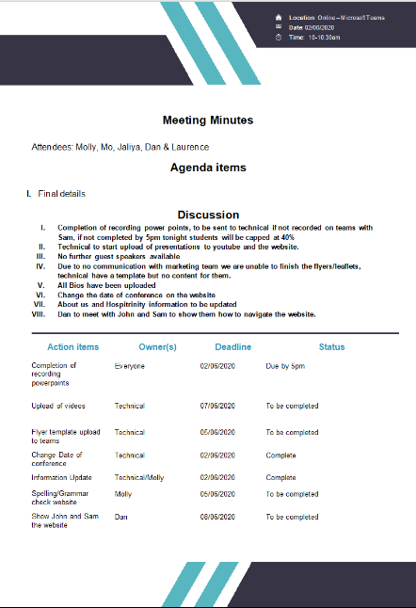

Gaant Chart

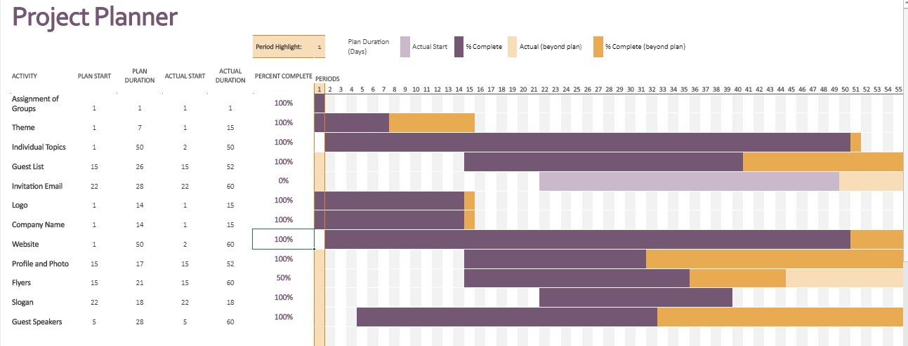

Website Content

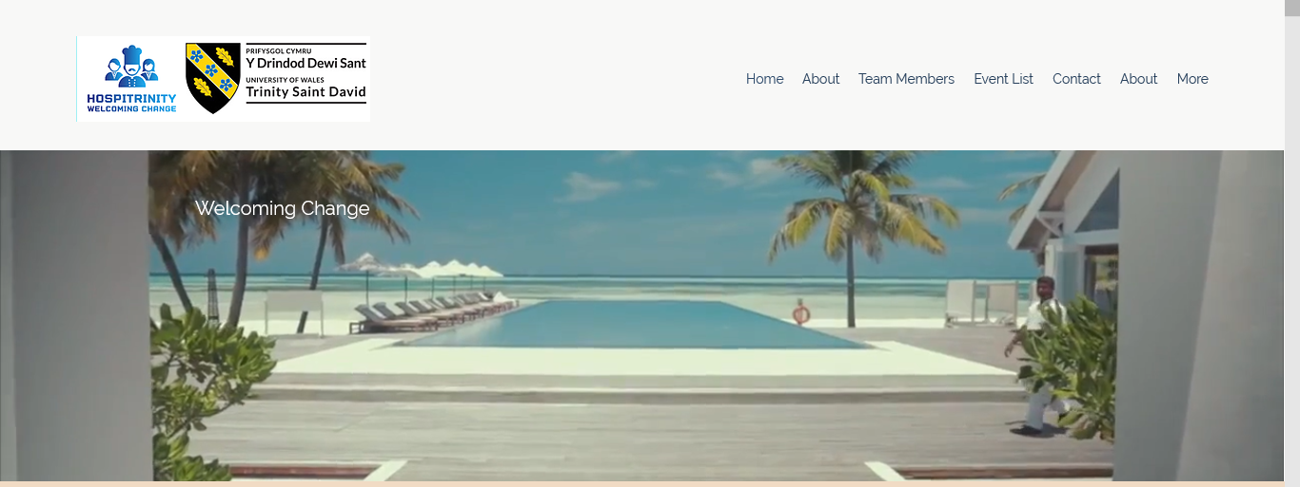

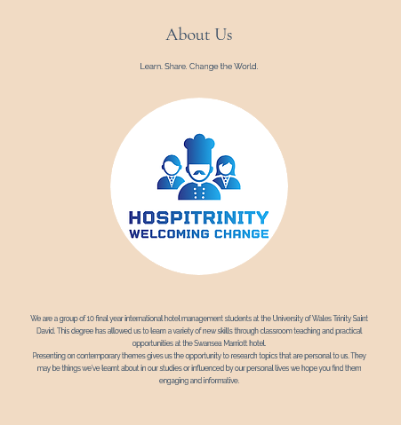

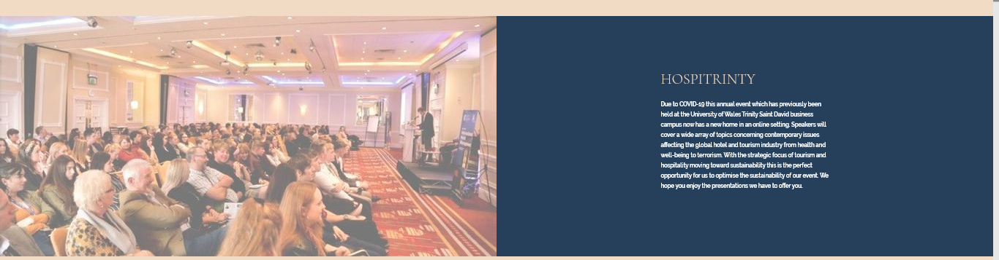

Bios Invitation

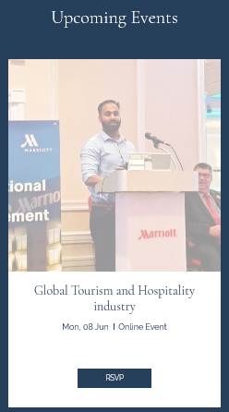
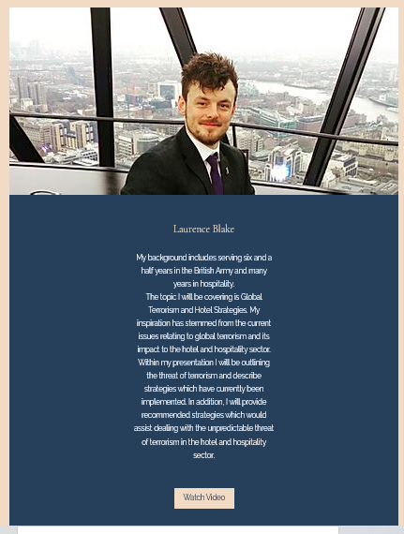

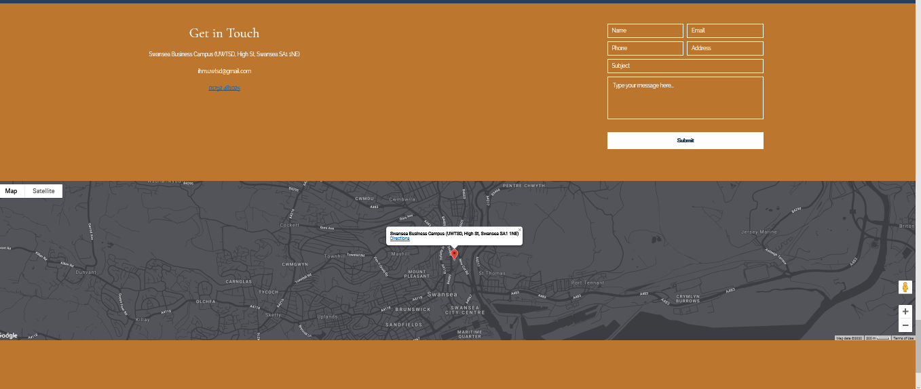

Conference Review | Planning; Organisation; Management; Marketing of the Event and Conference Delivery
Normally, this type of conference would be held in a physical location. However due to unforeseen circumstances of Covid-19 we had to improvise, adapt and overcome in such a circumstance and create a virtual conference. Even though the overall conference was a success, there were a lot of challenges as team we had to overcome to get into the position we are in today.

Planning the conference was well maintained and organised by the management team, this even included pre planning phases to ensure a week by week progress of the conference was maintained. From the meetings ‘Management’ would delegate to the relevant teams and monitor their progress. To get to this level of organisation didn’t come straight away, this even had its own challenges. In the beginning there was no point of contact, leaving the team with no guidance and sense of direction.
By creating the ‘Project Manager’ position as a single point of contact, this increased productivity and this person guided the team to complete the task.

Furthermore, with creating roles to guide and assist the project marketing created the marketing manager position to bring guidance to their efforts. Unfortunately, there were many times with the project that team members were not present for the meetings. In some cases, individuals with crucial taskings failed to upload required content, and or failed to communicate to other members of the teams. This resulted in areas being some content such as flyers and newsletter either not being completed or past on at a later stage to members of other teams.

Technical had some issues with communication as they were both creating the same content separately. This made the team counterproductive. So, by making creating polls this brought the selection to be carried out by other members of the teams. This was the fairest way to select and to reduce future conflict. Unfortunately, there were times when a member of technical was either not present at meetings or slow at meeting deadlines. It was suggested to allow every team member to get access to the website, as this was a crucial component to the conference. This increased productivity as if people were unavailable, multiple people can assist with content for the website.

The conference delivery deadlines had to be firm, this would give the Technical team enough time to upload and manage the videos on the website. Each member was notified prior to this and they were given strict instructions to follow. They had the option to either record themselves and send it to ‘Technical’ or record on 01/06/20. Unfortunately, some members did not complete this and this resulted in their recorded presentations not going on the website.

As a team we have all worked very hard to produce this conference, given to the current circumstances. Those who did attend the meetings and met the deadlines made the most impact and even members offered to support other teams which greatly enhance the team cohesion.

Following the conference this gave us all time to reflect about how future conferences can be delivered in a more sustainable way. In addition, it is more cost effective as there was no expense to book a conference facility and for food and beverage. All that was required is: good WIFI, a laptop or a mobile device and you are on your way. We will all look to the future now and use the lessons learnt from today, to give our world a better tomorrow.

