

Assessment 1 – Reading Task Template
PART 1: Upload your photo of your A3 in-class notes here:
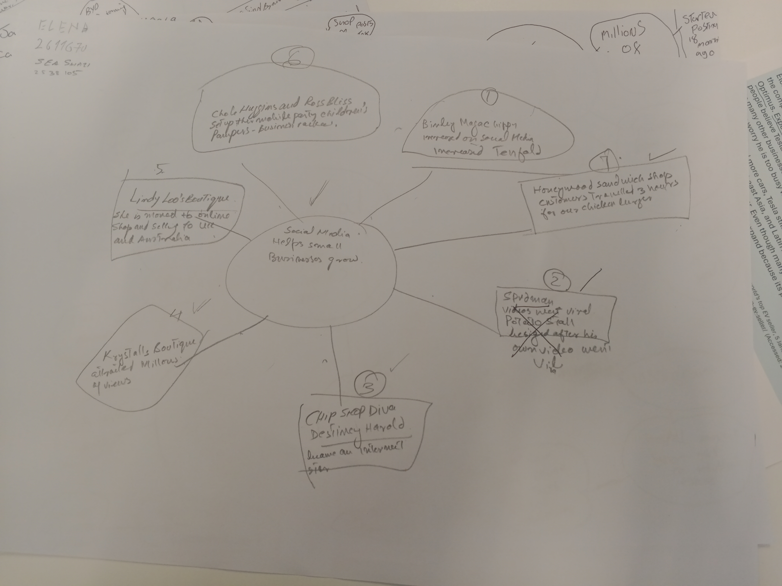

PART 2:
- Answer every question below in 1-3 full sentences.
- Use your own words. Do not use generative AI to answer these questions.
- Include a specific detail from the text when asked.
REMINDER
- The main idea is the overall message of the whole text.
- A key point helps to explain the main idea.
- A specific detail or example from the text shows that the key point is true.

- What is the main idea of the whole text?
Ans: Role of Social Media to help boost growth of small businesses, is the main idea of the entire text. Social Media being the cheapest source of promotion amply helps strengthening of small businesses. Having wider and deeper access amongst the masses, it can viral any business which ultimately helps its growth.

- What is one key point that supports the main idea, and which specific example from the text shows this?
Ans: Key point in support of the main idea is that how to give impetus to the business. In this age of media, social media has gained the vital and pivotal position for promotion of the business industry right from a needle to an aeroplane.

- What is a different key point that supports the main idea, and which specific example from the text shows this?
Ans: Actual happening has become a different key point ‘Customer travelled three hours for our chicken burger’. This is the main attraction for the people who, in line to suffice their curiosity travelled hours long distances and tasted the chicken burger which in turn proved to be pedestal for promotion of the business.

- Which part of the text do you think is most important, and why?
Ans: In my view point the text reading as ‘It is mostly loyal regular popping in for breakfast, but I am told that come the weekend, people will be turning up from far and wide’ is the most important part. This sentence has attracted the people to verify that what was the taste which has been attracting the people from far and wide, which ultimately is cause for promotion of the business.

Reflection:
- What did you find difficult in this task (including in-class components), and why was it difficult?
Ans: Reading of the article was not difficult but the way it was to be projected as Mind power was unfamiliar which subsequently was difficult due to the fact that this exercise was done for the first time. The entire exercise, directly engaged the mind which in turn was sharpened enough to think on the business-like approach.

- What helped you with this difficulty, and how did it help you?
Ans: To be honest, here comes the role of the tutor, who gave full understanding about the subject and then he clear elaboration of the idea unfolded the myth of the Mind Power, which was a unique stride. This unique idea of stirring the mind power gave the direction to start thinking on different lines with different and unique approach.

