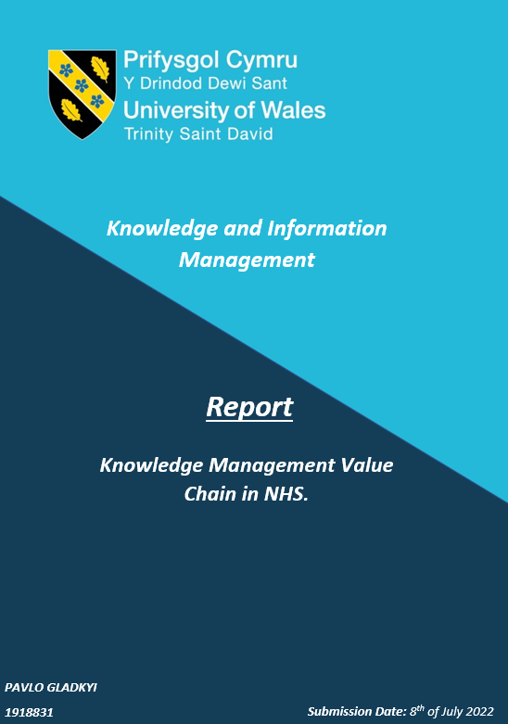
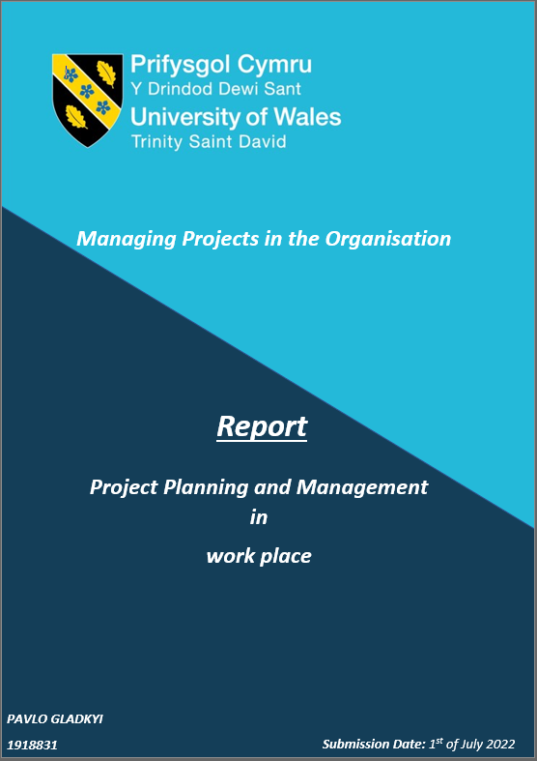

Executive Summary.

This report was conducted to examine the NHS Wales and its Knowledge Management system and analyse the current situation and methods that are organisation uses while dealing with its data, information and knowledge.

Within this report, the author discussed the NHS Wales KMVC efficiency, merits and demerits deployed by the organisation's practices in order to manage its knowledge.
It was revealed that the NHS Wales functions as a devolved administration and financially depends on the Welsh Government.

Moreover, the organisation is one of the fourth UK health care providers with slightly different approaches to dealing with KM systems.
The author concluded that the NHS Wales KM system is still in development and needs to be supported by the other management systems.

Furthermore, to cope with the population growth and the other recently occurred challenges, the report's author recommends increasing the NHS Wales investments in digitalisation, being competitive in the Health sector market and most importantly, providing a quality service to its internal and external customers.

Table of Contents

1.0 Introduction. 1
2.0 Findings. 2
2.1 NHS organisational profile. 2
2.1.2 NHS Wales. 3
2.2 Knowledge Management Value Chain in Welsh health care sector. 5
2.3 SECI model. 8
2.4 KMVC – Support Systems. 9
2.5 RBV and VRIO framework. 9
2.6 SWOT Analysis. 10
3.0 Conclusions. 11
4.0 Recommendations. 12
4.1 First Recommendation. 12
5.0 Appendices. 13
Reference List. 14

1.0 Introduction.

The report was compiled upon the request of Judith Paget, the Director-General for Health and Social Services and the NHS Wales Chief Executive, on 11/06/2022 and delivered on 08/07/2022 by Knowledge Management systems specialist Pavlo Gladkyi.

The primary purpose of this research is to analyse the Welsh Hospital Sector Knowledge management system's suitability and to answer the question of how effective the Knowledge Management Value Chain (KMVC) systems are within the NHS in relation to knowledge acquisition, storage, sharing and development and what kind of interdependent enabling knowledge management support mechanisms are in place to increase its efficiency and effectiveness whilst providing value for money.

Additionally, the report's author examined the health care sector's effectiveness in leveraging its employees' knowledge of tacit and explicit resources and the existing merits and demerits of this process.
Moreover, the discussion was carried out on the NHS's competitive advantage and the role of modern technologies in establishing and deploying the KMVC system with the aim of identifying valuable and rare resources to offer a sustainable competitive advantage.

As per request, the author had an in-depth deliberation of the NHS organisational structure and demographic profile. Furthermore, within the report, the author attempted to scrutinise Nevis and Quinn typologies, SECI model, RBV and VRIO frameworks through the example of NHS.

To meet the report requirements, the author provided a SWOT analysis related to the NHS KM system and placed it in the report's appendices.

To complete this research, the author utilised various sources of credible information such as books, official websites, blogs, articles and academic journals.

2.0 Findings.

2.1 NHS organisational profile.

According to Brain (2018), the NHS began its history in 1948 as a response to post second war crisis in British health care services to eliminate exclusivity and provide comprehensive, affordable and accessible healthcare for everyone despite their financial solvency, social status, gender, age, race, sexual orientation, religion or beliefs.
The NHS is an abbreviation that stands for the National Health Service. Aneurin Bevan, the Minister of Health, launched NHS for the first time at the Park Hospital in Manchester, officially initialising fundamental reforms in the UK's health care sector (NHS, 2012).
The National Archives (2019) states that the revolutionisation of the health care system was inevitable, as the new, upgraded system was intended to replace the antiquated Victorian-era Poor Law.

Gov.uk (2019) contends that NHS is publicly funded through national taxation and appertains to the Secretary of State for Health and the Department of Health. The department is responsible for strategic communication, funding and resources, systems reform and NHS and social care delivery, where health authorities play a crucial role.
Moreover, NHS (2015a) confirms that the UK health system holds under its umbrella four interdependent NHS services for each country that is part of the UK.
Thus, England, Wales, Scotland and Northern Ireland govern their local services and control them separately, so the NHS organisations' structure and available services slightly vary between the four UK nations.
For instance, NHS England is centrally funded by the Department of Health and Social Care. In contrast, NHS Wales, as a devolved administration, receives grants from the UK central government distributed by the Welsh Government accordingly.
Furthermore, another main difference is that in Wales, prescriptions for the patients are free of charge (Powell, Parkin and Kulakiewicz, 2022).
Also, NHS England uses NHS Digital for capturing and facilitating knowledge sharing. However, NHS Wales does not have access to the NHS Digital and uses instead created by the Welsh government knowledge managing system based on Secure Anonymised Information Linkage (SAIL Databank), where data only can be viewed by approved researchers and professionals through the secure SAIL Gateway (gov.wales, 2021). Moreover, the exact source of information states that the Welsh Government supports its health care system by investing in the National Data Resource (NDR) to ensure health and care data availability for NHS staff.
Although the NHS has a composite structure and incorporates multiple organisations in the four nations, the UK government sets its framework and keeps it accountable to Parliament.

2.1.2 NHS Wales.

Due to the vast scale of the NHS organisation, the researcher examined solely the Welsh Health care sector, which is located in Wales and provides its services to its population.
The history of the Walsh health care system started with the creation of the National Health Service Act in 1946, where NHS Wales was formed as a part of the UK health care structure (UK Parliament, 2019). Moreover, Institute for Government (2022) states that in 1969 NHS Wales was managed by the Secretary of State for Wales, and subsequently, in 1999, the NHS Wales was entrusted to the Welsh Assembly and the Government of Wales, which are in charge of it to the present day.
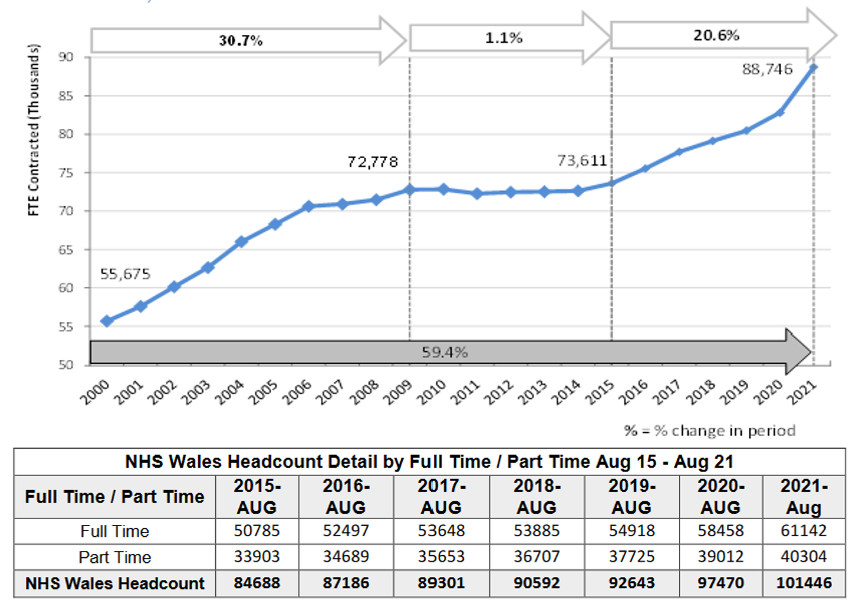
Today NHS Wales comprises seven health boards and three NHS trusts tied to the specific geographical areas where they provide health care services for three million people who live in Wales (Welsh Government, 2022).

Figure 1: Figure 2: NHS Wales Headcount Details (WELSH GOVERNMENT, 2022).
According to the latest statistic, the NHS Wales employs approximately 101,446 people and is considered the biggest employer in Wales (statswales.gov.wales, 2021).
It is noteworthy that NHS Wales's workforce increased by 21% between 2015 and 2021 (Thomas, 2021).
A deep dive into the demographical situation reveals that the workforce participation rate of the male associates is higher than females for every age group except 25 years-old one, where the rate is higher for females.
Additionally, the accomplished Staff Electronic Record states that 8% of the staff show a medium proficiency level in the Welsh language. Furthermore, the NHS Wales staff demonstrates diverse ethnic backgrounds, with over 12% of Black/ Asian/ Mixed and Other ethnic groups currently employed (statswales.gov.wales, 2021). Moreover, the same survey revealed that approximately 5% of the NHS Wales employees are not UK nationals.
Concerning the gender profile of the NHS Wales, its Midwifery and Nursing departments have the highest rate of female associates – 91% versus 9% of males.
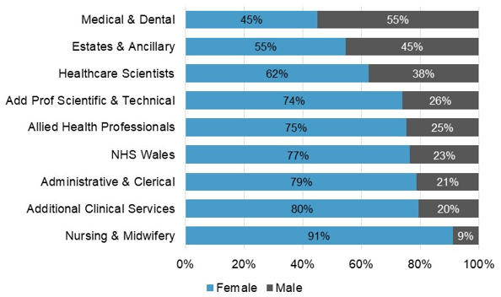
Figure 2: NHS Wales - Percentage of Male and Females by Staff Group (NHS Wales, 2021).
The NHS Wales age profile also shows a correlation to the increased workforce trends (NHS Wales, 2021). For instance, statistics from 2015 to 2021 comprise different age groups and illustrate the increase in 3% of associates in the 35-39 years old group and under, a decrease of 9% in the 40-54 years old group, increase in 9% in 55 plus age group (NHS Wales, 2021).
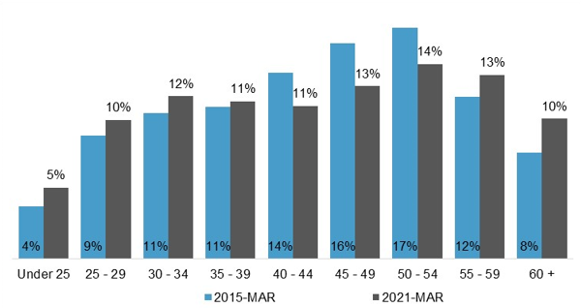
Figure 3: NHS Wales age profile by Year (NHS Wales, 2021).

In terms of the level of education, NHS (2015b) declares that arround 50% of the NHS workforce has a university qualification.

2.2 Knowledge Management Value Chain in Welsh health care sector.

Hajric (2018) contends that Knowledge Management (KM) is a systematic activity that aims to organise corporational knowledge resources in the most valuable way to achieve tactical and strategical organisational objectives, boost the company's competitive advantage and support continuous improvement. Similarly, Harrinson (2021) affirms that KM is a process of providing corporate knowledge assets at the right time to the right people.
Indeed, it is hard to disagree with Wilcox (2020) that it is vital for any organisation to create and inculcate an efficient KM framework with clearly defined needs, available knowledge resources, knowledge relevancy assessments, and secure knowledge assets storage and effective knowledge sharing process.
However, due to the KM's interdependence with other organisational disciplines and systems, the full integration of the KM is unachievable (Kiros, Mamo and Tesema, 2018). Hence, each KM model is unique and must focus on specific objectives while accepting its limitations and looking for further improvements.
The primary purpose of the KM systems is to capture and retain corporational tacit and explicit knowledge, stop their loss and incorporate them into the business that, as a result, ideally returns its investments in knowledge (Brooks, 2022).
Moreover, Denny (2019) states that the main focal point of any organisation regarding fully-fledged and efficient KM must be a knowledge-sharing culture.

The NHS Wales took the vector on developing knowledge-sharing culture when starting a health sector reformation. Moreover, the Digital and Data systems are the critical enablers of transformational change, especially in the information-sharing process (NHS Wales, 2019).
For instance, some leading digital health programs in Wales directly support knowledge-sharing culture and environment of digital innovation by bringing together industry, clinicians, policymakers, academics, innovators and funders (DHEW, 2022).

Nonetheless, Bali and Dwivedi (2010, pp.3–41) disclosed that there is a difference between clinical KM and healthcare KM. The authors argue that health care KM systems are a much broader and more complex concept, where the KM system concentrates on medical stakeholders' information dissemination, perception, and communication regarding medical practices, education and research activities.
As a response to the emerged problem and with a clear understanding that medical information and knowledge are the main assets in the healthcare industry, the NHS elaborated strategies to support KM (gov.wales, 2018).

While talking about effective KM, it is useful to consider the Knowledge Management Value Chain (Chyi Lee and Yang, 2000). This KM tool allows organisations to create a knowledge-based value system where the company's mission and vision will be aligned with KMVC components ensuring tacit and explicit knowledge collection, storage, dissemination and application.
First of all, the organisation must identify knowledge gaps by comparing its strategic objectives and existing knowledge and decide on methods of knowledge collection.

The NHS Wales Knowledge and Skills Framework (KSF) exists to identify NHS staff skills and knowledge gaps. Moreover, based on good people management principles, KSF supports the effective learning and development of individuals and teams by providing the resources required for their upskilling and development (NHS Wales, 2004). Consequently, it will positively impact NHS staff proficiency and add value to the organisation's activities and services.

Knowledge acquisition is the first stage of the KMVC, during which the organisation must create a network of repositories with a valuable corporate knowledge asset such as policies and procedures, expert reports, instructions or customer feedback.
As a continuation of the digital healthcare transformation, the NHS Wales made considerable improvements in organisational digitalisation and implemented some advanced technologies to increase its efficiency in collecting valuable data and information produced by various bodies (Wales, 2006a). Furthermore, according to the same source, the NHS Wales Information Products Unit (NWIS) contextualises, analyses and manages the collected data from the miscellaneous national databases for further storage and dissemination of the produced information.

The second stage of the KMVC is storing, represented by the NHS Wales national IT services. Wales health care system uses two data centres in Cardiff and Blaenavon to store its data. According to Informatic Services (2012), it was a strategic and most cost-effective solution that allowed data storage efficiency and security improvement. In addition, the services provide access to all the NHS Wales staff for further usage and incentivise the explicit to the tacit knowledge transformation process.

Indeed, the NHS Wales relies on the Welsh Community Information System (WCCIS) while sharing information across primary, community secondary and social care networks (NHS Wales, 2019). Moreover, WCCIS is a national program for a safe information-sharing environment that allows the NHS Wales workforce to exchange information, with the main emphasis on multidisciplinary staff. Hence, the NHS Wales declared to use a standard approach for all NHS Wales subsidiaries to maximise the use of technology and increase sustainability while adopting and providing innovations.

The researcher contends that knowledge application in the NHS Wales is practical skills and services that the NHS Wales staff provide daily to its internal and external customers. Moreover, the NHS Wales uses different organisational support systems as enablers to allow knowledge integration ensuring knowledge accessibility to all its staff. As a result, of these activities, NHS Wales attempts to increase the knowledge-sharing process and understand available information, experiences and skills (NHS Wales, 2022a).

For instance, depending on the department, the NHS Wales colleagues will have formal or informal ways of conveying knowledge, such as briefings, meetings, and reports. Moreover, according to NWIS (2012), the NHS Wales staff use codified tacit knowledge transmission through the national directory service via emails, the Walsh Health Telephone Network, the Welsh Health Video Service and the Public Sector Broadband Aggregation.

Another excellent example of explicit to tacit knowledge transformation is the NHS Wales Knowledge Directorate collecting social care data such as births, deaths, hospital workload, primary and community health, mental health services, the performance of the NHS and the NHS Workforce and NHS Finance. The captured digital data will be 5C's and after as a meaningful context presented in the government's health and care statistical publications.
Moreover, the statistical information will be accessible to the NHS Wales staff and 4C'sed throughout their reflection. For instance, specifically gathered contextualised patient data goes through categorisation, calculation, correction and connection processes before presentation as a piece of valuable information that is used by the NHS Wales staff to create knowledge.
However, this tacit knowledge cannot be easily transferred from one associate to another or collected by the organisation, as it is a complex subject, an amalgamation of learning, personal experience and intuition (Oragui, 2020).

It is noteworthy that deep dive into the NHS Wales KMVC system reveals some traces of Navis's and Quinn's typologies that the organisation uses while managing its knowledge.
For instance, the interaction with various sources of information allows the NHS Wales to apply to a certain extent Nevis's typology and forge stronger boundaries between patients and the organisation while collecting valuable data. Moreover, the typology incentivises further organisational development. However, the weakness of Nevis's typology relates to the time of this theory's creation, when the volume of knowledge management processes was lower, and organisations did not have the technologies to store and operate with it effectively. Hence, a complete application of this typology is ineffective for the NHS, as knowledge storage is increasingly crucial.
In Contrast, Quinn's typology was deemed most beneficial for the NHS, as it applies in all fourth areas of the Knowledge Management Value Chain, including knowledge storage. For instance, Cognitive Knowledge (know-what) and Systems Understanding (know-why) reasoning behind valuable data collection within the organisation. Additionally, our day technologies increase the effectiveness of Quinn's typology usage in NHS Wales.

2.3 SECI model.

The SECI model, also renowned as a knowledge conversion theory, was first introduced by Nonaka in 1991 and described organisational knowledge creation and interaction between explicit and tacit through social interaction (Nonaka and Toyama, 2003).
The researcher concluded that the SECI model has a practical application in the NHS Wales KMVC activities and supports each stage of the KMVC to a certain extent (Dubberly and Evenson, 2011). The NHS Wales created an environment for collaboration, interaction and learning (NHS Wales, 2022b).
For instance, the Socialisation process is represented by on-job training and apprenticeships allowing the NHS Wales to harvest new knowledge from its environment with tacit to tacit knowledge transfer.
The Externalisation can be identified in the knowledge capture process by codifying knowledge into documents that NHS Wales staff uses daily and through formal communication during the feedback sharing.
The Combination process within the NHS Wales is represented by web hosting and design services, including the HOWIS, Health in Wales websites and CASCADE – content management system. It allows the transformation of the explicit knowledge of groups to the explicit knowledge of the individuals through the digital technologies that would enable its conveyance. For instance, the slides with induction, guidance and other training materials care careering an explicit knowledge that will be observed and transferred to the individual tacit knowledge (Digital Health and Care Wales, 2022).
A significant amount of manuals and tutorials, and courses are used by NHS Wales staff as an explicit source of knowledge to learn. Indeed, this learning process allows Internalisation by modifying the NHS Wales staff's existing tacit knowledge.
For instance, according to NHS Wales (2004), Internalisation can be achieved by on-job learning and development programs through reflective practice, participating in specific work areas, learning from others on a job or coaching. Moreover, the NHS Wales also provides off-job learning and development on one's own such as private study, e-learning, and distance learning. However, off-job and development with other opportunities, such as formal courses, conferences, induction, role play, learning sets, and scenario-based learning, are also available.

Even though many organisations know and adopt the SECI model, constructive criticism cannot be ignored. For instance, some authors argued that Nonaka's model is not adapted to the western's management cultural practices and can only be considered for use in Japan
(Buono, Flemming Poulfelt and København, 2005). Moreover, Gourlay (2004) questions its paradigmatic status and states that the SECI model lacks some critical empirical aspects and credible backing. Therefore, it should be deemed unwarranted without robust quantifiable evidence. Given all these factors, the report's author concluded that his model is a semantic information creation rather than a knowledge creation theory.

However, this claim can be questioned on several grounds, as Nonaka used some empirical grounding to support his model. However, both of his main pieces of evidence were obtained in Japan, which challenges their validity in culturally diversified teams or organisations.
Moreover, language is a communication tool. People in multinational organisations can face information interpretation and understanding problems as they come from different cultural backgrounds and speak English as their second language. Another problem with the Socialisation process and conversion of tacit knowledge through interaction between individuals can be a lack of trust between staff members in the culturally-diversified organisation. Furthermore, in highly challenging environments where knowledge and ideas won't be shared, everyone has to overperform each other (Arshad, 2008).

2.4 KMVC – Support Systems.

As a part of the organisational strategy, KMVC cannot stand alone and must be supported by other organisational systems to be efficient and deliver results. Furthermore, different support systems within the company interact with KMVC and contribute to its successful integration. Additionally, support is needed to ensure effective learning from the organisational environment and further integration of the obtained knowledge into the business practice returning investments in knowledge management activities (Site Economics, 2016).
Muller (2018) states that there is a direct correlation between effective KM and the quality of the organisational management, culture and etiquette. Hence, all the contributions in KMVC systems, such as HRM and Finance, are entirely interdependent and directly impact its performance.
For instance, some KM enablers, such as technology, can provide tangible support. However, an amalgamation of the various factors such as worker personal characteristics, defined knowledge evaluation process, and cost of it, KM researching tools and a clear understanding of how to deal with tacit organisational knowledge also need to be considered while supporting KMVC within the organisation (Huettich, 2020).

2.5 RBV and VRIO framework.

The report's author scrutinised the RBV and VRIO framework regarding the KMVC and its strengths and weaknesses and revealed that NHS Wales KMVC could benefit from RBV in the data acquisition process in particular while utilising a heterogeneous method of collecting data from various organisational sources. Consequently, the accuracy of the obtained information will improve the stored knowledge.
In contrast, if the NHS Wales should use only intangible-tacit sharing information methods, the information quality decline will unequivocally impair knowledge dissemination.

Additionally, the report's author used the VRIO framework to analyse the NHS Wales KMVC resources in order to determine their value and capability in delivering a sustainable competitive advantage. It was disclosed that the NHS Wales has valuable knowledge that the organisation captures from the patients during the Knowledge acquisition process (Wales, 2006b).
For example, the rare medical and scientific knowledge obtained from the NHS Wales resources attracts extra government funds and hardly can be replicated by its competitors due to the cost. (Health and Care Research Wales, 2022).

2.6 SWOT Analysis.

The compilation and analysis of the KM system revealed some apparent flaws in the Welsh health care KM system. One of the critical limitations concerns the standardisation of the central data management approach that allows efficient data acquisition, storing and disseminating process due to its straightforward and coherent structure, making information more accessible and visible for all organisational units.
For instance, NHS Digital has a better organisation and user-friendliness, such as the alphabetical search for systems and services options. Simiralelly, regarding explicit to tacit knowledge transfer, NHS England has an NHS Knowledge and Library Hub where NHS staff and learners have access to knowledge and evidence resources in one place (NHS, 2022).

Another considerable barrier is that NHS failed on the paperless transition process in 2018, and due to this delay, the completely paperless data acquisition is unachievable (Brother UK Ltd, 2021).
Additionally, hybrid and decentralised data acquisition, evaluation, and storage cause backlogs in the information chain that significantly prolong the treatment waiting list and create additional barriers for patients with critical health conditions (Welsh Parliament, 2022).

Furthermore, a technological barrier limits available services for the patients and creates additional loops in the data acquisition process. For instance, the NHS mobile application is not working in Wales, nor is my GP, and private health care services are not fully integrated with the NHS Wales network, limiting information exchange and impeding users' and patients' experience.

On the other hand, COVID – 19 pandemic accelerated the NHS Wales digitalisation process (Hutchings, 2020).

The NHS Wales SWOT analysis is available in the Appendices.

3.0 Conclusions.

Based on the conducted research, the report's author concluded that the NHS Wales KMVC system is functional and tangibly adds value to the organisation. The NHS Wales uses advanced technologies for the data acquisition process, and its further management and conversion in add value knowledge inculcates organisational learning and has developed administrative support systems.
All in all, the KMVC system of the NHS Wales is organised. However, certain stages of it are still in early development compared to the NHS England and have to be improved to create a more streamlined process.

Additionally, the report's author identified an apparent usage of the SECI model for effective organisational knowledge conversion and RBV and VRIO models to manage its resources and their capability to deliver sustainable competitive advantage.

However, the deep-dive analysis of the NHS Wales KM system revealed some apparent problems and barriers mainly related to the raw digital systems, data errors and ongoing development of the knowledge-sharing culture.

Although the NHS Wales faces the aforementioned problems, the organisation developed a robust plan with coherent steps to overcome current issues.

Additionally, it was concluded that strong organisational culture plays a crucial part in the KMVC system, where a complex approach in every stage is required to consider all factors that potentially can cause barriers to knowledge-creating flow.

Moreover, the discussed in the report models and theories are partially or entirely suitable and more or less used by the NHS Wales to support its KMVC system.

4.0 Recommendations.

4.1 First Recommendation.

The report's author would recommend that NHS Wales find a feasible solution to minimise data discrepancy during the acquisition process, enhance its services for internal and external customers, streamline KMVC processes and improve its internal two-way communication.

4.2 Second Recommendation.

It will be recommended to leverage its resources and invest in software development, increase collaboration with NHS England, NHS Scotland and NHS Northern Ireland to follow up with their experience to improve its digital KM tools and standardise KMVC flow.

5.0 Appendices.

Appendix 1.
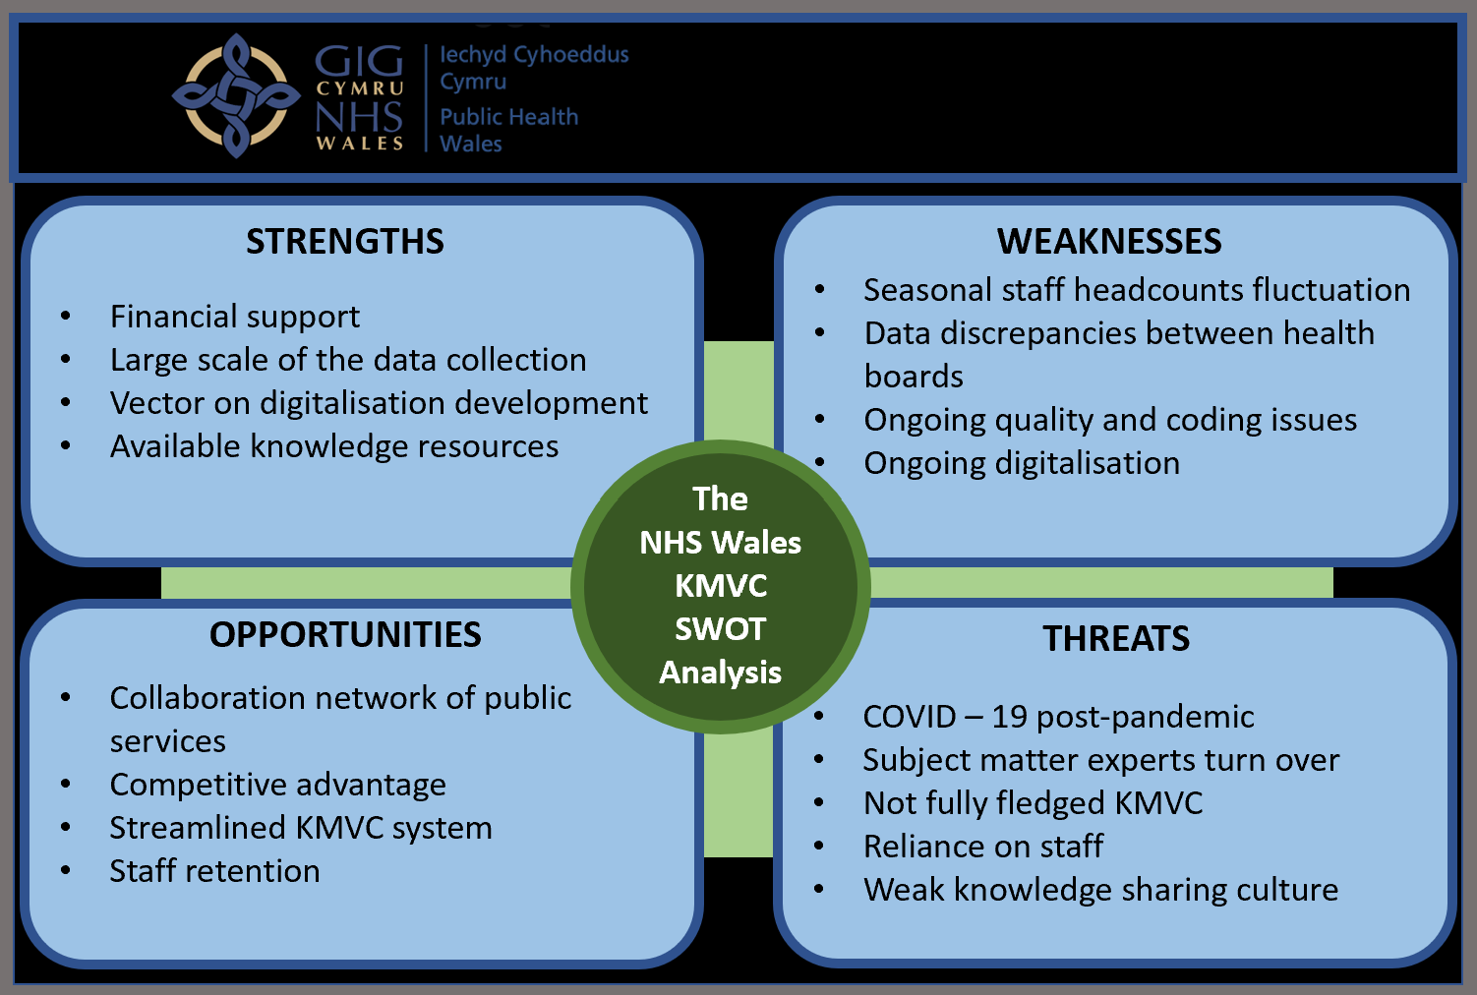

Reference List.

Arshad, M. (2008). Arshad - Knowledge Management- BISM 4410: A Critique of Nonaka's SECI Model Theory. [online] Arshad - Knowledge Management- BISM 4410. Available at: http://mfmarshad.blogspot.com/2008/02/critique-of-nonakas-seci-model-theory.html [Accessed 20 Jun. 2022].
Bali, R.K. and Dwivedi, AN (2010). Healthcare knowledge management : issues, advances, and successes. New York ; London: Springer, pp.3–41.
Brain, J. (2018). The Birth of the NHS. [online] Historic UK. Available at: https://www.historic-uk.com/HistoryUK/HistoryofBritain/Birth-of-the-NHS/ [Accessed 7 May 2022].
Brooks, R. (2022). Knowledge Management 101. [online] https://blog.netwrix.com/. Available at: https://blog.netwrix.com/2019/12/30/knowledge-management/ [Accessed 17 Jun. 2022].
Brother UK Ltd (2021). The paperless NHS – what went wrong? | Spark Blog. [online] Brother UK. Available at: https://www.brother.co.uk/blog/healthcare/2021/paperless-nhs-2020-targets [Accessed 24 May 2022].
Buono, A.F., Flemming Poulfelt and København, H.I. (2005). Challenges and issues in knowledge management. Greenwich, Conn. Information Age Publ. C.
Chyi Lee, C. and Yang, J. (2000). Knowledge value chain. Journal of Management Development, 19(9), pp.783–794. doi:10.1108/02621710010378228.
Denny, J. (2019). How to Create a Knowledge Sharing Culture. [online] www.youtube.com. Available at: https://www.youtube.com/watch?v=lmlEXRmhTjQ [Accessed 15 Jun. 2022].
DHEW (2022). Digital Health Wales. [online] Digital Health Wales. Available at: https://digitalhealth.wales/ [Accessed 17 Jun. 2022].
Digital Health and Care Wales (2022). Standard Operating Procedures (SOPs). [online] Swansea Bay University Health Board. Available at: https://sbuhb.nhs.wales/hospitals/a-z-hospital-services/research-and-development/standard-operating-procedures-sops/ [Accessed 4 Jul. 2022].
Dubberly, H. and Evenson, S. (2011). Design as learning---or 'knowledge creation' ---the SECI model | ACM Interactions. [online] interactions.acm.org. Available at: https://interactions.acm.org/archive/view/january-february-2011/design-as-learning-or-knowledge-creation-the-seci-model1 [Accessed 18 Jun. 2022].
Gourlay, S. (2004). The SECI model of knowledge creation: some empirical shortcomings. [online] Available at: https://eprints.kingston.ac.uk/id/eprint/2291/1/Gourlay%202004%20SECI.pdf [Accessed 20 Jun. 2022].
Gov.uk (2019). Secretary of State for Health and Social Care - GOV.UK. [online] www.gov.uk. Available at: https://www.gov.uk/government/ministers/secretary-of-state-for-health-and-social-care [Accessed 8 May 2022].
gov.wales (2018). The Parliamentary Review of Health and Social Care in Wales A Revolution from Within: Transforming Health and Care in Wales Final Report. [online] Crown copyright, pp.4–39. Available at: https://gov.wales/sites/default/files/publications/2018-01/Review-health-social-care-report-final.pdf [Accessed 20 Jun. 2022].
gov.wales (2021). Written Statement: Sharing patient records in Wales (8 June 2021). [online] GOV.WALES. Available at: https://gov.wales/written-statement-sharing-patient-records-wales [Accessed 17 Jun. 2022].
Hajric, E. (2018). Knowledge Management Definition. [online] www.knowledge-management-tools.net. Available at: https://www.knowledge-management-tools.net/knowledge-management-definition.php [Accessed 11 May 2022].
Harrinson, E. (2021). Getting the Right Knowledge to the Right Person at the Right Time | KMInstitute. [online] www.kminstitute.org. Available at: https://www.kminstitute.org/blog/getting-right-knowledge-right-person-right-time [Accessed 17 Jun. 2022].
Health and Care Research Wales (2022). Our funded projects. [online] Health Care Research Wales. Available at: https://healthandcareresearchwales.org/researchers/our-funded-projects [Accessed 20 Jun. 2022].
Huettich, J. (2020). What are the key challenges of knowledge management? | MindManager Blog. [online] MindManager Blog. Available at: https://blog.mindmanager.com/blog/2020/01/02/2020013-common-challenges-knowledge-management/ [Accessed 20 Jun. 2022].
Hutchings, R. (2020). Key points The impact of Covid-19 on the use of digital technology in the NHS. [online] Available at: https://www.nuffieldtrust.org.uk/files/2020-08/the-impact-of-covid-19-on-the-use-of-digital-technology-in-the-nhs-web-2.pdf [Accessed 18 Jun. 2022].
Informatic Services, NW (2012). NWIS ServiceGuide English WebVersion. [online] Available at: http://www.wales.nhs.uk/sitesplus/documents/956/NWIS_ServiceGuide_English_WebVersion.pdf [Accessed 17 Jun. 2022].
Institute for Government (2022). StackPath. [online] www.instituteforgovernment.org.uk. Available at: https://www.instituteforgovernment.org.uk/publication/devolved-public-services/nhs [Accessed 15 Jun. 2022].
Kiros, Z., Mamo, W. and Tesema, W. (2018). Factors and Barriers affecting Knowledge Management System on the Organizational Performance in Mesfin Industrial Engineering of Ethiopia. Universal Journal of Industrial and Business Management, 6(2), pp.23–29. doi:10.13189/ujibm.2018.060201.
Muller, J. (2018). Effective Knowledge Management and Organisational Learning in the Context of Sustainable Development. The Electronic Journal of Knowledge Management, [online] 16(ISSN 1479-4411), pp.56–66. Available at: https://www.researchgate.net/profile/Joy-Muller/publication/326919940_Effective_Knowledge_Management_and_Organisational_Learning_in_the_Context_of_Sustainable_Development/links/5b6d88dd45851546c9fa23ab/Effective-Knowledge-Management-and-Organisational-Learning-in-the-Context-of-Sustainable-Development.pdf?origin=publication_detail [Accessed 20 Jun. 2022].
NHS (2012). History of Trafford General Hospital. [online] Available at: https://assets.nhs.uk/prod/documents/History_of_trafford_general_hospital.pdf [Accessed 4 Jul. 2022].
NHS (2015a). Frequently asked questions on working in health. [online] Health Careers. Available at: https://www.healthcareers.nhs.uk/working-health/faqs-working-health/frequently-asked-questions-working-health [Accessed 15 Jun. 2022].
NHS (2015b). UK health systems. [online] Health Careers. Available at: https://www.healthcareers.nhs.uk/working-health/uk-health-systems/uk-health-systems [Accessed 14 Jun. 2022].
NHS (2022). NHS Knowledge and Library Hub. [online] Knowledge and Library Services. Available at: https://library.nhs.uk/knowledgehub/ [Accessed 17 Jun. 2022].
NHS Wales (2004). The NHS Knowledge and Skills Framework (NHS KSF) and the Development Review Process. [online] pp.3–297. Available at: http://www.wales.nhs.uk/sites3/Documents/433/KSF04088218.pdf [Accessed 17 Jun. 2022].
NHS Wales (2019). NHS Wales Planning Framework Message from the Cabinet Secretary for Health and Social Services Message from the Director General Health and Social Services and NHS Wales Chief Executive. [online] Available at: http://www.wales.nhs.uk/sitesplus/documents/862/Item%205.1.1%20NHS%20Wales%20Planning%20Framework%202019-22.pdf [Accessed 17 Jun. 2022].
NHS Wales (2021). Home - HEIW. [online] Nhs.wales. Available at: https://heiw.nhs.wales/files/nhs-wales-workforce-trends-as-at-31-march-2021/ [Accessed 15 Jun. 2022].
NHS Wales (2022a). NHS Wales launches dedicated Microsoft innovation hub for staff. [online] Digital Health and Care Wales. Available at: https://dhcw.nhs.wales/news/latest-news/nhs-wales-launches-dedicated-microsoft-innovation-hub-for-staff/ [Accessed 4 Jul. 2022].
‌NHS Wales (2022b). Reference Number: PHW 04. [online] Available at: https://phw.nhs.wales/about-us/policies-and-procedures/policies-and-procedures-documents/human-resources-policies/statutory-and-mandatory-training-policy/ [Accessed 20 Jun. 2022].
Nonaka, I. and Toyama, R. (2003). The knowledge-creating theory revisited: knowledge creation as a synthesising process. Knowledge Management Research & Practice, 1(1), pp.2–10. doi:10.1057/palgrave.kmrp.8500001.
NWIS (2012). NWIS ServiceGuide English WebVersion. [online] Available at: http://www.wales.nhs.uk/sitesplus/documents/956/NWIS_ServiceGuide_English_WebVersion.pdf [Accessed 18 Jun. 2022].
Oragui, D. (2020). Tacit Knowledge: Definition, Examples, and Importance. [online] helpjuice.com. Available at: https://helpjuice.com/blog/tacit-knowledge [Accessed 4 Jul. 2022].
Powell, T., Parkin, E. and Kulakiewicz, A. (2022). NHS Charges. [online] Parliament.uk. Available at: https://researchbriefings.files.parliament.uk/documents/CBP-7227/CBP-7227.pdf [Accessed 15 Jun. 2022].
Site Economics (2016). The Knowledge management value chain | site economics. [online] siteeconomics.blogspot.com. Available at: https://siteeconomics.blogspot.com/2016/10/the-knowledge-management-value-chain.html [Accessed 20 Jun. 2022].
statswales.gov.wales (2021). NHS Wales staff by staff group and year. [online] Gov.wales. Available at: https://statswales.gov.wales/Catalogue/Health-and-Social-Care/NHS-Staff/NHS-Staff-Summary/nhsstaff-by-staffgroup-year [Accessed 15 Jun. 2022].
The National Archives (2019). 1833 Factory Act. Nationalarchives.gov.uk, [online] 1(1). doi:https://www.nationalarchives.gov.uk/default.htm.
Thomas, E. (2021). The scale of NHS staff currently off with Covid across Wales. [online] WalesOnline. Available at: https://www.walesonline.co.uk/news/wales-news/scale-nhs-staff-currently-covid-22605688 [Accessed 16 Jun. 2022].
UK Parliament (2019). 1946 National Health Service Act. [online] UK Parliament. Available at: https://www.parliament.uk/about/living-heritage/transformingsociety/livinglearning/coll-9-health1/health-01/ [Accessed 15 Jun. 2022].
Wales, N.H.S. (2006a). NHS Wales | NHS Wales - About Us. [online] www.wales.nhs.uk. Available at: https://www.wales.nhs.uk/nhswalesaboutus [Accessed 15 Jun. 2022].
Wales, N.H.S. (2006b). NHS Wales | Sources of Data. [online] www.wales.nhs.uk. Available at: http://www.wales.nhs.uk/statisticsanddata/sourcesofdata [Accessed 16 Jun. 2022].
WELSH GOVERNMENT (2022). NHS PAY REVIEW BODY EVIDENCE FROM THE WELSH GOVERNMENT'S HEALTH AND SOCIAL SERVICES GROUP. [online] pp.22–34. Available at: https://www.nhsconfed.org/sites/default/files/2022-02/NHS%20Pay%20Review%20Body%20Evidence%20Report%202022-23.pdf [Accessed 15 Jun. 2022].
Welsh Government (2022). NHS Wales health boards and trusts. [online] GOV.WALES. Available at: https://gov.wales/nhs-wales-health-boards-and-trusts [Accessed 15 Jun. 2022].
Welsh Parliament (2022). What you told us about waiting times for treatment and diagnosis. [online] senedd.wales. Available at: https://senedd.wales/senedd-now/senedd-blog/what-you-told-us-about-waiting-times-for-treatment-and-diagnosis/ [Accessed 4 Jul. 2022].
‌Wilcox, E. (2020). How to Build Effective Knowledge Management Systems. [online] blog.getguru.com. Available at: https://blog.getguru.com/knowledge-management-systems [Accessed 17 Jun. 2022].

