Leading performance through effective leadership
The importance of line managers during performance management
CIPD (2022) outline organisations need a strong understanding of what constitutes to performance to assist them in measuring it, understanding why it varies and what factors increase or inhibit it.
Line managers play an integral role contributing to an organisations service delivery and to do this they need to ensure they have positive relationships with their teams to support and develop their skills. Furthermore, the relationship between line managers and the HR function has progressed, line managers have more responsibilities and support on various people management activities such as recruitment and performance management (CIPD, 2025a).
CIPD (2020) highlight managers have an important role to support their teams learning and development, detailing that line manager buy-in is needed to embed a learning culture. This could improve job satisfaction and reduced turnover.

Leadership approach and HR relationship
Within South Wales Police (SWP) operational HR has a team of business partners and advisors who support line management teams on any operational HR matter including maternity, sickness, flexible working, policy, workplace conflict and performance. HR advisors also will work with data and analyse any trends. They are the lead on all force people data (SWP, 2025b).
Supportive Leadership and Supervision is a key priority in the Chief Constable’s Delivery Plan 2021-2025 (SWP, 2021a), within the people strategy this is further highlighted by the forces commitment to creating a supportive environment where there are the right people, doing the right things in the right way (SWP, 2021b). This starts with clear management.
The way in which teams operate could reflect their organisations culture and the roles which they carry out (Watson & Gallagher, 2005). Line managers need to ensure they build upon a good organisational culture and lead effectively. Howlett (2023) highlights that both HR and L&D can support managers by identifying clear opportunities for development and accurately assess how managers can effectively support their teams through this process. Having an effective team is critical to an organisation’s success, any success or failure of teams is often linked to the manager (McKinsey, 2024).
There are many leadership styles which implemented or followed can support line managers. Good leadership can produce positive organisational outcomes, managers need the skills and abilities to foster trust, communicate clearly, be genuine and empathetic (Jones, 2020).
However, if line managers do not support or manage their teams correctly, this can have a detrimental impact on team and organisational performance. Sriganthan (2023) highlighted, poor management can also negatively impact employee’s mental health, which in turn could increase absenteeism.

Supporting line managers, developing teams and talent
Good culture and organisational structure with fewer layers allow for better decision making and performance (McKinsey, 2021). By reducing layers and barriers individuals will feel more valued and support the team’s performance.

Deloitte (2018) outlined, leaders that know how to recognise and develop talent, can also build their teams to have varying skills with complement each other. HR and L&D can support line managers during this process.
CIPD (2025b) discuss the difficulties organisations have in retaining and attracting talent. Highlighting how line managers are critical to L&D success. Employees that feel supported by their manager and organisation are keener to learn. L&D can support by ensuring that managers are prepared and ready to help their teams to reflect, practice, amend and foster good behaviours. Furthermore, Moss (2023) outlined data which showed that individuals who were promoted to management posts based on internal relationships and profile, rather than ability or performance. Lead to their peers looking to leave their organisation due their trust and inability to manage correctly.

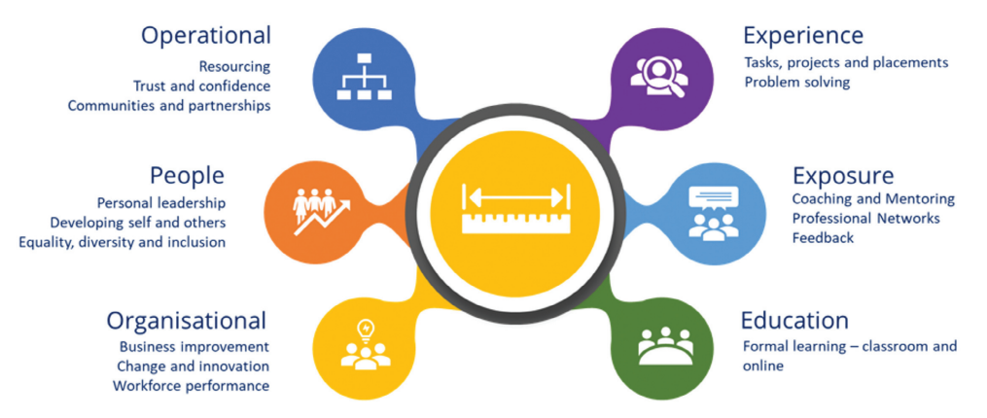
Talent development process (SWP, 2025a)
As part of the SWP talent development process, a variety of targeted development opportunities are offered to those identified as talented officers and staff, covering the core areas of operational development, people development and organisational development. Individuals are identified as talent through achieving 'Exceptional' Performance and 'High' Potential ratings within their PERFORM annual review. Individuals are measured and developed via experience, exposure and education.

Koche (2024) highlights the essential role in which HR management play in designing and implementing development training, coaching and mentorship, and fostering a supportive culture. By investing in leadership development, organisations can enhance leadership effectiveness, drive growth, and achieve strategic success.
Hughes (2024) discusses the relationship between HR and line managers, highlighting the support in which HR can provide. Such as acting as the medium between line managers and senior leaders and gathering quality feedback data to support the needs of line managers and their teams.

People analytics - assisting line managers
McBride, Cunden & Bryce (2021) highlight that people analytics relate to data sets about people held by HR systems which support in resolving organisational difficulties.
People analytics helps organisations improve their transactional HR and planning processes. Benefits include:
- Reduction in workforce planning cycles.
- Improved hiring processes, accuracy with data.
- Better retention.
- Employee satisfaction.
- Efficient talent management and skills management.
- Improved productivity and increased accuracy in workforce planning.
(SplashHR, 2021)
As highlighted, SWP HR advisors can support management teams by utilising the people data available within the internal systems. This data can drive and improve decision making when addressing areas of concern within a given department.

Wellbeing of staff
Within SWP, sickness absence specifically in relation to mental health has been a cause for concern. Comparing year on year absence there has been an increase in individuals reporting sick due to their mental health, this has increased from 155 to 168 during May 2025 (SWP, 2025c).
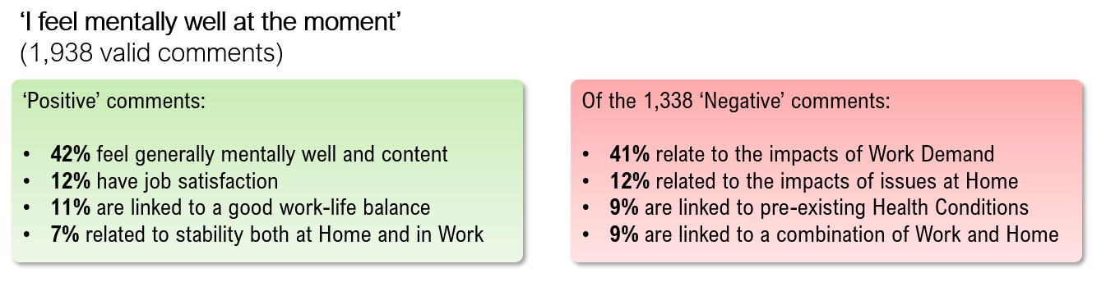
SWP staff survey emotional wellbeing results (SWP, 2024)
Feedback from SWP force wide internal survey in May 2024 indicated that employees were struggling workloads and demands. Those in frontline, operational roles were struggling the most with regards to health & wellbeing (SWP, 2024).
CIPD (2024) good work index highlighted that 31% of public sector employees reported a positive impact on mental health, compared with 41% of private and voluntary sectors. This feedback highlights the impact of individuals mental health specifically in the public sector.
Improving wellbeing of employees can help prevent stress and create a positive working environments where teams can succeed, wellbeing can also support employee engagement and organisational performance (Suff, 2024). Norris (2024) highlights line managers play a crucial role in ensuring mental and physical wellbeing of their teams, with support and training line managers can identify early signs of deteriorating wellbeing in their staff and put in place preventative measures to reduce the likelihood of long-term absence.
SWP has created a wellbeing portal on the force intranet to support with information on the force's plans to prioritise and improve the wellbeing of staff and officers. Providing individuals with initiatives around what they can do as an individual, as a team and as a department to ensure a sensible work life balance can be achieved examples include welfare support officers who provide support for a colleague, a point of contact and a voice or representation within the organisation during difficult times.
In addition, HR advisors provide absence management masterclasses and regularly meet with line managers to discuss opportunities to support their staff and best practice when managing any absence.

Coaching and mentoring opportunities
Coaching and mentoring are essential skills for line managers who want to develop their teams and foster a positive work culture (LinkedIn, 2023).
Harvard business review (2022) discusses the importance of coaching and mentoring in developing effective leaders, which supported retention of talent. Also examining how this personalised approach is now more desirable amongst employees.

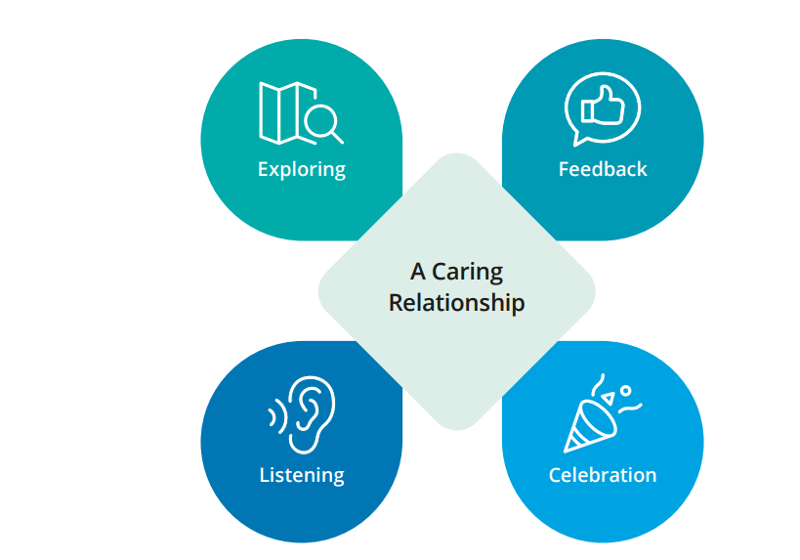
Deloitte (2020) highlight a 5-stage coaching model with the aim of building a relationship of trust, which provides an opportunity for managers develop and support employee behaviour. It aims to help managers bring out the best performance in their people.
HR & L&D can assist line managers by equipping line managers with the confidence, skills and framework needed to encourage their teams to upskill. This can then develop a culture of continuous learning that all employees can benefit from (Kolade, 2024).
Cooper (2019) outlined individuals have greater expectations of their managers in relation to their own development and they expect their managers to support their development. Further highlighting 5 areas which can help create a learning culture:
- Challenge coaching styles
- Utilise coaching models
- Acknowledge & reward questions
- Encourage personal conversations
- Embrace differences

CIPD (2020) define a learning culture as is one that embraces learning into how things are done at all levels including individual, team and organisational. Senior leaders and line managers play key role in delivering learning opportunities. HR, L&D and SMT are responsible for delivering learning strategies and should work with leaders and line managers to build a shared vision.

The SWP L&D unit have created a brochure of opportunities with the aim to support managers by ensuring there is clarity around their responsibilities and then prepare them with the right skills to support and develop their teams with confidence (SWP, 2025a).

Word count: 1483

References

CIPD (2020) Creating Learning Cultures. Available at: (https://www.cipd.org/globalassets/media/knowledge/knowledge-hub/reports/creating-learning-cultures-1_tcm18-75606.pdf) (Accessed: 20 April 2025).
CIPD (2022) People performance: An evidence review. Available at: (https://www.cipd.org/uk/knowledge/evidence-reviews/evidence-people-performance/) (Accessed: 02 April 2025).
CIPD (2024) CIPD Good Work Index 2024. Available at: (https://www.cipd.org/globalassets/media/knowledge/knowledge-hub/reports/2024-pdfs/8625-good-work-index-2024-survey-report-1-web.pdf) (Accessed: 02 May 2025).
CIPD (2025a) Line managers' role in supporting the people profession. Available at: (https://www.cipd.org/uk/knowledge/factsheets/line-managers-factsheet/) (Accessed: 01 April 2025).
CIPD (2025b) Analysis | How L&D can create value: Role of line managers in supporting skills development. Available at: (https://www.cipd.org/en/views-and-insights/thought-leadership/insight/learning-value-role-manager/) (Accessed: 21 April 2025).
Cooper, K. (2019) Five ways to create a coaching culture. Available at: (https://www.peoplemanagement.co.uk/article/1743794/five-ways-to-create-a-coaching-culture) (Accessed: 02 May 2025).
Deloitte (2018) People-Focused Leadership. Available at: (https://www2.deloitte.com/content/dam/Deloitte/us/Documents/about-deloitte/us-about-deloitte-people-focused-leadership.pdf) (Accessed: 21 April 2025).
Deloitte (2020) Coaching Employees to Reach Optimal Performance. Available at: (https://www2.deloitte.com/content/dam/Deloitte/us/Documents/human-capital/us-coaching-employees-to-reach-optimal-performance.pdf0 (Accessed: 02 May 2025).
Havard business review (2022) Leveraging Coaching and Mentoring to Create More Effective Leaders. Available at: (https://hbr.org/resources/pdfs/comm/torch/LeveragingCoachingAndMentoringToCreateMoreEffectiveLeaders.pdf) (Accessed: 02 May 2025).
Howlett, E. (2023) How can HR and L&D collaborate to allow employees more time to learn? Available at: (https://www.peoplemanagement.co.uk/article/1828439/hr-l-d-collaborate-allow-employees-time-learn) (Accessed: 20 April 2025).
Hughes, E. (2024) Analysis | Devolving HR management to people managers. Available at: (https://www.cipd.org/uk/views-and-insights/thought-leadership/insight/devolving-hr-management/) (Accessed: 21 April 2025).
Jones, S. (2020) What leadership style will support my team best? Available at: (https://www.deloitte.com/au/en/services/risk-advisory/blogs/leadership-style-support-team-best.html) (Accessed: 21 April 2025).
Koche, S. (2024) The Role of Human Resource Management in Leadership Development. Available at: (https://www.linkedin.com/pulse/role-human-resource-management-leadership-development-sharad-koche-naqmf) (Accessed: 21 April 2025).
Kolade, O. (2024) How HR professionals can build a culture of lifelong learning. Available at: (https://www.hrmagazine.co.uk/content/comment/how-hr-professionals-can-build-a-culture-of-lifelong-learning) (Accessed: 02 May 2025).
LinkedIn (2023) What are some common coaching and mentoring pitfalls for line managers and how to avoid them? Available at: (https://www.linkedin.com/advice/1/what-some-common-coaching-mentoring-pitfalls-line) (Accessed: 02 May 2025).
McBride, N., Cunden, M. & Bryce, V. (2021) How people analytics and AI are changing HR departments. Available at: (https://www.peoplemanagement.co.uk/article/1746231/how-people-analytics-and-ai-changing-hr-departments) (Accessed: 21 April 2025).
McKinsey (2021) The new possible: How HR can help build the organization of the future. Available at: (https://www.mckinsey.com/capabilities/people-and-organizational-performance/our-insights/the-new-possible-how-hr-can-help-build-the-organization-of-the-future) (Accessed: 01 April 2025).
McKinsey (2024) Go, teams: When teams get healthier, the whole organization benefits. Available at: (https://www.mckinsey.com/capabilities/people-and-organizational-performance/our-insights/go-teams-when-teams-get-healthier-the-whole-organization-benefits#/) (Accessed: 20 April 2025).
Moss, R. (2023) ‘Accidental managers’ are driving attrition. Available at: (https://www.personneltoday.com/hr/accidental-managers-attrition-retention-cmi-research-2023/0 (Accessed: 01 May 2025).
Norris, R. (2024) Why line managers are crucial when it comes to preventative employee health and wellbeing. Available at: (https://www.hrmagazine.co.uk/content/insights/why-line-managers-are-crucial-when-it-comes-to-preventative-employee-health-and-wellbeing/0 (Accessed: 02 May 2025).
South Wales Police (2021a) Chief constable delivery plan 2021-2025. Internal Report. Unpublished.
South Wales Police (2021b) People strategy. Internal Report. Unpublished.
South Wales Police (2024) Hive - wellbeing survey 2024. Internal report. Unpublished.
South Wales Police (2025a) Learning & Development – Programme of Opportunities. Internal report. Unpublished.
South Wales Police (2025b) HR Booklet. Internal report. Unpublished.
South Wales Police (2025c) BI tool – Absence – May 2025. Internal report. Unpublished.
SplashHR. (2021) Why is people analytics so important for HR? Available at: (https://www.peoplemanagement.co.uk/article/1745432/why-is-people-analytics-important) (Accessed: 21 April 2025).
Sriganthan, A. (2023) Half of employees with poor managers say work negatively impacts their mental health, research finds. Available at: (https://www.peoplemanagement.co.uk/article/1821838/half-employees-poor-managers-say-work-negatively-impacts-mental-health-research-finds) (Accessed: 29 April 2025).
Suff, R. Wellbeing at work. Available at: (https://www.cipd.org/uk/knowledge/factsheets/well-being-factsheet/0 (Accessed: 02 May 2025).
Watson, G.E. & Gallagher, J.K. (2005) Managing for Results. 2nd Edition. London: CIPD.

