12/18/2025
Module Code: ACCA4024
Synthesize a solution to a potential real-life scenario
Lecturer: Amit Naik
STUDENT NAME: Adriano Antonio Donda
STUDENT ID: 2428051

TRINITY SAINT DAVID UNIVERSITY OF WALES LONDON CAMPUS
Networks and Cyber Security Essentials

Table of Contents
1.Introduction 2
2.Organisational Context and Assumed IT Environment 3
3. Identification of Cybersecurity Threats 4
3.1 External Threats 4
3.2 Internal Threats 4
4. Security Policies and Mitigation Measures 5
4.1 Remote Access and VPN Security Policy 5
4.2 Authentication and Access Control Policy 7
4.3 Endpoint Security Policy 7
5. Monitoring and Logging 8
6. Incident Response and Breach Management 8
7. Staff Training and Security Awareness 9
8. Alignment with Cybersecurity Standards and Regulations 10
9. Conclusion 11
References 12
Appendix - PowerPoint Slide / Cisco Certificate 13

1.Introduction

FinSecure Ltd (FSL) is a medium-sized financial services company, which processes confidential client data about the identity and corresponding financial details. Following the suspected phishing incident and incident of attempted unauthorised access to its network systems, the agency is at higher-than-normal risk of a potential cybersecurity compromise. FinSecure Ltd like many businesses in the modern era, promotes flexibility and remote computer usage which is why you have been provided with access to our internal systems using a Virtual Private Network (VPN)[1].
Remote work not only brings operational and productivity advantages, but also adds more security concerns. Remote accessibility widens the attack vector and increases the chance of credential leak, unauthorized access then data breaches. Financial institutions are also a bee’s nest for cyber crooks, as the data they hold is one of the highest attraction points.
This report provides a detailed security policy recommendation for FinSecure Ltd specifically regarding VPN based remote access risks. The report highlights significant internal and external threats and suggests security policies and technical controls that are consistent with standard cybersecurity frameworks, as well as monitoring, incident response and staff training to strengthen the organisation's security posture, bolster compliance with regulations[2].

2.Organisational Context and Assumed IT Environment

For the purposes of this security policy it is assumed that FinSecure Ltd runs a hybrid IT environment. The company employs a centralised system to send email and collaborate, provides remote access through VPNs, and operates its own systems that house customer information of business significance. Employees can remotely connect to internal sources by the VPN over company provided laptops if they work from home.
Centralised management of user accounts and a role‐based access to systems. Being a UK based financial services company, FinSecure Ltd is subject to data protection laws (including the UK General Data Protection Regulation (UK GDPR)), which requires that personal data be protected through appropriate technical and organisational measures.
The selection of this assumed environment reflects most medium-sized companies and constitutes a pragmatic basis for creating security controls that do not depend on an organisation-specific proprietary solution.

3. Identification of Cybersecurity Threats

3.1 External Threats
Phishing is one of the most serious external threats that FinSecure Ltd encounters. One way to do this is via phishing, through which criminals try to trick employees into handing over their credentials by pretending to be from a known entity such as the company or an internal department. If they are successful, hackers can then use stolen credentials to log into the company’s VPN and internal systems from outside the network.
There will also be a serious threat of credential-based attacks, including password spraying and brute force attacks. Attackers may try to use the same common password on other accounts especially where loose password policies are in place. Those sorts of attacks can provide unauthorised VPN access unless there are added authentication controls in place.
A further exterior threat includes the delivery of malware via breached remote devices. Home-workers are particularly at risk of accidental downloading of damaging software via phishing emails or unsafe webpages. “If the VPN was compromised, these would also be potential avenues of internal access to systems or an entry point for ransomware[3].

3.2 Internal Threats
Internal dangers can be classified by malicious and unintended activities of employed staff. Unintended data disclosure is one of the typical hazards present in home office scenarios such as when data is mismanaged and access to sensitive information allowed (for instance on accidentally sharing files or sending confidential info to a wrong addressee or while using unsecured private devices).
Furthermore, overentitled access amplifies the damage of compromised accounts. Should employees have access to more systems in a broader portion of the environment than they need (least privilege is not implemented), it may be possible for an attacker with VPN access to traverse laterally within the network and target systems or data beyond that which was compromised.

4. Security Policies and Mitigation Measures

4.1 Remote Access and VPN Security Policy
FinSecure Ltd needs to adopt a policy framework for remote access that specifies how staff are allowed to connect to the organisation remotely. All remote access should have to go through a VPN that uses strong encryption for data in motion.
Only known users and devices are permitted its use of VPN. As early as possible access rights should be assigned by job roles applying the principle of the least right. This guarantees that users are only able to access the systems and information they require for their work responsibilities.
Auto-logout sessions when the VPN is idle are useful, but a re-authentication mechanism must be present to ensure that unattended sessions do not get abused. These are approaches to work to minimize the potential fallout of unauthorized access[4].
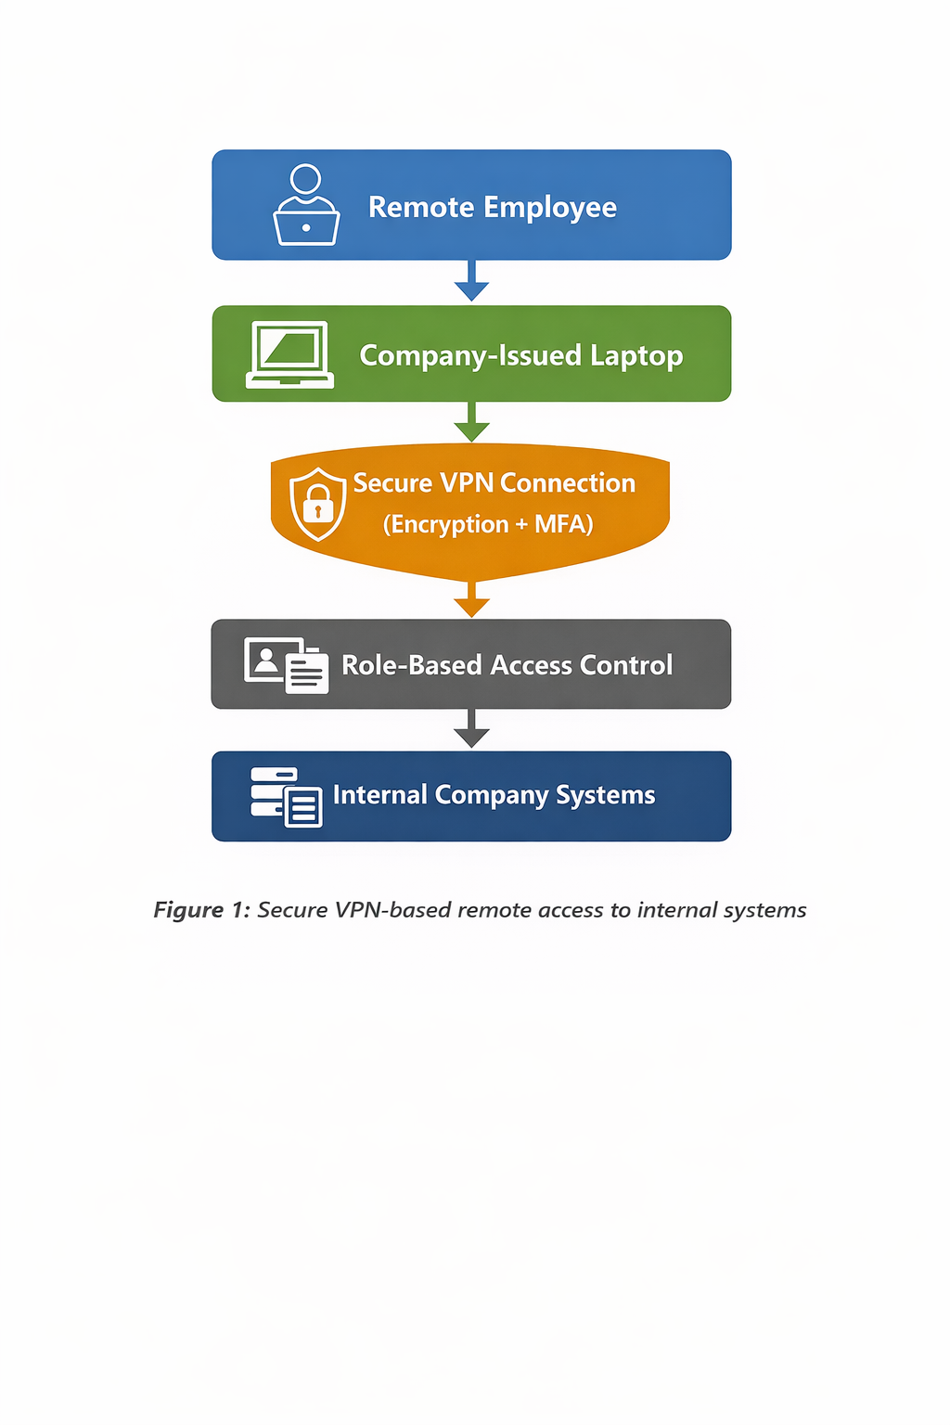

4.2 Authentication and Access Control Policy
Tight authentication controls but passwords are a big risk, Tight authentication measures mitigate the threat of credential-based attack. MFA needs to be mandated by FinSecure Ltd for all VPN users. MFA is an excellent deterrent to illicit access, even when passwords are discovered.
Password policies should also reflect the NCSC definition of what constitutes a good password, and support and encourage the adherence to their guidance but discouraging password reuse. Enforce account lockout or rate limiting to guard against Brute-Force and Password Spraying assaults.
Elevated (eg Admin) accounts should be isolated from normal user accounts and only used during administrative tasks. This decreases the likelihood of attackers obtaining elevated privileges by compromising user accounts.

4.3 Endpoint Security Policy
Security requirements for external devices, which connect to organisation systems via remote access lines. The use of company-controlled devices for remote work should be emphasized by FinSecure Ltd. Full-disk encryption on these devices should be turned on to prevent data from being compromised in the event a device goes missing.
“Endpoint detection and response (EDR) or antivirus tools must be installed and maintained current on all remote devices. Software and application release management Automate patching to keep your Windows systems current.
By blocking the use of unauthorized personal devices, you are preventing malware infections and unauthorized data loss from unmanaged devices[4. 1. 4].

5. Monitoring and Logging

It is necessary to continuously monitor the network to identify anomalies and respond to potential security breaches. FinSecure Ltd must keep complete records of all VPN connection attempts, successful or otherwise, timestamps, and origination location.
Automated alerts for abnormal activity (eg numerous failed login attempts/patterns, foreign country access) need to be established. Logs are reviewed periodically to detect attacks early and for post-incident forensics analysis.
Good logging is also that one which can keep you on the good side of the compliance guys by proving to them that monitoring and security controls are installed.

6. Incident Response and Breach Management

FinSecure Ltd should have a documented incident response procedure for remote access incidents. Active Steps​When suspicious VPN activity is detected; appropriate actions ought to be executed as soon as possible, including disabling affected accounts and terminating active sessions.
Passwords need to be changed, and MFA re-enrollment should still be performed to maintain safety. Security teams need to look at their logs for signs of unauthorized access and estimate how widespread the incident might have been.
The company must determine whether the loss of personal data is notifiable under UK GDPR – if it is, FinSecure Ltd will also need to inform those affected and, in some cases, the ICO.
Archiving insights of incidents may help enacting better security controls.
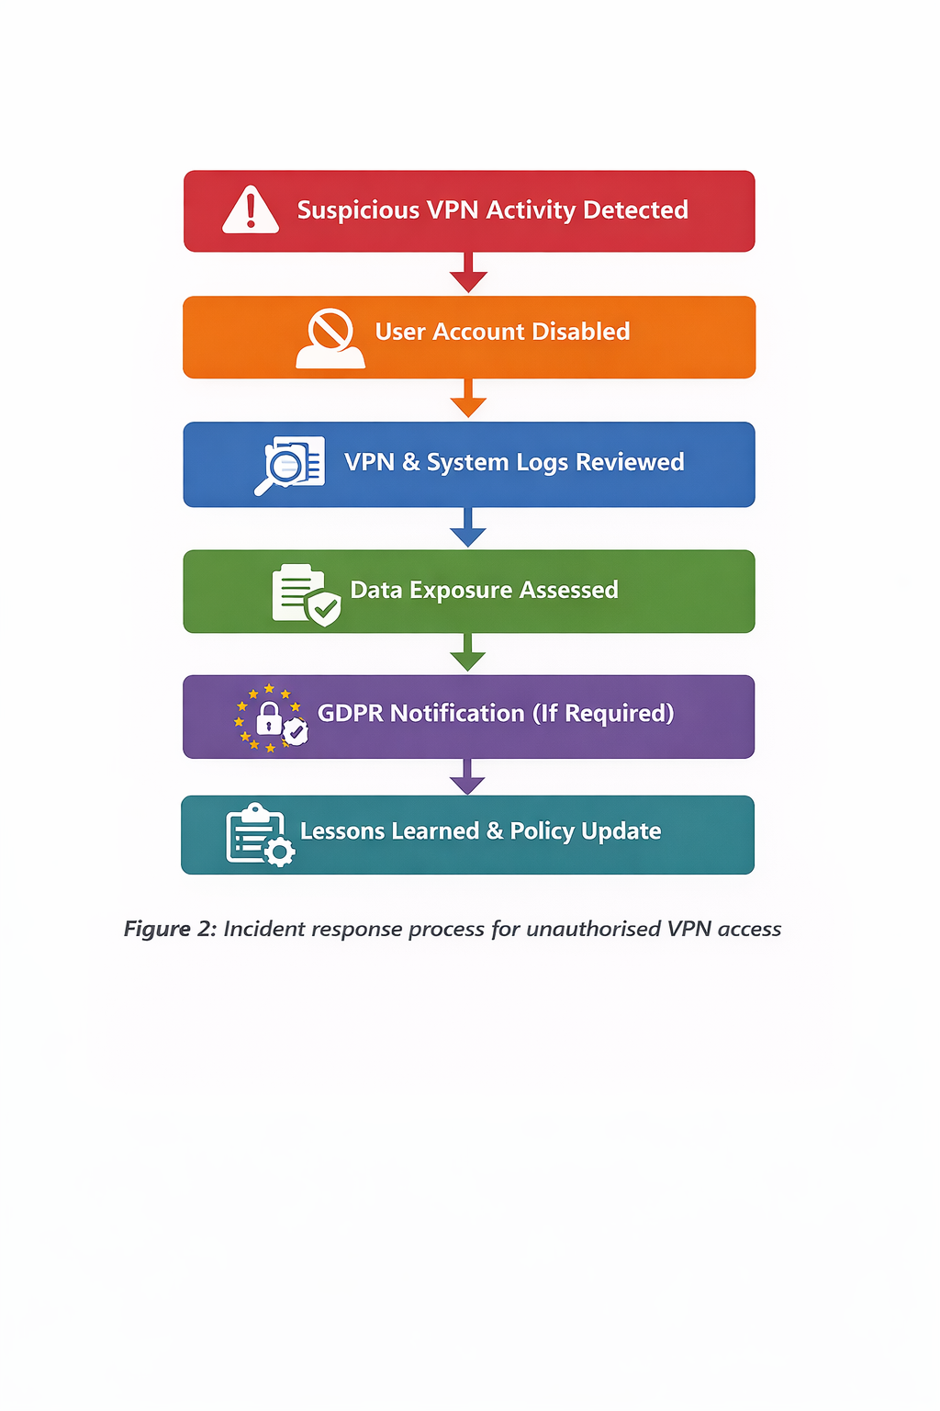

7. Staff Training and Security Awareness

Human drivers continue to be the largest threat when it comes to cybersecurity. FinSecure Ltd should provide routine cyber awareness training on identifying phishing, secure remote work practices and reporting an incident.
Employees can learn from phishing exercises that test them on awareness. Clear instruction on how to report any questionable phishing email or potential security incident to your helpdesk with fast response and containment.
A strongly trained staff is an important layer of defence in addition to technical security controls[5].

8. Alignment with Cybersecurity Standards and Regulations

The draft security policies and controls are consistent with established cybersecurity frameworks and standards. The NIST CSF facilitates a systematic way for organizations to identify, protect against, detect, respond and recover from cyber threats. ISO/IEC 27001 offers advice on how to set up an information security management system that involves access controls and remote working policies.
Also, UK GDPR Article 32 stipulates that organisations shall put in place technical and organisational measures to secure data. FinSecure Ltd meets The Payment Card Industry (PCI) Data Security Standards and that means our security controls are in line with this standard which means "you" have received it from a competent authority.

9. Conclusion

Remote working carries a host of cybersecurity risks, particularly for financial services firms like FinSecure Ltd. Strong VPN controls, secure authentication measures, endpoint protection, 24/7 monitoring and training of staff can all help an organisation reduce the probability of a cyber incident occurring and the damage it has if one does take place.
An effective security policy, when done right, secures data but at the same time enables the achievement of compliance requirements and makes an organization more resistant to emerging threats[6. 3. 6].

References

[1] "https://www.cisecurity.org/,"
[2] "https://ico.org.uk/,"
[3] "https://isoplanner.app/iso-27001/?utm_source=bing&utm_medium=cpc&utm_campaign=EN&msclkid=d9a96a65a8791b9341430320e213a652&utm_term=isms%20framework%20iso%2027001&utm_content=ISO%2027001,"
[4] "https://nvlpubs.nist.gov/nistpubs/SpecialPublications/NIST.SP.800-61r2.pdf,"
[5] "https://www.nist.gov/cyberframework,"
[6] "https://www.ncsc.gov.uk/collection/passwords,"
[7] "https://www.ncsc.gov.uk/guidance/phishing,"

Appendix - PowerPoint Slide / Cisco Certificate




