Theoretical Overview:
Additional Learning Needs (ALN) can be defined as a learning disability or difficulty which requires additional learning provision (Welsh Government, 2022). Children with ALN may experience more challenges in learning than other children the same age or have a disability that makes it difficult to utilise the learning facilities within a school, therefore pupils with ALN may need more support to learn (Welsh Government, 2022). Additional Learning Needs and Education Tribunal (Wales) Act 2018 provides a statutory framework for supporting pupils with ALN in Wales, replacing the previous legislation regarding Special Educational Needs and the assessment process of identifying and supporting pupils with learning disabilities and difficulties, including the introduction of Individual Development Plans (IDPs) (Law Wales, 2024). IDPs are legal documents that identify a child’s ALN and specify appropriate support and targets, varying in complexity depending on the needs of the individual, and are reviewed and updated every 12 months to reflect changing needs (SNAP Cymru, n.d). In 2021, the ALN Code for Wales was introduced as a statutory code of practice under the ALN Act of 2018, a legal framework providing guidance for diagnosing ALN and ensuring individuals are appropriately supported by schools and Additional Learning Need Coordinators (ALNCOs) (Welsh Government, 2021). ALNCOs are a required designated members of staff within a school who are responsible for advising staff, working with external organisations and agencies, to support pupils and parents and ensure that schools are meeting statutory ALN requirements (Pembrokeshire County Council, 2023).
The broad and inclusive approach to learning encouraged by the Curriculum for Wales also supports pupils with ALN, recognising that progression is an individual process, and supporting pupils to overcome any challenges associated with learning to achieve their full potential (Welsh Government, 2020). The flexibility in curriculum design can also further promote equality and inclusivity in education in Wales, as schools can ensure that their curriculum is reflective of their pupils’ needs and learning requirements. For example, an ALN school in Cowbridge has designed their curriculum around ensuring its pupils are emotionally available, independent and supported by their environment, evolving around pupil-centred planning so the school knows how to support and motivate pupils (Goldsmith, 2024). Wiliam emphasises the value of an individualised approach to learning through ongoing formative assessment, ensuring that teaching and learning is tailored to meet the needs of pupils so that all can make progress (Wiliam, 2018).

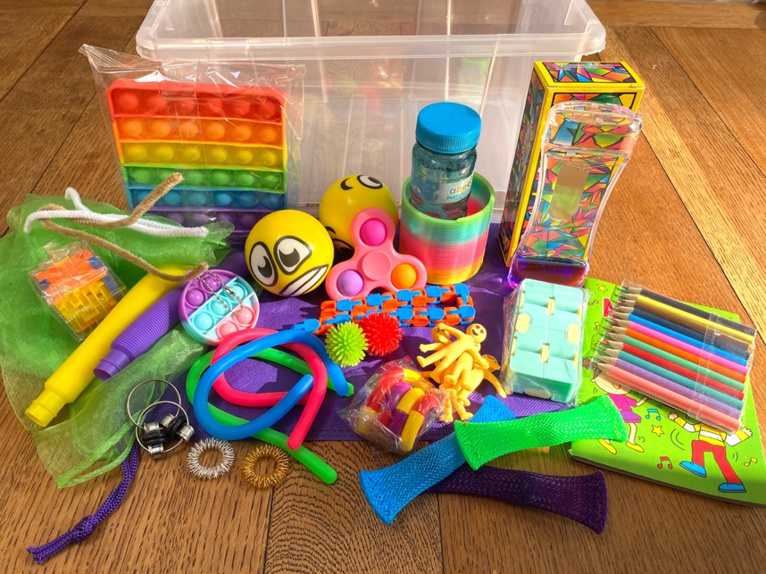
Strategy 1: Fidget Station
Image source: The Additional Needs Blogfather (n.d.) Fiddles/Fidget Boxes. Available at: https://theadditionalneedsblogfather.com/fiddles-boxes/ (Accessed: 8 May 2025).

One strategy that could be implemented in classrooms to increase inclusivity is a “fidget station”, consisting of a box of fidget toys in class. Fidget toys are designed to be an accessible method of helping individuals regulate and concentrate through tactile or visual stimulation (The COAST Clinic at Bradley Hospital, 2023). This can benefit all pupils, but especially those with attention deficit hyperactivity disorder (ADHD) or those on the autism spectrum. Children with ADHD may experience difficulty with maintaining attention, impulse control, and present higher levels of motor activity, however one case study found that fidget toys can support pupils with ADHD to ignore distractions and reduce more disruptive movements in the classroom (Aspiranti & Hulac, 2021). Sensory integration theory argues that sensory interventions in school can help pupils with ADHD remain calm and focused, supporting learning and daily functioning, by providing optimal sensory input to promote regulation of behaviour and emotions during episodes of learning (Rohrberger, 2011). Pupils with autism can also have trouble with attention span and engagement, which can impact their ability to understand new academic content, but sensory interventions can support pupils with being more actively engaged in their learning environment and content (Zimmerman, Ledford & Turner, 2023).
While on a teaching placement in School A, I was able to see the positive impact of fidget toys on pupils with autism and ADHD (BERA, 2024). During whole-class instruction, assemblies, and when sitting on the carpet, these pupils were allowed to pick a toy from the class fidget toy trolley. During these periods, I was able to observe pupils being more attentive to their environment, more able to sit still for longer periods and keep their hands to themselves. Furthermore, the class teacher had clear expectations of when and how fidgets could be used, to ensure that fidget toys were being used to support learning and focus, not play.
However, one implementation issue associated with fidget stations could be the cost. Many schools in Wales are facing funding restrictions, limiting some schools' access to resources. A NAHT Cymru survey of 416 members in 2024, 87% of school leaders reported that the ALN funding received by schools is inadequate (NAHT Cymru, 2024). Therefore, the cost of introducing new fidget toys to schools may be challenging. A solution could be using low-cost or repurposing items already in schools to support pupils, such as textured fabrics or pieces of Velcro. Another limitation of this strategy could be that the use of fidget toys may cause wider class disruptions, particularly the louder toys like pop-its, therefore creating lapses in attention throughout the class (Kriescher et al, 2022). This could be mitigated by only including quieter and less disruptive toys in the station, such as stress balls.

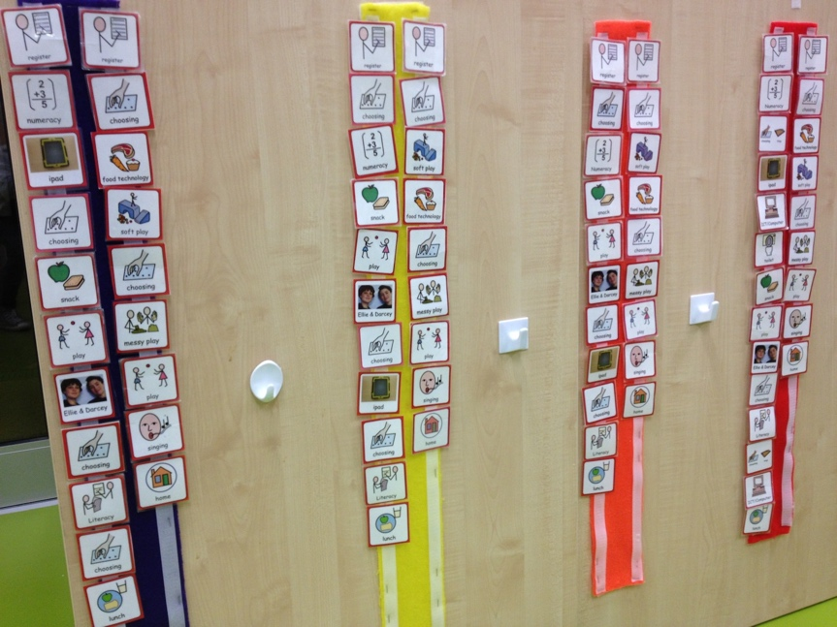
Strategy 2: Visual Timetables
Image Source: Reed, S. (2022) Visual timetables. Autism Spectrum Teacher. Available at: https://autismspectrumteacher.com/visual-timetables/ (Accessed: 8 May 2025).
Visual timetables are often used in classrooms to pictorially display the sequence of activities throughout the school day (Rutherford et al, 2020). Visual timetables provide all pupils, especially those with autism, with a clear and comprehensive overview of the day, which can be particularly valuable for those who struggle socially, as it is a straightforward way to check which task they should be doing and expectations (Hewitt, 2011).
Pupils with learning disabilities may struggle to understand the passage of time, so using visual timetables can be reassuring, as once an activity is completed it can be removed from the timetable to show it is over and the focus will be changing (Turner, 2011). While visual timetables can be useful to pupils with ALN, they can also benefit pupils who may not have ALN, further promoting inclusion and equity in the classroom. When pupils in Scotland were asked about the use of visual timetables in their class, pupils expressed that they would be more confused without the use of a timetable, and that they promote independence for everyone in the classroom (Rutherford et al, 2020).
While at School A, I was also able to see how visual timetables can be used in class to support pupils with autism. Every morning, there would be a “class meeting” where the teacher would stick images on a whiteboard explaining the outline for the day and giving pupils the opportunity to ask questions. Most pictures on the board were a daily occurrence, but for new or one-off activities, such as a guest speaker, this process was very reassuring for one child with autism, as they often struggled to regulate when the class routine changed. Therefore, having a clear structure for the day ahead was useful as pupils would be aware of any new activities from the start of the day, allowing them to look forward to it and prepare themselves for the change in routine.
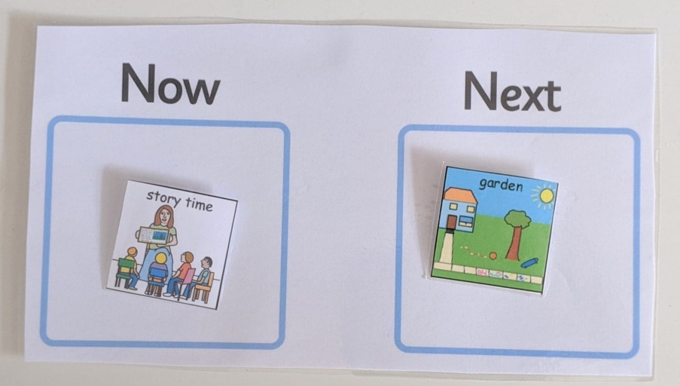
However, a limitation of visual timetables could be human error, for example if the teacher forgets to add one of the day's activities or forgets to remove one once it has been removed. Pupils with autism may struggle to comprehend changes to the previously outlined routine, and any unforeseen changes may create anxiety regarding what to expect next and possibly limit their ability to focus and self-regulate (Turner, 2011). A solution for these concerns could be the use of a “now and next” board as well as the visual timetable, to support pupils with any unexpected transitions.

Image source: The Autism Page (n.d.) Now and next boards. Available at: https://www.theautismpage.com/now-next/ (Accessed: 8 May 2025).
Conclusion:
It is crucial that schools recognise that progression can vary from individuals, especially for those with ALN as they may not progress at a similar rate to those a similar age, therefore by taking a learner-centred approach by collaborating with guardians and other agencies, positive learning experiences and holistic development can be encouraged (Welsh Government, 2023). Adapting teaching and learning to be more pupil-centred can also motivate pupils to be more active in their learning, as the approaches and topics are more reflective of their interests and learning requirements, guided by educators to make progress (Mihaela, 2013). Going forward, I will continue to strive for equity and inclusion in every classroom I work in, supporting pupils by having useful fidget toys and creating visual timetables so that each child has the optimal learning environment to make progress. Linking to articles 23 and 29 of children’s rights, which outline the children’s right to specific care and support within education to reach their full potential and lead an independent life (Children’s Commissioner for Wales, n.d).

References:
Aspiranti, K.B. and Hulac, D.M. (2021) ‘Using fidget spinners to improve on-task classroom behavior for students with ADHD’, Behavior Analysis in Practice, 15, pp. 454–465. https://doi.org/10.1007/s40617-021-00588-2 (Accessed: 8 May 2025).
British Educational Research Association (BERA) (2024) Ethical guidelines for educational research. 5th edn. London: BERA. Available at: https://www.bera.ac.uk/publication/ethical-guidelines-for-educational-research-fifth-edition-2024 (Accessed: 8 May 2025).
Children’s Commissioner for Wales (n.d.) Growing up to reach their full potential. Available at: https://www.childcomwales.org.uk/uncrc-guide-for-parents/growing-up-to-reach-full-potential/ (Accessed: 7 May 2025).
Goldsmith, E. (2024) Curriculum for Wales Equity and Inclusion Case Studies: Person Centred Planning. Available at: https://hwb.gov.wales/playlists/view/54616ab7-2cfe-44a1-98ae-071e2fde8468/en/4?preview=true (Accessed: 7 May 2025).
Hewitt, S. (2005) Specialist support approaches to autism spectrum disorder students in mainstream settings. 1st ed. Philadelphia, PA: Jessica Kingsley Publishers. (Accessed: 9 May 2025).
Kriescher, S.L., Hulac, D.M., Ryan, A.M. and King, B.L. (2022) ‘Evaluating the evidence for fidget toys in the classroom’, Intervention in School and Clinic, 59(1), pp. 66–69. https://doi.org/10.1177/10534512221130070 (Original work published 2023) (Accessed: 8 May 2025).
Law Wales (2024) Additional Learning Needs and Education Tribunal (Wales) Act 2018. Available at: https://law.gov.wales/additional-learning-needs-and-education-tribunal-wales-act-2018#:~:text=Menu-,Additional%20Learning%20Needs%20and%20Education%20Tribunal%20(Wales)%20Act%202018,people%20with%20additional%20learning%20needs(Accessed: 7 May 2025).
Mihaela, P.L. (2013) ‘The teaching approach from a pupil-centered perspective’, Procedia - Social and Behavioral Sciences, 76, pp. 19–23. Available at: https://doi.org/10.1016/j.sbspro.2013.04.066 (Accessed: 7 May 2025).
NAHT Cymru (2024) Falling short: The deepening school funding crisis in Wales. Available at: https://www.naht.org.uk/Portals/0/PDF's/Wales/NAHT%20Wales%20funding%20report_single-page-view.pdf?ver=2024-09-20-082120-060 (Accessed: 8 May 2025).
Pembrokeshire County Council (2023) Parent Partnership Service: Role of ALNCo and Professionals. Available at: https://www.pembrokeshire.gov.uk/parent-partnership-service/role-of-alnco-and-professionals#:~:text=The%20ALNCo%20at%20a%20school,the%20pupil's%20Additional%20Learning%20Provision(Accessed: 7 May 2025).
Reed, S. (2022) Visual timetables. Autism Spectrum Teacher. Available at: https://autismspectrumteacher.com/visual-timetables/ (Accessed: 8 May 2025).
Rohrberger, A. (2011) The efficacy of fidget toys in a school setting for children with attention difficulties and hyperactivity. Ithaca College. Available at: https://core.ac.uk/download/pdf/217299391.pdf (Accessed: 8 May 2025).
Rutherford, M., Lahood-Kullberg, B., Baxter, J., Johnston, L. and Cebula, K. (2020) ‘Pupils’ views on visual timetables and labels in mainstream primary classrooms’, Good Autism Practice (GAP), 21(2), pp. 11–22.
SNAP Cymru (n.d.) Individual Development Plan (IDP). Available at: https://www.snapcymru.org/get-support/idps/(Accessed: 7 May 2025).
The Additional Needs Blogfather (n.d.) Fiddles/Fidget Boxes. Available at: https://theadditionalneedsblogfather.com/fiddles-boxes/ (Accessed: 8 May 2025).
The Autism Page (n.d.) Now and next boards. Available at: https://www.theautismpage.com/now-next/ (Accessed: 8 May 2025).
The COAST Clinic at Bradley Hospital (2023) Fidget toys: What are they and how can they help children and adults? Brown Health University, 1 November. Available at: https://www.brownhealth.org/be-well/fidget-toys-what-are-they-and-how-can-they-help-children-and-adults (Accessed: 8 May 2025).
Turner, C. (2011) Supporting Children with Learning Difficulties : Holistic Solutions for Severe, Profound and Multiple Disabilities. 1st ed. London: Continuum International Publishing.
Welsh Government (2020) Curriculum for Wales Guidance. Available at: https://dera.ioe.ac.uk/id/eprint/34899/1/curriculum-for-wales-guidance.pdf (Accessed: 7 May 2025).
Welsh Government (2021) The Additional Learning Needs Code for Wales 2021 [Online]. Available at: https://www.gov.wales/sites/default/files/publications/2025-01/250124-the-additional-learning-needs-code-for-wales-2021.pdf (Accessed: 7 May 2025).

Welsh Government (2022) The additional learning needs transformation programme: frequently asked questions. Available at: https://www.gov.wales/additional-learning-needs-transformation-programme-frequently-asked-questions-html (Accessed: 7 May 2025).
Welsh Government (2023) Enabling Learning. Available at: https://hwb.gov.wales/curriculum-for-wales/designing-your-curriculum/enabling-learning (Accessed: 7 May 2025).
Wiliam, D. (2018) Embedded formative assessment. Second edition. Bloomington, Indiana: Solution Tree Press.
Zimmerman, K.N., Ledford, J.R. and Turner, V.R. (2023) ‘The impact of fidget toys on story detail acquisition and visual attention for elementary students with autism’, Journal of Positive Behavior Interventions, 26(2), pp. 101–112. Available at: https://journals.sagepub.com/doi/full/10.1177/10983007231200529 (Accessed: 8 May 2025).

