
An Assignment on
“Strategic Market Entry: The Role of Pioneer and Follower Strategies in Business Success”

Student Name: HUSSAIN AHMED
Student ID: 2424757
Module Name: Marketing Management
Module Code: LCMB7024
Lecturer’s Name: Dr Laila Maazouz
Work Count: 2737

Date of submission: 28/03/2025

Table of Contents
Introduction 3
Advantages of Being a Pioneer Company 4
Definition & Characteristics of Pioneer Companies 4
Key Advantages of Pioneer Companies 4
Case Studies of Pioneer Companies 5
Advantages of Being a Follower Company 7
Definition and Characteristics of Follower Companies 7
Key Benefits 7
Real-World Examples 8
Product Life Cycle (PLC) Strategies of Pioneer and Follower Companies 10
Understanding the Product Life Cycle (PLC) Model 10
PLC Strategies in the Growth Stage 11
PLC Strategies in the Maturity Stage 14
Conclusion & Recommendations 16
References 17

Introduction
In the dynamic business landscape, a company's market entry strategy greatly impacts its long-term success. Firms must choose between pioneering with a new product or service or following later with an improved or cost-effective alternative. Both strategies offer unique advantages and challenges that influence market position, profitability, and competitiveness. Pioneer companies gain first-mover advantages like brand recognition, customer loyalty, and industry influence, capturing 29% market share versus 17% for early followers and 12% for late entrants (Suntsova, 2025). However, four out of five pioneers fail due to demand miscalculations, technological risks, and high R&D costs. Followers learn from pioneers, refining strategies while avoiding early innovation costs. They focus on quality, cost reduction, and market positioning. Samsung (smartphones) and Facebook (social networking) surpassed pioneers through superior execution, but differentiation and consumer trust remain key challenges. Market timing is critical for both pioneers and followers. Entering too early risks low demand, while delayed entry can mean missed opportunities. Over 60% of venture capitalists see market timing as crucial, with 10% calling it the top success factor (Orlando, 2022). Studies show pioneers launching novel products face lower survival rates than those introducing incremental innovations, highlighting the need to assess market readiness before entry. This essay examines the pros and cons of pioneer and follower strategies, highlighting the role of market entry timing. It also explores their impact on PLC stages, especially growth and maturity. Through real-world examples and data, it provides insights into how strategic entry decisions drive long-term business success.

Advantages of Being a Pioneer Company

Definition & Characteristics of Pioneer Companies
A pioneer company introduces a new product, service, or business model before competitors, shaping consumer demand and industry trends (Teece, 2010). Key traits include innovation, market influence, and risk tolerance. Being first enables pioneers to build brand loyalty, secure partnerships, and set pricing. Pioneers invest heavily in R&D to launch disruptive technologies, establishing supply chains and consumer trust early (Markides and Sosa, 2013). However, they face high marketing costs to educate consumers—an effort followers often avoid.

Key Advantages of Pioneer Companies
Pioneer companies gain a competitive edge through four key advantages: first-mover benefit, strong brand loyalty, innovation leadership, and pricing power from economies of scale.
Advantage | Description
First-Mover Advantage | Pioneers have the unique opportunity to establish themselves in the market before competitors, allowing them to define product categories, set industry standards, and shape consumer behavior. Studies indicate that pioneers typically capture an average market share of 29%, compared to 17% for early followers and 12% for late entrants (Suntsova, 2025).
Brand Recognition & Customer Loyalty | Early entry into the market enables companies to develop strong brand identities that resonate with consumers. This results in higher customer retention rates and a reduced need for aggressive marketing efforts in later stages. Apple’s dominance in the smartphone industry, largely attributed to the iPhone’s pioneering role, has contributed to its 2024 revenue of $391 billion, making it the most valuable brand globally (Statista, 2024).
Innovation & Technological Leadership | Pioneers are often leaders in technological advancements, securing patents and setting benchmarks that competitors must follow (Zahra, Nash and Bickford, 1995). Tesla, for instance, revolutionized the electric vehicle (EV) industry, recording a net profit of $2.3 billion in 2022 and securing long-term technological leadership through its battery technology and autonomous driving systems (Fang, 2024).
Price-Setting Power & Economies of Scale | Pioneers have the ability to dictate initial pricing structures and benefit from economies of scale as they refine production processes. Amazon’s early dominance in e-commerce, coupled with its investment in logistics and cloud services, enabled it to generate nearly $638 billion in revenue in 2024, further reinforcing its market power (Amazon, 2025).

Case Studies of Pioneer Companies
Amazon (E-commerce)
Amazon's early entry into the e-commerce sector allowed it to establish itself as the dominant global online retailer. Launched in 1994 as an online bookstore, Amazon quickly expanded its product offerings and leveraged its first-mover advantage to create an extensive logistics network (Coppola, 2024). By continuously innovating with services like Amazon Prime, cloud computing through Amazon Web Services (AWS), and AI-driven recommendations, Amazon has maintained its leadership. In 2024, the company’s net sales revenue reached nearly $638 billion, making it one of the most valuable brands worldwide (Amazon, 2025).
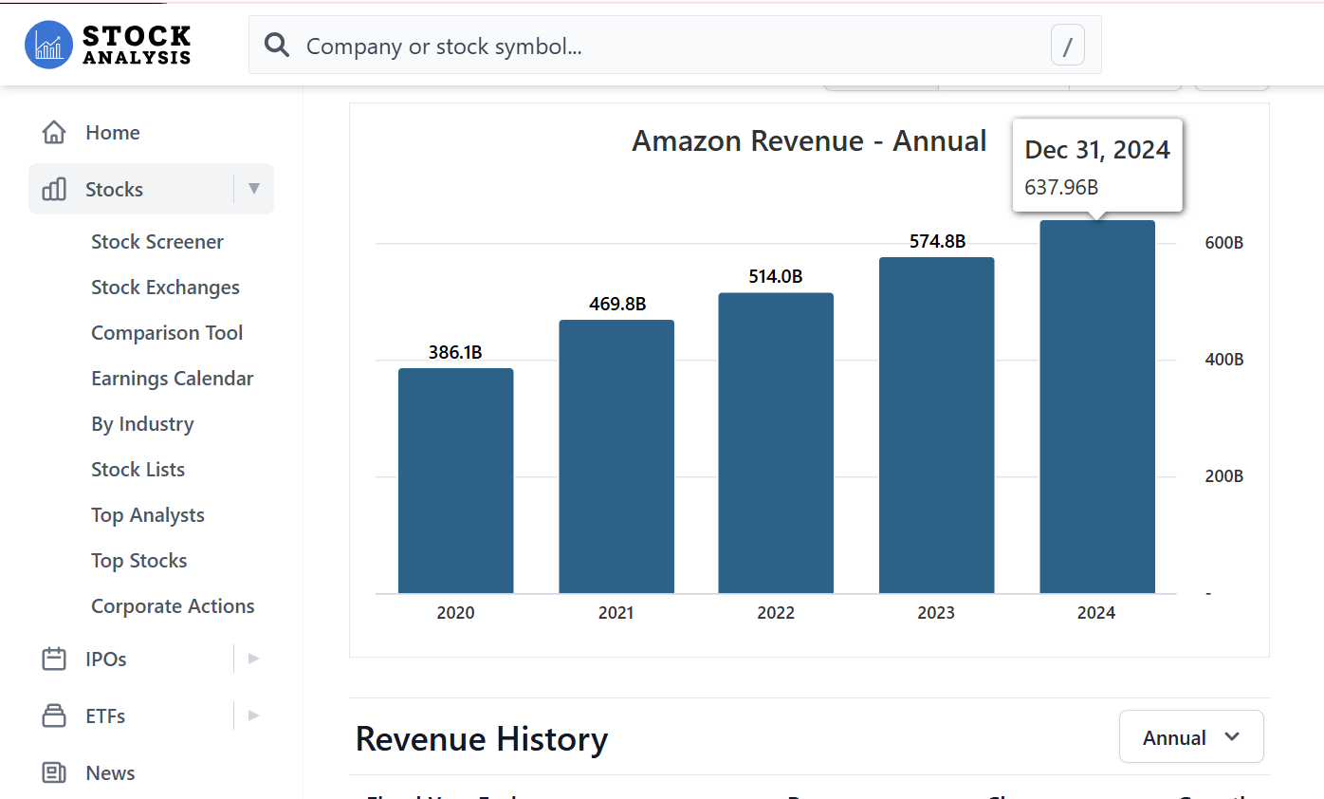
Source: (Stock Analysis, 2025)
The company also benefits from economies of scale, with third-party sellers accounting for approximately 60% of total paid units on Amazon’s platform (Coppola, 2024). This demonstrates how a pioneer can continuously innovate to sustain long-term dominance.
Tesla (Electric Vehicles)
Tesla disrupted the traditional automotive industry by pioneering the mass adoption of electric vehicles (EVs). Founded in 2003, Tesla's first-mover advantage allowed it to establish itself as a leader in battery technology, autonomous driving, and sustainable energy solutions (Olorunfemi, 2024). The company’s technological innovations, such as its Supercharger network and self-driving software, have set industry standards that competitors now strive to match. Tesla recorded $101 billion in projected revenue for 2025 and expects to reach 1.8-million-unit sales by 2029 (Statista Research Department, 2024). Its ability to secure early consumer trust and government incentives for EV adoption highlights the benefits of pioneering a transformative technology. However, Tesla continues to face challenges from emerging competitors, illustrating that sustaining a first-mover advantage requires constant innovation.
Apple (Smartphones)
Apple’s introduction of the iPhone in 2007 marked a defining moment in the mobile industry, positioning it as a pioneer in the smartphone market. Unlike earlier mobile phones, the iPhone combined a touch interface, app ecosystem, and seamless integration between hardware and software. Apple essentially created a new product category that redefined user expectations. As a pioneer, Apple secured significant first-mover advantages, including strong brand loyalty, premium pricing power, and high customer retention. The iPhone’s ecosystem strategy—linking devices, apps, and services—helped lock in users and made switching costs high for competitors. In 2024, Apple’s brand value reached $1.02 trillion (Faria, 2024), and its $31.4 billion R&D expenditure (Laricchia, 2024) underscores its commitment to innovation. Apple’s case demonstrates how pioneers can maintain market leadership by continuously innovating and leveraging early brand trust and ecosystem control to sustain competitive advantage over time.

Advantages of Being a Follower Company

Definition and Characteristics of Follower Companies
Follower companies enter the market after pioneers, avoiding the risks of launching novel concepts. Instead, they analyze market responses, refining strategies for better success (Min, Kalwani, Manohar U and Robinson, 2006). Key traits include strategic timing, adaptive innovation, and operational efficiency. They improve existing technologies, enhance designs, and use competitive pricing to attract customers.​

Key Benefits
The advantages of being a follower company can be categorized into several key areas:​
Advantage | Description
Lower Risk and Reduced R&D Costs | Followers avoid high costs and risks of new product development by learning from pioneers. This allows them to allocate resources efficiently, reducing financial risks associated with R&D.
Ability to Improve Existing Products | Followers analyze market response to pioneers, identifying improvements to gain a competitive edge (Gómez, Pérez-Aradros and Salazar, 2022). Samsung, for example, entered the smartphone market after Apple, offering larger screens and more features, attracting a wider audience.
Market Penetration Through Aggressive Pricing and Innovation | Followers use aggressive pricing and streamline production to reduce costs. They innovate on existing products, adding unique features or better quality, attracting cost-conscious consumers and those seeking enhanced functionality, boosting market share.

Real-World Examples
Several prominent companies have successfully employed follower strategies to become leaders in their respective industries:​
Samsung (Smartphones after Apple)
Samsung entered the smartphone market after Apple's introduction of the iPhone. By building upon the smartphone concept, Samsung introduced the Galaxy series, offering features such as larger displays and diverse price points. This strategy enabled Samsung to capture a substantial portion of the global smartphone market. As of February 2025, Samsung held approximately 23.58% of the global smartphone market share, making it one of the leading manufacturers worldwide (statcounter, 2025). ​
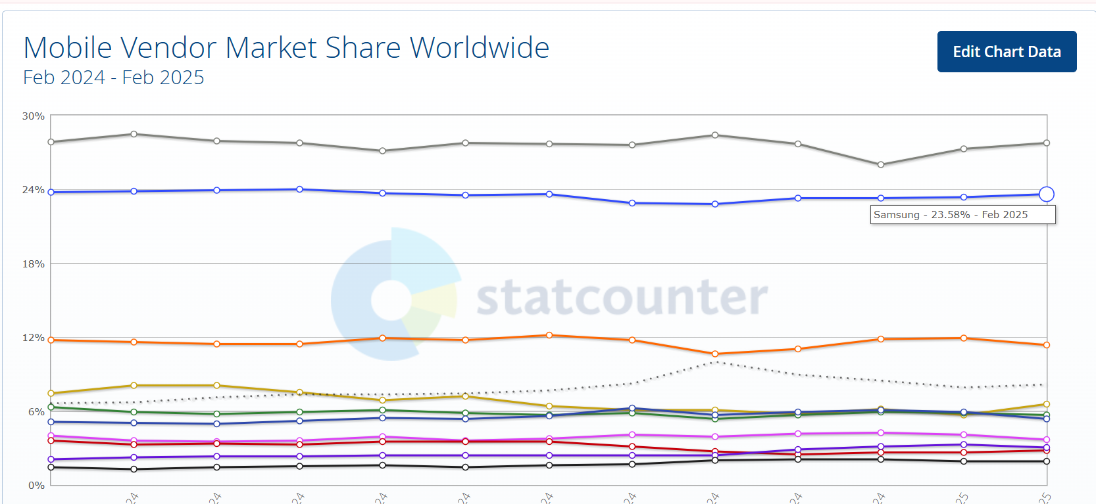
Source: (statcounter, 2025)
Facebook (Social Networking after MySpace)
Facebook launched after MySpace had established the concept of social networking. By focusing on a cleaner interface, exclusive networks (initially limited to university students), and continuous innovation, Facebook rapidly gained popularity. As of April 2024, Facebook boasts over three billion monthly active users globally, with significant user bases in countries like India (378 million users) and the United States (Dixon, 2024).
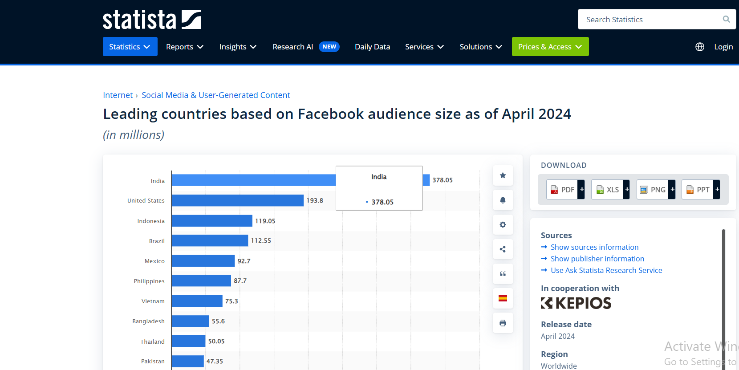
Source: (Dixon, 2024)
This massive user engagement has solidified Facebook's position as a dominant social media platform.​
Google Chrome (Web Browsers after Internet Explorer)
Google introduced Chrome in 2008, entering a market dominated by Internet Explorer (Richter, 2024). By offering a faster, more secure, and user-friendly browsing experience, Chrome quickly gained traction. As of December 2024, Google Chrome accounted for approximately 65.82% of the global web browser market share, making it the most widely used web browser worldwide (Vailshery, 2025).
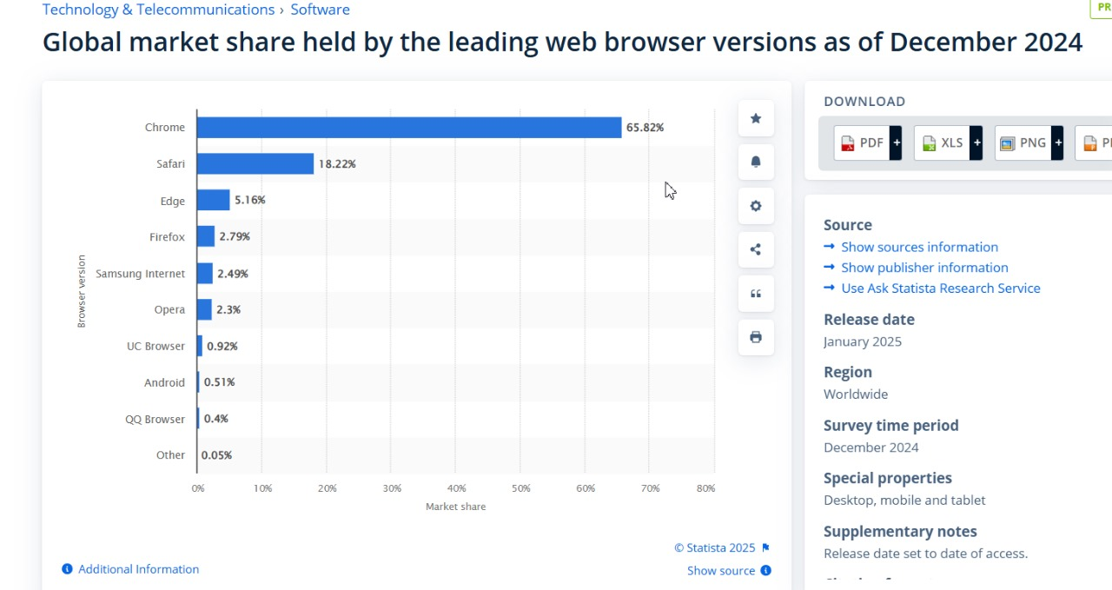
Source: (Vailshery, 2025)

Product Life Cycle (PLC) Strategies of Pioneer and Follower Companies

Understanding the Product Life Cycle (PLC) Model

Explanation of PLC Stages:
Introduction: The product is launched into the market, characterized by low sales and high promotional costs as awareness is being built (Cao and Folan, 2012).​ Growth: Sales increase rapidly as the product gains acceptance, leading to higher profits. Competitors may enter the market during this phase.​ Maturity: Sales growth stabilizes, and the market becomes saturated (Cao and Folan, 2012). Competition intensifies, often resulting in price reductions and increased marketing efforts to maintain market share.​ Decline: Sales and profits decline due to market saturation, technological advancements, or changing consumer preferences, leading companies to decide whether to rejuvenate the product or discontinue it.​
Why PLC Strategies Matter for Business Success:
Managing the PLC is key to business success, helping firms adapt strategies to each stage. In introduction, heavy promotion builds awareness, while in maturity, differentiation and cost-efficiency sustain profitability. Aligning strategies with the PLC boosts market presence and profitability.

PLC Strategies in the Growth Stage
How Companies Expand Market Share:
Market Penetration: Companies intensify efforts to increase their product's market share by attracting new customers and encouraging existing customers to use more of the product.​ Brand Positioning: Establishing a distinct brand identity helps differentiate the product from competitors, fostering customer loyalty and justifying premium pricing.
Strategies Used by Pioneers vs. Followers:
Strategy Type | Pioneers | Followers
Heavy Marketing | Pioneers invest substantially in advertising and promotions to build brand awareness and educate consumers about the new product category. | Not a primary focus as followers benefit from the awareness already created by pioneers.
Brand Loyalty | By delivering consistent quality and value, pioneers aim to cultivate strong customer loyalty, making it challenging for competitors to lure their customers away. | Followers must work harder to gain customer trust, often relying on competitive pricing and additional product features (Dreiling and Bican, 2022).
Supply Chain Efficiency | Optimizing supply chains ensures timely product availability, cost reduction, and the ability to meet increasing demand effectively (Dreiling and Bican, 2022). | Followers can refine and improve existing supply chains, benefiting from technological advancements and cost efficiency.
Competitive Pricing | Pioneers typically set premium pricing to recover R&D and marketing costs. | Followers often adopt aggressive pricing strategies to attract price-sensitive customers and quickly gain market share.
Customer Engagement | Pioneers focus on early adopter communities and innovation-driven engagement. | Building strong relationships with customers through personalized experiences and responsive support fosters loyalty and positive word-of-mouth.

Case Studies
Netflix (Streaming Dominance):
Netflix was among the first to shift from DVD rentals to online streaming, positioning itself as a pioneer in digital entertainment delivery. During the growth stage of the Product Life Cycle (PLC), Netflix invested heavily in original content, spending $18 billion in 2025 (Roth, 2025). This strategy helped create brand differentiation and build a loyal global subscriber base. Netflix also expanded into new markets and added features like offline viewing, mobile optimization, and live programming. These moves reflect classic growth-stage strategies for pioneers—expanding product offerings, targeting wider demographics, and enhancing value to stay ahead of followers like Disney+ and Amazon Prime Video. With nearly $10 billion in Q3 2024 revenue (Stoll, 2024), Netflix’s case illustrates how pioneers can sustain momentum by continuously innovating and adapting their strategies to extend the growth phase of the PLC. ​
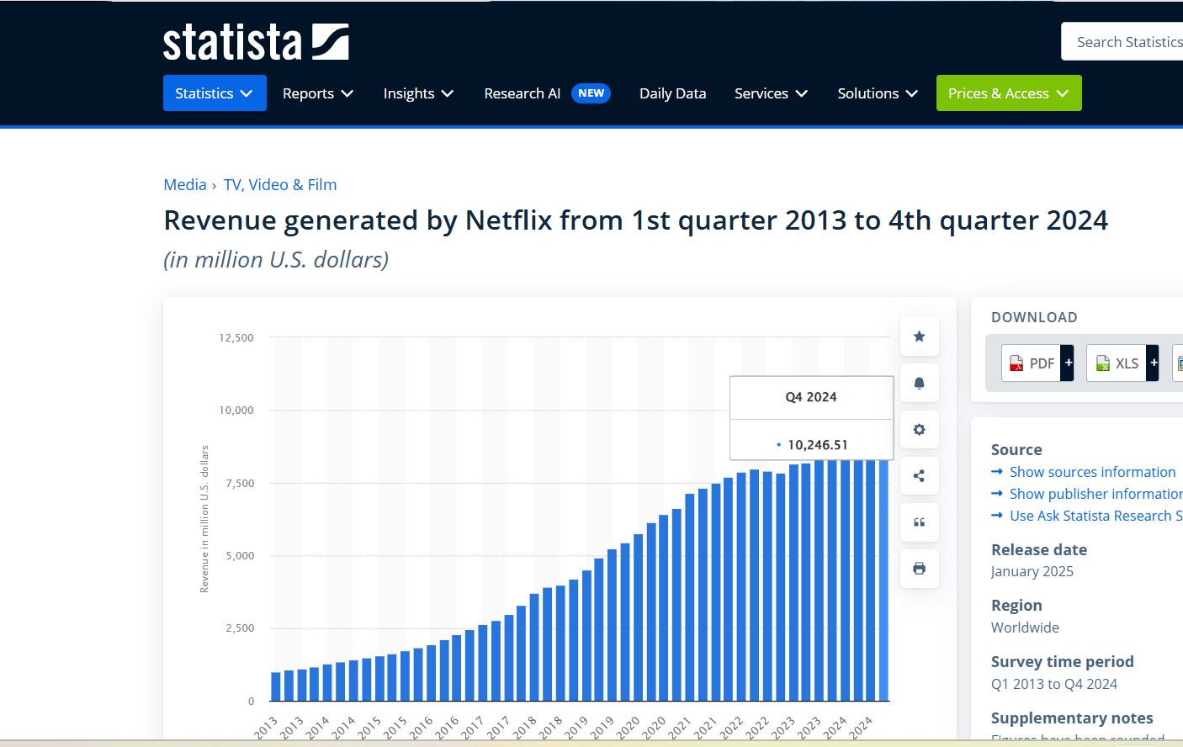
Source: (Stoll, 2024)
Xiaomi (Budget Smartphones):
Xiaomi, a follower in the smartphone market, adopted distinct strategies during its growth phase to rapidly gain market share. One major approach was competitive pricing and a strong value proposition. Xiaomi focused on offering high-quality smartphones at prices close to manufacturing costs, making advanced technology accessible to a wider audience (Zhang and Chun, 2023). The company also embraced innovative sales and marketing methods. Initially, it sold products exclusively online, reducing overhead costs linked to physical retail. Xiaomi used flash sales and social media marketing to create urgency and build a loyal consumer community. These aggressive strategies led to rapid market expansion. By 2021, Xiaomi had surpassed Apple to become the world’s second-largest smartphone manufacturer, showcasing the effectiveness of its growth strategy and its strong position in the global smartphone industry (Yadav, 2024).
Spotify (Subscription-Based Music Streaming):
As a follower in the music streaming industry, Spotify differentiated itself through personalized playlists and a freemium model. This approach attracted a vast user base, leading to its position as a leading music streaming service globally.

PLC Strategies in the Maturity Stage
Case Studies
McDonald's (Menu Innovation & Digital Transformation)
McDonald's has successfully adapted its menu and embraced digitalization to maintain relevance in the fast-food industry. The company introduced healthier menu options, plant-based alternatives, and localized products to cater to diverse consumer preferences. Additionally, McDonald's digital transformation, including self-service kiosks, mobile ordering, and AI-driven customer analytics, has improved efficiency and enhanced customer experience. As a result, McDonald's reported a 9% increase in digital sales in 2024, contributing significantly to its revenue growth (Investing.com, 2024).
Microsoft (Shift to Cloud Computing)
Microsoft transitioned from a traditional software sales model to a cloud-based subscription model through services like Microsoft Azure and Office 365. This shift allowed Microsoft to generate recurring revenue, increase customer retention, and reduce dependency on hardware sales. In 2024, Microsoft's cloud computing revenue reached $35 billion, accounting for over 40% of its total revenue (Microsoft, 2024). This strategic move has positioned Microsoft as a leader in cloud solutions, ensuring sustainable growth.
Nike (Product Innovation & Celebrity Endorsements)
Nike has sustained its dominance in the sportswear industry by continuously investing in innovation and marketing strategies. The company integrates cutting-edge materials, smart footwear technology, and AI-driven customization into its product offerings. Additionally, Nike's collaborations with celebrities and athletes, such as LeBron James and Serena Williams, enhance brand credibility and drive global sales. In 2024, Nike’s endorsement deals contributed to a 12% increase in brand value, reaching $59 billion (Nike, 2024).
How Companies Sustain Profitability & Avoid Decline
Market Expansion: Companies expand into new geographical regions, demographics, or customer segments to counter stagnating growth. By targeting untapped markets, firms increase their revenue potential (Gandy, 2015). For example, McDonald’s expansion into emerging markets like India and China has contributed to its sustained global presence. Rebranding: Rebranding efforts involve modernizing brand identity, messaging, and product offerings to stay relevant. Nike, for instance, continuously reinvents its branding strategies through high-profile celebrity endorsements and innovative marketing campaigns, keeping its appeal strong among younger consumers.

Conclusion & Recommendations
The analysis of pioneer and follower strategies highlights that both approaches offer unique advantages depending on market conditions, industry dynamics, and company resources. Pioneers gain a competitive edge through brand recognition, first-mover advantages, and technological leadership, while followers benefit from lower risks, reduced R&D costs, and the ability to refine existing products. Both strategies require careful market assessment and execution to maximize success. The PLC model guides strategic decisions at each stage. Pioneers focus on brand loyalty, supply chains, and marketing, while followers use pricing, differentiation, and engagement to gain market share. In maturity, firms sustain profitability through expansion, rebranding, cost reduction, and innovation. Netflix, Xiaomi, McDonald's, Microsoft, and Nike exemplify successful PLC strategies. The choice between pioneer and follower strategies depends on market demand, technology, competition, and financial resources. Sustaining a competitive edge requires adaptation, innovation, and strategic planning, driving long-term profitability and leadership. For businesses deciding between pioneer and follower strategies, it is crucial to assess market timing, industry trends, and financial capabilities before entering a market. Pioneers should invest in R&D, brand-building, and infrastructure, while followers must focus on competitive pricing, efficiency, and differentiation to challenge market leaders. Future research could explore emerging trends in digital transformation, AI-driven market strategies, and sustainability-oriented PLC adaptations, as these factors increasingly shape market entry and competitive longevity in modern business landscapes.

References
Amazon (2025). Amazon.com Announces Fourth Quarter Results. [online] Aboutamazon.com. Available at: https://ir.aboutamazon.com/news-release/news-release-details/2025/Amazon.com-Announces-Fourth-Quarter-Results/.
Cao, H. and Folan, P. (2012). Product life cycle: the evolution of a paradigm and literature review from 1950–2009. Production Planning & Control, [online] 23(8), pp.641–662. Available at: https://www.tandfonline.com/doi/abs/10.1080/09537287.2011.577460.
Coppola, D. (2024). Amazon. [online] Statista. Available at: https://www.statista.com/topics/846/amazon/#topicOverview.
Dixon, S. (2024). Facebook users by country | Statistic. [online] Statista. Available at: https://www.statista.com/statistics/268136/top-15-countries-based-on-number-of-facebook-users/.
Dreiling, A. and Bican, P.M. (2022). Pioneer or Follower. Routledge eBooks, pp.100–115. doi: https://doi.org/10.4324/9781003046899-10.
Fang, C. (2024). Tesla’s revenue forecast base on business model and financial statement analysis. SHS Web of Conferences, [online] 181, p.02022. doi: https://doi.org/10.1051/shsconf/202418102022.
Faria, J. (2024). Apple: brand value 2019 | Statista. [online] Statista. Available at: https://www.statista.com/statistics/326052/apple-brand-value/.
Gandy, D.L. (2015). Small business strategies for company profitability and sustainability. Walden University.
Gómez, J., Pérez-Aradros, B. and Salazar, I. (2022). How to beat early movers: The role of competitive strategy and industry dynamism on followers’ performance in the telecommunications industry. Long Range Planning, 55(5), p.102244. doi: https://doi.org/10.1016/j.lrp.2022.102244.
Investing.com (2024). Earnings call: McDonald’s reports robust growth and strategic confidence By Investing.com. [online] Investing.com. Available at: https://www.investing.com/news/stock-market-news/earnings-call-mcdonalds-reports-robust-growth-and-strategic-confidence-93CH-3293333.
Laricchia, F. (2024). Apple’s Research and Development Expenditure 2007-2018 | Statistic. [online] Statista. Available at: https://www.statista.com/statistics/273006/apple-expenses-for-research-and-development/.
Markides, C. and Sosa, L. (2013). Pioneering and First Mover Advantages: the Importance of Business Models. Long Range Planning, [online] 46(4-5), pp.325–334. doi: https://doi.org/10.1016/j.lrp.2013.06.002.
Microsoft (2024). FY24 Q4 - Press Releases - Investor Relations - Microsoft. [online] www.microsoft.com. Available at: https://www.microsoft.com/en-us/investor/earnings/FY-2024-Q4/press-release-webcast.
Min, S., Kalwani, Manohar U and Robinson, W.T. (2006). Market pioneer and early follower survival risks: A contingency analysis of really new versus incrementally new product-markets. Journal of Marketing, 70, pp.15–33.
Nike (2024). Nike, inc. reports fiscal 2024 fourth quarter and full year results. [online] Nike.com. Available at: https://investors.nike.com/investors/news-events-and-reports/investor-news/investor-news-details/2024/NIKE-Inc.-Reports-Fiscal-2024-Fourth-Quarter-and-Full-Year-Results/default.aspx.
Olorunfemi, B. (2024). The Innovations Driving Tesla’s Success: Disruptions, Competition, Business Model, Customer Transformation, and Entrepreneurial Strategies. Qeios. doi: https://doi.org/10.32388/HA56OH.2.
Orlando, P. (2022). Why Now: Timing and Product Success. [online] Startups Unplugged. Available at: https://startupsunplugged.com/why-now/why-now-timing-and-product-success/.
Richter, F. (2024). Infographic: 5 Years After Launch, Chrome is on Top of the Browser World. [online] Statista Infographics. Available at: https://www.statista.com/chart/1438/browser-market-share-since-2008/.
Roth, E. (2025). Netflix’s plan to spend $18 billion on content is ‘not anywhere near the ceiling’. [online] The Verge. Available at: https://www.theverge.com/news/626102/netflix-18-billion-content-spending.
Sherif, A. (2025). Apple - statistics & facts. [online] Statista. Available at: https://www.statista.com/topics/847/apple/#topicOverview.
statcounter (2025). Mobile Vendor Market Share Worldwide | StatCounter Global Stats. [online] StatCounter Global Stats. Available at: https://gs.statcounter.com/vendor-market-share/mobile.
Statista (2024). Global Revenue of Apple from 2004 to 2024. [online] Statista. Available at: https://www.statista.com/statistics/265125/total-net-sales-of-apple-since-2004/.
Statista Research Department (2024). Passenger Cars(Tesla) - Worldwide | Statista Market Forecast. [online] Statista. Available at: https://www.statista.com/outlook/mmo/passenger-cars/tesla/worldwide.
Stock Analysis (2025). Amazon Revenue 1995-2023. [online] Stock Analysis. Available at: https://stockanalysis.com/stocks/amzn/revenue/.
Stoll, J. (2024). Netflix - quarterly revenue 2021 | Statistic. [online] Statista. Available at: https://www.statista.com/statistics/273883/netflixs-quarterly-revenue/.
Suntsova, O. (2025). SSRN Electronic Journal. [online] doi: https://doi.org/10.2139/ssrn.5125609.
Teece, D.J. (2010). Business Models, Business Strategy and Innovation. Long Range Planning, [online] 43(2-3), pp.172–194. doi: https://doi.org/10.1016/j.lrp.2009.07.003.
Vailshery, L.S. (2025). Global market share held by web browsers as of December 2024. [online] Statista. Available at: https://www.statista.com/statistics/268299/most-popular-internet-browsers/.
Yadav, P. (2024). Xiaomi overtakes Apple to become world’s second-biggest smartphone brand in August 2024. [online] CNBCTV18. Available at: https://www.cnbctv18.com/technology/xiaomi-overtakes-apple-to-become-second-biggest-smartphone-brand-19478229.htm.
Zahra, S.A., Nash, S. and Bickford, D.J. (1995). Transforming technological pioneering into competitive advantage. Academy of Management Perspectives, 9(1), pp.17–31. doi: https://doi.org/10.5465/ame.1995.9503133481.
Zhang, X. and Chun, D. (2023). Business Model Innovation of Exponential Organizations: The Case of Xiaomi. Sustainability, [online] 15(7), p.5738. doi: https://doi.org/10.3390/su15075738.

