This essay will critically evaluate the higher education (HE) systems of the United Kingdom and the Netherlands. There will be a simple explanation on what higher education is before going onto examine the overall higher education systems, the tuition costs that go along with studying in both the UK and the Netherlands. This essay will be looking at the number of international students that access the higher education systems in both countries, how many HE institutions and how the qualifications are awarded, Higher education covers all post-secondary education. Universities and other higher education institutions are all different in the way they function. (Alemu, 2018) The United Kingdom is slightly larger than the Netherlands with a population of 67.26 million (Statista, 2019) and the Netherlands has a population of 17.28 million (Trading Economics, 2020) the Education systems are completely different, and they have a range of different features.
Throughout the years higher education has an increase and decrease of students, in the 2018/2019 academic year the UK had 2.4 million students. The United Kingdom’s higher education application process is UCAS, the 2019 academic year applications reached just over 700,000 for full-time studies, while only 541,000 applications were accepted. Out of all accepted applicants there were 33% more women accepted for the first time in 2019 since 1996. (Bolton, 2020). Furthermore, in the Netherlands there are less students, coming in at 300,000 students. (Pieter, 2019)
Moreover, the United Kingdom has a higher education system that provides educational levels four to eight. There are three forms of HE institutions in the UK, there are university colleges, Universities and higher education colleges. All HE institutions in the UK are private, however each institution differs in the way that they operate, for example their mission, their size and their tuition fees.

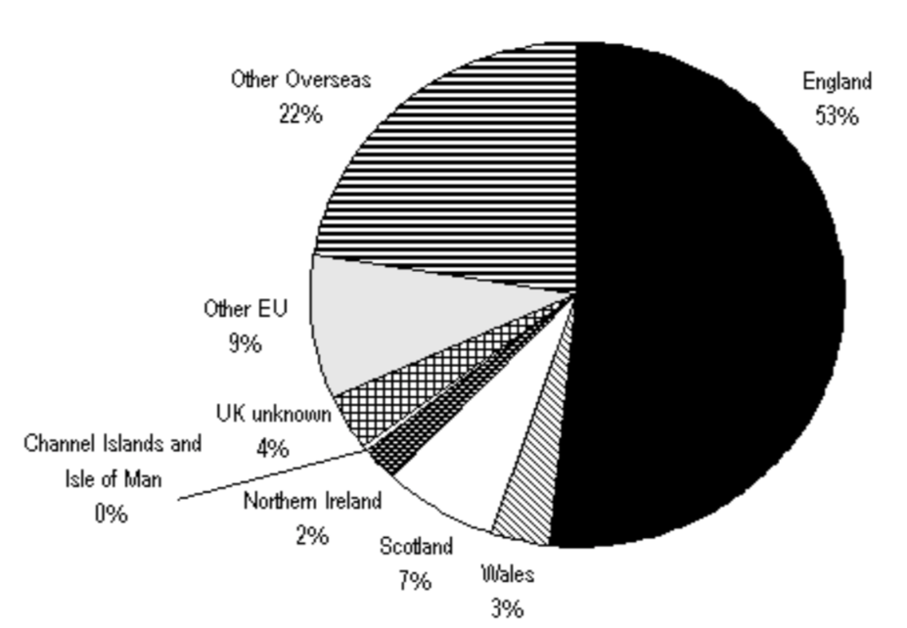
(Source A)

(SHAH, Et Al, 2012)

The above diagram shows the amount of graduated in the United Kingdom based on data from 2007, showing that the UK has the most graduates from England than from any other part of the world. (SHAH, Et Al, 2012)
Furthermore, higher education in the Netherlands is linked to all phases of education. In order to access higher education, you need to access two types of general education, there is HAVO which takes five years and there is VWO which lasts for six years, enrolment in these is considered based on their ability, in the last two years of HAVO and three years of VWO are considered to be upper secondary school, students focus on one to four core subjects to emphasis the area of study they want to focus on as well as the general curriculum. The six-year VWO program leads to four different subjects, only the diploma from this program can lead to a bachelor’s degree at a research university, while HAVO diplomas lead to bachelor’s degree in universities of applied science. The different forms of educational institutions are as stated above, there is the research universities which are the general courses such as engineering, teacher training and performing arts. Whereas the applied science universities are essentially what they are called, these universities are based around research subjects. (Nuffic, 2019) Within the Netherlands, they have a specific system that allows students to apply for their courses, this is studielink, (Study in Holland, 2020). The universities in the Netherlands have a credit system, meaning a year of studying must add up to 60 credits in order to continue study. (Nuffic, 2019)
It is clear that both HE systems are very different, while the United Kingdom have three different HE institutions, whereas the Netherlands have two different kinds, these are unique to the country that they were created in, it is clearly observed that the number of applicants are not very different, being that there is a 241,000 student difference, the overall difference showing that while the Netherlands is dramatically smaller in landmass than the UK, the higher education systems are equally as complicated and have different ways of operating.
Moreover, the UK has a range of tuition fees, however, they are all roughly £9000 a year. UK residents are able to apply for a student loan, they differ depending on what part of the UK they live in, nevertheless, the companies that provide the loans all offer to cover the tuition fee. (Department for Education, 2019). Student Loans are set up so that everyone can attend a higher education system, there are different loans that a student can apply for, these include the tuition fee, alongside that there is a maintenance loan which is also repayable, this is to help with everyday student needs. (SFE, 2019/20), Student accommodation is another set amount of money that students will need to pay if they decide to use the accommodation, within the UK the regular monthly cost in 2020 is £126 a week, or £547 a month if they decide to pay monthly. This obviously depends on what form of accommodation that stay in, privately rented accommodation will cost more due to other household bills such as internet which can cost up to £20 a month. Other bills that the average UK student will pay for is their utilities which can average to £50 a month. There is however the opportunity to get student discount in many places with an NUS card. Some universities in the UK also offer bursaries to help students with the essentials for university. (The World University Rankings, 2020) Student finance is different for the Netherlands. Higher education tuition fees in the Netherlands stand at €2,006 per year in 2018, it has stayed roughly the same in recent years. Estimating around €8,024 for the duration of study. Accommodation costs differ depending on the form of living, living alone in a privately rented apartment will cost around €419 a month, privately renting with someone else roughly €572 a month, whereas living in student accommodation costs around €340 a month, while utility costs will average around €165 a month. The government in the Netherlands have a system in place to help students with their higher education costs for students from low income families, this helps students access higher education even if they are unable to afford it themselves. (The World University Rankings, 2018). As well as this, students in the Netherlands are able to apply for a student ov-chipkaart, which gives them free public transport on select days, the card itself will cost them €7.50, however their select days of travel are free, this card gives them access by signing in and out of each station or transport, in order to use the card on other days they need to apply credit to the card so that they are able to use the services.
Tuition fees differ across the world differ, this is seen within both the United Kingdom and the Netherlands, both countries have a completely different system set up for students. The UK has the SLC/SFW that are readily available for students to access, these give students the chance to access higher education no matter their income, the loans are all based upon household income, basically meaning that the loans are determined based on the income, this means that a student may have more or less than another student due to that income. Studying in the UK is one of the most expensive options in the world, whereas the Netherlands have a lower tuition fee, this however does not mean that the cost of living is any different, both countries have a high living cost for students, this still works out lower in the Netherlands per year due to the lower tuition fee. While the UK has student loans made available for everyone, the Netherlands only have them available to students from low income families, this means that if a student has above the required income for a loan they will need to fund themselves, this can cause many financial issues for the family and the student.
Next, there is the average amount of international students who access the UK and the Netherland. In the 2017/2018 academic year in the UK there were 458,490 international students amounting to 19.6% of the overall student population. (Universities UK International, 2019) In the same academic year, the Netherlands had 122,000 international students studying HE, amounting to 14.8% of student population, this is for bachelor and master’s degrees. (Nuffic, 2017/18)
Clearly the international student population of each country is different due to the overall size of the countries, with a 336,490 difference, however both countries have just under 20% of the overall student population being international students. Of course, these are the numbers from the 2017/18 academic year, however, these numbers do not change drastically.
Additionally, universities offer a range of different degrees, the first being an undergraduate degree or Bachelor’s degree, this is the most common degree to be taken in HE, a Bachelors degree is found for most subjects, coming in the thousands for different courses, depending on whether a student takes the course full-time or part-time, the course can take three to four years to complete. The degree will give you a BA and BSc, this is found at the start of the course title. Next there is a postgraduate degree, that’s your PGCert/PGDip degrees, a master’s degree is part of this, a master’s degree is commonly pursued after a bachelor’s degree for those who wish to continue their studies. Furthermore, there is then the Doctorate or PhD, a PhD is the highest academic level, it is done through independent research, it can often take years to complete. (University of Essex, 2016)
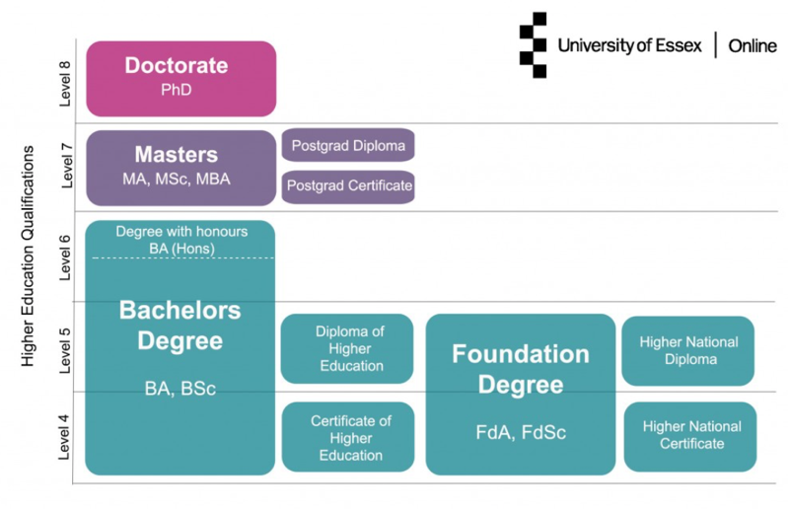
.(Source B)

(University of Essex, 2016)

You can see in the diagram above how the overall degrees are monitored and awarded, bachelor’s degree covering levels four, five and six, masters covering level seven and Doctorates covering level eight. These are covered in over 150 HE institution in the UK. (SI-UK, 2020)
The Netherlands has essentially the same system, their bachelor’s degree, providing students with a BA and BSc, which again last three years, moving onto a master’s degree, which can last from one to two years, then onto a PhD which again can last years. (ECA, 2014)
Both the UK and the Netherlands have the same qualification systems in place, making it easier for an international student to understand their systems. Looking back at Source B it is clear that both systems follow this guide, using the academic levels and degree levels together to create the best possible experience for their students.
To conclude, it is clear that higher education is important in both the United Kingdom and the Netherlands, the HE sector has millions of students every year. While both countries have a drastically different population, the higher education systems are very different, however, they are equally sought after, students from all over the world apply to be part of the universities. Furthermore, the supplication process is similar in both countries, UCAS and Studielink, these processes allow universities to directly access your application and accept you based on said application. The Universities have completely different systems, the Netherlands having only two kinds of universities while the UK has many different kinds. Following this, both countries have a completely different student finance systems, the United Kingdom having funds made readily available to all UK residents, while the Netherlands have funds only for those from low income families. Both countries have discounted options in place for students, this helps them save money while traveling or shopping. Moreover, there is a 336,490 difference between the countries in international student, when looking at the numbers it is clear that both countries have a similar international appeal. Source B shows the overall degrees offered at universities in the UK, this is similar to those offered in the Netherlands. The overall appeal for the universities comes down to the courses offered, however, the accessibility of each individual university is the leading factor to the student applications. From this essay, it has shown that the UK and the Netherlands have a unique system, from their application process to their tuition fees, their acceptance rates and their student numbers, the HE systems in both countries are unique to their specific country, however they share some similarities.

References:

Alemu, S. (2018). ‘Meaning, Idea and History of University/Higher Education: Brief Literature Review’ FIRE: Forum for International Research in Education, 4 (3), DOI: 10.32865/fire20184312. (Accessed: 10/05/20)

Bolton, P (2020) ‘Higher Education Student Numbers’, House of Commons Library, Available at: https://commonslibrary.parliament.uk/research-briefings/cbp-7857/ (Accessed: 12/05/20)

Department for Education (2019) ‘Higher Education Tuition Fee Prices’ Available at: https://assets.publishing.service.gov.uk/government/uploads/system/uploads/attachment_data/file/805055/Higher_Education_Tuition_Fee_Prices.pdf (Accessed:12/05/20)
ECA, (2014) ‘Higher education system in the Netherlands’, Available at: http://ecahe.eu/w/index.php/Higher_education_system_in_The_Netherlands (Accessed: 13/05/20)

Jones, E & Woodfield, S, (2015), ‘Internationalisation of Higher Education in the United Kingdom’, Research gate. Available at: https://www.researchgate.net/publication/340377541_Internationalisation_of_Higher_Education_in_the_United_Kingdom (Accessed: 12/05/20)
Nuffic (2017/18) ‘Incoming student mobility in Dutch higher education’ Available at: https://www.nuffic.nl/en/publications/incoming-student-mobility-dutch-higher-education-2017-2018/ (Accessed: 7/05/20)
Nuffic (2019) ‘Higher education system in the Netherlands’ Available at: https://webcache.googleusercontent.com/search?q=cache:zIU0zpd7Xg4J:https://www.nuffic.nl/documents/360/higher-education-system-in-the-netherlands.pdf+&cd=1&hl=en&ct=clnk&gl=uk&client=safari (Accessed: 7/05/20 )
Ov-chipkaart, (2020) ‘New student’ Available at: https://www.ov-chipkaart.nl/apply-1/students/new-student.htm (Accessed: 13/05/20)

Pieters, J (2019) ‘Most students ever: Peak enrolment at Dutch higher education institutions’ NL Times.NL, Available at: https://nltimes.nl/2019/10/16/students-ever-peak-enrollment-dutch-higher-education-institutions (Accessed: 12/05/20)

SFE (2019/20) ‘Student Loans- A Guide to terms and conditions’, Available at: https://media.slc.co.uk/sfe/1920/ft/sfe_terms_and_conditions_guide_1920_o.pdf (Accessed: 12/05/20)

SHAH, A, Et Al. (2012) ‘Does Higher Education System of United Kingdom Produce Enough Graduates?’, Archives des Sciences -Geneve-. 65. 90 - 105. Available at: https://www.researchgate.net/publication/224955306_Does_Higher_Education_System_of_United_Kingdom_Produce_Enough_Graduates (Accessed: 12/05/20)
SI-UK (2020), ‘UK University Rankings 2020’ Available at: https://www.studyin-uk.com/uk-study-info/university-rankings/ (Accessed: 13/05/20)
Statista (2019) Total Population of the United Kingdom (UK) from 2014 to 2024, Available at: https://www.statista.com/statistics/263754/total-population-of-the-united-kingdom/ (Accessed: 10/05/20)

Study in Holland, (2020), Studielink - How to apply to a university in the Netherlands, Available at: https://www.studyinholland.co.uk/studielink.html (Accessed: 13/05/20)
The World University Rankings (2020), ‘The cost of studying at a university in the UK’ Available at: https://www.timeshighereducation.com/student/advice/cost-studying-university-uk (Accessed: 13/05/20)

The World University Rankings, (2018) ‘The cost of studying at a university in the Netherlands’ Available at: https://www.timeshighereducation.com/student/advice/cost-studying-university-netherlands# (Accessed: 7/05/20)

Trading Economics (2020) Netherlands Population, Available at: https://tradingeconomics.com/netherlands/population (Accessed: 10/05/20)
Universities UK International (2019) ‘International Facts and Figures UK’ Available at: https://www.universitiesuk.ac.uk/International/Documents/2019/International%20facts%20and%20figures%20slides.pdf (Accessed: 13/05/20)
University of Essex (2016) ‘Higher Education Qualifications Explained’ Available at: https://online.essex.ac.uk/blog/higher-education-qualifications-explained/ (Accessed: 13/05/20)

