Student Name | Somi Naz
Student ID Number | 2421930
Programme | BSc Health and Social Care
Module | Principles of Health and Social Care Practice
Module Code | BMHP5016
Lecturer | Precious Igbinigie
Internal Verifier | Chloe Harries
Assignment Title | Assessment 2 – Report


Table of Contents
1. Introduction 1
2. PCC in Health and Social Care 1
2.1. Definition 1
2.2. Benefits of PCC 2
2.3. Limitations and Challenges 2
3. Theoretical Foundation of PCC (Carl Rogers) 2
3.1. Overview of Carl Rogers’ Humanistic Theory 2
3.2. Relevance to Health and Social Care Practice 3
4. Ethical Foundations of Health and Social Care Practice 3
5. PW in Health and Social Care 4
5.1. Definition and Importance 4
5.2. Benefits and Challenges of PW 4
6. Application of PW in Practice 5
7. Policy and Legislative Framework Supporting PCC and PW 5
8. Recommendations for Future Development 6
9. Conclusion 6
References 7

Introduction
The health and social care practice in the UK is now inclined to adopt strategies that focus on the needs, values, and experiences of people under care (GOV.UK, 2022). Another significant concept informing modern practice is person-centred care (PCC) and partnership working (PW), which both strive to improve the quality, coordination and responsiveness of services (Ahmed, Muijsenbergh and Vrijhoef, 2022). PCC emphasises on the identification of individuals as the involved parties in their care whereas PW promotes collaboration between professionals, service users and organisations. This report discusses the PCC concept, theoretical input of Carl Rogers (Joseph, 2025), ethical principles to support practice, PW, and discussions of relevant UK policy frameworks. The recommendations on how to improve future practice are also provided.

PCC in Health and Social Care

Definition
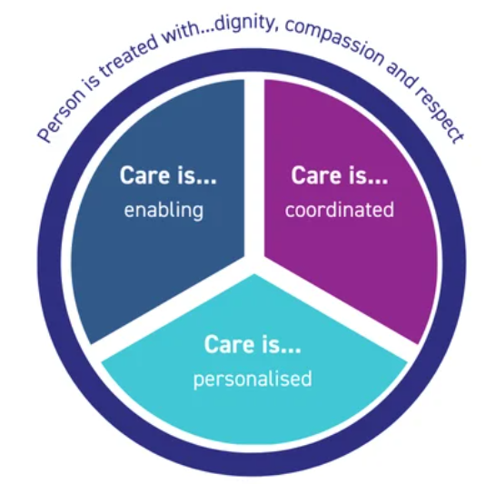
PCC is a concept in health and social care, according to which the individual is in the heart of decision-making and service provision (Figure 1). It focuses on the identification of individual needs, preferences and life experience coupled with upholding dignity, autonomy and independence (Damant et al., 2026). Patients are urged to be active in making decisions regarding their care and assistance. The humanistic approach of Rogers (Joseph, 2025), who focused on empathy, unconditional positive regard, and actual understanding of the views of individuals, is powerful in the principles of PCC.

Figure 1: Principals of PCC (Source: Skills for Health, 2025)

Benefits of PCC
PCC has a number of significant advantages in health and social care environments. PCC improves patient satisfaction by engaging people in the decisions related to their care and fostering a feeling of control and dignity (Byrne et al., 2026). When service users are respected and listened to, they will tend to comply with treatment plans and positively interact with health care providers. This form of collaboration can result in better health results and more efficient control of chronic illnesses. Additionally, PCC builds relationships of trust between the service users and the professionals involved, which in turn leads to good open communication and relationship of support that leads to holistic and responsive care delivery (Ekman et al., 2022).

Limitations and Challenges
Although PCC is advantageous, there are various challenges to its implementation in practice. The work of health and social care professionals is usually characterised by time constraints, as the workload can be too heavy to allow one to engage service users meaningfully (Younas, Inayat and Masih, 2023). Ability to offer complete individualised care can additionally be limited by resource constraints, shortages of staff. Personal preferences may be also conflicting with institutional procedures and organisational priorities (Mitchell, Cribb and Entwistle, 2022). Also, balancing between the decisions made by service users and professional judgement and clinical safety may introduce ethical and practical challenges in complicated care scenarios.

Theoretical Foundation of PCC (Carl Rogers)

Overview of Carl Rogers’ Humanistic Theory
Humanistic theory insists on learning about individuals based on their subjective experience. Rogers believed that individuals have an innate ability to grow and self-develop provided they are given a positive and understanding environment (Kahn and Rachman, 2000). This theory is based on three main conditions empathy, unconditional positive regard, and congruence (Krikorian, 2022). Empathy is a skill where the practitioner can truly apprehend the feelings and views of another human being. Unconditional positive regard is the acceptance of people without judgmental behaviour in spite of their conditions (Joseph, 2025). The concept of congruence or genuineness mandates professionals to behave naturally and clearly in their relationships (Figure 2). Collectively, these principles trigger practitioners to consider service users as individuals whose experiences, values, and emotions should be respected in care relationships.

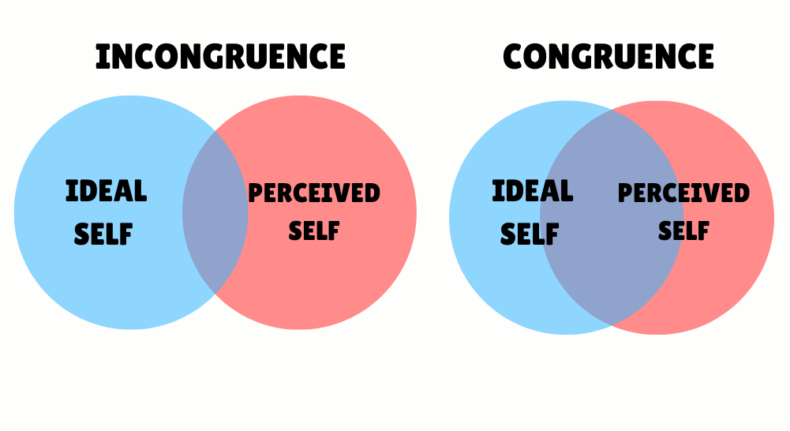

Figure 2: The Role of Congruence and Incongruence in Carl Rogers Humanistic Theory (Source: Brodie, 2024)

Relevance to Health and Social Care Practice
The humanistic approach of Rogers was used as a theoretical basis of PCC that focuses on respectful dialogue and relationships between practitioners and the service users (Greene, 2017). Empathy can motivate professionals to hear the issues of people and learn their lived experiences, whereas unconditional positive regard can advance dignity and respect when engaging with them. Congruence promotes honest communication, which helps practitioners to develop trust and emotional support in therapeutic relationships (Walker, 2010). Such values enable people to make decisions regarding their treatment and promote comprehensive practices that would meet emotional, psychological and social requirements in addition to physical well-being. Nevertheless, critics also state that the model by Rogers may be idealistic in current healthcare settings where time constraints, excessive workloads, and organisational restrictions might restrict the capacity of the professionals to realise fully person-centred interactions on a repeated basis (Singh, 2023; McMenamin and Munro, 2025).

Ethical Foundations of Health and Social Care Practice
The principles of ethics are a basic guideline to professional decision making in health and social care. Autonomy demands that practitioners consider the rights of persons to make intelligent decisions regarding their treatment, which maintains service users as active subjects in decision-making (Poškutė et al., 2022). Beneficence focuses on the role of professionals in encouraging the wellbeing of individuals through provision of care that enhances health and living standards (Cheraghi et al., 2023). Non-maleficence means that the practitioners should not engage in activities that can result in any form of harm; rather, the intervention should be safe and proper (John and Wu, 2022). Justice is concerned with equal opportunities and fairness, making sure that everyone should have equal access to care irrespective of their background and circumstances. Confidentiality also serves to guard individuals by making sure personal information is dealt with in a responsible manner and is not uploaded were not essential in care delivery (Turkstani et al., 2025). PCC and PW share these ethical principles since they ensure respect and trust and collaboration between professionals, service users, and families. Such ethical expectations are enhanced by professional regulatory frameworks such as those set by the Nursing and Midwifery Council, which are applied in practice (Griffith and Tengnah, 2023).

PW in Health and Social Care

Definition and Importance
PW means an understanding of collaboration whereby various professionals, organisations, service users, and families are involved in providing coordinated health and social care services (Morgan and Yaskey, 2025). In contemporary care systems, patients are likely to come with complex needs that are not efficiently delivered by one professional or agency. PW thus clings on partnership amongst health professionals, social workers, community organisations and informal carers to achieve overall assistance (NHS England, 2023). Through the sharing of expertise, resources and information, professionals will be able to come up with integrated care plans that meet the physical, psychological, and social needs of people. Such collaborative strategy promotes continuity of care and makes sure that services are responsive to the different and evolving needs of service users.

Benefits and Challenges of PW
PW has a number of notable advantages regarding health and social care provision. The relationship among professionals facilitates combined care delivery whereby people are provided with aligned care in various services. Better inter-agency communication can lead to better decision-making and less services duplication whilst mutual resources assistance can help achieve more effective service delivery (Firmin et al., 2022). Moreover, collaboration strategies foster comprehensive care because they identify the intertwined physical, emotional, and social needs of people (England, 2022). Nevertheless, successful team development is not always painless. Difficulties in communication between the professionals, variations in the organisational cultures, and the lack of clear roles could be restricting in coordinating. Partnership arrangements can further be complex due to imbalance of power existing between the agencies and complicate information sharing. The challenges outlined can be addressed using proper communication methods, respect amongst professionals, and frameworks that facilitate the use of the working practices (Patel et al., 2025).

Application of PW in Practice
PW is especially important in the community mental health services where people usually need the combination of assistive measures in different areas of professional’s work (Reist et al., 2022). Proper care also entails coordination between nurses, psychologists, social workers, families, and local authorities to provide patients with multi-level and long-term assistance. In the community environment, mental health nurses frequently organise the treatment plan, whereas psychologists offer therapeutic intervention and social workers discuss social determinants of health, like housing, employment, and welfare (Zabek et al., 2023). The family also has a vital role in tracking wellbeing and recovery, and the local authorities contribute to accessing the local resources and protective measures.
This shared treatment approach facilitates a continuity of care in that information, roles, and treatment objectives are shared between professionals and service consumers. PW also enhances PCC because it acknowledges the preferences and lived experience of the individual in the process of care planning (McLaney et al., 2022). This means that integrated support systems are able to enhance adherence to treatment regimens, boost recovery rates and decrease the chances of relapse or social exclusion.

Policy and Legislative Framework Supporting PCC and PW
The UK legislative and policy framework that governs the practice of health and social care highly supports the practice of PCC and PW. Health and Social Care Act 2012 (UK Government, 2012), brought about structural reforms to enhance integration of care systems and enhance cooperation between organisations in health and social care. The Care Act (2014) highlights the importance of individual wellbeing, personalised care planning, as well as coordinated services, between local authorities and healthcare providers.
Mental Capacity Act 2005 (GOV.UK, 2005) also endorses person-centred practice by safeguarding the rights of those who may not be able to make a decision but it also mandates that the decision taken on behalf of the person is not only made in their best interests but also their autonomy is respected whenever feasible. Besides this, the Equality Act 2010 encourages equality and non-discrimination in service provision where health and social care services are inclusive and accessible (GOV.UK, 2010).
The Data Protection Act 2018 helps to regulate data sharing and confidentiality, as the regulation is provided on the manner of managing patient information safely across organisations (Legislation. GOV.UK, 2018). Lastly, policy frameworks of the National Health Service facilitated integrated care pathways and partnerships in delivering services, which supports the essence of PW to ensure effective and person-centred results.

Recommendations for Future Development
PCC and PW need specific work of professional practice, and service coordination to develop in the future. To start with, interprofessional education would need to be reinforced to improve cooperation between healthcare specialists (Saragih et al., 2024). Communication, clarification of professional roles and shared decision making across the multidisciplinary teams can be enhanced by joint training programmes.
Second, service user involvement, in terms of care planning, should be given more prominence (Hickman et al., 2023). Increasing the level of empowerment by encouraging patients and families to be actively involved in decision-making can improve service individualisation and high satisfaction with the care delivery.
Third, integrating digital health systems should be increased throughout in health and social care organisations. Shared electronic records have the potential to enhance information sharing, decrease service duplications, and aid coordination and PCC across agencies (Heckemann et al., 2022).

Conclusion
PCC is another essential concept of the up-to-date health and social care practice with a focus on valuing the needs of individuals, autonomy, and dignity. Humanistic theory constructed by Rogers offers significant conceptual basis because empathy, understanding, and genuine relationships may be emphasised in care provision. The professional practice is also guided by ethical principles such as autonomy, beneficence and justice. Moreover, PW facilitates partnership work across the professionals, service users, and organisations to provide coordinated commitment. In conclusion, successful health and social care is a combination of person-centred health care and ethical practice, good working relationships and supporting legislations.

References
Ahmed, A., Muijsenbergh, M.E. and Vrijhoef, H.J. (2022). Person‐centred care in primary care: what works for whom, how and in what circumstances?. Health & social care in the community, 30(6), pp.e3328-e3341.
Brodie, K. (2024). Carl Rogers’ Theory: Humanistic Approach and Psychology. [online] Early Years TV. Available at: https://www.earlyyears.tv/carl-rogers-theory-humanistic-approach/ [Accessed 7 Mar. 2026].
Byrne, A.L., Hall, A., Cutmore, E. and Mulvogue, J. (2026). Beyond Satisfaction: Person‐Centred Care and the Physical Environment Revisited—An Integrative Review. Nursing Open, 13(1), p.e70395.
Care Act (2014). Care Act 2014. [online] Legislation.gov.uk. Available at: https://www.legislation.gov.uk/ukpga/2014/23/contents [Accessed 7 Mar. 2026].
Cheraghi, R., Valizadeh, L., Zamanzadeh, V., Hassankhani, H. and Jafarzadeh, A. (2023). Clarification of ethical principle of the beneficence in nursing care: an integrative review. BMC nursing, 22(1), p.89.
Damant, J., Hamashima, Y., Toma, M., Smith, N., Taylor, J., Caprioli, T., Jasim, S., Prato, L., Mcleod, H., Giebel, C. and Peters, M. (2026). Investigating Person‐Centred Care Planning in Care Homes Across England: An Exploratory Study of Practices and Contextual Factors. Journal of Advanced Nursing, 82(1), pp.617-631.
Ekman, N., Moons, P., Taft, C., Boström, E. and Fors, A. (2022). Observable indicators of person-centred care: an interview study with patients, relatives and professionals. BMJ open, 12(4), p.e059308.
England, N. H. S. (2022). Working in partnership with people and communities: statutory guidance. Care DoHS.
Firmin, C., Lefevre, M., Huegler, N. and Peace, D. (2022). Improving interagency collaboration. In Safeguarding young people beyond the family home (pp. 43-52). Policy Press.
GOV.UK (2005). Mental Capacity Act 2005. [online] Legislation.gov.uk. Available at: https://www.legislation.gov.uk/ukpga/2005/9/contents [Accessed 7 Mar. 2026].
GOV.UK (2010). Equality Act 2010. [online] Legislation.gov.uk. Available at: https://www.legislation.gov.uk/ukpga/2010/15/contents [Accessed 7 Mar. 2026].
GOV.UK (2022). Health and social care integration: joining up care for people, places and populations. [online] GOV.UK. Available at: https://www.gov.uk/government/publications/health-and-social-care-integration-joining-up-care-for-people-places-and-populations/health-and-social-care-integration-joining-up-care-for-people-places-and-populations [Accessed 7 Mar. 2026].
Greene, R. R. (2017). Carl Rogers and the person-centered approach. In Human behavior theory and social work practice (pp. 113-132). Routledge.
Griffith, R. and Tengnah, C.A. (2023). Law and professional issues in nursing.
Heckemann, B., Chaaya, M., Jakobsson Ung, E., Olsson, D.S. and Jakobsson, S. (2022). Finding the person in electronic health records. a mixed-methods analysis of person-centered content and language. Health Communication, 37(4), pp.418-424.
Hickman, S.E., Lum, H.D., Walling, A.M., Savoy, A. and Sudore, R.L. (2023). The care planning umbrella: the evolution of advance care planning. Journal of the American Geriatrics Society, 71(7), p.2350.
John, S. and Wu, J. (2022). “First, Do No Harm”? Non-Maleficence, Population Health, and the Ethics of Risk. Social Theory and Practice, 48(3), pp.525-551.
Joseph, S. A. (2025). The humanistic psychology of Carl Rogers: Understanding the person-centered approach. Oxford University Press.
Kahn, E. and Rachman, A.W. (2000). Carl Rogers and Heinz Kohut: A historical perspective. Psychoanalytic Psychology, 17(2), p.294.
Krikorian, M. (2022). Carl Rogers: A person-centered approach. In The Palgrave handbook of educational thinkers (pp. 1-13). Cham: Springer International Publishing.
Legislation. GOV.UK (2018). Data Protection Act 2018. [online] Available at: https://www.legislation.gov.uk/ukpga/2018/12/pdfs/ukpga_20180012_en.pdf [Accessed 7 Mar. 2026].
McLaney, E., Morassaei, S., Hughes, L., Davies, R., Campbell, M. and Di Prospero, L. (2022, March). A framework for interprofessional team collaboration in a hospital setting: Advancing team competencies and behaviours. In Healthcare management forum (Vol. 35, No. 2, pp. 112-117). Sage CA: Los Angeles, CA: SAGE Publications.
McMenamin, M. and Munro, K. eds. (2025). Applying the Person-centred Approach to Global, Social and Personal Crises: Contemporary Challenges. Taylor & Francis.
Mitchell, P., Cribb, A. and Entwistle, V. (2022). Vagueness and variety in person-centred care. Wellcome open research, 7, p.170.
Morgan, J. and Yaskey, J. (2025). Partnership working in health and social care. In Contemporary Issues in Health and Social Care Policy and Practice (pp. 68-82). Routledge.
NHS England (2023). Working in Partnership with People and communities: Statutory Guidance. [online] NHS England. Available at: https://www.england.nhs.uk/long-read/working-in-partnership-with-people-and-communities-statutory-guidance/ [Accessed 7 Mar. 2026].
Patel, H., Perry, S., Badu, E., Mwangi, F., Onifade, O., Mazurskyy, A., Walters, J., Tavener, M., Noble, D., Chidarikire, S. and Lethbridge, L. (2025). A scoping review of interprofessional education in healthcare: evaluating competency development, educational outcomes and challenges. BMC medical education, 25(1), p.409.
Poškutė, M., Bartkienė, A., Fatkulina, N. and Gefenas, E. (2022). The contribution of professional autonomy in advancing ethical behaviour: a narrative review of studies in nursing. Journal of Nursing Management, 30(7), pp.2301-2307.
Reist, C., Petiwala, I., Latimer, J., Raffaelli, S.B., Chiang, M., Eisenberg, D. and Campbell, S. (2022). Collaborative mental health care: A narrative review. Medicine, 101(52), p.e32554.
Saragih, I.D., Hsiao, C.T., Fann, W.C., Hsu, C.M., Saragih, I.S. and Lee, B.O. (2024). Impacts of interprofessional education on collaborative practice of healthcare professionals: a systematic review and meta-analysis. Nurse Education Today, 136, p.106136.
Singh, A. (2023). Essential of Humanistic Behaviour. Psycho information technologies.
Skills for Health (2025). Person Centred Care Meaning & Implications. [online] Skills for Health. Available at: https://www.skillsforhealth.org.uk/article/person-centred-care-meaning-implications/ [Accessed 7 Mar. 2026].
Turkstani, H.A., Almutawah, F.N., AlZamel, N.A., Zaid, M., Alshammari, A.A.A., Algharbi, M.T., Alsuayri, A.M., Badie, M., Gong, J.S.A. and Alnemer10, A.F. (2025). Privacy and Confidentiality in Healthcare: Best Practices for Protecting Patient Information. J. Healthc. Sci, 5(10.52533).
UK Government (2012). Health and Social Care Act 2012. [online] legislation.gov.uk. Available at: https://www.legislation.gov.uk/ukpga/2012/7/contents [Accessed 7 Mar. 2026].
Walker, B. (2010). The humanistic/person-centered theoretical model. In Routledge handbook of applied sport psychology (pp. 123-130). Routledge.
Younas, A., Inayat, S. and Masih, S. (2023). Nurses’ perceived barriers to the delivery of person‐centred care to complex patients: A qualitative study using theoretical domains framework. Journal of Clinical Nursing, 32(3-4), pp.368-381.
Zabek, F., Lyons, M.D., Alwani, N., Taylor, J.V., Brown-Meredith, E., Cruz, M.A. and Southall, V.H. (2023). Roles and functions of school mental health professionals within comprehensive school mental health systems. School Mental Health, 15(1), pp.1-18.

