Hotel Administration and Front Office Operations
Module Code: BMIH4004
Portfolio – 4 elements
Student Name: Shajahan Ali
Student Id:2118400
Lecturer Name:Mohammad Cassamo
Table of Contents

Introduction 2
Element 1 3
Response to a negative 1 star review The Chesterfield Mayfair 3
Element 2 4
Response to a positive 5 star review The Resident Covent Garden 4
Element 3 6
Room cancellation letter due to Hotel Renovation 6
Element 4 7
Response to a formal written complaint 7
Conclusion 9
References 10

Introduction
It is the front desk's job to greet guests upon their arrival and see them goodbye when they check out of the hotel (Bonn, 2019). Guest services like reservations, check-in, room assignments, and bill payments are all handled by this division. The visitor might always ask the front desk for further details or assistance (Gareev, 2016). Since the front desk is the first point of contact for visitors, the term "front office" is often used in hotels across the globe to describe the department responsible for greeting and assisting new arrivals (Brazil and Rys, 2022).
There are a total of four components that together represent a wide range of hotel-related pursuits in this portfolio. This portfolio provides a window into a hotel's approach to handling both positive and negative feedback, as well as unforeseen problems (Henschel, 2018).

Element 1

Response to a negative 1 star review The Chesterfield Mayfair
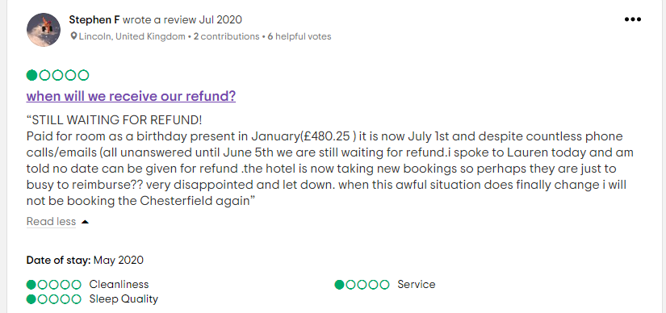
(Review source: The Chesterfield Mayfair - reviews, 2022)
Dear Stephen F.,
We appreciate you giving us feedback on your recent stay at The Chesterfield Mayfair.
I am very sorry to learn about the horrible experience you had to go through because of the miscommunication of our hotel service. In response to your concern, I will make sure you get your due refund as soon as possible. However, I am disappointed that our staff did not handle your problem in a more appropriate manner when you asked for the information.
The success of our business depends on the quality of the service we offer to each and every customer, and I am very sorry if we fell short of your expectations during your recent visit. Rest assured that the hotel's Customer Service and Management will give your feedback the attention it deserves.
According to the results of the previous evaluations, this is not the quality of service we aim to provide for our guests, and I hope that you will give us another opportunity to demonstrate that we are worthy of your trust. I would ask that you get in touch with me at my mail (email) so that we may talk more about your views.
It will be my great honour to see you come to our hotel again and this time we will make sure you have a phenomenal experience with us.
Sincere regards,

Shajahan Ali
Hotel Manager
E-mail: manager.sali@cmayfair.com

Element 2

Response to a positive 5 star review The Resident Covent Garden

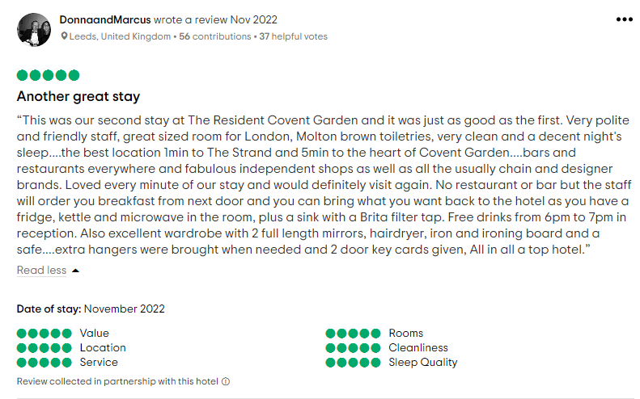
(Review source: The resident covent garden - reviews , 2022)

Dear DonnaandMarcus,
We are grateful for your really kind and encouraging review!
It is really satisfying to learn that your stay at The Resident Covent Garden was fantastic and that you found everything to be to your liking.
It is lovely to learn that the ease of access provided by our location was a factor in the enjoyment you had throughout your stay. As you said in your analysis, the fact that we are located in the heart of London's bustling business district is one of our many blessings.
The fact that each of the 57 rooms has a Nespresso coffee machine is one of my favourite perks of staying here. If you could let us know in advance of your next visit, we would be happy to stock your refrigerator with delectable food items in preparation for your arrival.
We are grateful that you took the time to inform us of the difficulties you encountered during your trip to our establishment. I regret that we did not find out about them earlier so that we might have immediately begun working on a solution to the problem. Our helpful receptionists are here to assist you at any hour of the day or night with any inquiries or issues you may have. Please understand that we really apologise for any inconvenience this may have caused you.
We are grateful for the outstanding compliment you have provided for the organisation.
I will be looking forward to your next stay with us and hope next night you will be having an even better experience with us.
Best wishes,
Shajahan Ali
Hotel Manager

Element 3

Room cancellation letter due to Hotel Renovation
November 30, 2022
Edinburgh Marriott Hotel
111 Glasgow Rd, Edinburgh EH12 8NF,
United Kingdom
Subject: Room cancellation letter due to Hotel Renovation
Dear Sir/Madam,
We are extremely sorry to put forth this news but all of the reservations made from the date between the 7th and the 21st of January 2023 have unfortunately been cancelled due to our sudden decision of renovations.
We have made the decision to renovate our reception area. This decision has been taken keeping you in mind. We have been getting many complaints regarding the convenience of the hotel reception area and recently there has been an event that forced us to take this abrupt decision.
We took into account the lack of healthcare facilities our hotel provided and how this has affected the guests in certain inevitable ways. We surely care about your health and wellbeing and for this reason our hotel has also made the decision to add a wellness centre which includes services like a treatment room and spa.
To make sure that you do not have to go through the hassle of booking hotel rooms, we have ensured all of our guests from the mentioned date are accommodated at a similar experience in our other branch or if you want a refund it will take 5 working days after you cancel booking. Also next time you walk in to our hotel, you will be charged 20% less for booking and service.
Since our previous customers have given us useful input and suggestions on how to continue, we are certain that we will be able to find a solution to this issue via concentrated effort.
We sincerely apologise for every inconvenience this abrupt cancellation has caused. Please know how much we appreciate your continuous understanding while we attempt to resolve this issue. We hope that we can be of service to you again in the near future.
Sincerely,

Signed,
Shajahan Ali
Hotel manager
Edinburgh Marriott Hotel

Element 4

Response to a formal written complaint
September 25, 2022
Subject: Response to a formal written complaint
Dear Mrs Mary Lewis,
We sincerely regret that you had such a negative experience during your recent stay with us. We take great pride in the quality of our service, therefore we conducted an inquiry to determine what went wrong this time. We value your feedback and want to thank you for writing to the Hotel. We really appreciate you taking the time to talk to us.
You stated that despite arriving at the hotel one standard check-in time, you were unable to check in to your due room because all of the available rooms were in use. You were supposed to get our newly renovated rooms which you have booked. Our front desk manager may have misunderstood the situation and made a mistake that is surely not something to overlook. Let us fill you in on the details of the inconvenience you had to face. Due to internal error, the hotel was yet to finish the renovations and thus we asked our front desk staff to explain to the guests about the avoidable situation. With your suggestions in mind, we have decided to invest in further training for our front desk staff.
Also, we extremely apologise for the experience you had at your stay in the hotel. The recent renovations are just over and we took your every feedback into consideration. We hope that you will find our accommodations to be of an exceptionally high grade after our recent renovations.
Please accept my heartfelt apologies on behalf of the hotel for the trouble these issues have caused. We would like to extend to you a special offer of two nights at the discounted cost per night in one of our recently remodelled executive rooms so that you can see the improvements for yourself. A complimentary certificate for two to enjoy a meal at our recently renovated restaurant is included as well.
We invite you to take advantage of our special rate and look forward to your return. We hope to see you very soon.
Sincerely,

Signed,
Shajahan Ali
Hotel manager

Conclusion
The front desk at the hotel is in charge of creating both the first and lasting impressions that customers take away from their stay (Ahmad and Scott, 2014). A speedy and cordial welcome from the staff at the front desk might make a significant difference. When guests first visit a hotel, they will almost certainly create their first impressions of the establishment based on the lobby or reception area, which is also likely to act as the major meeting spot for guests at the hotel (Deroos, 2012). Unexpected problems might arise during hotel operations, and when they do, customers will look to the personnel for reassurance. The hotel staff has a responsibility to aid and oversee rescue operations in the event of an emergency, which may be caused by anything from a natural catastrophe to a technological failure to an honest mistake (Bondarenko, 2016).

References
Ahmad, R. and Scott, N., (2014). Managing the front office department: Staffing issues in Malaysian hotels. Anatolia, 25(1), pp.24-38.
Bondarenko, A.P., (2016). Business administration in hotel industry: problems and solutions (by the example of the Russian Federation). International Journal of Applied Business and Economic Research, 14(14), pp.651-660.
Bonn, M.A., (2019). Hotel employee's artificial intelligence and robotics awareness and its impact on turnover intention: The moderating roles of perceived organizational support and competitive psychological climate. Tourism Management, 73, pp.172-181.
Brazil, C.K. and Rys, M.J., (2022). Using the Rapid Upper Limb Assessment to examine the effect of the new Hotel Housekeeping California Standard. Applied Ergonomics, 106, p.103868.
Deroos, J.A., (2012). Planning and programming a hotel. The Cornell School of Hotel Administration on hospitality: Cutting edge thinking and practice, pp.321-332.
Dzhandzhugazova, E.A., (2016). Business administration in hotel industry: problems and solutions (by the example of the Russian Federation). International Journal of Applied Business and Economic Research, 14(14), pp.651-660.
Gareev, R.R., (2016). Business administration in hotel industry: problems and solutions (by the example of the Russian Federation). International Journal of Applied Business and Economic Research, 14(14), pp.651-660.
Gruner, A. (2018). Hotelmanagement. In Hotelmanagement. De Gruyter Oldenbourg.
Henschel, U.K. A. (2018). Hotelmanagement. In Hotelmanagement. De Gruyter Oldenbourg.
Kosheleva, A.I., (2016). Business administration in hotel industry: problems and solutions (by the example of the Russian Federation). International Journal of Applied Business and Economic Research, 14(14), pp.651-660.
Li, J.J., (2019). Hotel employee's artificial intelligence and robotics awareness and its impact on turnover intention: The moderating roles of perceived organizational support and competitive psychological climate. Tourism Management, 73, pp.172-181.
Nikolskaya, E.Y., (2016). Business administration in hotel industry: problems and solutions (by the example of the Russian Federation). International Journal of Applied Business and Economic Research, 14(14), pp.651-660.
Rutherford, D.G., (2021). Hotel management and operations.
The Chesterfield Mayfair - updated 2022 reviews London, (2022). Available at: https://www.tripadvisor.co.uk/Hotel_Review-g186338-d192064-Reviews-The_Chesterfield_Mayfair-London_England.html#REVIEWS (Accessed: December 3, 2022).
The resident covent garden - updated 2022 reviews London, (2022). Tripadvisor. Available at: https://www.tripadvisor.co.uk/Hotel_Review-g186338-d15134890-Reviews-The_Resident_Covent_Garden-London_England.html (Accessed: December 3, 2022).

