
applying lean techniques
Ben Rowland-Jones

July 22, 2024
University of Wales Trinity Saint David

Table of Contents
1.0 Introduction 2
2.0 Main Findings 3
2.1 RenAM500 Flex Process 3
2.2 Over Processing 5
2.3 Waiting 7
2.4 Transportation 8
2.5 Motion 9
2.6 Kaizen 11
3.0 Conclusion 12
4.0 Bibliography 13

1.0 Introduction

The concept of Lean Manufacturing (LM) started its life as the Toyota Production System in the 1970s, when the Japanese automotive company wanted to reduce or eliminate any wastes, improve on inventory management and increased quality across the manufacturing process (Ciarniene, 2012). LM is now a universally spoken about manufacturing philosophy and as such, has been incorporated into multiple different manufacturing sectors across the globe with the same common goal; providing a high quality product that does not cost too much at the customer end (Gupta, 2013).
The wastes that are mentioned above refer to the seven manufacturing wastes that an organisation can make, the reduction of which should make the overall process leaner and more efficient and reducing customers costs . The wastes are:
- Transportation
- Inventory
- Motion
- Waiting
- Overproduction
- Overprocessing
- Defects
- Skills
(Pereira, 2009)
The reduction of over processing, waiting, transportation and motion will be the main focus of this report; the first section will identify the specific wastes that are occurring in the chosen process which in this case is the RenAM500 Flex SLS 3D printing machine. Once the wastes have been identified, the value from the customers perspective will be analysed to see if it aligns with the RenAM500 Flex production process.
Lean manufacturing concepts will then be introduced into the process, with the aim of quantitatively reducing the amount of waste in the process thus, reducing customer purchase prices. The costs of the improvements will be mentioned and justified, whilst also considering any issues that could potentially be encountered along the way.

2.0 Main Findings

2.1 RenAM500 Flex Process

The Additive Manufacturing division within Renishaw currently produces two types of machines; the RenAM500 Recirc and the RenAM500 Flex (Renishaw plc, 2024). Both machines use the same selective laser sintering (SLS) process to print parts out of fine metal powder, but they differ in terms of powder management systems. The recirc (recirculation) machine boasts a inbuilt powder recovery system that allows the user to only have to fill the machine with metal powder once. Powder gets added to the machines powder hopper which is then fed through a sieve system, as shown below in Figure 1. The powder then gets pushed up to the top of the machine via argon gas to the top silo; from there it is gravity fed down into the sintering chamber, dosed across the powder bed using a wiper blade. Once the build is finished, the metal powder is reused again and again due to the recirculation system.
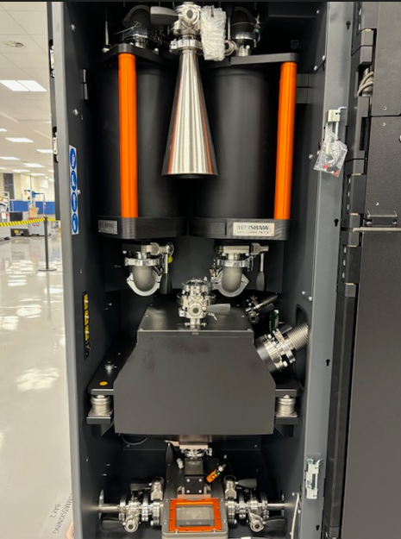

Powder Hopper
Powder Sieve System

Figure 1, RenAM500 Powder Recirculation System (Rowland-Jones, 2024)

The Flex machine variant differs in its powder processing, with this machine using a gravity fed system from the top of the machine, which feeds into the top silo and eventually into the sintering chamber. Once the build is finished on a Flex machine, the powder gets moved into two overflow bottles, as shown in Figure 2:
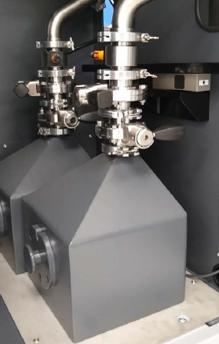

Figure 2, Flex Powder Overflow Bottles (Rowland-Jones, 2024)
This powder must then be removed from the machine, decanted into smaller bottles and put through an external sieving process before being able to be used again. The upside of using a Flex machine is the ability to easily change powder types between builds; for example one could build part of a bicycle frame out of Aluminium powder and quickly change the hopper and overflow bottles to be able to print something out of Titanium.
When making a Flex machine, it is entirely assembled as if it were a Recirc machine throughout the build line and during the commissioning stage. The relevant sacrificial recirculation components are then removed from the machine, making it a Flex variant. The machine is then passed through the commissioning process a second time before being shipped to the relevant customer. The sacrificial units are then stored in the production cells ready to be used on the next Flex machine.

2.2 Over Processing

One of the main wastes of Flex assembly is over processing, which is the existence of non-value adding production time that adds to the production cost of any given product (Rafique, 2019). The non-value adding time comes in the form of the fitment of sacrificial units to every Flex machine that is produced. Below in Figure 3, shows the layout of the RenAM500 build line and commissioning area:
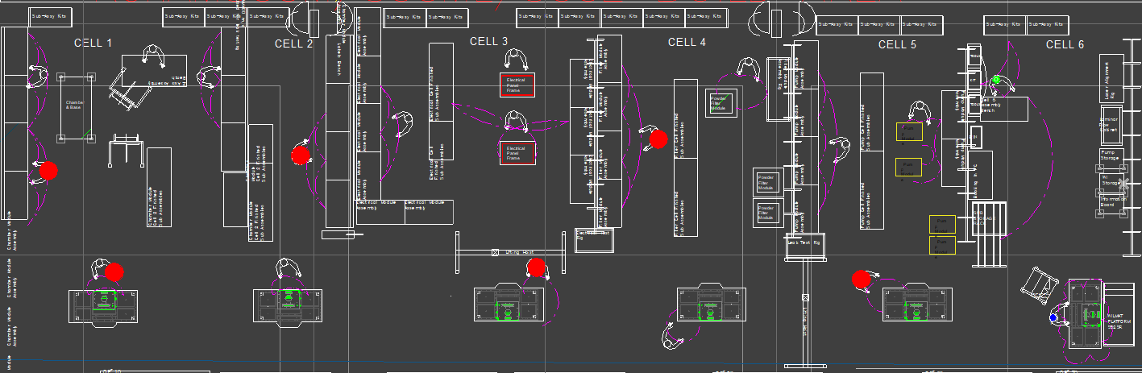
Figure 3, RenAM500 Build Line (Rowland-Jones, 2024)
As shown at the top of Figure 3, there are six build cells with each cell having its own set of tools, production equipment and work in progress (WIP) areas. Cells one, two, three, four and five each have sacrificial parts that are fitted and tested on every Flex machine that is produced. The total non-value adding time incurred per machine equates to 9.456 hours across all six production cells, which equates to £1077.98 (one hours labour is equal to £114). Renishaw sells on average one Flex machine per month so annual non-value adding time adds up to 113.47 hours and £12935.58 labour costs.
This non-value added time was calculated using a value stream map, which is a lean tool that displays all value adding and non-value adding operations from the warehouse at raw material level all the way through to the finished product at customer site (Thorn, 2024). The value stream map used in this report was carried out on Microsoft Visio, and can be seen in Figure 4 on the following page:

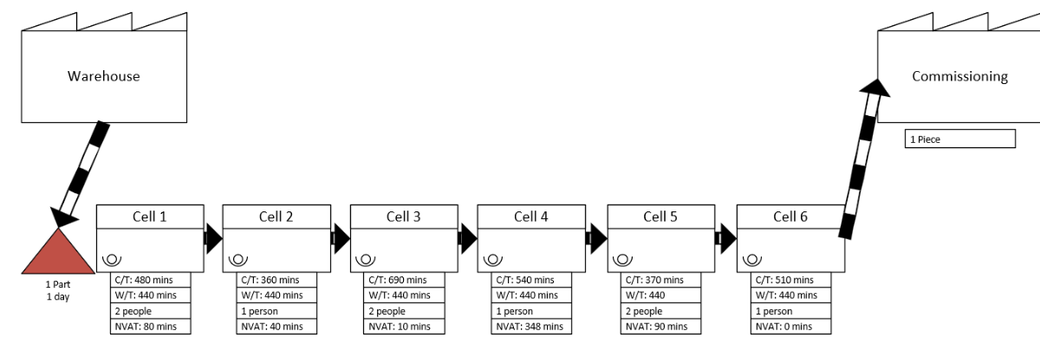

Figure 4, Value Stream Map of AM Build Line (Rowland-Jones, 2024)
As shown above, each manufacturing cell up to cell 5 has an amount of non-value adding time which is spent fitting and testing the sacrificial parts. This only includes the AM build line and does not show the commissioning procedure at all, because the entire commissioning process for a Flex machine is non-value adding. This is because each Flex machine needs to go through the commissioning process again once the sacrificial items have been removed and the Flex specific items are fitted. The table in Figure 5 below shows the commissioning process steps and its cycle times, with the addition of the Flex debuild/rebuild process:
Commissioning Cell | Cycle Time (mins) | Non-value Adding Time
Functional Comms | 1860 | 1860
Panel/Door Fitment | 480 | 480
Optical Comms | 720 | 720
Dry Comms/Quality Checks | 360 | 360
Flex Debuild/Rebuild | 900 | 450
Figure 5, Table Showing Commissioning and Flex Process Time (Rowland-Jones, 2024)
As shown, all of the commissioning processes are 100% non-value adding as the machine goes through the commissioning process twice due to the nature of the machine build. The Flex debuild/rebuild cell is at 50% non-value adding as half of the total time in the cell is fitting the Flex specific components, which is what the customer is paying for. This amounts to a total non-value added time (NVAT) of 64.5 hours during the Flex commissioning process, which after adding the build line NVAT equates to 73.956 hours (£8430.98 labour cost) per Flex machine. Current customer demand is one Flex machine per month so the total annual NVAT for the Flex process is 887.47 hours which equates to £101171.81 in the cost of labour.
To combat this problem, the Flex machine should be assembled as a Flex machine from the beginning by building the machine with the Flex specific items. This would remove the need to fit and test the sacrificial units across the build line, thus also removing the need for the machine to pass through the commissioning procedure twice, ergo removing the 73.956 hours of non-value adding time per Flex machine.
A potential problem with this method would be the initial cost of scrapping off the sacrificial units, with the overall value of the units being £29,745.48. This cost however, will be accounted for after four Flex machines are built due to the £33,723.92 labour cost saved.

2.3 Waiting

Waiting, from a lean manufacturing perspective, is seen as non-value adding time meaning a cost that is paid for by the manufacturer rather than the customer (Durakbasa, 2020). There is evidence of waiting within the Flex process, specifically the “dry commissioning” test where the machine runs a stress test. This test stresses the heater plate, z-axis assembly and the powder dosing system by running a build file that mimics a typical machine build, but without any metal powder and without firing the lasers.
The test lasts for eighteen hours in total and, whilst the test is running, the machine sits idle and no work is carried out on it. This is a test that is repeated during the second time a Flex machine goes through the commissioning procedure, totalling in thirty six hours of machine run time. As the total planned production time per day is 7.33 hours, the total time lost to an idle machine is 14.66 hours per Flex machine.
There is also a test during the optical commissioning procedure that asks the operator to run a positional accuracy test with all four lasers, wait twenty four hours, then run the same test again to measure ambient positional drift of the laser beams. Again, as planned production time equates to 7.33 hours per day, the time lost to an idle machine is 7.33 hours.
The two tests equate to 21.99 hours of non-value added time per Flex machine due to waiting, a number that could be reduced by eight hours if the machine was wrapped with doors and panels as it was undergoing the dry commissioning procedure. The potential problem with carrying out this change would be fitting panels to a live machine using 3-phase power, so this would introduce a health and safety hazard to the process.

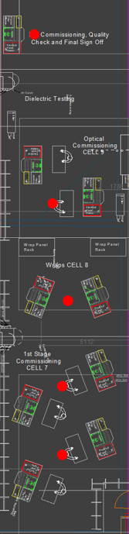
2.4 Transportation

Transportation of goods from one production plant or even area to area within the same plant is categorised as unnecessary waste and expenditure (Villarreal, 2009). For the Flex process, this can be defined by the commissioning area and it’s material flow. When a Flex machine enters the area, it first goes into the functional commissioning cell (cell 7), where the machine is powered up for the first time and undergoes a comprehensive functional check of each sub-system and its components. A 2D CAD layout of the commissioning process can be seen in Figure 6:
Figure 6, Commissioning Area (Rowland-Jones, 2024)
After the functional checks, the machine is disconnected from its 3-phase power source to be wrapped with panels and doors in cell 8, before being connected to power and a water chiller unit to able to carry out optical commissioning in cell 9. After this test is carried out, the machine is again disconnected and moved up the commissioning area to cell 10 where it goes through dielectric testing, dry commissioning and quality checks. This procedure means that each machine is disconnected, moved and reconnected to services four times before being signed off and shipped to a customer. To rectify this waste, a process reshuffle should occur where the AM build line and commissioning area is reshaped into a horseshoe shape, a concept that is visually represented by Figure 7 on the following page:
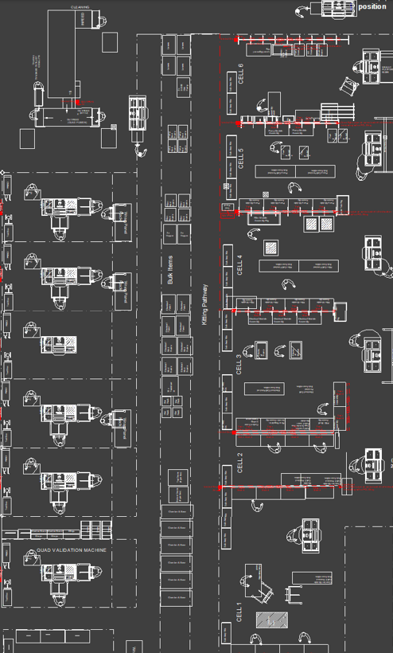
Figure 7, Proposed AM Build Line and Commissioning Area (Rowland-Jones, 2024)
As shown, the new proposed layout has the machine move through the build line and then moves round the bottom of the process in a horseshoe fashion. The machine is put in to one of the six bays in the commissioning area where it will stay until all commissioning and testing is complete so it is only connected to power and services once, ergo eliminating the NVAT due to transportation waste by an hour per machine.

2.5 Motion

This Lean waste can be described as the unnecessary movement of people or any equipment during any given process, this unnecessary motion is non-value adding and should be eliminated if possible (Green, 2014). For this process, there is a wet commissioning test where the machine undergoes a “real life” build where metal powder is loaded into the machine and is sintered by the lasers as it would at a customer site. The powder hopper on a Flex machine is located at the top, due to the powder being gravity fed into the powder chamber which means the powder is loaded one tub at a time until the hopper is full. The Flex hopper is shown in Figure 8 on the following page:
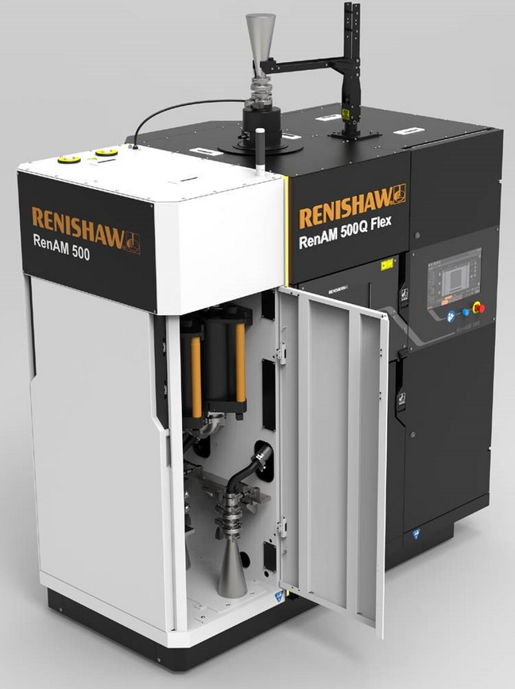
Flex Powder Hopper
Figure 8, RenAM500 Flex Powder Hopper (Renishaw plc, 2021)
The operator takes a 10kg powder tub to the top of the machine via a stepladder, opens the powder hopper and pours the powder in until the hopper is full, which is usually when it holds 110kg of powder. Meaning that the operator is going up and down the stepladder eleven times to fill up the powder hopper.
To reduce this waste, the hopper should removed from the machine and filled up on the floor, where it is easier and safer. Then, after the hopper is full it should be refitted to the machine, which would remove the need for the operator to use a stepladder and would reduce the time taken to full up the hopper by forty five minutes. The potential problem with implementing this change would be the working load limit on the current lifter, which is only capable of lifting 100kg, meaning a new lifter would have to be procured for this operation.

2.6 Kaizen

Many of the changes and waste reductions mentioned in this report were born out of a desire to follow the Kaizen philosophy, which is the process of continuous improvement across any given manufacturing process in order to elevate the standard way of work (Singh, 2009). Kaizen can be split in to two words; “Kai”, meaning “change” and “Zen” meaning “for the better” (Alukal, 2006) and is one of the foundations of lean manufacturing.
Other lean tools that could be implemented into the Flex process as part of the Kaizen philosophy could be Heijunka, which is a production levelling tool used to ensure that the inventory of parts in a process is driven by customer demand, ensuring that there is minimum inventory at any given time thus, maximising production efficiency (Koide, 2007). This would mean stopping the build of Flex machines to go into stock awaiting for a customer order and instead only building a Flex machine when the customer demand deems it necessary.
Another tool that follows the Kaizen philosophy would be the implementation of 5S which would introduce an organised, clean and highly effective and efficient workspace; reducing the time looking for certain tools and improve the safety of work. The name 5S in an acronym of five Japanese words as follows (Michalska, 2007):
- Seiri (sort)
- Seiton (set in order)
- Seiso (shine)
- Seiketsu (standardise)
- Shitsuke (sustain)
This concept works around organisation and everything having its own place, meaning designated areas for work in progress and material kits, tooling shadow boards and a clean work environment, all moving towards a clean and effective manufacturing process.

3.0 Conclusion

It is important to remember that applying lean techniques to any given process is not achieved in one project, rather it is an ongoing process that every person within an organisation must buy in to in order for the changes to be effective and lasting.
There are a lot of wastes in the Flex manufacturing process including over-processing, motion and transportation. These wastes can be reduced by implementing the lean tools that have been mentioned in this report, leading to a more stable and efficient process.
In conclusion, the tools mentioned were firstly identifying any non-value added time (NVAT) via a value stream map, then implementing changes to reduce the NVAT. Tools such as 5S, introducing a stable manufacturing cell layout and Heijunka and all feed into the lean continuous improvement philosophy of Kaizen. Lean manufacturing was able to reduce the NVAT of the Flex process by at least eighty three hours per Flex machine.

4.0 Bibliography
Alukal, G. (2006). Lean Kaizen. Milwaukee: ASQ.
Ciarniene, R. (2012). Lean Manufacturing: Theory and Practice. Economics and Management.
Durakbasa, N. M. (2020). Digital Conversion on the Way to Industry 4.0. Istanbul: Springer.
Green, C. F. (2014). A waste walk through clinical pharmacy: how do the ‘seven wastes’ of Lean techniques apply to the practice of clinical pharmacists. International Journal of Pharmacy Practice.
Gupta, S. (2013). A literature review of lean manufacturing. Management Science and Engineering Management.
Koide, K. (2007). Kaizen Through Heijunka Production (Leveled Production) . Transactions Journal of Aerospace.
Michalska, J. (2007). The 5S methodology as a tool for improving the organisation. Journal of Achievements in Materials and Manufacturing Engineering.
Pereira, R. (2009). The Seven Wastes. iSixSigma.
Rafique, M. Z. (2019). Wastes in Lean Production Systems. International Journal of Innovative Technology and Exploring Engineering.
Renishaw plc. (2021). Bringing flexibility to additive manufacturing. Retrieved from Renishaw: https://www.renishaw.com/en/bringing-flexibility-to-additive-manufacturing--47194
Renishaw plc. (2024). RenAM 500 metal additive manufacturing (3D printing) systems. Retrieved from Renishaw: https://www.renishaw.com/en/renam-500-metal-additive-manufacturing-3d-printing-systems--37011
Rowland-Jones, B. (2024). Commissioning Area. Pontyclun, RCT, Wales.
Rowland-Jones, B. (2024). Flex Powder Overflow Bottles. Pontyclun, RCT, Wales.
Rowland-Jones, B. (2024). Powder Recirculation System. Pontyclun, RCT, Wales.
Rowland-Jones, B. (2024). Proposed AM Build Line and Commissioning Area. Pontyclun, RCT, Wales.
Rowland-Jones, B. (2024). RenAM500 Build Line. Pontyclun, RCT, Wales.
Rowland-Jones, B. (2024). Table Showing Commissioning and Flex Process Time. Pontyclun, RCT, Wales.
Rowland-Jones, B. (2024). Value Stream Map of AM Build Line. Pontyclun, RCT, Wales.
Singh, J. (2009). Kaizen Philosophy: A Review of Literature. The Icfai University Journal of Operations Management.
Thorn, A. (2024). Value Stream Mapping. Swansea, Swansea, Wales.
Villarreal, B. (2009). Eliminating Transportation Waste in Food Distribution: A Case Study. Transportation Journal.

