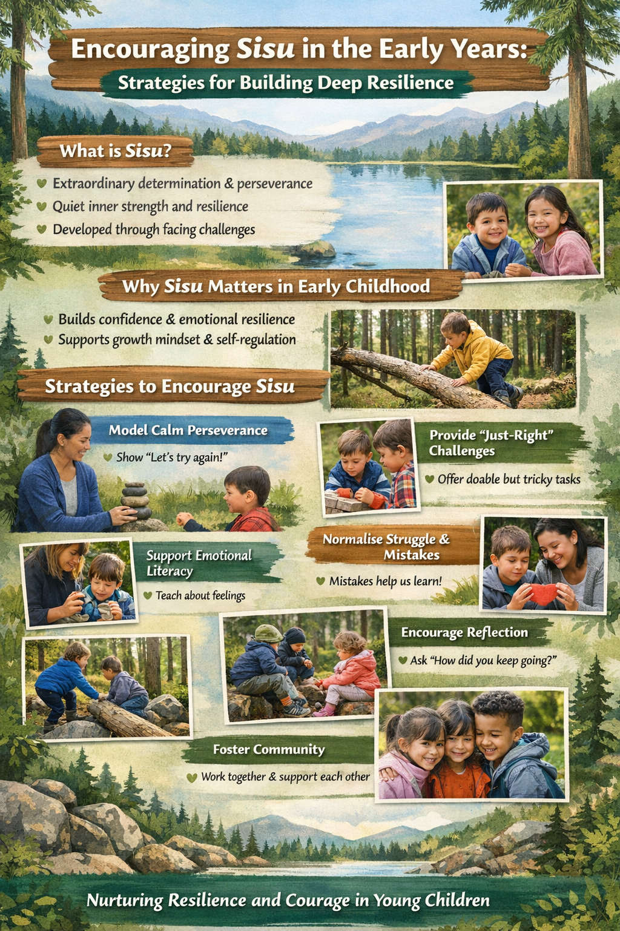
References

Department for Education (DfE) (2021) Statutory Framework for the Early Years Foundation Stage. London: DfE.

Dweck, C.S. (2006) Mindset: The New Psychology of Success. New York: Random House.

Ginsburg, K.R. (2011) Building Resilience in Children and Teens: Giving Kids Roots and Wings. Elk Grove Village, IL: American Academy of Pediatrics.

Intentionally Simple (2024) Sisu: The Finnish Approach to Resilience and Simple Strength. Available at: https://intentionallysimple.com/sisu-the-finnish-approach-to-resilience-and-simple-strength/ (Accessed: 1 April 2026).

Lahti, R. (2019) Sisu: The Finnish Art of Courage. London: Hodder & Stoughton.

Vygotsky, L.S. (1978) Mind in Society: The Development of Higher Psychological Processes. Cambridge, MA: Harvard University Press.

Whitebread, D. (2012) The Importance of Play: A Report on the Value of Children’s Play with a Series of Policy Recommendations. Brussels: Toy Industries of Europe.

Wise and Shine Zine (2025) Sisu: The Finnish Secret to Resilience and Happiness. Available at: https://wiseandshinezine.com/2025/04/12/sisu-the-finnish-secret-to-resilience-and-happiness/ (Accessed: 1 April 2026).

YouTube (2023) Sisu – Finnish Concept of Inner Strength. Available at: https://youtu.be/w-5PlqRR9zQ?si=uuQ4FnwctKD5Z6va (Accessed: 1 April 2026).

YouTube (2024) The Power of Sisu. Available at: https://youtu.be/HeJnYVRXJLw?si=XqPaaeQSD9XoJTLP (Accessed: 1 April 2026).

