Problem Solving and Decision Making

Name: Runeba Begum

Student Number: 1704953

Name of Organisation: University of Wales Trinity Saint David

Name of Host: Lianne Cuke

Submission Deadline: 20th April 2018

Summary

This report is written to define the current situation and problems of the NHS and the impact it is having on its stakeholders by using the stakeholder theory, PESTLE analysis and fishbone analysis. Options to resolve these problems use the SWOT analysis, PMI and Grid analysis, therefore suggesting recommendations of improvement.

Table of Contents

Introduction……………………………………………………………………………………1

PESTLE Analysis of NHS’s Problems…………………………………………………4

Cause and Effect Analysis to Explain the NHS’s Problems……………….6

SWOT Analysis to Resolve NHS Problems……………………………………....8

PMI Analysis to Resolve NHS Problems……………………………………………9

Grid Analysis to Resolve NHS Problems……………………………….…………10

Conclusions and Recommendations…………………………….…………………11

References…………………………………………………………………….……………….12

Introduction
The traditional view of an organisation assumes that organisations share to seek maximisation for all shareholders, such as businesses. These are often hierarchical and fixed, where employees follow a chain of commands to their superior (Jahan, 2016). This means that traditional views assume that organisations are about profit maximisation, as there is no flow within the different members. Jahan also stated that modern organisations have dynamic stability, more flexibility, a ‘flat’ hierarchy, teamwork, employee morale, risk management diversification and technology.
This links to alternative views such as the stakeholder theory. A stakeholder is an individual, group or organisation who is impacted by a consequence of a project. Stakeholders can have a positive or negative influence on a project, as they have an interest in the success and sponsorship of the organisation (Landau, 2017). However, stakeholders are not always equal, as customers are not entitled to the same considerations as a company’s employees (WebFinance Inc., 2018). These organisations seek to serve interests of all stakeholders. Landau provides examples of stakeholders as being a project leader, senior management, team members, customers, consultants, governments and more. He also states that without happy stakeholders, a project will not be successful.
An example of a stakeholder would be the NHS (National Health Services) organisation.
The NHS was launched in 1948 by Aneurin Bevan in the United Kingdom, to bring doctors, nurses, dentists and more under one umbrella organisation to provide healthcare to all (NHS Choices, 2017). Health care is financed entirely from taxation, so individuals pay according to their means. Some important evidence that support the NHS provide vaccinations from the 50s, transplants since 1968, scans since the 80s and quality care since the beginning. In 1967, The Salmon Report was published to set recommendations for developing the status of the profession in hospital management and developing nursing staff, additionally highlighting the importance of hospitals, general practice and local health authorities. This acknowledges the importance of future needs for individuals and the NHS.
Main bodies of stakeholders within the NHS include: NHS England who manage £100 billion of the overall budget; clinical commissioning groups who are responsible for 60% of the budget for secondary care and GP services; health and wellbeing boards who encourage health and social care; Public Health England who provide leadership and expert services towards public health; vanguards to develop the health system; and regulations to safeguard individual’s interests. The NHS is a stakeholder because the Health and Social Care Act 2012 states how they have a duty to involve people in decisions about health care, consultations and planning and changing health services (NHS Involvement, 2018). Other stakeholders within the NHS include patients wishing highest care of quality, employees receiving salary payment by NHS, suppliers who want prompt payment, and the government who wish to create jobs and look after the health of society. Other stakeholders within the NHS includes the British Medical Association, Royal College of GPs and more (NHS England, 2018).
Furthermore, stakeholders can be divided into three categories as shown in figure 1. This is divided in internal, connected and external. This shows how there are different branches of stakeholders within an organisation, all dependent upon one another to work efficiently.
Internal | Connected | External
Directors | Medical suppliers | Community
Manager | Competitors | Patients
Employees | Catering
Consultants | Food
Doctors
Nurses
Receptionist
Paramedics
Figure 1. Stakeholders of the NHS.
Additionally, Mendelow’s (1991) matrix model ranks stakeholders according to power and interest. These fall into 4 categories: minimal effort (interest and power are low), keep informed (interest is high, power is low), key players (interest and power are high). keep satisfied (interest is low, power is high). Below is an adaption of the matrix model, based on the NHS stakeholders (figure 2).
P  O  W  E  R | I N T E R E S T
P  O  W  E  R |  | Low | High
P  O  W  E  R | Low | Minimal effort  Receptionist  Patient | Keep informed  Nurse  Medicine  Catering/food  Competitors
P  O  W  E  R | High | Keep satisfied  Government | Key players  Directors  Consultants  Managers  Employees  Doctors

Figure 2. adaption of Mendelow’s model on NHS stakeholders.
Despite the positive reviews thus far, the stakeholder engagement report shows a negative current situation on the NHS and the impact it is having on its stakeholders (Palmer & Murray, 2014). For example, British Heart Foundation believe that research is key for commissioning, Asthma UK suggest the community should be more involved with commissioning, Sunderland Foundation Trust suggest that financial allocations are not yet right, Pelvic Pain Support Network suggests a single organisation are unable to deliver all specialised services and London Cancer suggest a more integrated system should be used to enhance the pathway. These are some of the few negative consequences that stakeholders within the NHS are receiving. Others include lack of staff, pay, equipment, finance, treatment and more, all highlighted within the official NHS report. This shows that the NHS as an organisation is not as efficient as it seems, as stakeholders from all categories are suffering consequences that can only be fixed through problem solving.
This report will therefore discuss problem solving within the NHS and its stakeholders.

PESTLE Analysis of NHS’s Problems

‘PESTLE’ is a relevant framework and analysis used to identify external factors surrounding an organisation to help develop areas outside control which may impact the organisation (Aguilar, 1967). This stands for political, economic, sociological, technological, legal and environmental. This is often used by the NHS, for example, the NHS Quality Strategy (2012-2017) have highlighted each factor with a main issue. Political factors look at legislation and bills, economic factors look at promoting efficiency, sociological factors focus on demographic changes and involving patients more as stakeholders, technological factors focus on IT and software, legal factors investigate monitoring changes, and environmental factors focus on changing medical education. This shows that the NHS suffers problems from all areas, which need to be resolved. This impacts patients as stakeholders as they are not involved in many decisions making for the NHS, it impacts employees working under the NHS because they feel pressured and it impacts the government due to the pressure they are receiving from all the stakeholders under their care for better improvement. There is also support from Warrington and Halton Hospitals (2014-2019), who produced a strategic plan with PESTLE on pp.8. It discusses issues from all areas, including reducing the carbon footprint for environmental factors, for example, taking less transport. This shows the NHS has both internal and external problems even for the smallest of factors, which leads to bigger issues (i.e., more transport means more staff which leads to financial struggles). This impacts paramedics as stakeholders, as it means that transport requires them to constantly be there at emergencies which increases the carbon footprint.
The researcher has applied two factors of PESTLE towards the NHS.
A political impact that explains the causes of the NHS problems could relate to ‘Brexit’ (UKEU referendum). It was found that 61% of British individuals considered for the NHS to be Britain’s biggest facing issues (Ipsos MORI, 2017). This meant that many were persuaded to vote to leave the EU because leave campaigners promised £350 million a week for the NHS. However, Williams (2018) has stated that Brexit has costed £350 million a week instead as importing equipment is more expensive due to the currency drop of Brexit. This shows a political cause on the NHS and its stakeholders, because this means that more money is being spent than given, which links to more taxation and jobs and affects all stakeholders. For example, patients receive less care quality, staff do not get salary up to standards with their quality of work, and budgeting is decreased for the NHS. Williams stated this weakens currency, investment and business for the economy as well. Additionally, another political impact of Brexit on the NHS would show that there has been a sharp fall of nurses and midwifes. Campbell (2017) has shown that there has been an 89% drop of nurses and midwives that had come to work from Europe to Britain. In addition, 4,067 European medics left the Nursing and Midwifery Council’s register from 2015-16. This shows a political impact as the cause of NHS’s problems, because this shows that European employees do not wish to pursue careers in the UK after Brexit. Therefore, political causes impact the NHS and stakeholders, because the NHS lose staff which means that the NHS is under pressure to stick to a budget and provide quality care.
Furthermore, according to the PESTLE framework, economic impacts would explain the causes of the NHS problems due to finance (as suggested previously). For example, in April 2016, there had been £167 million clinical income off plan due to unplanned cost pressures such as urgent care (NHS Improvement, 2016). In addition, clinical drugs exceeded the financial plan by costing £116 million, and supplies exceeded the plan by costing £119 million. This shows economic impacts as causes of problems to the NHS, because unplanned care and treatment means that the NHS struggle to finance for other areas. This means that the NHS are not able to follow original budget plans due to demands for treatment. This affects all stakeholders such as the government, because they need to cut budget on other areas to finance the NHS, it also affects the NHS because they are not able to follow their budget. Additionally, Robertson (2016) observed Maybin and Klein’s (2012) financial framework and applied it to the NHS. Six categories were analysed to describe how financial pressures affects the local health system. This includes: deflection where NHS refuses to treat a patent and places them elsewhere on the system, delay where individuals wait longer to be diagnosed and treated due to funding, denial where health care providers believe treatment is not appropriate due to clinical cost and effectiveness, selection where patients may not fit eligibility criteria, deterrence where the NHS consciously/unconsciously make it difficult for patients to find information about a service, and dilution where the quality of care may suffer (few appointments) due to budget cuts. Therefore, economic impacts explain the causes of problems of the NHS because research shows that lack of finance means that patient stakeholders do not receive quality care, as there are budget cuts in different areas of the NHS. This additionally means that there is not enough finance within the NHS.

Cause and Effect Analysis to Explain the NHS’s Problems
Moving on, the cause and effect framework (also described as the fishbone analysis by Ishikawa, 1968), identifies internal factors that effects an organisation, commonly used by the NHS as root cause analysis. This often analyses measurements, materials, people, machine, methods and environment as causes from the relevant issues, furthermore leading to the head of the ‘fish’ which is the identified problem. Sub-branches provide detail which leads to identification of the root of the problem and breaks down the process therefore is easy to read and understand. The sub-branches allow brainstorming to make place amongst the team to identify further problems to improve. To brainstorm, individuals are encouraged to think of the ‘5 whys’. This means that individuals ask themselves a question, then define and analyse it to bring another question until they have the five scenarios. For example, ‘why are patients upset? Because of the waiting list. Why is the waiting list long? Due to lack of staff’. This method will help understand the problem more clearly, eventually leading to a solution, or it might bring a delay to find a permanent solution. The diagram creates a visual snapshot for colleagues of an organisation to easily identify and solve, rather than focus on the history of a problem (NHS Improvement, 2017). Eventually it leads to the root cause of the problem to focus on, not the symptoms.
Firstly, the problem is identified (see figure 3), such as financial causes. Next, sub-branches are drawn, such as employees. Then there is analysis upon each subheading to find each of the causes. This will furthermore allow a solution to take place after the causes and effects are identified. In figure 3, the researcher has applied the main vague problems towards the fishbone analysis and concluded that financial problems seem to be the cause of the NHS’s main problems. Therefore, every department lacking in finance means that the NHS cannot work as an effective organisation.
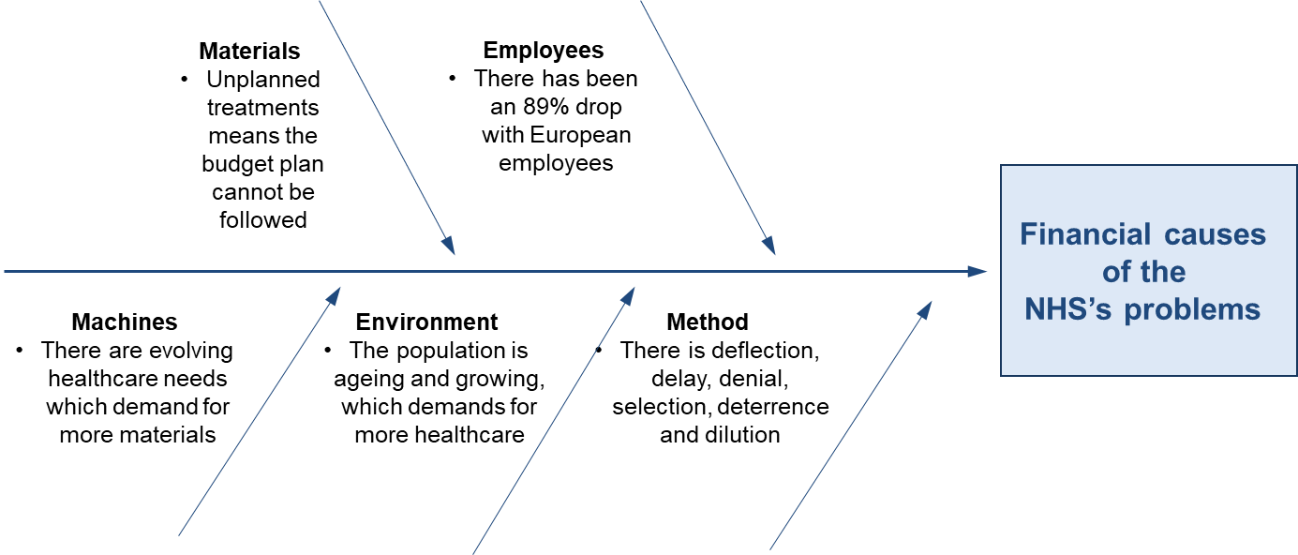

Figure 3. vague fishbone analysis on the financial problems of the NHS.

Research by Bose (2012) has investigated a case study of a hospital and applied the fishbone diagram to ‘inefficient supply chain management.’ For example, the factor inefficient management was due to hidden costs, short budget, and no employee orientation. This shows that a cause was obtained, then individuals used the ‘five why’ process to brainstorm to uncover the root cause of the problem. This can be applied to the NHS problems, because if certain departments have inefficient management, it can impact employees as stakeholders because they do not have a clear understanding. It can also impact patients because they will be affected in the process.
Supportive research towards the fishbone analysis by Phillips and Simmonds (2013) have applied ‘waiting times’ as a cause of the NHS’s problems. They had used method, environment, equipment and people as subheadings and brainstormed from each one. For example, for ‘environment’, it was brainstormed that small waiting rooms, lack of waiting rooms and the long process causes problems in waiting times. Therefore, the NHS is having problems on patients as stakeholders because the waiting time is uncomfortable. But it is having a negative impact on employees as they are pressured to work harder.
Moving forth, figure 4 shows an application of the fishbone analysis by the researcher, focusing on ‘challenges of an ageing population’ as a cause of the NHS’s problems. With statistics from Vernon (2016), the researcher applied that a factor to the challenge would be the environment. For example, as older people are frailer, they are more likely to be admitted into hospitals therefore take up a quarter of English beds. This would affect other patients as stakeholders as it means that they may not receive beds as frequently. This also impacts employees as stakeholders, because it means that the NHS must hire suitable staff for the ageing population, affecting finance. Therefore, challenges of an ageing population affect the current situation of the NHS because it affects all stakeholders.
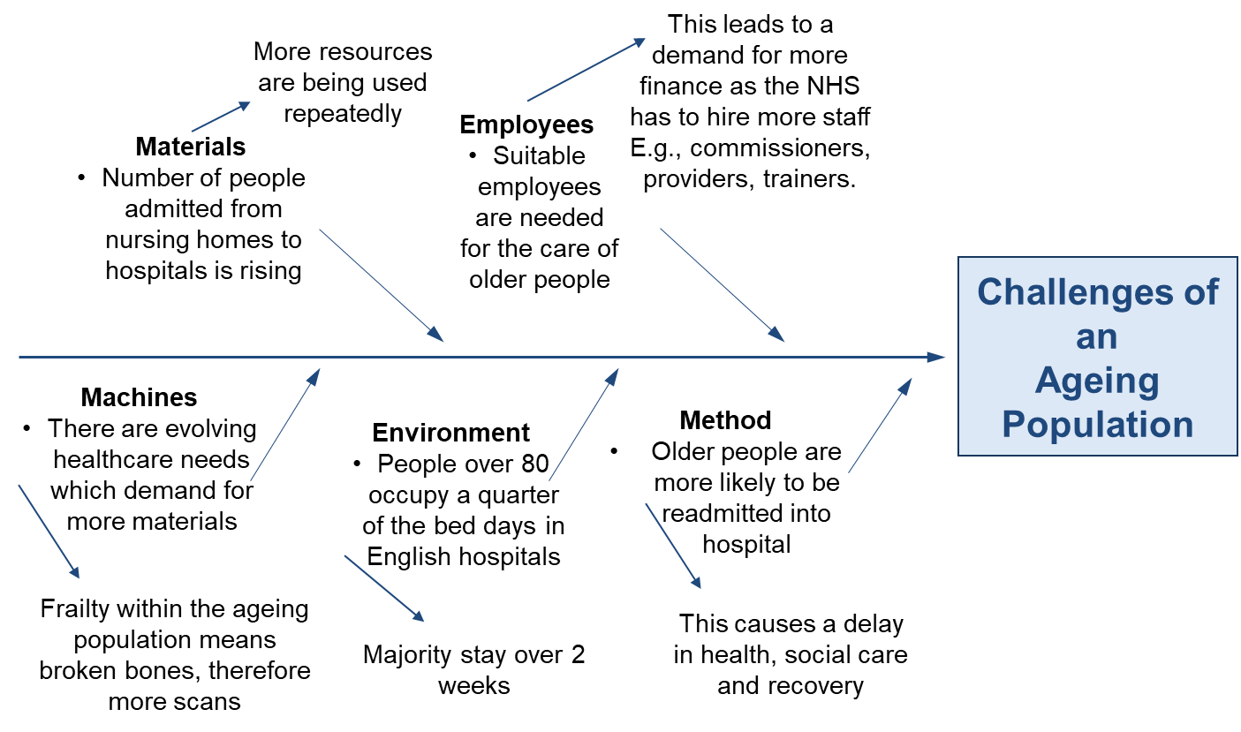

Figure 4. researcher’s application of ageing population as a cause of NHS’s problems.

SWOT Analysis to Resolve NHS Problems
A SWOT (strength, weakness, opportunities, threats) analysis would identify and explain causes of the NHS problems but also discover a solution. A SWOT analysis is used to look at internal strengths and weaknesses and external opportunities and threats within an organisation to identify causes of a problem and then solve it. A meta-analysis completed by van Wijngaarden, Scholten and van Wijk (2012) suggest that all stakeholders are used to generate a SWOT analysis to make future developments and improvements within a healthcare organisation, though there may be bias amongst employees. In addition, supportive research by Willis and Thurstone (2015) found that student nursing students found that communication was both a strength and weakness and found that working with clinical staff and disabled people was an opportunity for them. This shows that a SWOT analysis is essential for analysing causes of the NHS’s problems because it is clear and easy to read from and understand. This would therefore mean that the NHS cares to satisfy all stakeholder by analysing ways to improve an area.
The researcher has therefore provided their own SWOT analysis (see figure 5) on technological problems (imaging and scanning) of the NHS using statistics from NHS England (2017). The analysis therefore shows that technology is a strength because it is used to diagnose and treat illnesses to stakeholders within the environment. It provides opportunities for employee stakeholders to use new tests and provides different opportunities of treatments for patients. However, the resources provide a weakness because it is time consuming, waiting lists are long and therefore there is a demand for more finance for employees and resources, which does not fit into the budget. Despite this, the NHS can resolve the problem by working and planning efficiently to work effectively with other stakeholders and departments (GPs and hospital doctors) so that patients can receive a higher quality of care. The SWOT analysis is therefore useful in analysing specific problems within the NHS to develop and improve, such as the need for resources but it also shows how effective materials are.
Strengths | Weakness
- In November 2017, X-ray was most common test (1.87 million)  - This is a strength because it is cheaper than MRI and CT | - GP-referred period was longer for chest CT and brain MRI  - This is a weakness because stakeholders within the NHS organisation are not working effectively with each other
Opportunities | Threats
- In November 2017, 27% of all (scans) tests were used to diagnose or discount cancer  - This can save lives of patients as stakeholders | - 41.4 million imaging tests were taken from December 2016 – November 2017  - This can lead to lack of resources, need for more staff, and demand for more finance
Figure 5. SWOT analysis on NHS technological problems.
PMI Analysis to Resolve the NHS’s Problems
A PMI (plus, minus, implications) tool can be used to resolve the problems for the NHS. This weighs the pros, cons and implications of a decision, to check if it is worth taking. Supportive research by Formosa Post (2017) investigated the plus and minuses of the NHS, generalising the problems into main factors. Pluses include the fact that public health is improved as individuals seek help rapidly, there is no discrimination among individuals, there is full coverage, and it promotes human rights. On the other hand, minuses include the fact that it is time consuming, there is lack of options, there is low wages for doctors and nurses and there is a long waiting time. The NHS would therefore have a positive impact on stakeholder such as the patients because it means that quality care is provided for all. However, although there are minuses, this means that the NHS can provide solutions to develop them into pluses.
The researcher used evidence from Partington (2017) and applied what would happen if the NHS were to hire new employees (see figure 6). Challenges include how the NHS budget might be more restricted, however pluses include the fact that there is less pressure on other employees as stakeholders and patients receive more quality care due to more employees. This provides a solution to politics having an impact on the NHS (Brexit) as many European employees decided to leave after the vote. Hiring new staff would balance out the initial impact Brexit had on the NHS and its stakeholders.
Hiring new employees for the NHS
Plus | Minus | Implications
Average salary a week is £511  +3 | However, this means that some workers lost more than £4000  -3 | The amount of work may not be equal to the lack of pay  -3
Public sector (NHS) pay rose in comparison to private  +4 | Working conditions less hectic in private sectors  -2 | More people in public sectors means more help is needed  +4
NHS have a staff shortage – employees in public sector fallen by 1 million  +3 | New employees may not have much experience or knowledge  -2 | There is a gap for new employees, but lack of experience may cause fatal mistakes  -3
Government is training 1,500 new doctors a year  +5 | Lack of knowledge and experience for new doctors  -3 | New doctors mean 20,000 new mental health posts  +5
More staff means patients receive quality care  +5 | NHS make more budget cuts because money is going towards salary  -3 | More staff means more patients are looked after  +4
Figure 6. PMI solution to hiring new staff to solve problems for the NHS.
Grid Analysis to Solve the NHS’s Problems
Grid analysis is a tool which looks at several alternatives and factors to consider. Firstly, options are listed and factors that influence the decision are also listed. Next, the relative importance is worked out to way preferences of importance of the factors. Furthermore, each option is scored from 0-3, then it is multiplied by the relative importance (out of 5) to provide an overall score in the decision. The highest score is the best factor.
Below, the researcher has provided a grid analysis on budget cuts for the NHS. The researcher considered fining, purchasing, cancellations and beds potential solutions towards the budget problems in the NHS (NHS Improvement, 2016; Johnson, 2017). Patients, employees and the government were used as factors because they are the main stakeholders as part of the NHS (see figure 7). From the analysis, it seems that the most prominent solution for sticking to the budget would be to fine patients for missing or cancelling appointments at short notices (see figure 8). Therefore, fining would solve the NHS’s financial problems, because it will provide more money for stakeholders within the NHS.
Factors that impact: | Patients | Employees | Government
Fine individuals for missing or cancelling appointments at short notice as 20% of NHS’s appointments go to waste | 3 | 3 | 1
Buying fewer supplies of the same product. E.g., purchasing only how much is essential (0.1-0.5% cost raise) | 0 | 2 | 3
Reducing cancellations in theatres by managing appointments better (0.1-0.6% cost raise) | 2 | 2 | 0
Free up capacity (beds) by reviewing patients without the need for an overnight stay (0.1-0.2% cost raise) | 2 | 2 | 0
Figure 7. Unweighted grid analysis of potential financial solutions

Factors that impact: | Patients | Employees | Government | Total:
Weights | 5 | 5 | 3
Fine for cancelling appointments | 15 | 15 | 3 | 33
Fewer purchases of supplies | 0 | 10 | 9 | 19
Reducing cancellations | 10 | 10 | 0 | 20
Freeing capacity | 10 | 10 | 0 | 20
Figure 8. Weighted grid analysis of potential financial solutions.

Conclusion and Recommendations
To conclude this report, the NHS suffers many problems throughout the organisation, both internal and external affecting all stakeholders. Internal factors include financial problems, such as not being able to fund for bed or supplies, as mentioned earlier in the PESTLE analysis. This affects employees as stakeholders as they face pressure when caring for patients, but it also affects patients as stakeholders as they are suffering. External problems include environmental factors such as an ageing population, as shown in the fishbone analysis. When the NHS first started, individuals did not live past 65, however with development of healthcare many live beyond the age (men = 79, women = 83). This affects patients because it means lack of bed spaces, and it affects employees because older people may require specific care, as mentioned in the PMI. Overall, the governments as stakeholders are also affected because there is demand for more finance and care. Earlier the NHS did not suffer from many problems or affect its stakeholders, but now as the population becomes older, the budget for the NHS has increased over £100 billion but is still not enough.
Solutions provided in the SWOT analysis suggest ways for employees within the NHS to improve, by finding strengths and weaknesses then analysing them to make an improvement. For example, GP diagnoses for scans take longer than hospital ones do, suggesting an improvement for all employee stakeholders to work with each other efficiently to provide quality care. Additionally, the NHS can solve its problems by using PMI analysis, for example the researcher applied hiring staff towards the PMI with statistics and found it to be efficient. By hiring more employees, patient stakeholders will have more care and employees will have less hassle.
Despite this Green (2018) discusses the problems that the NHS faces today, such as ambulances in carparks, A&E overflowing, and 50,000 operations being postponed due to lack of beds. From this report it is understandable that the NHS will continue to face its problems, though many can be addressed through simple changes, as mentioned in the SWOT, PMI and Grid analysis. Stakeholders will therefore have to work with each other to make the organisation more efficient in hopes for the NHS to survive.

References

Aguilar, F.J. (1967). Scanning the Business Environment, (1st Ed), London: Macmillan.
Bose, T.K. (2012), ‘Application of fishbone analysis for evaluating supply chain and business process – a case study on the St James Hospital’, International Journal of Managing Value and Supply Chain, 3:2, 17-24.
Campbell, D. (2017), ‘European nurses and midwives leaving the UK in droves since Brexit vote’, [online]. Available: https://www.theguardian.com/society/2017/nov/02/european-nurses-midwives-leaving-uk-nhs-brexit-vote, [2018, April, 4].
Formosa Post (2017), ‘Pros and cons of universal health care in the United Kingdom’, [online]. Available: https://www.formosapost.com/pros-and-cons-of-universal-health-care-in-the-united-kingdom/, [2018, April, 5].
Green, M. (2018), ‘Towards an eternal winter – can the NHS survive?’, [online]. Available: https://www.newstatesman.com/politics/health/2018/01/towards-eternal-winter-can-nhs-survive, [2018, April, 5].
Ipsos MORI (2017), ‘Ipsos MORI May issue index: sharp rises in concern about the NHS and education’, [online]. Available: https://www.ipsos.com/ipsos-mori/en-uk/ipsos-mori-may-issues-index-sharp-rises-concern-about-nhs-and-education, [2018, April, 4].
Ishikawa, K. (1968), Guide to Quality Control. Tokyo: JUSE
Jahan, S. (2016), ‘Modern Organization vs traditional organization’, [online]. Available: https://www.linkedin.com/pulse/modern-organization-vs-traditional-safinaz-jahan, [2018, April 3].
Johnson, S. (2017), ‘Nine ways to save the NHS – by healthcare professionals’, [online]. Available: https://www.theguardian.com/healthcare-network/2017/jul/07/nine-ways-save-nhs-healthcare-professionals, [2018, April, 5].
Landau, P. (2017) ‘What is a Stakeholder?’, Project Management 101 [online]. Available at: https://www.projectmanager.com/blog/what-is-a-stakeholder, [2018, April, 2].
Maybin, J. & Klein, R. (2012), ‘Thinking about rationing’, [online]. Available: https://www.kingsfund.org.uk/publications/thinking-about-rationing, [2018, April, 4].
Mendelow, A. (1991), Stakeholder mapping (1st Ed), Cambridge: MA.
NHS Choices (2017) ‘The history of the NHS in England’, [online]. Available: https://www.nhs.uk/NHSEngland/thenhs/nhshistory/Pages/the-nhs%20history.aspx, [2018, April, 3].
NHS England (2017), ‘Diagnostic Imaging Dataset: Statistical Release’, [online]. Available: https://www.england.nhs.uk/statistics/wp-content/uploads/sites/2/2018/03/Provisional-Monthly-Diagnostic-Imaging-Dataset-Statistics-2018-03-22.pdf, [2018, April, 4].
NHS England (2018) ‘Keeping stakeholders informed and involved’, [online]. Available: https://www.england.nhs.uk/commissioning/primary-care/primary-care-comm/pcs-services/stakeholders/, [2018, April, 2].
NHS Improvement (2016), ’10 ways for the NHS providers to find savings and make cost improvements’, [online]. Available: https://improvement.nhs.uk/resources/10-ways-nhs-providers-find-savings-and-make-cost-improvements/, [2018, April, 5].
NHS Improvement (2017), ‘Cause and effect (fishbone diagram)’, [online]. Available: https://improvement.nhs.uk/resources/cause-and-effect-fishbone-diagram/, [2018, April, 5].
NHS Improvement (2016), ‘Quarterly performance of the NHS provider sector: quarter 3 2016/17’, [online]. Available: https://improvement.nhs.uk/resources/quarterly-performance-nhs-provider-sector-quarter-3-1617/, [2018, April, 4].
NHS Involvement (2018), Identifying Stakeholders [online]. Available: http://www.nhsinvolvement.co.uk/connect-and-create/identifying-stakeholders, [2018, April, 2].
Palmer, J. & Murray, J. (2014), ‘Stakeholder engagement report to inform the developing scope of the five-year strategy for specialised services’, [online]. Available: https://www.england.nhs.uk/wp-content/uploads/2014/01/stake-engage-rep-0114.pdf, [2018, April, 3].
Partington, R. (2017), ‘Public sector employers ‘preparing to hire at fastest pace since 2015’’, [online]. Available: https://www.theguardian.com/society/2017/sep/12/public-sector-employers-hire-nhs-staff-workers-manpower-group, [2018, April, 5].
Phillips, J. & Simmonds, L. (2013), ‘Using fishbone analysis to investigate problems’, Nursing Times, 109:15, 18-20.
Robertson, R. (2016), ‘Six ways in which NHS financial pressures can affect patient care’, [online]. Available: https://www.kingsfund.org.uk/publications/six-ways, [2018, April, 4].
Sheffield Teaching Hospitals NHS (2012-2017), ‘Quality Strategy’, [online]. Available: http://www.sth.nhs.uk/clientfiles/File/Enclosure%20E2%20-%20Quality%20Strategy%202012-2017.pdf, [2018, April, 4].
Van Wijngaarden, J.D.H., Scholten, G.R.M. & van Wijk, K.P. (2012), ‘Strategic analysis for health care organization: the suitability of the SWOT-analysis’, The International Journal of Health Planning and Management, 27:1, pp. 34-39.
Vernon, M.J. (2016), ‘Our ageing population presents the NHS with its greatest challenge’, [online]. Available: https://www.england.nhs.uk/blog/martin-vernon/, [2018, April, 5].
WebFinance Inc. (2018), ‘Stakeholder’, [online]. Available: http://www.businessdictionary.com/definition/stakeholder.html, [2018, April, 2].
Williams, P. (2018), ‘The NHS is already in crisis – Brexit could finish it off’, [online]. Available: https://www.newstatesman.com/politics/health/2018/01/nhs-already-crisis-brexit-could-finish-it, [2018, April, 4].
Willis, D.S. & Thurston, M. (2015), ‘Working with the disabled patient: Exploring student nurses views for curriculum development using a swot analysis’, Nurse Education Today, 35:2, pp. 383-387.

