UWTSD
WISA



Project Planning
Engineering Management
Management, Innovation and Sustainability
ACHA5012

Daniel Jack Briggs
2312568
30/10/25

Contents
1 Introduction 1
1.1 Justification 1
1.2 Aims 1
2 Team Dynamics 2
3 My Roles and Responsibilities 3
3.1 Belbin Assessment 4
4 Group Tasks And Associated Timings 5
4.1 Billing and expenditures 6
5 Gateway and Milestones 7
6 Areas of concern 8
7 Further Work 8
8 Group Project Timeline (Gant Chart) 9
9 References 11

Figure 1(Shows a Yamaha FZR 1000 1989 model) [(Staticflickr.com, 2025).] 1
Figure 2 (The preferred mounting positions) [ROAD RACING STANDING REGULATIONS. (n.d.).] 3
Figure 3( The TR2 transponder) [Moto Performance, (2025).] 6

Table 1 (My Belbin Assessment) 4
Table 2 (The Group Tasks) 5
Table 3 (My Group Project Tasks) 5
Table 4 (Billing and Expenditure) 6
Table 5 (Group Milestone and Gateway) 7
Table 6 (Solo Milestone and Gateway) 7

Introduction
The group is working on repairing and rebuilding a motorcycle and modifying the motorcycle for an endurance race. The motorcycle the group is rebuilding is a Yamaha FZR 1000 (1989 model). The Endurance Race the group is looking at is by “No Limits Racing”. The first objective for the group is to find out whether the motorcycle's chassis can be repaired or if the group will need to replace the chassis. The chassis has a crack running through the steering stem.
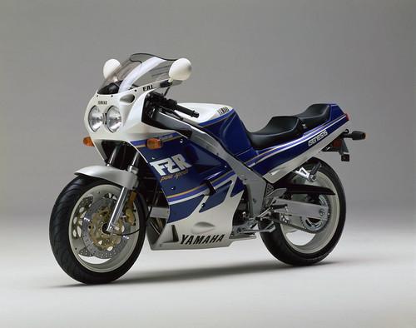
Figure 1(Shows a Yamaha FZR 1000 1989 model) [(Staticflickr.com, 2025).]

Justification
This technical report is to show how the group planned our group project and what tasks the group are going to carry out on the motorcycle.

Aims
- To give a brief description of the group project.
- Describe the team dynamics and roles for the group project.
- Give a list of tasks that the group is looking at for the project.
- Show the milestones and gateways that the group are going to achieve.

Team Dynamics
- Daniel Briggs (2312568)
I will be looking at what sensors I can put on the motorcycle for race compliance and for data collection, as well as where the sensors will need to go, trying to keep them all at a centralised point within the motorcycle, and looking at protection for the sensors. My other task is to support the rest of the team with their roles, as the sensors can only be installed on the motorcycle after it is rebuilt.
- Finn Flye (2304833)
Finn will be inspecting the engine clearances, ensuring the valves and camshaft are within the motorcycle's specifications. Once the inspection is completed, Finn will then focus on redesigning the rear fairings and suspension unit.
- Moses Adir (2403675) Team Leader
Moses will be looking at the exhaust system with a potential for redesign. Also, Moses will be looking at the headers and collectors for the motorcycle. The third part of the motorcycle Moses will be looking at is the electrical wiring.
- Oska Robertson (2301207)
Oska will review the race regulations and ensure the motorcycle complies with the required standards set by the ACU (Auto Cycle Union Bike Sport GB). This will entail replacing the brake light with a rain light, oil sealing, removal of indicators, removing the glass and examining the chain guard for compliance.

My Roles and Responsibilities
My primary role is to research the sensors that will need to go on the motorcycle to keep the motorcycle compliant with the regulations for the endurance race. The Other sensors I will be looking at putting on the motorcycle are for diagnostics and race analysis.
I need the motorcycle mostly rebuilt to wire up the sensors and perform basic performance tests, ready for the endurance racing. So while I am waiting for the motorcycle to be rebuilt, I am helping the others in the group with their tasks and getting started on researching different types of sensors to go on the motorcycle and reading the regulations for the endurance race.
The endurance race requirement only allows two types of sensors, which are:
- AMB TranX 260
- MYLAPS X2
The MYLAPS X2 has been updated and is now the MYLAPS TR2. This is the sensor that the group will use on the motorcycle. The sensor must be mounted on the side of the motorcycle below 600mm
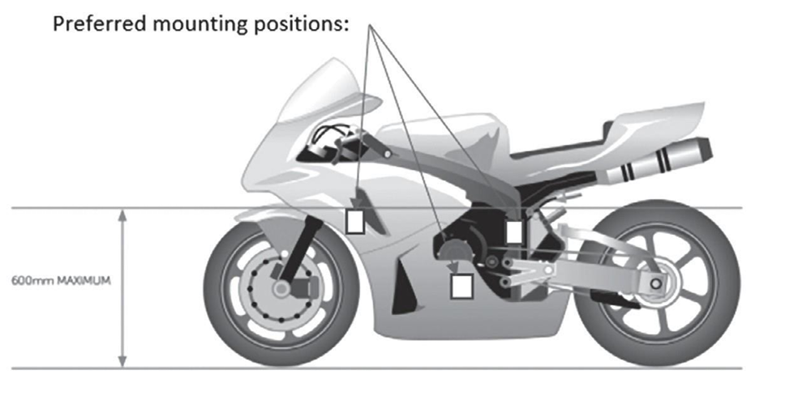
Figure 2 (The preferred mounting positions) [ROAD RACING STANDING REGULATIONS. (n.d.).]
I have also been supporting the other members in the group with some of their tasks:
- I have supported Oska with some research in finding out some of the regulations for the endurance race.
- I have helped with disassembling the motorcycle and removing the engine from the chassis.
- I have supported Moses with measuring the exhaust system for a potential redesign.
- I have helped with taking the chassis apart, looking at whether the chassis can be fixed, or if the group needs to replace the chassis.
- I have supported Finn with the reassembly of the motorcycle engine after Finn had finished measuring the clearances and valves.

Belbin Assessment
The Belbin assessment is a team role model that characterises nine different behavioural styles individuals use when working in a team to balance and improve the effectiveness of the teamwork. The assessment was created by Dr Meredith Belbin in 1981 after a nine-year study on the behaviour of a team, and the original test had eight Behavioural styles. It was then updated in 1993 to have nine behavioural styles and changed some of the behavioural styles Names. These nine behavioural styles are categorised into three groups that are thought-oriented, action-oriented and people-oriented roles. [Moultrie, J. (2016).]

Table 1 (My Belbin Assessment)
 | Implementer | Co-ordinator | Shaper | Plant | Resource Investigator | Monitor Evaluator | Team Worker | Complete Finisher
My Score | 10 | 11 | 4 | 11 | 10 | 5 | 8 | 6
Average Score | 10 | 8.8 | 11.6 | 7.3 | 7.8 | 8.2 | 10.9 | 5.5

A review of the Belbin assessment results will show where my strongest assets are.
Thinking Roles
- Plant (creates innovative ideas).
Social Roles
- Co-ordinator (listen to everyone’s input and delegate tasks).
- Resource Investigator (explores and develops opportunities).
Action Roles
- Implementer (puts plans into place and acts on them).
- Complete Finisher (ensures accurate details and deadlines are met).

Group Tasks And Associated Timings
Table 2 (The Group Tasks)
The Group Tasks | Start Date | Duration (Days) | End Date | Duration (Hours) | Task Status
Introduction and start of the project | 13/10/25 | 1 | 13/10/25 | 2 | Completed
Motorcycle disassembly | 07/10/25 | 14 | 21/10/25 | 1 | Completed
Identifying areas of interest and improvement | 10/10/25 | 14 | 24/10/25 | 1 | Completed
Task logistics | 14/10/25 | 6 | 20/10/25 | 0.5 | Completed
Allocation of personal areas of work | 20/10/25 | 15 | 04/11/25 | 1 | Completed
Individual research and development | 05/11/25 | 57 | 01/01/26 | 2-2.5 | Completed
Consolidating prototypes | 01/12/25 | 63 | 02/02/26 | 1-1.5 | Pending
Testing prototypes | 04/12/25 | 86 | 28/02/26 | 1.5-2 | Pending
The rebuild of the motorcycle (engine and running gears) | 01/12/25 | 31 | 01/01/26 | 1.5-2 | Pending
Final motorcycle assembly | 02/01/26 | 44 | 15/02/26 | 1-1.5 | Pending
Track testing | 15/02/26 | 16 | 03/03/26 | 1.5-2 | Pending
Report submission/presentation | 08/03/26 | 2 | 10/03/26 | 3 | Pending
End of project | 24/03/26 | 1 | 24/03/26 | 1 | Pending

Table 3 (My Group Project Tasks)
My Group Project Tasks | Start Date | Duration (Days) | End Date | Duration (Hours) | Task Status
Research race regulations | 06/10/25 | 1 | 06/10/25 | 2 | Completed
Research what sensors the endurance race requires | 06/10/25 | 1 | 06/10/25 | 0.5 | Completed
Research what data sensors would help the group for track testing | 14/10/25 | 51 | 04/12/25 | 1 | Pending
Mount the sensors on the motorcycle | 02/01/26 | 44 | 15/02/26 | 2 | Pending
Track testing | 15/02/26 | 16 | 03/03/26 | 1.5-2 | Pending
Review the data from the sensors | 03/03/26 | 7 | 10/03/26 | 2 | Pending
Submit the technical report to the Group for review | 10/03/26 | 1 | 10/03/26 | 2 | Pending

Billing and expenditures
Table 4 (Billing and Expenditure)
Name of item | Quantity | Cost | Justification
LG Gram 16” Laptop | 1 | £1,299.99 | Research and design
Solid-Works (1 Year) | 1 | £3,604.91 | Design program
Oxford math set | 1 | £4.85 | Drawings
A4 Note pad | 1 | £3.20 | Drawings and Notes
Pens pack (10) | 1 | £4.00 | Notes
Microsoft 365 Business Standard (1 Year) | 1 | £124.99 | Presentations and reports
Mylaps TR2 Direct Powered Transponder - Motorcycle / Car (1 Year) | 1 | 188.40 | For racing

The reason that the cost of the sensors has not been added to the billing and expenditures list yet is that the group has not decided which sensors are required for data collection. The race sensor is on the list because that sensor is a requirement for the endurance race.
The TR2 will take 2 weeks to arrive when ordered.
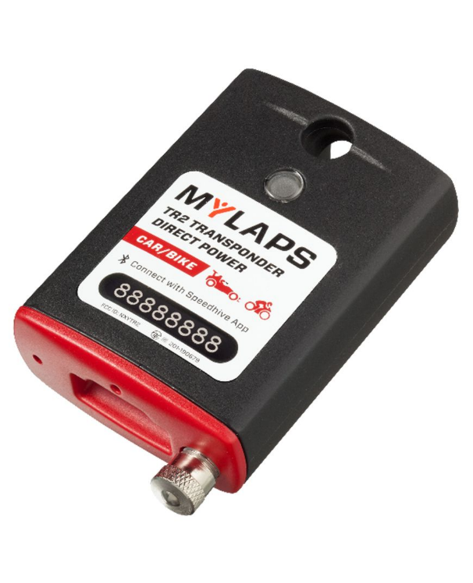
Figure 3( The TR2 transponder) [Moto Performance, (2025).]

Gateway and Milestones
Table 5 (Group Milestone and Gateway)
Category | Unit / Type | Target | Method
Group | Gateway | Disassembly of the motorcycle | Working as a group, disassemble the motorcycle
Group | Milestone | Reassembly of the engine | Working as a group, reassemble the engine
Group | Milestone | Engine reinstalment | Working as a group, reinstall the engine (after the chassis is repaired)
Group/ solo | Milestone/ Gateway | Fully assemble the motorcycle | Working as a group, fully assemble the motorcycle
Group | Milestone | First engine start | Start the engine
Group | Gateway | Track Testing | Collect data

Table 6 (Solo Milestone and Gateway)
Category | Unit / Type | Target | Method
Solo | Milestone | Research different sensors | Researching regulations to find out what sensors are allowed for racing.
Solo | Milestone | Reinstall the Engine | Working as a group, reinstall the engine (after the chassis is repaired).
Solo | Gateway | Fully assemble the motorcycle | Working as a group, fully assemble the motorcycle.
Solo | Milestone | Mount the sensors | Mount the sensors at the point specified by the regulation.
Solo | Gateway | Track testing | Collect data.
Solo | Milestone | Review data | Review the collected data from the track testing.

Areas of concern
There are a couple of areas of concern I have while working on this group project, which are:
- The biggest area of concern is that the chassis cannot be repaired and that a replacement chassis is not available in time for the project's completion.
- The second area of concern is that the TR2 is out of stock when ordering the sensor, or it gets damaged during the delivery of the sensor.
- The third area of concern is that not all the group members will do their fair share of the work, causing the rest of the group to pick up their tasks.
To reduce the risk of the areas of concern, the group has implemented the following precautions:
- For the first concern, the group will make plans for the chassis. This means if the group can't fix the chassis, the group has researched how much it would cost to buy a new chassis for the motorcycle or fabricate a new chassis.
- For the second concern, I have looked at alternative websites to be able to buy the sensor from. While keeping within the time frame that the group has set out. [HS Sports -. (2022).]
- For the Third Concern, the group has created a group chat as well as a group project page on Microsoft Teams. The teams page has lectures invited to the page to keep track of the group's progress and support the group when the group require help and advice.

Further Work

After the group has finished reviewing the collected data, the group can look at where we can improve the motorcycle performance and handling in the endurance races.
One area of improvement I was considering was reducing the weight of the yokes. This can be hypothetically achieved by strategically cutting material away without reducing the strength of the yoke and keeping the stress on the part as low as possible. I will also change the material the yoke is made from, for example, from steel to titanium.
Another area of improvement I have considered was adding a spoiler to the belly pan of the motorcycle. This will hypothetically pull the motorcycle's rear wheel down, providing more grip on the rear of the motorcycle. [GPone (2025). ]

Group Project Timeline (Gant Chart)

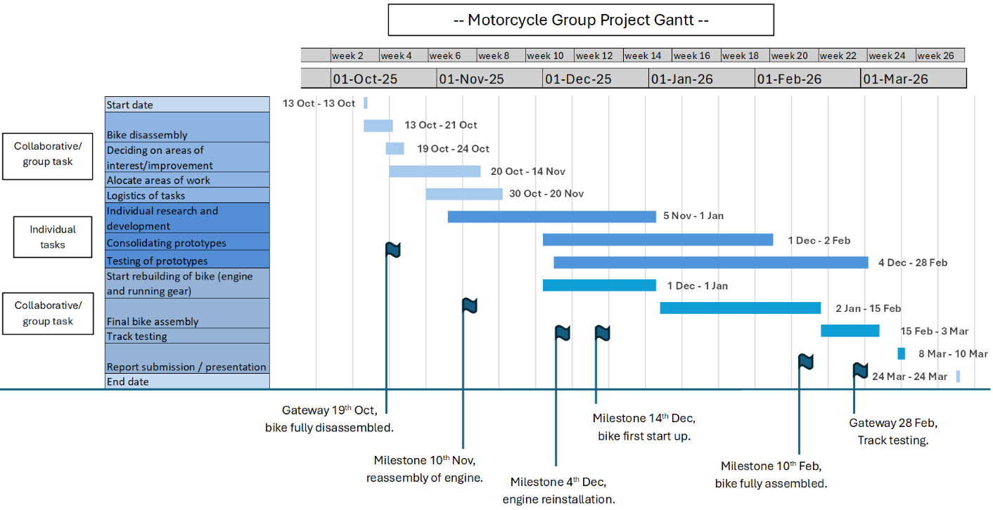
My Group Project Tasks
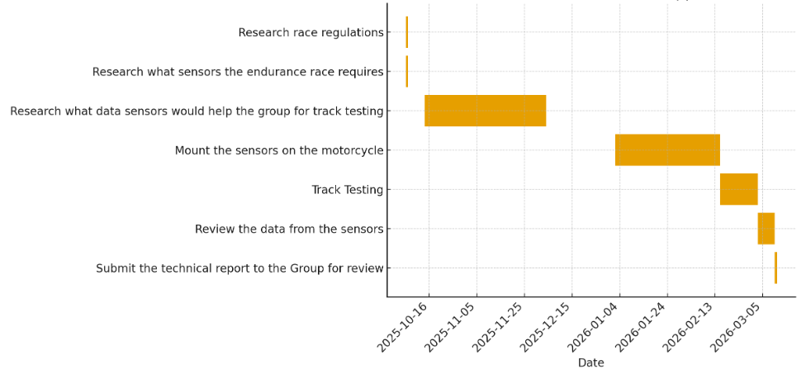

References

5.2.4 2014 NO LIMITS RACING TECHNICAL REGULATIONS. (2013). Available at: https://nolimitstrackdays.com/media/wysiwyg/nlr-docs/2014_Technical_Rules_NLR_V1_1_.pdf

Currys (2024). Currys [online] www.currys.co.uk. Available at: https://www.currys.co.uk/

GPone (2025). MotoGP, Ducati improves aerodynamics: new fairing for Bagnaia and Marquez. [online] GPone.com. Available at: https://www.gpone.com/en/2025/11/18/motogp/ducati-improves-aerodynamics-new-fairing-for-bagnaia-and-marquez.html

HS Sports -. (2022). Mylaps TR2 Direct Powered Car / Bike Transponder - HS Sports. [online] Available at: https://hssports.co.uk/sales/mylaps-tr2-direct-powered-car-bike-transponder/

‌Moto Performance. (2025). Mylaps TR2 Direct Powered Transponder - Motorcycle / Car. [online] Available at: https://moto-performance.co.uk/transponders/complete-kits/mylaps-tr2-direct-powered-transponder-motorcycle-car/

Moultrie, J. (2016). Belbin’s Team Roles. [online] University of Cambridge. Available at: https://www.ifm.eng.cam.ac.uk/research/dmg/tools-and-techniques/belbins-team-roles/.

NO LIMITS RACING 2024 SUPPLEMENTARY REGULATIONS. (n.d.). Available at: https://storage.googleapis.com/wzukusers/user-18730654/documents/24edd90a2fe844a284dc785c502fbf5c/NLR%202024%20SuppRegs%20Final%20240124.pdf
‌ROAD RACING STANDING REGULATIONS. (n.d.). Available at: https://www.acu.org.uk/Uploaded/1/Documents/2024%20Paperwork/Handbook/Updated/2024-Road-Racing-Standing-Regulations-Final.pdf

SolidWorks (2018). [online] Solidworks.com. Available at: https://www.solidworks.com/

Staticflickr.com. (2025). Available at: https://farm8.staticflickr.com/7826/47285518042_1a4b1b8bc6.jpg

‌

