OOP Programming (c++)
Sharla Passariello

UWTSD
Advanced Software Development

Introduction
Object Oriented Programming (OOP) is a programming paradigm that allows real life objects to be represented in programming. The objects are represented together with their attributes and behaviours. Through designing software around data and objects as opposed to an extensive list of functions and logic, OOP allows for objects to be manipulated to achieve desired functionality whilst allowing for better maintainability and reusability. OOP is well-suited to large and complex programs that need to be maintained and actively updated [1].
OOP is associated with four main principles: Abstraction, encapsulation, inheritance, and polymorphism; and is also comprised of concepts such as classes, objects and more.
This report aims to achieve the following objectives:
- Detail the principles and concepts of OOP using examples from the author’s Tic Tac Toe game
- Detail the importance of OOP and its advantages within software development
- Detail the testing of the authors Tic Tac Toe game
- Provide an accessible link to a video demonstration of the authors Tic Tac Toe game

OOP Principles and Concepts
The author developed a Tic Tac Toe game using OOP in C++. The following demonstrates the principles and concepts of OOP used whilst providing examples from the Tic Tac Toe code.

Abstraction
Abstraction displays the essential information whilst hiding the unwanted internal details. An example of abstraction is creating a class. Classes allows us to group data and functions together and can be used without the need of showing all the internal attributes. The following is an example of abstraction from the Tic Tac Toe game.
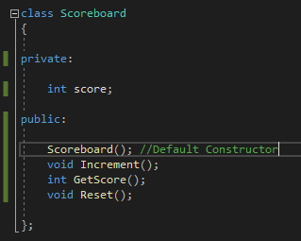
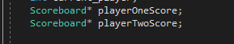

Classes
A class can be defined as a blueprint or template for creating a data structure, also known as a user defined data type. A class will define the attributes and actions of its data type. For example, attributes can be represented as variables, and actions can be represented as methods within a class. [2].
The Tic Tac Toe game consists of six classes in total. In the GameLogic class example below, there are private variables and public methods that have been defined as class members. The GameLogic class incorporates all gameplay related attributes and actions such as drawing the board, placing the marker, and checking for a winner.
The additional classes created within Tic Tac Toe include DisplayWelcomeMessage, RuleAlert, ShowRules, Scoreboard, and EndMenu.
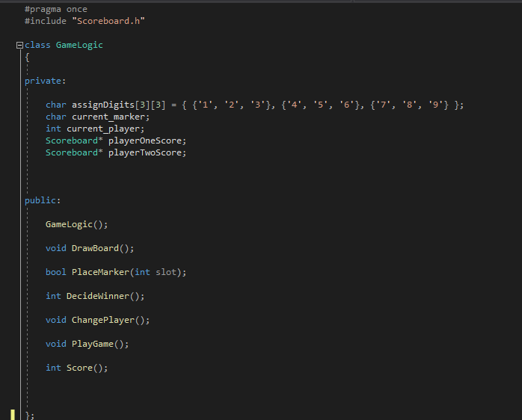

Objects
An object is an instance of a class. An object needs to be created to operate the members of a class. When an object is created, it allocates memory to the RAM. The memory can be allocated to the stack or the heap.
Memory that is allocated to the stack is allocated in contiguous blocks of memory. When the function is called, the compiler knows the size of memory needed to be allocated on the stack. When the function call is over, the memory is then deallocated. Stack memory allocation is temporary and will only be allocated until the method is completed. Memory that is allocated to the heap is allocated by the programmers, for example when an object is created. The memory is allocated to an address randomly unlike the stack that allocates contiguously. Heap memory must then be deallocated by the programmers to prevent memory leaks. When an object is created on the heap, the referencing information for these objects is stored in the stack memory. Heap allocation allows for more flexibility as it can be resized, however heap allocation is costlier, slower to access, and not as secure in comparison stack allocation.
In the example below, objects have been created from the DisplayWelcomeMessage class, the RuleAlert class, and the ShowRules class. These objects have allocated memory to the heap. Once these methods have been executed, they are then deleted from the heap to free up memory and prevent memory leaks.
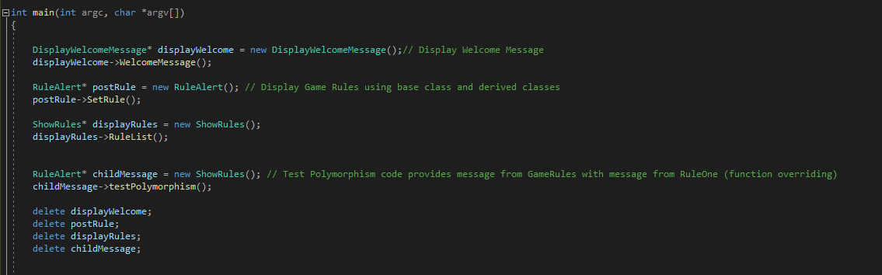

Methods
Methods are functions that are defined within a class. When an object is created, a method can be called to operate on the data within the associated class. This prevents the need to write out a function repeatedly.
The example below displays methods created within the Scoreboard class. Here the Increment method and the GetScore method can be seen being executed for a players score to increment and then display. Instead of writing a function for the score to be added each time a player wins, the method Increment is called.

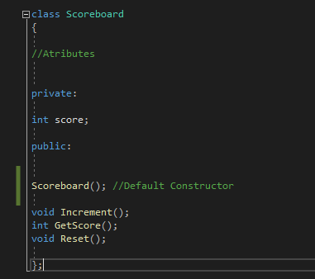
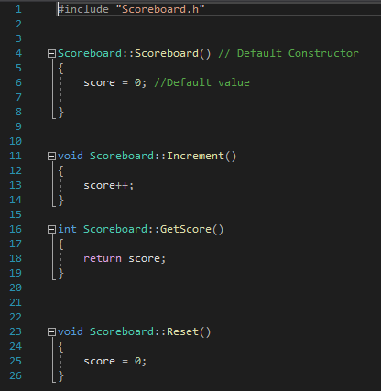
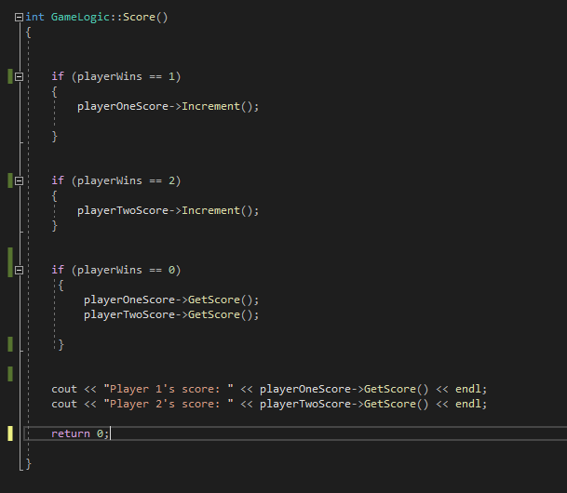

Inheritance
Inheritance allows classes to reuse attributes and behaviours from other classes. The class that will be inherited from is known as the base class, and the classes that are inheriting the data are known as derived classes. Inheritance allows for reusability by avoiding duplication.
An example from Tic Tac Toe displays the base class of RuleAlert with a derived class of ShowRules. The Method testPolymorphism is then inherited (although this method will soon be overridden to incorporate polymorphism into the game).
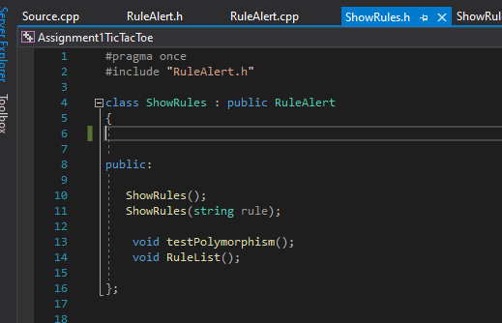
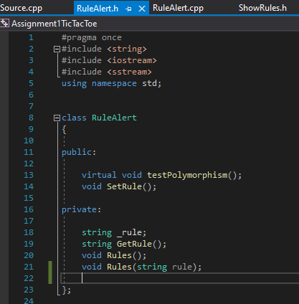

Polymorphism
Polymorphism means “many forms” and allows for derived classes to express functionality in relation to the base class functionality. Polymorphism allows messages to be displayed in more than one form and can be done through method overloading or method overriding. [4]
Method overloading, also known as static polymorphism, allows methods to use the same name but the passing parameters are different. Method overriding, also known as dynamic polymorphism, allows the method name of the base class and derived class to be the same, while the derived class function overrides the base class function.
In Tic Tac Toe, polymorphism was used to replace a message after the rules are displayed. Using inheritance between the RuleAlert class (base) and the ShowRules class (derived), the base class method testPolymorphism was set as a virtual function to tell the compiler that the method from the derived class should override the base class method. The method testPolymorphism in the RuleAlert base class outputs the message “This message should have been replaced by polymorphism code”. Through method overriding, the derived class ShowRules uses the same method name and thus overrides the message to output “Let’s play!”.
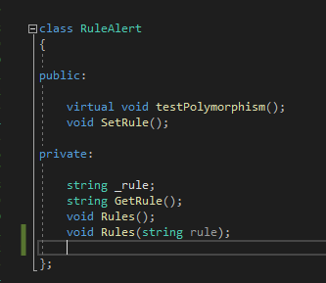
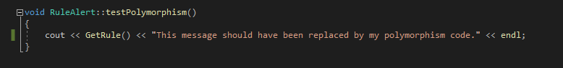
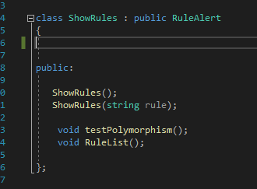
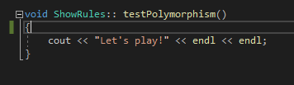
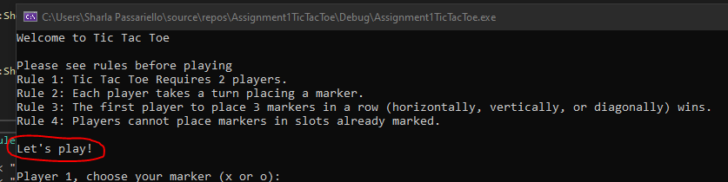

Encapsulation
Encapsulation allows the control of access to members within a class for the purpose of protection. Access to members within a class can be made private or public. If not defined, members of the class are private by default. If members of a class are private, they may only be accessed within the class. Members may also be defined as protected, which allows derived classes to access the members within the base class [2]. If variables of a class are made private, they can still be accessed through public methods within a class. Encapsulating the data within a class provides better security to the program.
In the Tic Tac Toe game, each class has encapsulated data by defining public and private access.
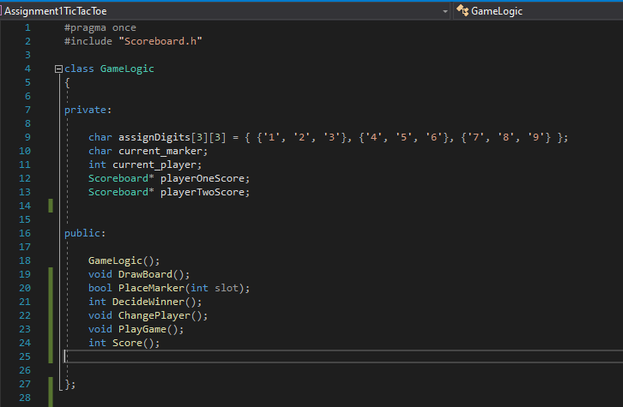
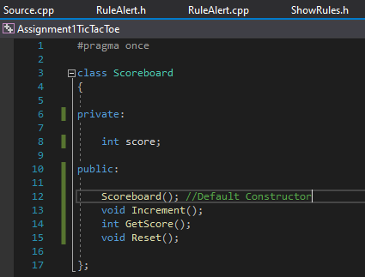

Advantages of OOP
The approach of OOP offers many advantages because the program can be broken down into bitesize blocks. Developing using the OOP paradigm allows for advantages such as:
- Maintainability – As code is not listed into multiple lines of functions and logic, but instead into objects, maintaining and troubleshooting through OOP is much easier. Areas of concern can be more easily pinpointed, and any changes can then be applied to a limited number of areas
- Reusability – Through inheritance, OOP allows code to be reusable which in turn creates greater software development productivity over traditional procedure-based paradigms. Reusability also allows for cheaper production costs as less time and effort are needed for development
- Flexibility – Through inheritance and polymorphism, code can be adapted to be fit the derived class functions. This provides flexibility in the sense that programmers do not need to create multiple methods every time they add a new class but can instead manipulate virtual functions to override the base function and execute the desired functionality. This makes development time quicker and creates cheaper development costs
- Expandability – As OOP’s advantages comprise of maintainability and reusability, these also provide the further advantage of expandability. Development that is easy to maintain, is flexible, and can be easily reused can in turn be easily expanded. This is because code is broken into simple blocks which can be expanded on as opposed to facing the struggle of expanding intertwining functions and logic through a traditional procedure-based approach [6].

With these advantages OOP is well-suited to large and complex programs such as game development, AI systems, simulation and modelling systems, office automation systems, and many more [7][8].

Testing
The following tests were executed on the Tic Tac Toe game developed by the author.

Test Case 1: When Tic Tac Toe is started, a welcome message appears, and the rules are displayed.
Expectation: When the game is started the welcome message and rules are displayed as defined in the relevant classes.
Result: Working as expected.
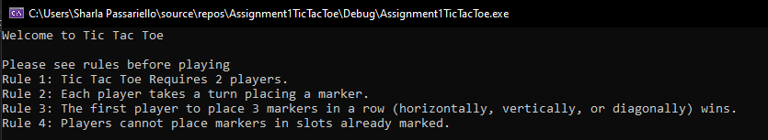

Test Case 2: After rules are displayed the phrase ‘Let’s Play!’ is displayed to test the polymorphism code.
Expectation: ‘Let’s play!’ is displayed instead of ‘This message should have been replaced by my polymorphism code.’
Result: Working as expected.
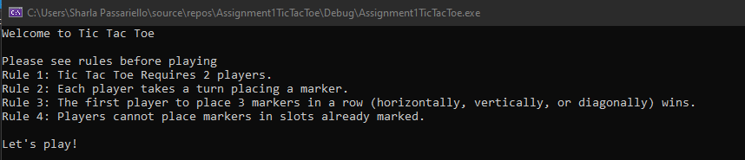

Test Case 3: Once rules are displayed, Player 1 is asked to select marker ‘x or ‘o’.
Expectation: Player 1 is given the option to select a marker.
Result: Working as expected.
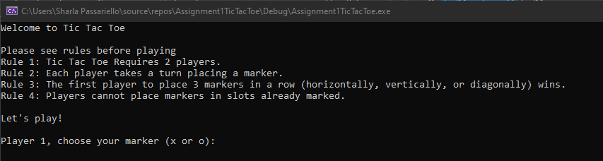

Test Case 4: When choosing a marker player cannot enter character that is not ‘x’ or ‘o’.
Expectation: The expectation is that this will currently break as no rule has been put in place yet to prevent this issue.
Result: Working as expected but code needs to be improved to not allow this.
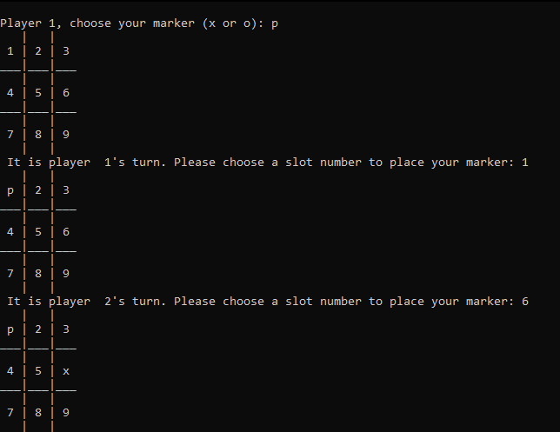

Test Case 5: Each player’s selected marker is placed in the chosen slot number.
Expectation: When marker has been chosen by Player 1, and they place it in a slot number. The correct marker is placed in the correct slot number. Player 2 is then given the other marker and the relevant marker is placed in the correct slot.
Result: Working as expected.
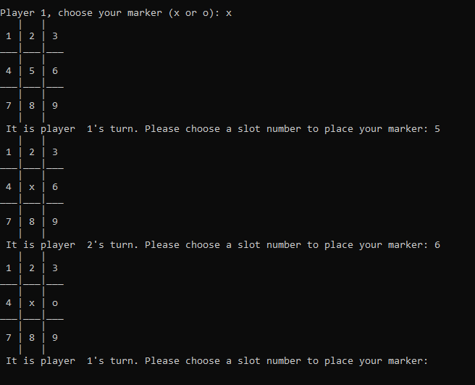
Test Case 6: Players cannot enter a number lower than one or higher than nine when placing a marker.
Expectation: Player’s will be asked to re-enter a number that is valid.
Result: Working as expected.
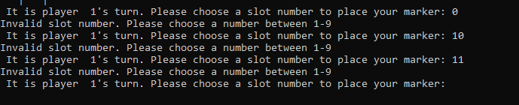

Test Case 7: Players cannot enter a non-numeric character when placing a marker.
Expectation: The expectation is that this will currently break as no rule has been put in place yet to prevent this issue.
Result: Working as expected but code needs to be improved to not allow this.
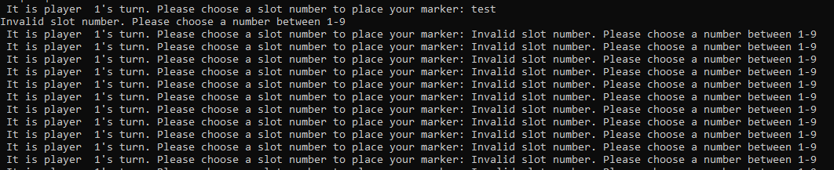

Test Case 8: When valid marker is placed, the gameboard is drawn again with marker replacing slot number.
Expectation: The gameboard is drawn again with correct marker in selected slot.
Result: Working as expected
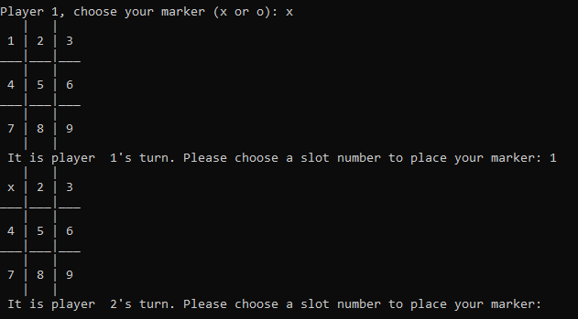
Test Case 9: Players win the game when three markers are aligned horizontally.
Expectation: When three of the same markers are placed aligned horizontally, the player is informed that they have won.
Result: Working as expected. 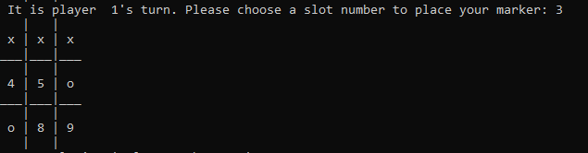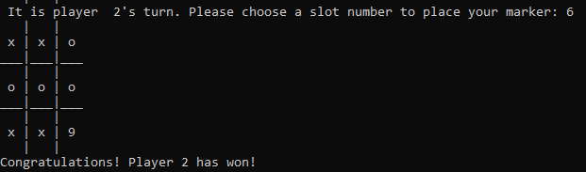
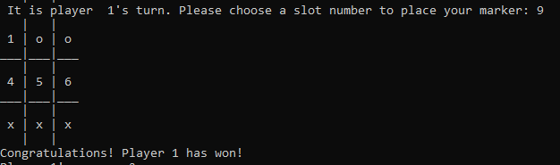

Test Case 10: Players win the game when three markers are aligned vertically.
Expectation: When three of the same markers are aligned vertically, the player is informed that they have won.
Result: Working as expected.
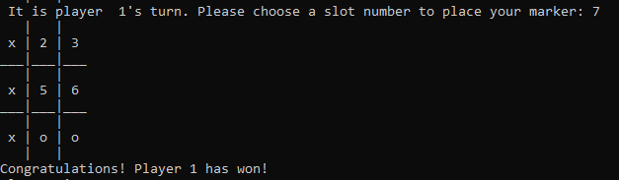
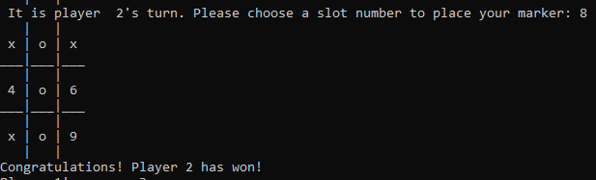
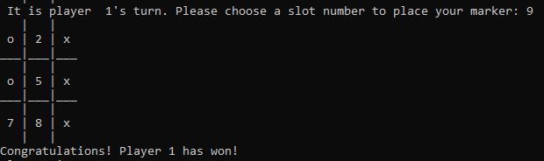

Test Case 11: Players win the game when three markers are aligned diagonally.
Expectation: When three of the same markers are aligned diagonally, the player is informed that they have won.
Result: Working as expected.
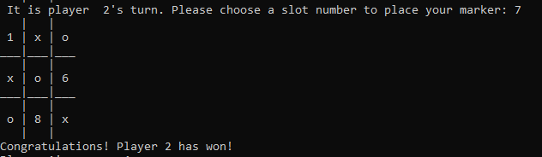
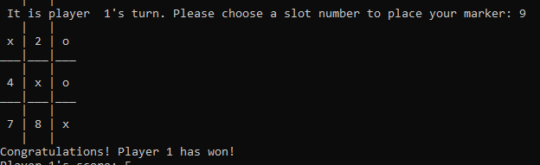

Test Case 12: Score is shown and displayed correctly for players when games are won.
Expectation: When a player wins their score increments by one and the scoreboard is displayed at the end of each game
Result: Working as expected.
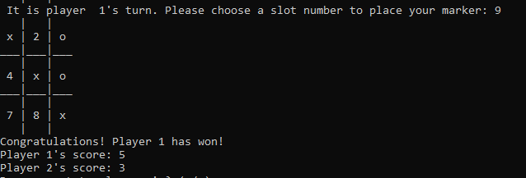

Test Case 13: When game between players ends in a draw, score displays appropriately.
Expectation: When a game results in a draw, the score does not increment for any player.
Result: Working as expected.
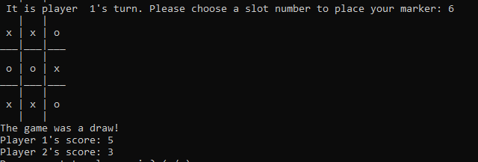

Test Case 14: At the end game, replay option is presented.
Expectation: Players have the option to replay the game by selecting ‘y,’ or not by selecting ‘n’.
Result: Working as expected.
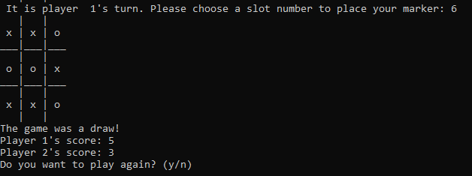

Test Case 15: If players select ‘y’ to replay, a new game begins.
Expectation: A new games begins with a clear board and the scoreboard does not reset.
Result: Working as expected.
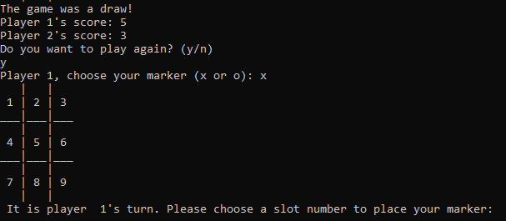

Test Case 16: If players select ‘n’ to end game, an End of Game Menu appears.
Expectation: End of Game Menu is displayed.
Result: Working as expected.
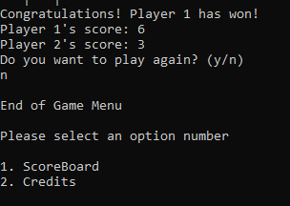

Test Case 17: Players can only enter ‘y’ or ‘n’ to replay a game.
Expectation: The expectation is that this will currently break as no rule has been put in place yet to prevent this issue.
Result: Working as expected but code needs to be improved to not allow this.
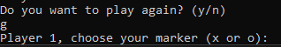

Test Case 18: When selecting ‘1’ on the End of Game Menu Scoreboard is displayed for players.
Expectation: Scoreboard is displayed and displays the correct score.
Result: Test Case failed. The End of Game Menu scoreboard is showing the latest winner as the overall winner of 1-0. This code needs to be improved to fix this defect.
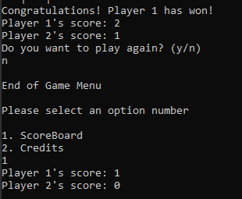

Test Case 19: When selecting ‘2’ On the End of Game Menu, the credits are displayed.
Expectation: ‘Created by Sharla Passariello’ is displayed.
Result: Working as expected.
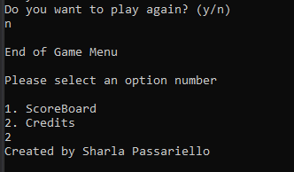

In conclusion of testing, there are three areas where known improvements need to be made prior to testing, and one area where a defect needs to be fixed. The majority of the code is working as expected and the game is in a playable state.

Video Demo
The following link will provide a video demo of Tic Tac Toe:
https://screenrec.com/share/sAimOxPCrS

References
[1] A. Gillis, "What is Object-Oriented Programming (OOP)?", SearchAppArchitecture, 2021. [Online]. Available: https://searchapparchitecture.techtarget.com/definition/object-oriented-programming-OOP. [Accessed: 01- Dec- 2021].
[2] B. Cyganek, Introduction to Programming with C++ for Engineers. Newark: John Wiley & Sons, Incorporated, 2021, pp. 227-244.
[3] "Stack vs Heap Memory Allocation - GeeksforGeeks", GeeksforGeeks, 2021. [Online]. Available: https://www.geeksforgeeks.org/stack-vs-heap-memory-allocation/. [Accessed: 26- Nov- 2021].
[4] R. Vats, "Polymorphism In OOPS: What is Polymorphism [Detailed Explanation] | upGrad blog", upGrad blog, 2021. [Online]. Available: https://www.upgrad.com/blog/polymorphism-in-oops/. [Accessed: 01- Dec- 2021].
[5] S. Sharma, "Basic Concepts of Object Oriented Programming using C++", Tutorialspoint.com, 2021. [Online]. Available: https://www.tutorialspoint.com/basic-concepts-of-object-oriented-programming-using-cplusplus. [Accessed: 01- Dec- 2021].
[6] "Advantages and Disadvantages of Object-Oriented Programming (OOP)", The Saylor Foundation, 2021. [Online]. Available: https://resources.saylor.org/wwwresources/archived/site/wp-content/uploads/2013/02/CS101-2.1.2-AdvantagesDisadvantagesOfOOP-FINAL.pdf. [Accessed: 05- Dec- 2021].
[7] "Why Is C++ the Most Popular Coding Option? - TechRound", TechRound, 2021. [Online]. Available: https://techround.co.uk/tech/c-most-popular-coding-option-game-developers/. [Accessed: 05- Dec- 2021].
[8] B. Hernandez, "10 Applications of Object Oriented Programming", Quickstart.com, 2021. [Online]. Available: https://www.quickstart.com/blog/10-applications-of-object-oriented-programming/. [Accessed: 05- Dec- 2021].

Reference for Gameboard
[9] “C++ Tic Tac Toe Game project", STechies, 2021. [Online]. Available: https://www.stechies.com/tic-tac-toe-cpp/. [Accessed: 27- Nov- 2021].

