MODULE CODE: BMSK4003
DIGITAL SKILLS AND RESEARCH METHODS
Lecturer: Balendran Kandasamy
Student name: Ioan-Alexandru Sumanaru
Student number: 1713838

Modern skills and technologies

Table of Contents

Introduction 1
Digital Skills: Definition and Types 2
Effectiveness of Modern Technology in Workplace 3
Use of Social Media in Workplace 5
Creating Own Professional Presence through Digital Marketing 7
Conclusion 9
References 10

Introduction
There is no alternative to having sufficient digital skills in order for performing to the expectation of the employers and thus ensuring professional career development. Digital skills can be referred to as the extent to which individuals can understand and use information in multiple formats presented via computers from a wide range of sources (Zuboff, 2012). With the passage of businesses continuously becoming digitized, each and every employee, irrespective of their position and role within the workplace, must have some basic digital skills. This paper focuses on the significance of digital skills within the workplace from the perspective of both employees and organisation. The paper incorporates definitions for digital skills and briefly discusses the types of most essential digital skills. The effectiveness of modern technology in the workplaces to what changes they can bring within the workplace is later discussed in the paper. The final part of the paper focuses on the use of social media for marketing, information
gathering and communication within the workplace.

Digital Skills: Definition and Types
With the passage of accelerated advancement in the field of science and technology, every sphere of our lives is now closely associated with and largely dependent on digital technology. This is more relatable for the business sector in today’s world. Now, individuals working in any business organisation, not just IT must have some basic knowledge about the use of and continuous changes in digital technology. This navigates our focus to the significance of digital skills for professional career development through superior workplace performance. The House of Lords have recently made a proposition that digital skills be taught as the third core subject after numeracy and literacy and be treated with the same importance (Tuten, 2018). As per the definition of the term ‘digital skills’, academics and industry commentators provide definitions of diverse nature. Wallace (2012) defined digital skills as the ability and effectiveness of individuals in finding, evaluating, sharing, utilising and creating contents through the use of information technology and the internet. Zuboff (2012), in similar definition, referred to as the extent to which individuals can understand and use information in multiple formats presented via computers from a wide range of sources. Although these definitions can help one understand the theoretical aspects of digital skills, a broader understanding of the types of digital skills required within the modern workplace is required for better understanding of the term (Tapscott, 2009). Although it is somewhat impossible to list all the types of digital skills, the ones which are essential for performing to the expectation of the employers are briefly discussed in the table below.
Table 1: Types of Digital Skills
Document Creation, Collaboration, and Management | Employers require that employees working for them should be able to create, collaborate and manage documents on digital platforms in a digitized workplace. Absence of these skills can lead to inefficient time management, ineffective communication and analytical errors which, in turn, can negatively impact individual and business performance (Tuten, 2018).
Project Collaboration and Management | Using the project management software tools such as Asana, Trello and navigating digitized workflow system, an employee is expected to be able to start, operate and finish projects with their team members, be it in the cubicle or across the world (Swanson, 2014).
Communication | Irrespective of the individual role within the organisation, digital communication is a must have skill for almost every employee as more than one-fourth of the workers’ time is spent in reading and replying to emails (Wallace, 2012). With efficiency in this area, one could free up valuable time which can be utilised in other functions.
Digital Etiquette | Netiquette or digital etiquette refers to the ‘dos’ and ‘don’ts’ of digital communication which is expected from every worker by the employers (Tapscott, 2009). Apart from gaining the basics of smart social presence, employees are expected to maximise brand messaging and not jeopardise company reputation.
Search and Research | One of the main keys to business applications is the ability to search and research the vast digital archives (Zuboff, 2012). One of the important skills, in this regard, is to find the required information quickly and be able to differentiate facts from fantasies.
Security and Privacy | One of the major concerns for today’s digitized organisations is data and security breaches mainly because of human error. Employees, hence, should have proper knowledge of digital security and privacy as well as businesses’ specific safeguards practices (Mahoney and Tang, 2012).

Effectiveness of Modern Technology in Workplace
Technologies are always in the path of evolution with leading to newer programs and software to resolves problems which the businesses are not yet aware of. With such drastic changes and advancements in the field of information and communication technology, many business leaders find it suitable to continue with the existing technology rather than rocking the boat by adopting newer unstable ones (Tuten, 2018). However, status quo is a major threat to innovation which can cause stagnant companies to fail. Through investment in cutting-edge technology, businesses are actually investing in business growth by empowering employees in a fast paced world. The discussions below point out the effectiveness of modern technology in the workplaces to what changes they can bring within the workplace.
Speed, Efficiency, and Agility:
One of the key goals for any office technology nowadays is to boost up the working speed of individuals and enhancing their efficiency thus saving up valuable time which can be spent on other important tasks (Tapscott, 2009). With the use of cutting-edge technologies, businesses are also able to respond to data and adapt to changes quickly as well as make informed decision.
Storage and Sharing:
According to a recent study, more than 20% of the workweek is spent in searching documents and information for organisation which are yet to be digitized (Zuboff, 2012). However, technology has provided business organisations with options to streamline information storage and sharing which can ensure security of data apart from saving valuable amount of time thus accelerating business operations.
Supports Innovation:
Technology is one of the best supporting tools for innovation in digitized organisations. Through the use of technology, businesses can create and suggest newer ideas thus transforming the business (Swanson, 2014). By searching and researching the internet and with the assistance of supporting modern technologies, employees can develop and find out newer ways to gain advantages over the competitors (Wallace, 2012). There can be found evidences of many business organisations creating technological challenges and rewarding employees for coming up with innovative ideas.
Human Resource Management:
The way human resource managers perform their job has drastically transformed with the inclusion of modern technology in the function. For instance, HR managers have improved the process of screening, recruiting and hiring new employees through digitizing the processes (Wallace, 2012). Job openings are now advertised through internet which targeted candidates can view easily and also submit their applications for the positions by submitting their resumes and filling up online forms. Apart from recruitment and selection, HR managers also use technology for tracking employee performance and productivity. The employees being aware of the fact that their performance and productivity are being monitored continuously, individual and organisational performance is sure to improve (Tuten, 2018).
Accelerated Communication:
Use of modern technology has resulted in accelerated communication for business organisations. Instead of paper mail and faxes, businesses can communicate with the employees, suppliers, customers and other partners through the use of email (Wallace, 2012). This has facilitated quick and efficient communication. In addition, there is less chance for error with technology based communication.
Facilitates Mobility:
Business organisations have become successful to overcome space and time boundaries through the inclusion of modern technology within the workplace (Swanson, 2014). Employees can now do their job from any place in the world thus having a better control over their job. Using virtual meeting applications, businesses can now arrange for meetings amongst individuals from different geographical locations without actually being physically present thus facilitating mobility of the next level (Zuboff, 2012). In addition, business can make real time data sharing thus reducing the time and space barrier to large extents through the use of modern technology.

Use of Social Media in Workplace
According to a recent study, more than 90% of the marketers were in agreement that social media has facilitated immense exposure for their business which is just one of many uses of social media in the marketing of businesses (Swanson, 2014). Social media marketing is now regarded as one of the ‘must haves’ in the marketing campaigns and strategies of any business organisation. The discussions below focus on the use of social media for marketing, information
gathering and communication within the workplace.
Increased Brand Awareness:
There is no better and more efficient tool than social media marketing for increasing brand awareness. Through social media, businesses can engage with a broad audience of consumer thus increasing business visibility (Neale and Mannix, 2014). Businesses need to create social media profile in the first place and then get the employees and partners like and share the page, profiles or contents to maximize audience reach.
Improved Search Engine Ranking:
Although there is no alternative to search engine optimization for improving search engine rankings, social media can play a vital role in this regard. According to a recent survey, more than 55% of the marketers who have used social media marketing for more than one year have experienced improved search engine rankings for their online business presence (Tapscott, 2009).
Increased Inbound Traffic:
Without social media marketing, businesses have little chance to reach anyone outside their loyal customer circle. Every social media profile and each of the contents is a gateway to be connected with newer customers (Mahoney and Tang, 2012). As individuals from different socioeconomic, demographic and cultural backgrounds have presence on social media, businesses can have access to all the market segments through social media marketing (Wallace, 2012). In addition, businesses can undertake customized marketing campaigns for specific market segments.
Market Research:
With the passage of time, more and more people from different backgrounds and preferences are coming under the umbrella of social media thus making it a great tool for market research. By researching the activities of the individuals, businesses can identify the preferences and interest of customers (Neale and Mannix, 2014). They can also assess what type of products and services appeal which customer groups through social media. According to a recent study, more than 80% marketers use social media for researching differentiated needs and preferences of different customer segments which, in turn, can be used for formulating differentiated marketing campaigns for the different segments (Tuten, 2018).
Communication:
Marketers use social media as a great tool for communicating with their existing and potential customers. Through their social media profiles, marketers engage with the customers and ask them to convey their suggestions, opinions or complain through social media profiles (Tapscott, 2009). In this way, businesses can come in a close contact with their customers and have insight of the areas which require changes or improvements.

Creating Own Professional Presence through Digital Marketing
The increasing online presence of people of different demographics throughout the world urges businesses to have their own professional presence in order for primarily marketing their brands and products and keeping close connection with the customers. The discussions below focus on how businesses can create and benefit from professional online presence.
Fit Kitchen is a food and drinks company in London, UK which has been quite successful in attaining their objective of customer attraction through digital marketing. Their key social media profiles which have contributed the most in attracting customers are Facebook and LinkedIn. They have developed a Facebook page for their business through which they market their products as well as facilitate for customer enquiries, complaints and suggestions. The figures below illustrate the Fit Kitchen’s online presence through Facebook.


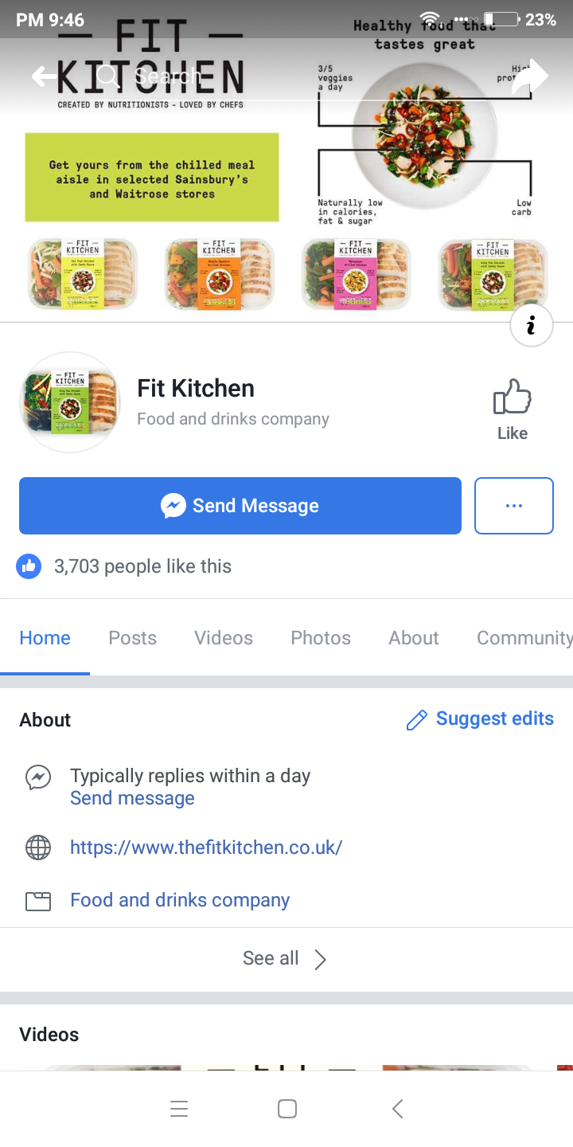
Figure 1: Fit Kitchen's Marketing through Facebook Page
(Source: www.facebook.com/fitkitchenuk)

Apart from their Facebook page, Fit Kitchen also has their active presence in LinkedIn. Alongside attracting customers and promoting brand, their presence through LinkedIn is also useful in recruiting employees for the business. The figure below illustrates their LinkedIn presence.
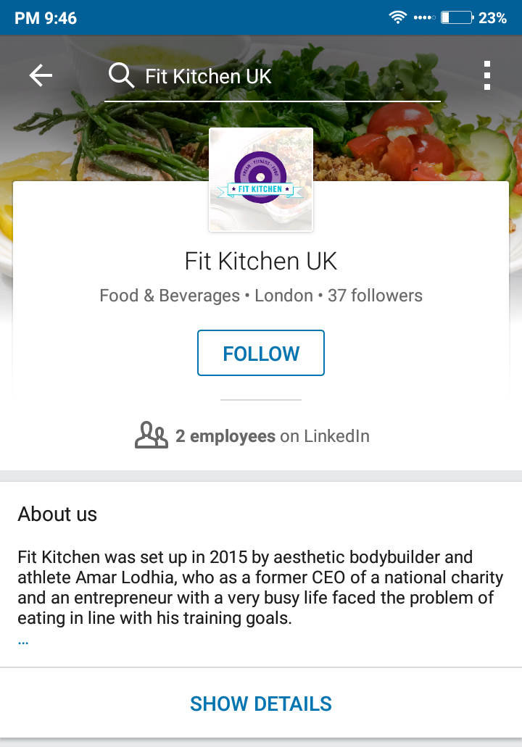
Figure 2: LinkedIn Profile of Fit Kitchen
(Source: www.linkedin.com/fitkitchenuk)
These social media profiles of Fit Kitchen UK account for a major portion of the company’s new customer acquisition. Having seen the benefits of online presence, they are now focused on creating profiles on other digital media.

Conclusion
In order for ensuring professional career development, there is hardly any alternative to acquiring digital skills as they are now part of almost every job in any organisation. Apart from acquiring digital skills, employees as well as employers should have proper knowledge about the use of modern technologies in different areas of the organisation. The role that social media can play in marketing of businesses must not be overlooked by businesses.

References
Mahoney, L. and Tang, T. (2012). Strategic social media.
Neale, M. and Mannix, E. (2014). Technology. Bingley, U.K: Emerald.
Swanson, R. (2014). Analysis for improving performance. San Francisco: Berrett-Koehler Publishers.
Tapscott, D. (2009). Grown up digital. New York: McGraw-Hill.
TUTEN, T. (2018). SOCIAL MEDIA MARKETING. [S.l.]: SAGE PUBLICATIONS.
Wallace, P. (2012). The Internet in the workplace. Cambridge: Cambridge University Press.
Zuboff, S. (2012). In the age of the smart machine. Basic Books.

