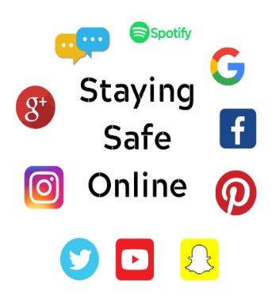  E-safety is all about risks, and being made aware of possible threats that online activity can bring and how to deal with them.  11.  Online bullying or cyber-bullying can be identified as using technology including phones, social networking sites, games consoles to harass, threaten or intimidate others. While grooming, predation and similar activities can often be the most concern for parents, it’s an alarming fact that bullying is one of the most common issues young people will face online. |  |   E-safety Statistics  - Teachers report that cyberbullying is their number 1 safety concern in the classroom.  - Nearly half of young people (47%) have received intermediating, threatening or nasty message’s online.  - There is a connection between intensive social media use and mental-ill health.  - Underage (U13) use of social media is common place. |  |     Keeping our children safe online is everybody’s responsibility.  UNCRC, Article 19: “You have the right to be protected from abuse”.
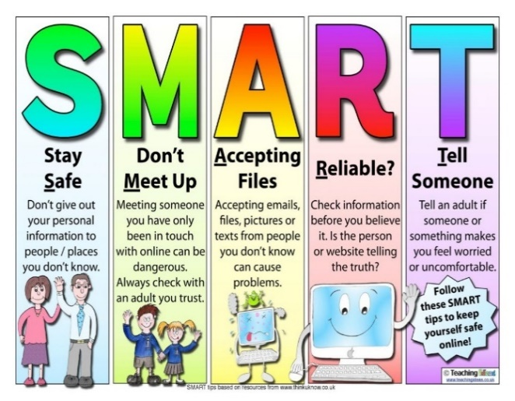  The internet is a great information tool, and can be a place where children learn, but we must always remember that when children are online, they are in public!  (Mark Kennedy) |  | 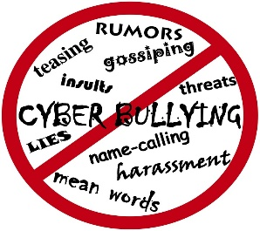  Talking to children about online safety  As a parent talking to our children about the dangers of the internet, is making them feel they can talk to you if anything is worrying them. Talking to them about their online activity in the same way you would do about anything else will help them to relax and open up to you, if they have any worries or concerns. (For more help and information on this see web links below.)  E-safety quick tips!  - Set up your child’s internet for safe use and set parental controls.  - Be informed up-to date and alert.  - Learn about social networks.  - Trust, invest time, monitor and educate. |  |     For help and guidance on helping your children understand internet safety visit the following links:-  https://swgfl.org.uk/online-safety/keeping-children-safe-online  https://www.nspcc.org.uk/keeping-children-safe/onlin e-safety  “Treat your password like a toothbrush. Don’t let anybody else use it and get a new one every six months.”  Clifford Stoll  always Think of it this way!
2.
Reference list:
All Author, 2021, Available at: https://allauthor.com Accessed on: (21/3/21).
Child safety online: A Practical guide for parents and carers whose children are using social media, 2021, Available at: https://www.gov.uk/government/publications/child-safety-online-a-practical-guide-for-parents-and-carers/child-safety-online-a-practical-guide-for-parents-and-carers-whose-children-are-using-social-media Accessed on: (21/3/21).
Clipart key, 2019, Available at: https://www.clipartkey.com Accessed on: (20/3/21).
E-Safety Facts – Staying Safe Online, SWGFL, 2021, Available at: https://swgfl.org.uk/online-safety/e-safety-facts Accessed on: (20/3/21).
Internet Safety 101, 2006, Available at: https://internetsafety101.org/cyberbullyingstatistics Accessed on: (19/3/21).
NSPCC, 2021, Available at: https://www.nspcc.org.uk/keeping-children-safe/online-safety Accessed on: (20/3/21).
Online Safety Action Plan for Children and Young People in Wales, 2020, Available at: https://hwb.gov.wales/zones/keeping-safe-online/online-safety-action-plan-for-children-and-young-people-in-wales Accessed on: (21/3/2021).
Munro, E, (2002), Effective Child Protection. London:Sage
Sechler, J, (2012) Internet Safety for Kids and Young Adults, Create Space: US Publications.
Teaching Ideas, 2020, Available at: https://www.teachingideas.co.uk/the-internet/smart-esafety Accessed on: (21/3/21).
United Nations, (1989) The Convention on the Rights of the Child. Geneva: Defence International and the United Nations Children's Fund.
3.3.
SJIE5006 Keeping our Children Safe
This rationale will be discussing and analysing child protection, safeguarding and promoting the welfare of children and young people. Demonstrating a critical understanding of policies, procedures, practice and current and future developments in child protection. This rationale will discuss the changes within policies and procedures over the years and the factors that have contributed to the changes within them. The rationale will reflect on the information outlined in the leaflet, discussing E-safety and how to promote safe use online, supporting both children, young people and information for parents. With the use of the internet and digital technology constantly evolving and becoming an integral part of everyday life for children and young people, so does the opportunity for miss use and the potential risk of harm to its users. Striving to make the internet a safe place for all is of critical importance to keeping safe, whilst still providing opportunities to socialise, communicate, be entertained, learn and find support (Gov.uk, 2020).
Safeguarding and promoting the welfare of children is the responsibility of all. Children and young people thrive in environments where they feel safe and secure, their feeling of security is enhanced when they experience positive relationships with those who care for them. Children are vulnerable in their own right due to their age and their ability to provide for themselves. Children are reliant on others (usually adults) to ensure that their needs are met. Vulnerability in children increases for those who have extra needs because of a disability or chronic illness, developmental delay or a behavioural/emotional problem (Morris, 1999). Safeguarding is a concept relating to ensuring children are not abused or subject to harm. The All Wales Safeguarding Procedures (2019) sets out guidance for those involved in the responsibilities in safeguarding children and adults. These procedures aim to support anyone who works with children and adults on what steps need to be taken in order to keep people safe. The All Wales Safeguarding Procedures (2019) are an amendment of The All Wales Child Protection Procedures (2008) following the implementation of the Social Services and Wellbeing Act (Wales) 2014. Together it is the aim that clearer guidance is provided in relation to peoples safeguarding responsibilities where children and adults are at risk or in need of support.
4.
The Every Child Matters strategy ‘be safe’ focuses on ensuring children are kept safe from harm. However, safeguarding is a broader concept than child protection as it encompasses safety from other forms of harm. The All Wales Safeguarding Procedures are slightly broader in that child abuse becomes the responsibility of all practitioners and professionals working with children. Previously responsibility has been placed on children’s social care services in order to ensure children are appropriately safeguarded. The Children act 2004 places a statutory duty on agencies and individuals to ensure that children are safeguarded and that steps are taken to support their welfare, (Kay, 2008). Safeguarding can be defined as “keeping children safe from harm, such as illness, abuse or injury’. (Children’s Rights, 2004). The concepts of child protection and safe guarding are closely related however child protection involves a range of activities that take place when child abuse or neglect is suspected or identified. However safe guarding is broader and promotes the prevention of harm to children and young people, and professionals should take steps to prevent harm to all children, (Kay, 2003). Working Together to Safeguard Children (2006) states that, “protecting children from maltreatment, preventing impairment of children’s health or development to ensuring children are growing up in circumstances consistent with the provision of safe and effective care and undertaking that role so as to enable those children to have optimum life chances and to enter adulthood successfully” (Gov.uk, 2006,34-36). One of the key recommendations within this document is the need for effective inter- agencies working together in order to assess the risk of harm and to put into place resources to support. (Barlow & Scott, 2010). This is re-enforced by the Munro report (2011) which is critical of multi-agencies in their response to high profile cases and argues where there needs to be clearer government guidance and better communication between agencies; deaths could potentially have been avoided.
It is important to be aware that there are multiple types of abuse currently defined within four categories: physical, sexual, and emotional and neglect. These categories are useful for analysis, however they do not reflect the real lives of children who may experience a range of different abuses over time and professionals should not be fixated upon them. These definitions of abuse need to be considered within the context of the child’s age and development, and abuse can be highlighted in a range of ways. The earlier a child experiences maltreatment the worse the outcome is likely to be on their development and into adulthood. Beckett, (2010) suggests that the harm caused as a result of ongoing abuse can have a negative impact on the individual’s view of the world. This view becomes part of the working model and influences how children position themselves within it, as described by theorist Bowlby, (1980). Arguably, this view suggests that people who experience abuse are less likely to live fulfilled lives. Therefore there is an increased need for preventative services, to reduce the likelihood of children and adults experiencing abuse over time.
5.
The maltreatment of children constitutes a complex interplay between the child, his/her family, the community and society. Bronfenbrenner’s (1979) ecological perspective provides a perspective on how the different aspects of the child and their context relate to one another. For example, Individual characteristics such as the child’s personality and physical health will link with their experience of parenting and family dynamic. The family structure is influenced by social and environmental factors that either support or increase stress. The cultural context describes the beliefs, values and societal rules that influence the way in which families and communities relate to one another, (Bronfenbrenner, 1979). When a child experiences abuse, it is important to consider cultural and environmental factors which may have lead up to the abuse. Research by Sidebotham et al (2006) identifies socio-economic deprivation and parental background, including poor mental health as key indicators for child maltreatment. The impact of deprivation indicates gaps in social support, availability of child care and poverty. This can relate to Maslow’s (1943) hierarchy of needs theory, which states if these basic needs such as food, clothes, shelter are not met then the higher level of needs the esteem needs and self – including love, friendships, self-respect and belonging cannot be met, and the child will not be fulfilled. When these needs are not met, children and young people are likely to experience abuse of some kind (Asmussen, 2010). The research from (Bolger & Patterson, 2003) suggests that although many experience adverse experiences in adulthood following early year’s abuse, some children appear to have a resilience that protects them from the long term impact of abuse.
Current policies emphasise the importance of safeguarding, an emphasis on multi- agency and multi-disciplinary working together is a key aspect of safeguarding. Recent policy and practice is strongly influenced by failings of agencies and professionals to work together effectively to protect children and young people. Documented in a long series of child death inquiry reports over more than 30 years which highlight this failure, summarised in the Laming Report (2003) into Victoria Climbie’s death in 2000. Serious case reviews criticise agencies multi agency working, and highlighting a need for better preventative resources. The Every Child Matters (DfES, 2003) and the Children’s Act 2004 provided the framework for developing more accessible services that would focus on the needs of children and young people, (Palaiologou, 2013). Current policies now reflect clearer structures and strategies to support the existing multi-agency approaches to safeguarding, (Iwaniec, 1995). Despite these policy developments, child protection is one of the key roles of any person working with children whatever their professional status, discipline or job. As stated in School A safeguarding policy, “As a school we fully recognise the contribution it makes to safeguarding, with a view to safeguarding and promoting the welfare of children whilst creating and maintaining a safe learning environment. There are three main elements to our policy: prevention through the teaching and pastoral support offered to pupils, procedures for identifying and reporting alleged abuse, as school staff are well placed to observe signs of abuse. Support to pupils who may have been abused”. Promoting the rights of the child through good practice, positive relationships with other professionals, and strategies to support the child and family is part of the development of a safeguarding setting. Keeping the child and his/ her needs at the centre of safeguarding strategies and practice at all times, ensures that good practice is developed and the child is safeguarded in the setting as well as within the family situation, (Beckett, 2007).
6.
The leaflet designed focuses on e-safety and providing information on how to talk and guide children through practising safe internet use, and the measures to take to ensure they are kept safe online. With the use of internet and digital technology evolving it has become an integral part of everyday life for children and young people. As the internet and its usage changes and develops so does the opportunity for misuse and the potential risk of harm to its users, (Hwb, 2020). The UNCRC (1989) Article 13 states that, “Every child must be free to express their thoughts and opinions and to access all kinds of information”, although this is a Childs rights it must be done in a way that does not affect or cause distress to another person .As quoted in the office for national statistics, (2020), “Around one in five children aged 10 – 15 years, experienced at least one type of online bullying behaviour”. With the internet and social media being used on a daily basis so comes with it the opportunity of cyber bullying. The long term effects this cyber bullying can have on children and young people can include psychological, emotional and physical stress. By parents, carers and teachers supporting, educating and showing good practice of how the internet should be used in the correct, responsible manner will teach our children to have a pro-active approach to online behaviour, (Munro, 2002). Arguably there has been a lack of policy in relation to internet safety and it is the responsibility of individual agencies to ensure that they are safeguarding against online abuse. Professor Donaldson implemented a new curriculum approach where technological competence is a key objective within curriculum for Wales 2022. It aims to support learners to become competent and confident in the safe and responsible use of the internet while supporting them in their learning journey, with the outcome to give them the skills they can use, need and facilitate as the internet and technology becomes more embedded into daily routines and lives, (Donaldson. 2015). With this new curriculum embed, professor Donaldson vision of making the principles of the UNRC children’s right to be safe, will have a positive impact and contribution towards making these articles a reality.
7.
To conclude, this rationale has highlighted the importance of policy and procedure in ensuring that everyone is aware of their responsibility in safeguarding children. The All Wales Safeguarding Procedures (2019) have evolved and developed as a result of changes in legislation. The procedures promote better multi-agency collaboration as a result of serious case reviews including the Lamming report and the Munro (2011) review of child protection procedures. Together they identify gaps to service provision which has now been included within up to date policy and procedure. Preventative services have become essential in implementing early support to reduce adverse childhood experiences occurring and resulting in unmet needs. Professionals have a duty to communicate safeguarding concerns and areas of needs to reduce the risk of abuse. Internet safety is an ever more likely area where children and young people experience abuse. Therefore individual agencies must ensure that there is an equal response to online bullying or abuse. Cyberbullying is increasingly more common in schools as a result of social media, and the leaflet attached outlines ways in which teachers and parents can promote online safety.
8.
Reference list:
Allen, S, Gordon, P, (2011), How Children Learn 4 Thinking on Special Educational Needs and Inclusion. 1st Ed, Practical Pre-School books.
Asmussen, k (2010), Key Facts about Child Maltreatment, London: NSPCC.
Barlow, J and Scott, J. (2010), Research in Practice: Safeguarding in the 21st century: where to Now? Sheffield: Darlington Press, University of Sheffield.
Beckett, C (2007), Child Protection – An Introduction. London: Sage.
Beckett, C (2010), Child Protection: An Introduction, 2nd Ed, London: Sage.
Bowlby, J (1980), Volume 1: Attachment and Loss Attachment, London: Pimilico.
Bolger, K and Patterson, C. (2003) Sequelae of Child Maltreatment: Vulnerability and Resilience, New York: Columbia University.
Bronfenbrenner, U, (1979), The Ecology Of Human Development. Cambridge, Harvard: University Press.
Donaldson, G, (2015), Successful futures looking at the curriculum and assessments arrangements in Wales, Available at: https://gov.wales/sites/default/files/publications/2018-03/succesful-futures-a-summary-of-professor-graham-donaldsons-report.pdf Accessed on: (15/3/21).
Every Child Matters, (2004), Available at: www.everychildmatters.gov.uk/socialcare/safeguarding Accessed on: (19/3/21).
Iwaniec, D, (1995), The Emotionally abused and neglected Child, Chichester: Wiley.
9.
Kay, J. (2003), Protecting Children,2nd Ed, London: Continuum.
Macleod – Brudenell, I, Kay, J, (2008), Advanced Early Years for Foundation Degrees, Levels 4/5, 2nd ed. Essex, Pearson Education Limited.
Maslow Hierarchy of Needs, (2020) Available at: https://www.thenational.com.pg/maslow-and-self-actualisation Accessed on: (23/3/21)
Munro, E, (2002), Effective Child Protection, London: Sage.
Munro, E, (2011) Munro review of child protection: final systems report. The Department for Education.
Morris, J. (1999), Disabled Children, Child Protection Systems and the Children Act 1989, Child abuse review.
OFNS, Office for National Statistics, (2020), Online Bullying in England and Wales, Available at: https://www.ons.gov.uk/peoplepopulationandcommunity/crimeandjustice/bulletins/onlinebullyinginenglandandwales/yearendingmarch2020 Accessed on: (25/3/21).
Palaiologou, I, (2013), The Early Years Foundation Stage Theory and Practice, 2nd Ed, London, SAGE publications Ltd.
School A, (2020). Safeguarding Policy.
The All wales safeguarding procedures, (2019), Available at: https://gov.wales/safeguarding-guidance Accessed on: (27/3/21).
Walker, G. (2008), Working Together for Children: A critical Introduction to Multi-Agency Working. London: Continuum.
United Nations, (1989) The Convention on the Rights of the Child. Geneva: Defence International and the United Nations Children's Fund.
10.

