Marketing Essentials

MODULE CODE: M4X01916
Lecture name: Dale Clarke
Name of student: Penka Ilieva
Student number: 1816778

Assignment brief:
Analyse the importance of marketing information system, its effectiveness within the hospitality and tourism industry as a tool for marketing, information gathering and communication

Contents:
1.Introduction………………………………………………...............2
2.Definition of MIS and its components…………….……....3
2.1. Internal Records……………………………………………….….3
2.2. Marketing Intelligence…………………………………………3
2.3. Marketing Research…………………………………………….4
- Definition of Marketing research …………………....4
- Types of Marketing Research……………………….....5
- Process of Marketing Research………………….…....5
2.4. Marketing Decision Support System…………………...6
3.Efectivness of MIS for the company...........................6
4.Conclusion..................................................................7
5.References………………………………………………………………8

- Introduction:
In this assignment today I will analyse one important marketing tool which is called Marketing Information System (MIS).
MIS is organized system of regular procedures and methods for the correct collecting, storage, processing and transmission of the internal of the company and their proper distribution.
Marketing information system is a “system in which marketing data is formally gathered, stored, analysed and distributed to managers in accordance with their informational needs on a regular basis” Kotler and Keller, 2006 (Academeresearchjournals.org.,2019).
The company I will go through is Holiday Inn, business in the sphere of hospitality, leisure and travel. The MIS for her is indispensable and vital resource for its business legal activity.
2.Definition of MIS and Its components:
As I mention above Marketing Information System is procedures and methods of status and trends in the development of the marketing environment. It’s an element of the strategic and marketing planning.
The structure of MIS includes 4 main subsystems:
2.1. Internal Records - analyses the internal accounting indicators of the company. Determines the strengths, weaknesses and threats of the company and identifies opportunities in the market. The internal information must be derived from marketing goals and be useful for achieving them, categorized, sorted, summarized and stored and available for management purposes.
“These records provide current information about sales, costs, inventories, cash flows and account receivable and payable. Many companies maintain their computerized internal records. “(Akrani,2013)
2.2. Marketing Intelligence- its purpose is to increase the effectiveness for particular marketing strategy. Provide analysed information to the management team about the events on the market. It is a means of early warning and performing ongoing early evaluations, applicable in a multitude of directions and looking beyond the boundaries of the corporation.
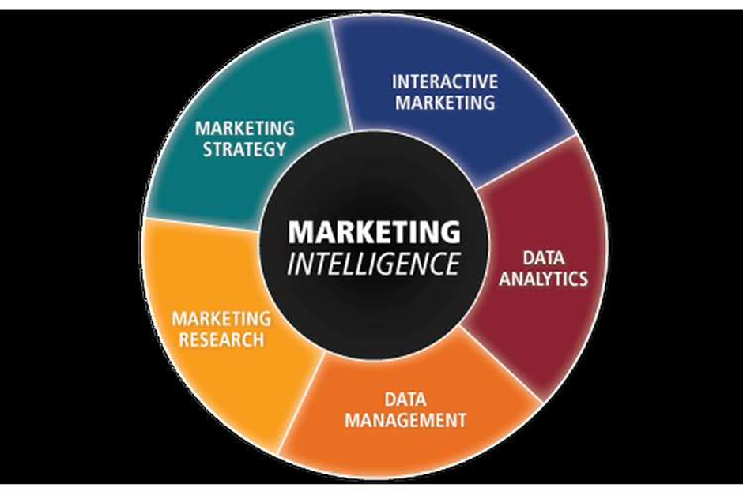Figure 1: Marketing Intelligence (Locusassingments.com,2019)
2.3. Marketing research
Definition: It’s a system for collecting, stored and representation of data, oriented to different possible but not existing situations so far for the resolving of a marketing problem and developing new perspectives.
Its purpose is to support the process of making adequate marketing decisions to the management team.
“MR is conducted to solve specific marketing problems of the company. This data is tabulated, analysed and conclusions are drawn. Then the recommendations are given for solving the problem. It can be used only for a particular purpose. MIS and MR are not substituting of each other. The scope of MIS, includes ‘MR’.” (Akrani,2013)

Types of Marketing Research
Exploratory -used when there’s is not enough information about the problem | Descriptive -measurement research of marketing phenomena
Causal- research to investigate the effects of changes in marketing phenomena | Predictive- a research to predict the success of a given marketing phenomenon

Process of Marketing Research:
The first step of Marketing research process Is to find the problem and define the marketing objectives.
It’s very important to hire professional investigators to do the correct marketing research and to avoid negative phenomena. The investigators will need relevant information about the company’s product and market. They must define which type of marketing research need to use, determine the objectives, the reasons the problem appears from, the problem symptoms and action they will undertake to solve it.

Second step of Marketing research is to create a plan for solving the problem. The plan needs to include information sources, strategies, steps and methods for the implementation of the research.
The sources of marketing information can be divided into 2 groups
Primary and secondary data.
The primary data is data collected for the first time and there is no information about her anywhere. It’s collected for clear purpose through fact, opinions and motives. But there’s negatives:
The information collection can be very difficult expensive method, that is why is not commonly used. It takes a lot of time; it has high risk and sometimes there is need to hire specialist research marketing agencies.
The secondary data is data collected from a person/books/places/internet sources/academic researches/institutes/congresses/conferences, which is already created, revised and stored for a purpose different from the marketing research purpose. But there are negatives:
The information can be incomplete, old, unreliable and ambiguity regarding budgets, accounts, references.

The third step of marketing research is to collect the primary or secondary data necessary for the research, processing the information and parsing.

The last step of the research is presenting the data.

2.4. Marketing Decision Support System – plays an ancillary role to the internal databases; is a system that supports deciding for marketing purposes and extracts the most important data and results. It consists of data tables, tools, models, methods etc. It helps to make important decisions in the business.
“Marketing Decision Support System are flexible system that recognise the importance of two-way communication between the marketer and the system. They do not replace the marketer but stimulate and support him or her in solving problems that are not very well structured.” (Wierenga and Bruggen,2000)

3.Efectivness of MIS for the company
MIS can give to the company support for the management activities, can evaluate the efficacy of marketing activities, can discover new market opportunities, can minimize economic risks and identify and guide strategies. It provides the company opportunity for better understanding for analysing, organizing, process data and make a report.
Marketing Information system main purpose every day is to provide the right information to the manager in the hotel about the negative and positive development of the company. This data helps to the management team to improve marketing activities, solve marketing problems and formation of competitiveness. Every day is collected data through MIS, is prepared a report about the profitability and the performance of the company to improve the service and quality and then is delivered to every department for implementation.
To answer the question is it effective Marketing Information System for the company or not I will say yes. The management team, in order to fulfil their duties, needs a huge amount of information in the process of achieving the goals and control of the company.
“A management information system is essential for any small business owner who is serious about improving the performance of his company. Without a good MIS, managers are managing by trial-and-error rather than making intelligent decisions based on a thoughtful analysis of data.”(J,Woodruff,2018)

Conclusion:
More and more companies are becoming aware of the shortcomings of information security and are adopting measures to improve their marketing information systems. From everything said above I understand that Marketing Information System is very important for the development and success of one company in any industry.
The Marketing Information System is helping for determination of the strengths and weaknesses of the company and helping managers to make rational decisions.
- It improves the communication between different departments in the working environment.
- It creates an opportunity for the management team to be capable to analyse future results before taking the decision.
- It takes off the responsibility of the employees to do a data research for the management team.
- It helps to analyse customers wants and needs and improve the quality of the proposed in the market product or service.
- It strengthens the competitiveness of the company.

References:
Academeresearchjournals.org. (2019). [online] Available at: http://www.academeresearchjournals.org/download.php?id=805476635275154217.pdf&type=application/pdf&op=1 [Accessed 13 Dec. 2019].
Locusassignments.com. (2019). Unit 17 Marketing Intelligence Assignment Sainsbury Super Market. [online] Available at: https://www.locusassignments.com/solution/unit-17-marketing-intelligence-assignment-sainsbury-supermarket [Accessed 12 Dec.,2019)
Akrani, G. (2013). 4 Main Components of Marketing Information System (MIS). [online] Kalyan-city.blogspot.com. Available at: https://kalyan-city.blogspot.com/2013/01/4-main-components-of-marketing.html [Accessed 13 Dec. 2019].
Akrani, G. (2013). 4 Main Components of Marketing Information System (MIS). [online] Kalyan-city.blogspot.com. Available at: https://kalyan-city.blogspot.com/2013/01/4-main-components-of-marketing.html [Accessed 13 Dec. 2019].
Wierenga, B. and Bruggen, G. (2000). Marketing management support systems. Boston: Kluwer Academic.
Woodruff, J. (2018). What Are the Benefits of a Management Information System? [online] Bizfluent. Available at: https://bizfluent.com/about-5672242-benefits-management-information-system-.html [Accessed 13 Dec. 2019].

