Fatumata Djarai Djalo
2008470
BMSW6102
Nishi

Developing Innovation and Creativity for Business Advantage

Table of content:
Introduction............................................................................................................................2
Section 1- The innovative service propositions……………………………………………….3
1.1Brief overview my innovative service I will provide………………………………………3
1.2 External factors analysis………………………………………………………………………4
1.3 PESTLE analysis……………………..…………………………………………………………5
1.4 Innovation model……………………………………………………………………………….6
Section 2 – eCommerce……………………………………………………………………………7
2.1 eCommerce……………………………………………………………………………………..7
Section 3- Marketing Strategy…………………………………………………………………….8
3.1Marketing mix……..……………………………………………………………………..………8
3.2The marketing strategy…………………………………………………………………………9
Section 4 - Privacy and Data Protection………………………………….……………………10
4.1Privacy and Data Protection…………………………………………………………………11
Conclusion ………………………………………………………………………………………..12
Reference……………………………………………………………………………………………12

Introduction

The business world is driven by constant changes due to the innovation that the sector requires, with new products and services emerging every day, so for a company to remain relevant and overcome competitiveness, it needs to be able to innovate.
Innovation is the transformation of a new idea into a new product, process or service that has the potential to be commercialized and consequently generate profits. thus, innovation is a systemic process and goes through several stages until its realization, from the perception of a consumer need, through the collection of information, to the development of the new idea, considering the company's vision and finally its commercialization, always with the objective of producing more at the lowest possible cost.

In recent years, it has been difficult to embark on an innovative idea because of the impact of the Covid-19 pandemic on our way of living, but what for some is an obstacle for others is an opportunity.
Lately, the great adherence to remote work, the number of motorhome drivers has increased in the Algarve and people have been dealing with some problems caused by the lack of parking and the few that exist do not offer security, so I saw this as an opportunity to innovate by offering motorhome drivers not only a park that only meets the minimum needs that this type of tourism requires but also provides leisure and security, which ends up being the differentiator of my enterprise, which will be a hotel for motorhomes where they will not have rooms but rather a space to park with all the other leisure activities that hotels offer.

This report will explain the process of developing an innovative service that will only be available on ecommerce, based on the open innovation model, I will develop my idea.
And as part of this process I will carry out an external analysis to have a macro understanding of the market using PESTLE analysis, I will also use the marketing mix theory to develop my marketing strategy and finally I will present my data protection policy.

Section 1- The innovative service propositions

Brief overview my innovative service I will provide.

In recent years, due to the pandemic, inflation and other events that have impacted people's social and economic lives, this has led to a search for a more alternative form of tourism, such as getting to know cities in motorhomes, and for some people more than a form of tourism this has become a lifestyle and Algarve is one of the cities with the greatest demand from both Portuguese and other European countries, which ended up causing a shortage of parking spaces for motorhomes and the spaces that exist do not meet the conditions to provide security and other facilities besides just a space to park and therefore tourists end up facing the lack of utilities that their motorhomes do not have or have to a limited extent, such as bathrooms that provide them with a hot shower and so they often end up moving around and looking for public spaces, which is sometimes very inconvenient.

The innovation service I developed is a motorhome parking service in which bookings will be available online and will be a hotel for motorhomes with some advantages that other spaces do not offer, such as leisure spaces, gardens, swimming pools and bathrooms. Customers will be able to schedule their parking spaces on an online page on the Airbnb digital platform for as long as they wish to use the space.
The service will be a parking space that will provide similar stays to a hotel where the only point of difference will be the absence of rooms, seeking to provide more comfort and security to motorhomes, a space that will allow the parking of up to sixty motorhomes and will have two swimming pools, twelve bathrooms with showers, and a garden with several spaces where people can dine and socialize, and all of these spaces are maintained daily with the aim of providing the best possible experience for customers.

The Algarve region, as I said, has been the most popular destination for motorhomes in Portugal and other European countries, especially in the winter and spring seasons. As the Algarve is the preferred region for a large part of the motorhome community, I hope to respond to the increasing levels of demands for a variety of reasons and offer incredible experiences in addition to the other reasons of interest they find in the region, from the mild climate to the hospitality, the quality of the landscape and environment to the rich cultural heritage, gastronomy and generous range of services.
Therefore, all these positive aspects that attract most motorhomes, this great demand and seeing that problems can actually be an opportunity is what led me to develop this innovative project in the Algarve.

External factors analysis

The pandemic greatly impacted people's lifestyles, especially regarding work, and during the period of social distancing everyone had to adapt to a new reality, performing their tasks from their homes instead of offices, thus being able to work from home. remotely, which made companies realize that many tasks can be done outside of the office, and this is in a certain way advantageous for them, and many people have adapted well to the freedom of not being restricted to a routine of going to the office to carry out tasks that can be performed remotely from anywhere.
So many people have joined motorhomes as a nomadic lifestyle allows them to be in different cities and experience other cultures without needing to maintain their jobs, as they do not need to be present for this, so they live without the need for a fixed location.

The War in Ukraine and inflation also had their influence on this wave of adherence to this nomadic lifestyle as it is a form of tourism or even a lifestyle considered low cost because living in a motorhome cost much less than living in a house conventional considering that many people adapt to this lifestyle to cut costs and travel to different locations.
Transforming motorhomes into homes has become a reality for many and with this comes several demands for better conditions in cities or more specifically in the places available to park their motorhomes.

PESTLE analysis

To have a macro view of the market and an understanding of the external factors that will impact my company, I will apply the PESTLE analysis method, which consists of an external assessment of everything that affects the company at a political, economic, social, technological and legal level, Therefore, this prior study of the market will allow my company to know the scenario in which it will be inserted in order to take precautions in relation to obstacles and perceive opportunities in this environment, therefore, in this way I will be able to create conditions to achieve my company's objective that is to stand out in terms of market potential. I will identify the impact that my company will have on each of the factors that make up the PESTLE analysis:

Political factors, the business having to do with tourism, political stability or instability greatly affect the success or failure of this type of business, therefore emergency situations such as the covid19 pandemic and war conflicts such as what is happening in Ukraine can have a big impact. impact and in addition the external policies that regulate the entry and exit of people in the country are also relevant as this business has everything to do with the movement of people and their need to park in a certain location and finally local policies regarding the authorizations necessary to open the location, such as opening permits.

Social factor, analyzing the target audience we realize that they are people looking for an alternative lifestyle or tourism and that it has increasingly become a trend leading to more people joining this form of travel, which for us is an opportunity and The location where the parking lot is established has a peaceful social environment but with a lot of cultural expression from local residents and this meets what our consumers are looking for and ended up helping us to develop a better marketing strategy.

The technological factor, is one of the most important factors for my company, as we depend on interaction in social media to advertise our location and attract as many people as possible and thus build a network of loyal customers, therefore acquiring knowledge and implementing technological innovations will allow us to better communication and interaction in the market.

Economic factors, much of the adherence to the type of tourism that my company will offer is due to the economic impact that the pandemic and inflation have had on people's lives, therefore the flexibility in terms of workplace and the inability of people to spend a lot of money It made motorhomes become a possibility to travel and experience other cities without the need to stay in hotels, which would be much more expensive, so the low economic growth and inflation that has been faced in recent years will have a direct impact on my business.

Ecological factors, the parking lot will be in the Algarve which has a very good climate, so this aspect will be a strong point in the construction of our marketing in order to attract people for a long summer (an almost tropical climate) compared to other European cities and with beautiful beaches.
Regarding environmental preservation, the company will respond to all current needs to preserve our planet through the implementation of a culture of sustainability and social responsibility.

Legal factor, respecting consumer rights is important to be successful, therefore keeping the location safe, private and strictly following data protection laws, maintaining absolute confidentiality in relation to customer data is essential to avoid legal problems and we will also create an environment of equality and inclusion both for those who work here and for the customers who visit here, therefore we understand that it is important that we are aware of the laws and apply them correctly for its best functioning and success.

Innovation model
The innovation model I use is open innovation because I will work in collaboration with other companies like Airbnb for example, so despite valuing and preserving my knowledge property I am willing to engage in collaborative efforts, leverage external resources, and I think it is important to have a great ability to adapt in this globalized business world and not be limited in terms of using the services that are available that can help raise the level of the business to success, which is why I can say that I have a more fluid operating system.

Section 2 - eCommerce
eCommerce
The marketplace I will use to sell my service is Airbnb, an American company based in San Francisco that operates an online marketplace for homestays and experiences. so this platform will be my main point of sale and is currently the point of reference for people looking for accommodation during their trips but I will also have official pages on Facebook and Instagram that will also be points of sale
payment services will be Visa, Apple Pay and PayPal.
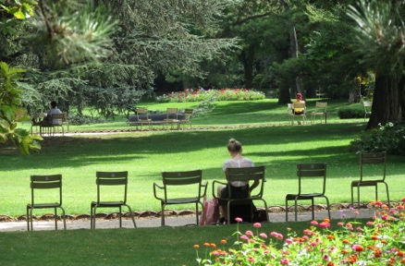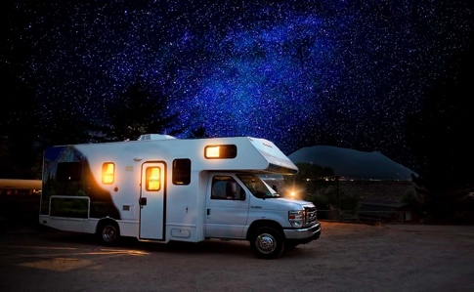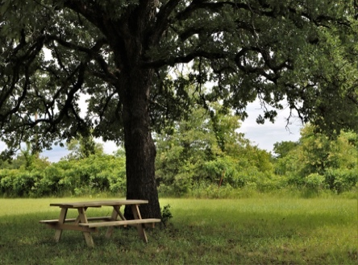
This Photo by Unknown Author is licensed under CC BY-SA
This Photo by Unknown Author is licensed under CC BY-NC

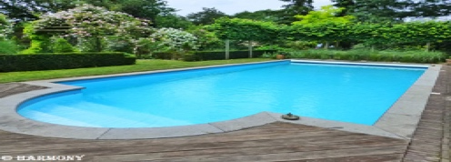
This Photo by Unknown Author is licensed under CC BY-NC-ND

Section 3- Marketing Strategy

Marketing mix

The marketing mix is ​​a concept that defines the 4 Ps of Marketing that are used as a structure for planning the company's strategies.
Therefore, Price, Product, Place and Promotion represent the four pillars that companies must apply to develop a successful marketing strategy, defining how the brand will reach its target audience and position itself in the market to achieve its objectives. To improve and adapt the concept to all types of projects and eliminate the gaps that existed mainly in relation to service companies, it was expanded by adding more letters and becoming 7 Ps.

Philip Kotler was responsible for popularizing the concept of marketing mix. In his book “Marketing Management”, released in 1967, the author presented these variables, citing McCarthy, as the main classification of the Marketing Composite.
From then on, the 4 Ps became a permanent part of marketing classes and business plans.

The marketing mix will guide me in planning the most effective strategies and placing the brand on the market, considering the positioning I want to achieve in the market, differentiating it from the competitor.
The objective is to consolidate at market level, always transmitting the essence of the brand in the imagination of the target audience and conquering an integrated space aligned with the image I want to transmit.

My target audience is people who are looking for a more alternative way of traveling and experiencing the good things that the city of Algarve offers, so it is an audience that is looking for good experiences at low costs.

My competitive strategy will be aligned with my marketing strategy to face the competitive market in a coherent and solid way, therefore it will be based on Cost Leadership aiming to reduce production and distribution costs as much as possible, offer services of acceptable quality and charge lower prices to obtain more profitability.
my Operational Marketing Plan, has the defined goals of every 3 months reviewing digital platforms and seeing what can be improved, always introducing new ideas and updating to maintain the level of interaction with customers and increase the level of popularity, and in terms of deadlines we try to comply as much as possible, and to consolidate each strategy that I outline, those responsible and the stages are always well organized. This is how I create action plans for each team and each employee, which makes the objectives more achievable.

The marketing strategy

Product/service - my service is to guarantee a space for motorhome drivers to park during their stay in the city of Algarve, but in addition I will offer security and leisure, which is what differentiates me from my competitors, so I know that My target audience will expect more than a simple space and my parking will live up to expectations, therefore it will be very accessible, all services will be offered with quality offering excellent services, with personalized attention to create the best experience.

Price - The company's focus is to accommodate the largest number of motorhome drivers possible, therefore the image I want to convey is of a company that offers quality services at more affordable prices to respond to the needs of the target audience and make a difference in relation to my competitors, especially because It is a style of tourism that aims at low costs, therefore it would not make sense to offer services with high costs, so following what our target audience is looking for, we draw a line of accessibility for everyone whilst offering comfort and safety and we understand the importance of reinforcing a perception positive that shows the value of my services despite the affordable prices that makes me stand out compared to my competitors (local hotels and other parking lots) and the accumulation of profit will be in the large number of customers that I will have.
Our price will be set at around €35 ​​per night, which is much lower than daily hotel prices and is comparable to the prices of other parking lots (in relation to other parking lots, we stand out through the additional services we will offer).

promotion - through digital marketing I will develop strategies to stimulate demand for my service among the target audience and therefore will be directed towards the use of social networks (such as Facebook, Instagram and YouTube where I will have an official page) with most of my target audience living in other countries this is the most effective way to reach them. I will create an effective line of communication about the brand that reaches as many of my target audience as possible around the world, with the aim of arousing interest and creating expectations in consumers about the tangible and intangible attributes of the services I will offer, aligning them strictly with promotion strategies to avoid consumer dissatisfaction. And nowadays, taking advantage of the great visibility of digital influencers when promoting services is important to gain credibility with the public, which is why I will work with some influencers to promote our services.

Place - the distribution channels and points of sale will be eCommerce because nowadays, before traveling anywhere, people research first, to compare prices and quality of services, and one of the research places is social networks, so it is very It is important to promote our services in these spaces and interact with our customers, we will have official pages on Facebook and Instagram where appointments will be possible and appointments can also be made with us on the Airbnb page, which will be our main point.

Section 4 - Privacy and Data Protection

Privacy and Data Protection

The General Regulation on the Protection of Personal Data of the European Union (GDPR), made in 2016, establishes the rules relating to the protection of personal data, being directly applicable in the legal order of all Member States. In Portugal, Law No. 58/2019, of August 8, is still in force, which ensures the implementation of the GDPR, which my company will strictly rely on within the scope of data protection laws.

I will only share personal data with third parties if I have a legal basis for this purpose, including the consent of the data subject.
Outside of this situation, your personal data will not be transmitted, sold or exchanged with third parties, and they will only be stored and processed within the technological infrastructure of the company, which is responsible for protecting all data collected here.

Through encryption, I will guarantee the security and protection of virtual data. And in this way we will make sure that information from the computer system is not stolen and read by anyone who wants to use it for malicious purposes.

Conclusion

Innovation is one of the most relevant factors in an organization in the globalized world we live in, where the demands for novelty and variety are immense, so in my case I see this as an incentive to increase the level of success of my parking company for motorhomes, so to meet demands I will continue to invest and create incentives for innovative initiatives within the company.
One of the issues that lead to the need to adapt to new ways of innovating is mainly the fact that nowadays products have a shorter life cycle and both the cost and the cost of investment in new activities are high, but this should not be an obstacle to investing in innovation because the opposite could mean failure.
At a time when we are experiencing challenges at an economic level, it is important to have initiatives at a personal level and put them into practice, taking advantage of all possible opportunities.
With the aim of creating more possibilities for myself, I developed this idea that I hope to consolidate.

Reference:
https://sciendo.com/article/10.1515/hjbpa-2017-0005
https://www.techtarget.com/searchsecurity/definition/cryptography
https://www.hypeinnovation.com/blog/open-innovation-models
https://pestleanalysis.com/what-is-pestle-analysis/
https://www.investopedia.com/terms/m/marketing-mix.asp

