
Operating Hotel Facilities
Student ID: 2119794


Assessment of Practical Tasks:

Housekeeping Team Member Development Plan

Introduction
The Housekeeping crew at the hotel works hard to provide each guest a comfortable and clean room throughout their stay. Even though the majority of guests staying at the hotel probably won't ever see the hotel's cleaning team at work, it is the cleaning staff's responsibility to keep the hotel appearing pristine and working properly in order to protect the hotel's image. There are several consistent cleaning procedures that apply throughout the sector, despite the fact that specific duties may shift somewhat from one hotel to the next. All of the tasks will be outlined within this development plan and you are welcomed to follow the description of tasks, the time table, the safety training as well as the branding for the Hotel Trinity.
The attention that the management pays to the comfort, stability, and efficiency of the hotel contributes to an increase in the degree to which guests are satisfied with the service provided by the hotel. Additionally, the facilities management team at Hotel Trinity is widely recognized as the leader in the hospitality industry when it comes to providing guests with extraordinary visual environments in hotels. This recognition comes as a result of the extraordinary visual environments that they have created for guests at Hotel Trinity. In addition to this, there are repercussions, one of which is the assignment of the market to a certain industry. It is the responsibility of those in charge of facilities management to ensure that hotels may be placed within a certain market segment. As a consequence of this, hotels are now in a better position to communicate with prospective clients interested in their services.
Time table of training activities.
In the next 8 weeks all staff needs to do safety training and perform all of their tasks with a more experienced staff member. They will have clear weekly meetings with their housekeeping manager in order to discuss any issues with their work. As well as this, there will be induction sessions every 2 weeks in order to remediate any issues with the work as well as to discuss performance on the role.

Description of training activities
It is the duty of housekeepers to clean the property and report any possible hazards to the property's management or the owners, whomever is in control of the property at the time. They are accountable for doing jobs including sweeping, mopping, vacuuming, emptying trash cans, dusting shelves, cleaning windows, and cleaning floors, among other responsibilities. In addition to duties such as cleaning dishes and changing bedding, some housekeepers are also responsible for pressing garments, performing light laundry and ironing, and completing minor housekeeping chores. If you provide your personnel with housekeeping training, you can be certain that they will know when, when, and how to utilize the various cleaning procedures and equipment necessary to maintain your facility in pristine condition. Training also prevents workers from acquiring poor habits, which might be contributing to the worsening of the issue (WorkWave, 2019).
Training objectives provide a condensed synopsis of the advantages that will become available to participants following successful completion of a training program, session, or course. The primary focus of training is on the tasks that need to be completed by the company, as well as the ways in which employees may contribute to the accomplishment of corporate objectives. During the training basic tasks will be covered such as making beds, dusting, cleaning the floors or the bathrooms correctly and the importance of fresh laundry. Create a standardized process for each task, such as how to remove stains from grout or how to steam clean carpet the right way, and then provide staff training for every member on how to carry out the procedures. Encourage your cleaning service staff to develop personal connections with customers rather than focusing on performance metrics so they can better serve you.
Housekeepers need to be knowledgeable with, cautious with, and able to maintain all of the essential housekeeping management equipment in order to execute their jobs effectively. As part of her responsibilities, the housekeeper must make certain that each of the hotel's guest rooms exudes a comforting scent and is immaculately tidy. If a guest like the scent of their hotel room, they may have an easier time relaxing throughout their stay. It is the responsibility of the housekeeper to anticipate and fulfill any requirements that the visitors may have throughout their stay. In addition, the lodging will come equipped with all of the essential conveniences, such as a towel, a bedroom kit, food, and a bathroom kit, among other things. Performing duties such as vacuuming the carpet from below the bed, washing the window sills, and wiping down the furniture in a hotel room are all instances of comprehensive cleaning jobs (Kokemuller, n.d.).
Description of tasks:
Sanitize glasses
Cleaning and sanitising toilets
Replace all the towels and bathroom mat
Replace laundry
Reporting any necessary repairs or replacements
Clean up spills on floor as soon as possible
Report Hazards
Wear uniform at all times
Know how to inform customers of an emergency
Monitoring cleaning supplies and ordering more as needed

Safety training such as fire safety, COSHH, health and safety etc.
Companies that handle hazardous materials are required by law to comply with the requirements outlined in COSHH, which stands for the Control of Substances Hazardous to Health 2002, as modified. In particular, it mandates that employers put control mechanisms into place and give people who work with hazardous compounds with appropriate training in order for them to be able to properly handle the substances (The Hub | High Speed Training, 2020). Due to the fact that they are responsible for cleaning such a large number of different hotel spaces, the housekeeping team goes through a lot of cleaning products. There is a possibility that some of the materials and instruments might pose a threat to the users. The members of the housekeeping crew are responsible for a broad variety of tasks, one of which is ensuring that this equipment is properly cared for and maintained.
Branding and logos for Hotel Trinity.
The housekeeper at a 4* Hotel is required to wear at all times a clean uniform with the branding and logos of Hotel Trinity. Furthermore, it is necessary that they understand the importance of branding Hotel Trinity when cleaning and arranging the rooms as there is a specific pattern and specific laundry to show the presence of the Hotel Trinity.
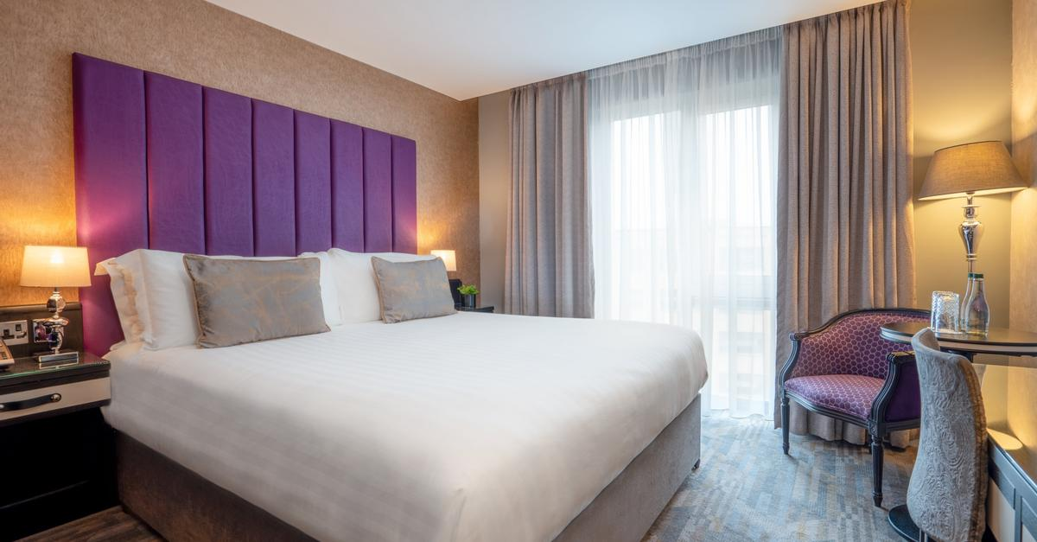

References
The Hub | High Speed Training. (2020). Do Cleaners Need COSHH Training? | Course Suggestions. [online] Available at: https://www.highspeedtraining.co.uk/hub/coshh-training-important-for-cleaners/.
WorkWave. (2019). 7 Tips for Training New Maids & House Cleaning Employees. [online] Available at: https://insights.workwave.com/industry/cleaning-services/7-tips-for-training-new-maids-house-cleaning-employees/.
Kokemuller, Neil (n.d) “Housekeeping Job Task Analysis” https://work.chron.com/housekeeping-job-task-analysis-24298.html

