
Project Management for sustainability BMSP5008
Natalie Male: 1702161
Report
Tutor: Glenn Behenna

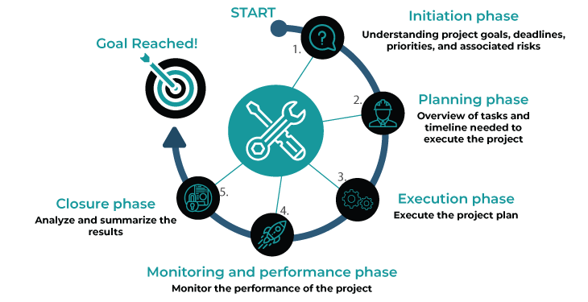
Table of Contents

Executive Summary
Introduction
Project Management definitions
Stages and planning in project Management
Methodologies of Project Management
Comparing the Methodologies
Project Managers Role and responsibilities
Management Theories
Role of social media in Project Management
Project Management Key Elements
A project Lifecycle
Stakeholder Analysis, Risk and Sustainability
Why projects fail
Conclusion
References

Executive Summary
The purpose of this report is to explore and recognise some of the important elements of project management. The methodologies discussed are Waterfall, Agile and Prince 2 exclusively, though other methodologies are widely used. Considering the role of the project manager and the tools, methodologies and theories they use to effectively manage all aspects of the project.
Introduction

The most important aspect of project management is having a viable project, that meets all requirements and is well planned. A project can be defined as “A series of interrelated activities undertaken to achieve a specific end result within a set time frame and budget”. (Project Management Principles, 2019) A project is timebound and will reach an end, however this could be before it is completed, if the project is found to be unviable. A capable Project manager with the correct methodology, or mixture of methodologies can be a crucial in the success or failure of any project.

Project Management definitions
There are many definitions of Project Management, though this can greatly depend on the nature of the organisation. The overall aim is to create a successful service or product. The project Management institute states that “Project management, then, is the application of knowledge, skills, tools, and techniques to project activities to meet the project requirements”. (What is Project Management?, 2019)
The Association for Project Management suggests that “The application of processes, methods, knowledge, skills and experience to achieve the project objectives”. (Body of Knowledge/ Glossary, 2019)
(Abramova, Pires, & Bernardino, 2016) states that “Project Management refers to the planning, monitoring and controlling of all aspects of a project, with the people involved in the project aiming to achieve the objectives on time and on budget to a specific quality standard”
Each definition, although different encompasses the meaning of project management.

Stages and planning in project Management
Once the project has been decided and the team assigned the planning stage can begin. Project planning informs the team what is expected and how it will be achieved. This can be a challenging phase as managers allocate resources and designate team member to roles. “Successful completion of a project is not an easy endeavour. It calls for a series of tasks to meet stakeholder and client requirements; a lot is involved in the process before the project reaches completion phase”. The planning phase sets out to establish and address all the stages, as displayed in Image 1.
Image 1
This will define what need to be achieved, what the project is trying to deliver, who will be part of the team and how each phase of the process will be monitored.
Methodologies of Project Management
A methodology can be defined as (Meaning of methodology in English, 2019) “A system of ways of doing, teaching, or studying something”. There are many Methodologies that can be used as technique to assist projects. (Spundak, 2014) states that “Project management methodology is usually defined as a set of methods, techniques, procedures, rules, templates, and best practices used on a project”. For the purpose of this report the methodologies discussed are Agile, Waterfall and Prince 2. The correct methodology or combination can help to obtain the desired outcome of the project.

Waterfall

The waterfall model was a paper published in 1970 by Dr Winston W Royce. The model follows a pattern of logical sequencing. Industries that implement this methodology include software development and construction companies. (McCormick, 2012) proposes that “Waterfall model, as the name itself signifies, is a sequential process of software development. Just like in a waterfall, the water progressively falls from one altitude to the lower, in a similar way, the production cycle progresses sequentially, from one stage to the other”. There are between five and seven phases that precede in a strict linear order. Each stage must be completed before the next stage can commence. The sequence is displayed in Image 2 (Comparing Traditional Systems Analysis and Design with Agile Methodologies, 2019)

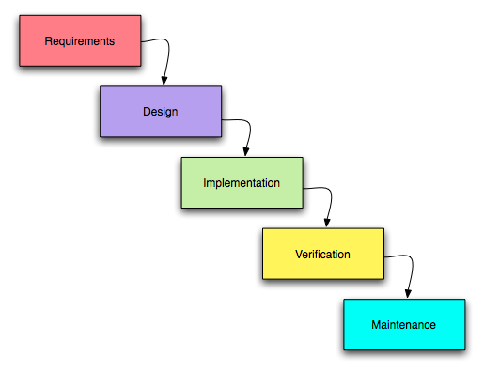
Image 2

Requirements: Information is gathered at the beginning of the project; this is a key stage in the waterfall methodology. All stakeholder and customer requirements are taken and recorded

Design: Both logical and physical design solutions are required. Logical solutions are sought and conceptualized for appropriate theory. The physical design stage is when the theory is developed into defined specification.

Implementation: Programmers understand the requirements of the previous stages and start to produce real code.
Verification: The product is released to the customer, which they then test to see if it meets the specifications outlined at the start of the project.
Maintenance: The customer continues to use the product during this phase, uncovering any issues. The project management team will correct the issues until the customer is satisfied.

The benefits of waterfall are that the requirements have been agreed at the beginning. Making scheduling and planning clear. With a schedule in place it is possible to estimate costs and keep to a deadline. Progress during this methodology is easy to measure. However, it can be difficult for customers to explain their requirements at the beginning of the project. At the verification phase if the customer is dissatisfied it can be costly to rectify and redesign. This linear structure is rigid and lack malleability to adapt to unforeseen circumstance.

Agile
The agile methodology doesn’t specify methods. Although, it offers guidance on how to choose methods and procedures that work best for the team. The methodologies that can be utilised in an agile project are Lean and Scrum, amongst others. The defining feature of Agile is that it produces and conveys work in a short time. This is repeated until the project reaches the exacting requirements of the customer. Agile begins with a plan of what is required, then timely delivery clarifies the needs of the project as it progresses. The recurring repetition of the process is a key characteristic of an Agile project. This way of working requires relationships and collaboration between members of the team and stakeholders. An example of the principles can be seen in image 3 below (Top 12 Agile Principles, 2019)

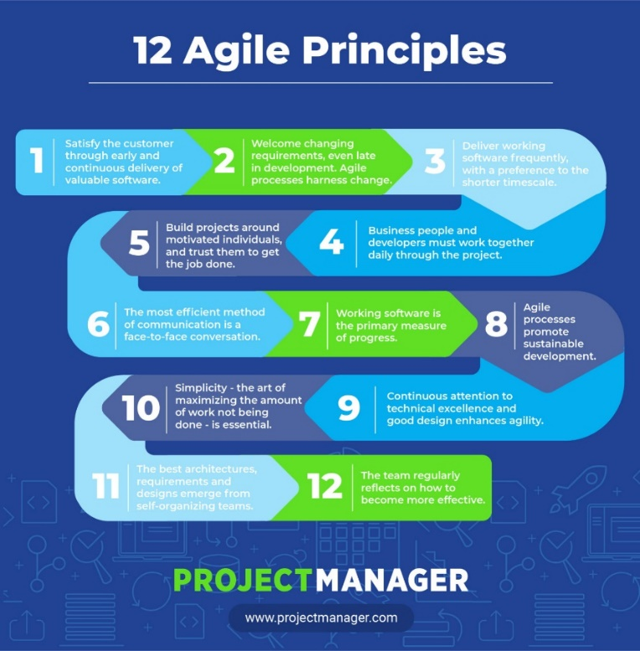

Image 3

The benefits of Agile are that importance is placed on interactions, rather than tools and processes. Developers and customers are able to continue to interact with each other. Working software is also able to be delivered more frequently. On the contrary Agile requires more commitment and time. There are more demands on developers and the clients they are interacting with. It is possible that with lack of structure the project could easily fall of track.

Prince 2

Prince stands for Projects in controlled environments. It was developed in 1989 by the uk government and was intended for use solely with IT projects. The 2 recognises that this is the second version.Prince 2 is a structured methodology, whose approach follows set processes. It appears to be the most widely used of the project management methodologies. There is control and organisation over the entire project from beggining to end. There are seven Principles, seven themes and seven processes. They are displayed in image 4 (Reasons to do a prince 2 certification, 2019)

There is a stage by stage approach and input, output and objectives are clearly understood. It is an inclusive process that involves many parties , including managers, suppliers and customers.

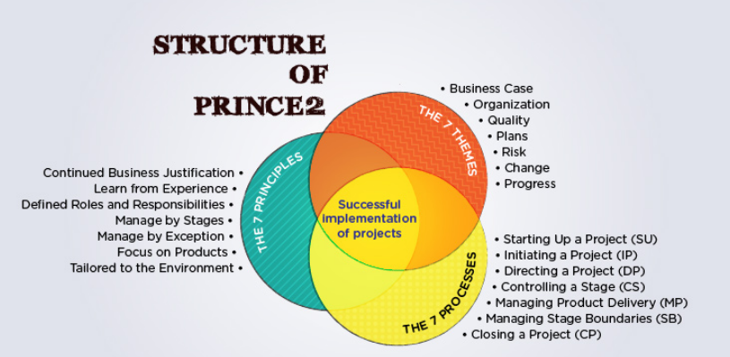

Image 4

The benefits of Prince 2 are that it is flexible and easily tailored for a vast amount of different projects. (Pincemaille, 2008) argues that“ Prince 2 is really interesting, because it is repeatable, teachable, built on experience, ensuring that everyone knows what to expect, able to warn early of problems, and rather proactive”. It is useful for projects of all sizes. Lessons are learned and can be documented for future projects. Although, it can be argued that prince 2 can be too unweildy for a smaller project. On the contrary it is difficult to know what is classed as a small project. (Ferguson, 2011) argues that “Firstly ‘small’ is a relative term. For example, in a global corporation it may mean a budget of millions. In a small charity it may mean a budget of thousands”.

Comparing the Methodologies
As with all the methodologies good communication and implementation is an important feature. Agile is the more flexible of the three methodologies, agility is the ability to adapt and change accordingly. Waterfall and agile are easy to compare to each other as they are both used during software development. (Charvat, 2003) purports that “ The rationale is that the basic building blocks of the model are relatively the same but need only be tailored to suit an organisation” Many project managers recognise the benefits of utilising a combination of methodologies. (Kift, 2019) “Working as a project manager for the NHS, I will often use a combination of agile and prince 2 methodologies”.
Project Managers Role and responsibilities
Having an accomplished and experienced project manager is a great asset to an organisation. This can increase the success of the project and possibly reduce costs. A project Managers role is to assist and lead the team to reach the goals of the project. They are not always able to select their team so must quickly build relationships, recognising strengths and weaknesses. A good manager will have excellent communication skills and be motivational and encouraging, although they must be able to lead effectively and challenge errors as they occur.
It could be argued that one of the most difficult aspects of PM would be the management of people. Conflicts within the team must be resolved swiftly. This leadership style can be different to that of a traditional manager, where the focus is a more classical style. Leadership differs from management as there is a different skill set required. (Anantatmula, 2010) suggests that “Leadership, on the other hand, is about motivating and guiding people to realize their potential and achieve tougher and challenging organizational goals”.
Management Theories
There are many well renowned theorists in the field of leadership and management. These theories can assist the project manager to adapt and get the very best from their team. Hershey and Blanchard’s model and Peter Drucker’s management theory are just examples. Drucker’s theory includes many concepts including; Decentralization, knowledge work, workforce development, corporate social responsibility, organizational culture and Customer experience. There is a real emphasis on inclusion and value throughout each concept. He also went on to identify Management by objectives, a theory that all employees work together to get the business to an agreed goal. Each employee is treated equally, and their opinions and ideas are given consideration. Although his ideas were initially in the 1940’s they are still relevant to today’s projects. (Alderton, 2019) states that “His advice is timeless. It will still apply years from now – whatever the current trends and technologies are."

Hershey and Blanchard developed the Situational leadership theory. This theory proposes that there is not one definite leadership model that is superior to another. The model focuses on leaders adapting to their environment, with flexibility. It is people driven and relationships are considered an important element, in choosing how to lead the task. They recognised four different leadership styles that managers could use. Delegating, participating, selling and telling.
There are advantages and disadvantages to this model. Leaders can adapt to change their leadership style when required, which is useful in an ever-changing environment. However, the model does have disadvantages and may not be relevant to different cultures. (Kenton, 2019) suggests that “On the downside, situational leadership may put too much responsibility on the manager, whose decisions may be flawed.”

Role of social media in project management

Given the ongoing trends in social media people are changing the way in which they communicate. This can be a very important consideration that can be used to a project managers advantage. (Taylor, 2016) suggests that “As people change the way they interact and share information and knowledge, the project management world should be capitalising on it”.
Managers can capitalise on these methods of social media to keep both stakeholders and customers informed. Networking is another useful tool that connects the wider community. (Taylor, 2016) does state that although the use of social media and apps have increased, not a lot has changed, and organisations are getting left behind. This is many due to the lack of co-operational of the organisation to make changes. The benefits are that working in collaboration and real time can be vital, not only time saving but cost effective for many businesses.

Project Management Key Elements
There are many elements to consider in the project management process. There are at least fifteen, but for the purpose of this report we will focus on four. The number of elements used in any organisation will depend on the project size. (Percival, 2011) suggests that “Each discipline may require measuring, reporting and adjusting to ensure the project stays on track. The degree of effort each discipline deserves depends on the type, size and complexity of the project.” Each of the following elements interlink and forms the building blocks for a project.
Resources- They are not just tools or materials. It is easy to forget that the team are a valuable resource. Anything that enables the project to succeed may be considered a resource.
Time- This is one of the most impacting elements of the project. Time will have an impact on all elements of the project, from beginning to end.
Money- This will be another element that impacts on the project. From the expense of resources to the overall projected profit.
Scope – This can be difficult to determine, although there are several factors involved. They include project goals, size and requirements. It can potentially seriously affect the other three elements.
A Project Lifecycle
The project lifecycle recognises the phases involved in successful delivery of projects. It recognises the objective and the methods of delivery. (Lifecycle, 2019) suggests that “A life cycle defines the inter-related phases of a project, programme or portfolio and provides a structure for governing the progression of the work”.
The phases are as follows:
The conceptualisation phase: Problems are recognised, what will be solved by the project, do the resources exist to sustain the project? This will lead to a presentation of the case, creation of a contract
The Planning Phase: Formal planning outlining goals and objectives. Looking at the mission of the project and any measurable criteria, Outline risk and have a schedule and budget deadlines.
The Execution Phase: The project commences and is monitored continually to ensure success
The Termination Phase: This phase can also be called project closure and is determined when the project has come to an end. It is possible then to see how successful the project has been and what future lessons can be learned.
The most used is the linear life cycle. An example of a linear project life cycle is displayed in Image 5 (Lifecycle, 2019)

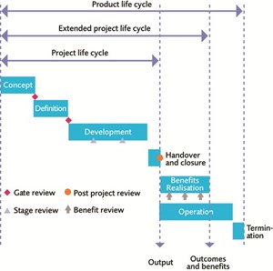
Image 5

Stakeholder Analysis, Risk and Sustainability
The ability to recognise and prioritise stakeholders can be crucial for a project’s success or failure. A stakeholder is anyone who has a vested interest in the project There are two categories of stakeholders, internal and external. In order to be able to understand and manage them effectively a power and interest grid can be used. (Power-Interest grid , 2019) advises that “A power-interest grid is a technique used to categorise stakeholders based on their power or influence and interest in a project. Before using the technique, you should identify all stakeholders involved in the project”. An example of the grid has been produced has been produced and is shown in image 6.
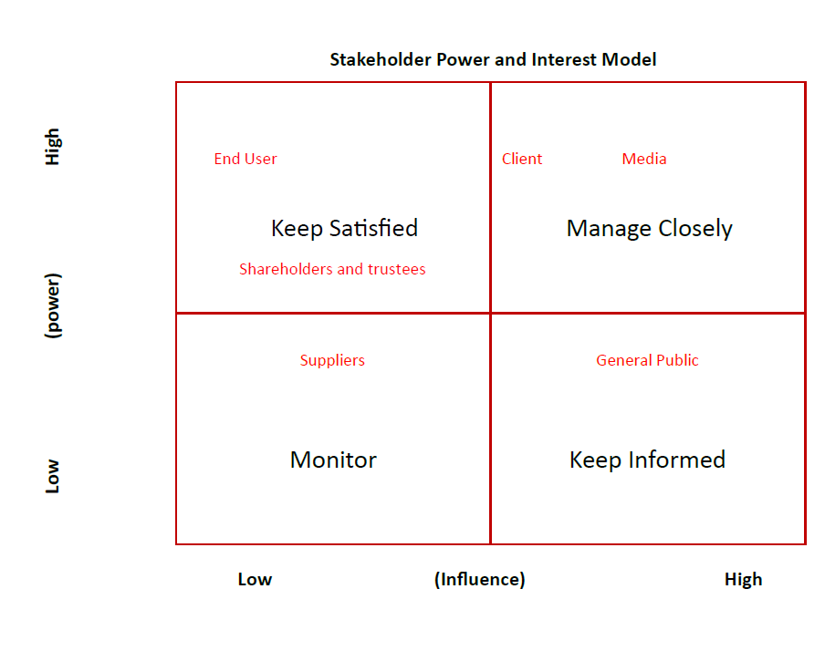
Image 6
Although some examples of stakeholders have been given, this will change with the nature of the project.
Within any project there will be an element of risk, either internally or externally. An issue is different to a risk, as it is something that has already occurred. A risk is something that could occur within the timescale of the project. By recognising and recording this helps to eliminate the impact on the project. There are many tools that can assist managers to minimise the effect of risk, such as a risk analysis or a manage-risk log. Risks are identified and an action plan is determined, for immediate and potential risk.
There are other areas to consider including the growing demand for sustainability in business. (Kohl, 2016) Argues that “From an investor viewpoint, management teams that take this holistic view are thought to be better managers, producing better results through opportunity maximization and risk minimization”. This will bring new challenges and considerations for the project management team. Although (Kohl, 2016) further states that “Project management professionals are well positioned to facilitate this change process utilizing project management methodologies

Why projects fail
Projects can fail for several reasons; this could be down to poor management or delays in the process when problems have occurred. Costs could have increased, and funds ended. A good project manager should be able to recognise when a project isn’t viable and act, thus saving money for the organisation.
For some projects it may be impossible to consider and foresee every risk. (Matta & Ashkenas, 2003) argue that “Managers expect they can plan for all the variables in a complex project in advance, but they can’t. Nobody is that smart or has a crystal ball.” This is where all documentation is useful and can be studied for future solutions.

Conclusion
Project management can appear to be a complex and structured profession, that requires a high degree of skill. There are many tools, methodologies and theories that can assist the project manager and their team to reach a specified goal. A good project manager can be an asset to an organisation, recognising and assessing risk and building important relationships. It is inevitable that not all projects will succeed, although, by utilising all available resources this provides the best possible chance of success. Social media will be an important too for inclusion of all team members and stakeholders moving forward. Sustainability will become increasingly important in future projects.

References
Abramova, V., Pires, F., & Bernardino, J. (2016). Open Source and Proprietary Project Management
Tools for SMEs. Journal of Information Systems Engineering & Management,, 177-186.
Alderton, M. (2019, October 11th). What Your Business Can Learn From Peter Drucker. Retrieved from https://www.business.com/articles/management-theory-of-peter-drucker/: https://www.business.com/articles/management-theory-of-peter-drucker/
Anantatmula, V. S. (2010). Project Manager Leadership Role in Improving Project Performance. Engineering Management Journal, 22, 13-23.
Body of Knowledge/ Glossary. (2019, November 19th). Retrieved from apm.org.uk: https://www.apm.org.uk/body-of-knowledge/glossary/
Charvat, J. (2003). Project Management Methodologies. New Jersey: John Wiley & Sons Inc.
Comparing Traditional Systems Analysis and Design with Agile Methodologies. (2019, November 19th). Retrieved from umsl.edu: https://www.umsl.edu/~hugheyd/is6840/waterfall.html
Ferguson, C. (2011). Prince 2 for small- scale projects. Retrieved 2019, from africanedevelopment.org: https://africanedevelopment.org/wp-content/uploads/2016/09/PRINCE2-for-small-scale-projects-White-Paper.pdf
Kenton, W. (2019, April 18th). Hersey-Blanchard Model. Retrieved from investopedia.com: https://www.investopedia.com/terms/h/hersey-and-blanchard-model.asp
Kift, S. (2019, November 14th). Guest Speaker.
Kohl, K. (2016). Becoming a Sustainable Organisation . Boca Raton,, Florida: CRC Press.
Lifecycle. (2019, November 26th). Retrieved from association for project management: https://www.apm.org.uk/body-of-knowledge/context/governance/life-cycle/
Matta, N. F., & Ashkenas, R. N. (2003). Why Good Projects Fail Anyway. Harvard Business Review , 1-9.
McCormick, M. (2012, September 8th). Waterfall vs. Agile Methodology. Retrieved November 23rd, 2019, from http://www.mccormickpcs.com/images/Waterfall_vs_Agile_Methodology.pdf.
Meaning of methodology in English. (2019, November 26th). Retrieved from Cambridge Dictionary: https://dictionary.cambridge.org/dictionary/english/methodolog
Percival, G. (2011, December 8th). The many elements of project management. Retrieved November 26th, 2019, from Cio.com: https://www.cio.com.au/article/409640/many_elements_project_management/
Pincemaille, C. (2008). Prince 2: a methodology of project management. Cork Institute of Technology, Computing department. Cork: Cork Institute of Technology.
Power-Interest grid . (2019, November 26th). Retrieved from improvementservice.org: http://www.improvementservice.org.uk/power-interest-grid.html
Project Management Principles. (2019, November 19th). Retrieved from primarycareone.wales.nhs.uk: http://www.primarycareone.wales.nhs.uk/sitesplus/documents/1191/PM%20Principles_Pre%20Course%20Reading%20V2%20Mar%202016.pdf
Reasons to do a prince 2 certification. (2019, November 22nd). Retrieved from arraspeople.co.uk: https://www.arraspeople.co.uk/camel-blog/prince2/reasons-prince2-certification/
Spundak, M. (2014). Mixed agile/traditional project management methodology – reality or illusion? . Social and Behavoural Science, pp. 939-948.
Taylor, P. (2016). The social project Manager Balancing Collaboration with Centrailsed Control in a Project Driven World. London: Routledge.
Top 12 Agile Principles. (2019, November 19th ). Retrieved from Projectmanager.com: https://www.projectmanager.com/blog/agile-principles
What is Project Management? (2019, November 19th). Retrieved from Project Management Institute: https://www.pmi.org/about/learn-about-pmi/what-is-project-management

