

Module Code: LCMB7023
Module Title: Human Capital Management
Topic
“Integrated Human Capital Blueprint: Re-Engineering for Excellence at Aether Innovations”

Student Name: Abdullah Al Mamun PAVEL
Group:02
Student ID:2528449
Course Tutor: DC: Charles Oham

Word Count: 2587

Table of Contents
1. Introduction 3
2. Option 1: Re-Engineering Performance and Job Design 4
2.1 Current HR Practices in Tech Industries 4
2.2 Proposed Performance Appraisal System 5
The OKR Framework 5
360-Degree Feedback and Continuous Coaching 6
2.3 Job Analysis, Descriptions, and Specifications 7
2.4 Linking Performance and Job Design 9
3. Reflection 10
3.1 Learning from Human Capital Management (Gibbs Reflective Cycle) 10
3.2 Future Career in the AI Era 12
4. Conclusion 14
Reference 15
Appendices 17
Appendix 1: The OKR Implementation Matrix 17
Appendix 2: Job Characteristics Model (JCM) Application Audit 18
Appendix 3: 360-Degree Feedback Competency Framework 19
Appendix 4: AI-Human Collaboration Roadmap 19

1. Introduction
Aether Innovations is on the brink of a strategic deadlock. Although the firm has scaled quickly to 300 employees, stagnant growth, high voluntary turnover, and free-falling customer satisfaction is hampering the business. The report can be used as a strategic roadmap to transform Aether into a high-performance organisation and out of a reactive startup. The proposed Human Capital strategy will help eliminate the gap between the engagement of employees and output in an organisation by concentrating on the integration of performance management and job design. Basing the argument on the current theories of HRM, this proposal suggests that performance is an outcome of role-architecture and incentivization of growth.

2. Option 1: Re-Engineering Performance and Job Design

2.1 Current HR Practices in Tech Industries
The world of technology is entering a Quiet Revolution in the field of human capital management, shifting away bureaucracies, moving to models which are more agile and focused on responsiveness. Industrial giants like Adobe, Microsoft and IBM are moving to abolish traditional annual performance reviews through a gradual process that has been marked by top-down ratings and retrospects. This has been seen in organisations that have substituted legacy systems with regular Cheque-ins and feedback loops in view of the fact that one annual conversation is not adequate in the ever-changing dynamics of the tech market (Cappelli and Tavis, 2016). It has been shown that about 70% high-performing technology companies have implemented agile performance management to align human performance with the shorter product development and short-sprint processes (CIPD, 2024).
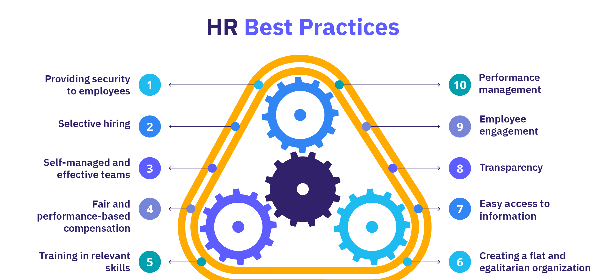
Figure 1: Current HR Practices (Vulpen, 2018)
Moreover, the job design in the modern technology has been changed to Depiction Fluid Roles Compared to the traditional rigidity, task-focused descriptions of a given role. Technological firms such as Google and Atlassian are proactive in using the Job Characteristics Model (JCM) to make sure that technical jobs have a high degree of autonomy and task concern, which are validated predictors of innovative behaviour. But the mid-sized enterprises usually run into the trap of Complexity. As these companies grow, functions often belong to too many specialists and forget about direct interaction with the end customer. The effect of this is the so-called silo effect: highly skilled engineers or marketers lose the overall organisational purpose, which ultimately leads to stagnation and high turnover as it is the current situation at Aether Innovations (Oldham and Hackman, 2010).

2.2 Proposed Performance Appraisal System
In order to turn the situation around, where flat growth and lack of employee retention are increasing at rate at Aether innovations, a proposal has been made to adopt a two-layered performance architecture. The system combines Objectives and Key Results (OKRs) and 360-Degree Growth Feedback to focus on the former and replace it with the latter.

The OKR Framework
In contrast to traditional Key Performance Indicators (KPIs) which can be limited and punitive, the okrs are based on ambitious and qualitative goals which have specific and measurable outcomes. In the case of Aether Innovations, there is vertical and horizontal alignment in this framework. As soon as the CEO establishes a high-level goal of the type of Revolutionising Customer Experience, it flows down to the engineering and HR departments as key results. Doerr (2018) asserts that OKRs achieve radical transparency as all the employees are able to see the flow of their individual contributions into the company North Star goal. This transparency is essential in a 300-person company whereby people tend to feel like cogs in a machine.
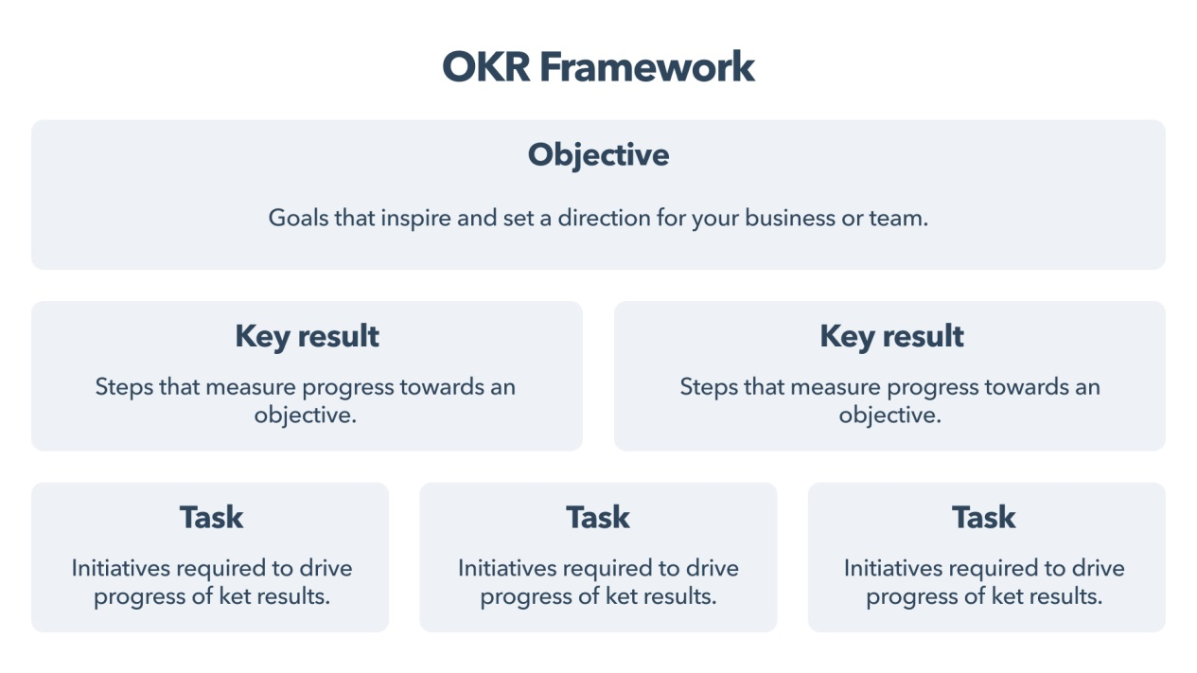
Figure 2: OKR Framework (Flinder, 2022)

360-Degree Feedback and Continuous Coaching
The appraisal process should be shifted to the future in an effort to overcome the turnover crisis as it can no longer be used the same way by assessing the past. Through the use of 360-degree feedbacks, the employees of Aether will obtain multidimensional feedback about themselves through their colleagues, juniors, and bosses. This gives a holistic perspective of performance, where emphasis is laid on behaviour competencies like collaboration and intrapreneurship (Taylor, 2014). Adoption of this with frequent coaching dialogues would see the retention of the employees to higher levels. According to the recent reports in the industry, the developmental feedback loops have provided 30% more engagement than the traditional numeric rating scales (CIPD, 2024).
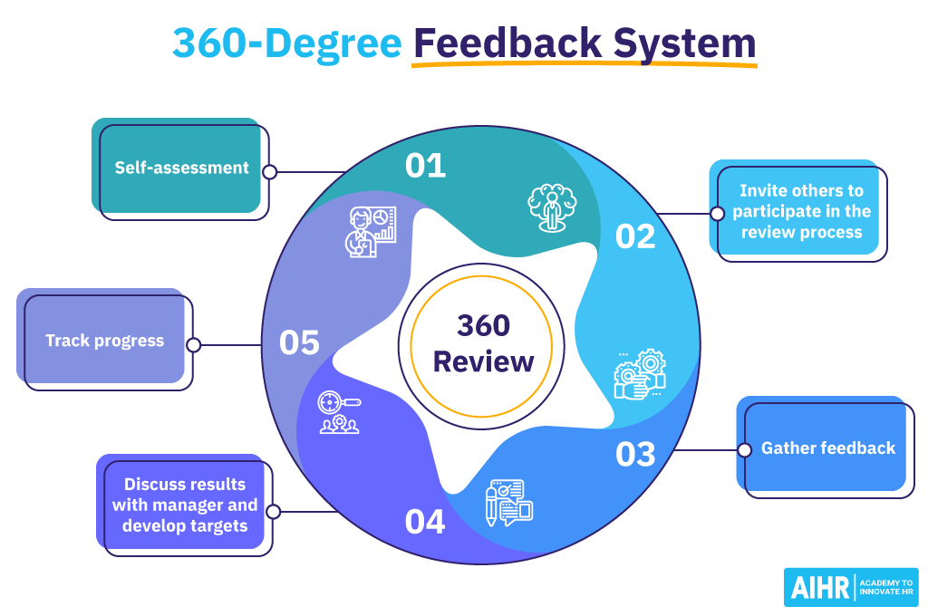
Figure 3: 360-Degree Feedback (Vulpen, 2020)

2.3 Job Analysis, Descriptions, and Specifications
The Job Characteristics Model (JCM) has been used to design the following job into six key leadership roles. The objective is to enhance maximum the psychological conditions of meaningfulness, responsibility and knowledge of outcome to promote innovation.
Chief Executive Officer (CEO)
Job Description: In charge of long term strategic vision and maintenance of cultural health of Aether. The CEO also serves as a Culture Architect, making sure that there are no cross-departmental silos and that a psychological safety climate is promoted.
Job Specification: A Master degree in Business or Technology, 15 or more years of leadership experience in growing technology companies, and demonstration of success in transformational leadership.
Design Focus: A high autonomy to pivot strategy with a high task significance, which directly affects the organisational survival and market impact.
Chief Financial Officer (CFO)
Job Description: In addition to financial supervision, the CFO has to be a "Strategic Business Partner. This entails allocation of capital that has particular focus on high-growth of R and D and human capital investment as opposed to unidirectional cost-containment.
Job Specification: CPA or CFA designation, 10 years of experience in financial management in technology sector, and work in venture capital or pre-IPO environment.
Design Focus: Improved skill difference by engaging the CFO in product-market fit and talent acquisition strategy.
Chief Technology Officer (CTO)
Job Description: Location Jobcentric The technical infrastructure and long-term tech stack sustainability. The CTO makes sure that engineering teams have the tools needed to be innovative without them being weighed down by technical debt.
Job Specification: PhD/ Masters in Computer Science, strong technical background of AI integration and experience of running agile, high output engineering departments.
Design Focus: Entertainment of the engineering department towards as much autonomy as possible to do experimental coding and blue-sky research..
Chief Innovation Officer (CIO)
Job Description: A new role position on new programme with responsibility of Intrapreneurship. The CIO controls the innovation pipeline and makes sure that the customer feedback is feedbacked directly into the product design lifecycle.
Job Specification: 8+ years of experience in product innovation leadership, Lean Startup methods and professional background in Design Thinking.
Design Focus: Committing high feedback loops between the outward market and internal development teams.
HR Director
Job Description: Split of administrative supervision to strategic talent management. The HR Director is in charge of the so-called Talent Ecosystem, which is concerned with the employee experience (EX), the employer branding, and organisational design.
Job Specification: CIPD Level 7 or SHRM-SCP certification, specialised understanding in organisational psychology, and skill in HR analytics based on data.
Design Focus: Task Identity, permitting the HR Director to monitor the full lifecycle of a talent initiative starting with creation and documented retention value.
Head of R&D
Job Description: Leads the idea laboratories and cross-disciplinary group of designers and engineers to create the next generation product portfolio of Aether.
Job Specification: Strong base in applied sciences and/or engineering, 10 years experience in R&D management; and track record of patented innovations.
Design Focus: Task importance and high skill variety to avoid stagnation in the development stages of the process, which last the long periods of time.
Position | Primary JCM Driver | Strategic Contribution to Aether
CEO | Task Significance | Drives cultural transformation and strategic alignment.
CFO | Skill Variety | Integrates financial modeling with sustainable R&D.
CTO | Autonomy | Ensures technical agility and infrastructure excellence.
CIO | Feedback | Bridges the gap between market needs and product evolution.
HR Director | Task Identity | Enhances the talent ecosystem to reduce turnover.
Head of R&D | Skill Variety | Directs cross-functional teams toward breakthrough innovation.

2.4 Linking Performance and Job Design
The alignment between the suggested OKR system and the JCM-based job design will be the main engine of Aether recovery. With jobs designed with high autonomy and skill variety, such employees would inherently be more motivated to set and work towards the high goals of the OKR system, which are the stretch goals. The 360-degree feedback system, in turn, offers the Knowledge of Results the JCM needs to maintain the internal work motivation (Oldham and Hackman, 2010).
This integration creates a Performance-Driven Culture, whereby the employees do not only carry out tasks, but own strategic results. By thinking less about jobs specification and more about specification based on the effect they had on innovation, Aether will be able to fill a gap between the human effort and customers satisfaction. Independent and motivated workers will be capable of addressing customer issues proactively, which will turn around the drop in satisfaction scores (Taylor, 2014). This blue print makes sure that the practises of people are not separate functions but they are entrenched in the competitive strategy of the firm.

3. Reflection

3.1 Learning from Human Capital Management (Gibbs Reflective Cycle)
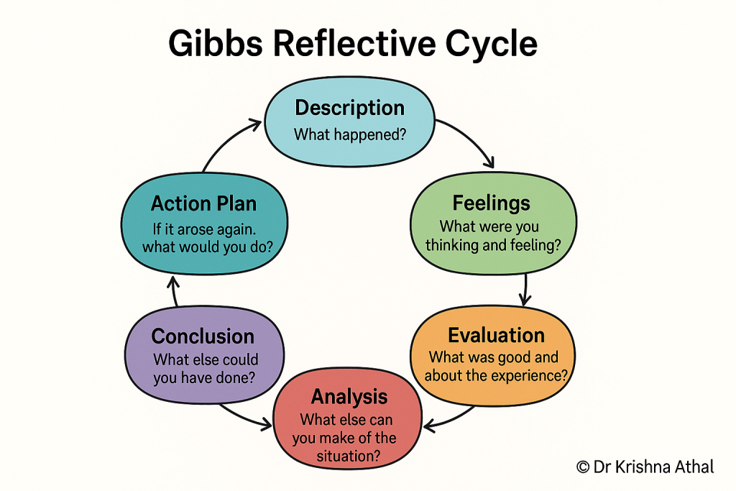
Figure 4: Gibbs Reflective Cycle (Athal, 2025)
Description
During the period of this module, the academic interest became less mechanical business processes to the intertwining of human psychology and organisational efficiency (Gibbs, 1988). The curriculum encouraged an exposure to a wide array of theories, including simple constructs such as Maslows Hierarchy of Needs to more modern changes in the direction of Skill-Based Organisations. Much of this journey saw a thorough investigation of the case of Aether innovations. This analysis showed that technological limitations and lack of funds were not the major factors preventing growth, but instead, human-related failures that were still deep rooted. The realisation was in line with the perception that human capital was the only untapped source of sustainable competitive advantage in a highly commoditized tech market (Barney and Wright, 1998).
Feelings
The feeling of fear dominated at the start of the module mainly because of the perceived impenetrability of HR metrics and the quantitative character of workforce analytics (Parker, 2024). But when the study proceeded to the Job Characteristics Model (JCM), a big Aha! moment occurred. This theoretical framework gave grammaticity to previous professional frustrations. I also realised that the past experiences of burnout or disengagement were not a consequence of workload per se but the outcome of a severe lack of the two attributes of Task Significance and Autonomy. This individual appeal has turned the scholarly content into a format of a practical kit applied to the diagnosis of organisational health.
Evaluation
The most favourable moment in this learning process was the paradigm shift in the perception of Human Resources as a auxiliary support service, to Strategic Human Resource Management (SHRM) as a primary driver of the business (Bailey et al., 2018). The review of Aether Innovations emphasised the absence of an effective connexion between job design and performance appraisal as a result of which the high-quality talent will ultimately perform poorly or leave the organisation. The toughest aspect was the intellectual shift of a rather administrative and reactive Personnel Management mentality towards a Human Capital mentality, treating employees as assets that need a strategic investment and a careful architectural positioning (Taylor, 2014).
Analysis
Gibbs Reflective Cycle can be used to study professional development in more depth. In the past, product-market fit was assumed to be almost the sole success factor in a company. This was disputed by the module, which introduced the concept of the Psychological Contract (Rousseau, 1989). By comprehending Aether in this perspective, it became clear that high turnover is hardly ever about pay; instead it is a side effect of a violated deal in which employees feel their development concerns and efforts are overlooked. This discussion indicates that the silo effect at Aether was a design flaw, though not deliberate, where the lack of integration between the social and technical system at the company was not achieved.
Conclusion
This module has reinforced the realisation that in order to develop a "Growth Mindset" (Dweck, 2006) a career could be viewed as a collection of "Innovation Sprints" as opposed to a ladder-like ascent. Technical proficiency is just the price to get in the door; the sweetness is in learning the art of the soft power of organisational design and cultural persuasion. I have decided to learn that the skill of formulating roles which have inherent motivational power is much more important than that of merely managing headcounts.
Action Plan
To make sure that these scholarly lessons can be used to apply professional excellence, the following action plan has been formulated to keep a culture of innovation and personal development alive.
Action Item | Implementation Strategy | Intended Outcome
Weekly Reflective Practice | Dedicating sixty minutes every Friday to evaluate decisions using the Gibbs Cycle. | Continuous improvement and avoidance of repetitive strategic errors.
JCM Role Audits | Every six months, I will audit my own professional responsibilities for Autonomy and Task Significance. | Maintenance of high intrinsic motivation and prevention of career stagnation.
360-Degree Feedback | Proactively requesting feedback from peers and subordinates twice annually. | Identification of "blind spots" in leadership style and interpersonal communication.
Lifelong Learning Sprints | Engaging in one micro-credential course per quarter regarding emerging HRM technologies. | Staying ahead of industry shifts and maintaining technical relevance.

3.2 Future Career in the AI Era
The aspiration of the Generative Artificial Intelligence (AI) develops a paradigm of duality in the position of a Human Capital consultant. Even though AI can now generate the job description process, process of generating the complex data of turnover, and even the first wave of analysis of employee surveys in great precision, it is restricted by its nature. It lacks the capacity of their Contextual Intelligence and the nuanced Empathy to develop the political and emotional landscape of a 300 person organisation like Aether Innovations (Huang and Rust, 2018).
The other strategy, which will be relevant, is a move to an AI-Augmented Strategist role. This plan uses AI in management of quantitative component of the job, which involves predictive attrition planning and human resource planning. This is because it automates approximately 40 of the traditional administration HR functions such that this can be able to run 100 percent of human energy on high value activities i.e. Qualitative interventions. These include cultural building, resolution of complicated conflicts, and high level strategic coaching (Charlwood and Guenole, 2022).
Problem Framing is the future of the profession. The human consultant is expected to know the questions to ask in order to inculcate the most strategic value, though the AI has the capability of answering them. Predictable and data-intensive tasks are likely to be replaced by AI, whereas the fact-based approach will never be able to replace the Trusted Advisor relationship needed to introduce change to an organisation. As something that will be perceived as the channel between the technological information and the human understanding, a consultant will ensure that AI is an aid but not a replacement of human cognition.

4. Conclusion
Aether Innovations does not have talent but the issue is the organisational fit. Under this Integrated Human Capital Blueprint application, the company is stagnating to a stage of constant innovation. Re-engineering of performance through the implementation of OKRs and Job Characteristics Model redesigning of jobs will restore the psychological contract with the staff. This will be a turn strategy that will create the internal involvement that will ensure customers happy, not mentioning, that Aether will be a competitive company in future. Lastly, the appropriateness of performance and people would make human capital the most viable resource of the firm transforming turnover into retention and flat growth into long-term growth and success.

References
Athal, D. K. (2025). Gibbs reflective cycle explained: A framework for structured self-reflection. https://drkrishnaathal.com/blog/gibbs-reflective-cycle-explained-a-framework-for-structured-self-reflection/
Bailey, C., Mankin, D., Kelliher, C., & Garavan, T. (2018). Strategic human resource management. Oxford University Press.
Barney, J. B., & Wright, P. M. (1998). On becoming a strategic partner: The role of human resources in gaining competitive advantage. Human Resource Management, 37(1), 31–46. https://doi.org/10.1002/(SICI)1099-050X(199821)37:1<31::AID-HRM4>3.0.CO;2-W
Cappelli, P., & Tavis, A. (2016). The performance management revolution. Harvard Business Review, 94(10), 58–67.
Charlwood, A., & Guenole, N. (2022). Can HR adapt to the paradoxes of artificial intelligence? Human Resource Management Journal, 32(4), 729–742. https://doi.org/10.1111/1748-8583.12433
CIPD. (2024). Performance management resources. https://www.cipd.org/uk/topics/performance-management/
Doerr, J. (2018). Measure what matters: The simple idea that drives 10x growth. Penguin.
Dweck, C. S. (2006). Mindset: The new psychology of success. Random House.
Flinder. (2022). What are OKRs? https://www.flinder.co/insights/what-are-okrs
Gibbs, G. (1988). Learning by doing: A guide to teaching and learning methods. Further Education Unit.
Huang, M.-H., & Rust, R. T. (2018). Artificial intelligence in service. Journal of Service Research, 21(2), 155–172. https://doi.org/10.1177/1094670517752459
Oldham, G. R., & Hackman, J. R. (2010). Not what it was and not what it will be: The future of job design research. Journal of Organizational Behavior, 31(2–3), 463–479. https://doi.org/10.1002/job.678
Parker, G. (2024). Deconstructing people, analytics and platforms: Multimodality, inclusion and practice.
Rousseau, D. M. (1989). Psychological and implied contracts in organizations. Employee Responsibilities and Rights Journal, 2(2), 121–139. https://doi.org/10.1007/BF01384942
Taylor, M. A. S. (2014). Armstrong’s handbook of human resource management practice. Kogan Page.
Vulpen, E. V. (2018). 7 human resource best practices: A mini-guide to HRM. AIHR. https://www.aihr.com/blog/human-resource-best-practices/
Vulpen, E. V. (2020). 360-degree feedback: A comprehensive guide. AIHR. https://www.aihr.com/blog/360-degree-feedback/

Appendices

Appendix 1: The OKR Implementation Matrix
This matrix is an actual presentation of how Aether Innovations can spread high-level strategic goals to the measured outcomes in individual departments. This facilitates horizontality and vertical openness..
Level | Strategic Objective | Key Result 1 (Quantitative) | Key Result 2 (Qualitative/Process)
Corporate | Re-establish market leadership through innovation. | Achieve 15% revenue growth from new products by Q4. | Complete 100% of the HR re-engineering blueprint.
Product/R&D | Accelerate the "EcoCharge" product lifecycle. | Reduce time-to-market from 12 months to 8 months. | Conduct 20 deep-dive customer feedback sessions.
HR/People | Rebuild the Talent Ecosystem and reduce attrition. | Decrease voluntary staff turnover by 25% within 6 months. | Achieve 85% participation in the new 360-degree feedback loops.
Engineering | Enhance technical agility and system stability. | Reduce technical debt tickets by 40% via "Innovation Sprints." | Deploy two major system upgrades with zero downtime.

Appendix 2: Job Characteristics Model (JCM) Application Audit
This audit tool will be focused on the HR Director. It will help him to assess the quality of job design among the workforce of 300 people. It examines the existence of the core job dimension which makes workers highly motivated in their work.
JCM Dimension | Diagnosis Question for Managers | Aether’s Current Risk Level | Targeted Intervention
Skill Variety | Does the role require a diverse range of activities and talents? | High (Roles currently too specialized) | Implement cross-functional project squads.
Task Identity | Can the employee see a "whole" piece of work from start to finish? | Medium | Redefine workflows to ensure end-to-end ownership.
Task Significance | Does the employee understand the impact of their work on the customer? | High | Monthly "Customer Impact" newsletters sharing success stories.
Autonomy | Does the employee have the freedom to schedule and perform work? | High | Shift from micro-management to result-oriented (OKR) oversight.
Feedback | Is there direct and clear information about effectiveness? | Medium | Move from annual reviews to bi-weekly developmental check-ins.

Appendix 3: 360-Degree Feedback Competency Framework
To move the assessment in evaluating to developing, the macro-managing behavioural competencies will be assessed in the feedback loops as below. These are in congruence with a culture of innovation and a growth mind.
Competency Cluster | Behavioral Indicator | Weighting
Intrapreneurship | Identifies process improvements and takes calculated risks to innovate. | 30%
Collaborative Agility | Shares knowledge across departments and supports peer development. | 25%
Customer Centricity | Translates customer pain points into actionable internal solutions. | 25%
Resilience & Growth | Views failures as learning opportunities and proactively seeks new skills. | 20%

Appendix 4: AI-Human Collaboration Roadmap
This table specifies how AI tools and Human Capitals consultants should be divided practically in the first year of the transformation of Aether Innovations.
Phase | AI Responsibility (Automation) | Human Consultant Responsibility (Strategic)
Analysis | Running sentiment analysis on 300 employee surveys. | Conducting focus groups to understand the "why" behind the data.
Recruitment | Initial screening of CVs against the new job specifications. | Final values-based interviewing and "cultural add" assessment.
Development | Generating personalized learning paths based on skill gaps. | One-on-one leadership coaching for the six key positions.
Performance | Tracking real-time progress of Key Results (KRs). | Facilitating difficult feedback sessions and conflict resolution.

