Sophie Evans (2108843)

Digital Business
(BMSP6002)

Dr Roisin Mullins

Contents
Introduction 2
Airbnb Landscape 2
Airbnb Business Model Canvas 3
Strategic Formulation Framework 1
Tools/Systems 5
Conclusion 9
References 10

Introduction

This report will critically examine Airbnb as part of the sharing economy. Specifically, it will examine the company's business model, strategic formulation framework, and strategic positioning within the grand strategy matrix. Additionally, the report will look at Airbnb's competitive position and market growth. The systems and tools that Airbnb uses to support its business operations will also be included in the report.

Airbnb Landscape

Airbnb news (n.d) mentions that Airbnb was established in 2007, It was founded by Brian Chesky, Nathan Blecharczyk and Joe Gebbia. Folger (2023) mentions that through its e-commerce platform, Airbnb links individuals searching for short-term lodgings with property owners who wish to rent out their space. Airbnb (n.d.) mention that Airbnb offer unique stays where hosts are willing to share their lodgings, which range from modest cottages to exquisite penthouses. Whether on a business trip, a weekend escape, or a family vacation. Airbnb also offer experiences which are according to Airbnb (n.d.) online or in-person events led by knowledgeable and motivating locals. Experience Hosts offer their love of cuisine, animals, music, and so much more, from horse whispering to canyon climbing. Sine Airbnbs inception Airbnb news (n.d) also mentions that over 4 million hosts have welcomed over 1.5 billion guests, which are spread throughout nearly every nation on earth. Every day, hosts provide visitors with distinctive stays and experiences that enable more genuine connections with local communities. According to Companies market cap (2023) Airbnb's market value is $90.41 billion as of December 2023, along with a share price of $141.07. Since Airbnbs inception the company has entered several markets and according to Statista Research Department (2023) with 4.2 billion US dollars in sales as of 2022, North America accounted for the majority of Airbnb's revenue. In contrast, the European, Middle Eastern, and African area (EMEA) generated US$2.9 billion in revenue. Around the world, 393.7 million Airbnb nights and experiences were reserved in 2022. Airbnb had its greatest gross booking value of 63.21 billion US dollars in that same year.
Airbnb is a company that sees its future as it offers unique stays and experiences it’s a company that continues to want to grow as it wants investors and shareholders in its business to ensure a prosperous future for the company. Airbnb has revolutionised the travel and tourism industry as according to Reddy (2023) it has changed the way people travel, stay, and discover new areas. Moreover, it has given rise to a new economy of hosts and visitors.
With a strong global presence Airbnb dominates in the sharing economy market according Clifford (2023) it is speculated that Airbnb currently accounts for 20% of the holiday rental sector. In addition to this Airbnb still has many competitors such as Vbro, Booking.com, Expedia & many more. Vbro and Airbnb are similar but are set apart by according to Lodgify (n.d.) one of the primary distinctions between Airbnb and Vrbo is that Vrbo exclusively rents out full homes, In comparison to Airbnb, where guests may undertake house shares, As a result, Vrbo tends to attract larger and more upscale rental homes. Whilst Booking.com sets itself apart from Airbnb as Airbnb has always been about allowing homeowners to market their spare rooms or homes for profit, but Booking.com is still mostly about reserving hotel rooms. According to Statista Research Department (2023) Airbnb.com ranked third globally in terms of traffic among travel and tourist websites in January 2023. 105.8 million people visited Airbnb's website during that month. Booking.com, with 564 million visitors overall, was the most popular travel and tourist website.
Airbnb have faced legal challenges due to regulation changes in certain cities, according to Khazem (2023) Due to users' failure to abide by state laws, which in certain cases require the owner to live in the apartment for a set amount of time in order to legally rent out their apartments or a room in an apartment, Airbnb has encountered legal troubles in a number of cities, including Barcelona, New York, and New Orleans. Legal problems for Airbnb also arise from some states' requirements that property owners who rent out their residences to Airbnb users pay hotel and tourism taxes. These restrictions have been violated by a few of the renters.
For Airbnb to continue to develop, it must continue to monitor regulatory changes in regions and ensure that its hosts are aware of new laws and regulations. To maintain their market share, Airbnb must continue to offer unique stays and experiences that distinguish them from their competition.

Airbnb Business Model Canvas

A business model canvas is according to VanZandt (2023) an organisational tool that aids in visualising the evolution of a possible company framework. It outlines the elements needed to effectively launch a business. Ultimately, the purpose of utilising a business model canvas is to enhance comprehension of a target market, optimise revenue generation, and provide value proposition. Osterwalder & Pigneur (2010, p. 14) define a business model as the logic behind how a company generates, distributes, and retains value. Osterwalder created the business model canvas which according to Osterwalder & Pigneur (2010, pp. 16-42) consists of 9 building blocks which are:

- Customer Segments
- Value Propositions
- Channels
- Customer Relationships
- Revenue Streams
- Key Resources
- Key Activities
- Cost Structure
- Key Partnership

Airbnb is a multisided platform that connects guest and hosts from across the globe. According to Pereira (2023) the sharing economy is embodied in the Airbnb business model, which is why the firm views itself as a "community built on sharing." People can increase the value of assets that are underutilised or idle through the sharing economy sector.
Below is a Business model canvas of Airbnb, In addition to the business model canvas, the remarks highlighted in blue have been included to demonstrate what additional content can be contributed to the Airbnb business model canvas
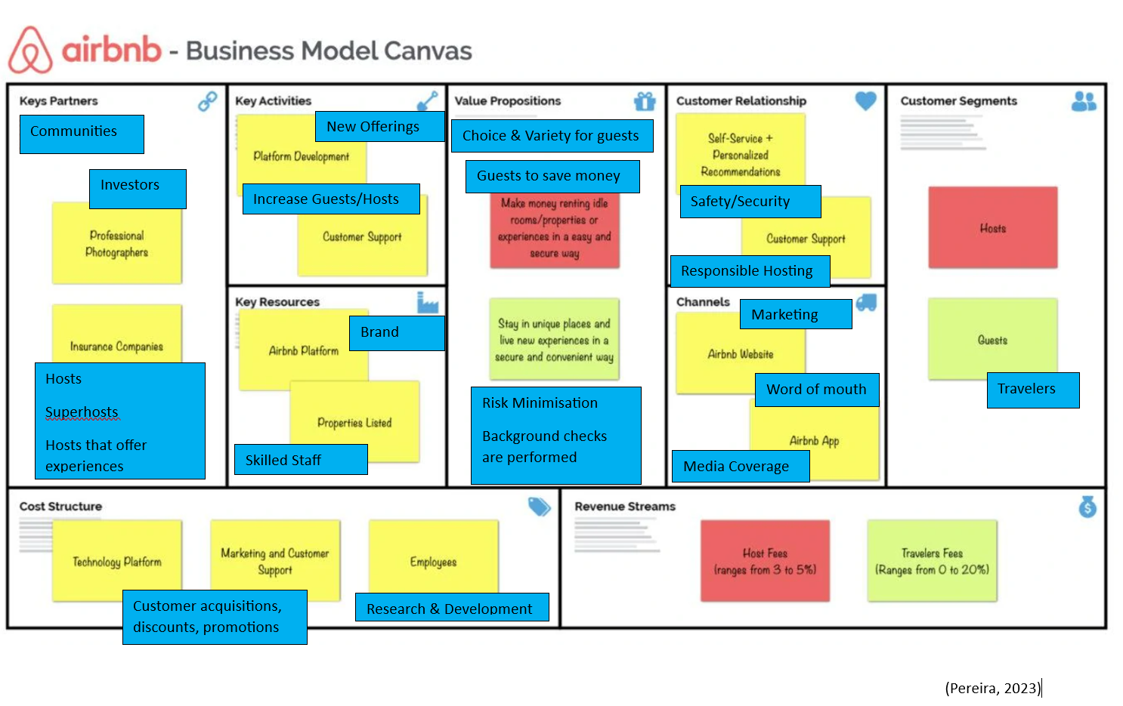

Key points to the contributions to Airbnbs Business model canvas are:
Hosts, Superhosts and hosts that offer experiences have been contributed to the business model canvas as they are key partners for Airbnb as without them there would not be offerings of unique stays and experiences.
New offerings have been included in key activities as Airbnb need to continue to offer new listing and services to entice guests and set itself apart from its competitors, as an example Airbnb established Airbnb Luke where according to Airbnb luxe (n.d.) is an array of immaculate, masterfully crafted residences including upscale conveniences, services, and committed travel coordinators.
In addition to value propositions a few remarks have been included such as with Airbnb stays guests are likely to save money as according to French (2023) for extended stays and larger groups, Airbnbs are typically less expensive than hotels, but they don't have the same amenities.
By utilising the Business Model Canvas Ramirez (2023) mentions that Airbnb may gain a better understanding of their business model, highlight opportunities for development, innovate and keep modifying its business plan to meet the changing demands of both hosts and guests.

Strategic Formulation Framework

Strategic Formulation Framework is according to Torlak & Sanal (2007) is a structure devised by Fred David for formulating strategies that aids in the generation of realistic options, their assessment, and the selection of a particular course of action. It is possible to include strategy formulation techniques into a decision making framework. This three-step framework, which consists of an input stage, a matching stage, and a decision stage, may be used to identify, assess, and choose strategies. According to David (2011) a three-stage decision-making framework can incorporate key strategy-formulation processes. The tools in this framework can assist in identifying, assessing, and choosing strategies, and are relevant to all organisations.
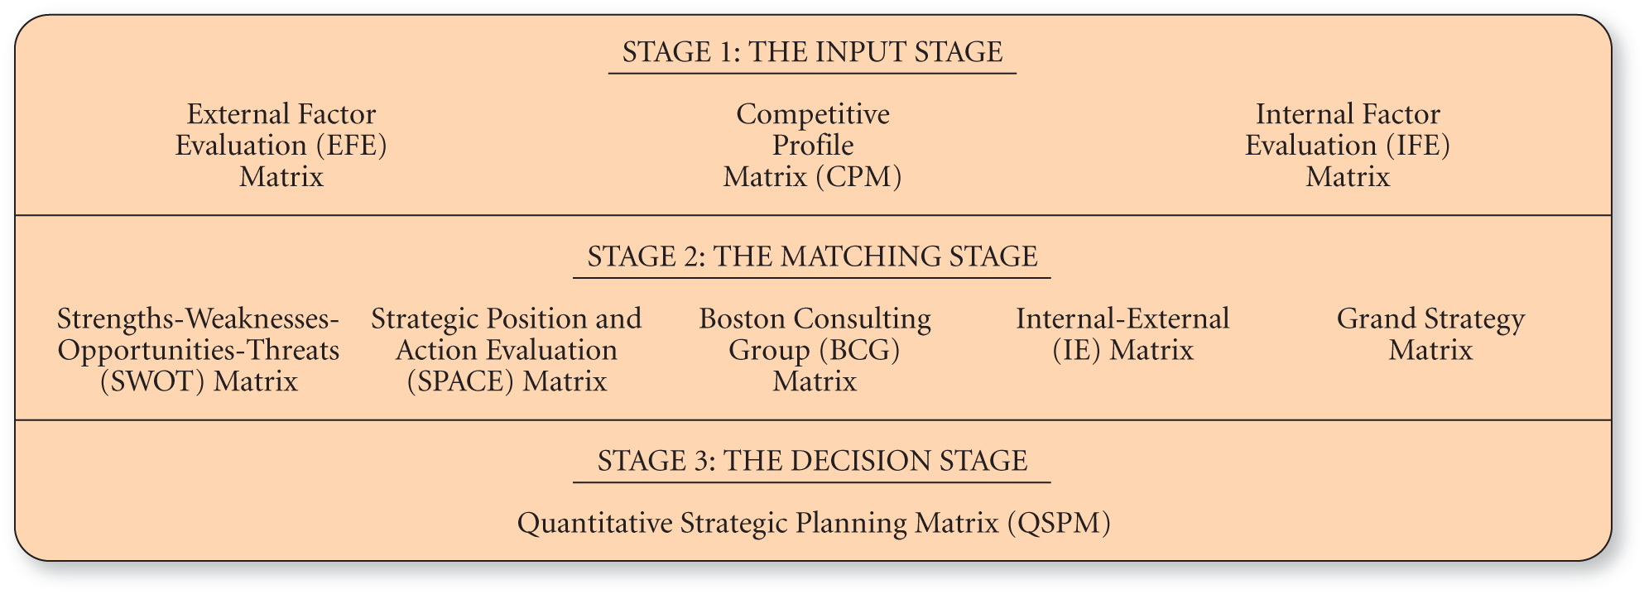
The three stages are demonstrated in the fig below.
(O`reilly, n.d.)
Within the formulation framework David (2011) explains that Stage 1 includes the Competitive Profile Matrix (CPM), the EFE Matrix, and the IFE Matrix. Stage 1, often known as the Input Stage, provides an overview of the fundamental input data required to develop strategies. The purpose of Stage 2, also known as the Matching Stage, is to align important external and internal components in order to generate workable alternative plans. The Strategic Position and Action Evaluation (SPACE) matrix, the Boston Consulting Group (BCG) matrix, the Internal-External (IE) matrix, the Grand Strategy matrix, and the Strengths-Weaknesses-Opportunities-Threats (SWOT) matrix are examples of stage 2 methodologies. Ther final stage which is stage 3 which is referred to as the Decision Stage: the Quantitative Strategic Planning Matrix (QSPM). A QSPM use Stage 1 input data to impartially assess workable alternative solutions found in Stage 2. A QSPM offers an objective foundation for choosing certain methods by exposing the relative attractiveness of many alternatives.
According to Wright (2023) during a certain phase of the strategic management cycle, usually the stage of strategy formulation and review, a strategic framework serves as a useful tool for businesses. By highlighting strengths, flaws and the optimal course of action, these frameworks provide insights into the corporate environment. Organisations may focus more clearly, handle complicated situations, and create a plan for long-term success by choosing or combining the best strategic frameworks. Utilising Strategic formulation framework can be beneficial to a company such as Airbnb as with its use of tools as according to Wright (2023) with an effective strategic plan, companies will begin to have data regarding which of its goals it is hitting and which are falling short as it begins to implement the strategic plan. At this stage, using a strategic framework makes it easier to assess the organization's present organisational strengths and weaknesses. In addition there are limitations to the use of the SFF tools such as each tool differentiates, whereas a swot analysis can look at strengths, weaknesses, opportunities and threats involved within an organisation, it fails to illustrate how to gain a competitive edge.

For the purpose of this report The Grand Strategy matrix will be the tool utilised, which will demonstrate where Airbnb strategic positioning is. A Grand Strategy Matrix is a tool that according to Smyth (2021) aids businesses identify many strategy alternatives based on the strength of their competitive positions and the expansion of their respective sectors. A combination of a company's competitive position and market growth is represented by each of the four quadrants that are divided by an x- and y-axis.

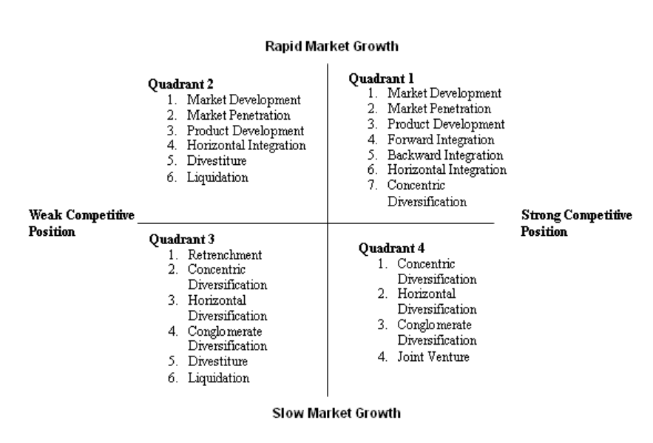
Grand Strategy Matrix
Airbnb
(Eco Travel, 2024)

It is advantageous for a business such as Airbnb to utilise a grand strategy matrix as according to Mabu (n.d.) it can assess its potential for growth and expansion in the market.
Within the grand matrix Airbnb currently sits within quadrant 1 as according to Ismail (2017) In a sector that is growing quickly, Airbnb has a tremendous competitive advantage. It should keep exploiting this advantage to accelerate its rate of growth. Furthermore, given Airbnb's significant market presence, Airbnb would need to concentrate on market penetration and development to keep its strategic advantage in quadrant 1. By ensuring use of market development Airbnb's reach will grow as a result of its ability to target consumers and other markets.
According to Marketwide Research (2024) with a projected global market share of $71.3 billion in 2020, the P2P accommodation business is one of the fastest-growing segments of the hospitality sector. From 2021 to 2026, the market is anticipated to expand at a compound annual growth rate (CAGR) of 15.4%, driven by the rising need for distinctive yet reasonably priced accommodation options. Airbnb currently holds according to Elad (2023) as of 2021 a market share of over 20% compared to its other competitors.

The market shares of a few of Airbnb's rivals are displayed in the figure below.
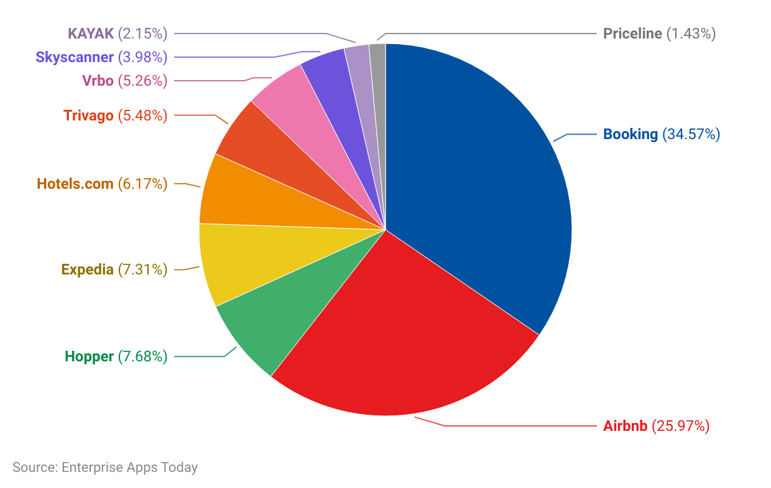
(Elad, 2023)

According to Ballard (2022) Statista mentions that the travel and tourism industry is predicted to expand at an annualised rate of 10.5% through 2026, with the travel and tourism industry being valued at $949 billion. With the travel and tourism sector expanding and a practically unlimited supply of accommodations on Airbnb's platform, there is an opportunity for Airbnb's business to expand and outperform its competitors.

Tools/Systems

With Airbnb being a platform based in digital business, it utilises tools/systems to support its business activities. Supply chain management is essential to Airbnb as it’s an element in their success which allows the firm to meet consumer demand for unique and distinctive travel experiences without sacrificing efficiency or sustainability. According to Tisa (n.d.) Dave Chaffey defines supply chain management as the collaboration of an organization's supply chain, ranging from its suppliers and partners to its consumer base
Apps associated with Supply Chain Management are according to Apps Run the world (n.d.) are:

- Advance Planning and scheduling

- Inventory Planning

- Logistics Management

- Supply Chain Management

Logistics management can support business activities as according to Fingent (n.d.) is part of the supply chain that employs planning and implementation to store and transport products and services to the consumer. The logistics management system manages inventory control, orders processing, supply and demand planning, and incoming and outbound transportation. Logistics software management would support Airbnb business activities as the software does inventory control which could keep track of all the listings that Airbnb have to offer and within this Airbnb will be able to plan the supply and demand for further listings to expand their business. According to Dudovskiy (2019) due to its entirely online business model, Airbnb's inbound logistics for its basic services only take a few minutes. In particular, hosts are able to market their homes or avail services on the platform in minutes. Due to the fact that hosts, not the corporation, provide guests lodging, experiences, and adventures, outbound logistics has even less bearing on Airbnb operations.

Enterprise Resource Management is according to Anderson (2023) is a software system that businesses utilise to integrate and manage the key components of their operations. In addition, an ERP software system can incorporate human resources, finance, sales, marketing, planning, buying inventory, and more. According to Apps Run the world (n.d.) the table below illustrates what software and applications are being used by Airbnb.

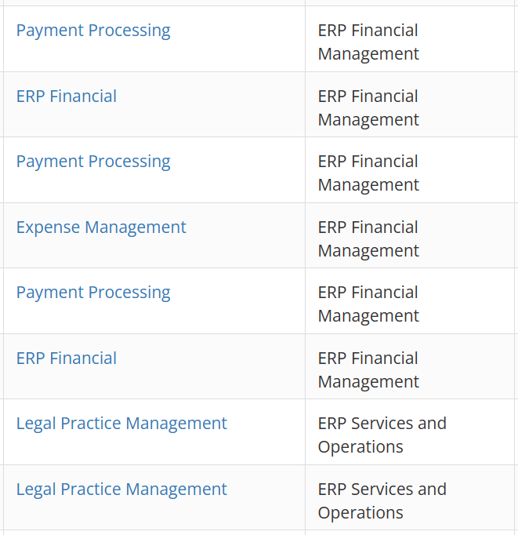
(Apps Run The World, n.d.)

With Airbnb utilising several Apps within ERP systems, payment processing is essential to have as according to App Master (2022) online payments are made possible by the software. After it is connected to a credit card, users may use it to make purchases. For every firm, it streamlines transactions and saves time. This is essential for Airbnb to have on their platform, for guests to purchase their services in a swift and convenient way.

Customer Relationship management systems is used according to Salesforce (n.d.) to manage a business's interactions and connections with current and future clients. Enhancing commercial connections is the clear objective. Businesses may increase revenue, optimise operations, and maintain client connections with the aid of a CRM system.

According to Apps run the world the table below shows the enterprise software and cloud applications being used by Airbnb UK

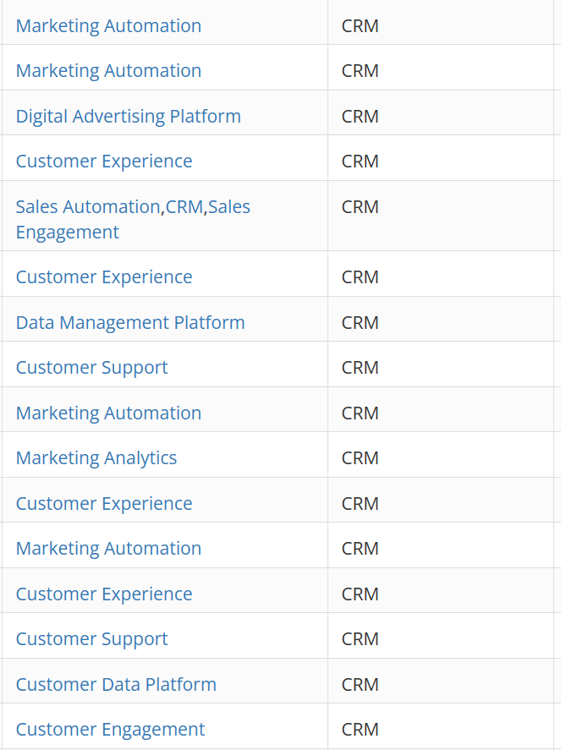
(Apps Run The World, n.d.)

Airbnb utilises several applications within CRM, Customer experience being one of them which according to Qualtrics (n.d.) which is a methodical strategy for enhancing how a company engages with and offers value to its consumers. It entails paying attention to what consumers have to say about the organisation and acting upon the knowledge the organisation acquires. By employing customer experiences, Airbnb will build a more devoted customer base, reduce the likelihood that customers will look for similar services and experiences elsewhere, encourage customers to give positive reviews and recommend its offerings, all of which will increase the value of the organisation.

Airbnb platform utilises several tools/systems to support is business activities the following being: according to Wallis (2023)

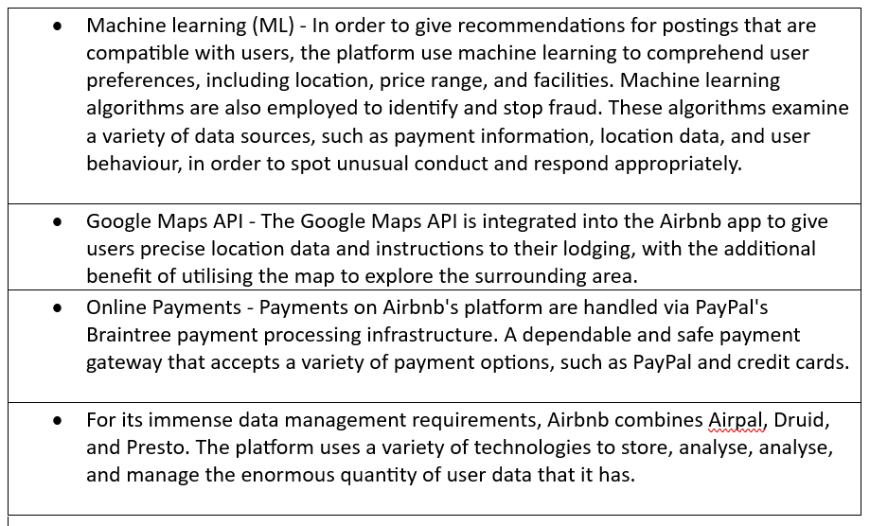

Conclusion

Airbnb is an essential component of the sharing economy; it has a strong market presence with future growth for its business as long as it continues to provide novel and unique services to its customer base, ensuring its business stands out from rivals. Using frameworks such as the Business Model Canvas can draw attention to possible areas for development and innovation. SFF implementation can help Airbnb with strategy identification, evaluation, and selection. Adoption of technology such as SCM, ERP, and CRM will aid Airbnb's business operations.

References

