Did the Eastern Cataphract Create a Lasting Legacy Within the Roman Military?
Discussion Essay.
Darren Tierney
16/03/2023
Level 5

The Roman military was a revolutionary force that swept the Mediterranean. During the time of the Roman expansion, we see multiple examples of adopted military traditions from conquered and opposing forces. One example adopted from the territories east of the Roman Empire is the cataphract, or clibanarii. The Collins Latin dictionary translates the word cataphract as a coat of mail, and cataphractus as wearing mail. The adoption of foreign tactics was not a new concept for the Roman Empire. The Roman Empire often made usage of local fighting customs and strategies in the form of auxiliaries. Haynes states that ‘it was capable of incorporating widely different peoples into its own network of power.’ This auxiliary system helped create the flexibility that the Roman military was renowned for. For this essay I will be using the term cataphract mainly, instead of its many translations and regional names, i.e ‘Kataphractoi’, ‘Grivpanvar’, ‘Catafractarii’, etc.
At the time of adoption, the cataphract was not a new concept by any means. Roman warfare with the east, and the steppes of the north, allowed Roman generals to experience the proficiency of ‘super-heavy’ cavalry when used as a sole force without an infantry backup. It is evident in sources that the cataphract was an eastern tradition. This concept was one that is argued to have propped up in several separate places at once in the Iranian/Sogdian area of the Asian continent. The earliest example of horse armour we can find comes from the Assyrians, but the cataphract was a concept that propped up in various places almost at once. This may be due to the reliance of cavalry and the rare resource that a pedigree warhorse would have been in that timeframe.
There could be no better way to protect your warhorse than to cover it with as much armour as it could reasonably carry. It could be argued that this tradition could be the reason that we see heavy cavalry in the west during the Middle Ages in such a large abundance, whereas before the introduction of the cataphract, lightly armoured cavalry reigned supreme. In this essay I will be discussing some of the primary sources we find that talks about Rome’s interaction with the Iranian cataphract, and if these interactions influenced a lasting impression and tradition on the Roman military.
We get few written descriptions throughout the classical age of the cataphract, and there is some sculpture that shows them in an artistic style. Trajan’s column goes into detail in bringing out the personality of the cataphract. In scene 31 and 37, we are shown the Sarmatian cataphract aiding the Dacian forces in the siege of a Roman fort. This iconography gives us a simple insight into the equipment of a Sarmatian cataphract, we have the scale mail coat for both the rider and the horse, a helmet for the rider and a bow as one of their weapons. Scott discusses that the conditions for a unit of heavy-cavalry to be considered a cataphract is somewhat vague in ancient sources. It is also a discussed topic among modern scholars, Scott writes, ‘Like all forms of warfare cavalry evolved due to the circumstances and enemies encountered by a nation, often simultaneously.’ This gives a good summary, the nature of adaptation to warfare had created branches that differentiate the Roman clibanarii, to the Sassanian cataphract, although both by definition can be considered cataphracts. This same concept is applicable for a Byzantine cataphract when compared to a Seleucid cataphract, and all other examples that fall under this umbrella.
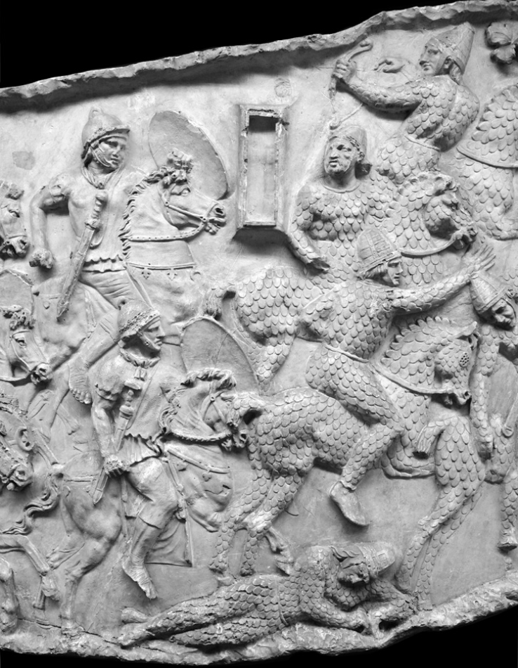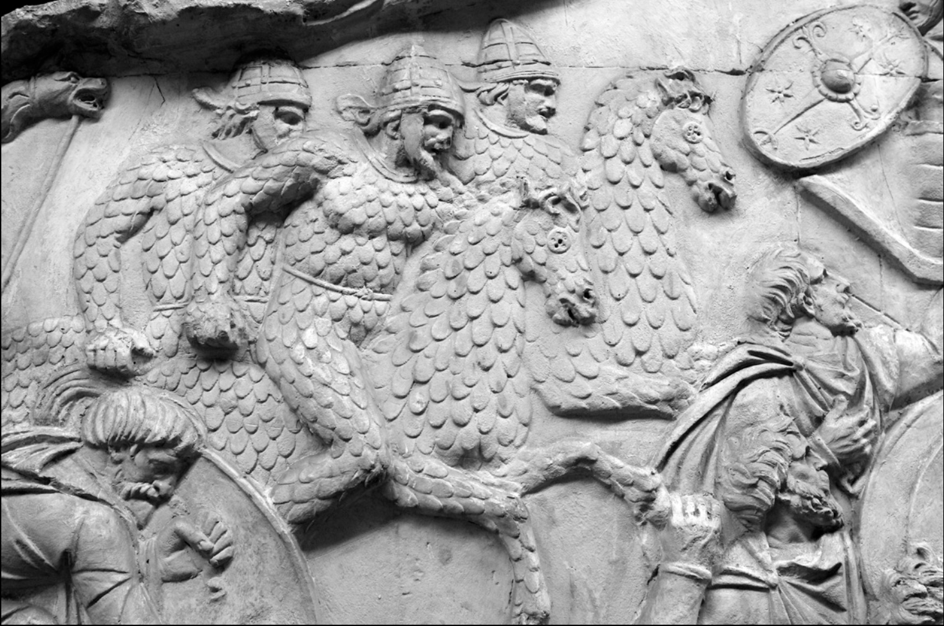
Description of cataphracts from ancient sources do prop up from time to time, while the type of armour and armaments they used varies from place to place, the concept remains the same, they are heavily armoured shock-cavalry. Ammianus Marcellinus writes,
‘All the troops were clothed in steel, in such a way that their bodies were covered with strong plates, so that the hard joints of the armour fitted every limb of their bodies; and on their heads were effigies of human faces so accurately fitted, that their whole persons being covered with metal, the only place where any missiles which fell upon them could stick, was either where there were minute openings to allow of the sight of the eyes penetrating, or where holes for breathing were left at the extremities of the nostrils.’
Julian writes about the Roman cataphract rider armour, although this goes into detail about the armour of the rider, there seems to be no reference to the armour of the horse itself,
‘Your cavalry was almost unlimited in numbers and they all sat their horses like statues, while their limbs were fitted with armour that followed closely the outline of the human form. It covers the arms from wrist to elbow and thence to the shoulder, while a coat of mail protects the shoulders, back and breast. The head and face are covered by a metal mask which makes its wearer look like a glittering statue, for not even the thighs and legs and the very ends of the feet lack this armour. It is attached to the cuirass by fine chain-armour like a web, so that no part of the body is visible and uncovered, for this woven covering protects the hands as well, and is so flexible that the wearers can bend even their fingers.’

Although the concept of armouring a horse is a simple one, the progenitor of a purely cavalry force was the Assyrians, instead of pulling a chariot that was previously popular in the bronze age. The chariots of this time were large war machines, pulled by multiple horses that could carry four men, the men were armoured, and the horses were armoured with either cloth or hair. The invasion by the Cimmerians of the kingdoms of Assyria, then the following invasion by the Scythians was a turning point in the development of the cataphract. The Scythians later allied with the Assyrian Empire before 637BC.The alliance between the Scythians and the Assyrians led to a sharing of technology, the Scythians shared their military might, the Assyrians shared their metal scale type armour. This ‘scale armour was so prized by the Scythians that the mounts of the wealthiest horsemen were even given the protection to cover the chests of the animals.’ The armour was fashioned in such a way that four layers of plates would have to be pierced by an arrow, spear or blade. The Massagetae were also recorded as using heavy armour for their cavalry, Herodotus says,
‘They make very extensive use of gold and bronze; they use bronze for the heads of their spears and arrows and for the blades of their sagareis, and gold to decorate their headgear, belts and chest-bands. The same goes for their horses too: they put bronze breastplates on their fronts.’
During the wars with the various Greek city-states the Achaemenid Persian Empire had employed the use of these heavy Scythian style cavalry. Anderson tells us that this war created veteran elite troops of nobility that began to increase the armour worn by the heavy cavalry, much like their nomadic foes. At this point the concept of a cataphract as a viable military unit had permeated the entirety of the Achaemenid Persian Empire, the ideology of an elite super-heavy cavalry had become a part of the eastern military culture. We find various examples early on of cataphract-like cavalry across the eastern Mediterranean. Due to the expansive campaign of Alexander of Macedon, the conquest of such a large area contributed to a large sharing of technology which included eastern heavy cavalry. For example we find record of Ptolemy II giving the Greeks mercenaries he acquired. These horsemen had been completely covered in felt armour, it covered the whole body except from the eyes on the horse, and the riders were most likely as equally as armoured. While not traditionally armoured in the eastern style of the cataphract, this outfitting is eerily similar. Although much later, this could be considered a proto-cataphract in the same fashion as the early Scythian proto-cataphracts.
The Seleucid Empire were famous for their elite cataphract unit, Rome had many battles with the Seleucid Empire. By the time of the next subject of discussion, the Battle of Carrhae, cataphracts would have not been a foreign concept to the Roman military. Grainger writes that Antiochus III of Seleucia had a ‘newly developed force of cataphracts…. They were more heavy armoured than usual so could be used as shock troops… He regarded the cataphracts as the battle winning weapon’ during his battle with Scipio of Rome. In this battle Rome won outright, the cataphracts proved ineffective against the Roman battle formation, this may have contributed to Rome’s general ignorance to the concept of a cataphracts use in battle as an effective tactic.
The Battle of Carrhae is the first real interaction we have of the Roman-Parthian war of 54BC-217AD. Marcus Licinius Crassus led an incursion into Parthian territory. The Roman forces made many mistakes which led to their defeat, although the cataphracts of the Parthian forces were the deciding factor in the defeat of the roman forces, some scholars such as Eadie suggest that it was the Roman mismanagement of tactics that was the cause for the defeat and not the military forces of the Parthians themselves. Crassus is led to the desert outside the city of Carrhae, ignoring advice from his closest advisors he decides to pursue the Parthians deeper into the desert. The outcome is effectively decided at that point, they were fighting with a foreign force on foreign territory, and up against tactics that Crassus army was simply unprepared for.
The Battle of Carrhae itself is recorded in two ancient sources, we have Plutarch’s Lives, book III, and Roman History by Cassius Dio, book XL. Both of the sources have some minor differences, but they effectively portray the same events similarly. Sampson writes that ‘Plutarch presents us with a far more realistic description of the Battle of Carrhae,’ and I can agree with the statement, there is far more detail in Plutarch’s accounts when compared to Cassius, but that does not mean Cassius accounts should be dismissed, they have value as a secondary reference to the battle.
The key phrases that we can take from these sources are the descriptions of the Parthian cataphract cavalry, Plutarch describes them as a ‘thousand mail-clad horsemen’, ‘blazing in helmets and breastplates, their margianian steel glittering keen and bright, Horses clad in plates of bronze and steel’. Cassius describes them as ‘their forces consist of mounted archers and pikesmen, mostly in full armour.’ The imagery is the same, this force is a large amount of mailed cataphracts wielding pikes. Plutarch’s description of ‘margianian’ steel seems to insist on a regional steel of higher quality, and points towards crucible steel of the city Merv, Feuerbach describes this in detail in her thesis of Damascus steel. Plutarch writes, ‘horses hard to move owing to the weight of their armour’, although Plutarch is telling us of the remarkable concept of the cataphract, he is still noting that the armour heavily hampers the movement of the horse.
It is unclear if the horse archers also don the iconic armour of the cataphract, as we have spoken about previously. There are many different armours that would be sufficient for their utility, for a light armour leather or felt would be applicable here. The Parthian cataphract equipped some form of metal due to the gleam that the Parthian forces gave off after removing their cloth coverings as Plutarch describes. Sampson tells us that the Parthian army was fronted by one thousand cataphracts, ‘clad in heavy armour and armed with long lances, superficially resembling medieval knights and far superior to the Roman cavalry.’ In reference to this battle being a turning point for the Roman attitude to cavalry, Eadie writes, ‘The disaster at Carrhae served to demonstrate, however, the vulnerability of the legions to cavalry attack and the necessity of strengthening the Roman cavalry, which had been neglected since the military reforms of Marius.’

Eadie writes, ‘The principal credit for this major cavalry innovation must be assigned to Hadrian’. The Roman adoption of the cataphract was a slow process, the men seemed to have given the form of the cataphract a pet name, the clibanarii or ‘Camp-oven bearers’ as it somewhat translates to. This was likely a reference to how hot it would have been to wear that amount of armour for long periods of time, the word clibanarii itself could be taken as humour. The Roman’s had an advantage, they were masters at adopting military tactics and technologies and incorporating it into their own forces. Sometimes this was by the auxiliary system and other times they were adapted by the core roman legions. Even in the most barbarous of enemies, where Rome saw value, they capitalised on the concept. Haynes explains, that Arrian indicates Rome’s cavalry is ‘enriched by so many exotic borrowings, characterizes the spirit that made the Empire great.’
The concept of adaptation is not a new one for the Roman army, and this aspect could be argued to contribute to Rome’s success. We find records of the use of cataphracts in the Roman military, and such notables are the introduction of cataphracts in places as far as the British isles by Hadrian. Eadie writes ‘the Romans adopted the vocabulary of eastern cataphract warfare, but modified the armour to meet Roman requirements’. While it could be argued Roman cataphracts may not have been used to the same effectiveness as their Parthian or Sarmatian counterparts, the reform that took place because of the interaction with these empires changed the way that Rome looked at cavalry. Negin and D’Amato Write, ‘In his Panegyric, Nazanzius states that the catafracti were trained to maintain their momentum after they crashed like a ram (arietare) into the enemy’s line, and ‘since they are invulnerable they resolutely break through whatever is set against them’.’And although cataphracts seemed to be effective when deployed properly, they changed far more than just adding a different style of military to the belt of Rome. Eadie writes that ‘the protection afforded by the coat of mail might well justify adoption’ by the Roman Military. Ammianus gives us a description of the Roman Cataphracts under Constantius rule, as he arrives at Rome. Ammianus writes,
‘Among these were scattered cavalry with cuirasses, whom the Persians call Clibanarii, protected by coverings of iron breastplates, and girdled with belts of iron, so that you would fancy them statues polished by the hand of Praxiteles, rather than men. And the light circular plates of iron which surrounded their bodies, and covered all their limbs, were so well fitted to all their motions, that in whatever direction they had occasion to move, the joints of their iron clothing adapted themselves equally to any position.’
Eadie writes that we have little knowledge of the actual armaments of the Roman deployed cataphracts and argues that they simply wore a coat of mail and carried a ‘contus’ spear. Due to the lack of information mentioned in the Notita Dignitatum, all we can get from the source is the distribution of the cataphract corps, there is mainly a focus on distribution in the east, possibly as an answer to the Persian forces. Eadie explains that the cataphracts were recruited from both the eastern and western provinces, showing that the monopolisation of the cataphract in the east was phased out gradually in the Roman empire. Negin and D’Amato tell us, under Hadrian was the first emperor to fully introduce the cataphract into the Roman military, the unit had either a strength of 480 or 960 men, Eadie describes this cataphract to be a mailed Contarius so there is no distinction on what exactly the armaments of this cavalry unit would have been. Although the terminology is difficult to discern, this is a Roman cataphract at its core, it is a valid development adopted from the Iranian Empires and steppe nomads. Eadie summarises his findings into a good conclusion and writes the following,
‘The adoption of the clibanarius in the fourth century is another matter. Units of these highly specialized horsemen probably were created not only to match Persian tactics-the primary stimulus-but also to attain tactical superiority vis-a-vis the majority of Rome's enemies.’

The last time we see a Roman nation leading a force of these now classically roman military forces is within the Byzantine Empire. The Byzantine cataphracts were an elite troop, and they were some of the finest outfitted cavalries in medieval Europe. Although the cataphract is somewhat outdated at this point, they are still a relevant part of Byzantines military tradition. According to Scott, the Byzantine army did not fully utilise the cataphracts until the age of reconquest of the 10th century. Before this point the Byzantine empire relied mainly on lancers, they doubled as bowmen and were lightly armoured due to the nomadic tribes they were fighting against.
In a conclusion, Eadie Tells us, ‘The Roman experiments with mailed cavalry, especially the clibanarius, ended in failure’. When reviewed at face value Eadie is correct, but in the greater sense the cataphract may have introduced the ideology of the importance of heavy cavalry in pitched battles. The cataphract contributed to the reforms that Rome had put in place to counter the crippling defeat at Carrhae. The Roman introduction and adaptation of the cataphract although thought of as a failure, led to more overarching look at Rome’s then outdated cavalry, and led to the cavalry we see in late antiquity, and the technologies that came with the Iranian cataphract. Scale bronze and iron being used in vast amounts, which could be likened to a medieval knight. While the initial effect of the reforms did contribute to the experimentation with ‘super-heavy’ cavalry, it seems to have mostly faded out before being brought back to wage war with the Saracens of the 10th century as Scott has investigated. Did the Eastern Cataphract Create a Lasting Legacy Within the Roman Military? I believe the answer is twofold, the cataphract itself did not have much of an impact on the Roman military as a unit of worth as it was a logistical nightmare and bound to pitched field battles, but the cataphract did have a major part to play in the reforms of Rome’s military and innovations. Rome’s experimentation with the unknown is one of the aspects of their Romanitas, and a strong aspect that made Rome arguably the most iconic empire that had waged war in the ancient world.

Bibliography

Primary Sources
Ammianus Marcellinus, The Roman History of Ammianus Marcellinus, Trans. C. Yonge, Unpublished eBook, available at https://www.gutenberg.org/files/28587/28587-h/28587-h.htm [Accessed 16/03/2023]
Cassius Dio, Roman History, Volume III: Books 36-40, Trans. E. Cary, H. Foster, Loeb Classical Library 53, (Cambridge: Harvard University Press, 1914)
Julian, Emperor of Rome, The Works of the Emperor Julian (Vol. 1 of 2), Trans. W. Wright, (Cambridge: Harvard University Press, 1913), Available at https://www.gutenberg.org/files/48664/48664-h/48664-h.html#noteref_178 [Accessed 16/03/2023]
Plutarch, Plutarch’s Lives Vol.3, Pericles and Fabius Maximus, Nicias and Crassus, Trans. B. Perrin, (London: Heinemann, 1915),

Secondary Sources
Anderson, E., Knights of the Ancient Eastern Empires, (Barnsley: Pen & Sword Military, 2016)
Basset, S., The Death of Cyrus the Younger, Classical Quarterly, 49.2 (1999), 473-483
Beckmann, M., Trajan’s Column and Mars Ultor, The Journal of Roman Studies, 106, (2016) 124-146
Eadie, J., The Development of Roman Mailed Cavalry, The Journal of Roman Studies, 57, 1/2, (1967), 161-173
Feuerbach, A., Crucible Steel in Central Asia: Production, Use and Origins, Unpublished PhD thesis, University College London Institute of Archaeology, (2002)
Grainger, J., The Seleucid Empire of Antiochus III (223-187BC), (Barnsley: Pen & Sword Military, 2015)
Haynes, I., Blood of the Provinces: The Roman Auxila and the Making of Provincial Society From Augustus to the Severans, (Oxford: Oxford University Press, 2013)
Kidd, D., Collins Gem Dictionary, Latin-English, English-Latin, ed. W. McLeod, (London: Harper Collins Publisher, 1957)
Negin, A., D’Amato, R., Roman Heavy Cavalry (1): Cataphractarii & clibanarii, 1st Century BC-5th Century AD, (London: Bloomsbury Publishing, 2018)
Scott, E., The Changing Role of the Cataphract in the Byzantine Army, The Student Researcher, 4, 1, (2017) 19-30
Sampson, G., The Defeat of Rome: Crassus, Carrhae and the Invasion of the East, (Barnsley: Pen & Sword Military, 2008)

Online Images
Ulrich, R., Photograph, Trajan’s column scene 37, 2017, Online Image, Available at http://www.trajans-column.org/?page_id=107#PhotoSwipe1679600004139 [Accessed 18/03/2023]

Ulrich, R., Photograph, Trajan’s column scene 31, 2017, Online Image, Available at http://www.trajans-column.org/?page_id=107#PhotoSwipe1679600271640 [Accessed 18/03/2023]

J. Eadie, The Development of Roman Mailed Cavalry, The Journal of Roman Studies, 57, 1/2, (1967), 161-173, p. 173
D. Kidd, Collins Gem Dictionary, Latin-English, English-Latin, ed. W. McLeod, (London: Harper Collins Publisher, 1957), p. 47
I. Haynes, Blood of the Provinces: The Roman Auxila and the Making of Provincial Society From Augustus to the Severans, (Oxford: Oxford University Press, 2013) p. 2
Haynes, Blood of the Provinces, pp. 70-72
E. Anderson, Knights of the Ancient Eastern Empires, (Barnsley: Pen & Sword Military, 2016) pp. 1-13
Anderson, Knights of the Ancient Eastern Empires, p. 17
M. Beckmann, Trajan’s Column and Mars Ultor, The Journal of Roman Studies, 106, (2016) 124-146
E. Scott, The Changing Role of the Cataphract in the Byzantine Army, The Student Researcher, 4, 1, (2017) 19-30, p. 21
R. Ulrich, Photograph, Trajan’s column scene 37, 2017, Online Image, Available at http://www.trajans-column.org/?page_id=107#PhotoSwipe1679600004139 [Accessed 18/03/2023]
R. Ulrich, Photograph, Trajan’s column scene 31, 2017, Online Image, Available at http://www.trajans-column.org/?page_id=107#PhotoSwipe1679600271640 [Accessed 18/03/2023]
Ammianus Marcellinus, The Roman History of Ammianus Marcellinus, Trans. C. Yonge, Unpublished eBook, available at https://www.gutenberg.org/files/28587/28587-h/28587-h.htm [Accessed 16/03/2023] P. 375
Julian, Emperor of Rome, The Works of the Emperor Julian (Vol. 1 of 2), Trans. W. Wright, (Cambridge: Harvard University Press, 1913), Available at https://www.gutenberg.org/files/48664/48664-h/48664-h.html#noteref_178 [Accessed 16/03/2023] pp. 98-100
Anderson, Knights of the Ancient Eastern Empires, p. 6
Anderson, Knights of the Ancient Eastern Empires, p. 6
Anderson, Knights of the Ancient Eastern Empires, p. 8
Anderson, Knights of the Ancient Eastern Empires, p. 8
Anderson, Knights of the Ancient Eastern Empires, p. 8
Anderson, Knights of the Ancient Eastern Empires, p. 8
Anderson, Knights of the Ancient Eastern Empires, p. 14
Anderson, Knights of the Ancient Eastern Empires, p. 16
Anderson, Knights of the Ancient Eastern Empires, p. 27
S. Basset, The Death of Cyrus the Younger, Classical Quarterly, 49.2 (1999), 473-483, p. 482
Anderson, Knights of the Ancient Eastern Empires, pp. 7-13
J. Grainger, The Seleucid Empire of Antiochus III (223-187BC), (Barnsley: Pen & Sword Military, 2015), pp. 181-182
Eadie, The Journal of Roman Studies, p. 164
Plutarch, Plutarch’s Lives Vol.3, Pericles and Fabius Maximus, Nicias and Crassus, Trans. B. Perrin, (London: Heinemann, 1915)
Cassius Dio, Roman History, Volume III: Books 36-40, Trans. E. Cary, H. Foster, Loeb Classical Library 53, (Cambridge: Harvard University Press, 1914)
G. Sampson, The Defeat of Rome: Crassus, Carrhae and the Invasion of the East, (Barnsley: Pen & Sword Military, 2008), p. 124
Plutarch, Plutarch’s Lives Vol.3, p. 379
Plutarch, Plutarch’s Lives Vol.3, p. 387
Cassius Dio, Roman History, Volume III: Books 36-40, p. 427
A. Feuerbach, Crucible Steel in Central Asia: Production, Use and Origins, Unpublished PhD thesis, University College London Institute of Archaeology, (2002) pp. 257-258
Plutarch, Plutarch’s Lives Vol.3, p. 394
Plutarch, Plutarch’s Lives Vol.3, p. 387
Sampson, The Defeat of Rome, p. 120
Eadie, The Journal of Roman Studies, p.164
Eadie, The Journal of Roman Studies, p. 167
Eadie, The Journal of Roman Studies, p.169; I, Haynes, Blood of the Provinces, p. 92, 307; Scott, The Student Researcher, p. 20
Haynes, Blood of the Provinces, p. 240
Haynes, Blood of the Provinces, p.240
Eadie, The Journal of Roman Studies, p.169
Eadie, The Journal of Roman Studies, p.168
A. Negin, R. D’Amato, Roman Heavy Cavalry (1): Cataphractarii & clibanarii, 1st Century BC-5th Century AD, (London: Bloomsbury Publishing, 2018), p. 45
Eadie, The Journal of Roman Studies, pp. 164-165
Eadie, The Journal of Roman Studies, p.173
Ammianus Marcellinus, The Roman History of Ammianus Marcellinus, p. 101
Eadie, The Journal of Roman Studies, p. 169
Eadie, The Journal of Roman Studies, p. 169
Eadie, The Journal of Roman Studies, p. 169
Negin, D’Amato, Roman Heavy Cavalry (1), pp. 36-37
Eadie, The Journal of Roman Studies, p. 173
Eadie, The Journal of Roman Studies, p. 173
Scott, The Student Researcher, pp. 22-23
Eadie, The Journal of Roman Studies, p. 173
Scott, The Student Researcher

