Student Name: Bogdan Ioan Sigheti
Student Number: 1817824
Lecture Name: Paul Wallin
Module Code: BMSK4003
Title: Virtual Learning Environment
Module Name: Digital Skills and Research Method

Table of Content……………………………………………………………………………
Introduction…………………………………………………………………………………1
Methodology……………………………………………………………………………….2
Primary data…………………………………………………………………………….....3
Secondary data…………………………………………………………………………….4
Objectives…………………………………………………………………………………….5
Recommendation…………………………………………………………………………6
Rationale………………………………………………………………………………………7
Conclusion…..……………………………………………………………………………….8
Reference.……………..……………………………………………………………………..9

Introduction
Definition: A Virtual Learning Environment (VLE) is a framework for passing on learning materials to understudies by strategies for the web. These frameworks meld evaluation, understudy following, coordinated effort and explicit mechanical gatherings. They can be gotten to both on and off-grounds, proposing that they can strengthen understudies' learning outside the lobby 24 hours reliably, seven days out of consistently. This connects with foundations to show standard full-time understudies similarly as the individuals who can't routinely visit the grounds because of geographic or time limitations, for example those on separation learning courses, doing evening classes, or laborers thinking low support.
A virtual learning environment (VLE) in instructive innovation is a Web-based stage for the automated pieces of courses of study, generally inside instructive establishments. They present assets, exercises and communications inside a course structure and accommodate the various phases of evaluation. VLE's additionally generally report on support; and have some degree of joining with other institutional frameworks.
For teachers who alter them VLE's may have a true job as creating and structure situations.VLE's have embraced practically advanced teaching establishments in the English-talking world.
Methodology
Teaching methodology - essential benchmarks: The education process speaks to the entire of the instructional-instructive exercises, teachers.
The didactics (or approach) has as study object - the general issue of the instructive procedure from the perspective of:
- The substance of the training procedure: the volume and nature of information;
- The innovation of the training procedure: standards, strategies, means types of association of the instructive procedure;
- Teacher-understudy relationship composed, arranged and led in useful foundations, under the coordination.
Teaching - In present day start, showing means complex activities also, showing practices with the job of deciding learning (apud Nicola, 1996), when looking at educating, we consider the additional instructing styles:
Authoritarian: the teacher with powerful power has two sorts of approaches: approach difficult (scary, embarrassing, controlling replacements), more and more sensitive methodology (disappoints, limits, disappoints the replacement).
Detached: the instructor without control, paying little mind to class, the understudies exploiting his indifference.
Democratic: the main teacher is leader and upright to the class movement, forcing himself by form of mind and individual model.
Learning: Active assimilation of data (by defying dangerous situations also, beneficial experience) for versatile purposes. At the point when we talk about learning, we will essentially think about the sorts of learning.
These are gathered by:
1. Psychic forms included:
- Aware learning (careful concentration of data)
- Mechanical learning (data storing as it were)
2. The most effective method to buy data:
- Receptive learning
- Passive (mechanical)
- Active (knowing)
- Learning through revelation (through one's very own understanding, investigation)
- School learning happens in the useful procedure and is a movement
methodical, coordinated, concentrated, in which the experience is academically sorted out in a few phases:
A. Getting material
B. Recording of information
C. Understanding the material
D. Fixing the material
E. Refreshing of the material by spread or usage.
Didactic evaluation: Procedure of estimation, evaluation and choice with respect to the consequences of the procedure training. After the minute when the assessment is done, three structures can be recognized assessment.
Initial: • Continuous (developmental);
• Final (summative, accounting report).
Primary Data:
Definition: According to (Bouras and Tsiatsos, 2019) primary sources are not simply archiving and composed records. There are a wide range of sorts of essential sources, including: first-individual records, archives, physical antiques logical information that has been gathered yet not translated.
Formats of Primary Sources:
Audio — oral accounts or journals, interviews, music
Images — photos, recordings, film, fine art
Objects — apparel (style or regalia), instruments, stoneware, tombstones, creation, weapons, memorabilia Statistics — enumeration information, populace insights, climate records
Text — letters, journals, unique archives, legitimate understandings, arrangements, maps, laws, promotions, plans.
Using primary sources:
Advantage: Primary sources clearly address your topic and as often as possible give information that is difficult to reach elsewhere. For example, the requests you make for a gathering or an audit will likely concentrate on your remarkable energy for the point. Additionally, to test a theory, you can design your own special examination.
Disadvantage: Some basic sources, for instance, eyewitness accounts, may be extremely close to the subject, missing the mark on a fundamental division. Others, for instance, gatherings, studies, and assessments, are depressing to design, manage, and research.

Finally, aside from on the off chance that you have been set up in recognized frameworks, your own special basic research in explicit fields of study may not be generous.
Primary data collection methods: Interview method, Observation method, Telephone surveys, Questionaries’ method, Schedule method.

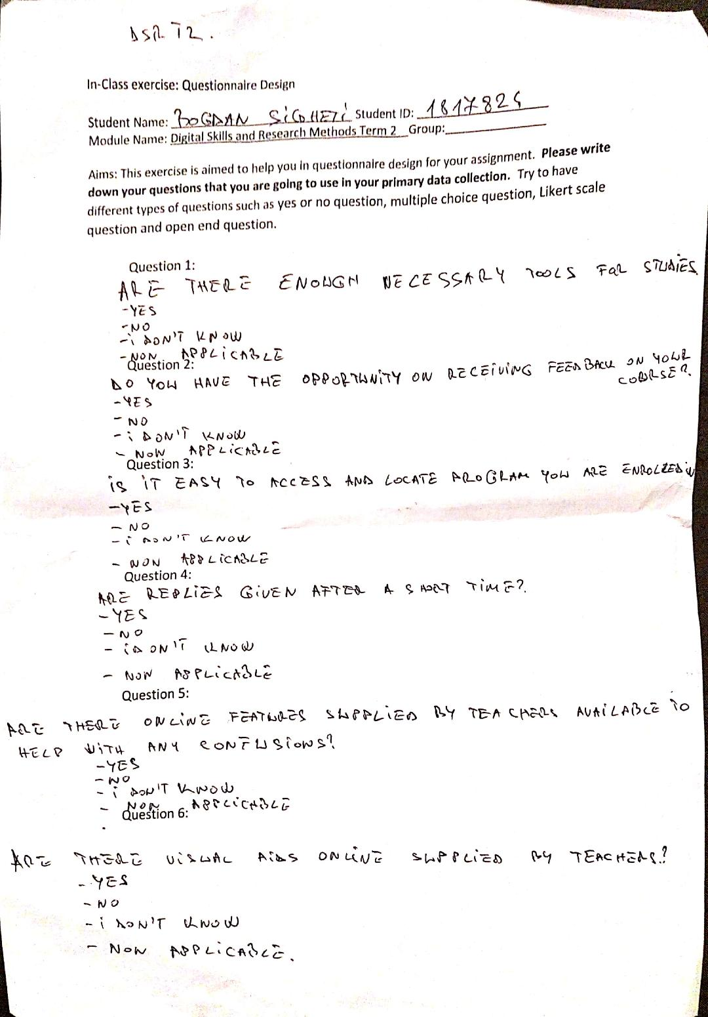

Secondary Data:
Definition: According to (Carlsson & Hagsand, 1993) secondary sources describe, talk about, read, comment upon, examine, survey, consolidate, and process basic sources. An secondary source is normally at any rate one phases removed from the event or time span and are created or conveyed a while later with the upside of knowing the past. Secondary sources routinely don't have the freshness and nearness of the main material. Every so often, helper sources will accumulate, form, and repackage basic source information to extend usability and speed of transport, for instance, an online reference book. Like basic sources, helper materials can be formed or non-made (sound, pictures, movies, etc.).
Formats of Secondary Data:
- Reference books, including dictionaries, encyclopedias, and atlases
- Articles from magazines, journals, and newspapers after the event
- Literature reviews and review (e.g., movie reviews, book reviews)
- History books and others popular or scholarly books
- Works of criticism and interpretation
- Commentaries and treatises
Using secondary data sources:
Advantage: The best favored situation of using optional data is that it will when all is said in done be logically sensible. Another person has as of late gathered the information, so the analyst doesn't need to give cash, time, importance and points of interest for this season of research. Now and again the right hand instructive record must be obtained, yet the expense is routinely lower than the cost of get-together a for all intents and purposes blurry educational document with no arranging, which if all else fails incorporates pay rates, travel and transportation, office space, gear, and other overhead costs. As Well, since the data is starting at now accumulated and ordinarily cleaned and set away in electronic connection, the ace can contribute an epic bit of their importance detaching the data instead of setting up the data for assessment.
Disadvantage: A huge issue of using discretionary data that it may not answer the master's ask about inquiries or contain express data that the star ought to have. It like way most likely won't have been gathered in the geographic area or during the years required, or with the majority that the master is eager about investigating. For instance, an analyst who is enthused about examining youngsters may find that the partner enlightening arrangement just unites energetic adults.
Objective.
- Recognizing understudies' learning status or issues for delivering flexible learning by breaking down their learning practices or intelligent substance and giving customized learning substance or practices.

- Empowering approach producers and chairmen to have a worldwide perspective on current instructive arrangements or issues by examining huge scale instructive information to recognize significant pointers for assessing the instructive status from neighborhood, territorial, national or universal viewpoints.

- Empowering specialists or educators to have bits of knowledge into understudies' cooperation’s with courseware, companions and instructors by breaking down their practices from top to bottom perspectives, for example, bringing up an issue with logical originations, looking for data identified with a particular issue, mentioning objective facts and correlations, proposing new thoughts or presenting a right answer.
- Giving proof to clarify understudies' learning execution in instructive settings by breaking down the learning personal conduct standards of various gatherings of understudies; for instance, for what reason does one gathering of understudies have better learning accomplishments.

Recommendation
According to (Koubek, Laister, Kober, et.all 2001) the Internet assumes a significant job in the lives of adolescents and youngsters all through the world, both in its quality as a social relic, yet in addition as its very own culture.
Similarly, young people structure a gathering of people, non-same, socially, who embrace extraordinary segments of the Internet, for various purposes and the selection of digitalization involves the plausibility the cooperation of youngsters in building another data society, with the point of helping them to consummate their way of life of associativity and to express their personality, as a requirement for improvement in the virtual space, where the social meets the innovation, making in this manner trades simple among open and private space.
Rationale
People are goal driven beings and get rapidly on the abilities and perspectives on other people who affect their careers. If managers and teaching staff don't utilize e-Learning, are accusing of it as a learning device or describe it as a second-rate learning technique, their associates will frequently take on similar perspectives.
There will consistently be people who use e-Learning out of close to home premium however association wide take-up will be driven by the perspectives and activities of the people who are in a situation to impact and sort out.
On the off chance that administrators and encouraging staff are ridiculing of e-Learning it might be down to mindfulness, preparing and poor individual experience. The issues can be analyzed and activity by senior leaders to advance a progressively uplifting manner towards the circumstance can be taken.
In any change program it is significant for change leaders to know how associates feel about the new initiative. The primary stage for any change head is to see completely the relationship that people have in connection to the new initiative. Are those people mindful of their job? What is their opinion about it? Is it true that they are focused on the new activity or will they just go along or more regrettable, contradict? There are numerous devices that change heads can use to assist them with diagnosing issue zones and settle on the best move to make.
People participate and learn in online in which communication and collaboration are central features for understanding the social activities. Some people associate computers with information providers, but more often computers and the internet are used as tools for communication.

Conclusion
My primary theory that was that the advances that I would recognize in the manners by which youngsters utilized the innovation, and the advances it created in their knowledge would identify with their capacity to deal with, present and procedure information.
They survey I conducted for the in-class exercise on my colleagues about the virtual learning environment on students in schools university I have came to of final decision that the VLE is a very good and a most for every students from everywhere is beneficial for the 21st century for our learning we can access every information everything we want to learn we can expend our knowledge and improve our skills our vision about everything.
The challenges for teachers in class is that of presenting curriculum and learning process in ways which will all be enable all to successes.

Reference
Bouras C, Philopoulos A, Tsiatsos T (2001, July) E-learning through distributed virtual environments. J Netw Comput Appl, Academic, 24(3):175-199.
Broll W (1997, June 18–20) Bringing people together—an infrastructure for shared virtual worlds on the internet. In: Proc. of the IEEE WE-TICE '97 (Sixth international Workshop on Enabling Technologies: Infrastructure for Collaborative Enterprises). Cambridge, Massachusetts, USA, IEEE Computer Society, Las Alamito.
Carlsson C, Hagsand O (1993) DIVE: a multiuser virtual reality system. In: Proc. of IEEE 1993 virtual reality annual international symposium, VRAIS '93, IEEE Service Center, Piscataway, New Jersey, pp 394–400
Dalgarno B (2002, August) The potential of 3D virtual learning environments: a constructivist analysis. e-JIST Electronic Journal 5(2)
Koubek A, Laister J, Kober S, Modera W, Aichinger R, Goren-Bar D, Aviram R, Comay O, Lior E, Kempf F, Leukert S, Wöhr A, Kumm J, Beckmann H, Kuljis J, Cohen A, Chen Ch, Lehmann H (2001, February 26) User processes in collaborative learning and basic user requirements for INVITE. Deliverable of INVITE (Intelligent Distributed Virtual Training Environment) project of the European Commission, INVITE Document Number: T2.1/T2.2-D.2.1-TJ-005

