

Non-profit Organizations

Social Housing and Support Services

Table of Contents

- Reflective commentary………………………………………3
- Introduction…………………………………………………..7
- Mission statement…………………………………………….9
- Values………………………………………………………..10
- Mental Health and Substance Misuse Services……………...11
- Photos……………………………………………………..…13
- References……………………………………………………15

Reflective Commentary.

When we were first told in university that we had to find a place to volunteer at, I immediately knew where I would like to go to experience being a volunteer. Hazel court is a unique and wonderful place that does extremely important work in our community. And although this opportunity was made almost impossible by the pandemic, I still got the chance to experience and view the wonderful ways the staff at Hazel court help so many vulnerable and needy people. I have been lucky to have spent time in Hazel court over the last few years and have experienced the “family” atmosphere among the people living there and the surrounding community. Caredig has replaced Family Housing as the company's name. They state that ‘Caredig is who we are, and it means "kind" in Welsh.’
Using the Gibb’s framework (1998), I will reflect on my time spent learning and growing from my experiences over the 5months I spent volunteering from afar during the covid pandemic and whilst the world was shut down and inaccessible to so many of us. Kolb's experiencing cycle served as the foundation for Gibbs' reflective cycle. (Kolb, 1984) and is regarded as the model that health care experts use the most. Because of the pandemic, Hazel Court was closed to visitor and volunteers, with a skeleton workforce. Luckily for me, my supervisor and mentor Mrs Sian Hilton, was working remotely and was more than willing for me to join her for my experience. Daily covid tests and mask wearing was mandatory, but even after these precautions there was still a huge obstacle in our way. The pandemic was making it very difficult to meet clients face to face, in a safe and secure environment, and Sian was extremely cautious about where and when we could meet with the most vulnerable as a last resort. I witnessed the struggle of the staff working tirelessly in finding ways in which they could assist their clients without bringing harm to them, and I felt frustration for them in dealing with the pandemic and the needs of the clients still being the same as before covid hit.
It seems the pandemic had exasperated many individuals’ situations, such as domestic abuse and largely a lack of funds for the most basic of personal needs for such a large amount of people. One of the ways Caredig were helping in this situation was to hand out vouchers to the neediest for food shops and medications, with meetings being held in cafes that were willing to take vouchers for food and drinks for the victims of abuse. I found this very difficult to witness, and more than once I had to excuse myself from the situation as I was overwhelmed with sadness at the awful situation some of these people were going through. It made me incredibly grateful for my family and for the life I have been able to build for myself and looking back at where my personal situation was at that time, it probably was not the best time for me to be a volunteer. I was incredibly sad after losing my children’s father a few months previously, and although I was immensely strong at home with my children, being surrounded by individuals that were going through the worst possible times, my heart was broken, and I was not able to help in the way in which I would have liked. My own weaknesses made me unqualified to help and support others and I found this immensely challenging for myself. My self-reflection at that time was very difficult to sit with, suddenly becoming my children’s only parent, supporting them through the loss of their Daddy and not giving myself the time to grieve over my own loss, hit me very hard in these quiet moments when I was alone.
Thankfully for me at that time, I was able to work from home with Sian and spent many hours with her as she supported her clients through Microsoft teams, which was such a lifesaver for so many people during the pandemic. Not being able to physically visit her clients, Sian interacted with the most vulnerable in-house clients through video calls, helping to order shopping, pay bills, give advice, but most importantly, just being a friendly face to see and talk too. I learnt how important these brief moments were to these clients who were stuck inside their homes for long periods of time, I am immensely proud of Sian and so happy to call her my friend.
I did enjoy my experience and I learnt a lot about myself during my time volunteering, but in hindsight, I was not ready for it. Sian was so supportive and still is. She taught me that we cannot help everyone, some people don’t want to be helped, and sometimes all people want is someone to tell their story too and to be heard. I would like to go back and volunteer now that the pandemic is less extreme, there are so many people who need help with the most basic of needs, support from all areas is needed more than ever now that the world is getting back to normal. Mental health issues are more prevalent than ever, people need to be able to find the help they need and to reach out. The work being done and the support available through Caredig and Hazel court is so important for the residents there, and through Sian’s teachings, I have learnt that empathy and time are the most important traits to have when volunteering. Looking back at this time and rereading through notes I had written at that time, have been quite cathartic. Midwinter et al., (2015) state that reflective journaling can allow feeling and thoughts to evolve and can ‘reflect who you are at any stage of development’.
It is hard to put into words the emotions that arise when you engage in unselfish deeds for your society, such as volunteering, and I would like to continue my visits to Hazel court when the time is possibly. A crucial step in the transformative learning process is reflection; according to Fosnot et al., (2005) “Reflective abstraction is the driving force of learning.

References

Fosnot, C. T., & Perry, R. S. (2005). Constructivism: A psychological theory of learning. In C. T. Fosnot (Ed.) Constructivism: Theory, perspectives, and practice (2nd ed., pp. 8-38). Teacher’s College Columbia University.
Gibbs, G. (1988). Learning by doing: A guide. Birmingham, UK: SCED.
Kolb, B. (1984). Functions of the frontal cortex of the rat: a comparative review. Brain research reviews, 8(1), 65-98.
Midwinter, R., & Dickson, J. (2015). Embedding counselling and communication skills: a relational skills model. Routledge.

Introduction

In order to address the lack of high-quality, reasonably priced housing options in the Swansea region for those in need of accommodation, a group of locals founded Caredig (formerly known as Family Housing) in 1975.

The Association offers a variety of housing options for single individuals, families, seniors, and persons who require assistance in keeping their tenancy. The Association has collaborated with several statutory and non-profit organisations in Wales to offer specialised housing and support services for a variety of people:

• Homeless people
• People with disabilities
• Women with support needs
• Young vulnerable people
• Young people leaving care
• People with learning disabilities
• People with unsettled backgrounds
• People with mental ill-health
• Older people with care & and support needs



Hazel Court
Sketty, Swansea
Caredig provide a variety of care and support services to people in their own homes so that they can continue to live independently and remain in control of their own lives.
For people over 55, Hazel Court offers tastefully furnished apartments and community amenities. When it was initially constructed, it was the first of its sort in Wales and included studio and two-bedroom apartments as well as a gym, a hair salon, and a restaurant that was accessible to both residents and visitors.
Everyone and everything Caredig do is centred on people and connections. They establish flourishing Communities where individuals may prosper by providing Homes where people feel safe and secure.

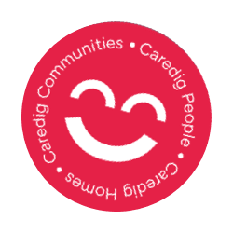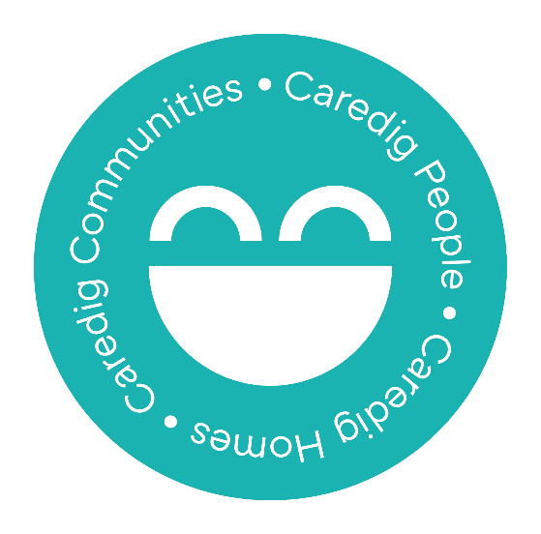
Our Mission
Is to create strong, vibrant, and resilient communities where people can live active, fulfilling, lives - living independently and safely.
Hazel court have independent living spaces for individual, whilst being contained in a safe and secure building, with support and assistance. Its goal is to build strong, thriving communities where people may live satisfying lives while being autonomous and safe whilst being offered the support they need from a wonderful and caring staff.

Our Vision
Is that by 2025 we will be a landlord, employer, and partner of choice; we will continue to make a positive difference to the lives of our tenants, staff and the communities we work in; we will have achieved an ambitious development programme and supported the circular economy within the areas we work in Wales.
Hazel court will continue to improve the lives of their tenants, helping them to live an independent life, giving a variety of housing options so that individuals may keep affordable homes throughout their various life phases.

Our Values
Our behaviour demonstrates what we value. Our values determine how we behave towards our customers, our colleagues, our partners, and our work. They influence the decisions we make as individuals and as an organisation.
Caredig believe that there are many values that need to be observed to maintain a safe and happy living and working environments for all its tenants and equally for its staff.

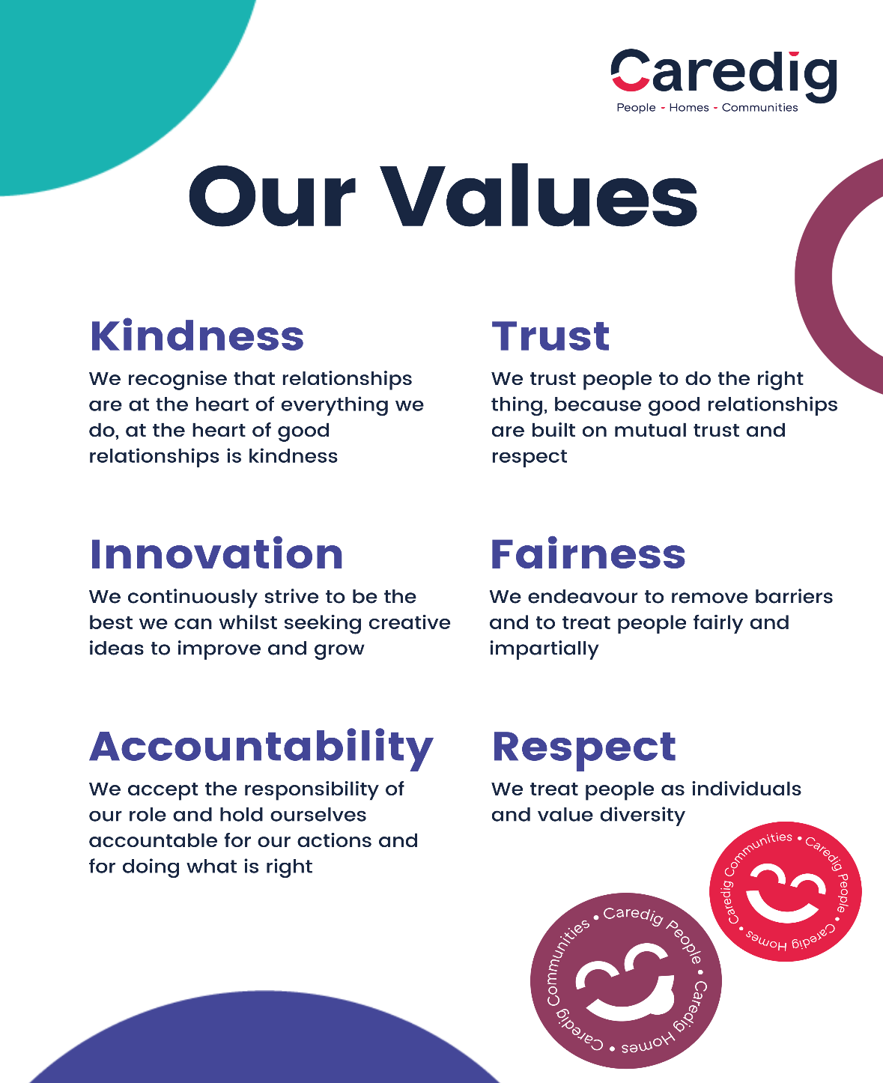

Mental Health and Substance Misuse Services
In Caredig’s opinion, everyone has a story to tell, and while they may listen to these experiences and learn from them, they do not have to use these stories to categorise or judge other people. Instead, they collaborate with their service users to help them advance and have prosperous lives. Caredig have a 360 Psychological Model, a framework that combines all the methods we employed, covers this.

Person Centered
We believe that putting service users at the heart of their support is essential in their healing. We know that service users themselves are best placed to make decisions about their support. With this is mind, service users are involved with every aspect of their support, such as devising their own support plans and setting individual goals.

Psychologically, Trauma and ACE Informed
Being psychologically informed means to consider the emotional and psychological needs of individuals. For us, we apply the PIE framework in the design and delivery of our services to ensure that the people who use our services feel supported, listened to, and understood.
Similarly, being trauma and ACE (Adverse Childhood Experience) informed means to recognise and respond to service users who have experienced trauma in their life. We empathise with service users, listening compassionately to their experiences and responding effectively. We always aim to ask, ‘What’s happened to you?’ rather than ‘What is wrong with you?’

Strengths based
We believe that everyone has their own unique strengths and talents that should be celebrated. When supporting the people that use our services, we empower them to tap into these strengths and use them to build confidence, resilience and lead a flourishing life.

Restorative
We take a restorative approach, meaning that we aim to cause ‘no more harm’. This includes repairing issues and relationships by working with all involved and practicing compassion and empathy to arrive at a resolution.

Photos of staff and residents celebrating The Queens Jubilee.
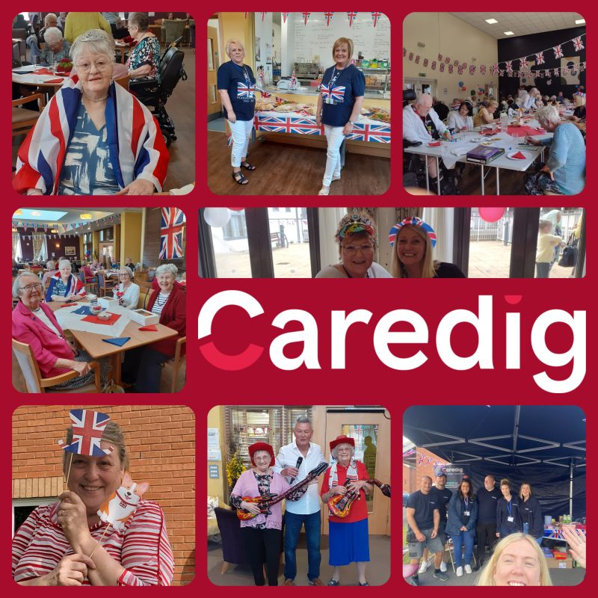


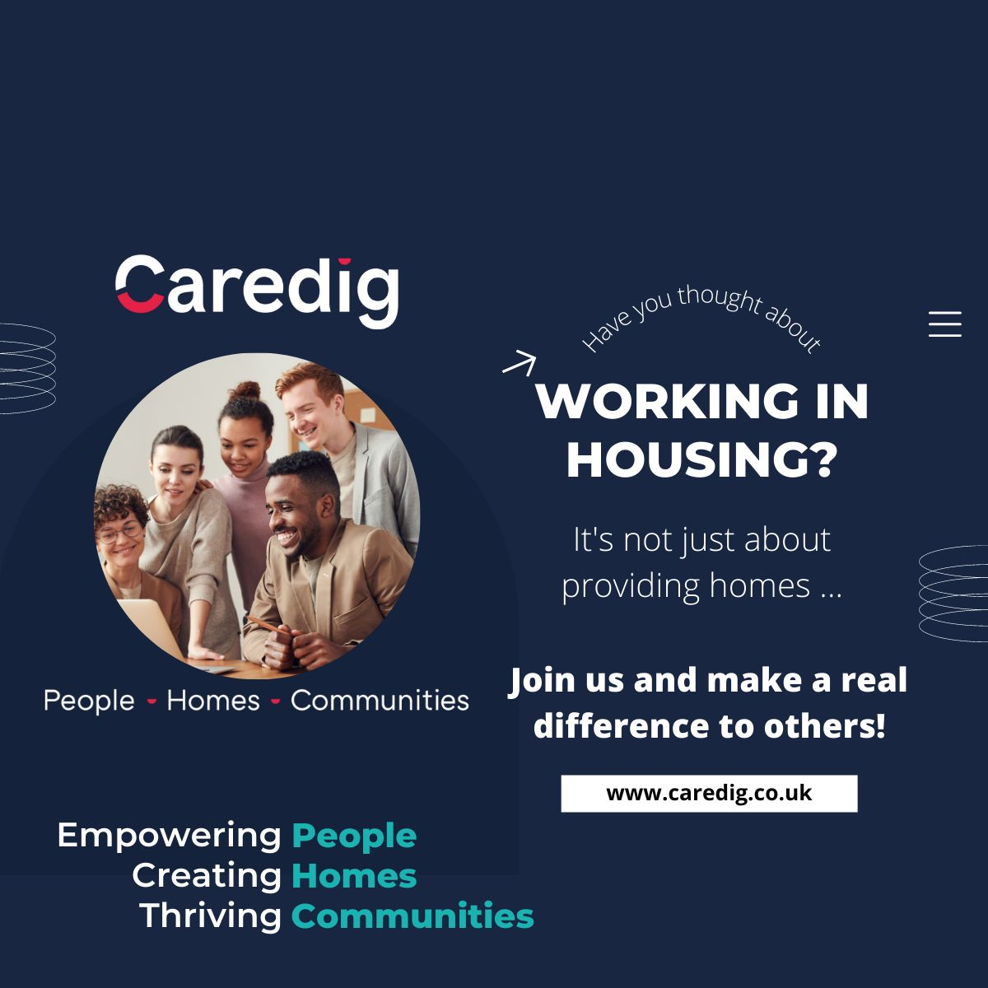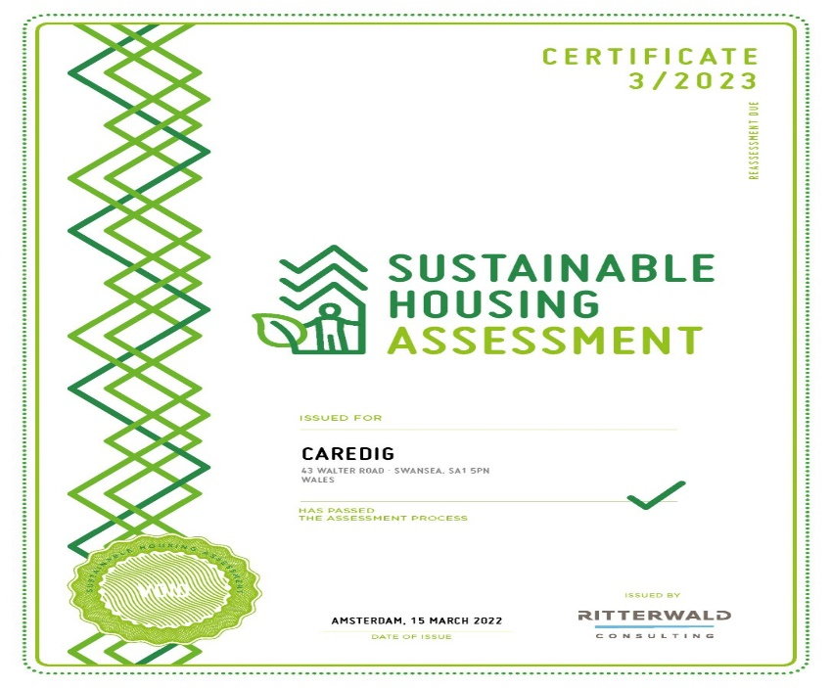

References.

Homepage - Caredig www.caredig.co.uk

Caredig | LinkedIn
https://www.linkedin.com/company/caredigltd

