
Database Concepts


^{[1]}
School of Applied Computing | Title of Coursework  BSc/HND Computing Portfolio | Code ACCA4023
Module
Introduction to Web and Database Concepts

Student:  Theresa Darzins  No 1909721 |  | Lecturer:  B. Holland  Date: 6th April, 2021

Contents
0.0 INTRODUCTION 1
0.1 Overview 1
0.2 Aims 1
0.3 Objectives 1
1.0 ANALYSIS 2
1.1 Status 2
1.2 Context Diagram 2
1.3 Level 0 Data Flow Diagram 3
1.4 Design Plan 4
1.4.1 Purpose - Reports Needed by Departments 4
1.4.2 Tables - 3rd Normal Form (3NF) 5
1.5 Summary of Must Have Client Requirements 6
1.5.1 Query Information About Catering Events 6
1.5.2 Purchase Order Transactions 6
1.5.3 Auto Generated Designed Invoice to View/Send to Print 6
1.5.4 Master and Embedded Forms 6
1.5.5 Macros 6
1.5.6 Calculate Quarterly and Yearly Profits 6
2.0 SOLUTION 7
2.1 Entity Relationship Diagram 7
2.1.1 ERD Relationships/Degrees of Relationships 8
2.1.2 Relationships Linked in Access Database 9
2.1.3 Relationship Report in Access Database (Report 1) 10
2.2 The Tables and How They Relate to Departments 11
3.0 QUERYING CATERING EVENTS BOOKED 12
3.1 Entering the Order Details 12
3.2 Customers Report 13
3.3 Orders Report 14
3.4 Products Report 15
3.5 Query – Customer/Order/Product in Date Order 16
3.6 Calculated Field Customers/Orders/Products 17
3.6.1 Above Query with Venue and Customer Address 18
3.7 Calculated Field Orders/Customers Sorted by Branch 19
4.0 TRANSACTIONS SHOWING PURCHASES 20
4.1 Entering the Purchasing Details 20
4.2 Suppliers Report 21
4.3 Purchase Orders Report 22
4.4 Supplies Report 23
4.5 Querying the Tables Purchase Order/Supplier id/Supplies 24
5.0 DESIGNED INVOICE – AUTO GENERATED 25
5.1 Designed Invoice 25
5.1.1 The Source Query 26
6.0 MASTER AND EMBEDDED FORMS 27
6.1 Customers Master Form 27
6.1.1 Customers with Order Embedded Form 27
6.2 Orders Master Form 28
6.2.1 Orders With Customer Embedded Form 28
6.3 Products Master Forms 29
6.4 Purchase Order Master Form 29
6.4.1 Purchase Orders with Suppliers Form 29
6.4.2 Purchase Order with Supplies Form 30
7.0 MACROS 31
7.1 Orders Form 31
7.1.1 Links to Invoices Form 31
8.0 CALCULATING QUARTERLY AND YEARLY PROFITS 32
8.2 Money In - Customer Orders Query 32
8.3 Money Out - Purchase Orders Query 34
9.0 APPENDIX 36
9.2 Many to Many in Order Detail 36
9.1 If the Prices Change according to Date 36
10.0 REFERENCES 37

Table 1 Design Plan 4
Table 2 Purpose - Reports Needed by Department 4
Table 3 Third Normal Form 5
Table 4 ERD Relationships/Degrees of Relationships 7
Table 5 The Tables and How They Relate to Departments 10
Table 6 The Tables that Can Be Interrogated to Query Catering Events Booked 11
Table 7 The Sales Staff Enter the Order Details 11
Table 8 Transactions showing Purchases 15
Table 9 The Purchasing Department Enter the Buying Details 15

Figure 1 Context Diagram Celtic Catering 2
Figure 2 Level 0 Data Flow Diagram 3
Figure 3 Third Normal Form Example 5
Figure 4 Entity Relationship Diagram of New Computerised System 6
Figure 5 Relationships in Access Database 8
Figure 6 Relationship Report in Access Database 9

INTRODUCTION

Overview

The report is arranged over 10 Sections:
- Analysis
- Solution
- Querying Catering Events Booked
- Transactions showing Purchases Made
- Designed Invoice - Auto Generated
- Master and Embedded Forms
- Macros
- Calculate Quarterly and Yearly Profits
- Appendix
- References

Aims

To show a knowledge of Access Databases, and how these are related to Context and Data Flow Diagrams, in order to build a realistic model of how computerisation of processes helps businesses run smoothly.

Objectives

Analyse the needs of a business and display how these can be met.

ANALYSIS

Status

Celtic Caterers are using paper-based invoicing, which is causing:
- delays in payments to suppliers
- delays in collecting payment from clients
- difficulty in analysing profitability
- inefficiency as there has been an incidence of double-booking
- inefficiency as each branch providing different menus causing confusion calculating profits, therefore, extra work

Context Diagram
Figure 1 Context Diagram Celtic Catering

Level 0 Data Flow Diagram
Figure 2 Level 0 Data Flow Diagram

1.4 Design Plan
^{[2]}
Table 1 Design Plan
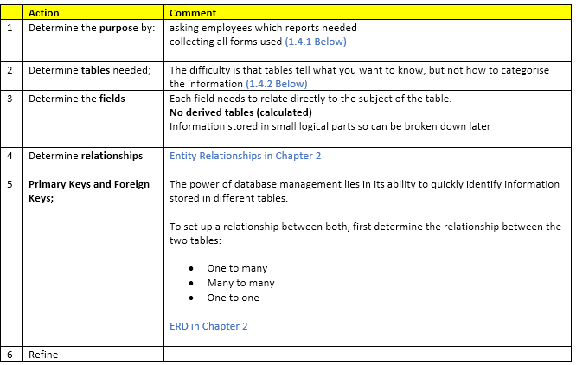

Purpose - Reports Needed by Departments
Table 2 Purpose - Reports Needed by Department
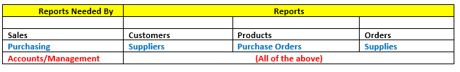

Tables - 3rd Normal Form (3NF)
Table 3 Third Normal Form
^{[3]}
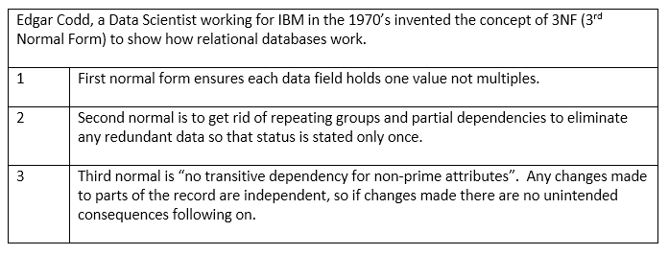
^{[4]}
The example below shows the ‘DNUMBER’ should be in a different table, so that it can be a primary key there, not a foreign key in one big table, but separated out into its own table.

Figure 3 Third Normal Form Example
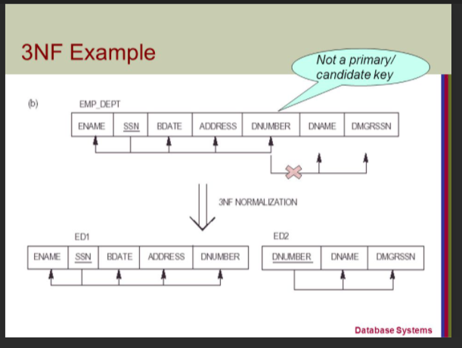

Summary of Must Have Client Requirements

1.5.1 Query Information About Catering Events
Chapter 3

- Record Sales
- Record Customer details
- Query Catering details (venues, customers, quantities)
- Specify Branch that is Catering, to avoid double bookings

1.5.2 Purchase Order Transactions
Chapter 4
- Record Purchases
- Record Supplier/Supplies details
- Record Purchasing transactions
- Query Purchase orders

1.5.3 Auto Generated Designed Invoice to View/Send to Print
Chapter 5

- Record Invoices
- Provide automatically generated invoices to Customers to keep a record of income generation

1.5.4 Master and Embedded Forms
Chapter 6
- Show the forms the end user sees

1.5.5 Macros
Chapter 7
- Provide Macros to support users

1.5.6 Calculate Quarterly and Yearly Profits
Chapter 8
- Run Queries as to all Sales Income vs all Purchase Orders Outgoings
- Ensure Customers billed and Suppliers paid on time

SOLUTION

Entity Relationship Diagram

Figure 4 Entity Relationship Diagram of New Computerised System

2.1.1 ERD Relationships/Degrees of Relationships

Table 4 ERD Relationships/Degrees of Relationships
All Membership Classes are Classified as Mandatory (for the purposes of this Report)

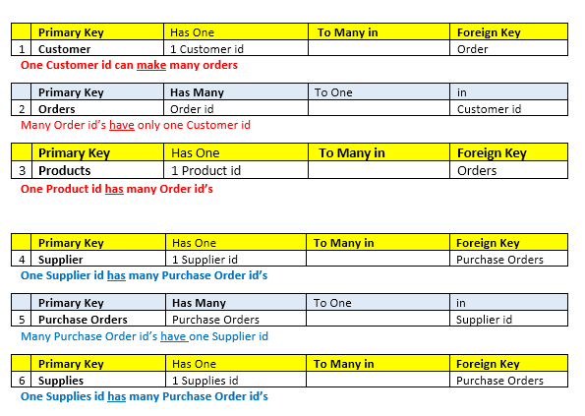

Relationships Linked in Access Database
Figure 5 Relationships in Access Database

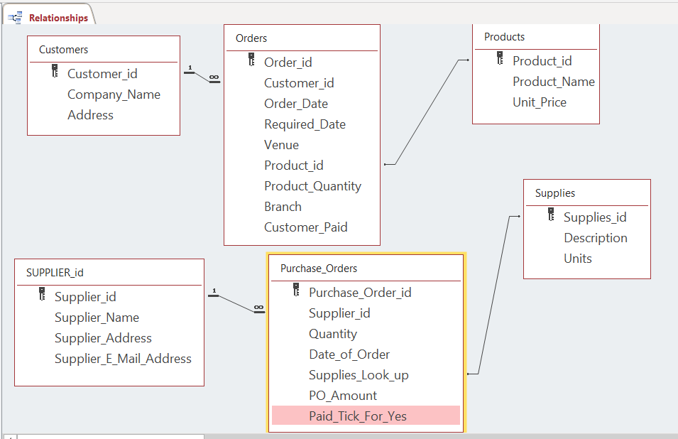

Relationship Report in Access Database (Report 1)
Figure 6 Relationship Report in Access Database

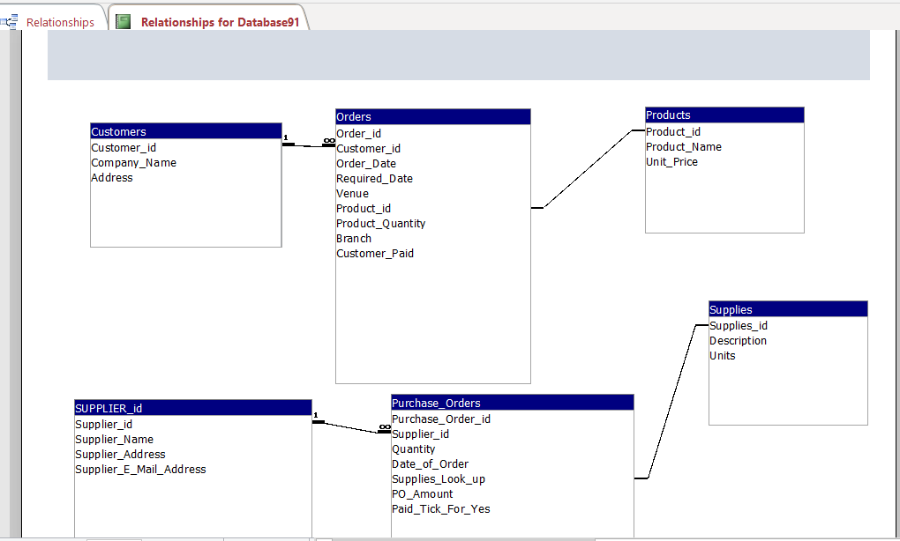

The Tables and How They Relate to Departments

Table 5 The Tables and How They Relate to Departments

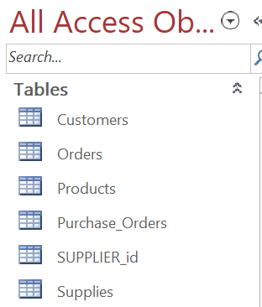 |  | Table
 | 1 | Customer | Sales
 | 2 | Orders | Sales
 | 3 | Products (a look up list in Orders) | Sales
 | 4 | Supplier | Purchasing
 | 5 | Purchase Orders | Purchasing
 | 6 | Supplies (a look up list in Purchase Orders) | Purchasing
 |  | All of the above | Accounts

3.0 QUERYING CATERING EVENTS BOOKED

In order to Query the Catering Events Booked, there are 3 Tables that can be interrogated:

Table 6 The Tables that Can Be Interrogated to Query Catering Events Booked

 | Table Name
1 | Customers
2 | Orders
3 | Products

See 3.5 onwards for the Queries/Calculations.

3.1 Entering the Order Details

Table 7 The Sales Staff Enter the Order Details

 | Table | Action
1 | Customer | Enter the Customer and Contact details
2 | Orders | Enter the order details
3 | Products | Look up Table to be used in Orders to find Product id

3.2 Customers Report

The Customer Table displays just the Customer details;
- Customer id (auto number)
- Company name (user enters)
- Address (user enters)

This way the Customer id only needs to be entered in Orders (unless a new Customer so a check is necessary first to ensure they aren’t already there before entering a new Customer entry)

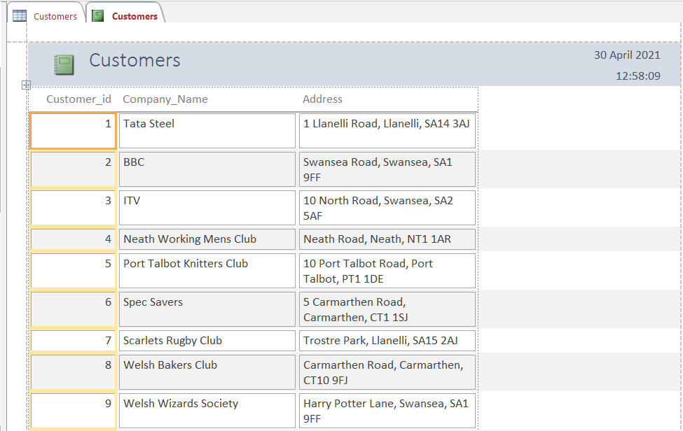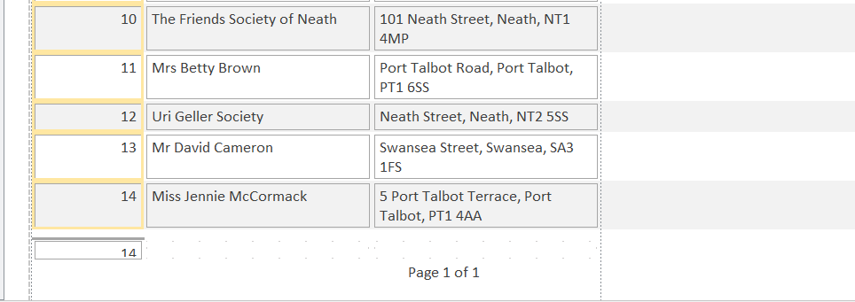

3.3 Orders Report

The Orders displays the:
- Order id (auto number)
- Customer id (user enters)
- Order Date (date pick for user entry)
- Date Required (date pick for user entry)
- Venue (user enters)
- Product id (user chooses from drop down list)
- Product Quantity (user enters)
- Branch (user chooses from set drop down list)
- Customer Paid (Tick Box to say if customer paid – blank when not)

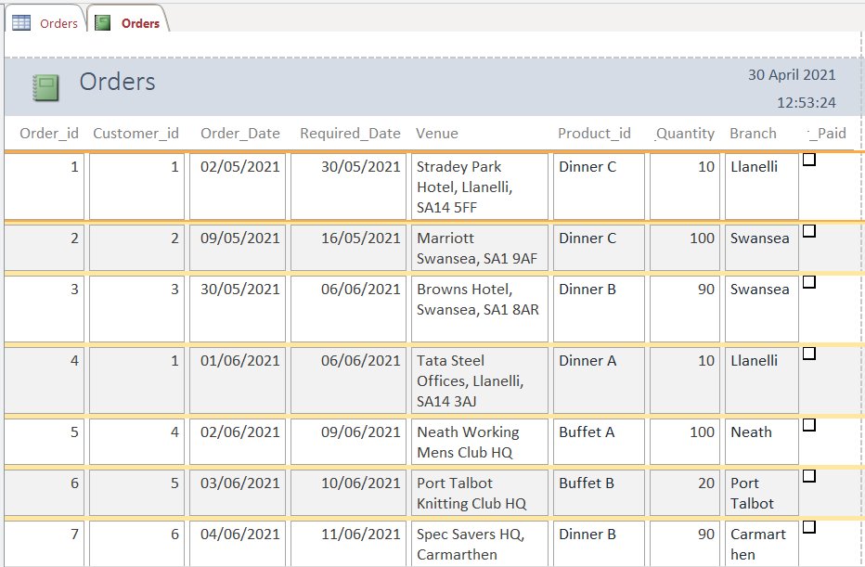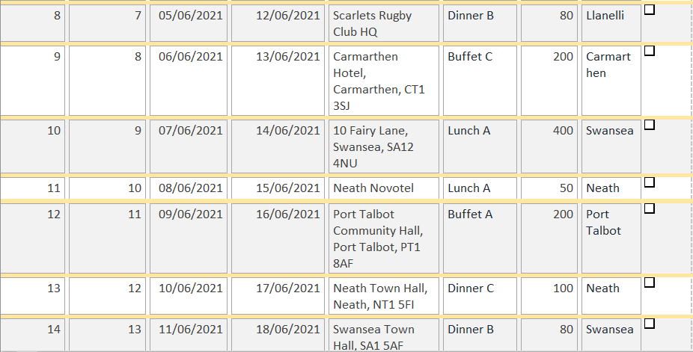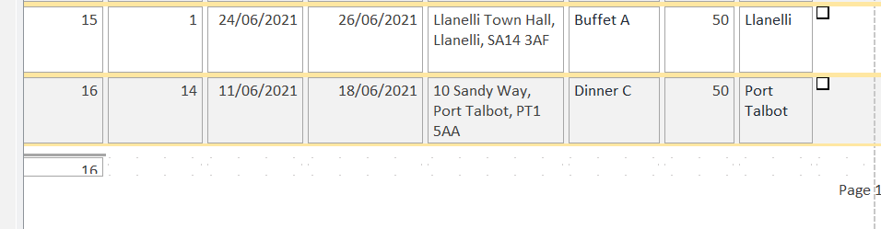

3.4 Products Report

A look-up table for the type of menu the Customer has ordered with prices per head.
- Supplies id (auto number)
- Description
- Unit Price

Products can be updated.

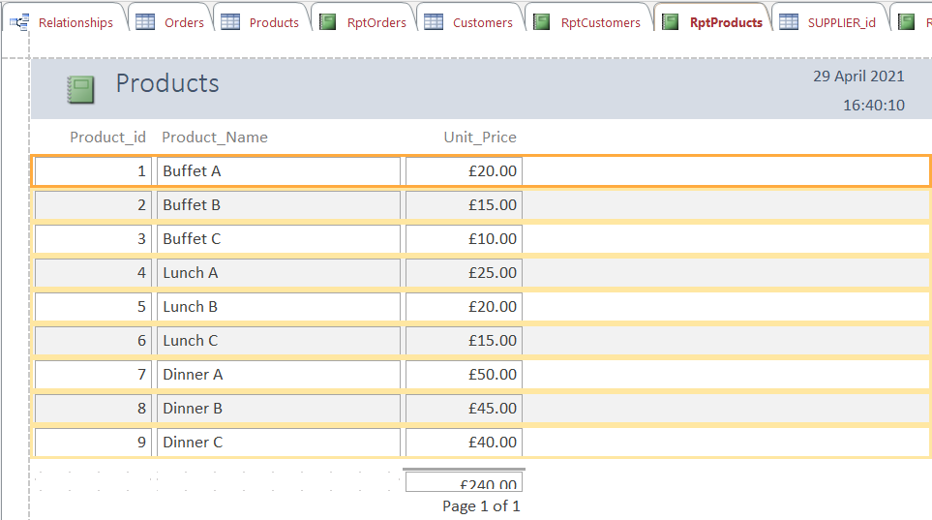

3.5 Query – Customer/Order/Product in Date Order

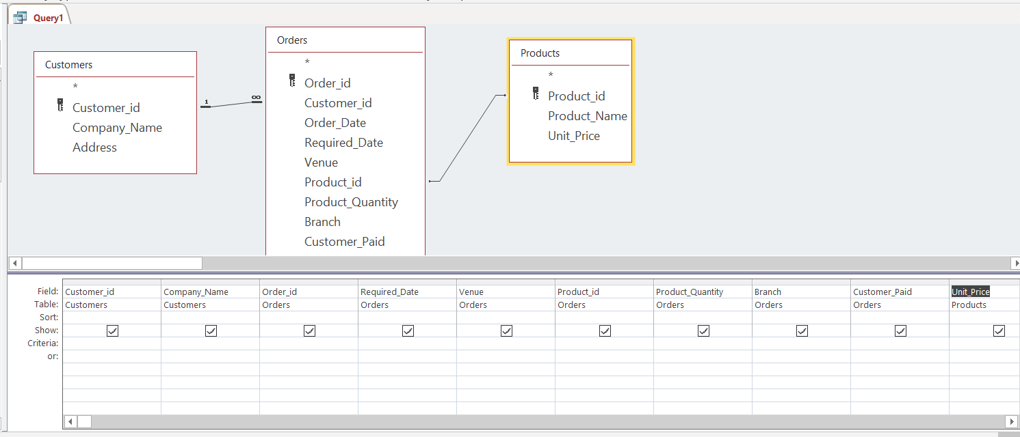

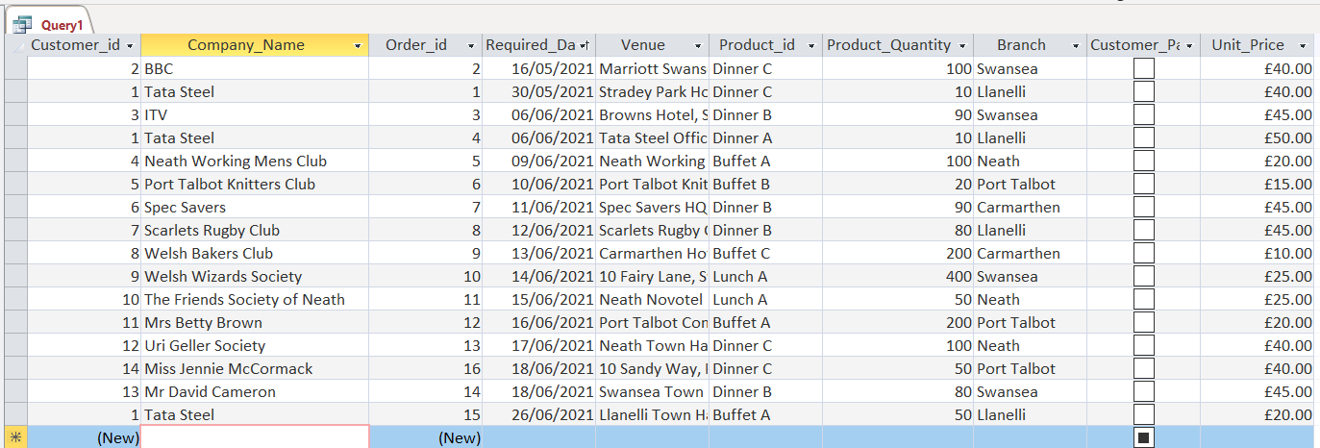

3.6 Calculated Field Customers/Orders/Products

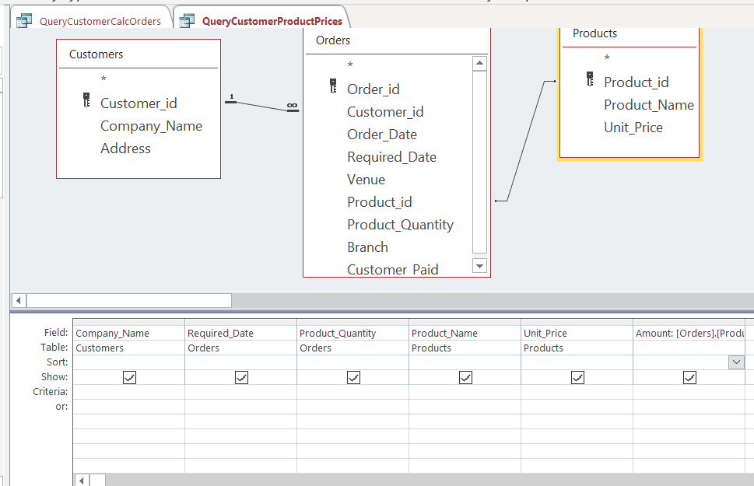

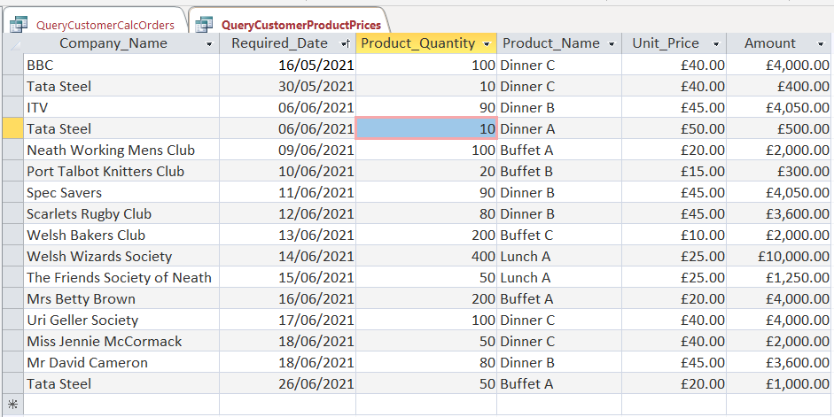

3.6.1 Above Query with Venue and Customer Address

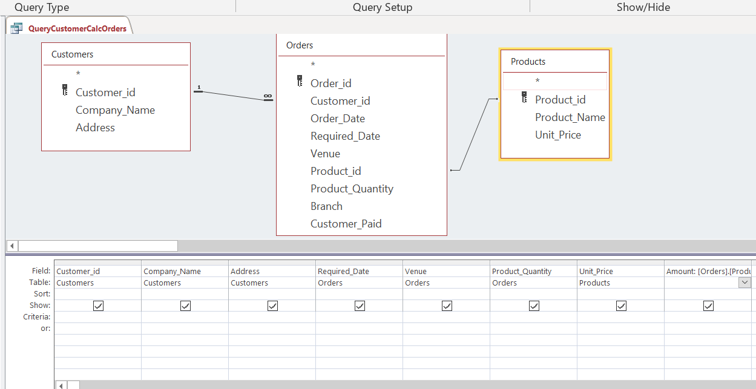
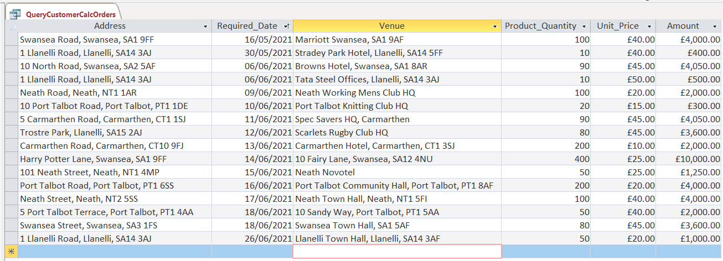

3.7 Calculated Field Orders/Customers Sorted by Branch

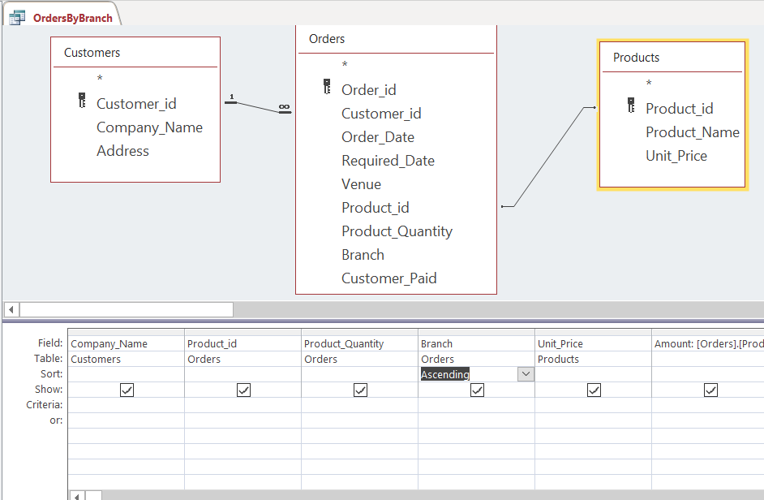
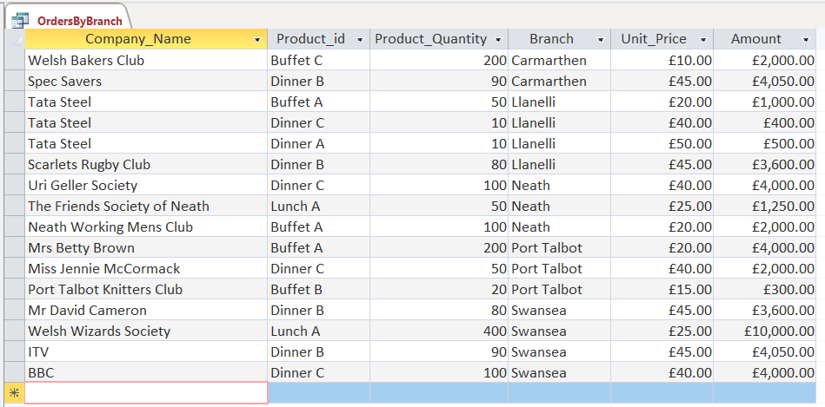

4.0 TRANSACTIONS SHOWING PURCHASES

See 4.5 for Query
Table 8 Transactions showing Purchases
 | Table Name
4 | SUPPLIER
5 | Purchase Orders
6 | Supplies

4.1 Entering the Purchasing Details

Supplier table is in caps to make it easier to distinguish from Supplies table.

Table 9 Entering The Purchasing Details

 | Table | Action
4 | SUPPLIER_id | Enter details of Suppliers used to purchase items
5 | Purchase Orders | Enter details of Purchases made
6 | Supplies | To be used in Purchase Orders to find supplies id

4.2 Suppliers Report

This table is filled in with the:
- Supplier id (auto number)
- Supplier Name (user entry)
- Supplier Address (user entry)
- Supplier E Mail Address (user entry)

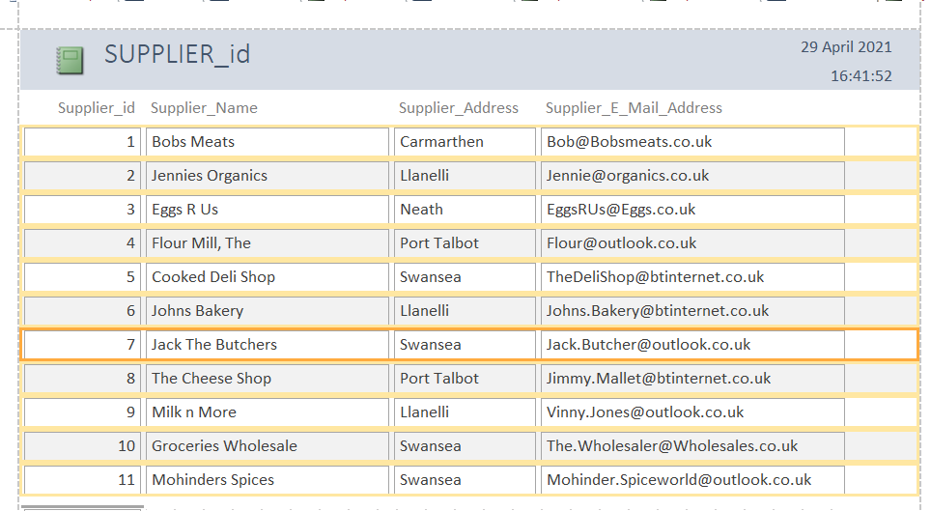

4.3 Purchase Orders Report

This table is filled in with the:
- Purchase Order id (auto number)
- Supplier id (user entry)
- Quantity (user entry)
- Date of Order (date pick for user entry)
- Supplies (look up table for user to choose)
- PO Amount (currency for user entry)
- Paid (tick for yes, blank for no)

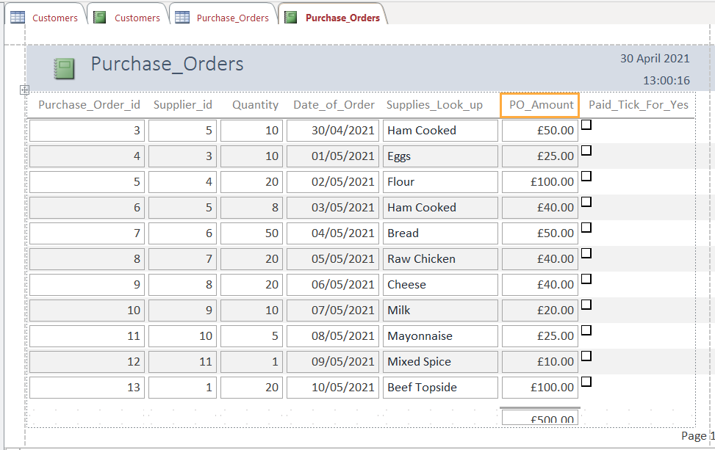

4.4 Supplies Report

This table is filled with the:
- Supplies id (auto number)
- Description
- Units

And is a pick list to be used within the Purchase Order Table. This pick list can be added to.

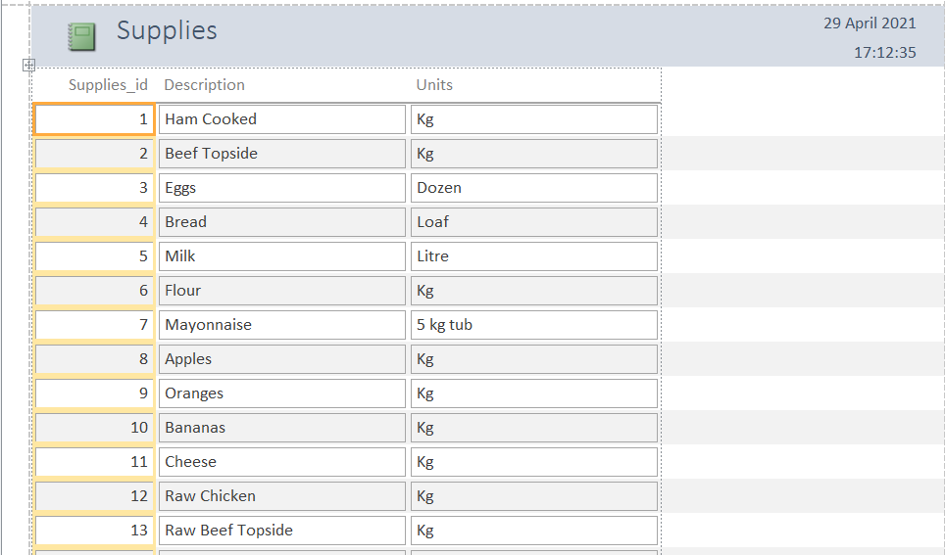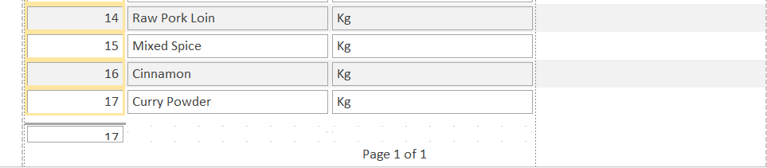

4.5 Querying the Tables Purchase Order/Supplier id/Supplies

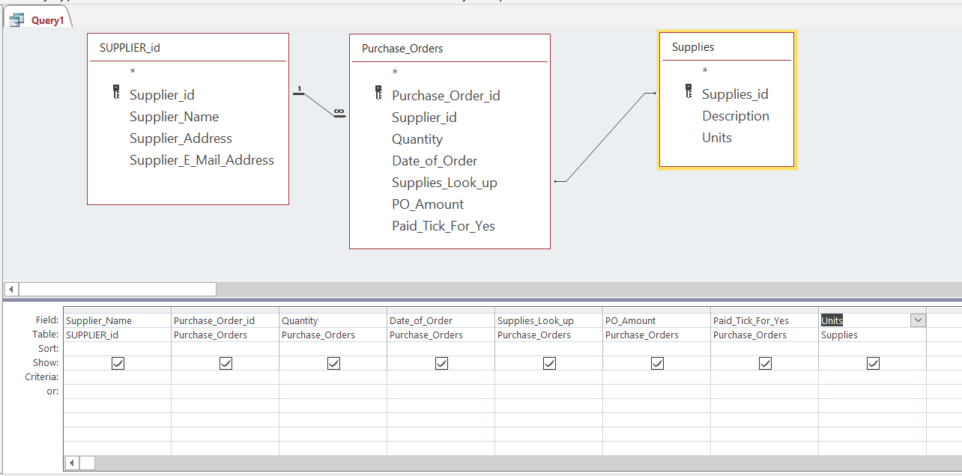
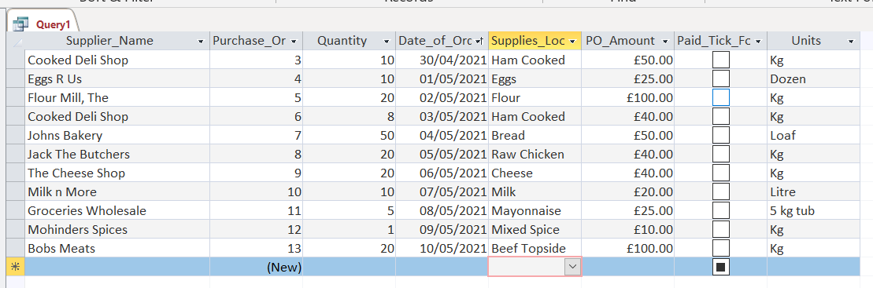

5.0 DESIGNED INVOICE – AUTO GENERATED

5.1 Designed Invoice
^{[5]}
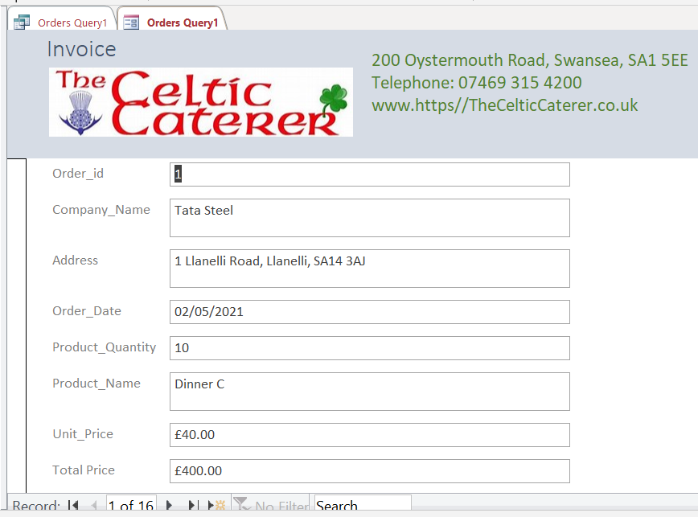

5.1.1 The Source Query
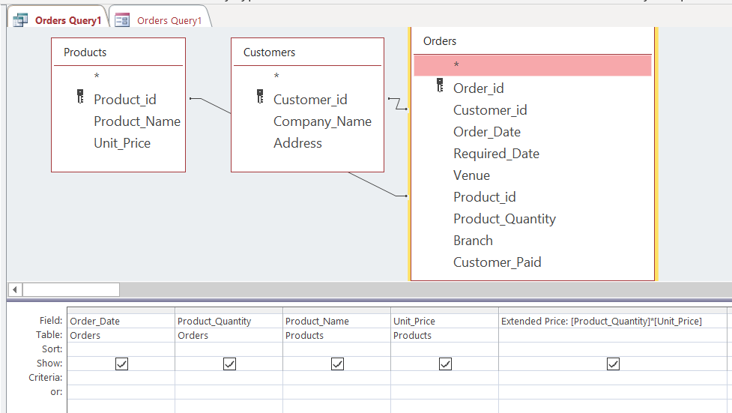
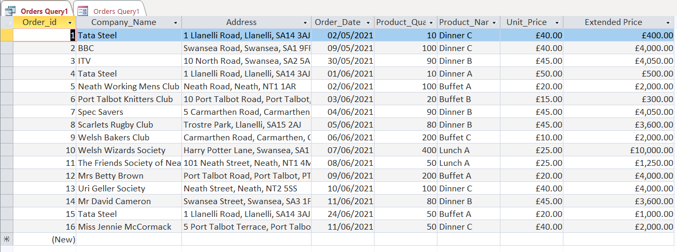
Note: Extended Price is used (not Amount) to total each order separately so individual invoices generated for each event.

6.0 MASTER AND EMBEDDED FORMS

6.1 Customers Master Form

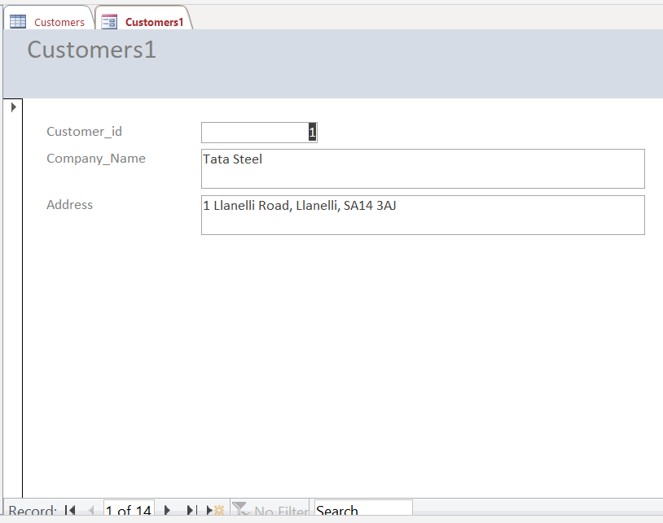

6.1.1 Customers with Order Embedded Form
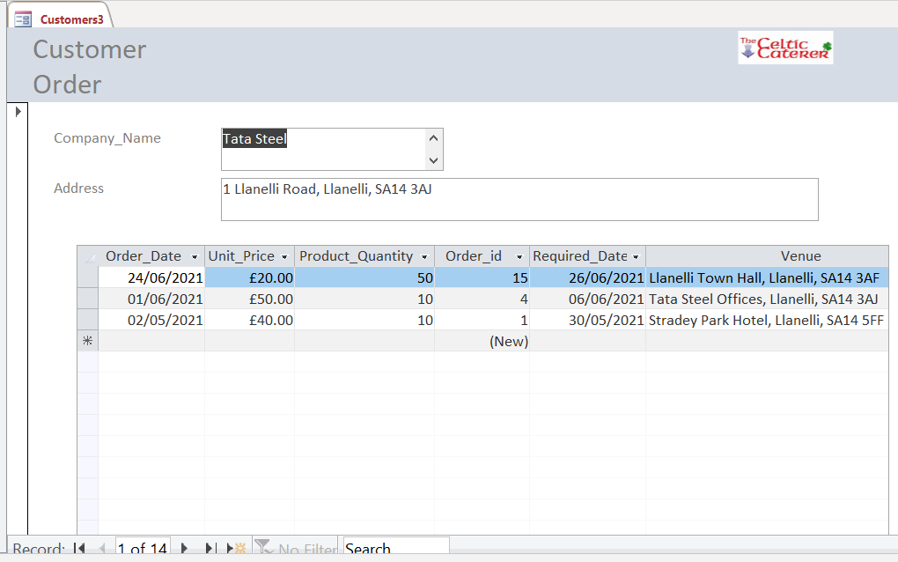

6.2 Orders Master Form

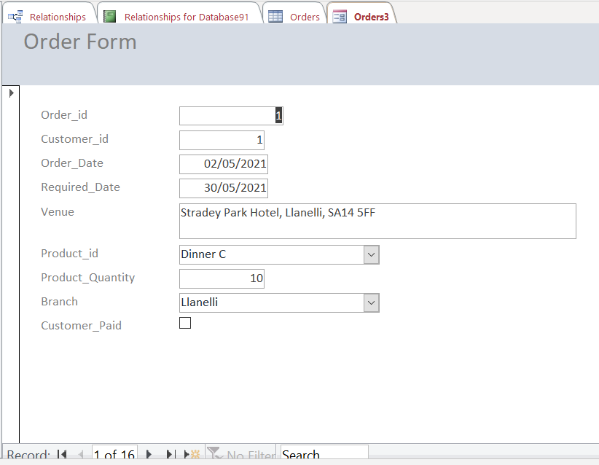

6.2.1 Orders With Customer Embedded Form

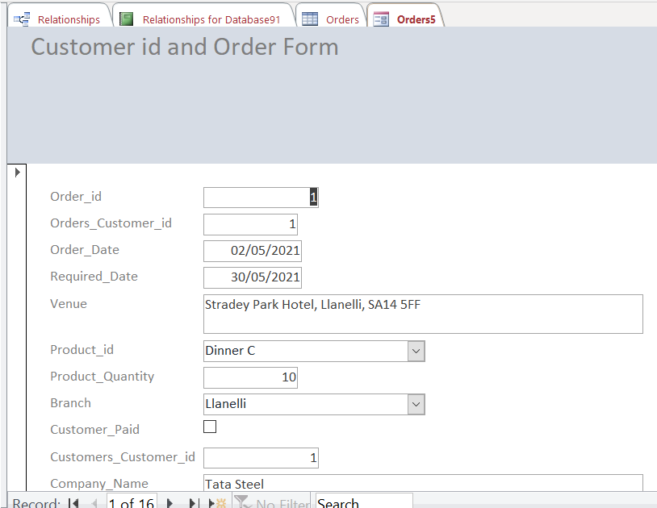
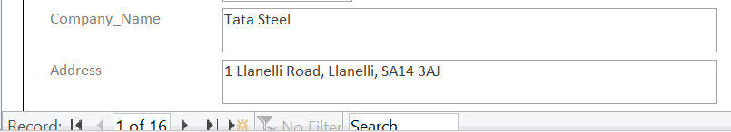

6.3 Products Master Forms

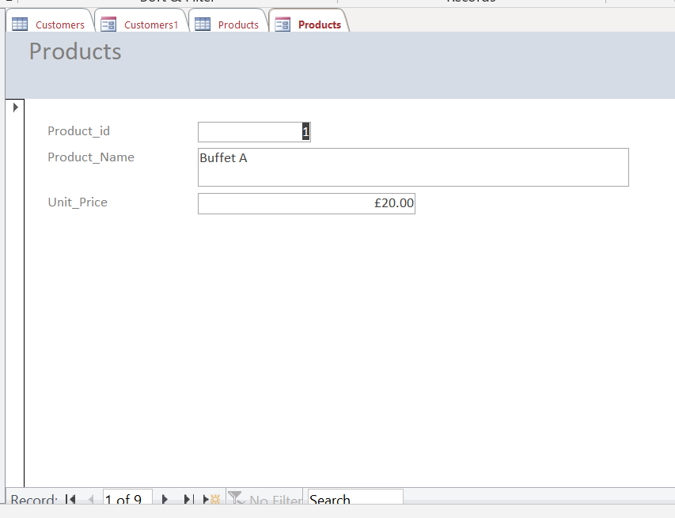

6.4 Purchase Order Master Form

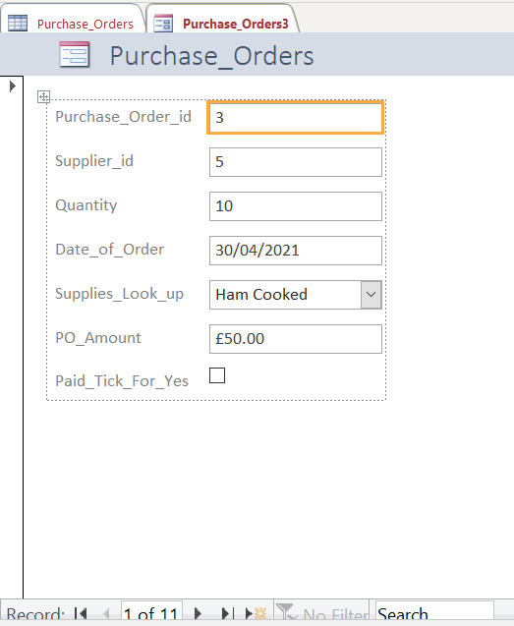

6.4.1 Purchase Orders with Suppliers Form
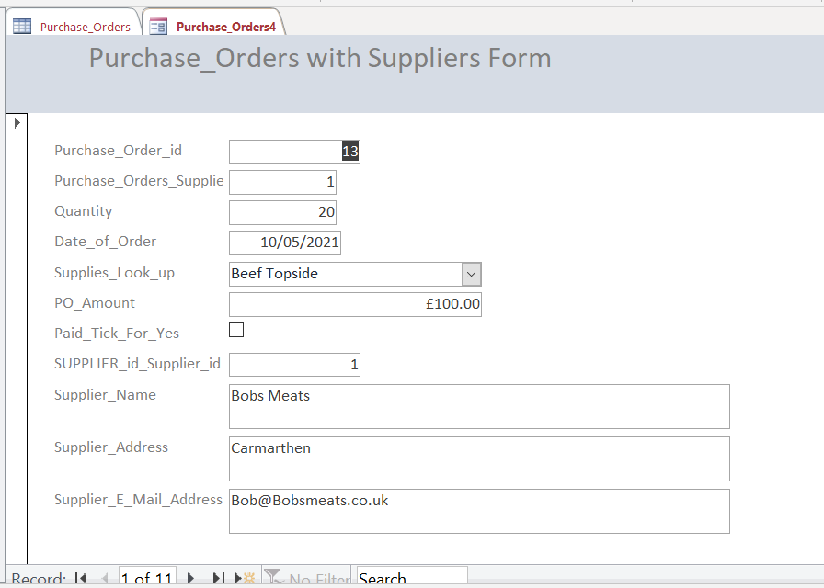

6.4.2 Purchase Order with Supplies Form
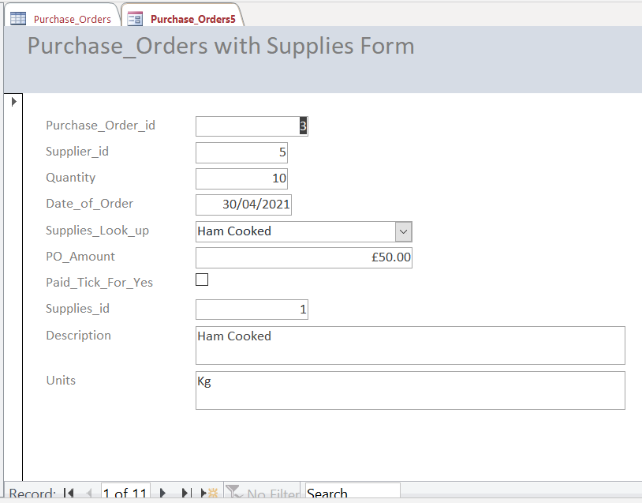

7.0 MACROS

7.1 Orders Form

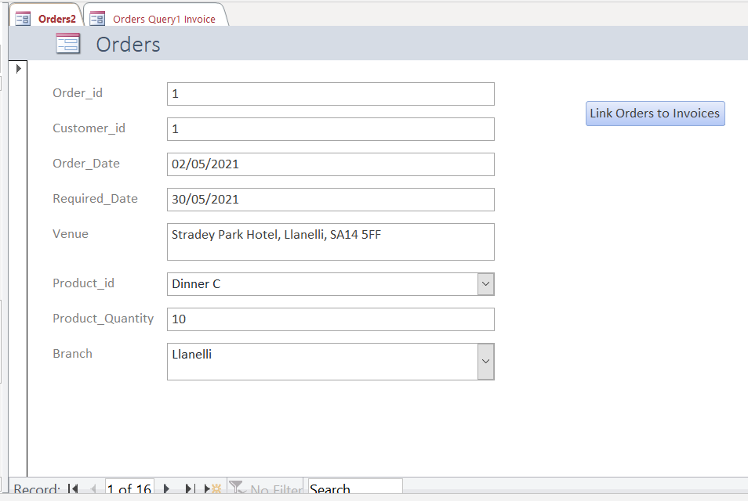

7.1.1 Links to Invoices Form
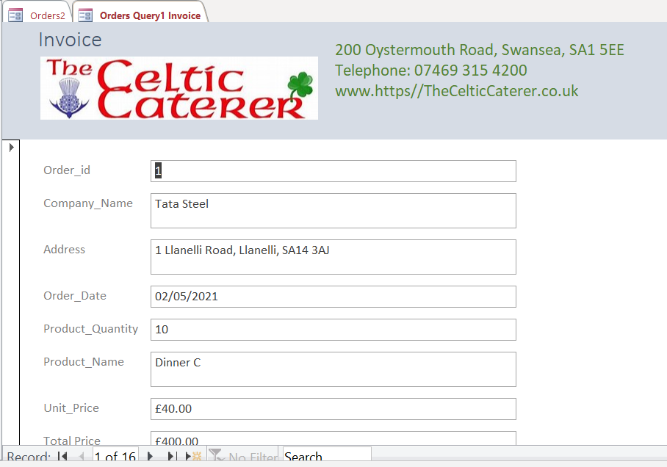

8.0 CALCULATING QUARTERLY AND YEARLY PROFITS

8.2 Money In - Customer Orders Query
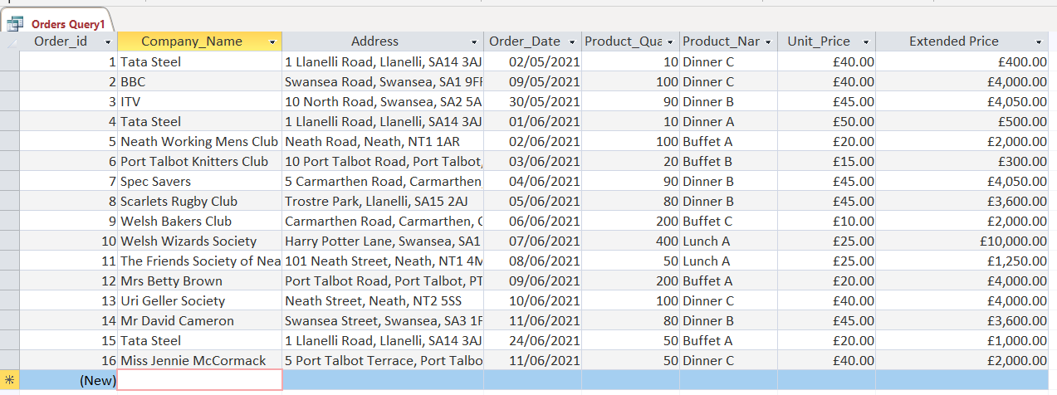
By comparing:
- the Orders (£35, 100) to the
- Purchase Orders – Money out (£500)

A snapshot of how the company is faring can be obtained.
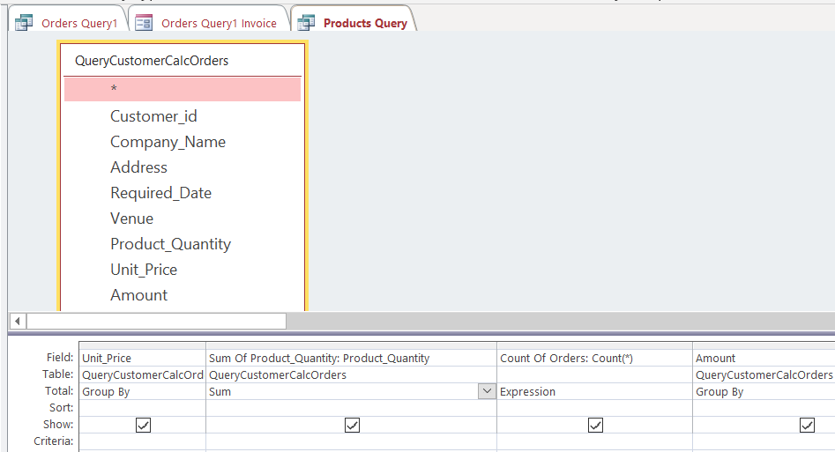

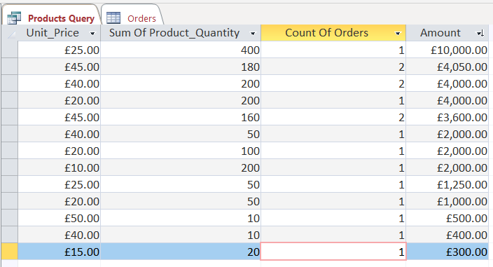
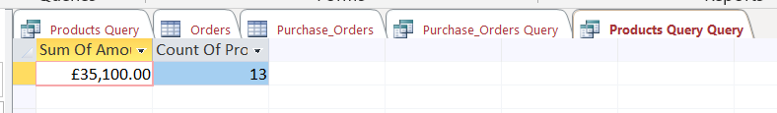

8.3 Money Out - Purchase Orders Query

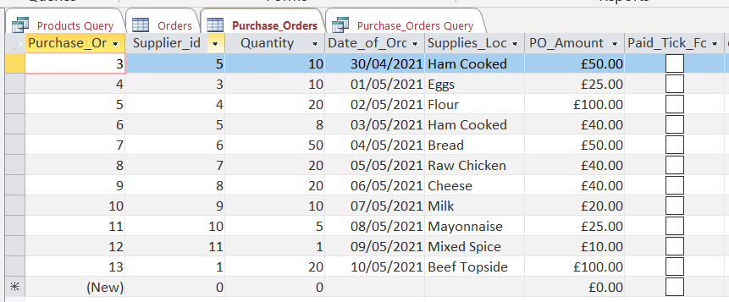
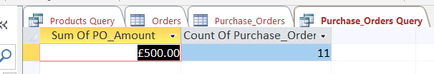

Word Count
 | 1,098 | Gross
 | 125 | Tables & Figures
TOTAL | 973 | Net Words

9.0 APPENDIX

9.2 Many to Many in Order Detail

This was the original ERD Diagram but simplification was necessary to implement a workable solution as the combo key (many to many) in OrderDetail would not allow population.
^{[6]}
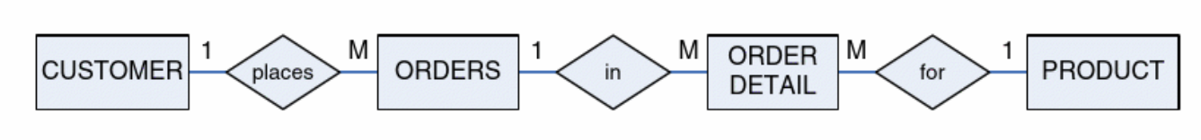

9.1 If the Prices Change according to Date
^{[7]}
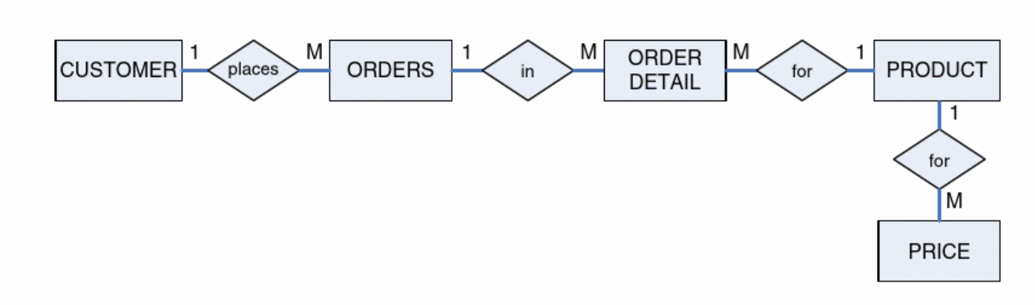
Unless bending the rules to apply price at time of booking in Orders.

10.0 REFERENCES

[1] | “computer-hardware-electronics-hardware-logo-trademark-poster-building.jpg (1000×650) (techopedia.com)” 2021 [Online] Available://https computer-hardware-electronics-hardware-logo-trademark-poster-building.jpg (1000×650) (techopedia.com) Accessed April 10, 2021
[2] | Microsoft Access Relational Database Management System for Windows Document Version 2.0, No DB53728-0294, Avery Dennison Corporation, USA, 1994, p20-29
[3] | “What is the Third Normal Form (3NF)? - Definition from Techopedia” 2021 [Online]  Available: https//What is the Third Normal Form (3NF)? - Definition from Techopedia Accessed April 11, 2021
[4] | “3nf examples - Bing images” 2021 [Online] Available://https 3nf examples - Bing images Accessed April 11, 2021
[5] | “Celtic-Caterer-Logo_lg – The Celtic Caterer” 2021 [Online] Available://https  Celtic-Caterer-Logo_lg – The Celtic Caterer Accessed April 11, 2021
[6] | Eckstein, Jonathan, and Bonnie R. Schultz. Introductory Relational Database Design for Business, with Microsoft Access, John Wiley & Sons, Incorporated, 2018. ProQuest Ebook Central, https://ebookcentral.proquest.com/lib/trinity/detail.action?docID=5131970. p146
[7] | Eckstein, Jonathan, and Bonnie R. Schultz. Introductory Relational Database Design for Business, with Microsoft Access, John Wiley & Sons, Incorporated, 2018. ProQuest Ebook Central, https://ebookcentral.proquest.com/lib/trinity/detail.action?docID=5131970. p272

