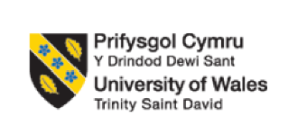

Programme: BA (Hons) Leadership and Management Skills for the Workplace
Module: Developing and Managing Individuals and Teams
Module code: LCLM5002
Assignment Title: Component 2- Individual Report
Student Name: George Burlui
Student ID: 1907641

Table of Contents
Introduction 3
Factors related to business transformation 3
Different contemporary HR practices 4
Role of Departmental Managers in Implementing Contemporary HR Practices 6
Conclusion and Recommendations 7
References 8

Introduction
Globalisation, technology, and worker needs are fast transforming modern companies. London-based multinationals like Unilever must combine business transformation, digital technology uptake, and flexible working arrangements to adapt to these changes. HR now drives organisational resilience and growth rather than administrative control. It critically examined how contemporary HR practices in various industries solve internal concerns like employee complaints and external market and societal demands while maintaining competitiveness. This study will evaluate how Unilever might leverage HR innovation to manage change and sustain employee engagement and efficiency. It explored how departmental managers inspire urgency and how leadership affects execution. Research highlighted how HR can facilitate transformation, leverage digital potential, and encourage diversity via adaptable policies utilising relevant theories and real-world examples. This report examines the rising strategic importance of HR and offers practical ideas to support sustainability-driven business strategy at Unilever.

Figure 1: Unilever
(Source: Unilever, 2025)

Factors related to business transformation
The transformation of Unilever is driven by sustainable and agile business transformation methods, digital technology trends that increase customer engagement and HR efficiency, and flexible working arrangements that link staff wellness with organisational objectives. Managing change comprehensively helps Unilever remain competitive and adaptable in a fast-changing corporate environment.
Digital Technology Trends and Workforce Impact
Digital technology has changed HR, consumer engagement, and product innovation at Unilever. Big data and AI assist companies in forecasting client demands and evaluating employee performance (Chen, 2023). AI-enabled video interviewing systems evaluate spoken responses, micro-expressions, and behaviour, changing the hiring process at Unilever. This idea reduced recruiting time and addressed unconscious bias to make recruitment more inclusive. To drive marketing and product launches, Unilever London employs advanced data analytics to analyse customer purchase habits. Cloud-based HR systems like Workday integrate payroll, training, and career progression into one digital platform, providing workers with self-service and HR managers with real-time data (Sasidharakarnavar, 2025). HR professionals may focus on talent development after automating administrative tasks. Technology also improves Unilever's consumer approach. Digital twins and AI-powered models in product development allow London teams to mimic packaging sustainability before production, reducing waste and costs. Unilever scaled up recyclable packaging using computer modelling of Dove and Hellmann (Unilever, 2024). Unilever analyses local consumer behaviour via e-commerce and digital marketing using social media listening. With these digital advancements, the organisational growth of Unilever depends on technology.
Flexible Working Arrangements
During its Agile Working experiment in London, Unilever has used hybrid and remote-working approaches. HR has encouraged work-life balance to reduce burnout and boost productivity (Bello et al., 2024). Flexibility in working hours and locales is valued when nine-to-five office attendance becomes outmoded. The London headquarters of Unilever changed to allow remote working and collaborative hubs. Offering more work-life balance control has reduced overhead costs and enhanced employee contentment. Chung and van der Lippe (2020) found that the flexible working choices of the companies help in supporting diversity and inclusion goals.
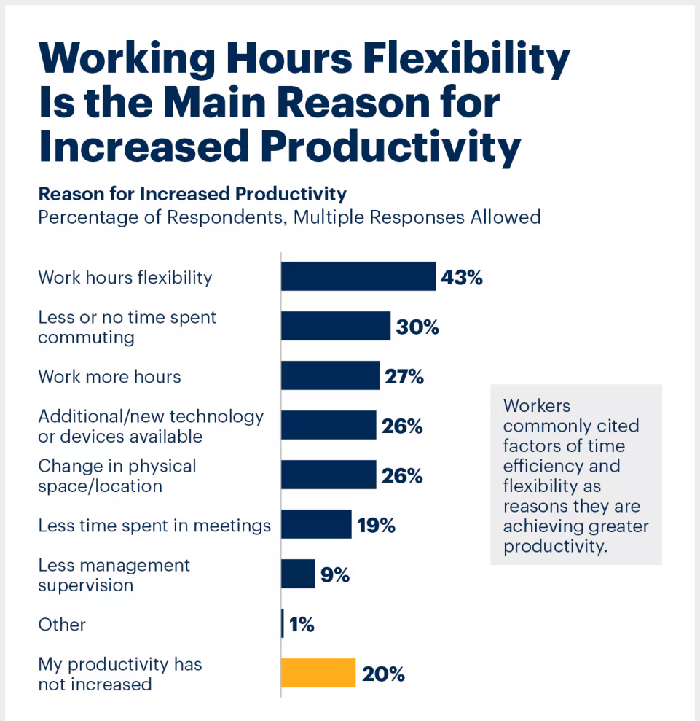
Figure 2: The significance of Flexible work arrangements significance
(Source: Lynagh and Hull, 2023)
Unilever has created a more inclusive workplace that benefits society by accommodating parents, carers, and others with accessibility needs. Online wellness initiatives, team-building seminars, and mental health support kept Unilever workers engaged throughout the pandemic. The London HR team has also utilised flexible agreements to hire talented outsiders. This has increased the talent pool of the company and made it more competitive in a tight job market. Other corporations may learn from the policies of Unilever. One of the first UK corporations to embrace flexible working as a culture rather than a response to external issues (Unilever, 2023). Low attrition rates from flexible hybrid models helped keep women in leadership roles post-maternity. Microsoft Teams and other communication tools were used at Unilever to guarantee that remote working did not hinder productivity. Flexible working is a strategic company and employee benefit, as seen above.
Business Transformation and Organisational Change
Innovation, agility, and sustainability drive the corporate transformation of Unilever London. Recently, restructuring has included cultural renewal and inclusive, efficient work procedures. The compass strategy, which linked financial growth to environmental standards, helped Unilever rethink its ambitions. HR now drives employee engagement and leadership development rather than compliance (Moore and Hanson, 2022). Adjustments in client behaviour, legal restrictions, and the necessity for rapid responses in a dynamic global market drive the adjustments. Unilever adjusted its London supply chain during the epidemic to ensure hygiene and home care product availability, combining operational resilience and social responsibility. Removing separated divisions and switching to a matrix structure increased global and regional team interaction, allowing the corporation to respond faster to business needs.

Different contemporary HR practices
Evaluation of HR Practices for Business Transformation
In major companies like Unilever, HR must go beyond administrative duties and drive cultural, structural, and workforce reforms. Strategic Workforce Planning (SWP) predicts workforce requirements based on market and business goals, aligning with transformation (Afriyie, 2019). If the company switches to sustainable packaging or climate-friendly goods, HR must anticipate the technical and managerial capabilities needed. This proactive approach ensures corporate agility by providing timely recruiting, targeted reskilling, and simple workforce redeployment. Change Management Training, which guides all workers through transition, is also crucial for Unilever. HR creates change resilience treatments, including leadership bootcamps, peer mentoring, and scenario-based simulations. HR can help managers build urgency, develop guiding coalitions, and inspire people to change using Kotter's 8-Step Change Model. Galeazzo, Furlan and Vinelli, (2021) discussed that management promotes compliance and employee participation in organisational changes by integrating such practices. Change comes via pulse polls and town halls. These strategies let leaders quickly receive feedback, evaluate change readiness, and adapt policies. Unlike annual engagement surveys, modern solutions preserve employee trust throughout changes via continual involvement. HR strategies in business change nowadays focus on foresight, agility, and participative decision-making to promote morale and meet market needs.
Evaluation of HR Practices for Digital Technology Trends
HR departments must rethink recruitment, training, performance, and employee experience due to digital technologies. Current HR Analytics predicts employee turnover, performance, and career progression (Edwards et al. 2024). Dreichuk and Sytnyk (2025) opined that analytics can help HR identify at-risk employees and provide growth, retention, or flexible options. HR becomes a data-driven decision-maker, linking company strategy to HR. Moreover, HR helps employees enhance digital and soft skills using microlearning, gamification, and personalised skill pathways. People would learn at their own pace, acquire knowledge, and use their abilities at work in digital ecosystems. Human Capital Theory shows that skills investment benefits people and businesses (Kuzminov et al. 2019). Therefore, HR produces tech-savvy, inventive workers utilising such ways. HR recruitment also needs AI-powered Talent Acquisition Systems (TAS). CVs, videos, and cultural fit are assessed by algorithms in these systems. Calibrated instruments reduce bias beyond efficiency, increasing variety. HR routinely assess these systems for fairness and ethics, highlighting the growing governance role of the profession (Trevino and Nelson, 2021). HR uses Slack, Teams, and Workday-integrated communication for digital collaboration. These streamline HR and link workers. Welcome portals, virtual introductions, and automated support speed up and engage recruits.
To integrate flexible working into organisational strategy, HR needs to reconsider policies. Hybrid Work Policy Design of HR offers fair and inclusive flexibility. Establish office attendance, virtual collaboration, and performance evaluation norms. Tyagi et al. (2019) argued that modern HR tracks outputs and outcomes rather than attendance, improving accountability and reducing absenteeism. Also important are remote and hybrid worker wellness initiatives. Deshmukh et al. (2025) opined that HR support systems include virtual therapy, mindfulness workshops, and digital health check-ins. Digital Employee Assistance Programmes (EAPs) provide confidential mental health treatments anywhere.
Maslow's Hierarchy of Needs reinforces the idea of human resource managers that psychological safety and well-being motivate and produce. Another improvement is Flexible Talent Sourcing. HR at Unilever can add gig platforms, project-based contracts, and global talent to teams (Evans-Uzosike and Okatta, 2023). HR matches personnel acquisition with shifting workloads to increase capacity without contracts. The managers can hire professionals for short-term duties without substantial onboarding in digitally specialised businesses, which is useful. HR fosters trust, outcome-based monitoring, and inclusive communication. The company develops leaders who can manage across physical and digital spaces to reduce remote employee disengagement and unequal treatment. Finally, HR adds Legal and Compliance Practices into flexible working solutions to guarantee remote employment contracts, health and safety, and data security. Human resources are increasingly responsible for home office ergonomics and GDPR compliance in remote work solutions.

Role of Departmental Managers in Implementing Contemporary HR Practices
Unilever departmental managers are key to HR strategy implementation. Their ability to quickly adopt current HR practices influences organisational transformation. It is not enough to implement policies; one must adapt them to departmental contexts, influence employee behaviour, and build accountability mechanisms that relate daily operations to strategic objectives. Saeed et al. (2019) opined that to balance operational restrictions with long-term sustainability, managers must enable and supervise HR activities. Integrating transformation approaches into everyday operations comes first. When managers link strategic direction to team-level execution, abstract or centralised company transformation fails. Umana et al. (2022) argued that performance dashboards that relate departmental KPIs to transformation goals help managers prioritise. If Unilever offers sustainability-linked transformation goals, supply chain or marketing managers may monitor emissions reductions or sustainable product launches weekly. Daily quantification of change goals creates urgency. Managers must combat inertia by narrating why change is needed. This is crucial at Unilever because global teams may interpret change differently.
Digitalisation in departments is another aspect. Afriyie (2019) suggested that HR develop digital recruitment, analytics, and learning frameworks, but departmental managers must implement them. Managers at the marketing division of Unilever can use digital consumer insights dashboards in campaign planning sessions to replace intuition with data. Managers can establish short-term deadlines for digital upskilling programs or relate completion to career progress to build pressure. Technology in SOPs may help operations managers encourage digital practices. Requiring predictive analytics in inventory planning boosts uptake and reduces shortages and overstocking. Digital adoption must be linked to performance, and workers must be warned that not using it will put them behind. Departmental managers must combine automation with human discretion to prevent digital fatigue and ensure technology supports staff. Arshad et al. (2025) argued that in hybrid workplaces, department heads must ensure justice, productivity, and inclusiveness while managing flexibility. Urgent implementation requires explicit deliverables, communication, and availability criteria from managers.
Finance and R&D managers at Unilever London headquarters can plan weekly office collaboration days and remote work. This enhances hybrid standards and avoids ad hoc flexibility fragmentation. Instead of waiting for annual assessments to build urgency, managers can implement pilot programs with quick feedback loops to collect employee input in weeks and make changes. Iterative methods prevent flexible working practices from stagnating or being inconsistently applied. Chung and van der Lippe (2020) found that management is key to equity and inclusion in flexible arrangements. Without direct supervision, remote workers may lose promotions and visibility. In response, departmental heads may arrange performance reviews around outcomes rather than office attendance. They must also provide easy virtual collaboration tools and fair meeting integration of remote and local participants. Unilever departmental managers may accelerate gender equality by assessing women leader retention and advancement under hybrid models. Managers promote inclusive flexibility and hold colleagues responsible by publishing these findings at the departmental level. The psychological safety of managers affects urgent implementation. If they think their concerns will be heard and faults will not be punished, employees will readily adopt new HR procedures. Management must establish safe places for people to debate digital systems, transformation goals, and flexible work patterns.

Conclusion and Recommendations
According to the research, the HR department of Unilever drives organisational transformation using modern practices to boost resilience and long-term competitiveness. HR now uses strategic workforce planning, data-driven decision-making, and flexible work models to improve performance and engagement, not simply administrative responsibilities. Departmental managers must implement the company strategy and sustain momentum. HR must prioritise digital upskilling to provide all employees with the technical skills to respond to industry changes and innovation to accelerate and enhance development. Managers need agile change tools to quickly identify obstacles, alter processes, and reward achievement in transformation sprints (Chukwunweike and Aro, 2024). Established guidelines and transparent performance evaluations ensure flexibility, promote equity and justice; therefore, inclusive hybrid arrangements require attention. To encourage exploration and learning, workers need psychological safety to explore new tools and approaches without fear of punishment. Cross-functional accountability and shared sustainability, HR, and performance goals should encourage departmental collaboration and reduce silos. HR and management must work together to encourage urgency, inclusivity, and inventiveness. These practices may help Unilever retain its market leadership and establish a flexible, fair, and socially responsible workplace.

References
Afriyie, D., (2019) ‘Aligning strategic workforce planning with future-of-work trends through advanced performance management and digital HR infrastructure.’ 04(02), 207-226
Arshad, I.A., Ali, A. and Audi, M. (2025) ‘Evaluating Remote and Office-Based Work: A Multidimensional Analysis of Employee Outcomes in the Evolving Workplace.’ Bulletin of Management Review, 2(2), pp.187–216.
Bello, B.G., Tula, S.T., Omotoye, G.B., Kess-Momoh, A.J. and Daraojimba, A.I. (2024) ‘Work-life Balance and Its Impact in Modern Organizations: An HR Review.’ World Journal of Advanced Research and Reviews, 21(1), pp.1162–1173.
Chen, C. (2023) ‘Influence of Employees’ Intention to Adopt AI Applications and Big Data Analytical Capability on Operational Performance in the High-Tech Firms.’ Journal of the Knowledge Economy, 15.
Chukwunweike, J. and Aro, E. (2024) ‘Implementing agile management practices in the era of digital transformation.’ World Journal of Advanced Research and Reviews, 24(1), pp.2223–2242.
Chung, H. and van der Lippe, T. (2020) ‘Flexible Working, Work–Life Balance, and Gender Equality: Introduction.’ Social Indicators Research, 151(2), pp.365–381.
Deshmukh, B.B., Kumar, A.S. and Devi, P., (2025) ‘Revolutionary Potential of AI in HR and Mental Health Support.’ In Synergizing Data Envelopment Analysis and Machine Learning for Performance Optimization in Healthcare (pp. 49-80). IGI Global Scientific Publishing.
Dreichuk, M. and Sytnyk, Y. (2025) ‘HR analytics as a risk monitoring tool in personnel management systems.’ Economics & Education, 10(1), pp.22–28. doi:https://doi.org/10.30525/2500-946x/2025-1-3.
Edwards, M.R., Edwards, K. and Jang, D., (2024) Predictive HR analytics: Mastering the HR metric. Kogan Page Publishers.
Evans-Uzosike, I.O. and Okatta, C.G., (2023) ‘Talent Management in the Age of Gig Economy and Remote Work and AI.’ Shodhshauryam, International Scientific Refereed Research Journal, 6(4), pp.147-170.
Galeazzo, A., Furlan, A. and Vinelli, A. (2021) ‘The role of employees’ participation and managers’ authority on continuous improvement and performance.’ International Journal of Operations & Production Management, 41(13), pp.34–64.
Kuzminov, Y., Sorokin, P. and Froumin, I. (2019) ‘Generic and Specific Skills as Components of Human Capital: New Challenges for Education Theory and Practice.’ Форсайт, 13(2 (eng)), pp.19–41.
Lynagh, M. and Hull, P. (2023) How flexible working can unlock productivity and growth. [online] World Economic Forum. Available at: https://www.weforum.org/stories/2023/01/flexible-working-productivity-and-growth-davos23/. [Accessed on 24 Sept. 2025]
Moore, J.R. and Hanson, W. (2022) ‘Improving leader effectiveness: impact on employee engagement and retention.’ Journal of Management Development, 41(7/8), pp.450–468.
Saeed, B.B., Afsar, B., Hafeez, S., Khan, I., Tahir, M. and Afridi, M.A. (2019) ‘Promoting employee’s proenvironmental behavior through green human resource management practices.’ Corporate Social Responsibility and Environmental Management, 26(2), pp.424–438.
Sasidharakarnavar, S (2025) ‘Revolutionizing Hr: Leveraging Workday Platform For Enhanced Workforce Management.’ International Journal of AI, BigData, Computational and Management Studies, 6(1), pp.98–105.
Trevino, L.K. and Nelson, K.A., (2021) Managing business ethics: Straight talk about how to do it right. John Wiley & Sons.
Tyagi, M., Tyagi, P.K., Daga, A. and Gupta, S.K., (2019) ‘Effect of HR interventions based on Biometric Attendance System records to improve Employee Absenteeism.’ Journal of the Academy of Hospital Administration, 31(2), pp.5-13.
Umana, A.U., Afrihyia, E., Appoh, M., Frempong, D., Akinboboye, O., Okoli, I., Umar, M.O. and Omolayo, O., (2022) ‘Data-driven project monitoring: Leveraging dashboards and KPIs to track performance in technology implementation projects.’ Journal of Frontiers in Multidisciplinary Research, 3(2), pp.35-48.
Unilever (2023) The Future of Work Is Flexible. [online] Available at: https://www.unilever.com/files/4bbfab9a-54aa-4493-a9b0-146c1c4aa738/glo-wired-x-unilever-workplace.pdf. [Accessed on 22 Sept. 2025]
Unilever (2024) Our ambition is an end to plastic pollution through reduction, circulation and collaboration. [online] Unilever. Available at: https://www.unilever.com/sustainability/plastics/. [Accessed on 20 Sept. 2025]
Unilever (2025) Unilever global company website | Unilever Global. [online] Available at: https://www.unilever.com/. [Accessed on 20 Sept. 2025]

