
Climate Change and
the Changing Landscape of Business

By Pauline Conaghan
for the Faculty Gazette,
NYU Abu Dhabi

The impact of Climate Change on the world and its associated policies and regulatory frameworks is arguably one of largest transformative changes affecting business.

The effects of global warming are being felt in some of the world’s top destinations with potentially some at risk of completely vanishing¹. The Maldives, the lowest-lying country in the world, is already displacing many of its people due to rising sea levels; by this time next century, Venice is expected to be under water due also to rising sea levels and higher temperatures; rising sea temperatures are bleaching coral reefs around the world threatening their very ecosystems; and in the Alps, significant snowmelt has meant shorter winter seasons.

And according to the World Economic Forum’s Global Risks Report, four of the five major global risks associated with Climate Change are extreme weather, water crises, major natural disasters and failure of climate-change mitigation and adaptation. The fifth risk is Weapons of Mass Destruction!

The historic Paris Agreement within the UN’s Framework Convention on Climate Change (UNFCCC) of December 2015² is one of the main ways the world is tackling Climate Change. Almost 200 countries have signed onto the agreement, with the aim of "enhancing the implementation" of the UNFCCC by:

- Holding the increase in global average temperature to below 2°C above pre-industrial levels and to pursue efforts to limit temperature increase to 1.5 °C above pre-industrial levels, recognizing this would significantly reduce the risks and impacts of climate change;
- Increasing the ability to adapt to adverse impacts of climate change and foster climate resilience and low greenhouse gas emissions development, in a manner that does not threaten food production;
- Making finance flows consistent with a pathway towards low greenhouse gas emissions and climate-resilient development.

Many countries have already ratified the agreement, including France, who will no longer use coal by 2022 and is investing €4 billion to boost energy efficiency. The sale of petrol and diesel in Norway, the Netherlands as well as France will cease in 2025, 2030 and 2040 respectively paving the way for electric vehicles. In addition, a bill was passed in The Netherlands earlier this summer requiring that by 2050 The Netherlands would sever its 1990 greenhouse-gas emissions level by 95% thereby exceeding the goals of Paris Accord.

Prompted by the Paris Accord, the world’s leading global companies³ are shifting to a low-carbon economy influencing others to follow suit and they have begun taking advantage of opportunities using renewable energy, adopting innovative low-carbon technologies as well as working on innovative and transformative solutions.

In moving to renewable energy with less reliance on fossil fuel, countries such as the UAE have and will be affected as much of the income comes from the oil industry. This affects the livelihoods of many people not only here but around the world and further impacts have been felt in part through the decline in oil prices from fracking. Whilst the UAE economy is already diversifying, there have been many economic impacts on cities like Abu Dhabi with a number of expat families repatriating to their home countries adding to socio impacts on the expat communities who remain. Effects are also felt widely on real estate with demand for homes falling and rents and house prices also declining. As a result, major property developers have seen their profits drop and other businesses have downsized, reducing demand for offices and office space.

However, the UAE has also invested substantially in renewable energy and announced last January at the World Future Energy Summit in Abu Dhabi that renewable energy will make up 44% of its energy mix by 2050⁴.

In adopting innovative low-carbon technologies, Abu Dhabi’s Shams Solar Park was the first utility-scale solar plant in the Middle East; and the Mohammed bin Rashid Al Maktoum Solar Park made up of nearly 4,000 acres of solar photovoltaic panels is currently in its 3rd Phase and aims to result in offsetting 1.4 million tons of carbon dioxide emissions and power 160,000 homes by 2020. By 2030, it will have a capacity of 5,000 MW, offsetting 6.5 million tons of CO₂ emissions and generating enough energy to power 800,000 homes.

Through investment in renewable energy, the economy looks to grow with new jobs and opportunities for those in the oil industry transiting to renewable energy.

Education is joining forces with governments and industry to develop innovative initiatives to combat climate change and thereby change the lives of millions around the world.

The UAE is investing in education to strengthen the economy and ultimately strengthen local and regional business. New York University Abu Dhabi is one of the Universities working in collaboration and partnership with the government of Abu Dhabi who has made significant commitment to Climate Change through science, research, innovation, technology, development and analysis not only focusing on the region but also on important global issues.

David Holland, NYU faculty and NYUAD research and his team of scientists from the Centre for Sea Level Change⁵ captured on video a four-mile iceberg breaking away from a glacier in eastern Greenland, an event that points to one of the forces behind global sea-level rise. This highly sought after news story was featured also on National Geographic⁶.

With regards to impact on Sustainability and Climate Change, the University’s collaborative research and collective insight is working in fostering climate resilience with research specifically in Resilient Systems focusing on multi‐hazard risk assessments for infrastructure systems, assessment and mitigation at city‐wide scale and includes protection against sea‐level rises and other natural and manmade hazard. Urban System faculty experts are concerned with the technological challenges and innovations for the smooth functioning and sustaining of urban centres including examining urban infrastructure, energy efficiency and transportation planning as well as the developing technology of electric vehicles following the move from fossil fuels.

Marine Biologist John Burt⁷ uses the Arabian Gulf as his natural laboratory to study coral reef ecology in the Gulf in extreme environments and he also examines how coral communities respond to and recover from mass bleaching events, as well as ecological and management implications of coastal developments in urban areas to pursue a more sustainable coastal management practices in the Gulf.

The Centre for Prototype Climate Modelling aims to bridge the gap between climate theory, modelling, and observation, with the goal of better understanding fundamental processes in the earth system, and improving our ability to predict future climate.

These technological and environmental initiatives and innovative and transformative solutions create opportunities for research and partnership as well as employment and expansion for business.

The Low Carbon Technology Partnerships Initiative (LCTPi) is a collaboration led by the World Business Council for Sustainable Development to advance the development of low-carbon technologies and scale up implementation with collaboration from 150 companies and 70 partners bringing transformational solutions to the climate challenge that could never be achieved by a single company on its own⁸. The LCTPi could stimulate between $5 and $10 trillion investment into the low-carbon economy while creating between 25 and 45 million jobs around the world each year adding to much needed recovery.

Businesses are the greatest implementation partners for governments. Meanwhile, governments need to apart their policies to their national contexts and needs.

Businesses are reeling from the radical shake up of Climate Change from insurance to institutional research, farming to financing, and civil servants to civil engineers. As a result, no matter what business you are in, everyone needs to understand the impact of Climate Change as a prerequisite to the role as is social media. Training should include climate patterns as part of future planning needs for roles such as urban planners, designers, architects and engineers.

In establishing new opportunities, it would therefore come as no surprise that France is attracting more scientists, researchers and other highly skilled workers to fight climate change in light of the Paris Agreement. With Climate Change affecting all industries, those who are and remain innovative have a greater chance to secure a more sustainable future and to stand the test of time.

Salaries are increasing and are highly competitive in climate-related roles with these skills and expertise valued by today’s and tomorrow’s companies who are taking climate change seriously. And now there is a higher number of people working in corporate responsibility and sustainability sector in North America, Europe and the UK⁹.

There is already an employment evolution in energy in the UK alone with job postings for 2017 in the renewable energy rising 51.5% of all energy industry postings¹⁰. This has resulted in part to the fall in oil prices and competition in natural gas. Employers and job-seekers with less opportunities in oil and gas, are moving to more green economy positions, which are increasingly more attractive with transferable skills⁹.

A great example of business leading the way is Unilever who have promised a number sustainability initiatives and plans on sourcing 100% of its production energy to be renewable by 2030 and in doing so, have already cut carbon emissions by 43% from 2008 to 2016⁹. Other industry leaders include Coca-Cola, Ikea and Walmart committed to 100% renewable energy. Conscious consumers are drawn by these social and environmental commitments and companies who want to make any impact in the world need to be talking about sustainability or climate change.

Droughts, hurricanes, flooding and other forms of extreme weather are hitting insurance premiums hard. Hurricane Sandy in 2012 was a watershed moment with extraordinary ramifications for the insurance industry and resulted in more than $70B in economic losses, due to flooding. Of this amount, only $26B billion was covered by insurance¹⁰.

Flood insurance follows the premise that floods affect certain low-lying areas, with owners with homes above sea level tending to not purchase it and as a result, flood insurance is more expensive and not included in most insurance premiums. Rising sea levels are also increase the cost of premiums adding to the strain of the industry. Many insurance providers are no longer providing insurance and this has a massive effect on more than 6.5 million homes in the US only at risk of storm damage¹¹.

Disruption in one part of the world can also have consequences for business in another part of the world. During Hurricane Sandy many NYU research labs were affected with years and years of research samples irreplaceably lost. This affected a number of affiliated faculty from New York who had moved or were ‘seconded’ to NYU Abu Dhabi to set up adjoining labs. They could only sit back helpless and watch some their research destroyed. Homes of colleagues were also lost in this vicious hyperstorm. During the Hurricane, all power was also cut and even backup generators failed including those sourcing vital life-saving equipment at the NYU Langone Medical Center. Thankfully there were no fatalities as result.

New research and opportunity has since emerged through the Superstorm Research Lab (SRL)¹², to understand the changes in how New York City policy makers, NGO leaders, activists, volunteers, and residents are thinking about social, economic and environmental issues following Hurricane Sandy.

In addition, a new The Energy Building at NYU Langone is a leader in sustainability, ensuring a reliable source of care during times of natural disaster or a utility power interruption. In addition, the campus perimeter is protected with a flood wall system and vulnerable areas have been structurally reinforced.

And Finally, a note on Climate Change from the President of NYU, Andy Hamilton from his inaugural remarks on his commitment to Climate Change¹³.

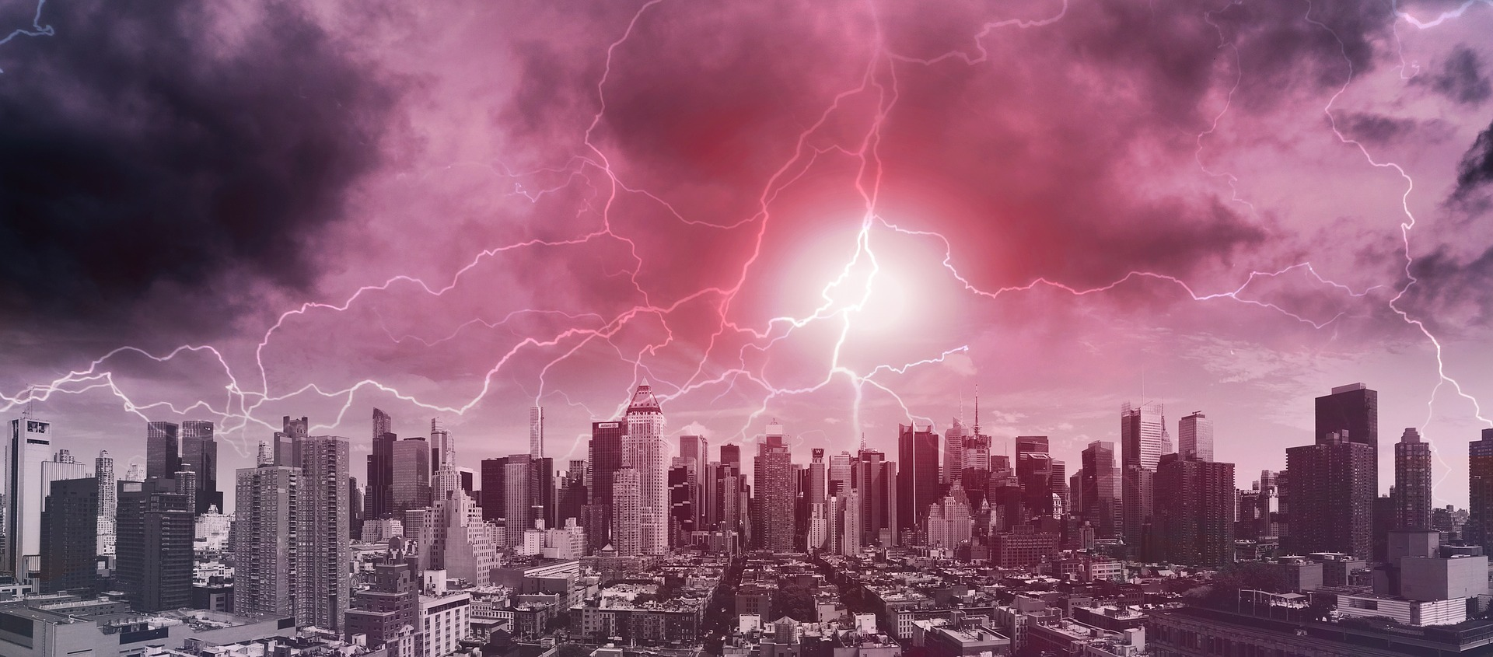
We've constructed a highly efficient, state of the art Cogeneration Plant, installed high energy lighting and climate controls that enable a substantial lowering of campus electrical consumption, launched Green Grants to seed and support sustainability ideas conceived by students and faculty. Together these enabled us to meet our public pledge to reduce our carbon emissions by 30%.

Now is the time to do more, working harder on this pressing issue of our time and seeking to make NYU among the greenest urban campuses in the nation …

References

- https://www.cntraveler.com/gallery/10-places-to-visit-before-theyre-lost-to-climate-change
- https://en.wikipedia.org/wiki/Paris_Agreement
- https://www.wbcsd.org/Overview/News-Insights/Insights-from-the-President/The-role-of-business-in-climate-change
- https://www.smithsonianmag.com/sponsored/uae-betting-big-renewable-energy-180967320/#fxEoJflyofjKyQIm.99
- https://nyuad.nyu.edu/en/research/centers-labs-and-projects/center-for-global-sea-level-change.html
- https://www.nationalgeographic.com/environment/2018/07/glacier-ice-collapse-greenland/
- https://nyuad.nyu.edu/en/academics/divisions/science/faculty/john-burt.html
- https://www.wbcsd.org/Overview/News-Insights/Insights-from-the-President/The-role-of-business-in-climate-change
- http://www.bbc.com/future/story/20170705-how-climate-change-could-transform-the-work-force
- http://www.bnamericas.com/news/insurance/swiss-re-raises-insured-losses-estimate-from-sandy
- https://www.cnbc.com/2014/10/22/7-industries-at-greatest-risk-from-climate-change.html?slide=2
- https://superstormresearchlab.org/
- https://www.nyu.edu/about/leadership-university-administration/office-of-the-president/communications/inauguration-speech-of-andrew-hamilton.html

