Responsive Web Design and Development
  - Lecture 8c Lab Tutorial Exercise

Cross-Platform Mobile Development with Apache Cordova and AngularJS

Objectives
The aim of this lab exercise is to introduce you to some more Angular concepts, specifically implementing the CRUD operations via Custom Services.
Note: This lab exercise is a continuation from the previous exercise.

Exercise 1: Adding a New Note
- Open your project from the last exercise.

The Notes Service
- Open up your service.js file. It should already contain an “addItem” method. You just need to add in the code to add the new note item. The addItem function accepts one parameter, note, which is a JSON object representing the new note to add.
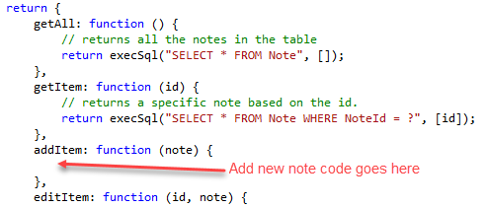

SQL Explanation
Provided here is an explanation of the SQL that is going to be used to add the new note.
- To add a new note, the SQL statement is as follows, where the “?” represents dynamic values.
Note: for Created and Modified, you need to set this to the current date and time and the method, datetime('now', 'localtime'), is SQLite date method to return the current date and time.
INSERT INTO Note
(Title, Details, Picture, DueDate, Reminder, Done, CategoryID, Created, Modified)
VALUES
(?,?,?,?,?,?,?,datetime('now', 'localtime'), datetime('now', 'localtime'));
- The highlighted question mark “?” represents the categoryID.
Note:
  - The user is allowed to specify a category that is not in the list using note.OtherCategory. If this the case then you need to insert that category first – a separate INSERT statement.
INSERT INTO Category
(Name) VALUES (?);
Where the single “?” representing the dynamic value is what is in note.OtherCategory.
  - When the new category has been added, you can then use a subquery to get the ID of the newly inserted category, so that your SQL Statement becomes:
INSERT INTO Note
(Title, Details, Picture, DueDate, Reminder, Done, CategoryID, Created, Modified)
VALUES
(?,?,?,?,?,?,(SELECT CategoryId FROM Category WHERE Name = ?),datetime('now', 'localtime'), datetime('now', 'localtime'));

Implementation
- Recall that it is always best practice to use an array to specify the dynamic values for an SQL statement when using SQLite. Add the following statement to initialise the array.
// initialise values array
- Next, SQLite does not have a Boolean data type, so you have to use 0 for False and 1 for True. Add the following to check the Done property of the Note item and use it to set the variable to either 1 (True) or 0 (False).
// SQLite does not have a Boolean type
// Set to 1 if done, otherwise 0
- Next, if the user has not specified a Category for the note (the selected ID will be zero), you need to insert NULL into the database. Add the following code to check if the category has been specified and if not, set to NULL.
// set the category id to null if it has a value of zero
- Next, you will start building the SQL required to add the new Note item using string concatenation – there are 6 question marks listed, separated by commas.
// Start building SQL to add new Note to database
// start of values
// dynamic values up to Done
- Next you need to check if the user has specified a new category.
// If a new category has been specified, you need to add this to the database first
  - Run SQL command to add the new category to the database using the execSql function.
// Execute the command to insert the new category
  - Now you can use a subquery to get the Category ID of the newly added category in the SQL statement (stored in the variable sql) you are building to add the new Note item. Note the use of the “?” in the subquery, this represents the name of the new Category.
// Use a subquery to get the CategoryId of the newly inserted category
  - Next you need to specify the dynamic values for the SQL INSERT statement. The order of the items is important and must correspond to the correct “?”. The order of the items is (do not add this, it is just to show you the order of the fields):
  - Now, specify the array dynamic values for the SQL statement as follows. Note: values for Created and Modified have been omitted, you will add these in a different way.
// set the values for the dynamic SQL query
- Else (Using an existing note category
  - Add another “?” to represent the dynamic value for the Category ID
// dynamic value for Category ID
  - Next you need to specify the dynamic values for the SQL INSERT statement. The order of the items is important and must correspond to the correct “?”. See order of the items above.
  - Now, specify the array dynamic values for the SQL statement as follows. Note: values for Created and Modified have been omitted, you will add these in a different way.
// set the values for the dynamic SQL query
- End the if {} statement – add a closing curly brace: }
- Now add the values for the Created and Modified date to the SQL query using the SQLite date functions.
// Add current date time values for Created and Modified date values
// This also marks the end of the values – two closing: ))
- If you wish, you can add the following to log the built SQL string and the dynamic values array to the console, so you can inspect. You may want to comment when you are done testing.
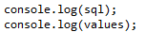
- Finally, send the SQL and dynamic values to the execSql function to be executed and return the result of the executed query.
// run the SQL to insert the new record and return to calling function.
- Save your changes.

The Controller
- Open up your controller code and locate the save function in the EditCtrl. If the current note item does not have an ID (id == null), it means it is a new note. There is already and if { } else { } statement block that does this check. You need to add the code to add the new note in the else part as shown below.
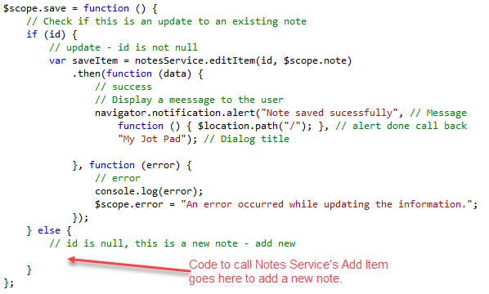
- You need to call the note service’s addItem() method, passing in the new note item ($scope.note) to add a new note record to the database. If this is successful, it prompts the user and redirects to the list page, otherwise displays an error. Add the following – highlighted box.
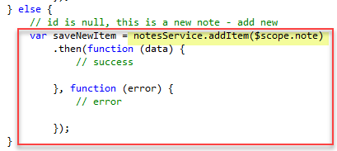
- Look at what was done in the success and error functions for the editItem and display appropriate messages/notifications.
- Save your changes.

Configuring a Route for Adding a New Note
- Now go back to your app file and configure a new route for adding a new item. Note:
  - The route should load the views/edit.html file. Same view is being used for editing and adding new note.
  - You do not need to include /:id as a new note will not have an ID.
  - Set the controller to editCtrl or whatever you have called your edit controller.
- Open up your views/list.html file.
- Locate the Search tab/button that you have added, and add a new button/tab to add a new note and set the href URL to the add new note route. This is what mine looks like.
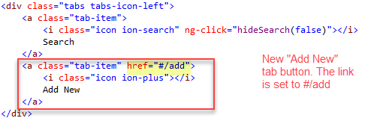
- Save your changes and test.

Exercise 2: Deleting a Note
- Now try implementing the Delete function – this is not a difficult task.
  - You will need a button/icon for the user to click on to delete a specific note item.
  - You may want to confirm that the user actually wants to delete the note.
  - Implement the deleteItem method in the notes service. The syntax for an SQL DELETE is (Note: the WHERE clause is important or else you will end up deleting all rows):
DELETE FROM TableName
WHERE searchCondition;

Exercise 3: Display Details Page
- If you have not done so already, create a new view called details. This page will display the details of the selected note item, but not in an editable format. For example, think of when you look at the details of a contact on your phone. You get the details in a readable format first and then you can choose to edit the details. Look at the Ionic Card Display, it may help you with the implementation.
- Create (or modify) appropriate links between the List of Notes, the Edit/Add New Page and the Details Page.

Exercise 4: Editing a Note (Explanation)

The Notes Service
This section provides an explanation of the code that was provided to add a new note in the notes service. You DO NOT need to implement this, I gave you the code to copy and paste in Exercise 8b.

SQL Explanation
Provided here is an explanation of the SQL that is going to be used to update an existing note.
- To update an existing note, the SQL statement is as follows, where the “?” represents dynamic values.
UPDATE Note SET
Title = ?,
Details = ?,
Picture = ?,
DueDate = ?,
Reminder = ?,
Done = ?,
CategoryID = ?,
Modified = ?
WHERE NoteID = ?

- The highlighted question mark “?” represents the categoryID.
Note:
  - The user is allowed to specify a category that is not in the list using note.OtherCategory. If this the case then you need to insert that category first – a separate INSERT statement.
INSERT INTO Category
(Name) VALUES (?);
Where the single “?” representing the dynamic value is what is in note.OtherCategory.
  - When the new category has been added, you can then use a subquery to get the ID of the newly inserted category, so that you can set the CategoryID in the UPDATE Statement as follows:
UPDATE Note SET … CategoryID = (SELECT CategoryId FROM Category WHERE Name = ?),… WHERE NoteID = ?

Implementation
- Recall that it is always best practice to use an array to specify the dynamic values for an SQL statement when using SQLite. Add the following statement to initialise the array.
// initialise values array
- Next, SQLite does not have a Boolean data type, so you have to use 0 for False and 1 for True. Add the following to check the Done property of the Note item and use it to set the variable to either 1 (True) or 0 (False).
// SQLite does not have a Boolean type
// Set to 1 if done, otherwise 0
- Next, if the user has not specified a Category for the note (the selected ID will be zero), you need to insert NULL into the database. Add the following code to check if the category has been specified and if not, set to NULL.
// set the category id to null if it has a value of zero
- Next, you will start building the SQL required to update the existing Note item using string concatenation.
// Build the SQL string to update the note in the database
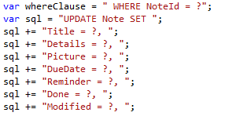
- Next you need to check if the user has specified a new category.
// If a new category has been specified, you need to add this to the database first
  - Run SQL command to add the new category to the database using the execSql function.
// Execute the command to insert the new category
  - Now you can use a subquery to get the Category ID of the newly added category in the SQL statement (stored in the variable sql) you are building to update the Note item. Note the use of the “?” in the subquery, this represents the name of the new Category.
// Use a subquery to get the CategoryId of the newly inserted category
  - Next you need to specify the dynamic values for the SQL INSERT statement. The order of the items is important and must correspond to the correct “?”. The order of the items is (do not add this, it is just to show you the order of the fields):
  - Now, specify the array dynamic values for the SQL statement as follows. Note: values for Created and Modified have been omitted, you will add these in a different way.
// set the values for the dynamic SQL query
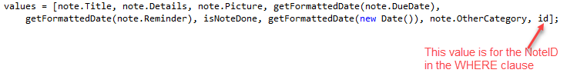
  - Note: for Modified, I have used the JavaScript function to set this to the current date and time: getFormattedDate(new Date()). In the Add New example, I used the SQLite date function.
- Else (Using an existing note category
  - Add another “?” to represent the dynamic value for the Category ID
// dynamic value for Category ID
  - Next you need to specify the dynamic values for the SQL INSERT statement. The order of the items is important and must correspond to the correct “?”. See order of the items above.
// set the values for the dynamic SQL query
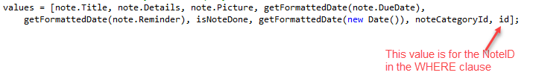
- End the if {} statement – add a closing curly brace: }
- Now add the WHERE Clause to the SQL statement string, otherwise all the rows in the database will be updated with the same values.
// Add the where clause so it only updates for this specific note item
- If you wish, you can add the following to log the built SQL string and the dynamic values array to the console, so you can inspect. You may want to comment when you are done testing.
- Finally, send the SQL and dynamic values to the execSql function to be executed and return the result of the executed query.
- // run the SQL to insert the new record and return to calling function.
- That’s all for today.

