Rhys Whatty (1900045)

January 13th 2020
ACCB4013 Information Engineering
Practical Test Analysis of Systems Requirement

User Diagram
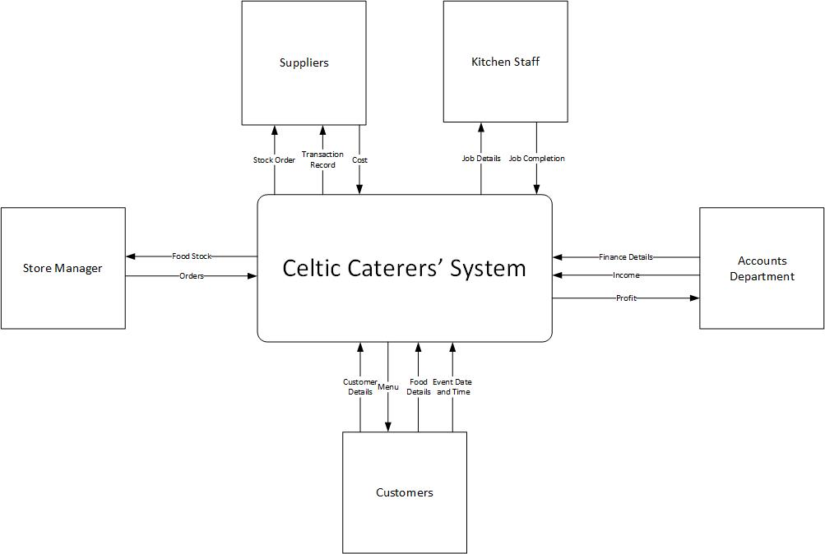
The Diagram above shows how each of the five user types (Customers, Store Manager, Kitchen Staff, Suppliers and the Accounts Department) will contribute to the overall workings of the System.

Level 0 DFD
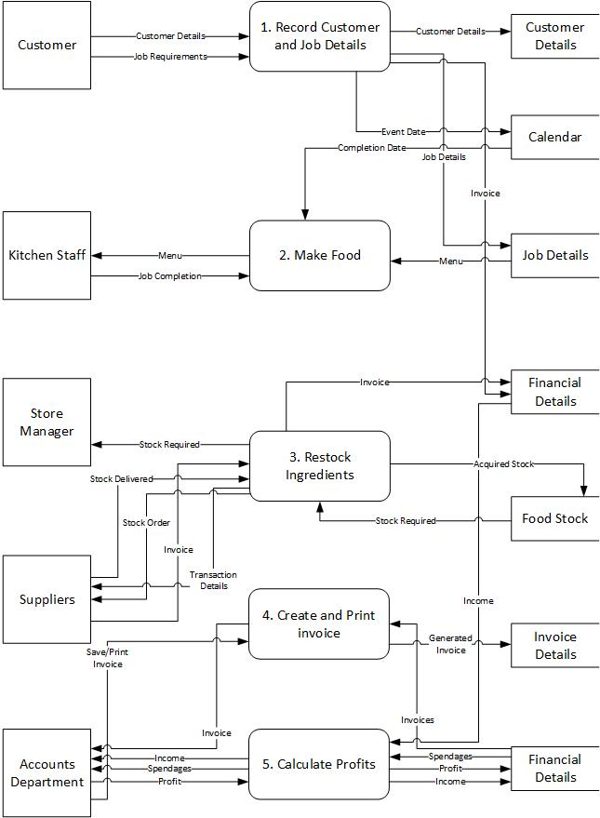
The diagram above shows the Data Flow Diagram for the whole system, and who and how is involved in each separate parts of the system, which include recording Customer and Job Details, Preparing the Food, Restocking Ingredients, Creating and Printing the Invoices and Calculating Company Profits.

Level 1 DFD
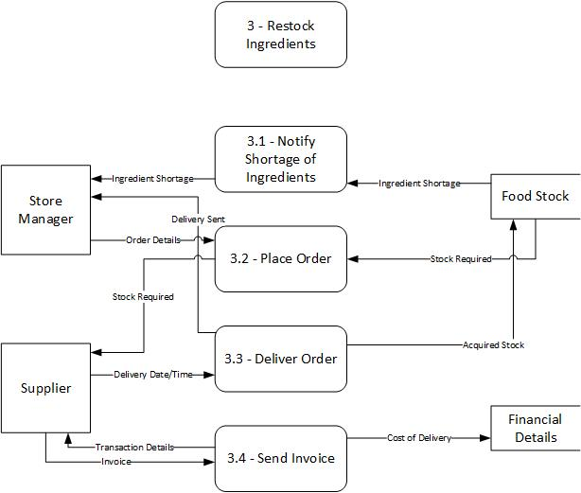
This diagram shows a Level 1 Data Flow Diagram, which takes a process from the Level 0 DFD above, and breaks it down into individual steps for a more in-depth look at how users and storages are involved in each process. For this step, I used step 3, Restocking Ingredients from Storage.

Entity Relationship Diagram
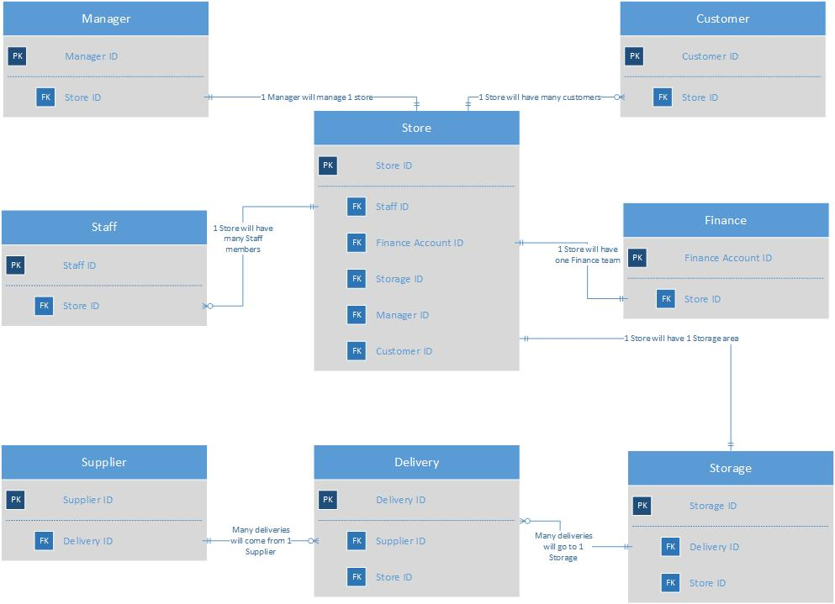
The final diagram shows the relationship between all of the entities within the system and how they are linked together. They are joined using the Crow’s Foot Notation, which is used to display a one-to-one or one-to-many relationship, with descriptions of each relationship on the lines.

