
Applied Leadership and Management in the Workplace
Module Assignment Submission
Student Name: | Linda Cullen
Student Number: | 2416910
Module No: | BMSK4011
Module Title: | Continuous Professional Development

Statement of Confirmation of Authenticity
By the act of making this submission, the student declares that this is the work of the student named above. The work has not, in whole or in part, been knowingly presented elsewhere for assessment, or where assessment has been built on a previous assessment, this has been identified. Where materials have been used from other sources it has been properly acknowledged. If this statement is untrue, the student acknowledges that an assessment offence has been committed.
Attention is drawn to the plagiarism and unfair practice policies of both the University and of ILM.

Table of Contents
Section 1: Know how to identify development needs 3
1.1 Identify learning styles for self and another 4
1.2 Use a simple technique for identifying development needs for self & another 4
1.3 Identify potential barriers to learning for self and another. 9
1.4 Explain how these barriers to learning can be overcome. 10
Section 2: Know how to develop self & others to achieve organisational objectives 11
2.1 Analyse learning/development options to meet needs of self & another. 11
2.2 Identify support mechanisms for the development of self & another 13 2.3 Prepare development plans for yourself and another person 15
2.4 Method used to monitor the development of self & another. 17
Conclusion 20
Reflection on the Recruitment process 18
References 21
Appendix A Curriculum Vitae 23
Appendix B Continuous Professional Development Record 25
Appendix C Kolb Reflection Cycle 26
Appendix D Covey Time Management Matrix 27

Introduction

Continuing Professional Development exists to ensure that an individual enhances their skills and abilities once they have formally qualified. Typically, academic qualifications may have already been completed at this stage and an individual is now working within their specific industry and job function. (CPD News team, The Importance of Continuing Professional Development (CPD) | the CPD Certification Service, 2020)
In this assignment I will be identifying learning styles for myself and another person who shall be referred to as Person 2. I will be carrying out a SWOT analysis to identify developmental needs and identifying potential barriers and how to overcome these. Once we have identified these, we can then put plans in place to help us develop. I will analyse learning/ development options and identify what support networks we have in place to achieve these. After this I will prepare a personal development plan for each of us and discuss Methods in which we can monitor the progress of our development.

Section 1: Know how to identify development needs

(MindTools, 2024) says You need to take the time to understand the training that each individual needs, so that you can provide the right training for the right people. As well as improving performance, this saves time, resources, and money. So, in order to be able to manage a team it is important to firstly understand how you learn as a person once you have done this you can work on identifying the development needs of those within your team. You can do this by using questionnaires which will determine how people learn. These include
HONEY MUMFORD which will teach you how a person learns internally
VARK Which will teach you how a person receives information
DANTEC which shows you what learning environment is best for that individual
By using models such as the SWOT Analysis by Albert Humphrey in the 1960s (Teoli et al., 2023) to identify a person’s Strengths, weakness, opportunities and threats you can introduce ways to draw on what the individual can bring to your business and what you can do to work together to develop and aide progression for them in the workplace.
Once you have identified these you can look at more detailed goals and then introduce a new framework such as the Go Mad Framework by Andy Gilbert in 1997 (Our Story - Go MAD Thinking, 2024) you can develop a personalised training schedule which can also include Formal and informal training. Formal learning is the name given to training that is structured and takes place within a planned setting, these could mean like a classroom or online. It is planned and has a set Goal at the end and is normally taught by an instructor or trainer. Whilst Informal learning is the name given to learning that’s unstructured and takes place away from a traditional, formal learning settings, like a classroom. it’s often unplanned and self-directed by the learner.

Identify learning styles for self and another

Upon identifying the development needs I then learnt how to identify the learning styles for myself and another person. I completed 4 learning styles for each of us but will only be focusing on 3 learning styles for myself and 2 learning styles for the other person please see the table below for the results of these.
LEARNING STYLES | MYSELF | PERSON 2
VARK | Visual | Aural
HONEY MUMFORD | Reflector | Theorist
DANTEC | Emotional/Psychological | Emotional/physiological
MBTi | ISFJ | ISFJ

Whilst this is not an exact science and we both may sometimes learn in other ways by doing this it will give us a clearer insight in self- awareness of our individual weaknesses, barriers and developmental needs. In identifying these developmental needs, we are able to put strategies in place in regards to training which will be more beneficial to the person and the business, Knowing how to identify and meet these needs means you're able to put effective practices in place to facilitate them. (How to Identify Learning and Development Needs: A Guide, 2024).

1.2 Use a simple technique for identifying development needs for self & another

Once I had completed a learning style assessment, I then used a simple technique this being a SWOT analysis to help understand the development needs for myself and another. It is a good tool because it will help identify our strengths, weakness, what opportunities and what threats we may face. (MindTools | Home, 2024) says SWOT stands for Strengths, Weaknesses, Opportunities, and Threats, and so a SWOT analysis is a technique for assessing these four aspects of your business.
SWOT Person 1

STRENGTHS  I am determined.  I care about people.  I can communicate well both verbally and written. | WEAKNESSES  I get Anxious in new environments.  Cake piping skills are not good.  I am not very good at Maths
OPPORTUNITIES  Doing the ALAMo will help me develop new skills and help me learn new skills.  My family and friends are very supportive.  My Boss is very supportive and encouraging and open to any ideas that I have, | THREATS  Anxiety of taking on a new role.  Time Management  Car breakdowns.

Having done a SWOT on myself I then done one on Person 2.
SWOT Person 2

STRENGTHS  Is good at working with people.  Attention to detail.  Has 15 years baking experience and a 5* hygiene rating. | WEAKNESSES  Poor organisation skills.  Not assertive.  Fondant skills.
OPPORTUNITIES  Implementing an IT system.  Employing another baker.  Skills classes. | THREATS  Employing staff costs money  Courses are far away and expensive would need to close the business for a few days to attend losing money.  Secret recipes being leaked by employees.

From doing this SWOT analysis I learn that I am determined, caring and can communicate well. I struggle with anxiety, and this can hold me back. I struggle with learning in certain environments, and I have poor maths skills. I have identified some opportunities that I can work towards and help to overcome these challenges,
For Person 2 I have learnt that they work well with people and pay attention to detail and have a lot of experience in their field. They are however very unorganised, lack assertiveness and have some decorating skills they need to improve on.
After having done a SWOT analysis I was then able to do a Gap analysis to help overcome the weaknesses I identified. Please see them below.
Gap Analysis person 1
PRESENT POSITION | ACTIONS | DESIRED POSITION
Getting Anxious in new environments | By the end of 2025 I will have anxiety coping mechanisms in place that will require continuous work. By the end of December 2024, I would have spoken to medical professional and see what they advise and take support where needed. | To overcome Anxiety
Poor decorating skills | By the end of March 2025, I will be having 1 to 1 decorating skills session with my employer to cover the basics.  By the End of June 2025, I would have enrolled in some decorating courses to learn more complicated designs. | Able to confidently decorate cupcakes.
Poor maths skills | By the end of 2025 I would have completed some of the brilliant.org online maths courses.  Starting immediately, I will not be too embarrassed to use a calculator when needed. | To be better and more confident undertaking basic maths tasks.

Having done a Gap Analysis on myself I then done 1 on person 2.
Gap Analysis person 2
PRESENT POSITION | ACTIONS | DESIRED POSITION
Poor organisation skills | They have immediately implemented List making based on the covey time management matrix quadrants 1 and 2 this works as it will identify where tasks need to placed (Ingram, 2024) says coveys time management matrix shows strategies for prioritizing by dividing tasks into 4 quadrants of time management based on how urgent and important they are.  By the beginning of January 2025, they will have a new diary and Wall calendar which will be updated every time a new order comes in. | Having an organised workspace and system in place.
Not assertive | They have already started using Covey’s time matrix quadrant 3 to identify tasks that can be delegated to others to free up more time for urgent orders. Please see appendix for time management matrix.  From having the organisation system in place above they will quickly be able to check availability straight away. | Being confident  to say no to last minute orders to also be able to delegate tasks to others.
Poor Fondant Skills | By the end of Feb 2025, they would have contacted and enrolled on some local classes.  In Jan 2025 offer a small reduction on Fondant covered cakes to use as a training tool to gain confidence. | Competent and confident in Fondant making

From the gap analysis I have learnt that there is a solution to most problems you just have to be willing to put the work and time in to achieve your goals.

1.3 Identify potential barriers to learning for self and another.

From doing both a SWOT analysis and identifying which of the learning styles we are, we are then able to then find potential barriers that could hinder our development at work. I will identify some of them based on learning barriers and the SWOT in the table below.

 | Potential barrier 1 from Honey& Mumford | Potential Barrier 2  from SWOT | Potential barrier 3  From Dantec
Myself | Employers could get annoyed that tasks take longer to complete.  Employers could not have time to give physical demonstration on how to do a new task. | Bad time management could pose a risk to making sure tasks are completed on time.  Not being able to Pipe cupcakes will cause delays at busy periods. | Can get discouraged if the baker is not there to offer a clear goal and offer regular feedback.  Could struggle with spontaneous environment such as an urgent personalised order.
Person 2 | They could struggle with written instruction such as orders through email.  When working alone they will not have anyone to discuss the ideas with. | Staff stealing secret recipes and starting their own business using these.  Decorating classes that are further away they would have to close the business down while taking these and lose money. | Short attention span when working alone, so can be easily distracted and fall behind.  May under preform when working at a time that does not best suit their needs.

Now we have identified the barriers we can look at strategies to overcome these.

1.4 Explain how these barriers to learning can be overcome.

In pinpointing these barriers, we can then look at strategies to overcome these.
For myself
Explain to employer that sometimes things may take you a little longer but assure them you will get there.
Ask for a demonstration if not find a quick YouTube video to how you.
Have regular feedback meetings, appraisal, reports.
Take a few minutes in your own time to reflect on the task.
Make lists using coveys time management matrix.
Undertake cake decorating classes.
For Person 2
Offer an in person or call consultation to talk through personalised ideas.
Talk through what you are doing before starting an independent task.
Get all staff to sign a non-disclosure agreement.
Find classes that are nearer or fall on your days off.
Find the time that works best for them and try and arrange shifts to suit these.
Play some music in the background to keep self-engaged,

Section 2: Know how to develop self & others to achieve organisational objectives

It is important as a manager to improve staff and yourself in order for you to structure your business so your staff are working in their strongest areas, not only will this help your business grow but your staff will feel confident in what they are doing and will work harder and smarter, making less mistakes and keeping up to date with current trends, Putting time and effort into the way that you manage them can mean the difference between a positive or negative working environment. Not only will good people management grow the business, but it will also boost your employees’ careers and help them to grow as individuals (Personnel, 2020).

2.1 Analyse learning/development options to meet needs of self & another.

In order to Analyse the learning and development needs for a person we need to refer back to the learning styles we identified earlier. I will give some examples for myself and person 2 on what we can do to develop our skills based on the weaknesses we have already identified in our SWOT analysis.
Myself
As Identified earlier I am a Visual, Emotional and Psychological reflector learner this means I learn best by Watching videos, and physical demonstrations before trying them myself. I have a deep desire to Succeed and am motivated by knowing and understanding more about subjects. I am easily distracted and prefer learning by myself.
Person 2
As I identified earlier person 2 is an Aural, Emotional and physiological theorist learner. This means they learn best through discussion and verbal reassurance. They are highly motivated when interested in the task they perform better at certain times of the day, so you need to be flexible when allowing them to have breaks to get the most out of them. They prefer learning in groups.
Please see the table below where I have identified some formal and informal learning opportunities that would benefit our development.
Myself
Formal Learning opportunities | Informal learning opportunities
Brilliant.org maths online Courses | You tube piping video tutorials
Piping skills private class at Swansea Sugar craft | Maths online quizzes
MBL Seminar on time management-how to take back control of your day. | Ted talks online video on Time management

Having done this for myself I then done this for person 2
Person 2
Formal Learning opportunities | Informal Learning opportunities
Fondant decorating and skills class at Swansea Sugar Craft | How to gain control of your free time  Video by Laura Vanderkam
Professional IT tuition | Tik Tok fondant skills videos
Attending group support groups that are aimed towards confidence and assertiveness | You tube video- a nice persons guide to being assertive

My learning opportunities are more based on individual learning whilst person 2 are more group based leading to discussions.

2.2 Identify support mechanisms for the development of self & another

To identify the support mechanisms for myself and person 2 I used the go mad framework this is a list that offers solution focused thinking and has allowed me to know what support is in place and how it benefits us.
In the tables below please find a list of who supports us and what they do to support us.
Person 1- GOAL – To self-manage a cake shop.
Support | What they do
Partner | My partner is supportive in every aspect, he is encouraging and always more than happy to taste test new products and give feedback.
Children | My son is very helpful in helping me to develop some of my ideas he is neurodivergent and some of his ideas whilst maybe sometimes a bit out there he enjoys working with me to develop them into something achievable.
Employer | My employer is always open to listening to my ideas and actively seeks my opinion and input to tasks. They are open to any training I may want and need and will offer praise where deserved and constructive criticism where needed.
Friends | I have a small network of friends who are available to help with childcare and taking my son to his many sporting training and games when I am unavailable to take him as my partner does not drive so he cannot do this.
Cousin | My cousin is the only family I have locally as the rest live 200 miles away she keeps me calm and will help with childcare especially overnight when I have to be in work early or have late night finishes.

Having done this on Myself I then went on to do this on person 2
Person 2- GOAL- Expanding business into online sales.
Support | What they do
Mum | Helps with childcare when they have to work late or start early. Also helps in the shop whenever they can.
Dad | Helps with doing shopping trips to get stock and sourcing the best quality ingredients at the lowest cost.
Partner | Is emotionally supportive and always willing to help bounce ideas around will cook when they have had a stressful busy day.
Employee | Is willing to learn and offer reassurance and suggestion to help the business grow, they are open to training and opportunities given.
Customers | Are happy to try new products and offer feedback on taste, presentation and delivery. Repeated custom and recommending the business to friends and family.

Having a good support network in place will help us both and we both have a lot of support at home and in the workplace and people to offer us feedback both positive and negative and ideas on how we can improve. I identified a weakness for myself as not having a large support network and only a handful of people around this may lead to occasional times where I have no childcare.
2.3 Prepare development plans for yourself and another person
Having identified what we need to work on I then developed a PDP for myself and person 2 (intelligent people, 2023) say that A Personal Development Plan (PDP) is a structured and systematic approach to personal and professional growth. It is a strategic roadmap that individuals create to identify their career goals, assess their current skills and competencies, and outline actionable steps to acquire new skills and achieve their desired outcomes.
Person 1
What do I want to learn? | What do I have to do? | What support and resources will I need? | How will I measure success? | Target Date for Review
Math skills | Brilliant.org online maths course | Computer, time | By passing the course and grade achieved | December 2025
Time Management | Planning time efficiently according to schedule and tasks | Diary  Time  Order book  Coveys time management matrix | If I am completing tasks on time and managing to balance everything | Weekly
Cake decorating | Take training courses  Practice | Access to courses and training  People  Tools  Money | By monitoring development and skill set | Weekly

Having done a PDP, I have come up with a set of learning objectives for myself and person 2.

Personal Objectives
My Long term goal is to be able to be confident in managing a shop by myself that is thriving.
Short Term Goals (next 12 months)
Learn how to bake and decorate cupcakes
Learn secret family recipes
Learn the banking and payroll systems
Secure premises for a new shop
Medium Term Goals (1-2 years)
Open shop
Have loyal customers to help spread the word
Expand knowledge of decorating into larger cakes such as birthdays, weddings
Long Term Goals (2-5 years)
Have a busy, successful shop with repeat and new customers that is consistently turning over a profit.

After I done mine, I then done one for person 2
Person 2
What do I want to learn? | What do I have to do? | What support and resources will I need? | How will I measure success? | Target Date for Review
Fondant Skills | Classes  Practice | Computer  Fondant tools  People | Has it become Easy or second nature  Reviews and feedback from customers | Monthly
An online ordering system to allow for online sales and postal orders | Find a website builder  Build a website with a shop  Source a delivery company | Money  Computer  Printer  People | By monitoring if the online shop is working  Are they getting more orders  Is it easier  Are people receiving their orders still fresh and in good condition | Weekly
Organisation | Make lists  Get designated spaces for everything  Label things  Have set days of the week for certain tasks | Diary  Computer  Printer  Space  Boxes  timetable | Checking if things are being completed on time.  Are things easier to find? | Daily

After completing person 2 PDP I was then able to set some personal objectives for them.

Personal Objectives
Person 2 would like to go into online sales and postal orders. This will enable them to expand their business and reach customers who do not live locally.
Short Term Goals (next 12 months)
To research what other people are doing and how to make your products stand out.
Source a delivery company that will be cost effective.
Find a website designer or research how to build an online shop yourself.
Have a small number of products available to ship.

Medium Term Goals (1-2 years)
To have website up and running
To trial and expand products available for postage
Have a loyal and dedicated customer base
To be running at a small profit
Long Term Goals (2-5 years)
To Have multiple branches of shops.
Have a busy online store with a bakery purely dedicated to online sales
To be making enough money that they are mortgage free.
These goals will help both of us to succeed as we have a clear goal to work toward by breaking it down into smaller time frames and goals these goals will feel achievable and realistic making us work harder and more efficiently.

2.4 Method used to monitor the development of self & another.

According to (Deanna Debara,2020) Employee growth plans lay the groundwork for your team members to grow and evolve in their careers. And by carefully measuring and monitoring their progress, you can empower them to achieve goals, reach their full potential, and build a thriving career and progress.
Some methods to monitor progress would be.
Appraisals,
Reports,
Exit tickets,
Assessments,
Progress meetings,
Myself
Appraisals would be a more beneficial method for myself as it gives you time to reflect and talk about what you have learnt and what you have to work on. It is a positive process and gives a good insight into where you are currently and what you need to do to get to where you want to be
Person 2
Progress meetings would be more beneficial for Person 2 as they would have more chance to discuss and talk about things in a less formal environment.

Reflection on the Recruitment process

In reflecting a recruitment process I decided to use an interview that did not very well I will be using Kolb reflective process, and I have included this in appendix B

Experience
Bad Interview

Reflective Observation
I was very nervous and fumbled through answers during the interview. I had to repeatedly ask the interviewer to repeat or reword questions, as the interview progressed, I became more aware that it wasn’t going well and became more nervous which made it worse at one point having a complete brain black out and couldn’t even remember what training I had previously done.

Abstract Conceptualisation
The Interview went wrong because I was nervous, I had not slept well the night before and this had led to be being tired and therefore increasing nerves, as the interview progressed, and I could sense it was going downhill I just became more and more nervous and distanced from the answers that I knew.

Active Experimentation
In future to avoid situations like this I plan to do my best to get a good night’s sleep the night before by clearing my schedule for the evening, doing research and refreshing my mind on the role using the job advert or job specification. Look up the interviewer on social medial to reassure myself they are a normal person just like everyone else. If I have a similar interaction again rather than just trying to fumble through it take a deep beath and explain to them I am nervous and ask to start over acknowledge the nerves and over them rather than trying to hide behind them.

C.V
To complete my C.V I created one using a template on the job search website Indeed. Please see appendix . It is important to keep your C.V up to date and relevant to the job you are applying for as it would normally be the first point of contact with a perspective employer it should detail your experience and qualifications, (indeed career guide, 2023) says A CV allows you to highlight all of your relevant professional and academic experience, and show an employer that you're a great fit for the job.
When compiling the C.V you should include the following
Name
Email address
Telephone number
In the job experience section please keep this specific to the role you are applying for, it is quite common for some people to have multiples depending on the role they are applying for e.g. Hospitality, childcare, retail. Each one should be no longer than 2 pages long and include the following for each job.
Job title
Name of company
Dates that you held this position
Key responsibilities and achievements. Keep this short relevant and to the point.
You should also add a list of qualifications and education that are relevant.
It should be easy to read and a simple layout using a standard font. It does not need to be fancy.

Conclusion

From doing this assignment I have learnt how to undertake learning styles assessments on myself and another person and which learning styles we are. I have identified strengths and weaknesses for myself and another person and not only what we need to do to develop ourselves and our careers but the best ways to do this.

References

CPC News team. (2020). The Importance of Continuing Professional Development (CPD) | The CPD Certification Service. Cpduk.co.uk. https://cpduk.co.uk/news/importance-of-cpd#:~:text=Continuing%20Professional%20Development%20exists%20to,specific%20industry%20and%20job%20function.
Crowe Associates. (n.d.). Covey’s Four Quadrants for time management. https://www.crowe-associates.co.uk/wp-content/uploads/2013/10/Coveys-4-quadrants-Exercise.pdf
Deanna deBara. (2020). How to Monitor and Measure an Employee Growth Plan’s Progress. Lattice.com. https://lattice.com/library/how-to-monitor-and-measure-an-employee-growth-plans-progress#:~:text=%E2%80%94-,Employee%20growth%20plans%20lay%20the%20groundwork%20for%20your%20team%20members,and%20organization%20%E2%80%94%20in%20the%20process.
Explorance. (2015). “I Do and I Understand” – Kolb’s Experiential Learning Theory Explained. Explorance. https://explorance.com/blog/i-do-and-i-understand-kolbs-experiential-learning-theory-explained/#:~:text=The%20experiential%20learning%20cycle&text=According%20to%20Kolb%2C%20effective%20learning,abstract%20conceptualization%20and%20active%20experimentation.
Indeed. (2023). Why Is a CV Important? Everything You Need to Know. Indeed Career Guide. https://uk.indeed.com/career-advice/cvs-cover-letters/why-is-a-cv-important
indeed. (2024). How to identify learning and development needs: a guide. Indeed Career Guide. https://uk.indeed.com/career-advice/career-development/learning-and-development-needs#:~:text=Knowing%20how%20to%20identify%20and,in%20place%20to%20facilitate%20them.
Ingram, A. (2024). Understanding the Covey time management matrix in 2024. Hellobonsai.com. https://www.hellobonsai.com/blog/covey-matrix-time-management#introduction-to-the-covey-time-management-matrix
MindTools | Home. (2024a). Mindtools.com. https://www.mindtools.com/ak0sc5b/career-and-personal-developmental-needs
MindTools | Home. (2024b). Mindtools.com. https://www.mindtools.com/amtbj63/swot-analysis
Our Story - Go MAD Thinking. (2024, April 30). Go MAD Thinking. https://gomadthinking.com/our-story/
Personnel, P. (2020, July 22). People management: Developing yourself and your team. Page Personnel. https://www.pagepersonnel.co.uk/advice/management-advice/employee-development-and-retention/people-management-developing-yourself#:~:text=Putting%20time%20and%20effort%20into,them%20to%20grow%20as%20individuals.
Richards, L. (2023, August 24). What Is A Personal Development Plan? Intelligent People. https://www.intelligentpeople.co.uk/candidate-advice/personal-development-plan/
Teoli, D., Sanvictores, T., & An, J. (2023, September 4). SWOT Analysis. Nih.gov; StatPearls Publishing. https://www.ncbi.nlm.nih.gov/books/NBK537302/#:~:text=SWOT%20Analysis%20(short%20for%20strengths,but%20this%20attribution%20remains%20debatable.
Wrike. (2024, March 25). How to use the Covey time management matrix | Wrike. Blog Wrike. https://www.wrike.com/blog/covey-time-management-matrix/

Appendix A Curriculum Vitae

Linda Cullen
Swansea
Lindajcullen0223@live.co.uk 07999349623

Work Experience

Shop Assistant
Lil Puddings-Swansea
June 2022 to Present
My role here is as a general assistant. I serve on the counter taking orders and payments, keep the kitchen area clean and organised.
I am confident is helping with baking the products and keeping up to face with allergens and paperwork.

Receptionist
Morgans Hotel-Swansea
December 2020 to May 2022
My last job was working as a receptionist at Morgan's Hotel.
The role includes taking reservations over the telephone, email and internet bookings.
Answering emails and telephone call enquiries.
Checking in guests and checking them out.
Answering guest enquiries and helping them with any problems they may have throughout their stay.
As the first person the guests meet when they arrive it is my job to make sure they feel welcome, safe and comfortable in the hotel.

Beverage Manager
Morgans Hotel-Swansea
April 2018 to August 2020
I have recently been made redundant from my previous role as the beverage manager for Morgans hotel due to effects of covid-19.
My daily duties include controlling and ordering stock.
Ensuring staff are meeting the high standards expected of them and are ensuring that guests are made to feel welcome and comfortable throughout their stay.
I have recently been a part of a new wine and cocktail menu overhaul.
In this role I have learn more about targets and what we can do to ensure targets are met.
Doing rotas and holidays.
Although this role has a beverage manager title, I am solely responsible for the hotel, its guests and staff in times when the general manager is not there throughout all departments housekeeping front of house and food and beverage. This includes overseeing booking rooms and checking guests in and out when reception staff are unavailable. Checking rooms are of a suitable standard and ready for our guests.

Bar Manager
The Rhydding-Swansea
April 2017 to August 2018
I worked full time covering a range of shifts.
Duties include taking food orders, making drinks and taking food to the tables.
I am also in charge of rotas for each week and making sure the day-to-day jobs are completed by staff and myself.

Deputy Manager
Woolwich taverns-London
October 2012 to March 2016
At Churchills I worked with the Manager on day to day running of the pub.
I would do my normal bar duties as well as banking, cashing up.
I would often do opening up and locking up.
As Deputy Manager I would be in charge of rotas, wages, paperwork, stock taking ordering and taking delivery of stock.
When the Manager was away on Holiday I would cover her leave with a live in position and take over full responsibilities.
I left this position as we relocated to Swansea from London. And have been back since to cover her holidays.

Cashier/Sales Assistant
Peacocks-London
April 2000 to March 2013
I worked here during weekends on the tills and on the floor filling up stock and checking stock for customers.

Bar Maid
Fulham C.I.U club-London
February 2003 to March 2008
I did normal bar duties including serving customers, taking cash and cleaning.
We were based opposite Chelsea Football club and would get extremely busy on match days.
I learned the importance of customer service and to be quick and work in a small area with a lot of people.

Education

Diploma in Childcare and Education
Kingston College

Certifications and Licenses

Personal Licence
Present

Appendix B Continuous Professional Development Record

Continuous Professional Development Plan – Linda Cullen
Formal | Informal | Date | Duration | Status | Details
ILM Level 4 Diploma in Leadership and Management |  | 2024 | 1 Year | In Progress | ILM
L4 Certificate of HE Applied Leadership and Management |  | 2024 | 1 Year | In Progress | University of Wales Trinity Saint David
Personal Licence |  | 2015 | 2 Days | Complete | BIIAB
Diploma in Childcare and Education |  | 2003 | 2 Years | Complete | CACHE
 | Microsoft Word for beginners-you tube | 2024 | 45 Minutes | Complete
 | Food and wine pairing basics-wine folly | 2018 | 1 Hour | Complete
 | Cellar Management | 2019 | 5 Hours | Complete
Innquest software training |  | 2021 | 2 days | Complete
Level 2 Health and safety |  | 2021 | 3 hours | Complete | CPD

Appendix C Kolb Learning Cycle

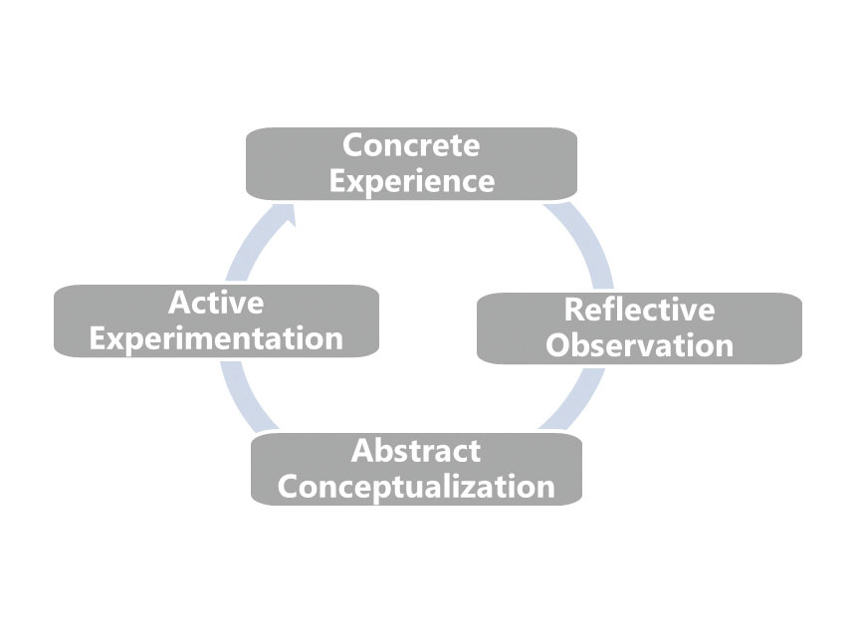

(Explorance, 2015) How one learns is a fascinating process that includes a variety of theoretical methods and individual learning styles. In 1984, David Kolb created the Experiential Learning Theory (ELT) and it is still one of the most widely used learning models. ELT is based on the premise that a person learns from direct experience or ‘learns by doing’.
“I hear and I forget. I see and I remember. I do and I understand.” – Confucius
Confucius’ quote summarizes Kolb’s theory wonderfully, the crux being that a person learns through action. Kolb’s theory is particularly interesting because it focuses on the learner’s perspective and on personal development. In experiential learning, the individual guides the learning process as opposed to the conventional, didactic method.
‌

Appendix D Coveys Time Management Matrix

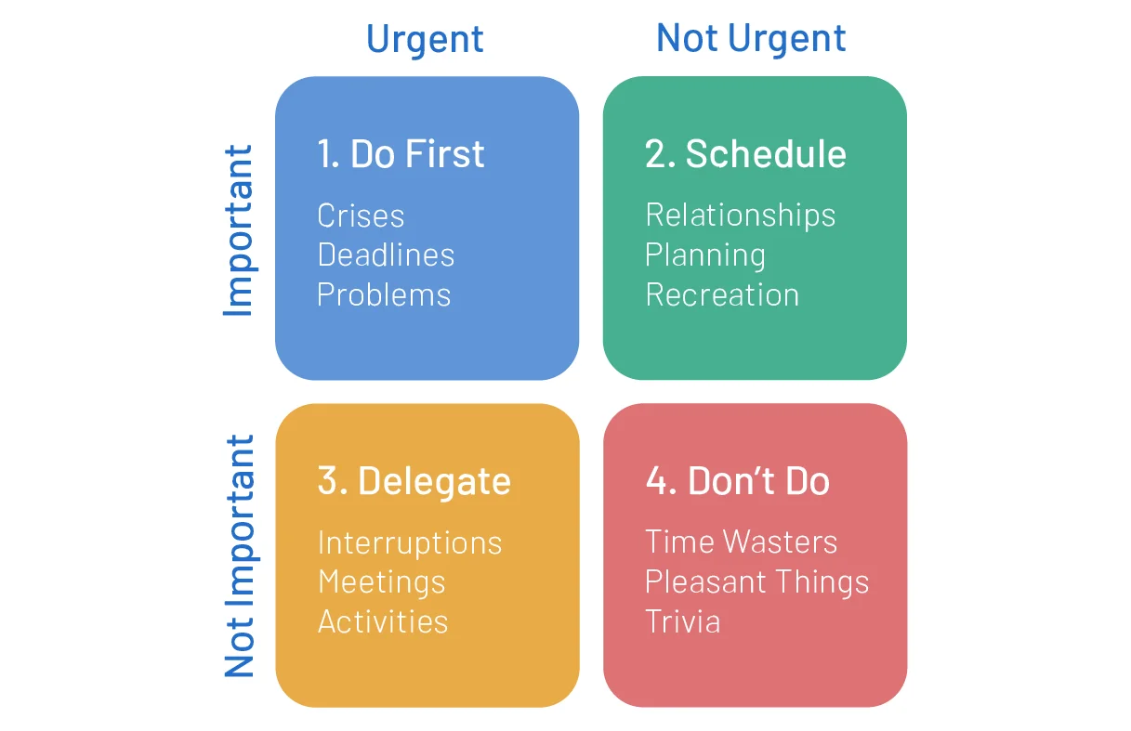
Stephen Covey, author of “The 7 Habits of Highly Effective People,” believed all tasks can be categorized based on urgency and importance. Urgency refers to tasks that require immediate attention, while importance focuses on tasks that align with our goals and values.
Covey’s matrix comprises four quadrants representing a different combination of urgency and importance (Wrike, 2024).

