Financial Management for the Hotel Industry
BMIH5007, 5002
Assignment 2: Marriott
International
Student Name: Alexandru-Gabriel Ispas
Student ID: 2025167

Table of Contents
Introduction: 3
Marriott International Background: 3
Comparison of the Marriott 2020 and 2021 financial ratio performance 3
Trends in Marriott’s key financial ratios 4
Limitation of Ratio Analysis 8
Understanding of ratios and its importance for decision making 9
Conclusion: 10
References 11

Introduction:
This research analyses Marriott International's financial statements for the years 2020 and 2021 and delivers their findings. The study discusses the history of the company and conducts an analysis of the most important financial parameters and their implications. This study draws its data and information from the annual reports published by Marriott International, as well as news items, relevant reports, analyst comments, business websites, and reports and websites pertaining to industry indicators. The indicators of liquidity, solvency, activity, and profitability for Marriott International are broken down and analysed in this research.

Marriott International Background:
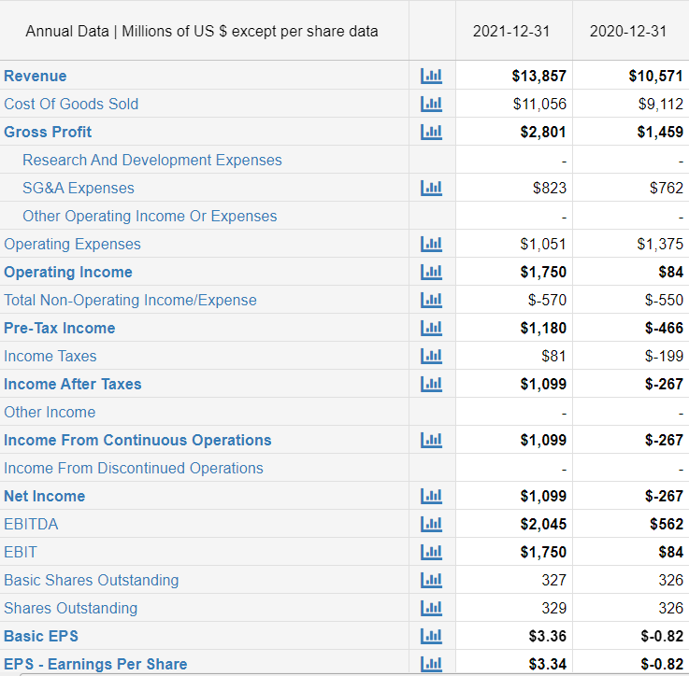
When J. Willard and Alice S. Marriott opened their first hotel in California in 1927, they launched what would become Marriott International, Inc. (Verizon Media, 2021). Marriott International, Inc., was founded in 1927 and has its headquarters in the Nation's Capital. After John Willard and Alice Marriott added food items to the menu, they rebranded their businesses from A&W Root Beer Stand to Hot Shoppes. In 1957, Marriott went into the lodge business enterprise with the original motor motel establishing in Arlington, Virginia. Bethesda, Maryland is home to Marriott International's administrative offices. Ernst & younger LLP serves because the independent auditor for the agency. NASDAQ's ticker picture serves as a reminder that Marriott is a publicly traded company. Similar to the calendar year, Marriott International's fiscal year finishes on December 31.

Comparison of the Marriott 2020 and 2021 financial ratio performance
According to Kim (2021), Marriott International's recommendation trends were analyzed as 'dissatisfied' 1, 'hold' 11, 'buy' 8, and 'strong buy' 5. Overall, Marriott's recommended rating for April 2020 is between Hold and Buy. According to a survey of analysts, the average EPS forecast for 2021 is $1.95, while the forecast for 2022 is $4.57. As a result of the pandemic, business is booming. Hotel occupancy in 2020 stood at 44%, according to the American Hotel and Lodging Association, and is forecasted to rise to 52.5% in 2021 and 61.4% in 2022. (Macrotrends.net, 2022). Room revenue is predicted to reach $144 billion by 2022. Regulation and health concerns associated to COVID-19 led to a drop in 2020 hotel occupancy and continue to hold it down today. Approximately the same percentage of consumers (56%) say they will take a trip of some kind in 2021 as they did in the previous year. The main contributor to hotel profits, business trips, are predicted to drop by 85% between now and April of 2021. Slow growth is anticipated to begin in May 2021, with return to pre-pandemic levels not occurring until 2023–2024. About half of consumers think vaccine accessibility will be important for future vacations. Widespread deployment of a COVID-19 vaccination would help raise travel demand as customers feel more comfortable in public settings (American Hotel and Lodging Association, 2021).

Trends in Marriott’s key financial ratios
Current Ratio:
Marriott's current ratio has remained mostly consistent from the past three years, increasing slightly from fiscal 2020. This small addition due to the companies' current assets of $2.8 billion and their current liability of $5.6 billion earns a huge milestone in the Current Ratio at the end of the year (Macrotrends.net, 2022). Increases in both current assets and current liabilities of 15.6% and 3.7% respectively accounted for the rise in Marriott's current ratio from 2020 and 2021. Increases in receivables and assets held for sale pushed current assets higher. The rising costs of future periods and others contributed significantly to the rise in short-term liabilities.
The 2020-2021 growth in the current ratio was 4.3%. This was due to a drop in current assets of 9.7 percent and a drop in current liabilities of 13.9 percent. The biggest problem was a drop in Marriott's cash on hand. Accrued salaries and benefits were reduced, resulting in a reduction in current liabilities.
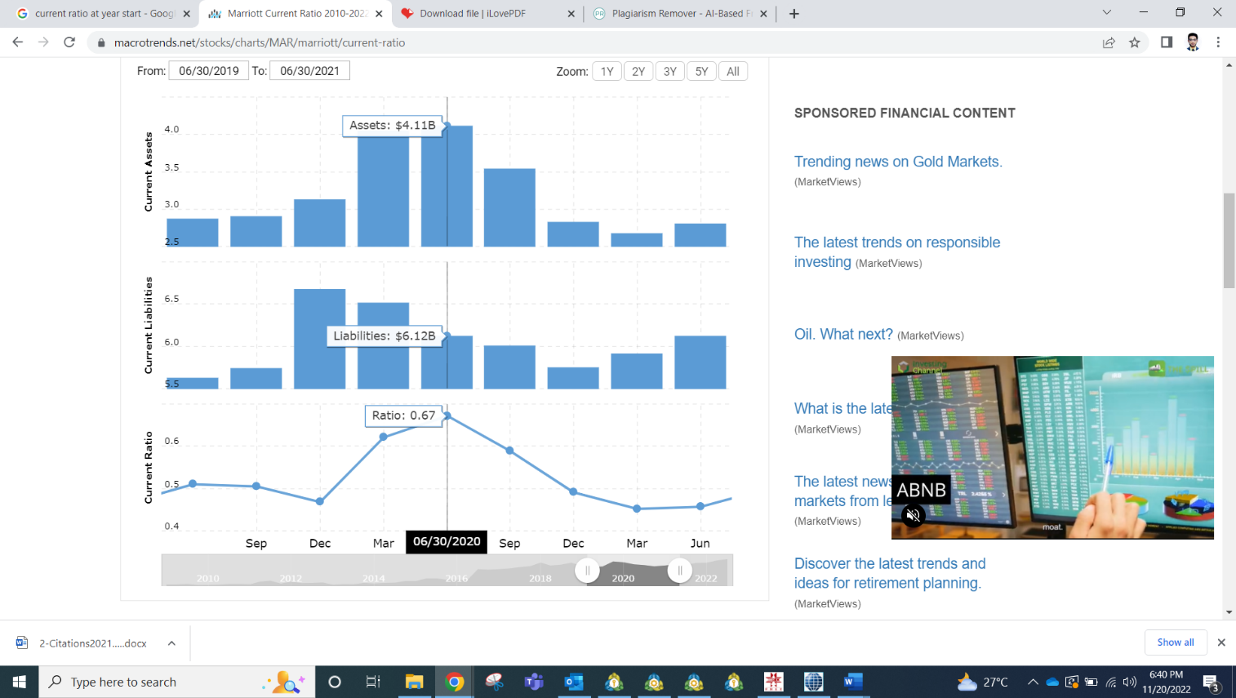
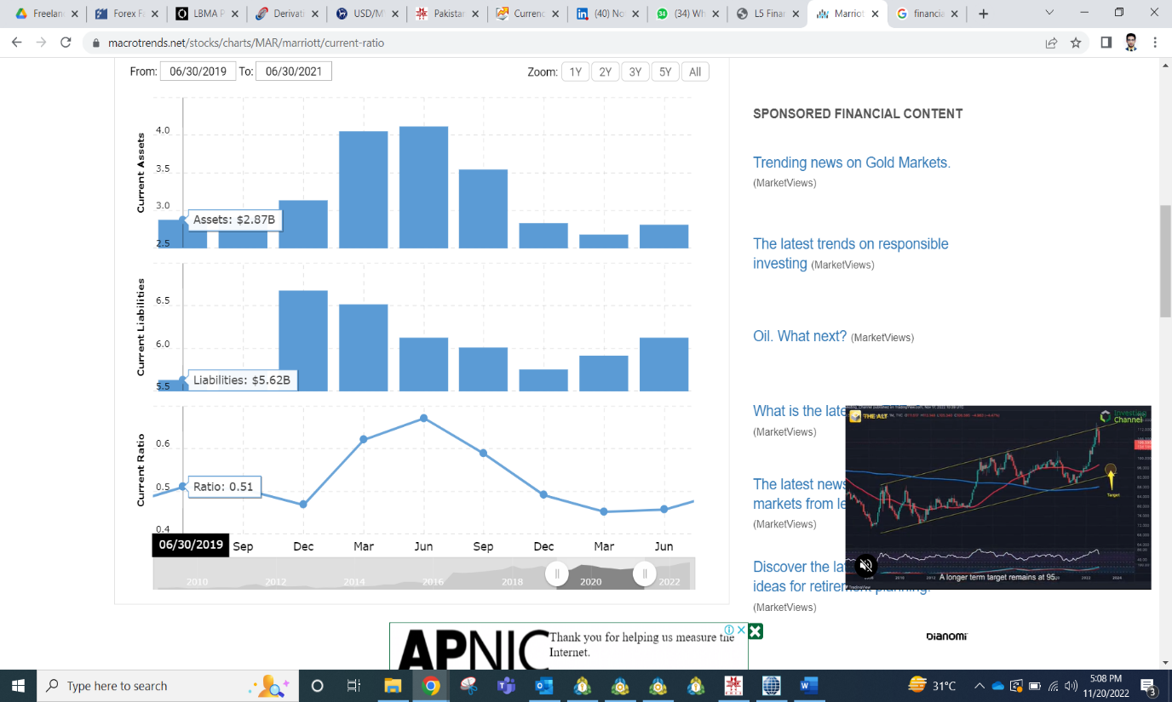

Source: (Macrotrends.net, 2022)

Long Term Debit:
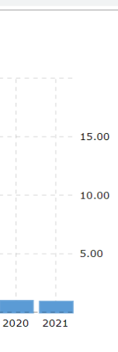
The main components that contribute to Marriott's long-term debt are senior notes, commercial paper, credit facilities and finance lease commitments. In order to calculate the long-term debt total, the current year's payment must be deducted from these accounts. Commercial paper and new senior note issuance accounted for 42.4% of the total growth in long-term debt from 2020 to 2021. By 2020, Marriott's long-term debt has dropped by 7.6 percent from 2019. (Macrotrends.net, 2022). This was partly due to Marriott not releasing any commercial paper in his 2020, whereas the 2019 commercial paper book value was $3.197 billion. Net of issuance and repayment, long-term debt decreased by 55% between 2020 and 2021. The decline in bond issuance is due to a reduction in the number of bonds issued by Marriott in 2020. Bond issuance totaled US$1.65 billion in 2020, compared to US$1.4 billion in 2021 .2020 debt repayment included.
Source: (Macrotrends.net, 2022)

Retained Earnings
The largest portion of equity assets is retained earnings. Internal reserves at Marriott rose from 2016 to 2019, then fell in 2020 and 2021. Retained earnings rose by 24% from 2017 to 2018 as a result of increased net income and the implementation of ASU 2016-01 and ASU 2016-16. (Macrotrends.net, 2022). The rate of increase in retained earnings between 2020 and 2021 was moderate, at 7.4 percent. In 2020, retained earnings will be $9,206, down from $9,644 in 2019. The fall in retained earnings was primarily caused by a 121% drop in net income as a result of COVID. The decrease in retained earnings was partially offset by a decrease in dividends. Marriott paid him $156 million in dividends in 2020 versus her $612 million in 2021.

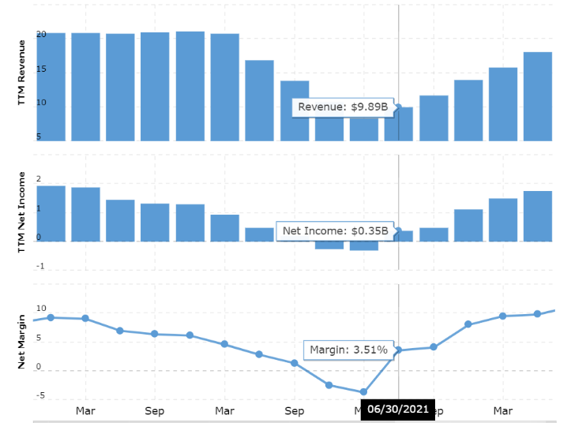
Net Profit Margins:
Source: (Macrotrends.net, 2022)
The decline in Marriott's net profit margin from 2020 to 2021 was due to the fact that the 78% decline in net income was greater than the 1% increase in revenue (Macrotrends.net, 2022).
Marriott's revenue fell 67% from 2020 to 2021 and net income fell 191%. Net profit margin declined in 2021, with earnings per share down from $13.75 billion to $8.2 billion. A drop in net income of 33.2% was largely responsible for the downturn, while a drop in average common shares outstanding of only 5% exacerbated matters.
In 2020, Marriott repurchased 1,000,000 of his common shares. Fortunately, this was counterbalanced by 1.4 million shares of stock.
In 2021, EPS dropped from 2020's $3.83 to 2021's ($0.82). A 121% drop in net income and a 2.7% drop in average common shares outstanding led to this result.

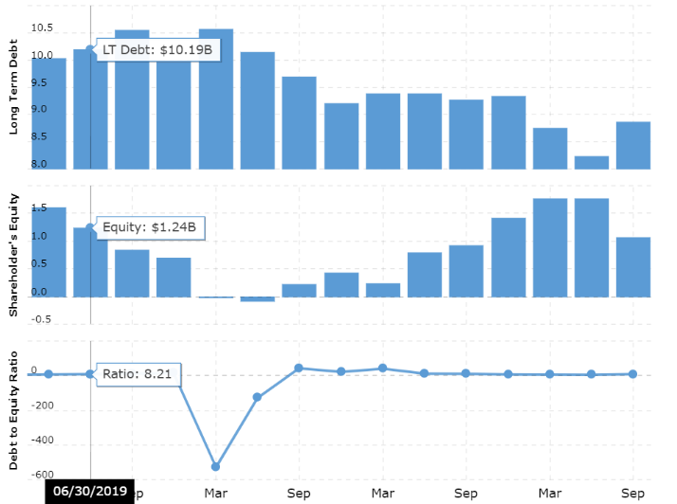
Debt Ratio:
Source: (Macrotrends.net, 2022)
The debt ratio for Marriott grew from 75.2% in 2021. This was due to a 12.6% rise in total liabilities and a 5.7% rise in total assets. Long-term debt, operating lease liabilities, and accumulated expenses and other all contributed to the rise in total liabilities. Total assets increased mainly due to increased assets held for sale, intangible assets, and operating lease assets (Macrotrends.net, 2022). (Macrotrends.net, 2022). A 9.1 percent drop in total liabilities and a 1.4 percent drop in total assets led to a 3.8 percentage point drop in the debt ratio between 2020 and 2021. Declines in long-term debt, deferred tax liabilities, and accrued wages and benefits contributed to a reduction in total liabilities.
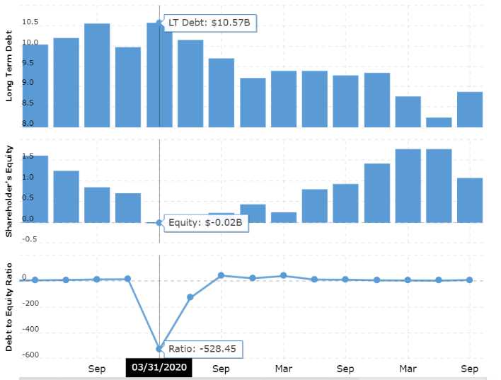
The impact of COVID it’s on peak 2020 company might owe more money to investors than its assets can cover.
Source: (Macrotrends.net, 2022)
The risk factor increases by 230% from the last year.
Extremely at risk or faced a bankruptcy overall the world can cause effective in COVID liabilities increases and the Equity up to negative in figure. But after a while good milestone cover after some month that increases the health of debit ratios and constants.

Total Asset Turnover
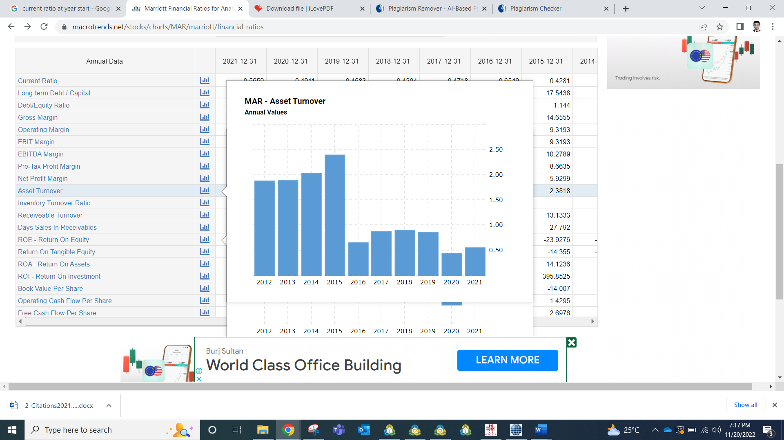
Total turnover of Marriott assets increased from 2020 to 2021. Total asset turnover increased by 42.8% from 2020 to 2021. The decline was primarily due to a 49.6% decline in revenue and a 1.4% decline in total assets. As mentioned earlier, COVID-19 has significantly reduced Marriott's 2020 revenue. 2020 net fees and commissions income decreased to $444 million in 2021. This was due to lower property management and franchising costs due to lower income per job. Marriott's revenue from its owned, leased, and other hotels fell by 137% as a result of falling demand and the temporary closure of 27% of its hotels. Lower royalties and recovery costs contributed to cost recovery, with net asset value growing 102% from 2020 to 2021. The COVID-19 factor is also a major contributor to the decline in overall Marriott property turnover from 2020 to 2021. Next, we analyse the rest of Marriott's balance sheet, starting with its liabilities. periodic assessment of debt.
Source: (Macrotrends.net, 2022)

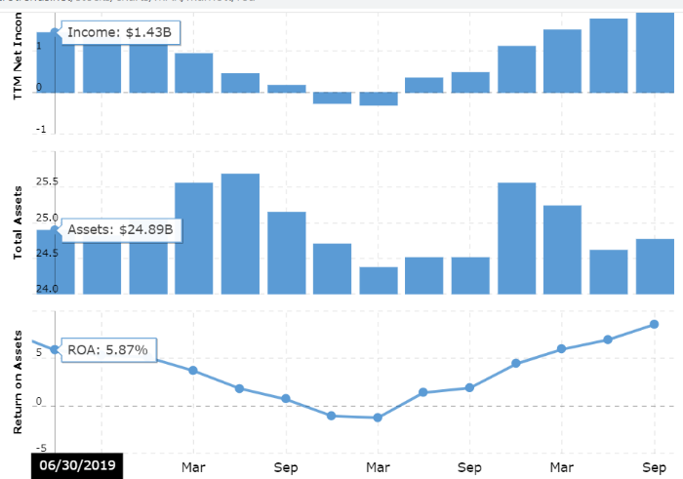
Return on Assets:
Source: (Macrotrends.net, 2022)
Marriott's return on assets fell from 9.9% in 2020 to 6.7% in 2021. The decline in operating cash flow in 2020-2021 was mainly driven by lower net income and changes in working capital (Macrotrends.net, 2022). Marriott's cash income from total assets decreased from 2020 to 2021 as operating cash flow decreased 48.8% and total assets increased 12%. In 2021, Marriott properties generated more returns. The chart shows the change in cash earnings for Marriott from 2020 to 2022.

Limitation of Ratio Analysis
Historical Cost vs Current Cost:
The information provided in Income Statement is calculated on current prices or close it to whereas on Balance Sheet calculated on historical prices these results might be give an unusual result on our ratio results. The impact our hotel management financial statement and unfair figures.
Source (Macrotrends.net, 2022)
Changes of Inflation:
The rate of inflation fluctuates every year. As a result, it is impossible to draw parallels between different time periods using numerical data. If the rate doubles in a single year, for instance, sales will double from the previous year. When in fact there was no increase in sales.
Interpretation:
When determining the reasons for the outcome of a relationship can be very difficult. The current 2:1 ratio, for instance, may look great until you factor in the fact that the company recently sold a lot of stock to improve its cash position. Depending on the specifics of the analysis, it may become clear that the current interest rate is only temporary and will eventually fall.

Highlighted Time:
The balance sheet is a source for some measures. Please take into account that the reported balance sheet data only pertains to the end of the accounting period. An out-of-the-ordinary rise or fall in account balances on the last day of the reporting period could distort the probabilities.
Due to shifts in the company's operations, it may no longer be possible to draw meaningful conclusions from a comparison of historical financial data with current data. For instance, despite a corporation's reduced investment in fixed assets as a result of implementing a constraint analysis system, the company may be overvaluing its fixed asset base, as determined by a ratio analysis.
In short, the utility of ratio analysis may be constrained by a number of issues. In spite of these caveats, ratio analysis still has value so long as we supplement it with other techniques for gathering and analysing data.

Understanding of ratios and its importance for decision making
Ratio analysis is a method of analysing a company's profitability, liquidity, operational efficiency, and solvency by comparing metrics across the various sections of its financial statements.
By comparing a company's performance over time to those of its peers in the same or related industries, ratio analysis can shed light on that company's health.
To gain a full view of a company's financial health, it is important to look at a variety of measures in conjunction with one another.
By comparing the company's past and present financial statements, analysts can determine the company's overall financial health using ratio analysis. Comparative data can illustrate how a company is performing through time and can be used to anticipate expected future performance. The information can also be used to evaluate the company in relation to others operating in the same field and to establish benchmarks against which future performance can be compared.
Executives should care about the company's financial stability. Hotels need to watch their spending to make sure they don't lose money. An effective commercial analyst recognises the need of managing the company's debt and capital flow in order to ensure the company's success in achieving its objectives (Kim, 2019). They understand that money is a constraint on his firm and that he needs to bring in more than money in order to turn a profit.
The forecasting power of the trend is growing, while the weight of the past figures is dropping. More and more organisations are turning to predictive forecasting models to aid in things like capital budgeting and the allocation of funds to various operational assets. In today's business world, where people, the planet, and sustainability are getting more attention, there is a lot of uncertainty and risk. This is especially true after the spread of the Coronavirus. There has been a shift in emphasis away from just financial metrics and toward other, more nuanced metrics that can provide insight into a company's performance. Cross-border deals, mergers and acquisitions, population shifts, and time zone shifts are all examples of how globalisation has increased the complexity of monetary transactions.
Evaluating currency ratios is essential for decision-making, but it is not without its hurdles. This method will not show the true picture of the decoration of the statement is contrary to financial and business ethics (Macrotrends.net, 2022). Ratio valuation techniques may no longer provide true comparative effectiveness either, but special organizations use their own valuation techniques for inventory and depreciation. Another point to odds ratings is that they only provide numerical results and no longer reflect causal relationships that can render those numbers meaningless. More research is needed to capture entirely new trends in assessing money ratios and make them more applicable.
Financial Ratio Analysis can be an invaluable analytical tool for making business decisions, not just mechanically, but when used with a proper knowledge of the factors affecting the business. Considering its limitations, it can be very useful to experienced business managers.

Conclusion:
Marriott global has been critically impacted via the COVID-19 virus outbreak and maintains to go through lingering outcomes. sales were negatively impacted by using COVID-19 factors, which include temporary resort closures, decreased lodge call for and reduced journey. Between the years 2020 and 2021, he had a 49.6% decline in his profits. As a consequence of this, Marriott forecast that it will incur an online loss of $4,444.267 million in the year 2020, in comparison to the amount of money it made on its website over the course of the previous four years. In 2020, Marriott had a decline in both its operating margins and its online margins in comparison to the previous years. The hotel chain's financial status regarding their debt has significantly improved. With the help of the credit score system, Marriott was able to borrow the maximum amount of 4.5 billion dollars that was authorised for use by the company. Due to weaker credit score ratings, the company decided to stop issuing commercial paper in 2021, however they did issue senior notes to the tune of $3.6 billion that year. The long-term debt held by Marriott was redeemed for a total amount of $1,887 million, of which $1,203 was for senior notes. By 2021, cash contributions from operating activities will be 2.7% lower than they were in 2020. The use of cash by Marriott for the reduction of debt, payment of dividends, and purchase of treasury stock.

References
AHLA’s State of the Hotel Industry 2021. AHLA. [online] Available at: https://www.ahla.com/sites/default/files/2021_state_o f_the_industry_0.pdf [Accessed 2 December 2021]

American Hotel & Lodging Association. (2021, January 21). [Accessed 2 December 2021]

Kim, C. (2019, March 18). Marriott International Announces Three-Year Growth Plan. Marriott International News Center. [online] Available at: https://marriott.gcs-web.com/news- releases/news-release-details/marriott-international- announces-three-year-growth-plan. [Accessed 2 December 2021]

Kim, C. (2021, February 23). Marriott International Appoints Anthony Capuano as New CEO And Stephanie Linnartz as President. Marriott International News Center. [online] Available at: https://news.marriott.com/news/2021/02/ 23/marriott-international-appoints-anthony-capuano- as-new-ceo-and-stephanie-linnartz-as-president. [Accessed 3 December 2022]

Macrotrends.net. (2022). Marriott Financial Ratios for Analysis 2009-2022 | MAR. [online] Available at: https://www.macrotrends.net/stocks/charts/MAR/marriott/financial-ratios [Accessed 3 December 2022].

Marriott International, Inc. (2020). Annual Report 2020 [online] Available at: https://marriott.gcs-web.com/static files/178683c9- c9d9-47b0-b115-726588f43130 [Accessed 3 December 2022]

Marriott International, Inc. (2021) Form 10-K 2020. [online] Available at: https://marriott.gcs-web.com/static files/9fb40a9d- d54f-41d8-b36d-f9c924ecf7db [Accessed 3 December 2022]

Marriott International, Inc. (2021). Annual Report 2020. [online] Available at: https://marriott.gcs-web.com/static-files/c5e1faef- f1e5-40e3-bd70-5efbbb929a7f [Accessed 3 December 2022]

Verizon Media. (2021). Marriott International (MAR) Analyst Ratings, Estimates & Forecasts. Yahoo! Finance. [online] Available at: https://finance.yahoo.com/quote/MAR/analysis/. [Accessed 4 December 2022]
Verizon Media. (n.d.). Hilton Worldwide Holdings Inc. (HLT). Yahoo! Finance. [online] Available at: https://finance.yahoo.com/ quote/HLT. [Accessed 4 December 2022]
‌

