Suneth Fernando
Sheanne Ojea
2133151
BMSW4001 Digital skills and research methods assignment
2022
Contents

1. Introduction
2. Analysis.
2.1 Secondary Data.
2.2 Primary Data.
3. Conclusion.
4. References.

1. Introduction.

My report will be highlighting the positive and negative impact of Virtual learning environment (VLE) – Moddle on my fellow students at the University of Wales Trinity Saint David London Campus. Moddle is a platform used by the university to aid their students in accessing course material, the virtual library, and other aspects outside of the university campus and learning hours. My report will be based on research methods to find a conclusive answer to whether Moodle has been successful in being an effective virtual learning environment despite components and influence from environmental issues and modern technology aspects based on opinions from fellow students in the form of Primary research data and my individual learning experience using the platform as secondary data.

2. Analysis.

2.1 Secondary Data.

Virtual Learning Environments (VLE) have become a massive tool in aiding in the educational field not only for students but also lecturers and teachers. They enable resources and activities based around the course structure to be accessible to the educational community 24/7 and even outside term dates. There are many components that are available on the platform to enable the learning experience to be strictly virtual such as real time communication through live video chats via Microsoft teams or engagement and administration tabs that track progress such as attendance and punctuality.

These components are only a few aspects that enable some critiques to believe VLE’s offer “opportunities to stretch imaginations of teachers and students alike” (fireflylearning.com 2022) In a positive aspect because it opens the communication fields that usually would not occur in social spaces such classrooms as many lectures are too large to enable all students to actively participate or some students may not have the confidence to speak in front of large crowds. Through discussion threads, students can discuss course material and receive the support they require fairly as teachers can take their time to read through the questions without the constant pressure of lecture timetabling and scheduling. In a recent article published by Nick Viland, the Columbia County school used VLE’s in a new way to enhance their use of technology skills within the educational institution, they had planned 2 half days of virtual learning for all students and teachers on campus to take grasp what they believe may be the adapted learning method soon. Michele Sherman, who is the superintendent of the County school mentioned adapting VLE’s into educational institutions are fundamental in continuing an efficient working environment when face to face learning cannot occur.

This can be agreed as a positive opinion that has occurred at the University of Wales where the VLE platform Moodle has become useful. In the recent months between June and October there has been several environmental issues that have occurred in London that have made face to face learning unsafe and inadequate (Tube Strikes and Extreme heatwave temperatures), with the presence of Moodle students were able to still able to attend lectures and sessions through video chat and access presentation slides uploaded by the lecturer. However, with this situation present, it presented a few anomalies in relying on VLE’s as a main form of teaching for some students who had no access to computers or Wi-Fi at home with complaints from Student services and Student Unions that VLE’s do not aid in students’ attentiveness to lessons which greatly impact their attendance and punctuality negatively. To conclude there is a balance between the positive negative and aspects of Moodle being used based on experts and critiques opinions, however the most important notion is whether the platform affects its students positively and their feedback.

2.2 Primary Data.

With the aid of Primary Data tools, we will be able to analyse how Moodle has affected the students at University of Wales. Primary data is based on research collected by the researcher themselves; these can be done through questionnaires, surveys, and observations. To collect the data, I conducted a series of surveys amongst my fellow students during my lectures to find out how our virtual learning environment Moodle impacted their studies. Once the data was collected, I presented them in a table of diagrams in the form of chart. The data highlighted below was based solely on my own research.

My questionnaire was based on four questions that will be analysed and explained in detail below. I ensured to highlight there was no right or wrong answer in answering the questionnaire it was solely based on gathering their opinion.

Do you know how to access our virtual learning environment – Moodle? Do you find the platform easy to navigate?

86.67% of students during the questionnaire stated they did know how to access Moodle and found the platform easy to navigate. One student stated, “I downloaded the UWTSD application on phone which makes very easy to use rather than logging on, on my computer”. However, 13.33% stated they had no idea how to access the VLE and didn’t know what its main purpose was. This information can highlight there is general number of students who use the VLE daily possibly during session times for course material, but a small percentage was missing out on the additional virtual benefits on the platform. Overall, one can say the platform has a positive impact on the students due to ease of accessibility.

What do you use Moodle mostly for?

Options: Attendance and Punctuality, Course Material (Revision), Course discussions/forums, Module/Course Progression (Assignment briefs).

6 out of 15 students stated they used Moodle to track their attendance and punctuality solely, 3 out of 15 stated they used the VLE for accessing course material through the online library or previous slides/sessions uploaded by the lecturer; 1 out of 15 said they used Moodle to interact with other students on the campus and courses through the forums and chat discussion pages and 5 out 15 used Moodle solely for progression tracking and using the platform to access the assignment briefs and grading criteria.

The platform we can see at has several components that are used by the students at the London campus that may not be easily accessible during face-to-face learning. Although this question did not highlight my fellow student’s opinion on VLE’s, it showed what the most interactive component they used when using the environment. From my personal experience based around this question I mostly used Moodle through the mobile app UWTSD HUB, and I usually accessed it for Attendance and Punctuality and Course Progression, I never found the Course material helpful as there was only one brief introduction on how to use the online library which wasn’t useful to me for any of my courses and the modules.

Would you be satisfied if University of Wales solely used Moodle as the only form of learning and face to face session no longer existed?

7 out of 15 Students said Yes and 8 out 15 Students said No.

This question brought a mixture of opinions there were both with negative and positive connotations. Regarding the positive feedback from the 7 students, the generalised answer was they believed Moodle would be successful in delivering a virtual form of learning and study at University of Wales as there is already many universities who solely use virtual learning as an option to learning, especially since many students were matured, they found balancing time around attending lectures and daily life activities would be easier. In addition to this opinion a lot of students mentioned that University of Wales already was using Moodle as the main form of delivering education during the Covid 19 Pandemic, which stopped all forms of face-to-face learning, they felt because of this change there wouldn’t be any issues if the university decided to make this change permanent.

However, the negative feedback from the 9 students, brought a generalised answer that stressed on a few issues that could arise such as technological and the lack of interactive communication between a student and professional teacher. Many of these students mentioned they wouldn’t feel comfortable or be getting the best assistance from the university with just a VLE and the elimination of face-to-face lectures due to language barriers. They believed they thrived better in a learning environment where they could see their students and lecturers’ facial expressions and body language.

Overall, has been your experience using Moodle as a student? Negative or Positive?

14 out of 15 Students answered Positive while 1 out 15 Students answered Negative.

From the data collected above Moodle received a 99% satisfaction rate from the candidates that were present during questionnaire despite having their own personal reasons for using the platform, this question was based on their overall answer with how the VLE has been integrated into their current situation as a student despite what they felt needed improvements.

From the Primary data collected from my questionnaire I was able to formulate a few charts to assist in my report.

(Source The Author, Ojea 2022)

(Source The Author, Ojea 2022)

3. Conclusion.

To conclude the final report, I have formulated a generalised answer on the impact of Moodle on the students at University of Wales with the assistance of both secondary and primary data research. Critiques have praised the presence of VLE’s in educational institutions for the past years, stating they will become the main form of teaching in the future. However, this opinion is based on the concepts as whole and not on a specific learning environment that are offered to students to use, with the use of only one research tool a biased answer would be presented.

Specifically for Moodle which is the Virtual Learning Environment used at University of Wales from my primary data research it has been concluded that it has a positive on majority of the students (This was based on a questionnaire of 15 students present during the session). This was based on exclusively what they used Moodle primarily for due the platform having plenty of uses to engage a student in an institution that offers higher education resources. Many students had this feedback based on the presence of Moodle being an addition to face-to-face learning.

Personally, as I also partook in the questionnaire, I believe Moodle is an effective platform for students to feel integrated and in tune with the university’s updates outside of term time lessons and lectures, it has assisted me in keeping track of attendance in which is not easily accessible unless a student was to request the information from student services through email or attending the office in person. It opens the world of education to many different platforms as many students have adapted to modern technology through computers and mobile phone devices. In the future I do see many educational institutions relying on virtual Learning Environments and adapting software’s to make them easier to navigate and understand. From the answers conducted by both research tools combined a student’s experience of a VLE is not based on the use of one but the way they are made and how easily accessible they are, as many VLE’s such as Moodle with have several components to navigate through and different ways on how to use them correctly.

University of Wales are actively ensuring Moodle is being integrated to work properly on computers and mobile phones through system updates to ensure students are always comfortable and at ease using the platform.

4. Appendices

4.1 Questionnaire

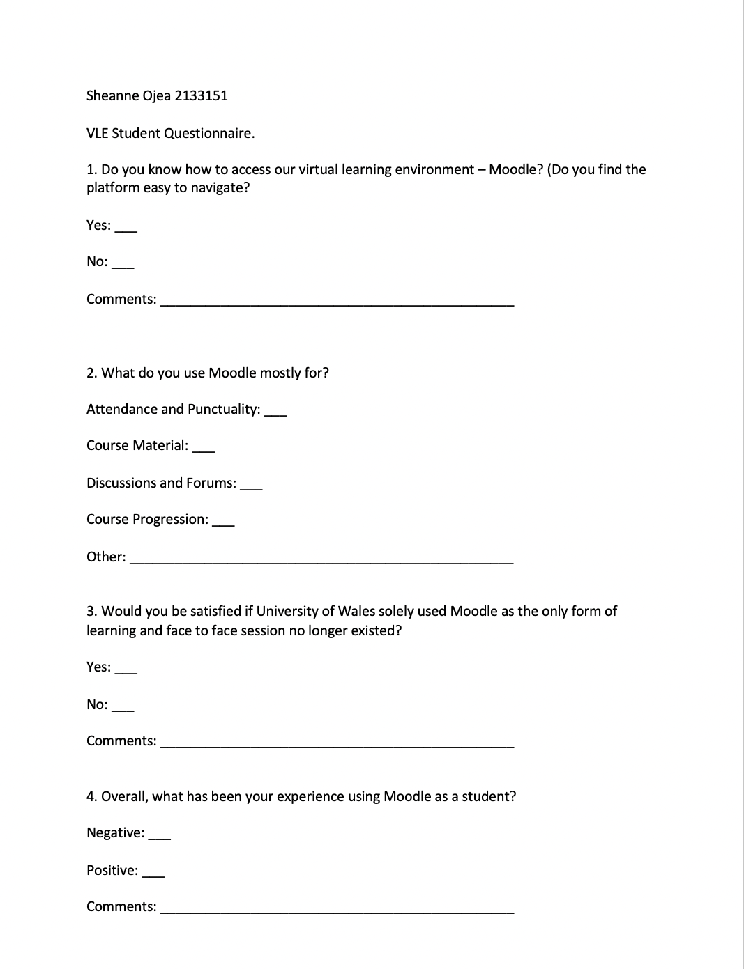

(Source The Author, Ojea 2022)

5. References.

1. Britain, Sandy; Liber, Oleg (1999). "A Framework for Pedagogical Evaluation of Virtual Learning Environments" (PDF). JISC Technology Applications Programme (Report 41). Archived from the original (PDF) on 9 July 2014. [Accessed 2 September 2022].

2. 2022. [online] Available at: https://www.wrdw.com/2022/08/24/columbia-county-schools-use-virtual-learning-new-way [Accessed 2 September 2022].

3. Firefly. 2022. What is a Virtual Learning Environment (VLE)?. [online] Available at: https://fireflylearning.com/what-is-a-virtual-learning-environment-vle [Accessed 2 September 2022].

4. XELIUM: clarity defined. 2022. VLE – What are the Advantages?. [online] Available at: https://www.xelium.co.uk/2010/05/vle-what-are-the-advantages/ [Accessed 2 September 2022].

5. Researchguides.ben.edu. 2022. Research Guides: Public Health Research Guide: Primary & Secondary Data Definitions. [online] Available at: https://researchguides.ben.edu/c.php?g=282050&p=4036581 [Accessed 2 September 2022].

