A Fragile Container
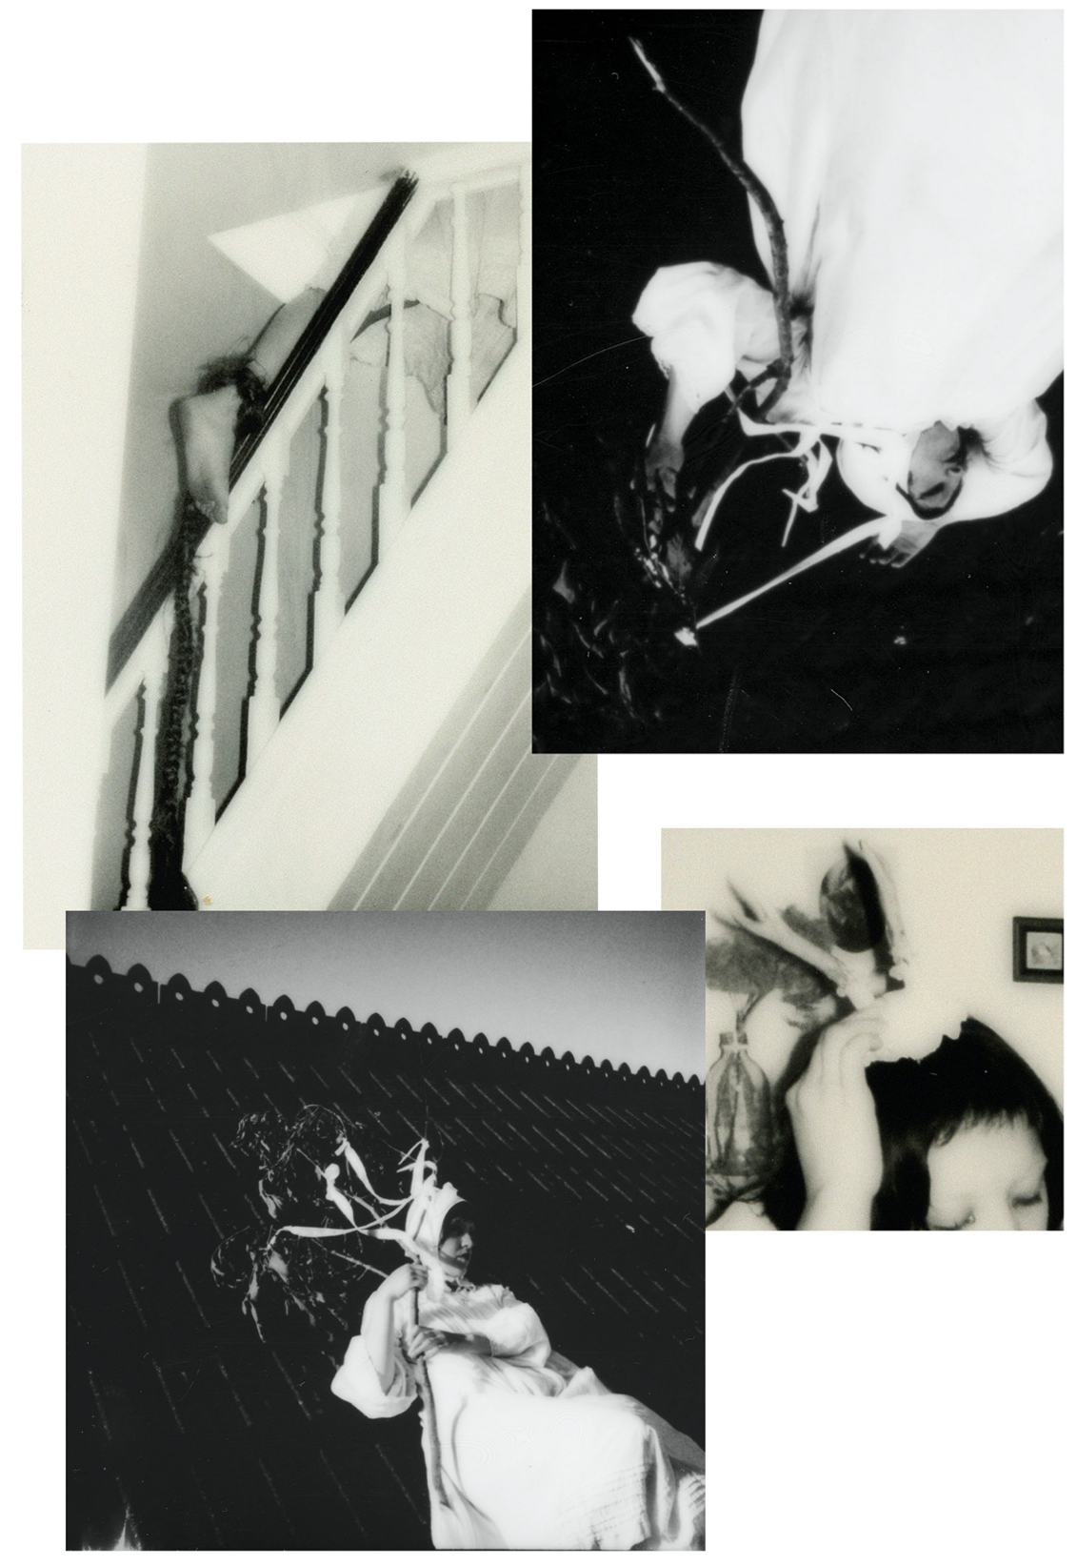
Dione Jones

MA Contemporary Dialogues: Photography
Student ID: 1903141
Confirmative Praxis ADAA7002
Word Count: 7500
List of Figures
Figure 2: Chadwick, H., (1986) detail of Cornucopia in Oval Court, collage of blue photocopies, installation shot at the Barbican, London, 2004, The Estate of Helen Chadwick, Victorian and Albert Museum, London, available at: https://www.thamesandhudson.com/blogs/all-news-features/helen-chadwick-disrupting-the-conventions-of-feminine-display?srsltid=AfmBOorN4--TapiFHh4VbevAtoolRV2fsMkdsqesg5WO4XxUXvJll8jb

Figure 3: (1984) Lindow Man, official name Lindow Man II, British Museum, available at: https://www.britishmuseum.org/collection/object/H_1984-1002-1

Figure 4: Anatomical Venus produced by the workshop at La Spacola between 1784-88, photo taken from Guardian article available at: https://www.theguardian.com/artanddesign/2016/may/17/anatomical-venus-anatomy-human-biology-joanna-ebenstein-books

Figure 5: Cahun, C., (1924) Self Portrait (double exposure in rockpool), Gelatin Silver Print, Jersey Heritage Trust, available at: https://catalogue.jerseyheritage.org/collection-search/?si_elastic_detail=collect_5748

Figure 6: Woodman, F., (1980) Blueprint for a Temple II, diazotype collage with gelatin silver prints, Woodman Family Foundation, available at: https://woodmanfoundation.org/news/now-on-view-francesca-woodman-at-gagosian

Figure 7: Woodman, F., (c.1977) Untitled, gelatin silver print, Woodman Family Foundation, available at: https://woodmanfoundation.org/artworks/a-waltz-in-three-parts---3

Figure 8: Akosau Viktoria Adu-Sanyah, The House is a Body, Picture from inside the exhibition sectioned titled The Attics, 2024
Figure 9: Jones, D., (2024) Daphne’s Passage, image 3, polaroid

Figure 10: Jones, D., (2024) Daphne’s Passage, image 2, polaroid

Figure 11: Jones, D., (2024) Daphne’s Passage, image 1, polaroid

Figure 12: Jones, D., (2024) Daphne’s Passage, image 4, polaroid

Figure 13: Jones, D., (2024) Daphne’s Passage, image 5, polaroid

Figure 14: Jones, D., (2024) Daphne’s Passage, image 6, polaroid

Figure 15: Woodman, F., (1980) Untitled, Gelatin Silver Print, Woodman Family Foundation, available at: https://woodmanfoundation.org/the-lady-of-the-glove-francesca-woodman-and-surrealism

Figure 16: Jones, D., (2024) Daphne’s Passage, image 7, polaroid

Figure 17: Jones, D., (2025) Untitled (Roe Deer), image 1, polaroid

Figure 18: Jones, D., (2025) Untitled (Roe Deer) image 2, polaroid

Figure 19: Jones, D., (2024) Untitled (bedroom), image 1, polaroid

Figure 20: Jones, D., (2024) Untitled (bedroom), image 2, polaroid

Figure 21: Jones, D., (2024) Untitled (bedroom), image 3, polaroid

Figure 22: Hesse, E., (1969) Expanding Expansion, fibreglass, polyester resin, latex, and cheesecloth, Guggenheim Museum, New York, available at: https://www.guggenheim.org/artwork/1648

Figure 23: Hesse, E., (1969) Expanding Expansion, Hesse in front of piece for 1969 exhibition Anti-Illusion: Procedures/Materials, Whitney Museum of American Art, New York, photo taken from article available at: https://brooklynrail.org/2022/09/artseen/Eva-Hesse-Expanded-Expansion/

Figure 24: Experiment with latex, thread, polaroid transparency and bird bone, 2025

Figure 25: Jones, D., (2025) Anatomica, image 1, polaroid

Figure 26: Jones, D., (2025) Anatomica, image 2, polaroid

Figure 27: Jones, D., (2025) Anatomica, image 3, polaroid

Figure 28: Jones, D., (2025) Anatomica, image 4, polaroid

Figure 29: Jones, D., (2025) Anatomica, image 5, polaroid

Figure 30: Jones, D., (2025) Anatomica, image 6, polaroid

Figure 31: Leonard, Z., (1990) Wax Anatomical Model with Pretty Face, gelatin silver print, Claire and Gordon Prussian Fund for Contemporary Art, available at: https://www.artic.edu/artworks/187174/wax-anatomical-model-with-pretty-face

Figure 32: Polaroid lift onto glass, encased in liquid latex, 2025

Figure 33:Polaroid life on glass, encased in liquid latex and backlit, 2025

Figure 34: Polaroid transparency encased in latex and backlit Figure, 2025

Figure 35:Polaroid transparency, latex and waxed thread, 2025

Figure 36: Polaroid transparency in latex, 2025

Figure 37: Chadwick, H., (1989) Enfleshings I, Transparency on lightbox, Tate, London, available at: https://www.tate.org.uk/art/artworks/chadwick-enfleshings-i-t06876

Figure 38: LEDs inserted into cut-out slots in the pillow, 2025

Figure 39: Polaroid transparency, latex, waxed thread, electrical wire and RBG LED, image 1, 2025

Figure 40: Polaroid transparency, latex, waxed thread, electrical wire and RBG LED, image 2, 2025

Figure 41: Bird Bones, latex, electrical wire and RBG LED, 2025

Figure 42: 2 polaroid transparencies, latex, 2025

Figure 43: Polaroid transparency, latex, waxed thread, electrical wire and RBG LED, 2025
Figure 44:

Figure 45:

Figure 46:

Figure 47:

Introduction

thread, bare
flesh
hand placed,
one on hip
other on face,
pulling all of herself
out from her navel
life
umbilical cord
returning

What does it mean to caress and untangle the feminine, to revel and play in a body that ceases to be contained within its numerous boarders imposed and reinforced by societal and cultural taboo, by fear and repulsion. Spill forth and caress the unimaginable depths of your own anatomy, undo the corporeal, trace fingers around frayed edges of morality and mortality. Drip with perverse desire to know it all, to know the limits and undo your body completely. Construct a new transparent flesh, one which has no boarder between inner/outer, lace, gauze, animal bones, allow more self to spread around, become invasive and generative. To be contained, to remain subjugated and sealed-off is one way in which the woman, and the gender non-confirming, body is othered and viewed as monstrous, for one leak, one slip reveals her true and dangers body which is irrevocably intertwined with both life and death, and that of a body which is more animalistic, more weak and fragile, more corruptible, than it’s cis-male counterpart. Through detailing key theorists and artists, I aim to unravel the feminist reclamation of the abject body.

Luce Iriguay’s notion of the “caress’ informs me, it instructs me of a feminine way of searching, of a fluid and open way to look and unravel that Other (feminine other) which desires, “…the caress lingers in the middling, delayed space between affective desire and epistemological endpoints. Its unfinished folding and unfolding processes echo the unresolved desires and identifications of the adolescent…” (Butler, p.78, 2025). The caress does not seek an end, it does not demand answers nor violate that Other, instead the caress is ambiguous, it is both expansive and like a small breeze, it is thirsty but does not lap, and through the caress I seek to unravel the boundaries of my own anatomy through the writing and works of my fellow perverse and leaky thinkers. “I caress you, you caress me, without unity – neither yours, nor mine, nor ours. The envelope, which seperates and divides us, fades away (…) It becomes fluid:” (Irigaray, p.59-60, 1992).

Cartesian dualism, the idea mind/body dichotomy, positions women as more susceptible to the weaknesses of her uncontainable excess, and therefore she is a more unstable mind, as opposed to a male counterpart. “Woman is often made to signify bodilyness in opposition to masculine intellect…” (Malson, 1997, p.233). This is where I introduce the abject-caress. The abject-caress is not a complete separation of inner/outer body, nor is it a complete merging. Abject-caress is a monstrous’ woman’s tool in creating and researching, to absorbing and birthing a self that is unsealed and uncomplete, and does not seek either. “It is not lack of cleanliness or health that causes abjection but that what disturbs identity, system, order.” (Kristeva, 1982, p.4). The unruly woman threatens the symbolic order, the Lacanian notion of the order of society, that which keeps us all functioning in our current systems. The abject woman threatens this, with her leaky, life-giving, constantly changing boarders.

Surveying Her Death(s)

“To calm the imagination of the invalid, so that at least he should not, as hitherto, have to suffer more from thinking about illness than from the illness itself- that, I think, would be something! It would be a great deal!” (Nietzsche, 1997, p.34)

Replace the “invalid”- the one whom has an incurable condition- as “female”. Nietzsche posits that the invalid suffers more when he is aware of his condition. When women who ignore their inferiority in our society under patriarchy, or see not the harm and submit to a passive role, this is a way in which to limit their own suffering, bury your head in the sand long enough and you’ll soon become accustomed to the dark. “Gender is not just the misogynistic expectations a female internalizes but also the process of internalizing itself, the self’s gentle suicide in the name of someone else’s desires, someone else’s narcissism.” (Long Chu, p.35, 2019).But it is not just one suicide a woman must endure, she must endure many suicides throughout her life, many deaths in order to remain tethered and productive to the Symbolic Order and to not allow her boundaries to dissolve. It is a death inside, a one she may not even mourn in a way she is aware, but when this mourning becomes something else, something her brain creates to distance her death and to try not to collapse completely. Here I posit three key self-deaths:
- Menstruation/adolescence: The death of innocence, of being sealed off and ‘pure’, of parting from our male peers, of the androgynous body, of being a non-object.
- Childbearing: Death of self as one entity, of autonomy, of control of weight and bodily appearance, of being something other than mother in the eyes of society.
- Menopause: death of youth, of use to the family unit, of beauty and value to society, of health, of knowing the intricacies of your cycle. You will become the hag you always were, and will remain until death.

Focusing on death number one, as young girls enter puberty there is a critical fissure between inner/outer body/mind. Puberty brings with it all of which, since birth, a woman has been destined to, an nontangible and unstoppable life of thrusting forth into the abject, from the first drop of blood between her legs to the hair that will grow and be frowned upon. It is here, with such unknowable and chaotic growth that she is perhaps her most vulnerable since birth. Many young girls in this vulnerable phase attempt to reject a body that is becoming the sexualized and socially codified Other, and in this rejection anorexia (amongst other eating disorders) becomes a defence against the Other. I write of this as part of the statistic, from the ages of 11-14 I was in a small world that seemingly only compromised of me and food, a world constructed in attempt, like many others attempt, to contain the unruly, and coincidentally turning over myself to the anorexic Mother that takes and takes in a way more unruly than the beast of puberty. “The abject is perverse (…) neither gives up nor assumes prohibition, a rule, or a law; but turns them aside, misleads, corrupts; uses them, takes advantage of them, the better to deny them (…) curbs the others suffering for its own profit.” (Kristeva, 1982, p.15). There is nothing to gain out of continuing to shun the abject, where society tells us to seal ourselves off and keep our bodies under control, the control turns inwards, and can corrupt us from the inside out until we are under the rule of not just the fear of the abject but fear of ultimately true-self. And this fear, this repulsion, is a death in itself, a self-loathing that the fear being monstrous renders us boarded-up vessels with no desire to explore ourselves or our true desires and expressions.

“Where uselessness and fragility, not strength, are prized, and shame of the female body in general is endemic, the ideal can be found in making yourself as inconsequential in your physicality as possible” (Dabiri, p.75, 2023). To be inconsequential means to supress, to contain, to bury desire and reject oneself. Containment, because the female form is irrevocably intertwined with excess, it is polluting and porous, it is abject. “The boundary of the body as well as the distinction between internal and external is established through the ejection and transvaluation of something originally part of identity into defiling otherness.” (Butler, p.182, 1990). Butler uses Kristeva’s abjection to further show how identities outside of the cis-white heteronormative male lens are also subjected to further scrutiny and are cast as Other, including queer, disabled and non-white bodies. As a queer person there is definitely a sort of extra layer to my art I use when exploring my flesh within the lens of the abject as a queer feminine presenting person, in which I play with gender boundaries and sexuality.
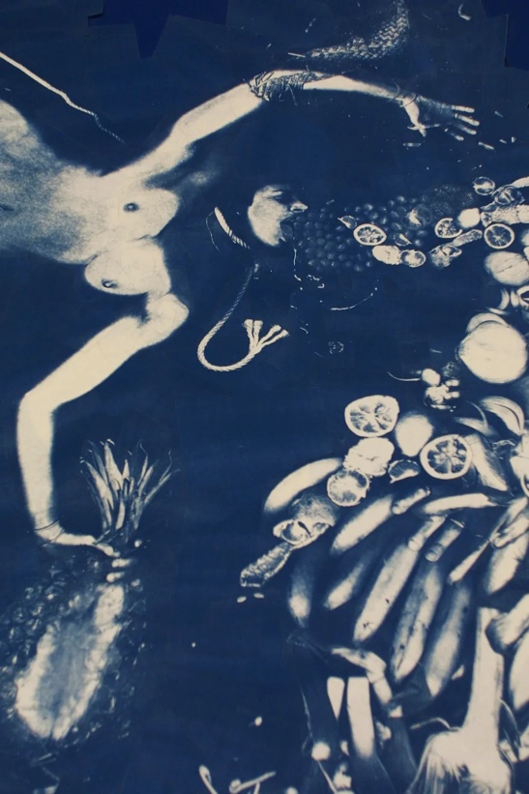
Helen Chadwick’s Oval Court is brimming with excess, with desire and carnal lust. In this close-up, she is spilling forth matter, food. She looks almost like a purging bulimic, expelling an intense and vast binge from her body. But perhaps that is projection, I think she is purging life, swimming in a teeming pond of pure unincumbered interconnectedness with flesh and self and all around her. She is the anti-bulimic, the anti-container of supressed desire, she refuses a small meagre form, she spills out beyond flesh.
Figure 2:Helen Chadwick, detail of Cornucopia, Oval Court, 1986

The adolescent girl experiences a significant shift within a Lacancian notion of the symbolic order, it is here, according to Lacan, that she experiences a major change in relation to the Other. She must begin to recognize, and preferably align with her allocated slot within the order (patriarchal society). I vividly remember the day I noticed my body hair, and in a way this so start of this “shift”. I was 10, when a boy pointed out my leg hair, this presented my young pre-pubescent brain with a way in which to be ashamed and disgusted with my body and what I cannot control, the beginning of the Other seeking containment, I went home and demanded my mother shaved them, and this is prior to even entering puberty and subsequent menstruation. When I was inpatient at a mixed gender psychiatric ward aged 22, I was once again thrust into thoughts of disgust through my own body hair by a fellow patient. He told me how much of “a turn on” the hair on my armpits was, and then proceeded to stare and follow me around. The man will seek to provoke disgust inside you, about you, to verbally attempt to make you and your body subject to their scrutiny. Either by letting you know how certain characteristics (like hair) are sexually appealing or unappealing to them and how at the end of the day you are but an object for them to either covet or repulse from. In these two examples hair was utilised to either reduce my sexual viability or to eroticize it, both resulted in an internal fracture between how I view myself and how I wish to be viewed. It often feels like either you accept hair and entail sexualisation in a fetishtistic kind of way, as a result of female body hair being taboo it is thrust into fetish, while it is somehow normal and “hygienic” to be completely bald.

“We perceive our bodies as both within and without, and the body as something we have rather than are” (Greenlaw, p.132, 2025). Each phase (or death) in a woman’s life is a confrontation with the abject, at each she must radically realign with her body and the ‘symbolic’, further repressing her and creating an inner feeling of being utterly and constantly on the brink of unruliness and complete abhorrence.

Venus-Bog

in that moment
I knew it all, the matter
tethered
we of the same parts
tooth, fur, joyous agony
mechanical joints that burr on
in eternal rest

in that space she lingered, heart
flickering out,
still there but somewhere new
my fingers seek
tangible
silken hair twisted around my index
your matter persists an awakening in
a cold clinical room

I first stumbled upon Luce Irigaray’s notion of ‘caress’ as a way to research and unravel work when I was reading Alice Butler’s essay in Gestures: A Body of Work (2025). In her essay she utilises the ‘caress’ to feel through the works of Francesca Woodman. “…forming a dwelling, a space in-between, that is ‘always in process’ and ‘never completed’” (Butler, p.28, 2025). Butler borrows the ‘caress’ and applies it to feminist essay construction. What appeals to me is the ambiguity and the emotionality of the caress, as I navigate through my research and my own work it swirls around my head and seems to struggle to leak out again, but the caress grants me permission to spill it out, to let the paper soak with my words and become heavy and bloated, instead of refined and precise, I am messy and fluid, I write and create through the abject-caress. It is here that I want to dissect and compare both the Anatomical Venus and bog bodies, and how the two can represent an unravelling feminist perspective on the abject and boundaryless creation of monstrous art that explores flesh and disgust. "The abject is edged with the sublime. (…) but the same subject and speech bring them into being. For the sublime has no object either." (Kristeva, p11-12)
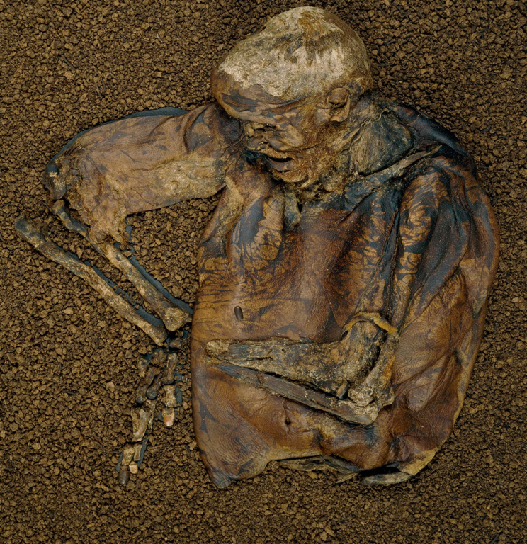

Figure 3:Lindow Man, British Museum disocvered in 1984

When attending an art event on Bog Bodies I discovered the Anatomical Venuses perverse sister. Preserve in a manner that seemingly contradicts itself, shrivelled and bloated, appearing dried out like some sort of jerky meat yet perpetually damp, hair still attached to shrinking pores. They seem to exist in a liminal space, threatening to appear and be acknowledged, I wonder if they long for discovery or if they would prefer to stay buried in a thriving and teaming bio-diverse home that encases their thin carcasses. They are worlds of their own, the body becomes a city within the bog, proving shelter and nourishment for its life. Both the bog body and the anatomical Venus allure in a similar way, they’re bodies in flux, spilling outwards/inwards, is unconfinable yet both are often stored in glass cases for scrutiny. The bog is brimming with fecundity, and endless pit of life and death, preservation and nourishment, like the mother’s body, it scares man because of its endless interconnectedness with life, with the abject, it expands like flesh, the bog is sublime.It is here I turn to an excerpt from Seamus Heaney’s Bog Queen:

My body was braille
for the creeping influences:
dawn suns groped mu head
and cooled at my feet

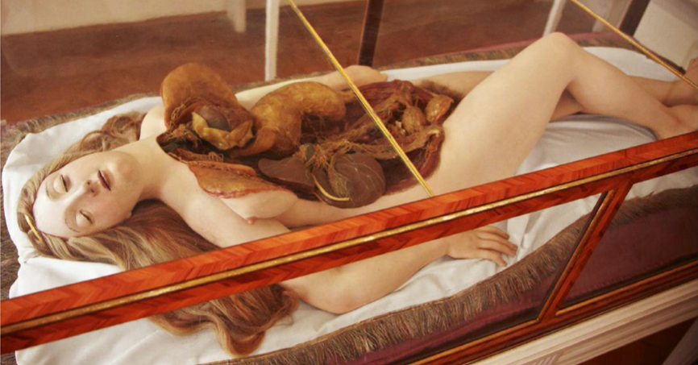
Figure 4:An Anatomical Venus produced by the workshop at La Specola between 1784-88
The Anatomical Venus often lay in a contrappocia pose, her head tilted back in pure ecstasy while her torso’s flesh is peeled back exposing her innards for all the male students to peer into and study. To caress her, is to unravel a woefully ill-informed history of women’s anatomy. I unravel her intestines and upbraid her silken hair. I scrub away my own flesh and begin weaving something new. Is it no surprise that the abject is deeply connected to many different ways in which women’s bodies have been portrayed as polluting, but one such major way is the medical history of female anatomy. The male equivalent of the Anatomical Venus does not exist. Created during the 18th Century, when women’s anatomy was beginning to come more in to light but was still gravely misunderstood. The study of female anatomy, during this era and for long after, was shrouded in shame and secrecy, often medicine men simply did not want to understand more about women’s anatomy and did not deem it important, consequences and biases that still have a knock-on effect to the treatment and understand of women’s health issues today. “…there are parts of your own body less known than the surface of Mars (…) the female body is considered more complex, more obscure, with much of its plumbing tucked up inside.” (Gross, introduction, 2023) Her conflicting beauty, produced in for the visual pleasure of the men studying her, lays within the stark contrast between her abject innards and her immense beauty, laid upon pristine cotton and silk, her hair draping around, framing the open wound on her chest. There is a sterility to the complete abhorrence of her condition, there is no blood or puss, she lays preserved, her face giving the impression of pleasure. Helen Ivory writes of the Anatomical Venus:
She has been cast for your instruction –
See, her organs are dislocated layer by layer.
The Heart was her undoing – observe the walls:
too slight to sustain her through her twentieth year (Ivory, 2019)
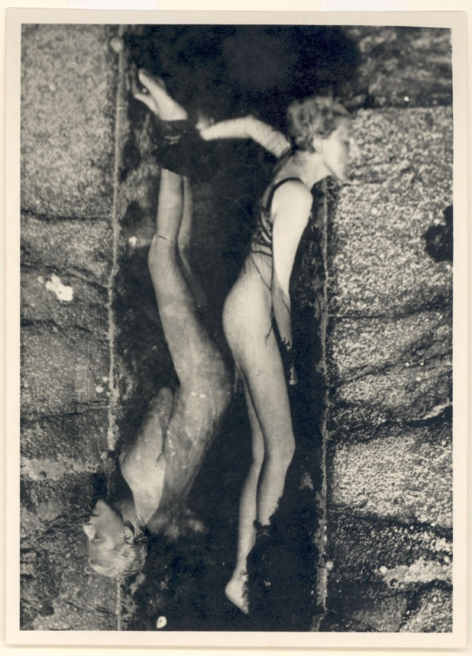
It is within this journey of traversing the boggy and waxy worlds of the venus-bog relationship that I think back to the work of Claude. “The combination of different forms of the abject is provocative, parodic and a deliberate affront to sexological discourses.” (Bailey and Thynne, p.7, 2005). Cahun repossess her gaze, confronting the camera as a tool that often captures idealized versions of women and their bodies and sprawls out of her flesh like the venus. As a queer person her flesh is already subject to more scrutiny, existing in a world outside of heterosexual desire and gendered roles. Queerness in inherently linked to the abject for these reasons, it threatens the Symbolic Order. In Self portrait (double exposure in rock pool), 1928, she lay nude, some sort of wire/twine wrapping around her body, she splits in two, both of her self’s contained within the pool which takes on a more of a box like appearance, that of which displays artefacts in museums. This duplicate threatens the stable “self”, her mirror is not symmetrical or clean, it is murky and split, laying top and tails. The body body has been preserved by nature, while the Anatomical Venus has been constructed and displayed by man, Claude Cahun, through their use of self-portraiture is enacting a process of self-preserving. “Like two mirrors turned inwardly together, the gaze of the alienated individual meets the gaze of the socially embedded self, and the myriad of eyes that make up each gaze are locked together…” (Colquuhoun, p.143, 2023)
Figure 5:Claude Cahun, Self Portrait (double exposure in rock pool), 1928

Body Architecture: Flesh, Walls and Decaying Foundations

When we peer into old houses we become intrigued by the lives that have wondered there and those who have died. If that house is derelict and crumbling there’s almost an emotional sense of seeing someone dying before us. But inside, there is a containment of life that has surpassed the human occupants, bugs packed into every corner, mold and furry mildew spreading across the peeling wallpaper and window seals. Things left behind, dressed up in thick dust. “The house is the safest place, a respite and a nest. What is a house, if not the promise of a home? If it is invaded, defiled or haunted, where do we go?” (Bogutskaya, p.45, 2024). The house has been a prison for women throughout history, a patriarchal dungeon in which she is somehow both prisoner and manager, she moves around in it, completely duties and nurturing young. The house, and it’s order/cleanliness become somewhat of an extension of her being, she is the home, the home is her. We have a wonderful way of compartmentalising our bodies under the male gaze, almost like a blueprint of a house, each part of our body is an area that requires differing attentions and care, like we chop ourselves apart in our minds and if one compartment is unruly or undesirable it radically devalues the overall ‘product’. Like a beautiful home that is perfect, but one speck of mould in one room makes you question the overall condition (I have been to more house viewings this year I couldn’t even count them).

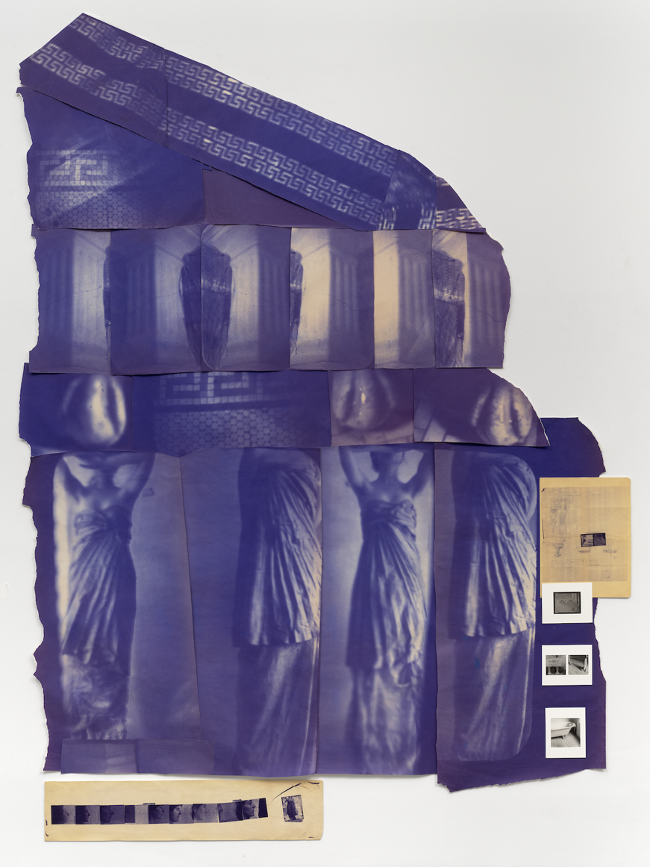
Figure 6:Francesca Woodman, Blue Print for a Temple II, 1980

Referring back to Helen Chadwick’s work being the anti-containment of desire, the house can be viewed as a container that supressed women, supressing and shrinking their flesh into the Symbolic. I caress the jagged lines of Francesca Woodman’s Blue Print for a Temple II, the imperfect structure rebels against symmetrical and scientific history of architecture which is heavily, like many fields, steeped in cis-white male centred designers. Within the chapter The Body, Open, Itself, Greenlaw laments over our experience in being, reflecting on how we are both shut out of and undeniably tethered to our insides, to our blood and guts, how bodies come to be almost compartmentalized (like the rooms on a floorplan) as a way for us to make sense of our organic matter moving through the world. She compares the body to a construction, to the houses in which we place ourselves in, how we relate to the inside of the house in regard to our bodies within it.

“Our joints, teeth, nails and hair can be reinforced or substituted, our organs too. Our walls are shored up while room by room we become empty, and our doors and windows warp and jam. The external interior was gradually sealed up, the last person leaving through the roof (…) We cannot remain exposed or we, too, would exist in a state of continual barren erosion. We contrive a surface and not wanting others to think of us as behind a wall, offer this as a version of the interior self- an external interior” (Greenlaw, p.121, 2024)

As we age, we tend to board ourselves up some more, covering more and more of our flesh, filling our teeth, peering out behind glass and metal frames as our vision faulters with age. We remain continually and perpetually under sort of bio-scaffolding that invades our boundaries in order for us to evade our crumbling biological foundations. Just like the house that is continually patched up and damp-proofed as the weather and elements continue to invade it’s boundaries, we cannot avoid the weather (or wither…) of age, of our vessels perpetual stumbling towards the end, towards death. And as our walls crumble we are ever more encouraged to patch up as urgently and quickly as possible or we risk losing our value in a system that devalues older women and their lack of fertility. “For men there is no destiny equivalent to the humiliating condition of being an old maid, a spinster. “ (Sontag, p.11, 2023)

One of my favourite past-times is looking at old Victorian houses, particularly American ”stick” and “Queen Anne” style builds often built in the late 1800s and early 1900s. I’m not interested in the re-done, or meticulously restored ones, but the crumbling, wood rotten, window caved-in ones. The once opulent expensive wood and tiles chipping and eroding, wall-paper peeling off, clumps of debris like confetti sprinkled across the floor. No matter how rich you are, how much bodily intervention you’ve paid for, eventually it will all crumble. ​For women, as our skin/walls crumble we are encouraged to reinforce, to buy expensive treatments and do everything we can to slow the wallpaper peeling away to show our rotten, abject insides.

We risk letting it be known we are our bodies when we talk of pain, of sickness, of leakage. So, those things become taboo and gory. You must present yourself as sealed or risk becoming gruesome and monstrous. We are all so utterly reliant on our bodies, we are scared of them, of them turning on us, of sickness and disfigurement. When I have a pinched nerve in my back I struggle to remember a time in which I wasn’t in pain, until it passes and suddenly I can think a little bit outside of my body, not completely and utterly aware of it every second of every day. “We perceive ourselves as both with and without, and the body as something we have rather than are.” (Greenlaw, p.132,2024). I think this especially true of becoming a woman, the changes that occur when you go through puberty plunge you (at least in to my case) in to often thinking endlessly about your body. It’s always with you, and it’s a chore as your hormones surge and societal pressure pokes you in so many different directions in terms of the many numerous things at fault with it. Quoting Whitehead, Greenlaw rebutes a quote of his in which he claims that no one ever says “here I am, and I have brought my body with me…” Greenlaw says “If Whitehead had been a teenage girl, he might have reconsidered. I felt as if I were hauling myself around for years” (Greenlaw, p.133). I seek to move with more freedom, less hinderance of my body, but at times I feel like a derelict house, a coastal home caving in to the cliffs below, both out of sheer curiosity and absolute terror, I’ve been at odds with this vessel, I’ve put myself in sticky situations….was I testing the foundations? Was I scarring the surface to seek the rotten insides?​
Within Francesca Woodman’s work she is often merging, splitting and scrawling within the space. The room merges with her, her body an unstable, energetic spectre, feasting on the energy within the room. This brings to mind the Caress, her unruliness acts not to sink in to the space, but to open it up to her body. “…and for women whose intrinsic leakiness marks a body that is always already breached, the ideal of a closed, powerful and self-defined corporeal schema is never less than compromised. “ (Shildrick, p.72, 2002).​ Like her Blueprint for a Temple work, her body rejects the confines of a sealed space, the rigidness of a buildings lay-out.

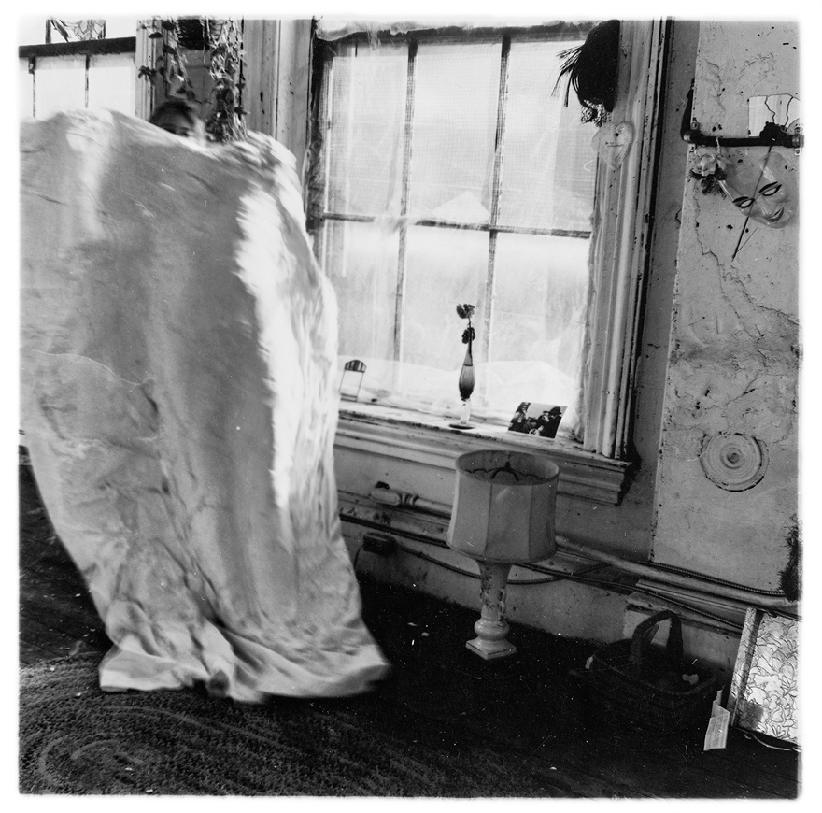

Figure 7:Francesca Woodman, Untitled, c.1977

While visiting the Georgian House Museum in Bristol to visit Akosua Viktoria Adu-Sanyah’s exhibition The House is a Body. The Georgian house was owned by John Pinney, a wealthy sugar merchant, plantation owner and slave owner. Among the staff at the house were two black enslaved people, Pero Jones and Fanny Cocker. During Abu-Sanyah’s residence at the house she explored scars and trauma held within the walls of a home that was commanded by a rich white man, stripping away autonomy and rights of those below him, especially the black people enslaved there.
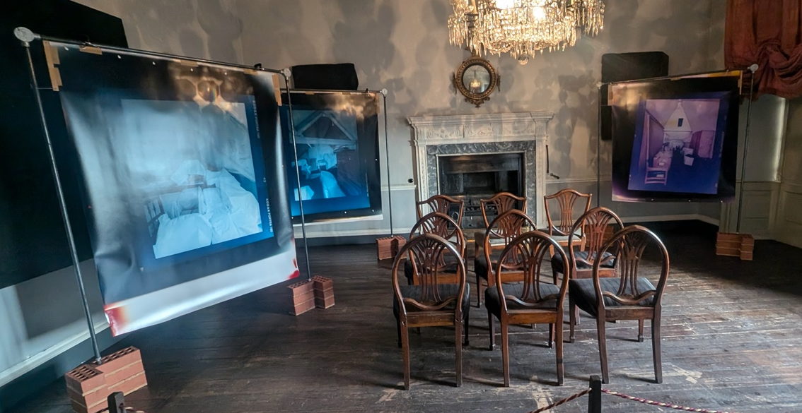
Figure 8 Akosau Viktoria Adu-Sanyah, The House is a Body, Picture from inside the exhibition sectioned titled The Attics, 2024

She explores the home as a body, trauma and pain as scars within the building itself, a living, breathing entity that represents the turmoil of those within it.While Pinney has passed and cannot be held accountable, the walls he once domineered still stand. The walls are, by extension, living relatives of Pinney, descendants of the suffering he inflicted, remembered and refurbished for people to visit for their viewing pleasure. While the museum does commemorate the history, the grandeur of the house stands in stark contrast to its history. I was particularly drawn in by her works depicting the attics of the house. Attics themselves are liminal, abject spaces. Tucked away, it’s where you put all of the stuff you don’t want on display, old boxes with bric-a-brac, containers filled with memories sent up to gather dust and sometimes mould. Attics threaten the stableness of a home, it is abject in that it is like organs being pulled out, it is hidden away but once you unravel it, it threatens to collapse in on the house, like the body and it’s innards

. Inaccessible to the public, Adu-Sanyah documents the state of the attics as they are presently. Storage space covered with boxes and furniture covered in white sheets, there’s a ghostly atmosphere. Things packed away, forgotten. The rest of the house has been meticulously restored, the attics remain hidden away, no plaques to educate people on the lives of the slaves whom spent their nights under the cobwebs of the attic ceilings. The chairs within the middle of this installation feel like they are waiting, waiting for an audience, waiting to be moved…waiting for something. The chandelier casts beautiful shadows, engulfing the room in rich patterns, but her photographs mark a stark contrast to the room they are present in, the room that they are occupying and almost moving-in on, like a threat that is slowly growing. ​ The images are large, clinging to metal frames, stabilized by bricks, they have an industrial feel. They completely reject the golden, often heavily embellished frames that house expensively commissioned paintings by affluent people. In fact, Adu-Sanyah completely removes these portraits from the room, putting black fabric on them, mirroring the sheets and hidden things housed within the attic rejects them, her images are the only things you need to pay attention to. “I had to contort myself in order to bring the inside of the box to my eyes” (Greenlaw, p. 203, 2024). We all have a deep seated desire to see the hidden, to sneak within the cracks so that we can see the life that alludes us, to see the inner workings of our walls, it intrigues us like our own insides.

​

Process

Within this section I will focus more on my creating and making in unison to the research I undertook. My work is auto-ethnographic, and therefore through my writing and creating I seek to think through and digest the themes and discourses which are personal to me as a queer, assigned female at birth artist. The abject-caress has become, for me, a research tool and a playground, an unfiltered and sprawling abyss in which I can revel and intermingle with.
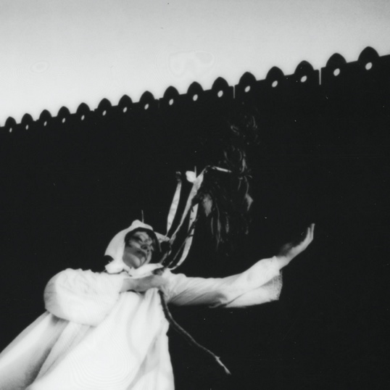
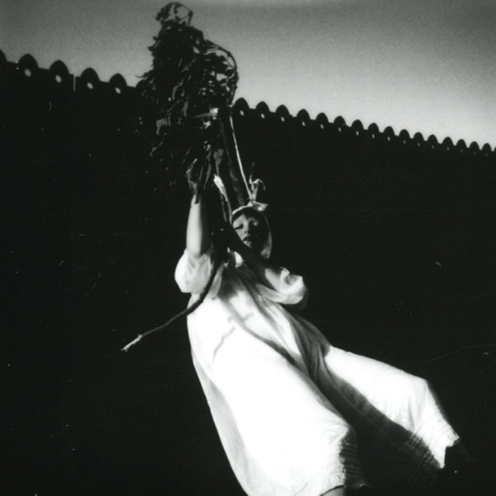
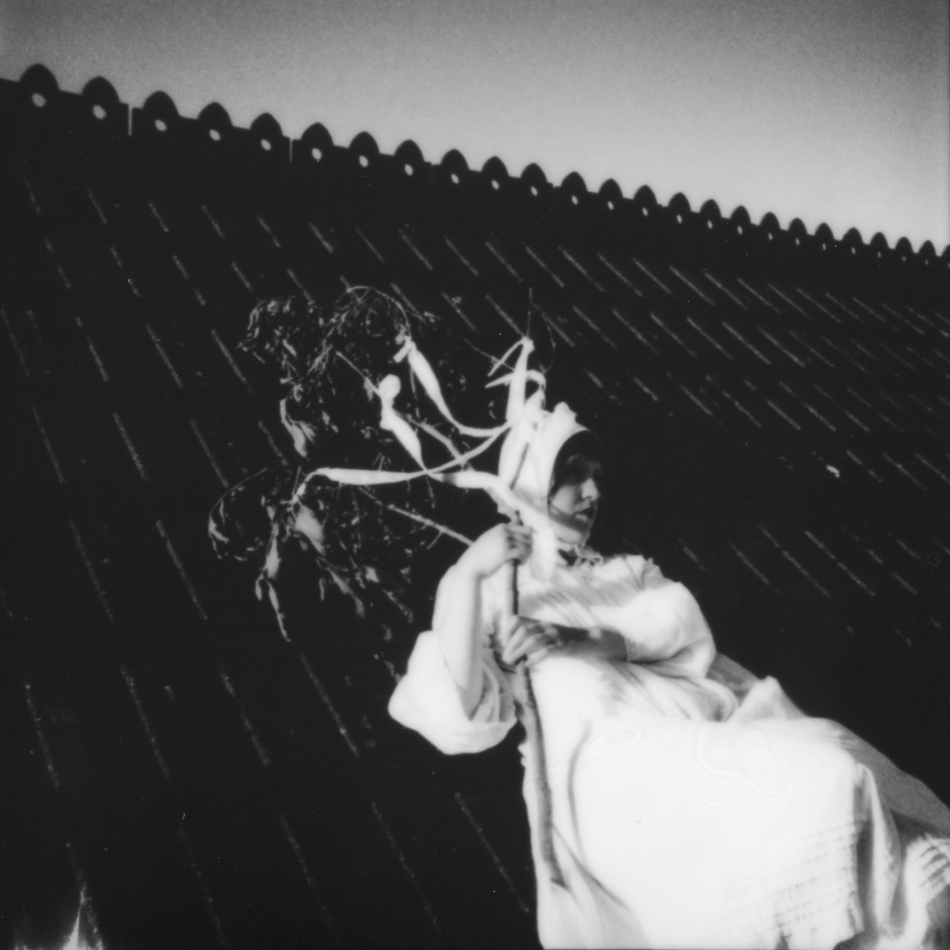
Figure 9:Dione Jones, Daphne's Passage, image 2, 2024
Figure 10:Dione Jones, Daphne's Passage, image 3, 2024
Figure 11:Dione Jones, Daphne's Passage, image 1, 2024

“ The women of mythology regularly lose their form to monstrosity.” (Carson, p.125, 2001) Daphne’s Passage, 2024, connected to a branch, I wanted to seek solace in the raw and natural morph into new life. Daphne was transformed into a Laurel tree by her father in order to escape the unwanted advances of Apollo, but as she could only escape the patriarchy by seeking help from a man, the patriarch of her family, where is her power? As Apollo came to see the Laurel tree as sacred, once again perusing Daphne’s flesh in her new form, did she ever really escape? Perhaps her father should have changed her into a poisonous laurel.

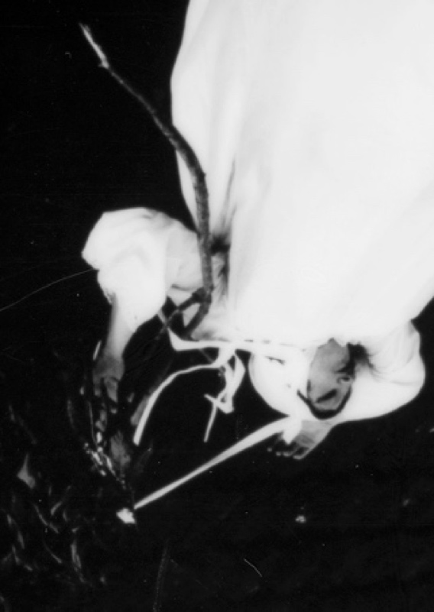
I seek to reclaim Daphne’s transformation, conducting their own ritual, taking ownership of their body, by their own hand, to escape the unwanted touches and objectifying gaze that scrutinizes our flesh. Instead of limbs twisting and writhing, as many sexualized depictions of Daphne often feature, I wanted to depict a peaceful passage, not an escape but a metamorphosis of Daphne’s body, a hybridization corroding the boarders of human, animal and organic matter. “In myth, woman’s boundaries are pliant, porous, mutable. Her power to control them is inadequate. (…) Deformation attends her. She swells, she shrinks, she leaks, she is penetrated, she suffers metamorphoses.” (Carson, p.135. 2001). The women of mythology are corruptible and weak, just like the women of the bible, they are lead to trouble through exploring that which they are forbidden (Pandora’s box), like Eve eating the apple, they are depicted as feeble, they are unreliable within their own boundaries and cannot be trusted not to spread their perverse desire and darkness to that which is pure and that which is masculine.
Figure 12:Dione Jones, Daphne’s Passage, image 4, 2024

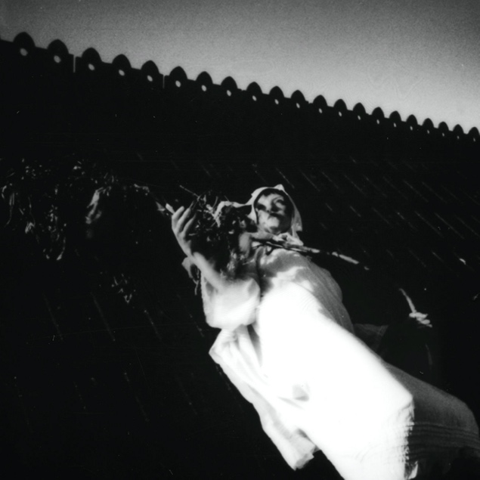
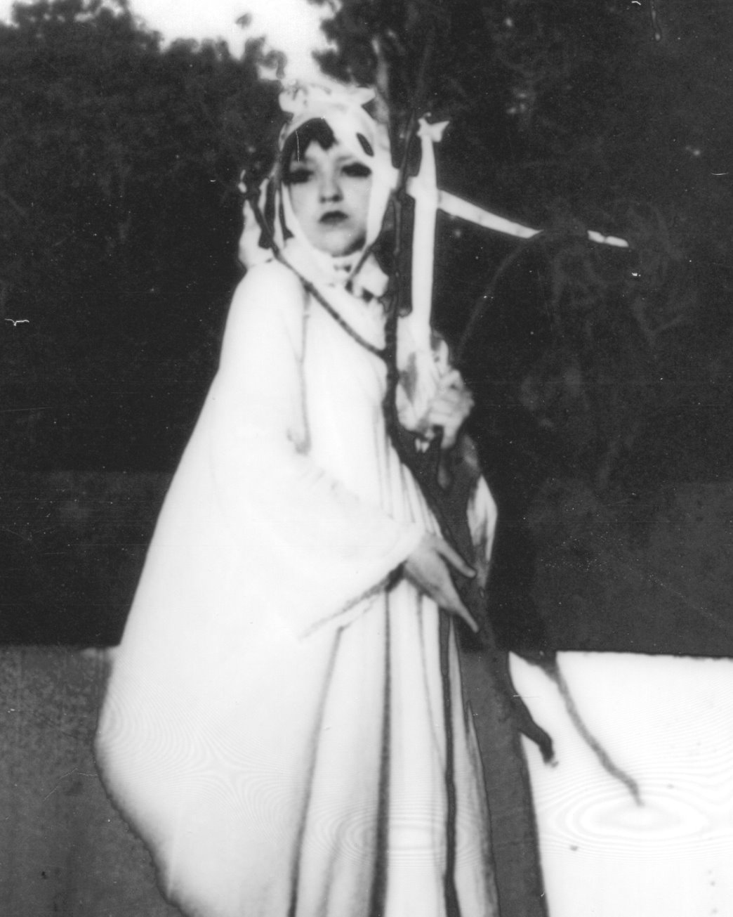
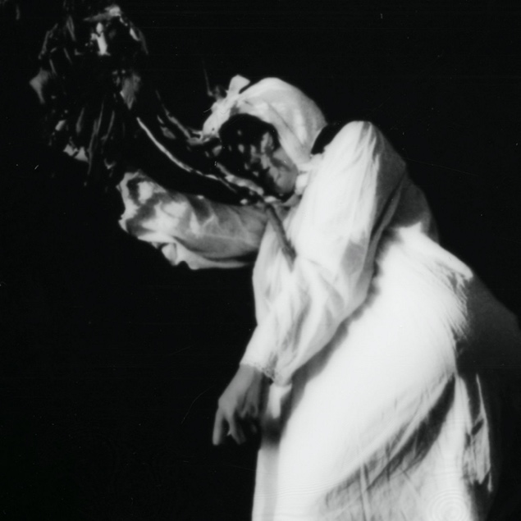

Figure 13:Dione Jones, Daphne's Passage, image 5, 2024

Figure 14:Dione Jones, Daphne's Passage, image 6, 2024
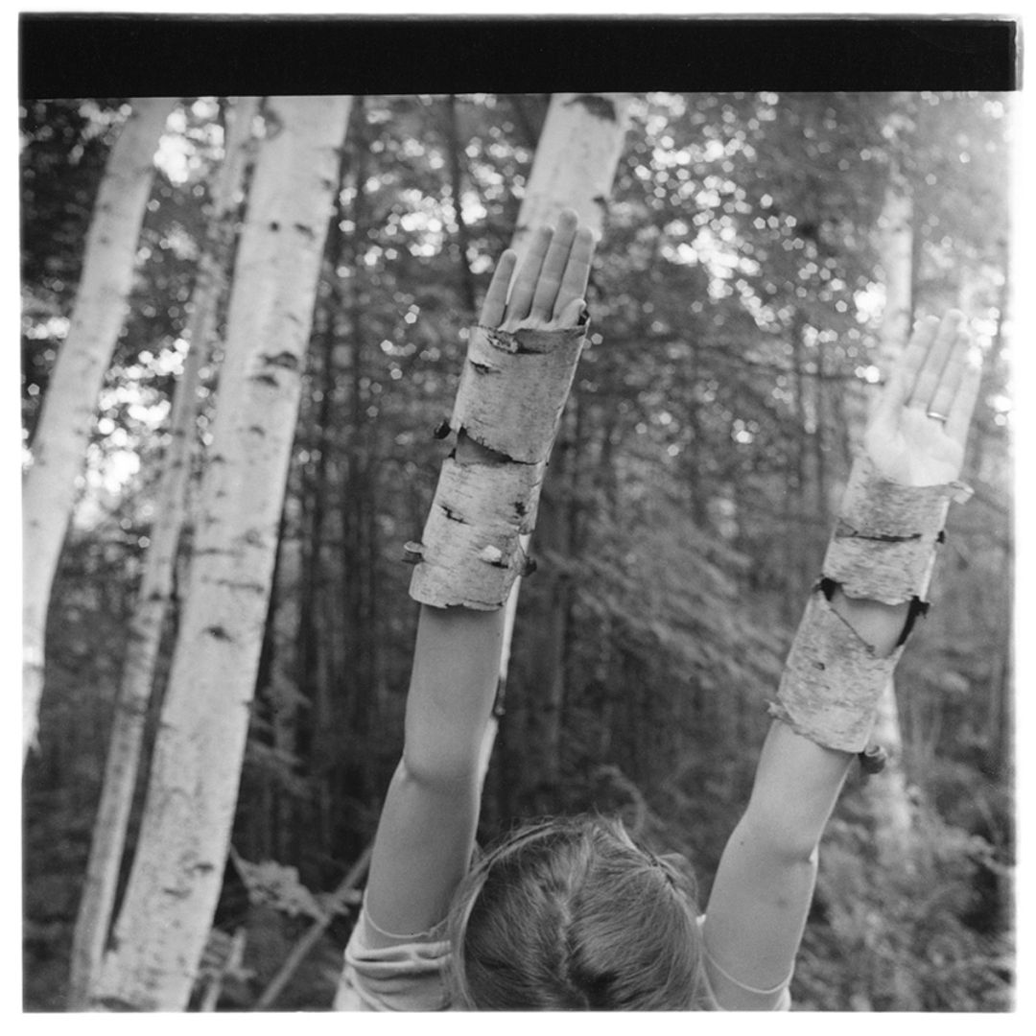
Figure 15: Francesca Woodman, Untitled, 1980

Figure 16:Dione Jones, Daphne's Passage, image 7, 2024

Figure 18:Dione Jones, Untitled (Roe Deer), image 2, 2025
Figure 17:Dione Jones, Untitled (Roe Deer), image 1, 2025
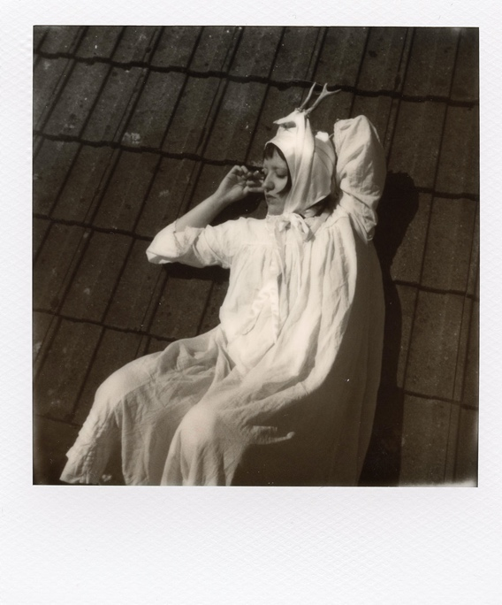
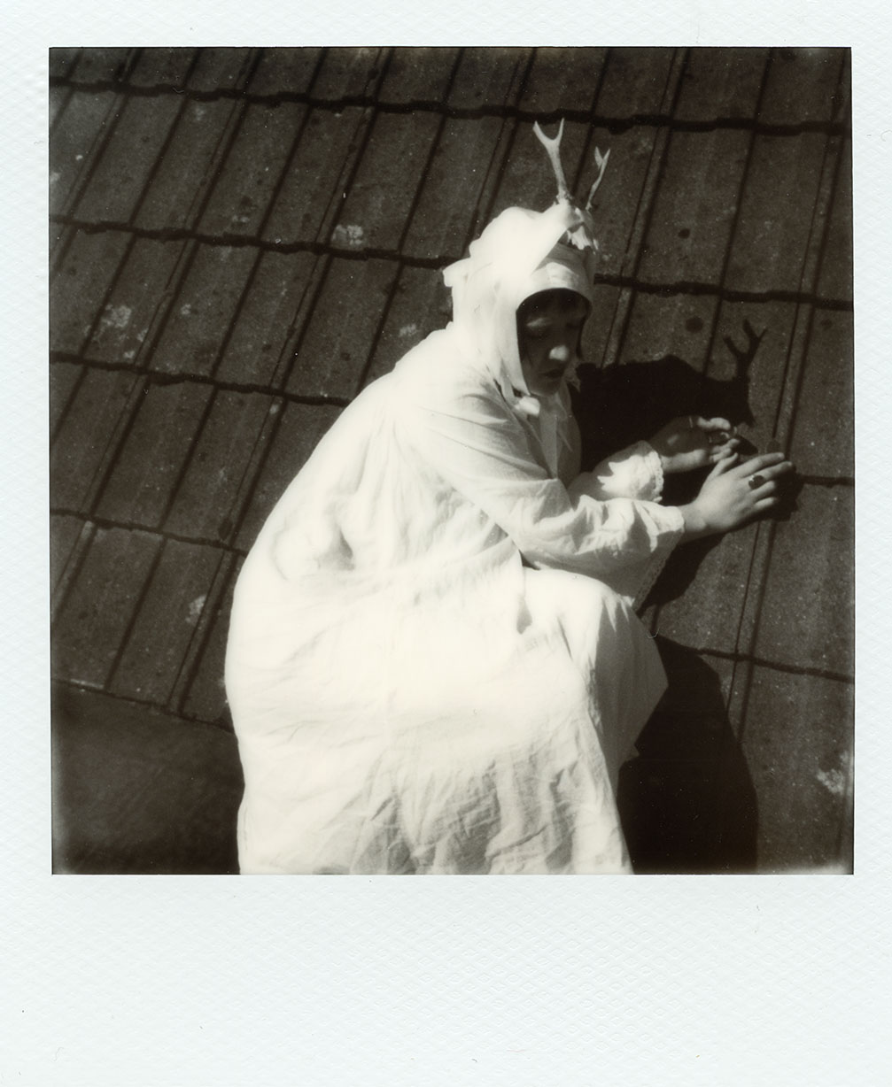
I later wanted to recreate the shoot but with a deer skull attached to my head instead, I liked how the way I attached it appears more bandage like compared to the strings of the bonnet reaching out like tendrils to the branches. It still plays with the themes of transformation like with Daphne’s transformation. A merging of animal/human and the disintegration of a fixed-self. The deer skull is also most commonly seen as a hunting trophy, hung on walls and left to collect dust. Here, by reattaching the skull to living flesh, it crosses the boundaries of life and death, breeding new life and caressing the tension
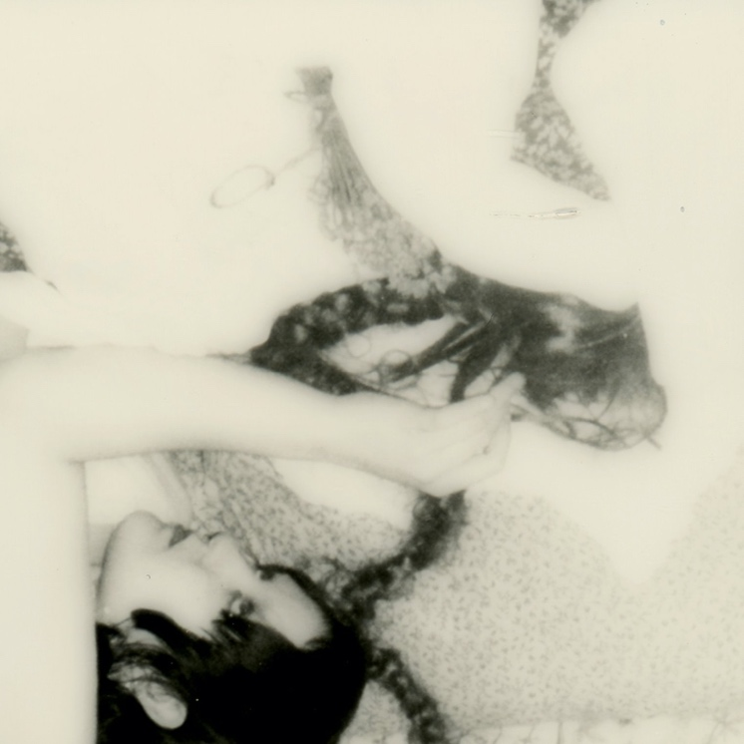
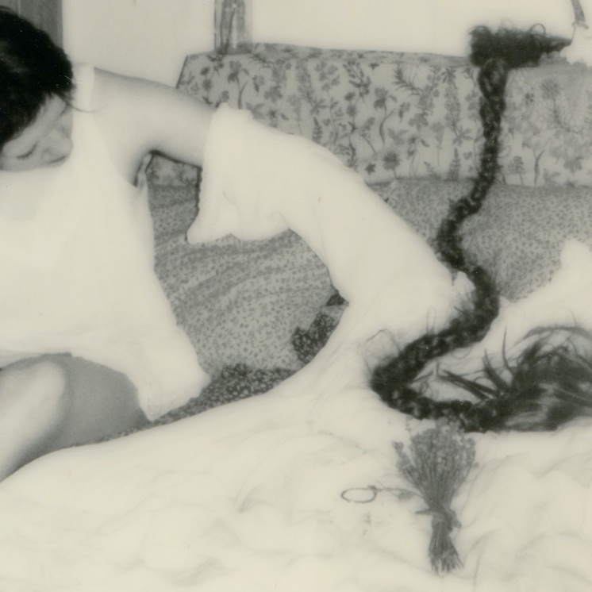
Figure 20:Dione Jones, Untitled (bedroom), image 2, 2024
Figure 19:Dione Jones, Untitled (bedroom), image 1, 2024
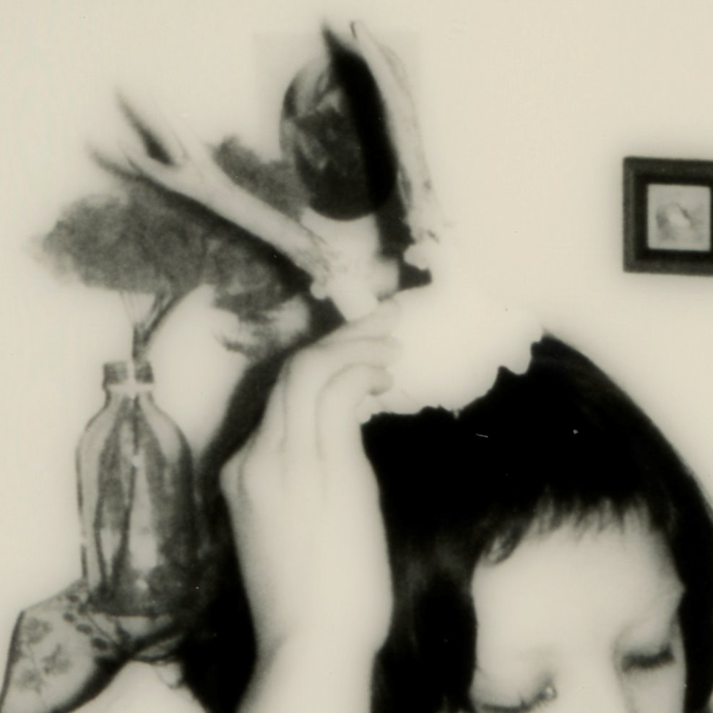
Figure21:Dione Jones, Untitled (bedroom), image 3, 2024

Within this set of images I wanted to explore the abjectness of the bedroom. To me, the bedroom is a pure site of abject, it is a place in which a woman untangles herself completely, but it it also a place that she may want to seal shut, to lurk within her depths uninterrupted from the outside world. It is a site where grief and loss of past versions of self, of childhood, haunt us in boxes sealed up and old posters flaking off of walls. It can sometimes be a personal space that is invaded or threatened. Within horror the monstrous woman often only reveals her true monstrosity behind closed doors, in her private sphere, it is there she is most ugly, most disgusting and most unappealing to the patriarchal gaze. Often, and I have struggled with this, even when a woman is completely alone she knows to what extent she is “ugly”, and with this internalised male gaze in our most vulnerable and transitional years we turn that gaze into self-hatred- often felt most in the privacy of our own bedrooms. “…we will have to spill out of all the windows and doors and out into the street, making the private public, the domestic political.” (Elkin, p.23, 2024). This set of self-portraits explores the difficulty in unmasking an idealised and “appropriate” self, while it almost looks ritualistic, it is a sort of mourning of the feminine ideal. It is not a sealing-up of boarders but rather an undressing and unravelling of my own self-longing for beauty, the ghost of care-free childhood girliness that become misconstrued as I grew older. The spectre laid out before is not a nightmare or a monster, she is my sister, she is admired at arms-length, she is my envious weakness but one I still yearn to love. The skull brings home a message of rebirth, like daphne’s passage, reconnecting to my bodies ugliness, its abjectness.

These shoots felt like capsules, self-contained within their own world. I began thinking about how I wanted to present my work for the exhibition. After these two shoots I had plans for more, but now was thinking more about how I wanted to present the work as I was shooting. I knew I wanted to produce something installation-based as I am more drawn to presenting my projects in a way that seeks to draw the viewer into the project, as opposed to just observing it. I wanted to create something that connected the separate versions of self together, in an abject way that refuses boarders and clean containers. During the infancy of this project, within the last module, I utilised latex as a material to create doilies that became somewhat alien-organism like, breeding on and ingesting self-portraits I had laid underneath. Thinking about Irigaray’s caress and this idea of an envelope splitting open so that that which is separate becomes intertwined, not taking from the Other, but nourishing each other equally, expanding together, and separate, not as one, but connected. This is the feminine abject. My flesh does not seek to completely split open, nor does my unruliness seek to make my flesh cease, it is a mutual relationship, flesh opening just enough to allow the abject to rear its head, to be present and to penetrate the lens and render flesh a flexible, understanding partner. “…this touch binds and unbinds two others in a flesh still and always untouched my mastery. Dressing the one and the other without the within, within and without in a garment that neither evokes, invokes nor takes pleasure in the perversity of the naked but contemplates and adorns it.” (Irigaray, p.186, 1993). I wanted to create an installation that connects flesh, a piece that reflects an harmonious destabilization of the feminine abject, an incubation and nurturing of monstrosity.
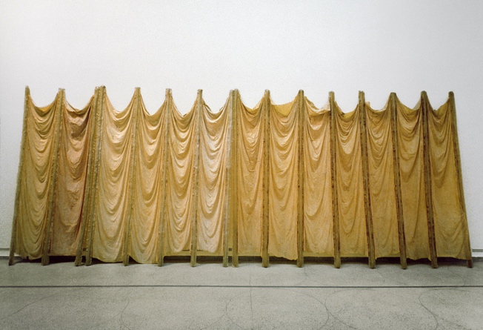
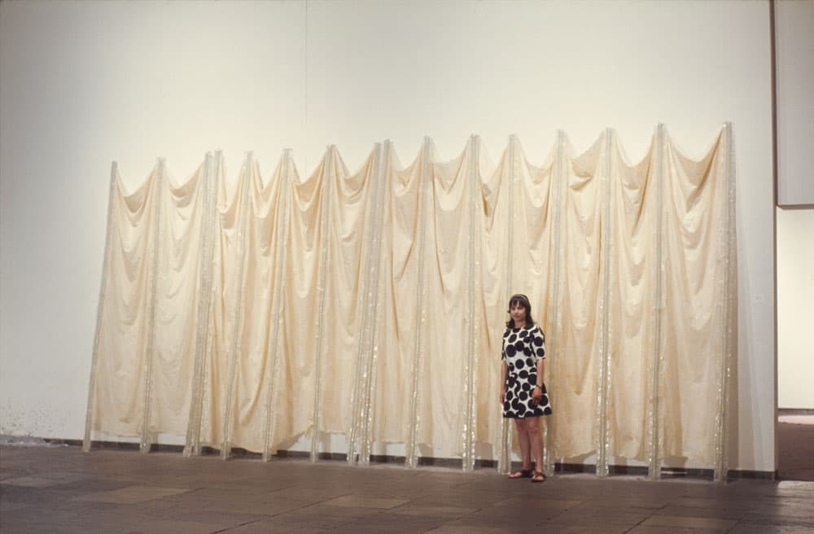
Figure 22: Eve Hesse, Expanding Expansion, 1969
Figure 23:: Eva Hesse with 'Expanding Expansion' at the 1969 exhibition 'Anti-Illusion: Procedures/Materials' at the Whitney Museum of American Art, New York

Eve Hesse utilized latex within many of her abstract sculptural works, above is her work Expanding Expansion, 1969. You can see how the latex has aged over time, the photo on the right being taken just over 50 years after the sculptures conception, bringing to mind previous musings on bog bodies. From a cream pearlescent appearance to a fleshy, more crumpled, grotesque form. “…the art monster is grasping after an art practice that is not simply a refutation of patriarchy but a gesture at building her own aesthetics. It is neither a channelling of normative practice nor a rebuttal of it; it is deviation, a hard left into a new territory.” (Elkin, p.73, 2023). What Elkin is saying her, to me, is truly the jist of what it means to embrace the abject and beome a true art monster, it is an abandoning of what is right and wrong, and instead what feels the most guttural and hard, it is embodiment of the expanding flesh you wish to convey through an act of reclaiming body through practice. Hesse’s use of latex, a material marked and degraded by time, dejects art as artefact, and instead insists upon sculpture as a sort of living organism, an extension of herself, which, too, will wither and succumb to time. It also speaks of how society views women aging, devalued as time goes on, her work challenges the idea that aging flesh should be frowned upon. “Work that charts the undoing of the body, and even undoes and decreates itself.” (Elkin, p.73, 2023).

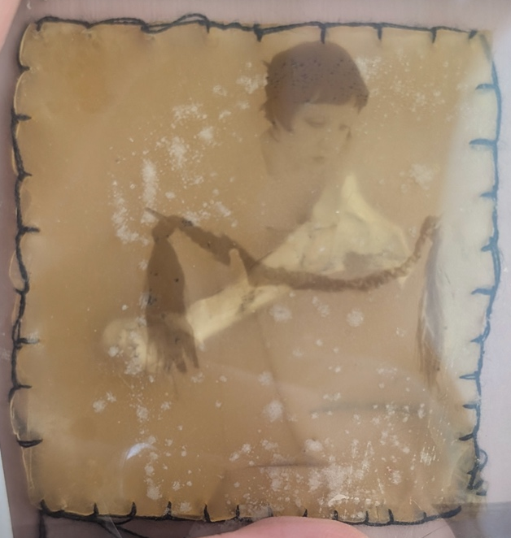
Planning the installation, I knew I wanted to incorporate light, my initial idea was to have some sort of wall-mounted interconnected grid of different flesh pockets/latex envelopes. However, reflecting on the Anatomical Venus I began thinking more about something that would be placed on the floor, looked down upon, as an ode to the Anatomical Venus who is always laid on her back, her glass cabinet placed no higher than hip height, inviting your downwards gaze.
Figure 24:Experiment with latex, thread, polaroid transparency and bird bone
An initial experiment with a reused polaroid transparency and bird bone. I found the stitching too distracting and the pocket itself too asymmetrical.
Liquid latex is by nature perverse, it mimics flesh but is synthetic, it is solid but it stretches and breaks, it is white yet dries the putrid yellowish tone of pure fat, it smells like fish and tarp and sticks to every single surface it touches. It breaks down over time, the colour shifts as it ages, it is leathery and tacky. I first began using it as a material when I became fascinated by the Anatomical Venuses and other archaic wax medical models. Their synthetic flesh is, too, perversely uncanny and grotesque in its visceral and shiny appearance.
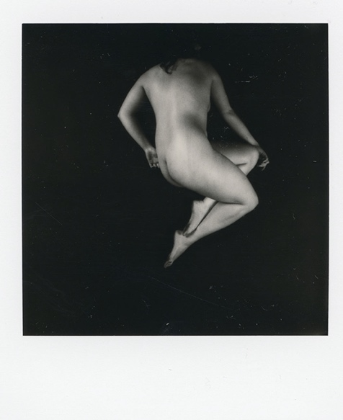
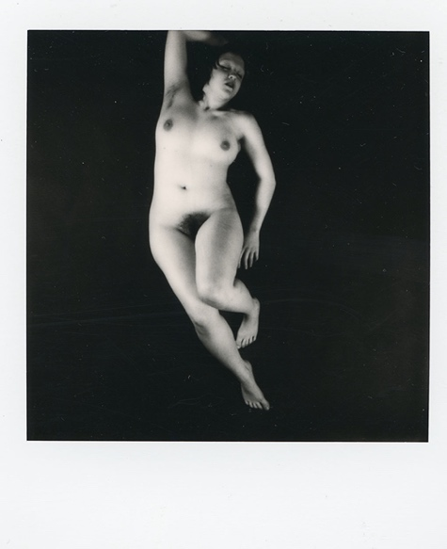
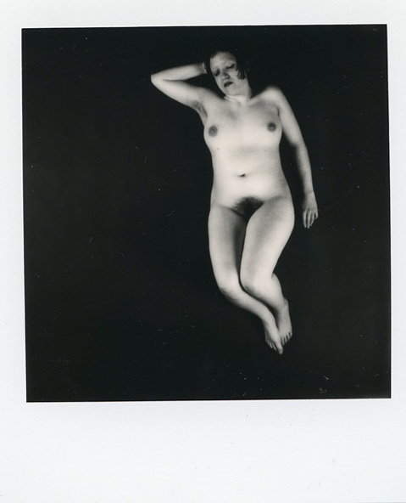
Figure 30:Dione Jones, Anatomica, Image 6, 2025
Figure 25:Dione Jones, Anatomica, image 1, 2025
Figure 26:Dione Jones, Anatomica, image 2, 2025
Figure 27:Dione Jones, Anatomica, image 3, 2025
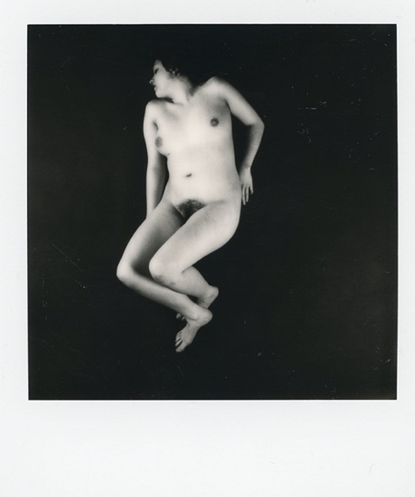
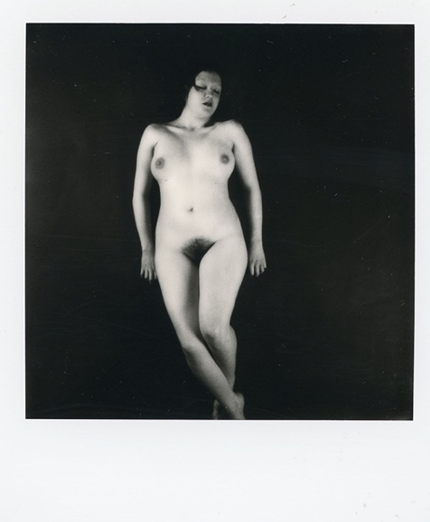
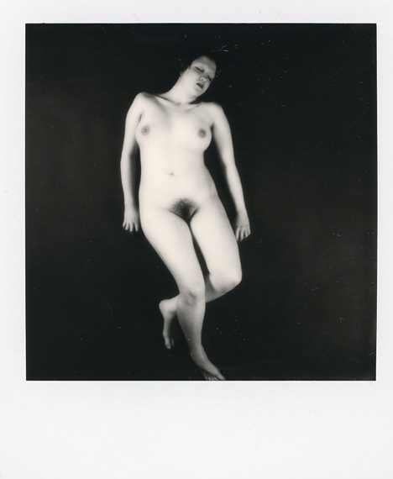
Figure 28:Dione Jones, Anatomica, image 4, 2025
Figure 29:Dione Jones, Anatomica, image 5, 2025
Inspired by the different positions and poses of the Anatomical Venus, especially those of which are featured in Joanna Ebenstein’s The Anatomical Venus: Wax, God Death & the Ecstatic.
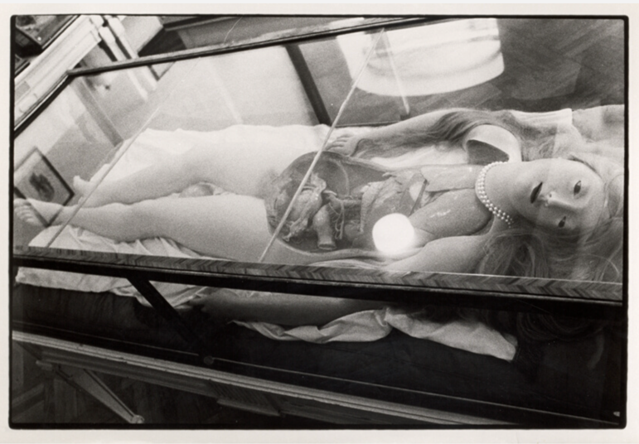
Figure 30

Figure 31:Zoe Leonard, Wax Anatomical Model with Pretty Face, 1990

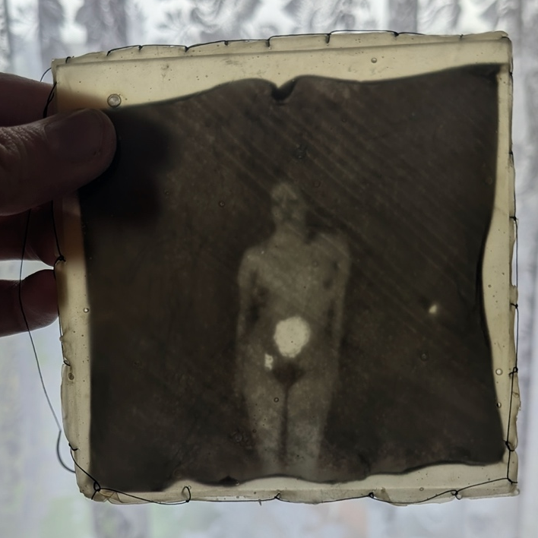
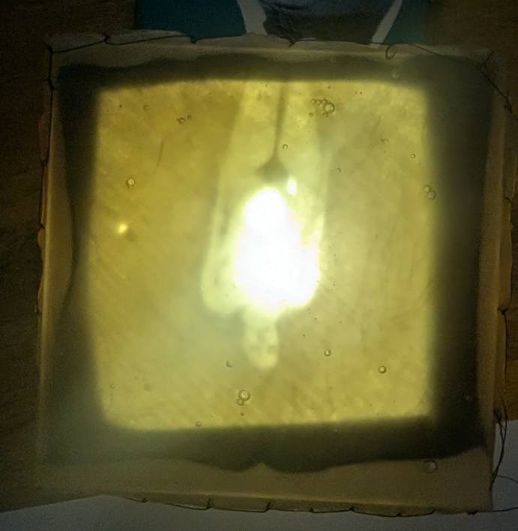
“…a classic example of uncanny. (…) two hundred years ago she was the perfect tool to teach human anatomy to the public; today she is bizarre – an alluring life-like was model in a state of ambiguous ecstasy…” (Ebenstein, p.19, 2016). Feminist artists are drawn to the uncanny, which at it’s core threatens and destabilises, threating our perceived boarders of self and reality. The Freudian notion of the uncanny is deeply intertwined with the feminine and the man’s fear of “returning to the womb”, thus his fear of genatalia-like places which could mean cellars, flowers…etc. The uncanniness found in the anatomical Venus threatens the boarders of body, her open cavity becoming both a place for death and a teaming hole where disease and bacteria dance around, she can be pulled-apart and repackaged, sometimes she is also the recipient of a tiny-wax baby lodged in to her womb. She is a crumbling map, in which lines cease meaning and sublimation, arousal and fear twist together. I guess, what I wanted to do was reclaim her, or more accurately caress her, in laying down, exposed, the lens from above is the eyes that look down onto her inside her glass case. My poses are an attempt to body her, in a body that, although sealed, is not as perfect as her waxen skin, her silken hair and lack of hair elsewhere. I wish to dissect myself, which self-portraiture is, in part, exactly that.
Figure 32: Polaroid lift onto glass, encased in liquid latex
Figure 33: Polaroid life on glass, encased in liquid latex and backlit

To begin mapping out how the images would work within the ‘”flesh-pockets” and being backlit, I did a polaroid transfer onto glass and roughly sewn in into a thin layer of uncoloured latex. I decided on not adding paint to the latex because I like how latex ages darker naturally, and to me, the beigey-white colour of latex looks like sort of visceral pure fat. The glass created too much of a reflection for the light, and the lift itself left the enamel of the polaroid quite thin and a bit too transparent. I also scraped away a section of my torso as a little ode to the Anatomical Venus. I opted for actual surgical thread this time, but still found it didn’t work, it was too thin and I wanted threat that cut in to the latex, like a corset on flesh, but without distracting from the image.

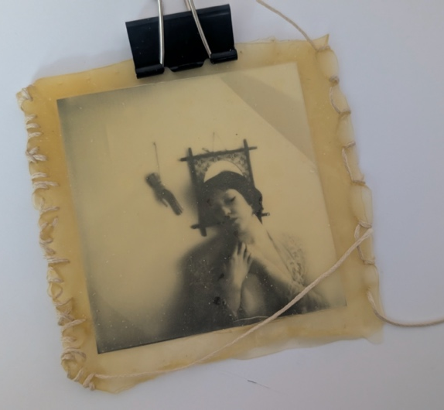
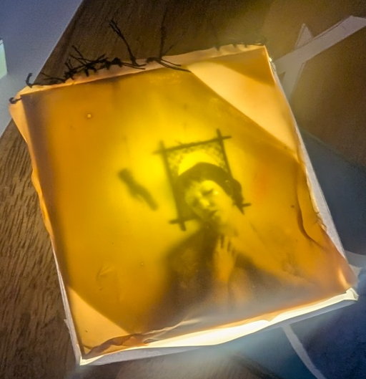
Figure 35:Polaroid transparency, latex and waxed thread
Figure 34:Polaroid transparency encased in latex and backlit

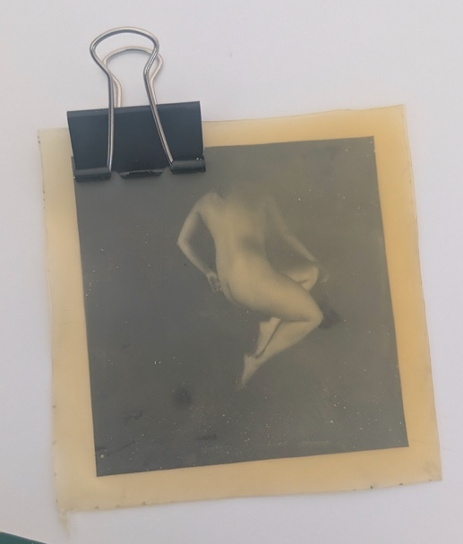
Having previously used polaroid transparencies I wondered if I could get a less transparent transparency by peeling apart a polaroid that was a few months old. The result is a clearer image when penetrated by light, however it was difficult to achieve without getting those sort of weird streaks visible in the image to the left. I also found the stitching I wanted to use, waxed threat for book binding, in a sort of cream colour, I stitched messily and liked the way it distorted the latex and framed the image within it. The colour reminded me of an umbilical cords
Figure 36:Polaroid transparency in latex
I found the sweet spot for the transparency to be about 3 weeks, the anatomical shoot I did had the right amount of texture without obstructing the light. I then began mapping out the installation. I wanted two pillows, each to containing 3 images, I wanted them to be backlit by lights, each image a window into “External Internal” (Greenlaw), the thread acting as not a sealant, but the frame of a window into the abject, into my unruliness, into my transformation, into the gestation of my vast attempt to externalise my perversity and lust to break down the symbolic order and reclaim the feminine-grotesque.
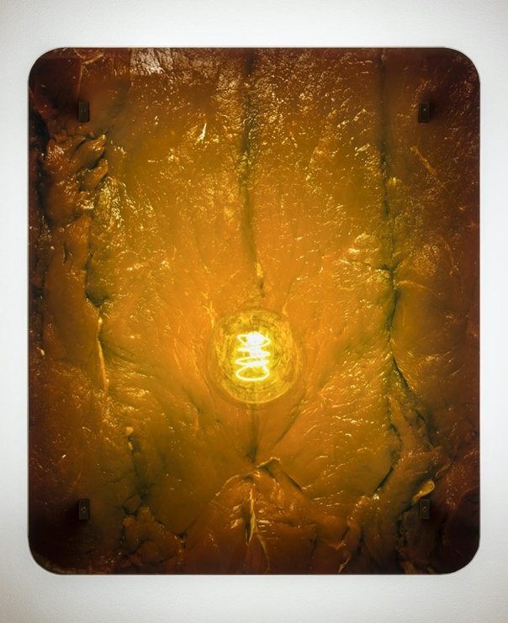
A core influence on my use of light is Helen Chadwick’s Enfleshings II and Enfleshings I (1989), as well as her Meat Abstract series (1989) Her use of light and flesh speaks to a sort of visceral sense of returning to the womb, to safety and incubation. These works present a raw look at flesh, we know not of its origin, raw flesh in any form forces us to confront what we are made of, it makes us confront the boarders of our being. She creates an uncanny landscape within her works of grotesque, that seem to dance between life and death, her images seeming both teeming with life and the discoloration and grotesque-ness of a butcher’s counter steemed with death. “Chadwick indicated that she saw the light as a reference to enlightenment rationality; enfleshing the light eradicated the body-mind split. ‘In a way’, she said, ‘(…)it is what it is, energy and flesh.” (Elkin, 2024 p.253). She captures the flesh in its raw (literally) state, separated from a host/mind the light reanimates it once more, and we are left to wonder when the decay will truly set in. Perhaps her flesh will remain in perpetual incubation, ”She was interested, above all, in using art not to stabilise the body, but to capture its fugitive quality.” (Elkin, p.254, 2024).
Figure 37:Helen Chadwick, Enfleshings I, 1989

For the lights I used small RGB LEDs operated by a micro-controller, which programmed the colour and brightness of the lights. The wires were soudered to the LEDS and the controller and then linked using electrical clips. The lights were powered by an external power supply plugged in to an outlet.

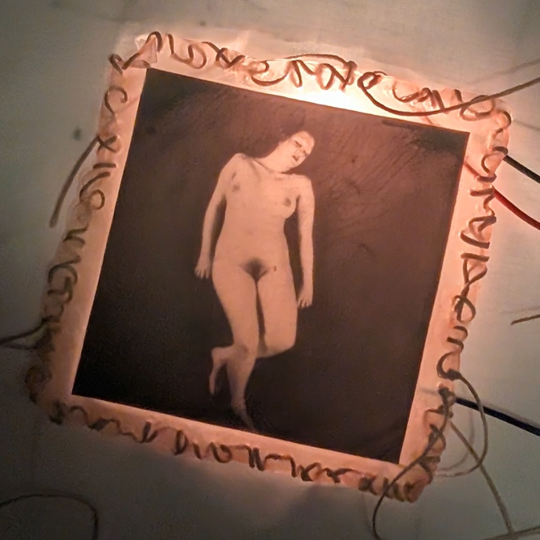
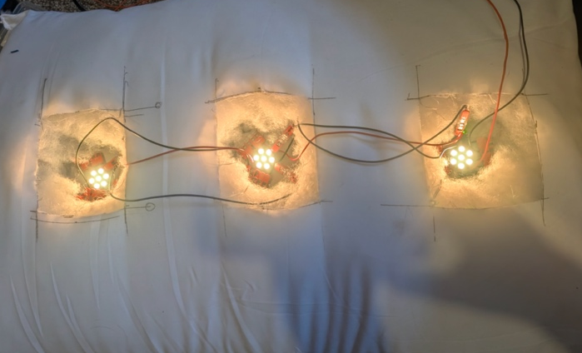
I measured and cut the pillows and placed the lights on to carboard backings so they would stay fixed in place. I then experimented with the numerous flesh-pockets I experimented made, seeing what composition worked best, I prefer to create installations in a more dynamic way, by making a few different ones I could switch and change the images, trying out different placements.
Figure 40: Polaroid transparency, latex, waxed thread, electrical wire and RBG LED, image 2
Figure 38:LEDs inserted into cut-out slots in the pillow
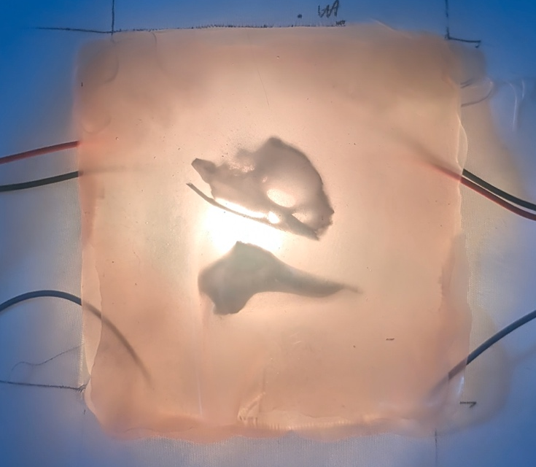
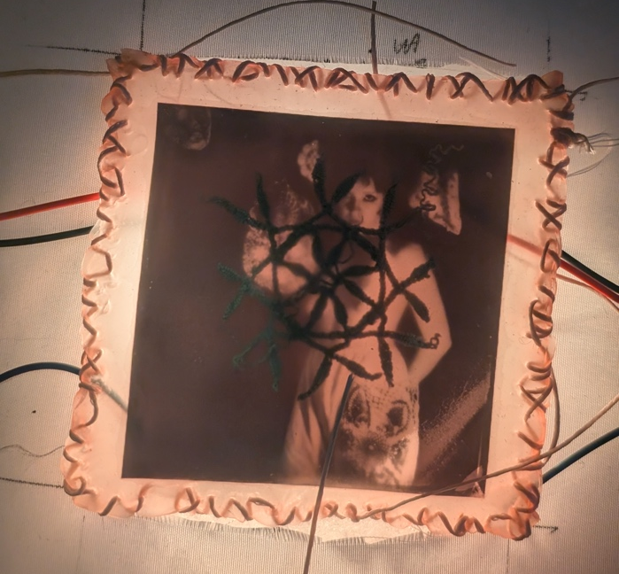
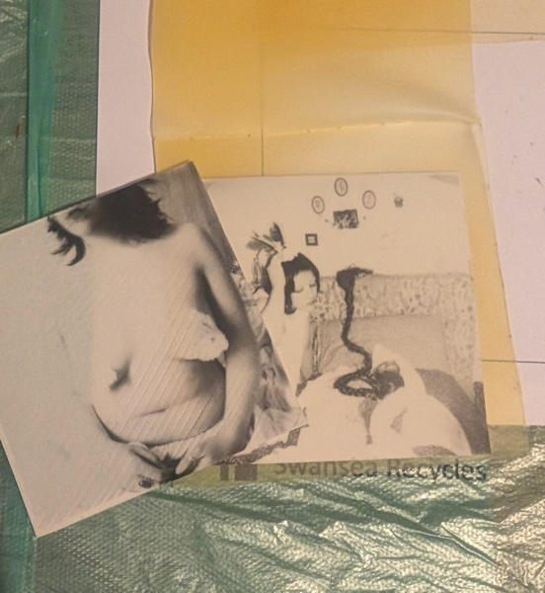
Figure 41:Bird Bones, latex, electrical wire and RBG LED
Figure 39:Polaroid transparency, latex, waxed thread, electrical wire and RBG LED, image 1
Figure 42: 2 polaroid transparencies, latex
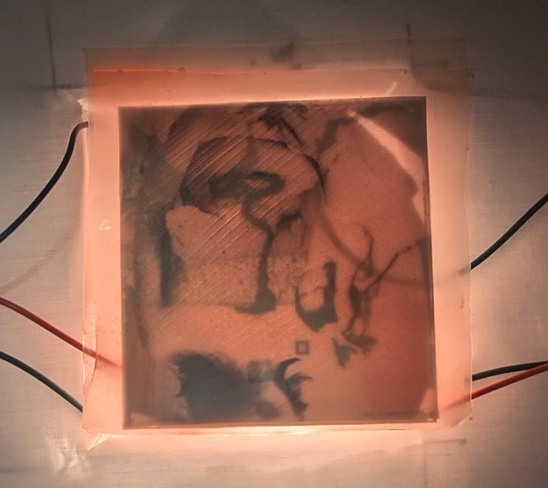
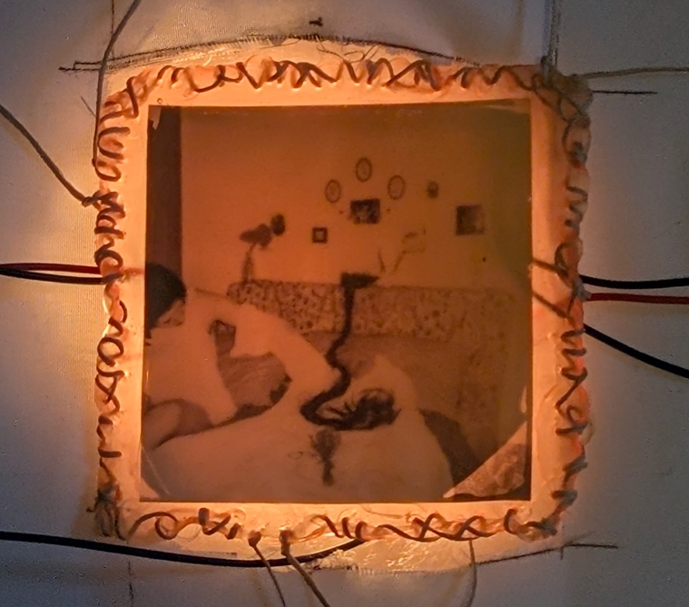
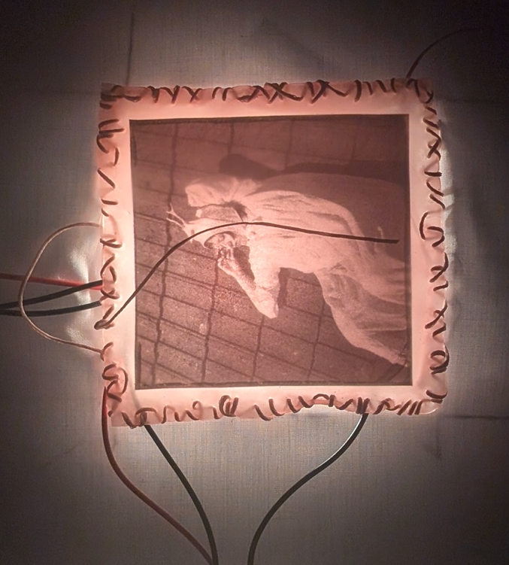
Figure 45: 2 layered polaroid transparencies, latex, electrical wire and RBG LED
Figure 44: Polaroid Transparency, latex, waxed thread, electrical wire and RBG LED
Figure 43:Polaroid transparency, latex, waxed thread, electrical wire and RBG LED

Final Piece / Conclusion

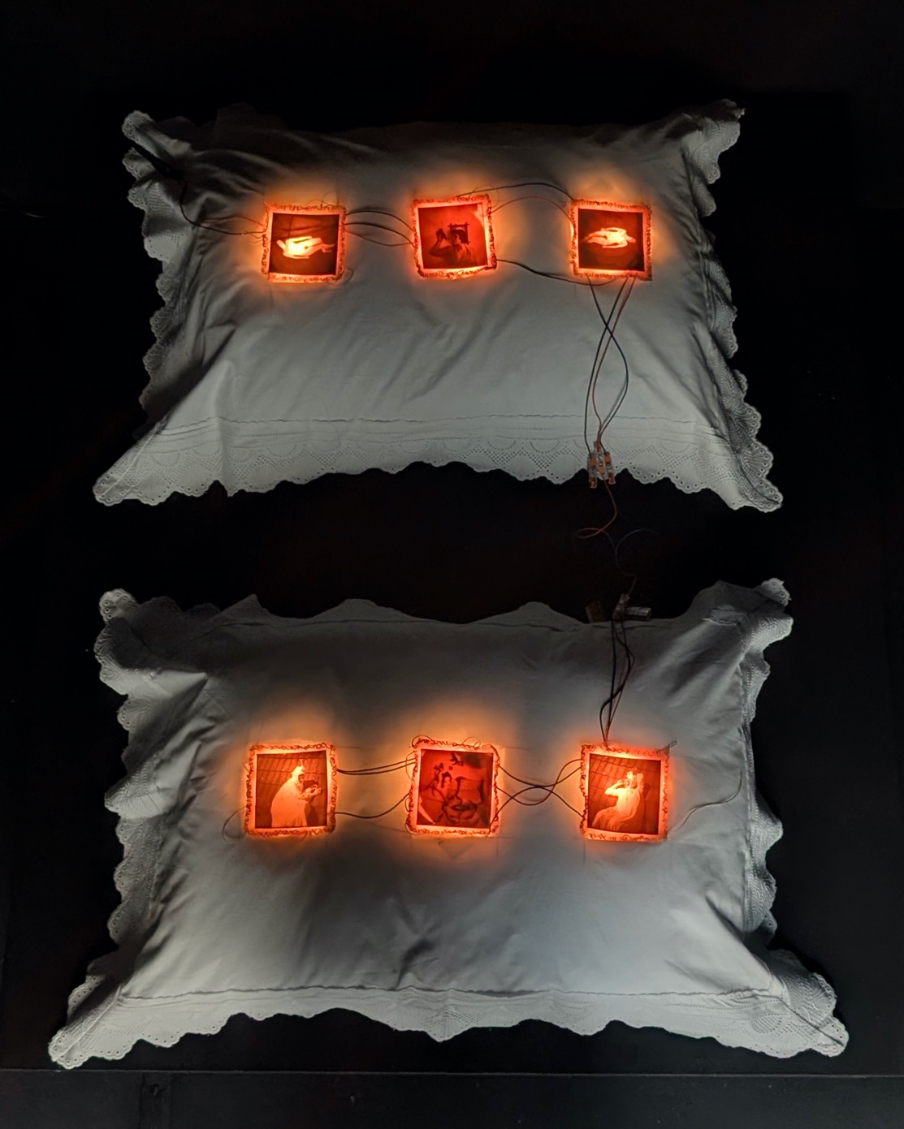

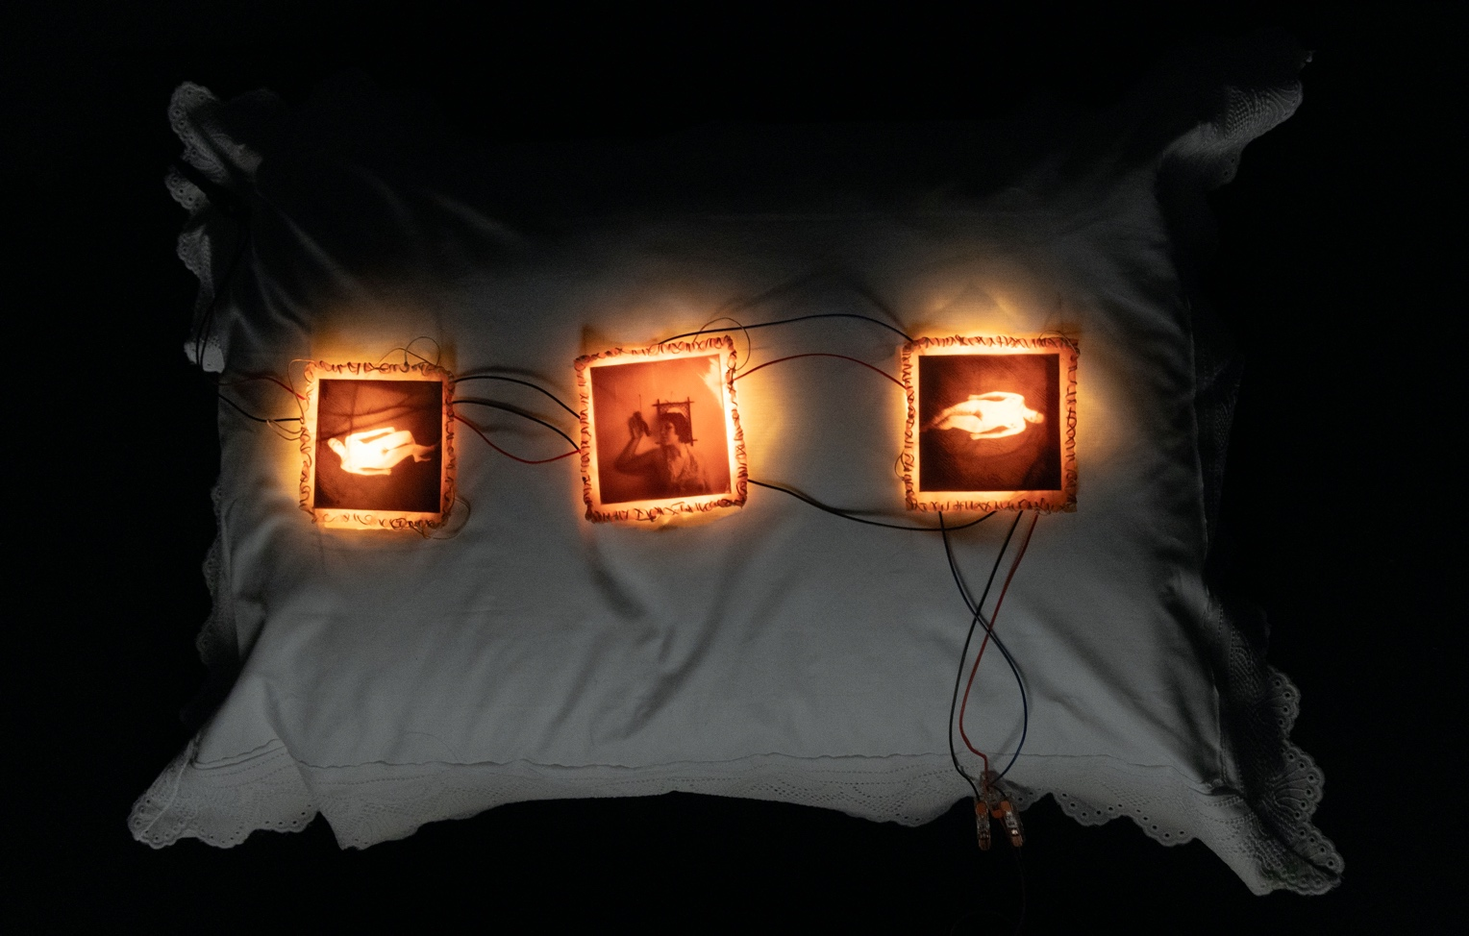

For the final group exhibition, Illumine, my piece, titled A Fragile Container, was placed in a completely painted black box-like room, slightly elevated from the floor on a black box. The room felt intimate and maybe intimidating, you peeled back the curtain to be greeted by a warm-orange glow emerging from two pillows, to investigate you have no choice but to enter, the images to small be seen from afar. I wanted to draw people in, to create that sort of abject feeling of being both on-edge and excited, repulsed and aroused. Each light incubates a different flesh-pocket. The juxta-positioning of the fleshy light and wires trailing across the pure white frilly pillows create a sort of monstrous rapture from the delicate feminine ideal. I liked the idea that the pillows represent a younger self, a sort of innocent girlhood marked by frilly dresses and expected gendered roles, but inside there is the monstrous artist slowly embedding into you as your body grows and becomes more unruly. The almost grid-like positioning of the images echoing that idea of containment within homes and the structed-nature of floorplans, how each room is built to contain a woman in different ways, built to confine a woman to her domestic duties. Each self-portrait explores my journey through the abject-caress and emerging in a body that is neither inner nor outer, but always transforming, a sort of eternal gestation.

Bibliography

Butler, A. (2025) Perversions at Her Fingertips, or, Francesca Woodman’s Autoerotic Attentions: An Essay-Caress, in Butler, A (ed), Osborne, N (ed), White, H (ed), Gestures: A
Body of Work, Manchester University Press, Manchester, pp. 75-92

Long Chu, A. (2019) Females, Verso, London

Nietchze Daybreak

Dabiri, E. (2023), Disobedient Bodies: Reclaim Your Unruly Beauty, Profile Books, London

Helen Chadwick the oval court marina warner

Greenlaw, V. (2024) The Vast Extent: On Seeing and Not Seeing Further, Faber & Faber, London

Bailey and Thynne 2005 https://www-tandfonline-com.ezproxy.uwtsd.ac.uk/doi/epdf/10.1080/03087298.2005.10441366?needAccess=true

Bogutskaya, A. (2024) Feeding the Monster: Why Horror Has a Hold On Us, Faber & Faber, London

Carson, A. (2001) Men in the Off Hours, Vintage Contemporaries, New York

Elkin, L. (2024) Art Monsters: Unruly Bodies in Feminist Art, Penguin Random House UK, London

Colquhoun, M. (2023) Narcissus in Bloom: An Alternative History of the Selfie, Repeater Books, London

Helen, I. (2019) The Anatomical Venus, Bloodaxe Books, Hexham

Irigaray, L. (1992) Elemental Passions, translated by Collie, J. and Still, J., Routledge, London

Irigaray, L. (1993) An Ethics of Sexual Difference, translated by Burke, C., and Gill, G.C,
Cornell University Press, New York

Helen Malson

Kristeva, J. (1982) Powers of Horror: An Essay on Abjection, translated by Roudiez, L.S., Columbia University Press, New York

Ebenstein, J. (2016) The Anatomical Venus: Wax God, Death and the Ecstatic, D.A.P, New York

Heaney, S. (1975) North, Faber & Faber, London

R. E, Gross. (2023) Vagina Obscura: An Anatomical Voyage, Norton & Company, New York

Sontag, S. (2023) On Women, Penguin Books, UK

