Title page should have the following details:

Name: Irene Matias

Student ID: 202543005

Module Name: Effective Teamworking and Communication Module (LCLM4003)

Lecturer’s Name: Abdallah Naser

Following are the characters in the video that you must watch before attempting to answer the questions. These character are a team of students working on a project.

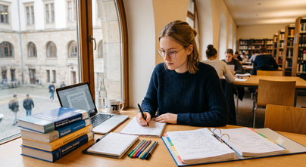 | Lena, a hardworking undergraduate from Germany, approaches her studies with detailed-oriented care and a consistent dedication to quality. Driven by a preference for precision and a reliance on empirical evidence, she consistently delivers exceptionally researched and thoroughly documented work.
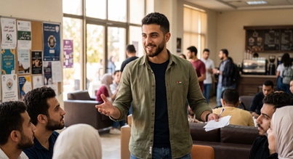 | Omar, an undergraduate student from Jordan whose confidence and persuasive charisma naturally draw others to him. With a natural ability to make quick decisions and a genuine talent for motivating those around him.
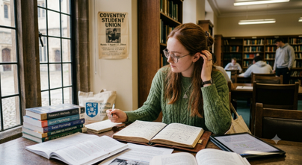 | Hannah, an undergraduate student from Ireland, whose calm manner and sharp intellect are instantly recognisable. Bringing her thoughtful, detail-oriented approach to everything she does, Hannah is a researcher through and through, thriving on evidence and considered evaluation.
 | Kenji, a Japanese undergraduate student known for his calmness, reliability, and strong sense of community. Always prioritising group harmony, Kenji always offers supportive guidance on group projects.
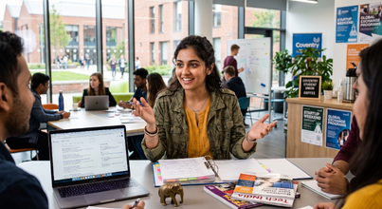 | Priya, an undergraduate student from India whose vibrant energy and dynamic resourcefulness are instantly recognisable. Bringing her unique blend of passion and practicality to the academic world, Priya is a natural networker and problem-solver.
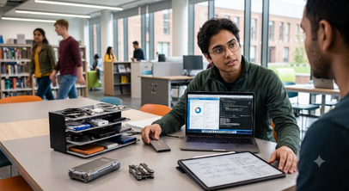 | Alex, a computer science major from Canada. Analytical, tech-savvy, and deeply practical, he approaches every academic challenge with a systematic mindset, always finding ways to streamline work using digital tools. He prefers to organise data for projects and fine-tuning workflows.

Watch the video and then answer the following ten questions within the spaces provided. Each question carries equal mark. Each answer should be a minimum of 100 words and a maximum of 150 words. Please note that the questions are grouped by topics, instead of following the timeline. You need to watch the whole video before answering the questions. Please make sure that you provide citation and references for all the relevant concepts you use in answering the questions.

Question 1
Explain what teamwork is, give examples from the video.
Teamwork is when a group of people contribute their skills, share one main objective, and combine their different abilities to work together (Morgan, 2017, p. 204). All members take responsibility and need to help each other. Communication is very important, because it allows everyone to explain their ideas and listen to each individual’s perspective.
In the video, the first important example is the use of shared tools and organisation. The team started to use a Notion workspace and Trello, so everyone could see the progress. Another example is the division of tasks. Responsibilities were split, including platform mapping and data validation.A final example is quality control. Omar gave the promotional text to be analysed and reviewed to check the academic tone, and the team compared it against the drafts and the rubric criteria.

Question 2
Omar states that the team has been debating for two hours, the team members look worried. Lena intervenes and argues, Omar intervenes again. Hannah looks troubled. (timestamp: 2:00 – 2:56). Identify which of Tuckman's Stages of Team Development this part of the video represents.
The team is in the storming stage because it shows conflict and disagreement over the direction of the campaign (Tuckman, 1965). Omar puts too much pressure on the team to decide quickly. In the video, he says that they have been talking for two hours without doing anything. Lena also argues with Omar and he intervenes again. Hannah is still worried about the situation. She says there is no empirical justification for the votes. The team resists and says that speed should not dictate quality. Basically, too much pressure causes communication difficulties. However, the team does not give up and stays focused on resolving the campaign direction. The group agrees on a compromise: the structure is approved today, with a strict timeline and clear task division.

Question 3
Identify & explain which Tuckman's Stages of Team Development is the team in during the last 2 minutes of the video (timestamp 4:00 – 5:58).
The team is in the performing stage (Tuckman, 1965). The conflict has been resolved, and everyone in the group works efficiently towards the shared goal. The Trello board is fully green, and tasks are monitored. Everyone contributes to delivering a successful campaign. Priya’s insights and Hannah’s analysis are integrated into the shared record. It is not another stage because the rules, the timeline, and the task division were already defined earlier. The market analysis matrix is finished, and two case studies were shared with the whole group. The team is ready to review the text to check whether it uses academic vocabulary and to schedule the presentation.

Question 4
Explain what Group Decision Making is, provide a relevant example from the video.
Group decision making is when several people work together to analyse a problem and choose the best solution, and the whole team participates (O’Sullivan, 2011). A relevant example is the decision about the campaign structure. Omar pressured the team to vote quickly, but the group argued that decisions need empirical justification. For this reason, the group approved the structure that day, created a strict timeline, and divided tasks. Everyone was involved in the decision. The group shows that working quickly is not safe, because it can lower the quality of the campaign. Everyone wants a good campaign. This shows that group decision making works best when it combines evidence with compromise. As a result, the group is now organised, and the Trello board is fully green.

Question 5
Explain what Nominal Technique is, provide an example from the video.
Nominal Group Technique is a structured method in which members first generate ideas individually, then share them, and finally rank them to reach a consensus (Vahedian-Shahroodi et al., 2023). No one dominates the decision. In the video, Omar pressured the team to vote quickly. The team did not have empirical justification, so they did not vote quickly. The group talked about the campaign for two hours and did not reach a decision. The Nominal Group Technique sets definite time limits. Someone suggested a deal: approve the structure, create a timeline, and divide the tasks. It had a clear structure and clear rules, and it avoided a chaotic debate. Each person’s contribution is shared in one shared workspace and meets all the criteria.

Question 6
What (Thomas-Kilmann model) conflict mode does Priya use when she states "We do not have to choose between being brilliant or being thorough.", and she supports Omar’s framework while giving Lena 48 hours to verify the data? (timestamp 3:20 – 3:36)
Collaborating. Priya does not choose a side. She tries to find a solution for both sides. This is the Collaborating mode of the Thomas-Kilmann model (Thomas and Kilmann, 1974). An example from the video is when she says, “We do not have to choose between being brilliant or being thorough.” She gives Omar the creative idea and Lena the rigor. Another example is that she gives Lena 48 hours to check the data and find empirical evidence. Omar and Lena both have their needs met. Omar keeps his creative idea and Lena has time to verify the data. Priya is not compromising, because nobody gives up.

Question 7
When the debate between Omar and Lena peaks, Hannah responds by "shrinking back slightly in her chair" and softly trailing off as she is spoken over. Using the Thomas-Kilmann Conflict Mode, identify and describe Hannah's conflict mode in this scene. ( timestamp 2:00 - 2:45)
Hannah used the Avoiding mode, because she does not defend her view or take a side (Thomas and Kilmann, 1974). She withdraws from the conflict instead of dealing with it. An example is when she is “shrinking back slightly in her chair.” She also does not defend her opinion when people do not listen to her. Hannah does not help to resolve the conflict. She is not accommodating, because she does not give in to Omar or Lena. She withdraws and avoids the discussion. She is not assertive and does not cooperate with the team, which is typical of the Avoiding mode.

Question 8
Identify which Belbin roles Alex and Priya might be demonstrating (e.g., Plant, Implementer, Coordinator, Specialist, Monitor Evaluator, etc.) and explain them with relevant examples from the video.
Alex is very organised with data and workflows. He draws attention in the group through the Notion workspace and the Trello board, which keep the tasks and digital assets in one space (Belbin, 2010). Alex plays the Implementer role and is a Specialist in digital skills. He uses digital tools to simplify the team’s work. Priya is a Resource Investigator because she brings external insights to the team, which were added to the shared record. She shows traits of a Coordinator when she says, “We do not have to choose between being brilliant or being thorough,” and gives Lena 48 hours to verify the data, while supporting Omar’s framework.

Question 9
Identify which Belbin roles Omar and Lena might be demonstrating (e.g., Plant, Implementer, Coordinator, Specialist, Monitor Evaluator, etc.) and explain them with relevant examples from the video.
In the video, Omar puts pressure on the group, suggests a vote, and motivates the group, which are typical behaviours of a Shaper (Belbin, 2010). He proposes an ambitious and innovative campaign, and the video mentions ideas similar to Zomato and personalisation based on AI. He has a creative idea for the campaign, which shows traits of a Plant.
Lena is a Monitor Evaluator because she resists pressure to decide quickly without empirical evidence. Lena also shows traits of a Completer Finisher. She is very careful with details and quality in her work, and she likes validating the data and checking the quality. Her profile says that she likes precision and delivers well-researched and well-documented work (Belbin, 2010).

Question 10
After watching the video, decide which Belbin role you would naturally take in this team and why would you take that role?
I would naturally take the Coordinator role, as I identify strongly with Priya. I like to organise everything, manage ideas, and listen to all opinions. In teamwork, when a group has one mission, the goal is that every member wins: everyone shares information, works together, gives a positive impression, helps others, and makes sure there is good communication to complete the work. I am a planner, and I am creative, innovative, and communicative, which are key qualities for a planner (Belbin, 2010). In the video, I would try not to debate for two hours without reaching a decision. First, I would split the tasks, and second, I would create specific deadlines to share our work and opinions. I would also listen to both sides and try not to lose time

References list

Belbin, R.M. (2010) Beyond the team. Oxford: Butterworth-Heinemann.

Morgan, P. (2017) The Business Student’s guide to study and employability. London: SAGE.

O’Sullivan, T. (2011) Decision making in social work. 2nd edn. London: Palgrave Macmillan.

Thomas, K.W. and Kilmann, R.H. (1974) Thomas-Kilmann conflict mode instrument. Tuxedo, NY: Xicom.

Tuckman, B.W. (1965) ‘Developmental sequence in small groups’, Psychological Bulletin, 63(6), pp. 384-399.

Vahedian-Shahroodi, M., Mansourzadeh, A., Shariat Moghani, S. and Saeidi, M. (2023) ‘Using the Nominal Group Technique in group decision-making: a review’, Medical Education Bulletin, 4(4), pp. 837-845. doi: 10.22034/meb.2024.434656.1090.

