

Student name: Christiana Joseph
Student ID: 2315420
Module name: Independent Project (BMHP6020_LON)
Module code: BMHP6020_LON
Supervisor’s name: Mr Jolly Nwankwo
Submission: 3rd July 2026

Recognition of AI Tool Application
I declare that no AI tools were applied to complete this assignment, and that all submitted work is entirely my own. Drafts, notes, and references have been retained and are available upon request.

  This Photo by Unknown Author is licensed under CC BY-SA |  | Exploring the Health Challenges Women Face During Menopause and Prevention Strategies in the UK.  This study aims to explore the health challenges women face during menopause and to identify effective prevention strategies within the UK context.  Objectives:  - To evaluate the most practical and effective menopause management and prevention strategies for women in the UK.  - Uses a secondary qualitative design with a scoping review based on Arksey and O’Malley’s framework (Khalil et al., 2016).  - To review academic articles, NHS guidance, and health organisation reports in order to identify evidence-based prevention strategies (Sowmiya Moorthie et al., 2024).  - To assess which strategies are both practical and effective for women, drawing on research evidence and reported outcomes (Sarkies et al., 2017).  Data Collection Method  - Data were collected from ten peer-reviewed journal articles using search terms including ‘menopause’, ‘UK’ and ‘menopause prevention strategies.  - Sources are accessed via the University of Wales Trinity Saint David library databases, including PubMed, Google Scholar, and ProQuest.  - A PRISMA-based search plan ensures comprehensive, high-quality, and systematic coverage of relevant research.  Inclusion criteria:  - UK-based studies secondary methodologies, adult women aged 45–60, Peer-reviewed journals published from 2016 onwards, English-language publications focused on menopause  Exclusion criteria:  - International studies not relevant to UK health systems, Books, websites, and reports, Journals published before 2016, non-English journals  Using these criteria ensures only credible, relevant evidence is included. |  | 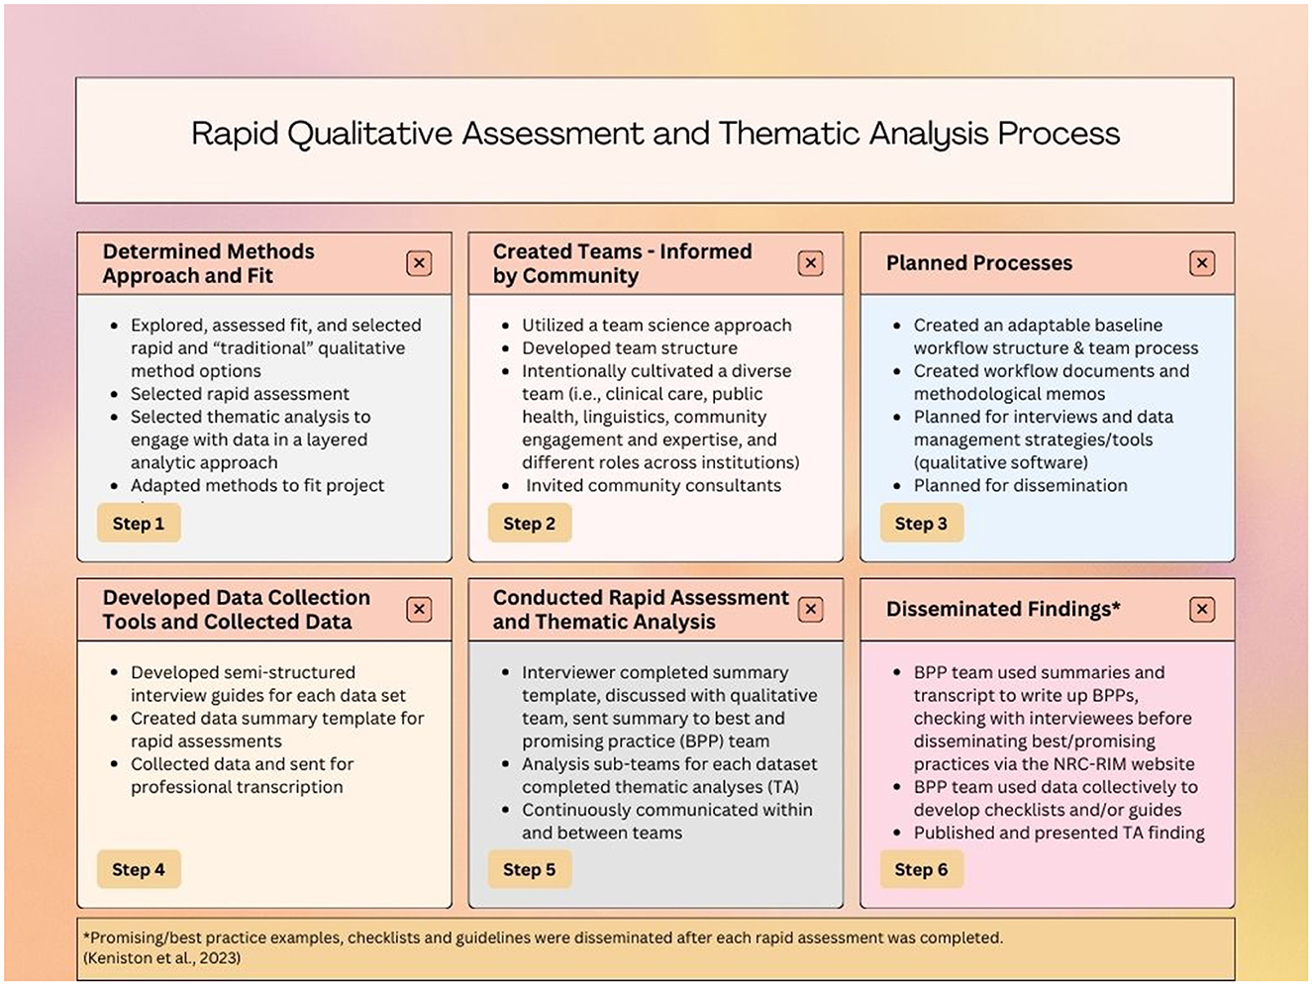  This Photo by Unknown Author is licensed under CC BY
Methodology:  - This research employs a secondary qualitative approach, drawing on existing literature to examine what is already known about menopause prevention (Kaveh Mohajeri and Karami, 2025). A structured scoping review framework guides the search and synthesis process.  - First, the study reviews academic papers, NHS guidance, and health organisation reports to identify evidence-based menopause prevention strategies, then evaluates which approaches are both effective and practical for women. |  |  |  | Data Analysis Method  - Uses thematic analysis (Braun & Clarke, 2021) to identify patterns and key ideas in the data.  - Analyses and groups findings into themes, examining lifestyle, medical, and workplace strategies for UK women, identifying the most practical approaches, and highlighting research patterns, trends, and gaps.  Ethical Considerations  - Uses only secondary, publicly available, peer-reviewed data, so a formal ethics review is not required.  - Ensures transparency, proper citation, confidentiality, and respect for intellectual property.  - Have been approved by UWTSD  Conclusion  A combination of lifestyle modifications, appropriate medical support, and inclusive workplace environments can together provide the most practical and effective menopause management strategies, ultimately improving health outcomes and overall quality of life.

References
Braun, V. and Clarke, V. (2021) One Size Fits all? What Counts as Quality Practice in (reflexive) Thematic analysis’, Qualitative Research in Psychology, 18(3), pp.328–352. Available at: https://doi.org/10.1080/14780887.2020.1769238.
Khalil, H. et al. (2016) “An Evidence-Based Approach to Scoping Reviews,” Worldviews on evidence-based nursing, 13(2), pp. 118–123. Available at: https://doi.org/10.1111/wvn.12144.
Lindsay, S. (2019) “Five Approaches to Qualitative Comparison Groups in Health Research: A Scoping Review,” Qualitative health research, 29(3), pp. 455–468. Available at: https://doi.org/10.1177/1049732318807208.
Mohajeri, K. and Karami, A. (2025) “Computationally Intensive Research: Advancing a Role for Secondary Analysis of Qualitative Data,” Journal of the Association for Information Systems, 26(3), pp. 832–849. Available at: https://doi.org/10.17705/1jais.00923.
Sarkies, M.N., Bowles, K.-A., Skinner, E.H., Haas, R., Lane, H. and Haines, T.P. (2017)’ The Effectiveness of Research Implementation Strategies for Promoting evidence-informed Policy and Management Decisions in healthcare: a Systematic Review; Implementation Science, 12(1). Available at https://doi.org/10.1186/s13012-017-0662-0.
Sowmiya Moorthie, Emre Oguzman, Evans, S., Brayne, C. and LaFortune, L. (2024)’ Qualitative Study of UK Health and Care Professionals to Determine Resources and Processes That Can Support Actions to Improve Quality of Data Used to Address and Monitor Health Inequalities; BMJ Open, 14(9), pp.e084352–e084352. Available at https://doi.org/10.1136/bmjopen-2024-084352.

