

STRATEGIC ANALYSIS OF INTERCONTINENTAL HOTEL GROUP
By
Saad Munir
MBA
Student Id:- 2214625
Strategic Management(LCMB7003)
Dr. Gladius Kulothungan

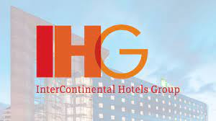

Executive Summary
The reason for this study is to give a basic evaluation of Intercontinental Lodging Group PLC's situation available and vital bearings. Moreover, the report will make suggestions for conceivable future key objectives. The report depends on the global Lodging Group PLC's ecological analysis. Intercontinental Inn Group PLC's improved development is being driven by its critical presence in the overall market, especially in creating markets. The company's extension has likewise been helped by its cutthroat places of authority as well as the ascent of the inn business, especially in developing business sectors. With the presentation of new ventures, the business is getting more cutthroat. In any case, the organization is utilizing its particular and uncommon capacities to acquire an upper hand. Climate analysis utilizing different philosophies, for example, SWOT and PESTLE are utilized to assess the company's essential position. The essential goals are analyzed utilizing the Ansoff system and the BCG framework.
Table of Contents
Executive Summary 2
1. Introduction 5
1.1 Strategic Management 5
1.2 Strategic Management steps 5
1.2.1 Identifying Direction 6
1.2.2 Analyzing Resources 6
1.2.3 Framing Strategies 6
1.2.4 Implementing Strategies 6
1.2.5 Evaluating Effectiveness 6
2. Intercontinental hotel group history and background 6
3. The Vision Statement of InterContinental Hotels 8
4. Intercontinental hotels group features 8
4.1 Exposure to China compared to competitors 8
4.2 Government support 9
4.3 Supporting staff management 9
5. InterContinental Hotel Strategic Analysis 10
6. Intercontinental Hotels Group PESTEL Analysis 13
6.1 Political Factors 14
6.2 Economic Factors 14
6.3 Social Factors 15
6.4 Technological Factors 16
6.5 Environmental Factors 17
6.6 Legal Factors 18
7. Porter’s five forces 18
8. Findings from PESTAL and Porter’s five forces analysis 19
9. Industry life cycle 20
10. Internal environment analysis 20
Strategic capabilities 20
11. VRIN analysis 21
12. Value chain analysis 21
13. Findings from value chain analysis 23
14. SWOT analysis 23
15. Findings from SWOT analysis 24
16. Strategic direction 24
Boston Consulting Group (BCG) analysis 24
16.1 Stars 24
16.2 Cash Cows 25
16.3 Question Marks 25
16.4 Dogs 25
17. Recommendations and conclusion 26
17.1 Recommendations 26
17.2 Conclusion 26
18. References 27

Introduction
Strategic leadership in an organization refers to the strategy development, leadership, and utilization of resources to establish and accomplish objectives efficiently, as well as a review of their internal operations and external factors affecting the business (Gass &Harris 1997, 759). Developing and carrying out strategies allow a business to proceed with its implementation plan (Haromszeki n.d). The continuous survey was moved by the yearning to embrace a full fundamental assessment of a picked context oriented examination using the strategies, hypotheses, and construction displayed in the fundamental business the chief's module. The investigation ought to focus on how the association settled its critical troubles and acquired an upper hand through essential administration choices. Understudies can exhibit their insight into key administration thoughts as well as their ability to apply them in genuine business conditions.

Strategic Management
The executives lay out targets for the organization's investors. It then makes draws near (prescriptive model) and carries out them (graphic model) System assessment, conveyance of assets, contender examination, and the inward structure assessment are basic transitional cycles (Oh & Oetzel 2022). Practically all organizations, scholarly foundations, and non-benefit associations use methodology improvement and execution to get an upper hand (Ritchie 2004).

Strategic Management steps
To be successful and fruitful, an organization must follow an array of practices for strategic planning. The steps in the procedure for strategic management are as follows ( Eppler & Platts 2009):
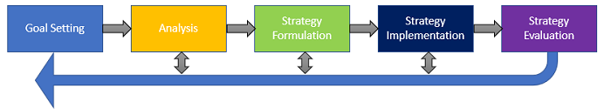
Figure 1 steps for strategic management

Identifying Direction
The main stage requires that the association has an unambiguous objective and course. Before thinking up techniques, an organization ought to characterize its targets for a long time to come. The association won't have clearness on its methods and techniques until it initially lays out its objectives (Godet 2000).

Analyzing Resources
To acquire the advantages of key administration, an association should initially sort out its resources to do specific obligations. Someone who succeeds at promoting, for instance, may battle to deal with the association's advertising. Subsequently, the board ought to assess its assets and pick the ideal one for each interaction (Haromszeki n.d).

Framing Strategies
Following the determination of the best assets for each interaction, the association fosters a game plan to accomplish the objective. This essential arrangement incorporates the components expected to achieve the characterized goals. The review, evaluation, and the executives of cycles at each level help the business in settling inside and outer challenges (Okoye & Ezejiofor 2013).

Implementing Strategies
Following the determination of the best assets for each interaction, the association fosters a game plan to accomplish the objective. This essential arrangement incorporates the components expected to achieve the characterized goals. The review, evaluation, and the executives of cycles at each level help the business in settling inside and outer challenges (Conz et al. 2023).

Evaluating Effectiveness
Following the determination of the best assets for each interaction, the association fosters a game plan to accomplish the objective. This essential arrangement incorporates the components expected to achieve the characterized goals. The review, evaluation, and the executives of cycles at each level help the business in settling inside and outer challenges (Sotirov & Winkel 2016).

Intercontinental hotel group history and background
InterContinental Hotel Group PLC (IHG) is one of the world's biggest hotel organizations. The enterprise works with hotels in the north of 100 countries all through the world. Latin America and the US are the main topographical classes, representing most of the absolute income all through the figure period (Son et al. 2021, 135). InterContinental Hotel Group is among the world’s biggest with regards to bed limit or limit or limit, cost, and a portion of the overall industry, trailed by the Marriott Enterprise and the Hilton Hotel Group. The partnership works with hotel chains under an assortment of brand names, including InterContinental and Hotel Indigo. Moreover, hotel chains utilize various business strategies, for example, diversifying, the executives, and completely claiming or renting auxiliaries ( Allison 2004, 52).
IHG (InterContinental Inns Gathering) is a worldwide inn enterprise. The organization's base camp are in Denham, Britain. They have right around 4900 lodgings in around 100 nations with roughly 674,000 rooms. Intercontinental Lodgings and Inns and Resorts, Hua Luxury Inns and Resorts, Crowne Court Inns and Resorts, KIMPTON Lodgings and Eateries, Inn Indigo, EVEN inns, Occasion Motel, Occasion Motel Express Transportation, Occasion Motel Resort, Occasion Hotel Club Get-aways, Remain Extension Suites, and Candlewood Suites are InterContinental Inns Gathering brands.
Out of the 4900 inns around the world, 4900 are run under establishment arrangements or are overseen by an organization whose stock is independently possessed, and constrained by a firm that is straightforwardly claimed. The basses Blue Triangle is the underlying brand name to be laid out in the Unified Realm in 1876. In 1989, the English government restricted the quantity of bars that the firm could straightforwardly claim, provoking Bass to put resources into a humble line of lodgings (known as Bass Inn) (Lee et al. 2016, p.14).
Occasion Motel Worldwide bought the Bass Lodging from its investor in 1990 and ventured into North America. Juan Trippe is the organization's pioneer behind Skillet American World Aviation routes (PanAm), and he established the principal InterContinental brand as a component of PanAm (Lindgren et al. 1999, 475). In 1946, Container American World Aviation routes lays out the principal Mainland Resort in Belem, Brazil. Kemmons Wilsons opens the absolute first Occasion Motel Express in Memphis, Tennessee in 1952. Occasion Motel is the underlying establishment hotel brand following two years. Occasion Motel was the main hotel chain to present a mechanized reservation framework in 1965. It's called HOLIDEX. Occasion Motel presents the world's most memorable hotel reward program, Need Club Prizes, in 1983. Occasion Motel was the primary unfamiliar hotel brand to work in China in 1984 (Waite & Kett 2004, 87).
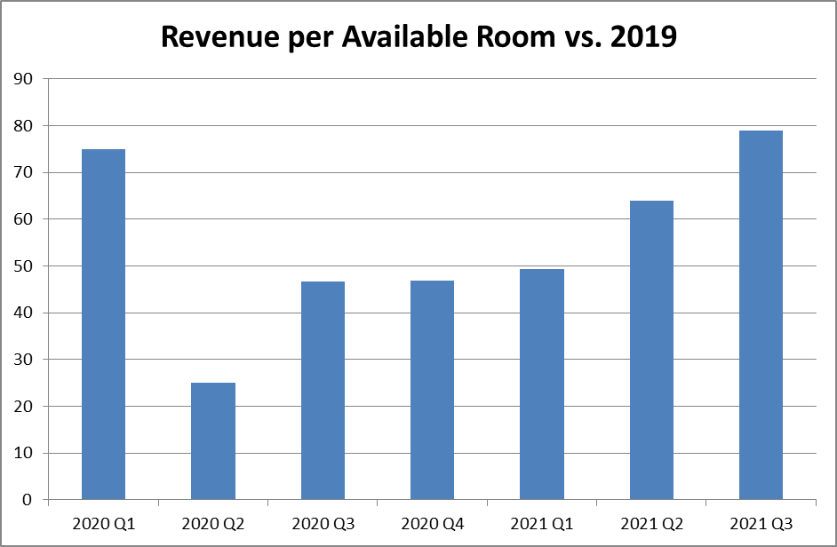
Figure 2 Revenue over time

The Vision Statement of InterContinental Hotels

InterContinental Inns Gathering PLC's vision articulation is its essential system for what's in store; it determines what and where the organization wishes to be in the future (Lee et al. 2016, p.18). The InterContinental Cordiality Gathering PLC vision explanation is a record that distinguishes the objectives of Worldwide Inns Gathering PLC to work with key, administrative, and general decision making processes. This shows that the organization didn't utilize extensive talks and exchanges to impart its situation to the general population and other relevant partners. The mission statement ought to be brief and exhaustive; it ought to make sense of the crucial standards of the organization and its future goals to assist customers with figuring out the organization's way of thinking and procedure. InterContinental Hotels Group PLC's vision proclamation ought to be compact yet complete (Lindgren et al. 1999, 478).

Intercontinental hotels group features

Exposure to China compared to competitors
HG has a stronger exposure to China than companies such as Hilton and was affected by the pandemic early. The hotel chain declared that it only managed to survive for 18 months if its properties had no capacity. Only 12 of IHG's 470 hotels in China are shuttered, indicating that the circumstance is improving. RevPAR increased from a like-for-like fall of 89% in February to around 75% in April. However, ten percent of its facilities in the United States are currently closed. Approximately fifty percent of hotels in the EMEAA regions are now shuttered (Hao et al. 2020). Across the company, occupancy numbers in open hotels are at present in the lower to mid 20% range. These data show that the company is still a long way from recovery; infection rates in the United States and Europe must fall dramatically before travel restrictions are eased and confidence in IHG's target markets is restored (World Travel & Tourism Council [WTTC] 2020, p.14).

Government support
IHG has achieved new financing arrangements, including the modification of its syndicated unsecured credit facility that includes an exemption of existing covenants until December 31, 2021. Furthermore, the Bank of England approved IHG as a suitable issuer for the United Kingdom's Government's CCFF, and IHG issued $600 million (US$745.2 million) in commercial paper through this facility (Hahang et al. 2022, 498). IHG stated that it now can access US$1.4 billion in cash on deposit and that existing financial institutions are now undrawn to the tune of US$660 million, bringing total liquidity on hand to US$2 billion. This amount of capital positions the company for dealing with the financial repercussions of COVID-19 in addition to expansion once the pandemic is finished (Jones & Comfort 2020, 3039).

Supporting staff management
As capacity is reduced, fewer people are employed. IHG announced "substantial decreases" in incentive payments and salaries for its upper management, as well as the cancellation of the dividend. Keith Barr, the CEO, stated that this has been an attempt to decrease expenses while retaining workers for when activities resume. The corporation has also developed a webpage to assist employees. The consequences of COVID-19 on hospitality workers have been severe (World Travel & Tourism Council [WTTC] 2020, p.15). With the opening of the IHG Hotel Colleagues Job Centre, IHG is assisting its employees. The new website intends to link employees from IHG establishments in the United States with potential employers from prominent US organizations looking to staff members with service industry skill sets. Amazon, Walmart, CVS, Albertsons, Domino, Pizza Hut, Lowe's, and The Home Depot are just a few of the firms with whom IHG is collaborating to divert job seekers during this crisis. This means that employees will be enabled to reduce financial losses and then come back to IHG once operations resume (Jones & Comfort 2020, 3040).
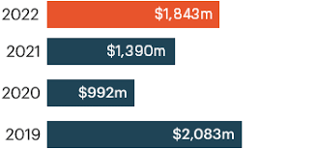
Figure 3
These findings highlight the economic damage sustained by IHG. As shown in the graph above, the company's worldwide Rev PAR dropped 24.9%, with March having the worst month, with Rev PAR down 55%. (Hao et al. 2020). The month of April was expected to be considerably worse, with the Rev PAR plummeting by about 80%. This is owing to a major drop in demand, with approximately fifteen percent (1,000 hotels) of the property closed by the end of April. However, IHG is concentrating on cost saving and hopes to save up to $150 million in operating expenses. This will have a positive economic impact. IHG's company approach should initially provide some protection. Despite possessing over 5,000 hotels around the world, the hotel company is not the owner of many of them and hence is asset-light. Furthermore, the company has $2 billion in assets and has negotiated fresh financing arrangements, such as amending its syndicated revolver credit agreement to include a relaxation of existing limits until December (Jones & Comfort 2020, 3042).

InterContinental Hotel Strategic Analysis
Intercontinental has adopted a variety of strategies for remaining in company operations, although overall survival seems to be difficult. The goal is to maintain doing business as usual but with higher attention to cleanliness and other issues such as cyber dangers. Regardless of the changes, it is clear that the group will remain financially reliant on assistance from the government (Shi et al. 2021, 2891).
  - Continuing with deals and business
Despite the dramatic decline in revenue, IHG stated that new hotel deals were still being pursued. Keith Barr, the CEO, indicated that the company had signed many contracts for bigger lodging properties in China, particularly one in the city of Shanghai under the upscale Regent brand. Hilton, a competitor, reported an increase of 8,800 rooms in the third quarter (Chan et al. 2021). Despite the crisis, IHG continued to sign new properties, with one of the most recent being the Regent Hotel in Shanghai Pudong in Lujiazui, Shanghai, a Chinese city, which is set to open in May after a makeover (Chan et al. 2021). This is supposed to be the main Officials property opened by IHG since the brand was bought in 2018. Proceeding with arrangements and obtaining will assist IHG with recovering financial strength later on; the pandemic is just temporary, and friendliness organizations ought to keep on anticipating what's in store (Hsieh et al. 2021).
  - Hygiene procedures hold significance now more than ever
As per Worldwide Information's Coronavirus purchaser studies from week 5, 83% of worldwide responders are either 'really' or 'to some degree' stressed in regards to the worldwide Coronavirus pandemic (Chan et al. 2021). The fear of getting the virus because becoming extremely ill is a major source of global concern, and the likelihood of this happening boosts a hotel. Lodging companies that launch new efforts to promote hygiene and the well-being of their visitors are likely to see an increase in reservations in the near to medium term, shortening their recovery time. According to IHG, it gives best practices and guidelines to its hotels. It has additionally complemented these resources with COVID-19-specific hygiene recommendations, training, and information (Chan et al. 2021).
  - Prioritizing loyalty schemes over rate reductions
Instead of promoting prospective room rates at reduced rates, delivering rewards through loyalty programmers allows hotels to retain pricing power. IHG has reduced the admission requirements for the next membership tier, which means that consumers are more likely to stay loyal (Hsieh et al. 2021). Customers may be enticed to explore a competitor's offerings during the height of travel limitations and lockdowns due to the greater amount of time to themselves available to them. As a result, during this moment of economic depression, this technique is incredibly helpful to a corporation (Shi et al. 2021, 2893).
  - Ensuring protection against cyber attacks
Hackers could exploit the predicament that many big hotel chains are currently in, with potentially greater vulnerability due to the use of one's own computing devices. Hotel firms are losing money at an alarming rate as a result of COVID-19's effects; they cannot afford to be the target of a high-profile cyber-attack, which might result in either a fine they cannot pay or damage to their general image. IHG previously collaborated with debit and credit card networks and cyber security professionals to remove insufficient spyware from each location. It has also pushed for sites to use the company's Secure Payment Solution (SPS) (Lund et al. 2020).
  - Utilizing technology will be beneficial
In this digital age, technology has a strong presence and can be used to give economic and promotional benefits. Technology has assisted in lowering costs, increasing operational efficiency, and improving services and customer experience (World Travel & Tourism Council [WTTC] 2020, p.16). As customers spend more time online, IHG should adopt AR/VR to deliver immersive ads. Over the previous decade, it has played an essential role in the hotel and tourism industries. Augmented reality, virtual reality, artificial intelligence, and technological gadgets such as smartphones are examples of technology employed in the sector. This approach has the potential to be extremely effective in reducing the effects of COVID-19 (Lund et al. 2020).
According to the 2020 COVID-19 worldwide consumer survey conducted by Worldwide Data, 57% of respondents stated that how pleasurable or distinctive the product/service is always or frequently influences their decision in the current circumstance (Jones & Comfort 2020, 3037).

  - Recovery will be slow
April was even worse than March, with Rev PAR falling by about 80%. This is due to a significant drop in demand, with around 15% of its properties closed as of the final day of April. However, IHG is focusing on cost-cutting and is on target to save its operating expenditures by as much as fifteen million. This will reduce the economic consequences. Initially, IHG's business strategy should provide some protection (Hsieh et al. 2021). It is difficult to see how the outlook for other large hotels could be any different, given that future consumer sentiments remain unknown and government help entails taking on loans that would saddle aircraft with mid-to-long-term debt. IHG also has $2 billion in liquidity and has achieved new financing arrangements, including the modification of its unsecured revolving credit agreement to include an exception of existing covenants through December 31, 2021 (Chan et al. 2021). China has started demonstrating improvement for many substantial hotel chains, including IHG, with utilization addressing 25% after April after submitting only a few percent at its lowest point, indicating that, while slow, recovery is possible, and IHG has proved prudent in maintaining finance to help it move around the choppy waters (Shi et al. 2021, 2893).

  - Government assistance is key to survival
If the dissemination of COVID-19 remains unpredictable and unmanageable, travel restrictions will almost certainly be extended. This means that there will be barely any demand for the foreseeable future. Travel disruption during the peak summer season would harm a crucial revenue generator. Many hotels would lack enough money to remain functioning, and catastrophes would be very likely. As previously stated, IHG is working to substantially reduce expenses and has received assistance from the United States government.
IHG has accomplished new supporting courses of action, including the alteration of its lengthy rotating funding consent to incorporate an exception of existing pledges until December 31, 2021. Besides, the Bank of London endorsed IHG as a reasonable issuance for the UK Government's CCFF, and IHG gave $600 million (US$745.2 million) in business paper through this office. IHG expressed that it has acquired admittance to US$1.4 billion in real money on store and that past bank offices are currently undrawn to the tune of US$660 million, bringing complete liquidity promptly available to $2 billion. This amount of cash sets the venture strategically set up to fight with the monetary repercussions of Coronavirus (Jain et al. 2020, 2448; Chan et al. 2021;World Travel & Tourism Council [WTTC] 2020, p.19).

Intercontinental Hotels Group PESTEL Analysis
PESTEL analysis International Hotel Group Plc is a management tool for analyzing an organization's surroundings. PESTEL refers to the socioeconomic, technical, ecological, political, and legal factors that influence the microenvironment of Intercontinental Hotels Group Plc. Changes in macro-environmental factors may have an immediate effect not only on The Intercontinental Hotels Group Plc, yet on other Consumer Services organizations. PESTEL analysis offers great detail concerning operating difficulties Intercontinental Hotels and Hotels Group Plc will face in the current macro environment other than forces of competition. For example, a business may be highly profitable with an impressive trajectory of expansion but it will be no good for Intercontinental Hotels and Hotels Group Plc if it is located in a volatile political climate. Spanish oil giant Repsol faced a similar situation (Buye 2021).

Political Factors
Political factors expect a basic part in concluding the components that can influence Intercontinental Lodgings Assembling Plc's somewhat long efficiency in a particular country or market. Intercontinental Lodgings Get-together Plc is working Being developed and Loosening up in excess of twelve nations and opens itself to various kinds of the universe of regulative issues and political design wagers. The make progress in such a unique Travel and Loosening up industry across different nations is to develop the specific dangers of a vast expanse of regulative issues (Report 2021)
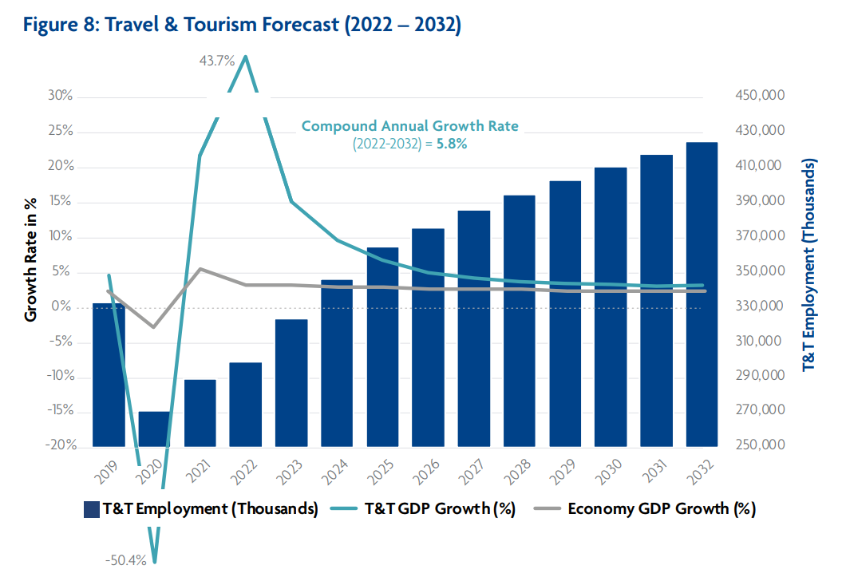
Figure 4 Economy growth with political changes

Economic Factors
The Full scale climate factors, for example, - improvement rate, save upholds rate, subsidizing cost, new change standard and cash related cycle pick the total income and hard and fast income in an economy. While tiny climate factors, for example, challenge standards influence the key position of the firm. Intercontinental Lodgings Get-together Plc can utilize the country's cash related part, for example, improvement rate, augmentation, and industry's financial pointers like Travel and Loosening up industry progression rate, purchaser spending, and so on to gauge the headway orientation of - - region name- - locale as well as that of the connection. Cash related parts that Intercontinental Lodgings Social Event Plc ought to consider while organizing PESTEL evaluation are
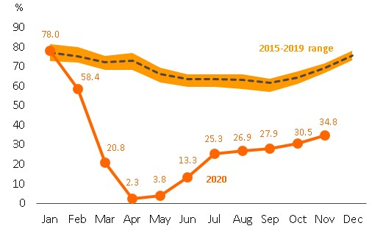
Figure 5 Stability in economic conditions

Social Factors
Society's lifestyle and way to deal with doing things impact the lifestyle of a relationship in an environment. Shared convictions and viewpoints of the general population expect a phenomenal part in how publicists at Intercontinental Lodgings Social occasion Plc will understand the clients of a given market and how they plan the advancing directive for Development and Unwinding industry customers. Social factors that the organization of Intercontinental Motels Get-together Plc should analyze for PESTEL assessment ( Le Breton-Miller et al. 2011, 704).
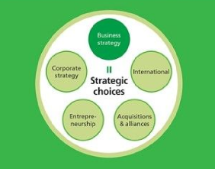
Figure 6 Society and business

Technological Factors
Improvement is expedient disturbing different endeavors in all cases. The transportation business is a decent case to address this point. All through late years the business has been evolving quick, not in any case, giving an entryway to the spread-out players to acclimate to the changes. The taxi business is at present destroyed by players like Uber and Lyft. The vehicle business is fast toward robotization driven by advancement firms like Google and gathering is annoyed about Tesla, which has conveyed electronic vehicle turmoil.
A firm shouldn't just do an imaginative evaluation of the business yet moreover the speed at which improvement upsets that industry. Slow speed will give additional time while quick speed of imaginative disrupting impact could give a firm brief period to change and be valuable (Aguilera & Jackson 2010). Improvement appraisal consolidates figuring out the going with influences - Late imaginative overhauls by Intercontinental Lodgings Party Plc contenders.
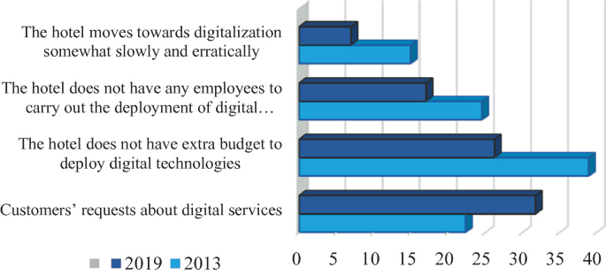
Figure 8 technology and hotel industry

Environmental Factors
Different business areas have different principles or normal rules which can influence the advantage of a relationship in those business areas. For sure, even inside a country often states can have different environmental guidelines and commitment guidelines. For example in the US - Texas and Florida have different obligation arrangements assuming that there ought to emerge an event of mishaps or environmental disaster. Correspondingly a lot of European countries give strong expense decreases to associations that work in the supportable region (Jacoby 2005, p.69). Before entering new business areas or starting one more business in an existing business area the firm should meticulously survey the biological rules that are supposed to work in those business areas. Piece of the environmental factors that a firm should consider quite a bit early is -
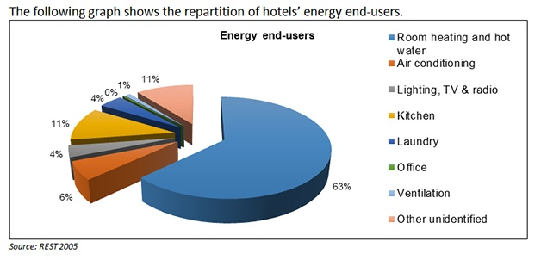
Figure 9 environmental effects on business

Legal Factors
In certain nations, the lawful system and foundations are not solid areas for enough protecting the defended progression chances of a connection. A firm ought to painstakingly overview prior to entering such business regions as it can incite burglary of connection's mystery fixing in this way the in ordinary key position. A piece of the genuine parts that Intercontinental Inns Get-together Plc drive ought to consider while entering another market is
Table 1 PESTEL analysis
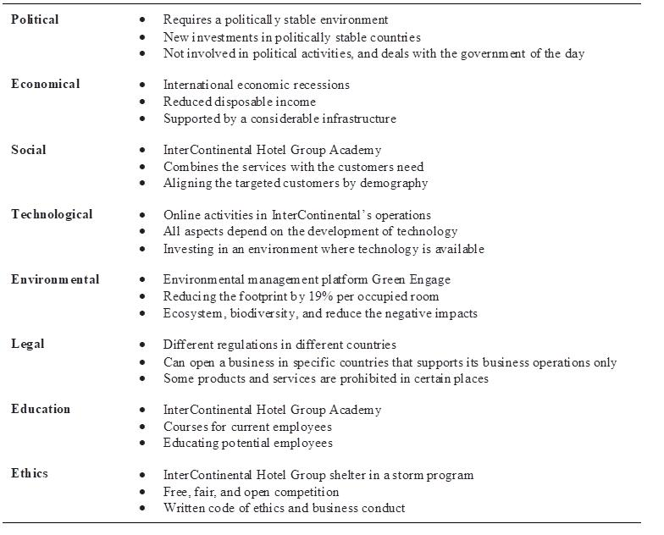

Porter’s five forces
According to the structure, there is greater competitive competition in the industry, as mentioned in Appendix 2. The heightened competitive competition is exacerbated by a large number of competitors, less client loyalty, and a high cost of living. However, the firm outperforms its competitors by leveraging its market strategic position along with other competencies. Furthermore, greater financial and managerial capabilities, as well as increased infrastructure development, have put the firm in a better position in the face of rising industry entry costs. Furthermore, the capabilities have positioned the firm in an advantageous spot to counteract growing entry obstacles.
Table 2 Porter's five forces.
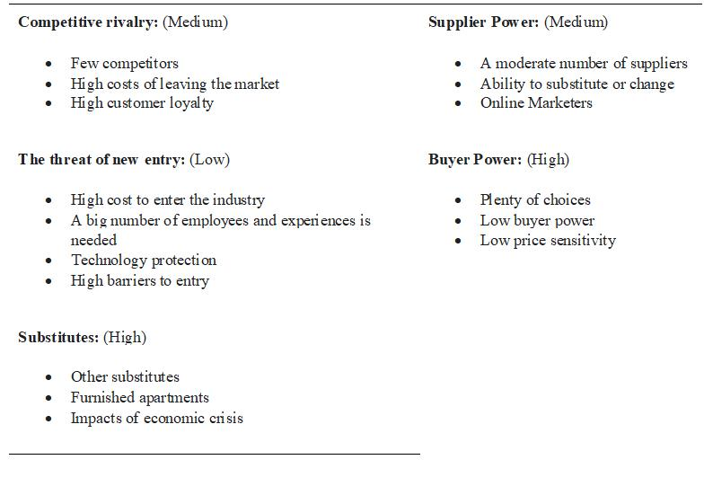

Findings from PESTAL and Porter’s five forces analysis
PESTLE assessment fills in as a technique for organizations to acquire understanding into the outer impacts that might affect their tasks. You can all the more successfully plan your business objectives, limit gambles, and expect the future by inspecting the different outside factors that can influence your association. Chiefs should be educated about advancements and modifications in the more extensive climate as well as the condition of the specific business, as both can change decisively over the long run.
While PESTEL evaluation is beneficial for understanding the broad environment, Porter's five forces analysis is effective for determining an industry's profit potential. Strategic groupings are useful for analyzing close competitors who have a greater impact on a company than other industry participants. When CEOs use these tools to closely monitor their organization's surroundings, they considerably boost their the company's chances of success.

Industry life cycle
Figure 10 portrays the development phase of InterContinental Hotel Group PLC. InterContinental Hotel Group PLC has a vital situation in the overall market because of advances in innovation and associations with client administration, creations that advance the upgrade of client relations and give ecological arrangements, as well as local area improvement support. Besides, chasing after a supportable arrangement is urgent for the company's future development and improvement.
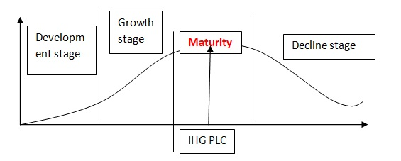
Figure 10 Industry life cycle

Internal environment analysis

Strategic capabilities
As displayed in Reference section 3, the company's limit capacities contain areas of strength for an establishment that considers upgraded upper hand. Specialized gifts, profoundly qualified experts, and a capable labor force are among the distinctive qualities..
Table 3 Strategic capabilities
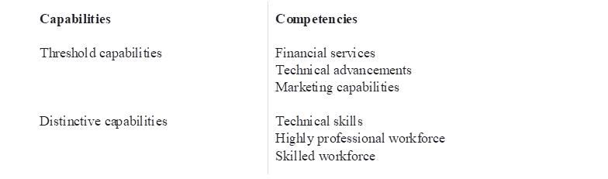

VRIN analysis
The VRIN procedure is utilized to evaluate a company's seriousness because of its own exceptional and limited abilities. As per the discoveries, the company's recognition and edge abilities have both helped its seriousness. The company's transient upper hands and burdens are very interesting. Nonetheless, long-haul upper hands, serious equality, and long-haul cutthroat offers are very important.
Table 4 VRIN Analysis: Impacts on Intercontinental Hotel Group Performance.
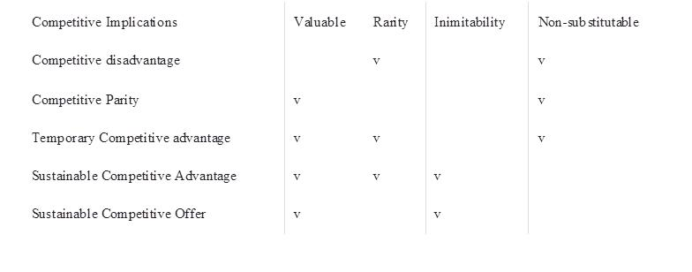

Value chain analysis
The value chain makes sense of the sorts of tasks inside an association that, when joined, bring about the production of help or great. Most associations are moreover essential for a bigger value framework, which is the assortment of hierarchical ties and connections expected to give an item or administration. Both fill a need in surveying an association's essential position and where critical assets and skills are found. Figures portray the value of the cycle for InterContinental Lodging Group. Despite the way that the value chain is practically identical to the ones of rivals, the InterContinental Inn Group value channel is unmistakable because of the utilization of its abilities.
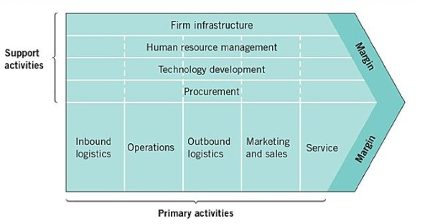
Figure 11 Value chain activities

Table 5 Value chain analysis
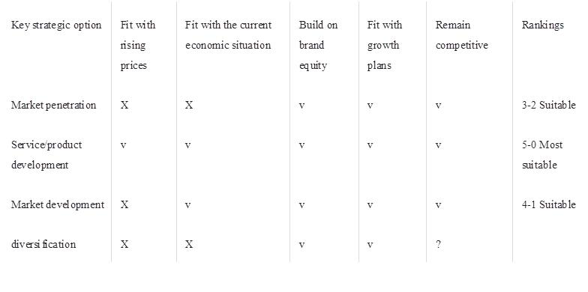

Findings from value chain analysis
Value chain analysis is a method for assessing every one of the exercises in an organization's value chain to comprehend where potential open doors for development lie. Directing a value chain analysis prompts you to consider how each step adds or deducts value from your result or administration. Value Chain Analysis is a powerful administration device, which assists us with recognizing the exercises inside the association that make an exceptional item or administration. Assuming we give such items and administrations to our clients, they will want to pay more, in this way creating higher benefits for the organization.

SWOT analysis
As demonstrated in Reference Section 7, an InterContinental Inn Group SWOT assessment can be made. The straightforward reality that InterContinental Inn Group possesses the most important lodging establishments permits it to benefit from an upper hand. Besides, the organization has huge tasks in arising as well as evolving countries (Riaz & Tanveer 2012, p.45). Notwithstanding, different reasons, prominently the company's accentuation on midrange and premium extravagance housing and resort brands, add to the association's declining seriousness. Besides, the company's strategic advantage is reduced by the sole market accentuation on top-of-the-line explorers. Conversely, taking into account the organization's extension and brand situating, the organization can involve its monetary assets to benefit from new advances in arising regions (Căruntu & Diţoiu 2014, p.232).
Table 6 SWOT analysis.
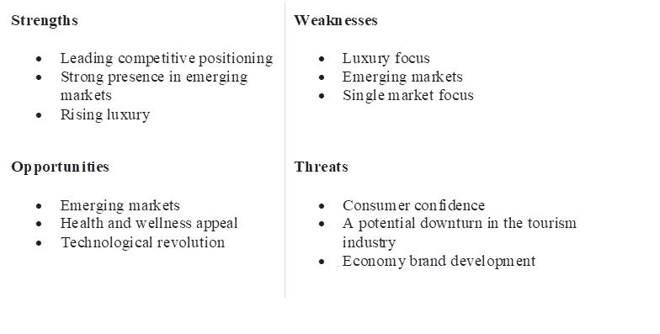

Findings from SWOT analysis
SWOT Analysis distinguishes the organization's assets, shortcomings, conceivable outcomes, and Dangers. It guides you to exploit your assets, address your shortcomings, handle new open doors, and limit gambles.
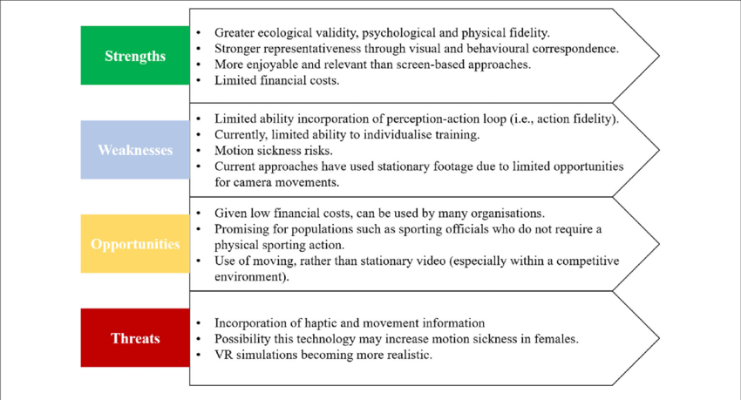
Figure 12 SWOT Analysis Conclusion

Strategic direction

Boston Consulting Group (BCG) analysis
The BCG is a decent structure for evaluating the essential place of InterContinental Lodging Group PLC's brand name portfolio (Hansen & Birkinshaw 2007, p.121). Moreover, the device helps understand the venture determinations that InterContinental Lodging Group PLC should embrace.

Stars
The constellation of stars is the items and solutions that outperform their competitors in marketplace operations (Morgan & Shanahan 2009, 55). Online activities and conveniences are evaluated as stars at InterContinental Inn Group the Programmable Rationale since they give extra chances to build the company's benefits. Thus, the organization ought to rise its spending on the progression of online assistance giving. In 2011, web distribution expanded by over 40%. Therefore, web access arrangements are basic to InterContinental Lodging Group PLC's drawn-out progress. Hence, the InterContinental Lodging Partnership PLC keeps on being a focusing light in the arrangement of administrations, especially in the utilization of data innovation.

Cash Cows
The kinds of revenue show the administrations that permit the InterContinental Inn Group PLC to accomplish market initiatives. InterContinental Lodging Group PLC proceeding to give facilities in nations where the organization doesn't at present work. Besides, the organization keeps on offering exceptional types of assistance that blow away customer joy. Notwithstanding, future development potential for the administrations is restricted. More than 100 housing foundations are distributed all through the world to keep on conveying a consistent stockpile of administrations to its clients, permitting the firm to procure incomes that can be taken a chance in Stars.

Question Marks
The administration's division of Worldwide Lodging Gathering PLC has a low portion of the overall industry however extraordinary development possibilities have been represented by the question marks (Langabeer & Napiewocki 2000). Secretly named lodging brands can catch a portion of the overall industry by offering imaginative types of assistance that make the InterContinental Hospitality Group PLC marks more interesting to customers.

Dogs
Dogs allude to InterContinental Hotel Group PLC's services, which have a low market share and are not appealing, as well as having minimal growth possibilities (Porter 2000, 15). InterContinental Hotel Group PLC hotels in competing nations are classified as Dogs. In essence, the corporation ought to avoid investing further in highly competitive countries.

Recommendations and conclusion

Recommendations
The firm ought to focus on carrying out current techniques while considering different perspectives, for example, its monetary conditions and the different perils the association faces. Besides, the organization ought to keep up with its expansionist arrangements, which are basic to its developing business sector presence. In any case, given the association's ongoing profitable situation in the overall travel industry and accommodation industry, InterContinental Inn Gathering PLC needs to further develop its image execution to address the test presented by rising economy lodging networks.
In a sense, the organization should ensure that its image stays engaging and that it keeps up with market authority over contenders. Besides, the association ought to take a stab at remarkable returns by working on the viability of tasks and income conveyance. Besides, the company ought to proceed to create and use its extraordinary and unmistakable capabilities to acquire an upper hand. The firm must furthermore be forceful to acknowledge significant yields, which are essential in expanding the company's monetary limits and permitting it to run productively and effectively.

Conclusion
By far most of InterContinental Inn Gathering PLC's associations have been compelling. Additionally, the association has continued to give various organizations through its overall housing associations. The affiliation's achievements can be credited to the suitable execution of its focal undertakings and the association's techniques. Various parts, in any case, influence the organization's fundamental activities. By and large, InterContinental Motel Assembling PLC's central organization and exercises are influenced by both inside and external normal effects. Notwithstanding outside normal obstructions, the association has stayed aware of its force. To additionally foster its market force, the firm ought to guarantee that its key procedures have been completed and focus capacities are adequately utilized.

References

Aguilera, R.V. and Jackson, G., 2010. Comparative and international corporate governance. The academy of management annals, 4(1), pp.485-556.
Allison, S., 2004. Inward investment into the European hotel investment market. Journal of Retail & Leisure Property, 4, pp.50-59.
Buye, R., 2021. Critical examination of the PESTEL Analysis Model. Project: Action Research for Development.
Căruntu, A.L. and Diţoiu, M.C., 2014. The perceptions of hospitality services of a tourism destination. Procedia-Social and Behavioral Sciences, 109, pp.231-235.
Chan, J., Gao, Y.L. and McGinley, S., 2021. Updates in service standards in hotels: how COVID-19 changed operations. International Journal of Contemporary Hospitality Management, 33(5), pp.1668-1687.
Conz, E., Magnani, G., Zucchella, A. and De Massis, A., 2023. Responding to unexpected crises: The roles of slack resources and entrepreneurial attitude to build resilience. Small Business Economics, pp.1-25.
Eppler, M.J. and Platts, K.W., 2009. Visual strategizing: the systematic use of visualization in the strategic-planning process. Long Range Planning, 42(1), pp.42-74.
Gass, S.I. and Harris, C.M., 1997. Encyclopedia of operations research and management science. Journal of the Operational Research Society, 48(7), pp.759-760.
Godet, M., 2000. The art of scenarios and strategic planning: tools and pitfalls. Technological forecasting and social change, 65(1), pp.3-22.
Hahang, E., Bayraktar, S. and Jiménez, A., 2022. Early evidence of leadership skills and strategies in managing the impact of COVID-19 pandemic in the hospitality industry. Cross Cultural & Strategic Management, 29(3), pp.493-515.
Hansen, M.T. and Birkinshaw, J., 2007. The innovation value chain. Harvard business review, 85(6), p.121.
Hao, F., Xiao, Q. and Chon, K., 2020. COVID-19 and China’s hotel industry: Impacts, a disaster management framework, and post-pandemic agenda. International journal of hospitality management, 90, p.102636.
Haromszeki, Ł., n.d. The Effects of TM and CM on Organizational Leadership in Foreign Entities of MNCs. International Journal of Contemporary Management.
Hsieh, Y.J., Chen, Y.L. and Wang, Y.C., 2021. Government and social trust vs. hotel response efficacy: A protection motivation perspective on hotel stay intention during the COVID-19 pandemic. International Journal of Hospitality Management, 97, p.102991.
Jacoby, S., 2005. Corporate governance and society. Challenge, 48(4), pp.69-87.
Jain, A., Sarupria, A. and Kothari, A., 2020. The Impact of COVID-19 on E-wallet’s Payments in Indian Economy. International Journal of Creative Research Thoughts, 8(6), pp.2447-2454.
Jones, P. and Comfort, D., 2020. The COVID-19 crisis and sustainability in the hospitality industry. International journal of contemporary hospitality management, 32(10), pp.3037-3050.
Langabeer, J. and Napiewocki, J., 2000. Competitive business strategy for teaching hospitals. Bloomsbury Publishing USA.
Lee, G.E., Bechteler, J., Pócs, T., Schäfer-Verwimp, A. and Heinrichs, J., 2016. Molecular and morphological evidence for an intercontinental range of the liverwort Lejeunea pulchriflora (Marchantiophyta: Lejeuneaceae). Organisms Diversity & Evolution, 16, pp.13-21.
Le Breton-Miller, I., Miller, D. and Lester, R.H., 2011. Stewardship or agency? A social embeddedness reconciliation of conduct and performance in public family businesses. Organization science, 22(3), pp.704-721.
Lindgren, T., Willers, S., Skarping, G. and Norbäck, D., 1999. Urinary cotinine concentration in flight attendants, in relation to exposure to environmental tobacco smoke during intercontinental flights. International archives of occupational and environmental health, 72, pp.475-479.
Lund, S., Ellingrud, K., Hancock, B. and Manyika, J., 2020. COVID-19 and jobs: Monitoring the US impact on people and places. McKinsey Global Institute.
Morgan, M. and Shanahan, J., 2009. Growing up with television: Cultivation processes. In Media effects (pp. 50-65). Routledge.
Oh, C.H. and Oetzel, J., 2022. Multinational enterprises and natural disasters: Challenges and opportunities for IB research. Journal of International Business Studies, pp.1-24.
Okoye, P.V.C. and Ezejiofor, R.A., 2013. The effect of human resources development on organizational productivity. International Journal of Academic Research in Business and Social Sciences, 3(10), p.250.
Porter, M.E., 2000. Location, competition, and economic development: Local clusters in a global economy. Economic development quarterly, 14(1), pp.15-34.
Report, A., 2021. True Hospitality for Good is to provide.
Riaz, W. and Tanveer, A., 2012. Marketing mix, not branding. Asian Journal of Business and Management Sciences, 1(11), pp.43-52.
Ritchie, B.W., 2004. Chaos, crises and disasters: a strategic approach to crisis management in the tourism industry. Tourism management, 25(6), pp.669-683.
Shi, F., Shi, D., Weaver, D. and Samaniego Chavez, C.E., 2021. Adapt to not just survive but thrive: resilience strategies of five-star hotels at difficult times. International Journal of Contemporary Hospitality Management, 33(9), pp.2886-2906.
Son, R., Yamazawa, K., Oguchi, A., Suga, M., Tamura, M., Murakawa, Y. and Kume, S., 2021. Morphomics via Next-generation Electron Microscopy. arXiv preprint arXiv:2111.14373.
Sotirov, M. and Winkel, G., 2016. Toward a cognitive theory of shifting coalitions and policy change: Linking the advocacy coalition framework and cultural theory. Policy Sciences, 49(2), pp.125-154.
Waite, R. and Kett, R., 2004. What is happening in the European hotel sector?. Journal of Retail & Leisure Property, 4, pp.86-92.
World Travel & Tourism Council [WTTC], 2020. “WTTC: The future of travel & tourism in the wake of Covid-19,” World Travel Tour. Counc., no. September, pp. 14–22.

