University of Wales Trinity Saint David
School of Engineering

Passive RC Filter Networks
Electrical and Electronic Principles

ACDB4002

Shanjidah Ahmed
2309702
06/03/2024

Abstract
Voltages will change due to an addition of resistors and capacitors in a circuit, these will have different effects depending on their configuration (Electronics Reference, no date). Attenuation will occur in order to filter out unwanted frequencies. Using equipment such as a function generator, fixed values were inputted through a breadboard circuit, to calculate the experimental cut off frequency of both a high pass and low pass filter. Trends in frequency, voltage and attenuation were seen and compared graphically based on both analytical and experimental results. It was seen that a high pass filter allowed the flow of high frequencies with little impedance, however the opposite occurred with a low pass filter in which lower frequencies passed to the output terminal, attenuating higher frequencies.

Introduction
High pass and low pass filter are generally used in the audio and communication industry (Gordon Lyn, no date), they impede and attenuate frequencies depending on their configuration (Electronics Reference, no date). High pass filters allow high frequency to pass through the system towards the output, whilst impeding low frequency waves through the capacitor. The opposite occurs when a low pass filter is in use, a higher frequency will pass through the capacitor and be grounded, whilst the lower frequency will pass through the circuit towards the output. The capacitance for high frequency is zero, therefore it will pass through without resistance, however in the case of low frequency the impedance is infinite, thus preventing low frequency passing through and allowing it to reach the output terminal instead (Electronics Coach, no date).
This report will look at the point at which -3dB of attenuation is achieved through two individual experiments using a high pass filter and a low pass filter. This is known as the cut off frequency and can also be defined as the “frequency at which the filter’s output drops to 70.7% of its maximum value” (Gordon Lyn, no date). For a low pass filter the cut off frequency are the frequencies above the -3dB threshold, whereas for a high pass filter the cut off frequencies are the frequencies below (Electronics Reference, no date). Cut off frequencies for both experimental and analytical results will be compared to determine the correlation between them, and thus the attenuation differences as the experiment progresses.

Circuit Description
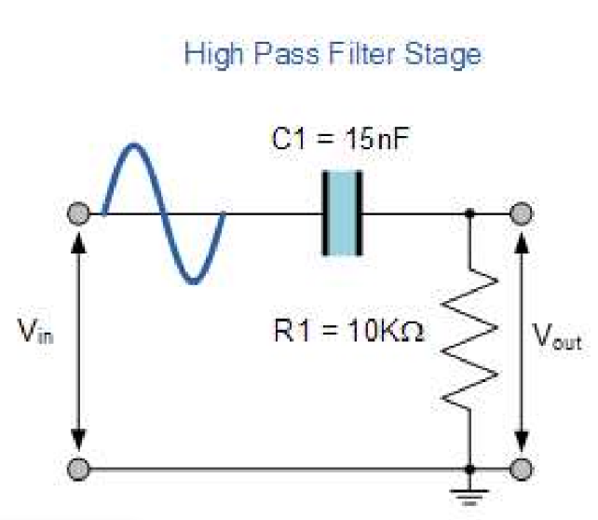
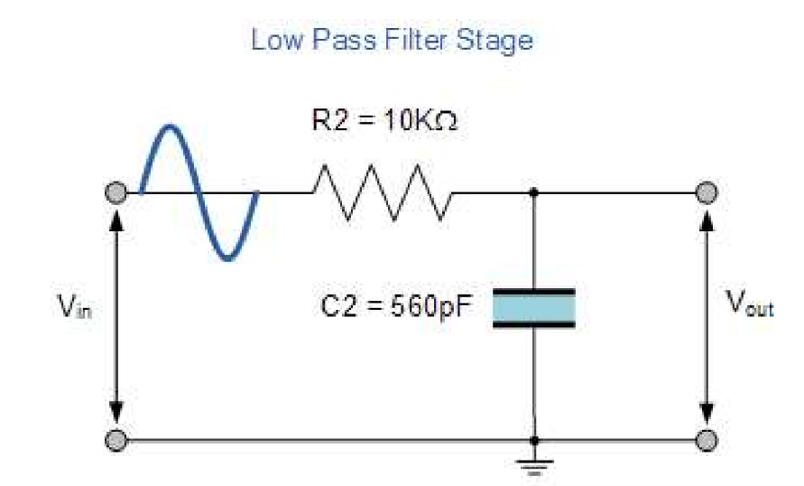
Experiments were carried out in order to generate results to show the effect of voltage change against frequency on both a high pass and low pass filters. A simple breadboard circuit was constructed which followed the guidelines set out in the task, as seen in figure 1 and figure 2. These were then connected to a function generator and an oscilloscope to monitor the change in voltage output in relation to the capacitors within. In addition to this the attenuation and impedance were also observed and evaluated.
Figure 1-Low Pass Filter Diagram (University of Wales Trinity Saint David, no date)
Figure 2 High Pass Filter Diagram (University of Wales Trinity Saint David, no date)
The low pass filter used a resistor of 10kΩ and a capacitor of 560pF, with an input voltage of 5V peak to peak. During the experiment the frequency was increased incrementally from 100Hz to 300kHz. Figure 3 shows the circuit created, with the red and brown wires connecting to the function generator.
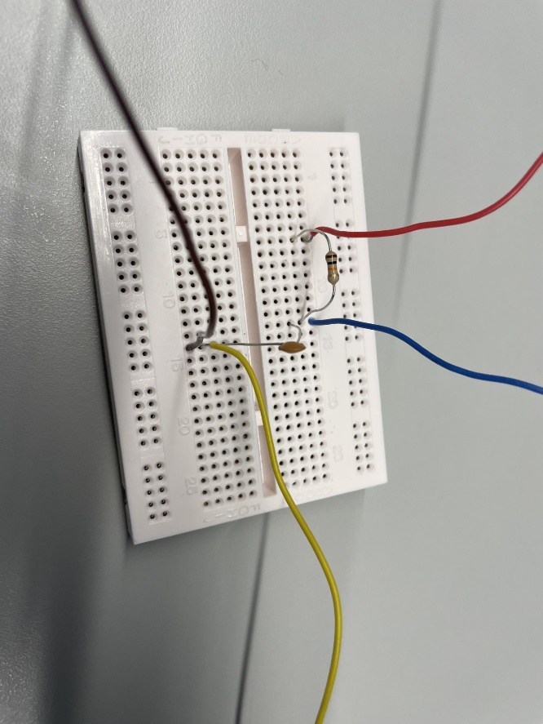
Figure 3 - Low Pass Filter Circuit

For the high pass filter similar parameters were used, including both an input voltage of 5 volts and a resistor of 10kΩ, which again saw a frequency increase from 100Hz to 300kHz. However, the capacitor used was rated at 15nF, and is situated before the resistor as seen in figure 4.
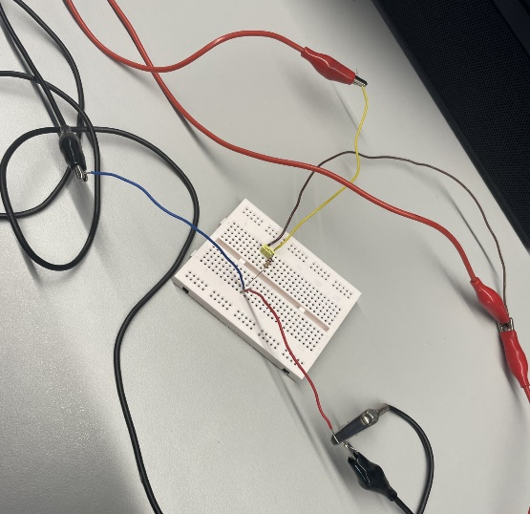

Figure 4 - High Pass Filter Circuit

Results
A logarithmic scale is used throughout the results displayed below; this is due to the fact that the results are easier to read as the frequency change for the experiment is large in number. A logarithmic scale uses powers of 10 thus allowing a wider insight towards the midpoint of the experiment at which deviation occurs. This labelling system is used throughout the report, in order to easily cross reference results. In addition to this, a logarithmic scale is used on both axis of the capacitance graph as seen in figure 5 and 11, this gives the graph a straight-line finish. And clearly highlights the decrease in capacitive reactance over an increase in frequency.
The results for low pass filter analytical results are shown in figure 5,6 and 7 below.
Figure 5 - Low Pass Analytical – Capacitive Reactance
Figure 6 - Low Pass Analytical – Voltage Output

Figure 7 - Low Pass Analytical – Attenuation

The results for the low pass experiment are shown in figure 8,9 and 10 below.

Figure 8 - Low Pass Experimental – Voltage Input

Figure 9 - Low Pass Experimental – Voltage Output

Figure 10 - Low Pass Experimental – Attenuation

The results for high pass analytical results are shown in figure 11, 12 and 13 below.

Figure 11 - High Pass Analytical – Capacitive Reactance

Figure 12 - High Pass Analytical – Voltage Output

Figure 13 - High Pass Analytical – Attenuation

The results for the high pass filter experiment are shown in figure 14,15, and 16 below.

Figure 14 - High Pass Experimental - Voltage Input

Figure 15 - High Pass Experimental - Voltage Output

Figure 16 - High Pass Experimental - Attenuation

Discussion

Low Pass Filter Analysis
Through the results of the low pass filter circuit, it can be seen in figure 9 that voltage output decreases as frequency increases, this is due to the fact that the impedance of the capacitor allows high frequency to pass without resistance thus becoming grounded (Electronics Coach, no date). However, the low frequency cannot easily flow though the capacitor therefore is fed though towards the output terminal.
It can be determined from the graph that at a frequency of 1000Hz there is little change in the voltage output, dropping from 5.08V to 5V. As the frequency increases to 10,000Hz the voltage has shifted from 5.04V to 4.72V, showing a slow reduction in voltage output. Looking further down the axis it towards 105,000Hz the voltage has dropped from 5.1V to 1.36V. This correlates with the analytical information shown in figure 6. Based on the theoretical results at a frequency of 1000Hz, 10,000Hz and 105,000Hz the voltage output should show a value of 5V, 4.72V and 1.31V respectively. These values are based on the calculation used to determine the voltage output, Vout considering voltage input as a fixed value. Equation 1 shows the parameters used to calculate voltage output analytically.

$$V_{out}=\left(\frac{X_{c}}{\sqrt{R^{2}+{\left(X_{c}\right)}^{2}}}\right)\left(V_{in}\right)$$
Equation 1 – Voltage Output - Low Pass Filter

In order to determine the value of Vout, the capacitor resistance Xc value needs to be calculated. The equation used to calculate this value is shown below in equation 2.
$$X_{c}= \frac{1}{2πFC}$$
Equation 2 - Capacitive Reactance

From equation 2 it can be seen that with an increase in F (frequency) the resistance of Xc decrease as it is inversely proportional. In connection with equation 1 this shows that a decrease in Xc will also decrease the value of the output voltage, Vout. This corresponds to the values displayed in figure 9.
Figure 5 and 11 show the capacitator resistance decreasing with an increase in frequency, this is due to the fact that low frequencies are impeded by the addition of a capacitor whilst high frequencies pass through without little resistance. From the figure 5 it can be seen that at a frequency of 1000Hz the Xc value is 2.84 x 10⁵Ω, however at a higher frequency of 105,000Hz the Xc value has reached only 2.71 x 10³Ω.
Voltage input for low pass filters have been stated in the appendices (table 1), this fluctuated through the duration of the experiment as seen in figure 8. The main source of discrepancies were due to the function generator, as frequencies were not always accurate. This however was accounted for when working out the attenuation for the experiment, as the output voltage was divided by the input voltage as seen in equation 3 below.

$$20\log_{10}\left(\frac{V_{out}}{V_{in}}\right)=Attenuation$$
Equation 3 - Attenuation

From equation 3 the attenuation of the experiment can be calculated, measured in dB. In the case of the analytical results the Vin will remain constant at 5V, however with the fluctuation of the experiment this value may shift slightly. The attenuation calculated on the analytical graph in figure 7, can be used to determine the point at which cut off frequency is met. This will be when attenuation (measured in dB) reaches -3dB and can be extrapolated from the graph. To work out the cut off frequency analytically for this experiment the equation 4 below will be used. After substituting the value for resistance R as 10kΩ and capacitor C as 560pF, the value calculated for cut off frequency Fc was 28420.5 Hz. From the equation it can also be seen that as resistance or capacitance increases the Fc will decrease.

$$F_{c}=\frac{1}{2πRC}$$
Equation 4 - Cut off Frequency
Figure 17 below shows a more enhanced view of at the cut off frequency. Which shows that at -3dB attenuation the cut off frequency for a low pass filter should be around 28400 Hz, which corresponds to the value calculated. Using this information, the experimental values can be investigated.

Figure 17 - Low Pass Analytical - Cut off Frequency

In reference to figure 17, 7 and 10 the values for attenuation can both be seen to decrease as the frequency increases. Figure 18 as seen below again shows a more enhanced view at the -3dB cut off point for the experimental data. This shows that the cut off frequency for the low pass experiment was around 28,000Hz. Which is similar to the information gathered analytically, however is around 400Hz different. This could be due to the fact that the components used in the experiment have tolerances which will implement the overall results. In addition to this, the values obtained in the experiment were at frequencies of 20,000Hz, 25,000Hz and 35,000Hz, which gave an attenuation of -1.83541dB, -2.54485dB and -4.12353dB respectively. Therefore, in order to get more reliable result of attenuation at -3dB, it would have been ideal to take additional measures between this period to ensure a more accurate result.

Figure 18 - Low Pass Experimental - Cut off Frequency

High Pass Filter Analysis
The voltage output (Vout) results in the experiment seen in figure 15 decrease as the frequency decreases, this corresponds to figure 12 which shows the analytic results of this variable. The voltage output will never exceed the voltage input of the circuit, therefore as the frequency increase so will the output, up until the input value is met. During the experiment the voltage output at frequency 10,000Hz was recorded to have dropped from 5.12V to 5.04V, showing little change, however as the frequency was reduced to 1,000Hz this figure dropped from 5.04V to 3.44V. A more significant change in voltage was seen, at 100Hz the recorded voltage dropped from 5.04V to 0.56V. This correlates with the analytical information gathered in figure 12. For the same frequencies of 10,000Hz, 1,000Hz and 100Hz, the theoretical results are as follows, 4.97V, 3.43V and 0.469V respectively. These results are similar to the experimental equivalent however in order to calculate the analytic results a separate calculation was needed, as seen in equation 5 below. Using this equation however, values such as the component tolerances are not taken into account, which can affect the values achieved during the experiment.

$$V_{out}=\left(\frac{R}{\sqrt{R^{2}+{\left(X_{c}\right)}^{2}}}\right)\left(V_{in}\right)$$
Equation 5 - High Pass - Voltage Output

Analytically the Vin voltage input will remain at 5 volts, assuming the function generator will precisely and accurately relay this voltage through the circuit and oscilloscope. It has been seen throughout the experiment as seen in figure 14 however that this is not always the case as the function generator will have discrepancies which will then be relayed to the oscilloscope and displayed, which will in turn show higher accuracies in measurement. During this experiment the input voltage ranged from 5.04V to 5.2V although in every instance the voltage was set at 5V through the function generator. Figure 19 below shows that the experiment at 300,000Hz was set at 5V, however when referring to figure 20 the input voltage (Vp seen in red) is stated as 5.12V and the output voltage (Vp seen in yellow) is 5.04V. This demonstrates that although a measurement can be made on the function generator, frequency discrepancies should always be considered and should never be assumed to portray the values set.
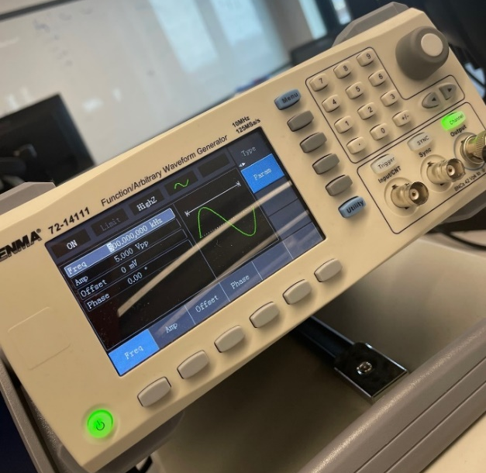
Figure 19 - Function Generator
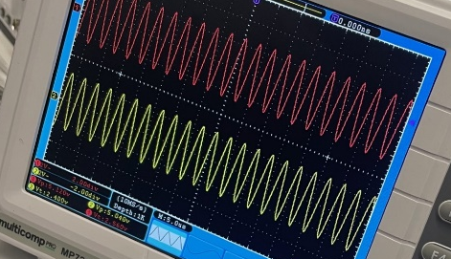

Figure 20 - Oscilloscope

Referring back to equation 5 (voltage output), the capacitance reactance Xc needs to be calculated, this is the same equation used for the low pass filter as seen in equation 2. From this it can be seen that with an increase of frequency F, found in the denominator the Xc will decrease and thus the frequency will increase. This is seen to be the case as the impedance for high frequencies in low, therefore it can pass through the capacitor without larger resistance. However, the opposite is seen when a low frequency wave is sent through the system, as the impedance is larger therefore attenuating more unwanted frequencies and preventing the voltage from reaching the output terminal. This is depicted clearly in figure 11, which shows the gradual decrease in Xc over an increase in frequency. For example, at frequencies 100Hz, 1,000Hz 10,000Hz and 300,000Hz, the values attained for capacitive reactance are 106,103.3Ω, 10,610.3Ω, 1061.03Ω and 35.4Ω respectively. Confirming the effect of impedance as a function of frequency.
The resistance impedance reduced over an increase of frequency, demonstrating the effect of the total impedance of both the resistor and capacitor within the circuit. The attenuation will increase away from 0 as the frequency is lowered this is due to the fact that a larger volume of unwanted low frequency is trying to pass through the system, therefore in order to prevent this the capacitor will block a higher volume of these waves from the output, increasing the value of attenuation dB. The calculation used to attain the attenuation values are stated in equation 3, using this it can be shown analytically that at 100Hz, 1,000Hz, 10,000Hz and 300,000Hz gave figures of -2.06 x 10¹ dB, -3.28dB, -4.86 x 10⁻², -5.43 x 10⁻⁵ respectively, these are depicted in figure 13. Comparing this with the information gathered from the experiment in figure 16 the results achieved over the same frequency points are -19.0849dB, -3.31744dB, -0.13679dB and -0.13679dB. There are similar results seen across both 100Hz and 1,000Hz however the attenuation will never pass above 0 as the output voltage cannot exceed the input voltage, therefore will incrementally move towards this but never pass. Although through the results gained from the experiment the input voltage was seen to reach 5.2 volts, therefore when calculating the result of attenuation, the figures would have shifted slightly to accommodate an output over 5 volts but below 5.2V.
Using the attenuation values seen in figures 13 and 16, the frequency cut off can be determined. This is the point when attenuation is at -3dB. Analytically this can be solved using equation 4. After substituting resistance R as 10x10³Ω and capacitor C as 15x10⁻⁹F the results determined was 1061.03Hz for the cut off frequency. The figure 21 below, show a close-up view of figure 13, this shows that the cut off frequency is at around 1100Hz which is slightly different compared to the numerical figure found when determining the Fc. This could be due to the fact that the measurements a spaced out thus the graph is showing a predicted value at -3dB.

Figure 21 - High Pass Filter Analytical - Cut off Frequency

The figures can then be analysed with the experimental information in figure 16. Below is an enhanced view at the -3dB cut off frequency, from figure 22, this again shows the cut off frequency to be at 1100Hz, similar to that found in the analytical graph.

Figure 22 - High Pass Filter Experimental - Cut off Frequency
It is important to note that with the experiments carried out all components will have their own tolerance values. Therefore, these will need to be considered to determine a more accurate result. For example, the resistor used in both experiments seen in figure 23 below shows a gold band indicating a ±5% tolerance thus the maximum and minimum values will be 10,500Ω and 9,500Ω. In addition to this the capacitor used during the low pass filter experiment was rated at 561 seen in figure 24, giving a tolerance of around ±1%. Whereas the tolerance for the high pass filter capacitor was 15nF seen in figure 25 which gave a general tolerance of ±3%. (Kaizer Power Electronics, 2020). With all these elements considered the equations use to calculate the capacitive reactance Xc, the attenuation dB, and the voltage output Vout will all provide different results, depending on the total tolerance of each circuit.

Figure 23 - Resistor
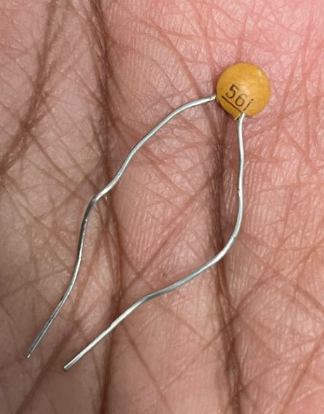

Figure 24 - Low Pass Capacitor
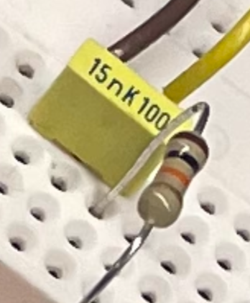
Figure 25 - High Pass Capacitor

Conclusions
Through both experiments it can be determined that impedance will attenuate the lower frequencies from reaching the output terminal. The configuration of the resistor and capacitor determines a high pass or low pass filters (Electronics Reference, no date). Low pass filters see a resistor first then capacitor, whereas the high pass will see a capacitor then resistor. The point at which attenuation of -3dB, will occur depends on the resistors and capacitor used in the experiment, however component tolerances will also play a part in the depriving or exceeding the value stated on components.
For the low pass filter the main findings were;
- An addition of frequency will reduce the voltage output, as the higher frequencies will be attenuated by the capacitor and grounded before reaching the output terminal (Electronics Coach, no date).
- The attenuation dB will noticeably decrease once the cut off frequency of 2.8 x 10⁴ Hz is met. Showing the point at which, more resistance is applied due to voltage against the capacitor.
- The voltage input is not always accurate although the function generator can be set correctly, therefore checking the oscilloscope to gauge the values is important for more consistent results.
A summary of the high pass filter results indicate;
- Voltage output as a function of frequency will increase retrospectively as resistance will not impede greatly on higher frequencies, thus flowing towards the output terminal with minimal restraint.
- Attenuation dB will increase from negative values towards 0dB, however will never pass this figure as voltage output cannot exceed voltage input, therefore as the frequency increases, attenuation will increase. Little attenuation is required if the majority of frequency is higher than the cut off frequency. For this experiment it was determined that the cut off frequency was 1061.03Hz.
- The voltage input again was set at 5V however due to the instruments used this figure varied slightly, therefore checking the oscilloscope before reading the output voltage was paramount.

References
Electronics Coach (no date) Difference between High Pass and Low Pass Filter, Electronics Coach. Available at: https://electronicscoach.com/difference-between-high-pass-and-low-pass-filter.html (Accessed: 22 February 2024).
Electronics Reference (no date) Low Pass vs. High Pass Filter, Electronics Reference. Available at: https://electronicsreference.com/analog/low_pass_vs_high_pass_filter/#6-low-pass-filter (Accessed: 22 February 2024).
Gordon Lyn (no date) Understanding Cutoff Frequency: What it is and How it Affects Your Audio, HiFiReport. Available at: https://www.hifireport.com/understanding-cutoff-frequency/ (Accessed: 22 February 2024).
Kaizer Power Electronics (2020) Capacitor Code Chart, Kaizer Power Electronics. Available at: https://kaizerpowerelectronics.dk/theory/capacitor-code-table/ (Accessed: 3 March 2024).
University of Wales Trinity Saint David (no date) ‘Level 4 Assessment Specification’. University of Wales Trinity Saint David. Available at: https://teams.microsoft.com/_#/pdf/viewer/teamsSdk/https:~2F~2Fuowtsd.sharepoint.com~2Fteams~2FACDB4002-ElectricalandElectronicPrinciplesDA_GRP~2FClass%20Materials~2FCoursework%20Notes~2FACDB4002_sem1_CW1_2023_24.pdf?threadId=19:oyxy9NPbnSggTBrVXQt1tHlVj96ouLUW7A9ctWH2yTk1@thread.tacv2&baseUrl=https:~2F~2Fuowtsd.sharepoint.com~2Fteams~2FACDB4002-ElectricalandElectronicPrinciplesDA_GRP&fileId=5ec39f98-4c35-4c6d-9371-7c39fd1a2874&ctx=openFilePreview&viewerAction=view (Accessed: 27 February 2024).

Appendix
Table 1 - Low Pass Filter - Input Voltage
Frequency (Hz) | V_{in} (V)
100 | 5.08
500 | 5.08
1000 | 5.08
2000 | 5.08
5000 | 5.08
10000 | 5.04
15000 | 5.08
20000 | 5.04
25000 | 5.04
35000 | 5.08
45000 | 5.08
55000 | 5.08
65000 | 5.12
75000 | 5.08
85000 | 5.12
95000 | 5.12
105000 | 5.1
120000 | 5.16
140000 | 5.12
150000 | 5.16
170000 | 5.12
190000 | 5.12
250000 | 5.08
300000 | 5.12

