
Module Name: Digital Skills for Personal Development and Business Growth
Module Code: BMSW4008
Assignment Title: Portfolio
Student Name: Kirsty McNulty
Student Number: 2531363
Lecturer: Scott James
Deadline: 16th March 23.59 2026

AI Acknowledgement Statement:
Examples of statements If you have not used AI
I confirm that I have not presented any AI generated materials as my own work.
I confirm that I have copies of my drafts, notes, and other resources I used, which I may be asked to provide in evidence.
Examples of AI statements if you have used AI
I acknowledge the use of Grammarly (https://www.grammarly.com/) on Date to check my work using the prompt(s):
1. Please check the following text for readability, grammar and syntax.
I confirm that I have not presented any AI generated text as my own work. I confirm that I have copies of my drafts, notes, and other resources I used before, and after the use of AI tools which I may be asked to provide in evidence.

Contents
Task 1: Assessment of Digital Skills (700 Words) 4
Introduction: Importance of Digital Skills 4
Overview of the JISC Digital Capability Tool 4
Summary of JISC Results 4
Strengths in Digital Skills 4
Areas for Improvement 4
Action Plan Using SMART Goals 4
Reflection and Conclusion 4
Task 1 References (Minimum 5) 4
Task 2: LinkedIn Learning Certificates – Office 365 5
Outlook Essential Training (Microsoft 365) 5
Word Essential Training (Microsoft 365) 5
Excel Essential Training (Microsoft 365) 5
PowerPoint Essential Training (Microsoft 365) 5
Task 3: Relevance and Importance of Microsoft Excel (1,000 Words) 5
Introduction 5
Uses of Microsoft Excel 5
Data Analysis 5
Budgeting and Financial Management 5
Reporting and Decision-Making 5
Practical Spreadsheet Task 5
Reflection and Conclusion 6
Task 3 References (Minimum 5) 6
Task 4: Reflective Presentation Summary (5 Minutes) 6
Overview of Presentation Content 6
Learning and Skill Development 6
Links to Task 1 6
Links to Task 2 6
Links to Task 3 6
Application to Studies and Career 6
Task 3 References (Minimum 5) 7

Task 1: Assessment of Digital Skills (700 Words)

Introduction: Importance of Digital Skills
Digital skills are a big part of everyday life now, especially in education and work. Most things we do involve technology in some way, like researching online, sending emails or using apps to help keep things organised. Because of this having good digital skills makes studying easier and helps people become employed. UNESCO (2024) explains that digital literacy is important for lifelong learning, which means people need these skills not just in school, but for their future careers too. Employers also expect staff to use digital tools confidently, communicate online, and manage information properly (National Careers Service, 2025). This is why understanding your own digital strengths and weaknesses is useful, as it helps you know what to improve.

Overview of the JISC Digital Capability Tool
The JISC Digital Capability Tool is a self assessment that helps people understand their digital skills. It looks at different areas such as communication, problem‑solving, information handling and digital wellbeing. The tool asks questions about how you use technology in your studies and everyday life, and then gives you a graph showing your results. Jisc (2023) says that digital capability includes things like using digital tools, finding information, staying safe online and being confident using technology. The assessment is helpful because it shows what you’re already good at and what you might need to work on.

Summary of JISC Results
My JISC results showed a mix of strengths and areas that need improvement. My strongest areas were digital creativity and problem solving, using digital tools and digital communication and collaboration. These were the highest parts of my graph. This means I’m confident trying out new tools, solving problems using technology and working with others online. I also scored well in finding information and resources which shows I can research effectively and use online sources properly. These strengths help me in my coursework because I can adjust to using different digital tools.
However, the results also showed two weaker areas, managing my digital learning and digital preferences and needs. These were the lowest parts of my graph. Managing digital learning means organising files, planning online work and keeping track of deadlines. I sometimes struggle with this, especially when I have lots of tasks at once. Digital preferences and needs is about understanding what digital tools work best for me and knowing how to use them properly. I don’t always use accessibility features or personalise my digital tools even though they could make my studying easier. According to UNESCO (2024), knowing how to adapt digital tools to your needs is an important part of digital literacy, so this is something I want to improve.
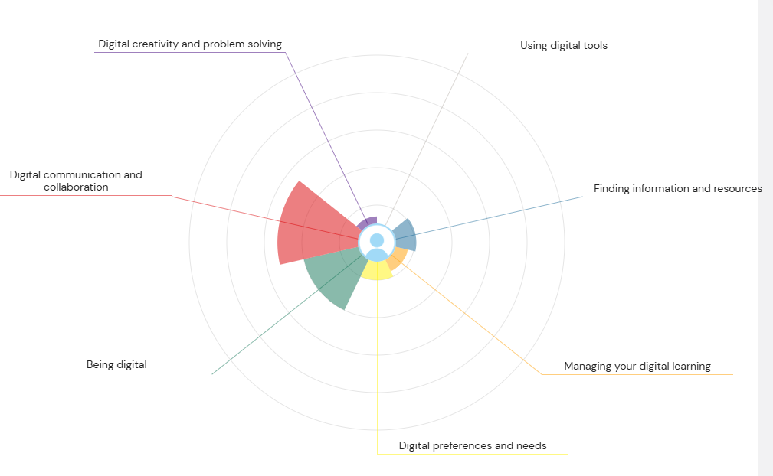

Strengths in Digital Skills
Two strengths stand out clearly. First, digital creativity and problem solving is a strength because I enjoy trying out different tools and figuring things out. For example, if I don’t know how to do something on Word or Excel, I will play around and try to find a solution. This helps me in my coursework because I can adapt quickly when using new software. Second, using digital tools is another strength. I feel more confident using software like Word, PowerPoint, and Excel, and now use them regularly for assignments. Jisc (2023) says that being confident with digital tools is important for both studying and working, so this is a useful skill to have.

Areas for Improvement
My two weaker areas are just as important to focus on. Managing my digital learning needs improvement because being organised online helps reduce stress and makes studying easier. When files are messy or deadlines aren’t tracked properly, it’s easy to fall behind. The UK Parliament (2023) highlights that digital organisation is a key skill for productivity, so improving this will help me stay on top of my work. Digital preferences and needs is another area I want to work on. I don’t always use features like Immersive Reader, display settings or accessibility tools, even though they could help me study more comfortably.

Action Plan Using SMART Goals
To improve these areas, I created two SMART goals. SMART Goal 1 is to improve my digital organisation. I will create a clear folder system for all my college work on OneDrive. Each module will have its own folder, and I will name files properly so they are easy to find. I will check and update my folders every Sunday for the remainder of my time at university. This goal is achievable because I already use OneDrive, and it will help me organise my digital learning better. SMART Goal 2 is to learn accessibility and personalisation tools. I will try at least three accessibility features such as Immersive Reader, dictation, and display settings. I will try to use each tool for at least one week and write notes about whether it helped. I will complete this within six weeks.

Reflection and Conclusion
Improving my digital skills will help me in both my studies and future career. Being more organised online will help me meet deadlines and reduce stress. Learning how to personalise digital tools will make my studying more comfortable and efficient. These improvements will also help with employability, as most jobs now expect people to use digital tools confidently (National Careers Service, 2025). By working on my weaker areas, I will become more confident, more independent and better prepeared for the digital workplace.

Task 1 References (Minimum 5)
Jisc (2023) Building digital capability: The six elements of digital capability. https://www.jisc.ac.uk
National Careers Service (2025) Digital skills to help your career. (nationalcareers.service.gov.uk in Bing)
UNESCO (2024) Digital literacy for lifelong learning. https://www.unesco.org
UK Parliament (2023) Developing essential digital skills. Postnote 643. https://post.parliament.uk
Microsoft (2024) Excel for business and education. https://www.microsoft.com

Task 2: LinkedIn Learning Certificates – Office 365

Outlook Essential Training (Microsoft 365)
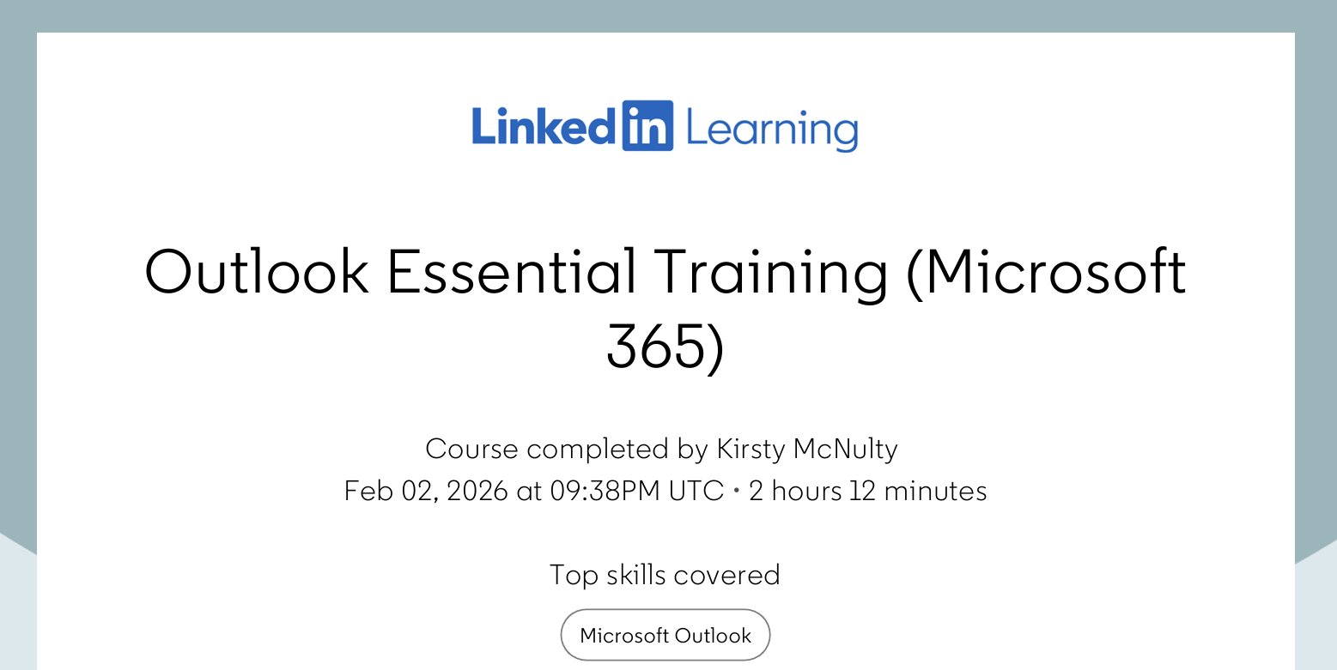

Word Essential Training (Microsoft 365)
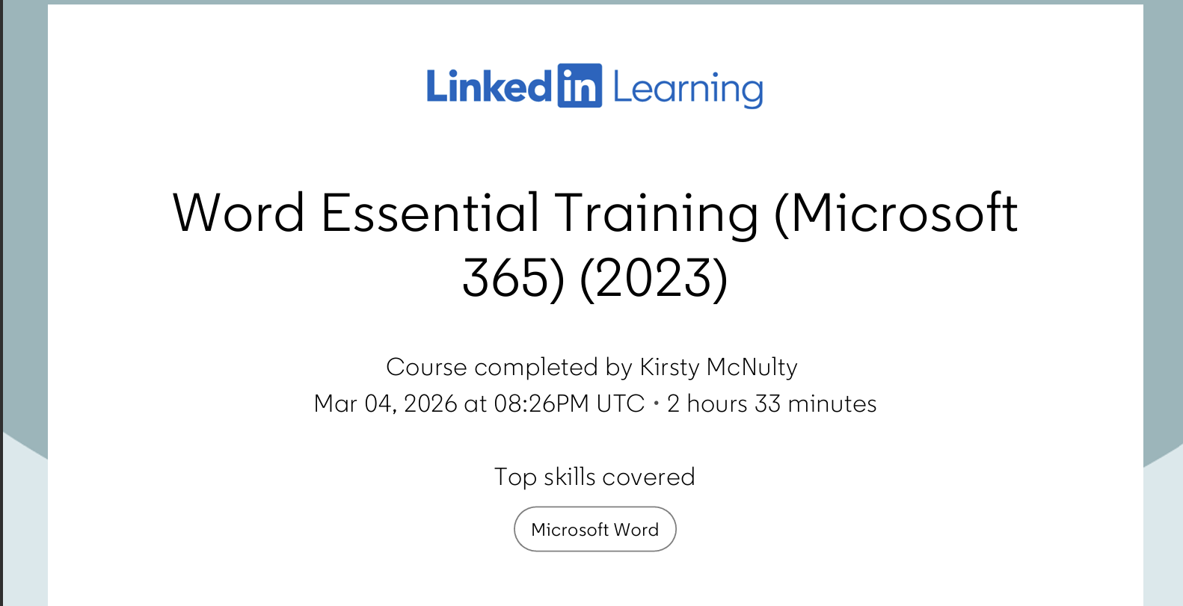

Excel Essential Training (Microsoft 365)
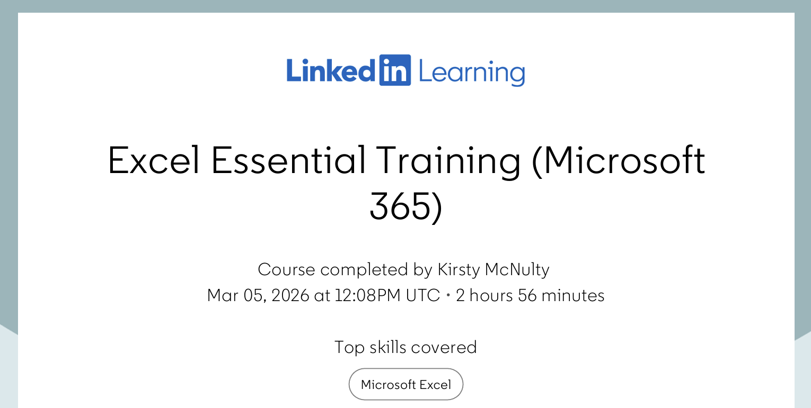

PowerPoint Essential Training (Microsoft 365)
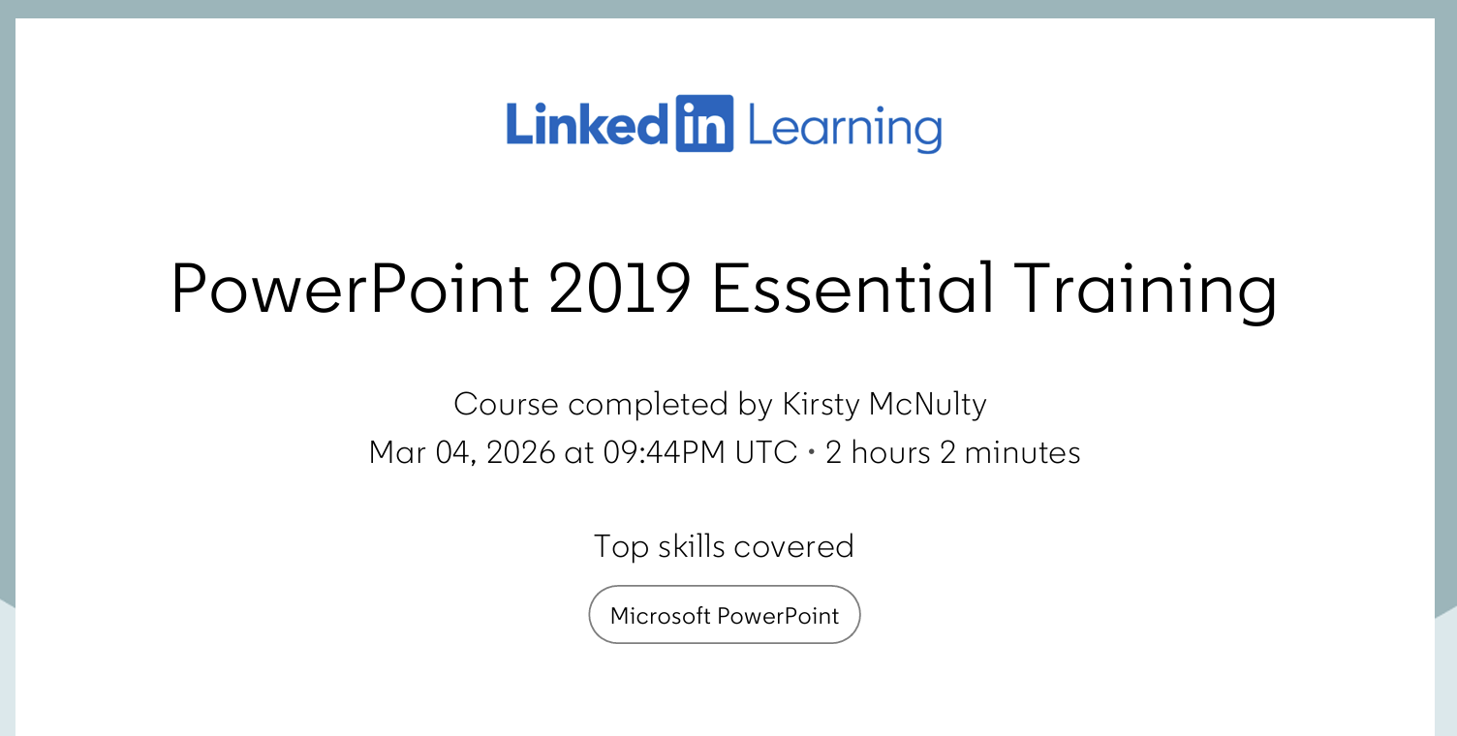

Task 3: Relevance and Importance of Microsoft Excel (1,000 Words)

Introduction
Microsoft Excel is one of those digital tools that nearly everyone has heard of, and it’s used in lots of different places like higher education, work and even at home. Even though new apps and software keep coming out, Excel is still a really important tool because it’s easy to use, and it can do lots of different things. Students, teachers and people in all kinds of jobs use Excel to organise information, work with numbers and make decisions. Since digital skills are now a big part of getting a job being confident with Excel is a useful skill to have (UK Parliament, 2023). Whether someone is studying, running a business or just trying to manage their money better, Excel can help to make things quicker and much clearer.
Excel also is helpful in education. A lot of college and university courses expect students to understand data, make charts or work with spreadsheets and Excel is usually the easiest way to do this. UNESCO (2024) says that digital literacy is an important part of lifelong learning, and Excel helps with this because it teaches people how to understand information, solve problems and show data in a visual way. Students often use Excel for things like researching projects, planning their work and keeping track of their budgets. These skills are useful later on in life too, because most employers expect people to be able to use digital tools confidently (National Careers Service, 2025).

Uses of Microsoft Excel

Data Analysis
One of the main things Excel is known for is data analysis. Businesses and organisations deal with loads of information every day, and Excel helps break it down so it makes it easier to understand. BusinessTech (2024) says that more than 750 million people use Excel to organise and analyse data. You can sort information and filter it and use formulas to work things out like totals, averages or comparisons. Basic functions like SUM, AVERAGE, IF and VLOOKUP help people spot patterns or answer questions quickly. There are also more advanced tools like PivotTables, Power Query, and Power Pivot, which help turn big sets of data into clear summaries or reports.
Excel is also useful for making decisions based on data. Kaplan UK (2024) explains that Excel is still relevant because it helps people understand current trends and make choices based on real information. For example, a marketing team might use Excel to see which products are selling best, or a teacher might use it to check how students are doing. Being able to turn data into something meaningful is a really valuable skill for both studying and working.

Budgeting and Financial Management
Excel is also great for budgeting and managing money. Students can use it to plan their monthly spending and to work out how much money they have left and keep track of their bills. Businesses use Excel for things like forecasting, financial planning and tracking expenses. BusinessTech (2024) points out that Excel is popular for budgeting because formulas can do the maths automatically, which helps avoid mistakes.
Excel also helps people make better financial decisions. A small business owner might use it to compare profits each month, check stock levels and plan future spending. Families might use it to plan a holiday budget or keep track of household bills. Because Excel is so flexible, it can be used for simple tasks like weekly budgets or more complicated things like business forecasts.

Reporting and Decision-Making
Excel is also a strong tool for reporting because it can turn numbers into charts, graphs, and dashboards. This makes information easier to understand, especially for people who don’t feel confident with numbers. Kaplan UK (2024) says that Excel’s visual tools make it easier to communicate information and support decision‑making. For example, a bar chart can show which items are most popular, and a line graph can show how something has changed over time.
Businesses use Excel for reporting because it’s easy to update and share. Teams can work together on spreadsheets, track progress, and present results in meetings. Excel is also used for project management, helping people create schedules, Gantt charts, and task lists. BusinessTech (2024) explains that Excel is often used for planning and monitoring productivity, especially in HR and operations.

Practical Spreadsheet Task
The household income and expenditure spreadsheet is a good example of how Excel can be used in everyday life. The aim of the spreadsheet is to help keep track of money coming in and going out each month. It includes things like wages, benefits, rent, bills, food and travel. When the amounts are typed into Excel, the spreadsheet uses formulas like SUM and AVERAGE to work out the totals automatically. This makes it easier to see if someone is overspending or saving their money.

Reflection and Conclusion
Overall, Excel is a really important digital skill that helps in higher education, work and everyday life. It helps people analyse data, manage money and present information clearly. These skills are useful for studying because students often need to work with data, plan their time and present their findings. Excel also helps with employability because many jobs expect people to be confident with spreadsheets and digital tools (Jisc, 2023). Learning Excel can make people more organised and confident and it prepares them for the digital workplace.
Improving Excel skills also helps with personal development. Being able to manage money, plan tasks and understand data more clearly helps people to make better decisions and feel more in control. As digital tools continue to grow, Excel will remain a valuable skill that supports learning, work and everyday life.

Task 3 References (Minimum 5)
BusinessTech (2024) Importance of Microsoft Excel in Business: 10 Reasons. https://www.businesstech.com
Jisc (2023) Building digital capability: The six elements of digital capability. https://www.jisc.ac.uk
Kaplan UK (2024) What is Microsoft Excel used for and is it still relevant? https://kaplan.co.uk
National Careers Service (2025) Digital skills to help your career. (nationalcareers.service.gov.uk in Bing)
UNESCO (2024) Digital literacy for lifelong learning. https://www.unesco.org

Task 4: Reflective Presentation Summary (5 Minutes)
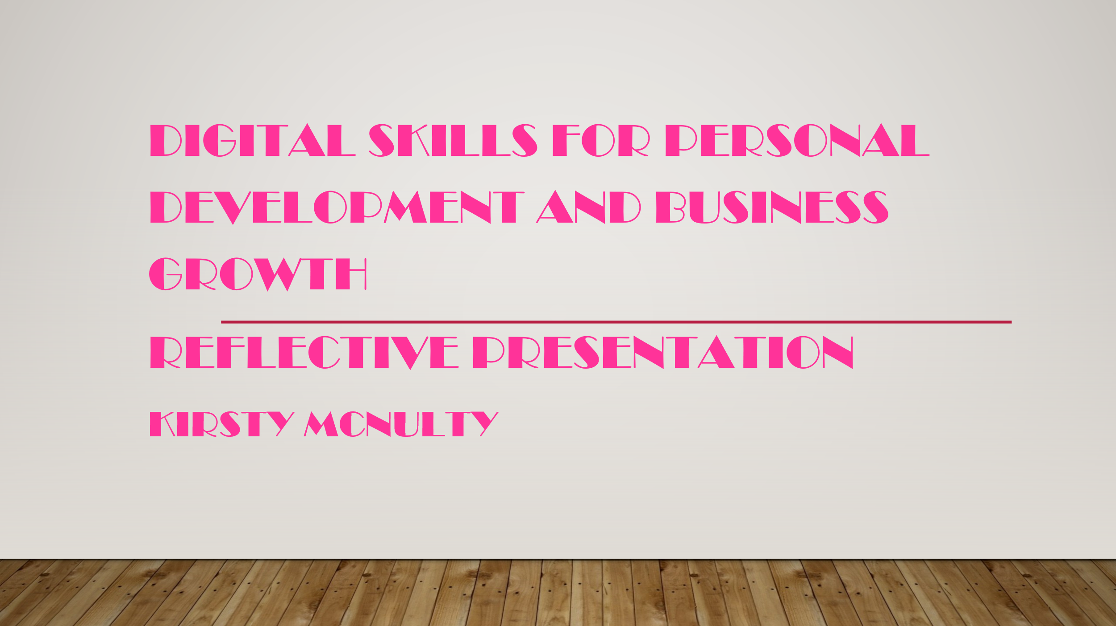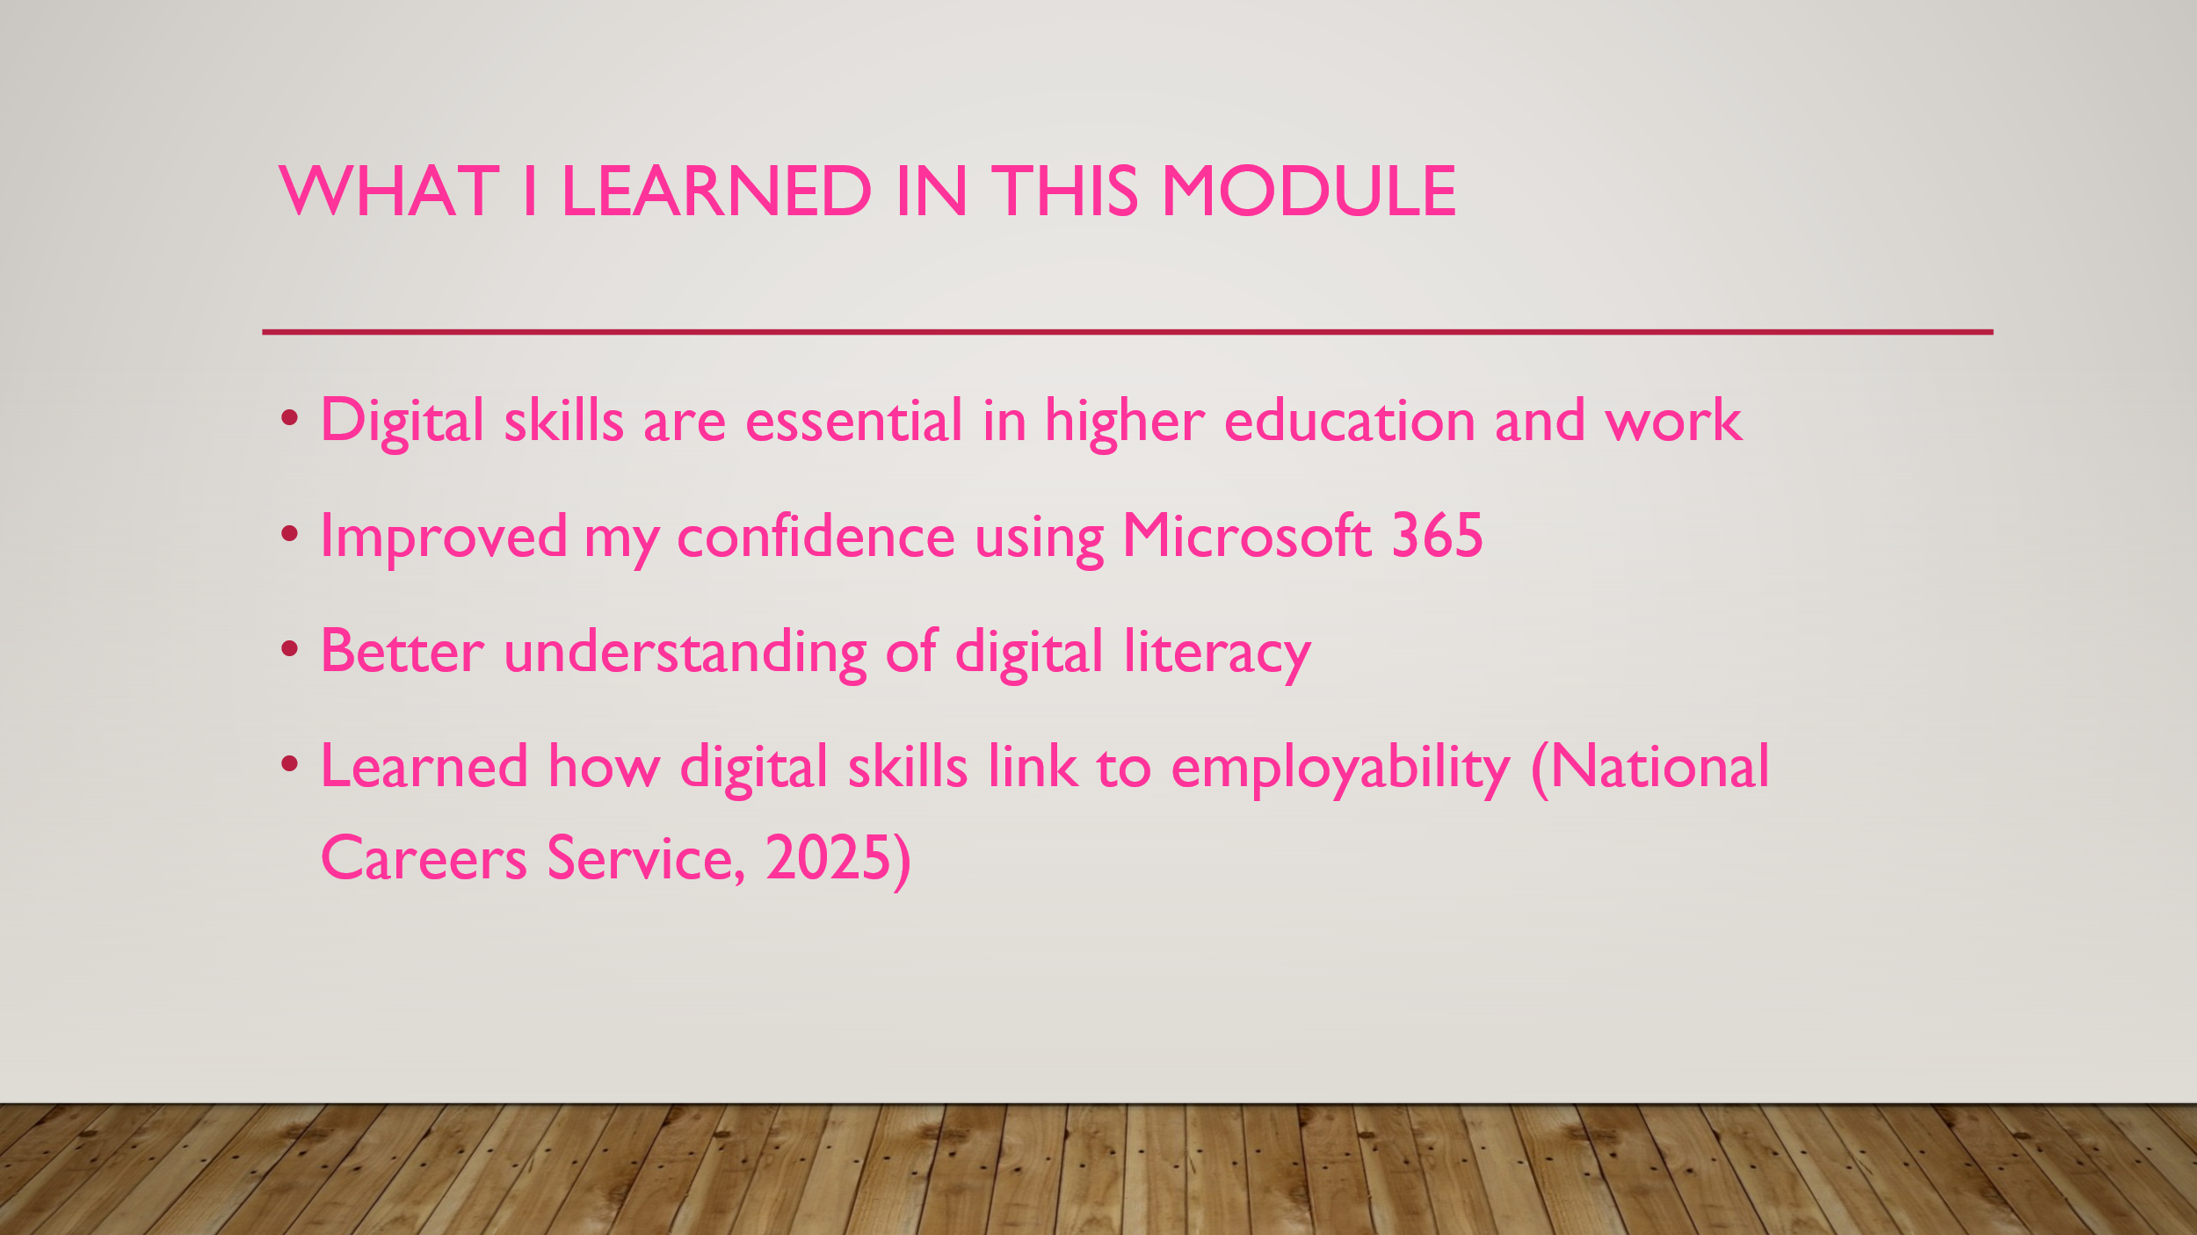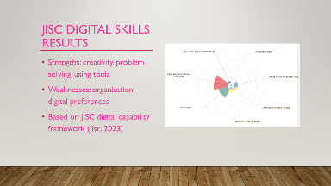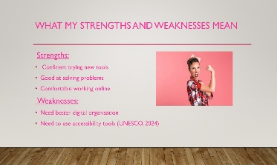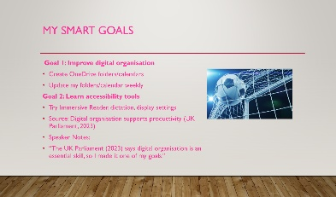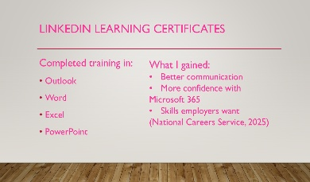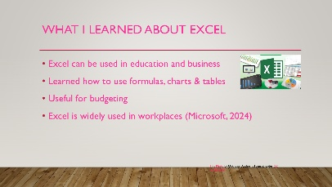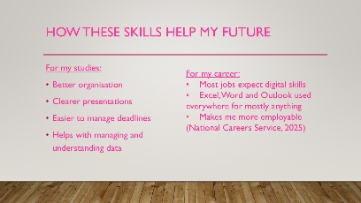

Task 3 References (Minimum 5)
BusinessTech (2024) Importance of Microsoft Excel in Business: 10 Reasons. https://www.businesstech.com
Jisc (2023) Building digital capability: The six elements of digital capability. https://www.jisc.ac.uk
National Careers Service (2025) Digital skills to help your career. (nationalcareers.service.gov.uk in Bing)

