EMPLOYEE ATTRITION WITHIN NURSING IN UK
LCBB5004
MANAGING PEOPLE
SILVIA MIHAELA TANACHE
2122649
LECTURER:MUSHFIQUR RAHMAN

Table of Contents
Introduction 3
1.Causes and effects of employee attrition 3
2. Monetary and five non-monetary existing retention schemes used by NHS 6
3.Recommendations to improve nurse retention 8
Conclusion 9
References 10

Introduction
Employee attribution within the nursing industry is the major part. The causes and effects of employee attribution will be discussed in this report along with the data from NHS England. The positive effect of employee attribution in the nursing sector will also be expressed. Monetary and non-monetary existing retention schemes are used by NHS for nursing professionals along with some appropriate recommendations for nurse retention in the UK also will be highlighted in a major part of the report.

Causes and effects of employee attrition
The rates of nurses and nursing associates leaving the professional register increased substantially in the previous year. 0.4% of the consultants left the NHS sector between April 2012 and May 2021 every month (Bimpong et al., 2020). Despite these enhancements vacancies in the medical and nursing sector of the NHS have also increased.
Causes of employee attrition
RCN has reported that employee attrition within the nursing industry happened for some reasons inadequate pay, insufficient staffing to confirm patient safety, a lack of career progression, discrimination in the workplace, and unsafe working conditions (Marufu et al., 2021). Data from NHS England show a vacancy rate of 11.8% on 30 June 2022.
There are some reasons leading to employee attrition within the nursing industry in the UK.
- Inadequate pay
Inadequate payment to the employees is an important reason for employee attrition within nursing in the UK. Some NHS staff has low wages, so the NHS is executed by the UK state (Buchan et al., 2019). The average payment of an NHS has fallen by 8% since 2010. They were paid £35,680 on average in 2022 April, and it is equating to a £3,000 reduction after the inflammation.
- Lack of career progression
Career progression opportunities make the employees interested in involving with the organization long-term. The opportunities have been observed in shortage to the industry, so the employees are not being interested to involve in the industry (Adams et al., 2021). This is important to confirm all nurses are afforded equal opportunity for career advancement which is essential for the growth of the nursing profession.
- Discrimination in workplace
Gender discrimination in the nursing industry is taking the preferential treatment of men which is making a relatively small percentage of the profession disproportionately in management. Even male nurses are paid higher than their female counterparts (Collard et al., 2020). Statistics in the UK show that 93% of total nursing staff men represent 45% in an approximate estimation who take up all opportunities for senior management positions.
- Unbalanced working conditions
Nurses are facing hazards in the workplace from exposure to certain disinfectants and other products applied to sterilizing equipment. There is inadequate staffing and a nursing shortage in the industry. Overwork and long working hours are being to the nursing employees to the unbalancing situation. So, nursing employees are attaining from the industry in the UK.
Effects of employee attrition
Employee attrition has influenced the nursing industry very much in the UK. 40.365 NHS nurses in England left their services in the previous year, which is related to the workforce size with a leaver rate of 11.5%.
- Nursing attrition in the UK leads to errors with higher morbidity and mortality rates. The hospitals with high patient ratios, nurses experience burnout is being failed to rescue the rates of the facilities with lower patient-to-nurse ratios (Collard et al., 2020). Inappropriate staffing levels are increasing the errors and patient satisfaction is being for decreased nurse retention rates.
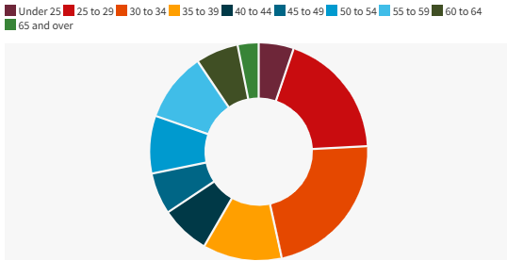
Figure 1: Age distribution of NHS staffs
(Source: digital, 2023)
- As per the NHS staff survey, 34% of nurses often thought to leave, 52% had felt unwell, which is the result of work-related stress, and 40% felt burnt out by their work. There will not be sufficient nurses to meet actual work levels recently (digital, 2023). The NHS’s operational performance has also fallen for the shortage of nursing employees.
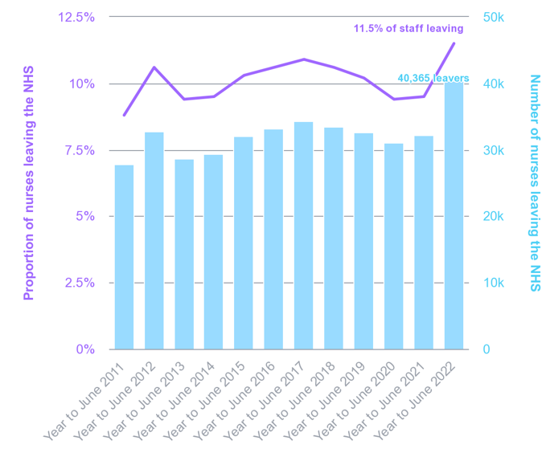
Figure 2: Proportion of NHS staffs
(Source: Holmes, 2022)
- Trends of nurses leaving the NHS are starker in the UK. According to recently available data, some of the 7,470 nurses are left at a leaver rate of 10.6%, which means one in nine employees. Over the decade this is the highest level in absolute leavers’ number which is related to workforce size (Holmes, 2022). So, the vacancy in the nursing industry in the Uk has increased to a higher level very recently. There has been a crisis in the industry of patient treatments.
- There are now more than 41,000 qualified nursing and midwifery posts have been vacant in the NHS in the UK. However, the stagnation in masks number has wide variances among the nursing domains (Nuffield trust, 2023). As an example, nurses and health visitors in FTE grew by 2.2% in children’s health and 1.2% in community services. This fall has driven health visitors to decrease negating the rise in community working services.
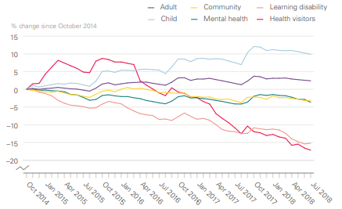
Figure 3: Health sector distribution of NHS staffs
(Source: Nuffield trust, 2023)
- NHS workers with staff shortages are harming the well-being of patients. This shortage is also leading to the impact of enhanced violence and aggression risk in the wards of hospitals (Bimpong et al., 2020). So, the patient's safety is also being impacted due to this attrition. So, overall, the patient risk is forecasted to this effect.

2. Monetary and five non-monetary existing retention schemes used by NHS
Monetary is referred to as the assets which can be changed into cash easily and the non-monetary is not changeable into the cash easily. These factors are expected to assume an important role in determining the demand for medical care as the money price falls due to the spreading of health insurance legislation.
Monetary schemas
The UK has a free publicly funded health care system which is the national health system, and it is different from other health care systems as it is funded by taxation than health insurance. Five existing monetary retention schemes have been identified by the NHS.
- Wages
This is one of the most valuable monetary schemes which is used by the NHS for their nursing professionals. There are 9 bands of pay scales in the industry and the scale starts from £20,270 to £109,475. The NHS is using the wages scale in an interesting manner for attracting employees in the professions.
- Bonus
A bonus is an extra payment to increase the interest of professionals in their work involvement. The NHS acts incentive to better the performance of the employees and indulge them in work.
- Financial incentives
The NHS provides financial incentives to their employees like medical allowances, house rent allowances, etc (Kinman et al., 2020). They provide support to facilitate employee-inclusive opportunities to attract them to the profession.
- Promotion
Promotion relates to the payment increase and it motivates the employees to better performance. The promotion also increases the attraction of work in employees (Hom et al., 2019). As the health industry provides promotion in the services employees can achieve better working chances in the industry.
- Profit sharing
This is an arrangement that is distributed by the NHS as compensation based established formula structured around company profitability (Hom et al., 2019). The profit sharing will increase the employees of NHS in better services to the industry.
Non-monetary schemas
Non-monetary schemas of the NHS sector are responsive to the developments in the jobs by elaborating on the impact on nurse retention. The employee retention response of the non-monetary retention scheme is heterogeneous. This is also for financial support for helping the nurses who may leave the profession to remain.
- Status
An employee is influenced by better designation and status in the organization. The NHS also provides better status and designation according to services in the industry. The industry offers job titles that convey the importance of the position.
- Work-life balance
Employees must be able to balance the segments of their life which are work and personal life. The balance confirms quality in work and life (Holland and Clayton, 2020). This will be motivational for industry development. The health industry can also benefit from the motivational work of employees.
- Delegation
Delegation is the authority that promotes commitment among employees and through this; the NHS health industry is trying to get satisfaction from employees who have faith in the industry. This is also motivational for the better performance of the employees.
- Working conditions
Working conditions like proper ventilation and proper lighting develop the work performance of the employees (Brook et al., 2019). The NHS is using proper working conditions for the desired outcome in the services. Through these NHS are trying to achieve the focus of employees in their services.
- Job enrichment
Job enrichment provides employees with more challenging activities and responsibilities in the workplace so that they give more focus to their work. The job enrichment scheme of the NHS involves more employees at work. The industry is expecting more outcomes from this scheme.

Recommendations to improve nurse retention
Nurse retention for the benefit of health care is necessary for better medical services, and for that purpose, some necessary guidelines should be followed. There are many reasons behind the attrition of nurses, and by following some steps, the situation of inadequate health progress is hampering the health unit in the UK.
- In the short term and in the longer term, the nursing industry should follow some strict guidelines for payment for their services. This guideline should be based on the fundamentals of equal and adequate pay for the nurses. Their wages can be paid as a reward for the work they do for the betterment of society.
- The management authority should take a step ahead of the mindset of giving the right opportunity to all for a better work environment and better work value that can be effective for society (Drennan and Ross , 2019). The nursing sector is serving for the betterment of society, and to ensure that they are doing a noble job, a generous mindset needs to be implemented.
- Equal pay generates equal value to the societal structure. During the pandemic time, the medical sector has shown its valuable liability to the whole of society. The government and NHS need to pay attention to the pay structure of this sector and staff health (Bimpong et al., 2020). Gender should not be the eligibility for equal pay, and so all individuals need to pay according to their work responsibility.
- Nursing is a part of the health system that needs to be renovated through some systematic procedure. This procedure needs to be inculcated to maintain some procedures for a better working environment (Senek et al., 2020). Many systematic appraisals like remuneration increases and giving good professional positions can be helpful for better medical service to society.
- The organization needs to pay attention to making some structural plans. The governmental rules and the organizational rules should be the same as these benefits the value of the services and because of it, the equality and equity principles need to follow.
- The management of a health organization should follow some basic principles. For this purpose, the organization can take a step ahead to a better work environment. Bigotry in the work environment needs to be removed to a better perspective of making the societal value of every person equal, and that is to be needed for better health services.
- The health sector is a noble job sector that serves the people for vital reasons. To ensure their career growth, the health organization needs to give better opportunities for the nurses in the long term (Adams et al., 2021). In the short term, many career designations can be given to them. Their mental health also needed to be taken good care of.
- The health organization should take some short-term steps to ensure that the initiative can be implemented fruitfully, and after implementing those initiatives for better work culture, findings should be taken to use it for its future infrastructure that can be used in the long term.

Conclusion
It is concluded after this report analysis that the nursing profession is important for entire human beings. NHS implement five effective monetary and non-monetary existing retention schemes for nursing professionals that were discussed in the above-given report. Some effective recommendations also were added to the report for nurse retention. The NHS’s operational performance has also fallen due to the lack of appropriate nurses in the medical organization. There are many medical sectors vacant due to a smaller number of nurses. So effective steps for nursing retention are important which were highlighted in the report.

References
Adams, R., Ryan, T. and Wood, E., 2021. Understanding the factors that affect retention within the mental health nursing workforce: A systematic review and thematic synthesis. International Journal of Mental Health Nursing, 30(6), pp.1476-1497. Available at: https://onlinelibrary.wiley.com/doi/pdf/10.1111/inm.12904
Bimpong, K.A.A., Khan, A., Slight, R., Tolley, C.L. and Slight, S.P., 2020. Relationship between labour force satisfaction, wages and retention within the UK National Health Service: a systematic review of the literature. BMJ open, 10(7), p.e034919. Available at: https://scholar.google.com/scholar?output=instlink&q=info:mY3lZTSkNBYJ:scholar.google.com/&hl=en&as_sdt=0,5&as_ylo=2019&scillfp=13564443509057413591&oi=lle
Bimpong, K.A.A., Khan, A., Slight, R., Tolley, C.L. and Slight, S.P., 2020. Relationship between labour force satisfaction, wages and retention within the UK National Health Service: a systematic review of the literature. BMJ open, 10(7), p.e034919. Available at: https://bmjopen.bmj.com/content/10/7/e034919.abstract
Brook, J., Aitken, L., Webb, R., MacLaren, J. and Salmon, D., 2019. Characteristics of successful interventions to reduce turnover and increase retention of early career nurses: A systematic review. International journal of nursing studies, 91, pp.47-59. Available at: https://www.sciencedirect.com/science/article/pii/S0020748918302591
Buchan, J., Charlesworth, A., Gershlick, B. and Seccombe, I., 2019. A critical moment: NHS staffing trends, retention and attrition. London: Health Foundation. Available at: https://www.health.org.uk/sites/default/files/upload/publications/2019/A%20Critical%20Moment_1.pdf
Collard, S.S., Scammell, J. and Tee, S., 2020. Closing the gap on nurse retention: A scoping review of implications for undergraduate education. Nurse education today, 84, p.104253. Available at: https://www.sciencedirect.com/science/article/pii/S0260691719306288
digital (2023) NHS choices. NHS. Available at: https://digital.nhs.uk/data-and-information/publications/statistical/nhs-vacancies-survey/april-2015---june-2022-experimental-statistics (Accessed: April 28, 2023).
Drennan, V.M. and Ross, F., 2019. Global nurse shortages: the facts, the impact and action for change. British medical bulletin, 130(1), pp.25-37. Available at: https://eprints.kingston.ac.uk/43086/6/Drennan-V-43086-AAM.pdf
Holland, P. and Clayton, S., 2020. Navigating employment retention with a chronic health condition: a meta-ethnography of the employment experiences of people with musculoskeletal disorders in the UK. Disability and rehabilitation, 42(8), pp.1071-1086. Available at: https://www.tandfonline.com/doi/abs/10.1080/09638288.2018.1519041
Holmes, J. (2022) The NHS nursing workforce – have the floodgates opened?, The King's Fund. Available at: https://www.kingsfund.org.uk/blog/2022/10/nhs-nursing-workforce (Accessed: April 28, 2023).
Hom, P.W., Allen, D.G. and Griffeth, R.W., 2019. Employee retention and turnover: Why employees stay or leave. Routledge. Available at: https://books.google.com/books?hl=en&lr=&id=knatDwAAQBAJ&oi=fnd&pg=PP1&dq=Employee+attrition+within+nursing+in+UK+&ots=ZKVvt3iEV2&sig=G_jjnq5mexb3mzHkxHkDfOtWGtg
Kinman, G., Teoh, K. and Harriss, A., 2020. The mental health and wellbeing of nurses and midwives in the United Kingdom. Available at: https://eprints.bbk.ac.uk/id/eprint/40551/1/2020%20-%20The%20Mental%20Health%20and%20Wellbeing%20of%20Nurses%20and%20Midwives%20in%20the%20United%20Kingdom.pdf
Marufu, T.C., Collins, A., Vargas, L., Gillespie, L. and Almghairbi, D., 2021. Factors influencing retention among hospital nurses: systematic review. British Journal of Nursing, 30(5), pp.302-308. Available at: https://www.magonlinelibrary.com/doi/abs/10.12968/bjon.2021.30.5.302
nuffieldtrust (2023) Peak leaving? A spotlight on nurse leaver rates in the UK, Nuffield Trust. Available at: https://www.nuffieldtrust.org.uk/resource/peak-leaving-a-spotlight-on-nurse-leaver-rates-in-the-uk (Accessed: April 28, 2023).
Senek, M., Robertson, S., Ryan, T., King, R., Wood, E., Taylor, B. and Tod, A., 2020. Determinants of nurse job dissatisfaction-findings from a cross-sectional survey analysis in the UK. BMC nursing, 19(1), pp.1-10. Available at: https://bmcnurs.biomedcentral.com/articles/10.1186/s12912-020-00481-3

