
Python application consuming api
Network Programmability

January 18, 2024
Owen Evans
2121421

Contents
Part 1 – GitHub Repository 1
Part 2 – Reflective Report 1
Appendix A – Full Code 4
Appendix B – Commit History 6

Part 1 – GitHub Repository

GitHub repository link: https://github.com/Oje99/PythonAssignment
To view the python script, select Assignment_2.py. Here you can see the full script and the history.
Full code: Link above/separate link shared on Moodle/Appendix A.
Git History: Link above/separate link shared on Moodle/Appendix B (brief view).

Part 2 – Reflective Report

To begin with, the final application used two simple APIs, both related to animal facts. The purpose and scope of the application was to have the user input an animal and a number, then for the application to get that specific number of facts from the relevant API.
That initial idea was to create a currency conversion program that would ask the user for an amount of money in a certain currency, then convert it to a currency of the users choosing and print out the number and conversion rate. The program would get this information from an API on the GitHub public APIs site. However, I encountered multiple errors that I was unsure of and so thought to move to something simpler with an API that was more consistent. As a novice programmer I did not want anything too complicated and as I have multiple pets, I decided on the dog facts API. As mentioned, this included two user inputs that would result in the program printing out random dog related facts.
I used PyCharm to create the python application as I have used it in the past and seemed simple to set up Git and link to GitHub. I did encounter some minor issues with GitHub repositories and did lots of testing on separate PyCharm project files to practise programming more and to understand how to make the application work as intended. The repository included in part 1 shows the stages of creation but without a lot of the error checks as PyCharm would not allow me to commit anything with an error. Some of the issues that cannot be seen in the Git history include the program not having any validation after user input, so the program would not print the correct number of dog facts or if there was an incorrect input, the program would not loop and would just end. Eventually, the program would ask the user for a number of dog facts, print out that many facts and then ask if they wanted to see more, and then either loop back through the program or end. Creating this application took multiple tests, and aid from various Google searches, other students, and work colleagues.
After the initial application was created, I tried adding a 2nd API. The API selected was for cat facts. The aim was for the user to be able to pick between a dog or cat fact and then the same application as before just with some slight changes to incorporate the 2nd API. Adding the 2nd API meant complicating the application, causing multiple looping issues where if the user inputted an invalid animal or number, the program would not loop and either end the program or print out a fact, ignoring the input. Again, after multiple tests and aid I managed to fix the issues and as far as my limited knowledge is concerned, there are no more issues with the program.
Although there are no issues, I do believe there is room for improvement. The main improvements are to do with shortening the program to not include so many lines of code. I did try this, but every time I removed something it would create errors in the code and so reverted the changes. The main thing I wanted to shorten in the code was the 2 separate functions for dog and cat facts. Ideally this could have been done as 1 function, but I kept encountering issues and so settled for the 2 functions instead. The other improvement was to add additional APIs or even create my own to include a wider range of animals. I stuck with the 2 as this was already more than I thought I would manage and did not want to complicate anything further when the program was already causing confusion.
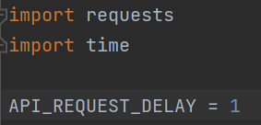
The above code imports the relevant libraries needed and sets a constant delay in the API requests. This was done due to occasional issues where the API would not respond to the call from the program.
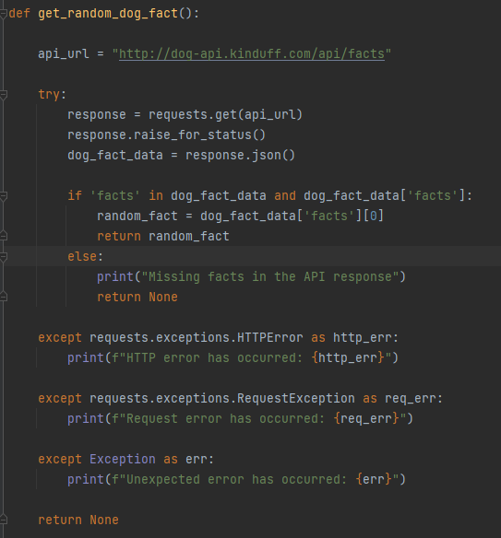
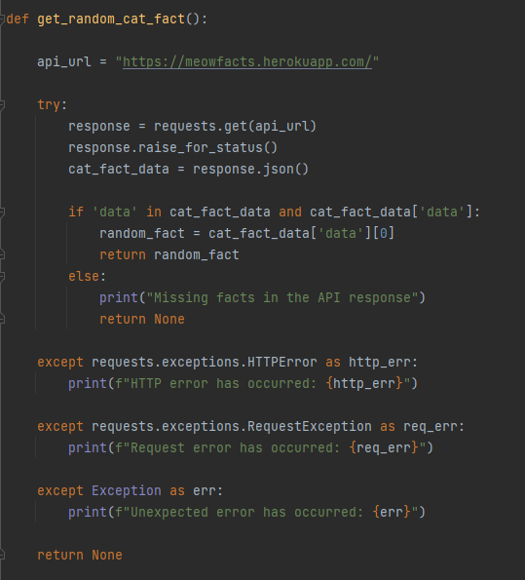
The 2 screenshots above are of the dog and cat fact functions. They are identical other than the URL and wording differences. The function includes the API endpoint and a get request so the program can get information from the API. The function will return the random fact if the API responds, otherwise it will print an error message relevant to the specific issue, such as request or HTTP errors. This is part of the code that could have been shortened to include less specific error messages or to possibly include those in their own function to avoid repeating code.
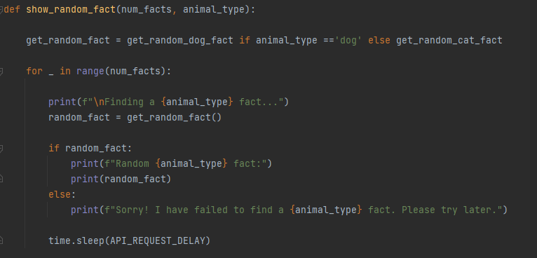
The next function is used for displaying the facts. This function includes variables set during user input in the main function and will print out the number of facts about the specific animal. The function also includes an error message for if the program could not find any facts for the animal inputted. The time.sleep code is for the delay mentioned. This function is used within the main function below and will loop as necessary to print the correct number of facts.
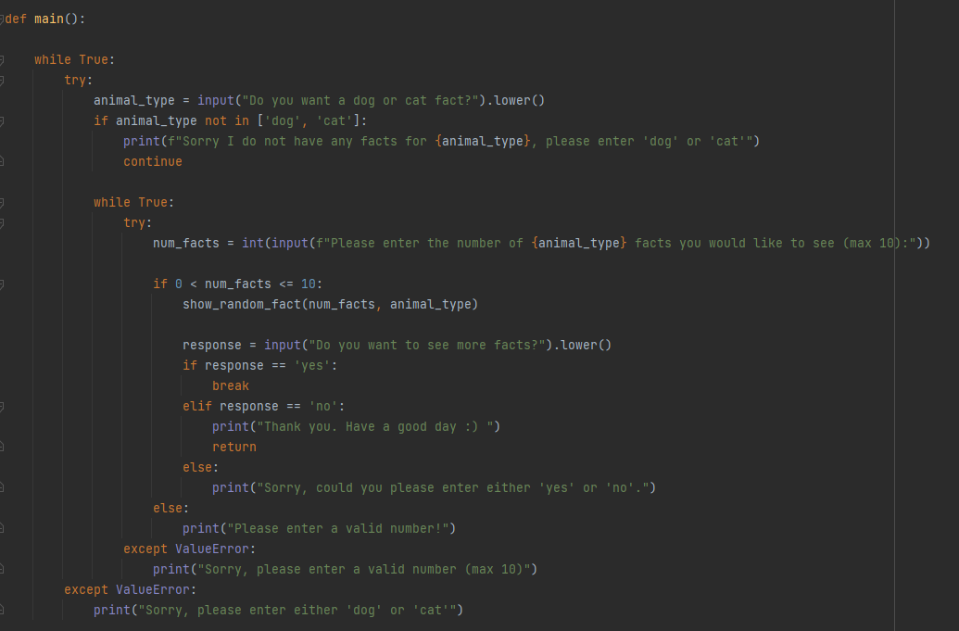
The main function includes the user input variables that decide how the entire program works. It starts with asking for an animal out of either a dog or cat. This input has been made to not be case sensitive. If the user inputs an animal not in the set array, then it will return an error message stating that it can not get facts about the users inputted animal. If the user inputs either dog or cat, then the program moves on and asks for a number. If the user inputs a number above 0 and 10 or less, then the program calls upon the previous function to display the facts. If an incorrect number is inputted, then the program will print an error message and loop back so the user can try again. Before the program ends it asks the user if they would like to see more facts. The program checks the user’s response and if they input yes, loops back through the program, if the input is no, print out a thank you message, or an error message if the user inputted something different. This is to cover all bases and so there is not an abrupt end.
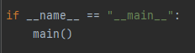
This code calls the main function to run through the code as needed.

Appendix A – Full Code

import requests
import time
API_REQUEST_DELAY = 1
def get_random_dog_fact():
api_url = "http://dog-api.kinduff.com/api/facts"
try:
response = requests.get(api_url)
response.raise_for_status()
dog_fact_data = response.json()
if 'facts' in dog_fact_data and dog_fact_data['facts']:
random_fact = dog_fact_data['facts'][0]
return random_fact
else:
print("Missing facts in the API response")
return None
except requests.exceptions.HTTPError as http_err:
print(f"HTTP error has occurred: {http_err}")
except requests.exceptions.RequestException as req_err:
print(f"Request error has occurred: {req_err}")
except Exception as err:
print(f"Unexpected error has occurred: {err}")
return None
def get_random_cat_fact():
api_url = "https://meowfacts.herokuapp.com/"
try:
response = requests.get(api_url)
response.raise_for_status()
cat_fact_data = response.json()
if 'data' in cat_fact_data and cat_fact_data['data']:
random_fact = cat_fact_data['data'][0]
return random_fact
else:
print("Missing facts in the API response")
return None
except requests.exceptions.HTTPError as http_err:
print(f"HTTP error has occurred: {http_err}")
except requests.exceptions.RequestException as req_err:
print(f"Request error has occurred: {req_err}")
except Exception as err:
print(f"Unexpected error has occurred: {err}")
return None
def show_random_fact(num_facts, animal_type):
get_random_fact = get_random_dog_fact if animal_type =='dog' else get_random_cat_fact
for _ in range(num_facts):
print(f"\nFinding a {animal_type} fact...")
random_fact = get_random_fact()
if random_fact:
print(f"Random {animal_type} fact:")
print(random_fact)
else:
print(f"Sorry! I have failed to find a {animal_type} fact. Please try later.")
time.sleep(API_REQUEST_DELAY)
def main():
while True:
try:
animal_type = input("Do you want a dog or cat fact?").lower()
if animal_type not in ['dog', 'cat']:
print(f"Sorry I do not have any facts for {animal_type}, please enter 'dog' or 'cat'")
continue
while True:
try:
num_facts = int(input(f"Please enter the number of {animal_type} facts you would like to see (max 10):"))
if 0 < num_facts <= 10:
show_random_fact(num_facts, animal_type)
response = input("Do you want to see more facts?").lower()
if response == 'yes':
break
elif response == 'no':
print("Thank you. Have a good day :) ")
return
else:
print("Sorry, could you please enter either 'yes' or 'no'.")
else:
print("Please enter a valid number!")
except ValueError:
print("Sorry, please enter a valid number (max 10)")
except ValueError:
print("Sorry, please enter either 'dog' or 'cat'")
if __name__ == "__main__":
main()

Appendix B – Commit History



