Essay for Developing Professional Practice
Assignment 2 - 2020


January 2020
Module name: Developing Professional Practice BMBM5005
Student name: Chloe Young
Student number: 1804122

Report remit
This Report will identify and Produce a professional development report supported by an electronic portfolio of evidence. It includes four key sections; it means to be a professional, group dynamics, project reflection and a professional self-assessment.

Introduction

What does it mean to be a professional?
The meaning of the word professional can mean different things to different people, some will say the word ‘professional’ is to follow an occupation as a means of livelihood or for gain (Dictionary, 2020). However, expert Lester argues; A professional… ‘Makes proficient use of expert or specialist knowledge, exercises autonomous thought and judgement, and makes a voluntary commitment to a set of principles. Such a person need not be a member of an easily-defined profession or of a professional association; it is possible to work as a professional from a set of expertise and skills that is relatively unique to the individual’ (Lester, 2010).
Although managers can define the dynamic of a group or business, they still have guidelines and standards to follow. The professional standard sets out best practice in management and leaders, with it underpinning all chartered management institutions (CMI’s) products and services. There are three main areas the CMI are made up of, these are:
- Personal Electiveness
- Interpersonal Excellence
- Organisation Performance
These three areas have been divided into segments consisting of; Values, Ethics and culture. The division of these segments are shown below:

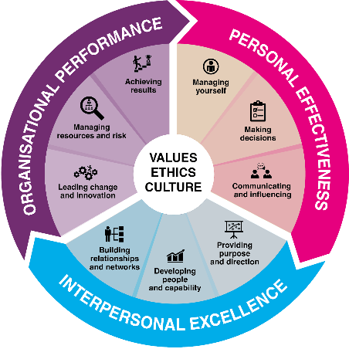
(Source: CMI, 2020)
CMI is a huge company and highly respected all over the world. The stakeholders of CMI believe in the company so much that they decided to follow a code of conduct (CMI,2020). This code of conduct is to be competent, professional, to have honesty and integrity and mean you have a duty to keep up-to-date with current good practice. It is because of this that any employer that hires someone who is a member of CMI will automatically get recognised for their training, skills and knowledge of conduct a professionalism.
Although CMI is well established and recognised, another company that is highly respected in business and management is the Chartered Institute of Personnel and Development (CIPD). They are also a body for experts in people at work (CIPD, 2020). The professional standards In CIPD are:
- Professional Competence and Behaviour
- Ethical Standards and Integrity
- Representative of the Profession
- Stewardship
Although some are different to CMI it does not necessarily mean that either are wrong. These are just the ethics that both take pride in and stand by. Both are powerful, beneficial and are recognised worldwide. Therefore, to have either qualification will put you on the a successful path in the business world.
What does the term group dynamic mean?
Group dynamics refers to the attitudinal and behavioural characteristics of a group. The reason group dynamics are important within an organisation is because the success of an organisation can depend on how groups form, configure and how they function. Another definition is “Kurt Lewin, a social psychologist and change management expert, is credited with coining the term ‘group dynamics’ in the early 1940s. He noted that people often take on distinct roles and behaviours when they work in a group. ‘Group dynamics’ describes the effects of these roles and behaviours on other group members, and on the group as a whole” (Mindtools, N.D.).
Group development, progression and dynamics are also key factors in the success of any project (Mullins, J. L, 2013). According to Tuckman and Jensen (1977) there are four main successive stages of group development and behaviour. These are: forming, storming, norming and performing (YouTube, 2014). Following more research Tuckman developed a fifth stage ‘adjourning’ (Mullins, 2013). These five stages are a great way to set the dynamic of a group.
With each group consisting of different specialities it is important to understand how the varied groups will still work. This is why there will always be a leader or manager in every group to guide but to also help sort conflict when it arises. It is inevitable within organisations for there to be conflict.
There are varied conflict methods you can use in these situations. One method that stands out for me is using the Thomas-Kilmann model (MTL, 2020) shown below:

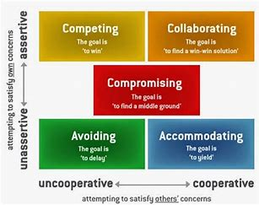
(Source: Letourneau, 2015)

Conflict abounds in the workplace. Research shows that each of us spends an average of 2 to 3 hours a week involved in some way in conflict. In the majority of cases, the outcomes are unsatisfactory and lead to fall-outs, disharmony, and distractions from the real purposes of work (Letourneau, 2015). The cost in lost productivity and human pain is considerable. That's why models of conflict resolution, such as the Thomas-Kilmann model, are vital to learning how to manage conflict more effectively (MTL, 2020).
Another powerful way to handle conflict resolution is to use The Interest-Based Relational Approach (IBR). Roger Fisher and William Ury developed the IBR approach and published it in their 1981 book, "Getting to Yes." They argue that you should resolve conflicts by separating people and their emotions from the problem. Their approach also focuses on building mutual respect and understanding, and it encourages you to resolve conflict in a united, cooperative way (Mindtools, N.D.).

Project management
Project management is defined as the practice of initiating, planning, executing, controlling and closing the work of a team to meet specific goals in a specified time frame
Recently I manged a project and found it one of the most interesting tasks I have undertaken. The reason for this is because I had to overcome certain issues that occurred by using different problem solving and management techniques. Along with the use of techniques, I learnt how to successfully influence, persuade and negotiate with my team. Along the way I used different tools and planning. One key tool to use is the gantt chart. The gantt chart I made for my team was to set structure and to give a plan of the timeline expected. This is shown below:

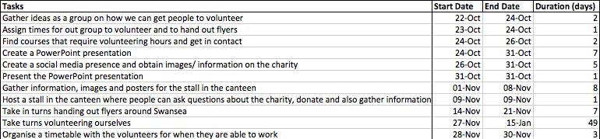
According to Belbin (2018) a high performing team needs access to all nine team role behaviours. However, this doesn’t necessarily mean you need nine people in a team, an individual can have one or more roles. (Mullins, 2013). Therefore, all nine roles were determined, and each member were allocated specific tasks accordingly. I gave myself the role of being the co-ordinator and implementer where as I gave Rhys, my fellow team member the role of a shaper and completer finisher. This enabled me to utilize everyone’s strengths and gave me the ability to trust my team members to finish a task they were given whilst collaborating and working as a team (Hoftede, 1980). This was my first problem to over come as other team members disagreed with my decisions. This meant I had to negotiate and prevent further conflict. However, I knew I had to use these rolls to identify strengths and weaknesses throughout the project.
Following this problem-solving task, I decided to do a bit of research to further my knowledge. It was because of this I decided to use the decision-making model for the duration of the project. Effectiveness as a manager requires knowledge about how to undertake the process of decision making and what tools you need to succeed as a decision maker (Hollenbeck, 1992). A leader must determine task specific outcomes the team are to accomplish (Hersey et al, 2001). This model is shown below:
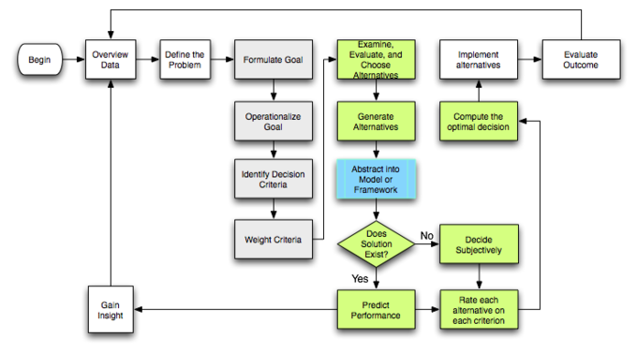
(Source: Boundless management, N.D.)

Profession development and self-assessment
As a manager I understand there is always more for me to learn. I always write myself a personal development plan so I constantly have something to work towards but also reflect on. Below you will see my plan:

Development Plan

NAME: | Chloe Young | MEMBERSHIP NUMBER: | 1804122
COVERING THE PERIOD FROM: |  | TO:

Planned outcome

Where do I want to be by the end of this period? What do I want to be doing? (This may be evolutionary or “more of the same”.)
What do I want/need to learn? | What will I do to achieve this? | What resources or support will I need? | What will my success criteria be? | Target dates for review and completion
Time Management | Ensure I have a back up plan for childcare cancellations.  Set more alarms  Write lists down. | Help from family.  Plan with my partner. | Target of 3 months with no childcare problems and no lateness. | 14/04/2020
Gain experience in different companies | Contact different companies with my CV.  Network events  Speak to lecturers | Internet  Lecturer  Attending networking events | Having experience in at least one other company within 3 months. | 14/04/2020
Achieve HR qualification | Speak to head of my year | Contacts  Brochures/ information | Completed within 3 months. | 14/042020
Find a placement | Speak to lecture  Apply for different oppportunies | Laptop | Completed within 3 months | 14/04/2020

Conclusion
To conclude, a business portfolio consists of different tools and materials that help with the success in projects and organisations. Using business models and getting the relevant experience and skills will not only make processes smoother and easy to manage but will set standards and be the core of the success to any business or organisation.

References

Bellbin.com. (2018). The Nine Belbin Team Roles. Available: https://www.belbin.com/about/belbin-team-roles/. Last accessed 14th January 2020.
Bennis, W. (1991) ‘The four competences of leadership’, in Kolb D. A., Rubin, I. M., Osland, J. S. The organizational behaviour reader (5th edn.) Englewood Cliffs, New Jersey: Prentice-Hall
Boundless Management. (N.D.). Rational and Nonrational Decision Making. Available: https://courses.lumenlearning.com/boundless-management/chapter/rational-and-nonrational-decision-making/. Last accessed 14th January 2020.
CIPD. (2020). Code of Professional Conduct. Available: https://www.cipd.co.uk/about/what-we-do/professional-standards/code. Last accessed 14th January 2020.
CMI. (2020). CMI Code of Conduct and Practice and Harassment Policy. Available: https://www.managers.org.uk/policies/code-of-conduct-and-practice. Last accessed 14th January 2020.
Dictionary. (2020). Professional. Available: https://www.dictionary.com/browse/professional. Last accessed 14th January 2020.
Fujitsui. (2019). Megatrends: The global changes shaping business and society. Available: https://www.fujitsu.com/uk/innovation/megatrends/. Last accessed 14th January 2020.
Hastorf, A.H., Schneider, D.J. & Polefka, J. (1970) ‘The perception process’ in corner, J. & Hawthorne, J. (eds) Communication studies, (1980 edn.) London: Edward Arnold
Hersey, P; Blanchard, H. K; Johnson, E. D. (2001). Management of Organizational Behaviour. 8th ed. New Jersey: Prentice-Hall, Inc. pg 324-325.
Hoftede, G. (1980) ‘Motivation, leadership and organization: do American theories apply abroad?’, Organizational Dynamics, Summer pp.42-63
Jackson, T (1993). Organizational Behaviour in international management. Oxford: Butterworth-Heinemann Ltd. pg 105-118.
Letourneau, N. (2015). How President Obama Handles Conflict. Available: https://washingtonmonthly.com/2015/02/15/how-president-obama-handles-conflict/. Last accessed 14th January 2020.
Mind-tools Videos. (2014). Forming, Storming, Norming, and Performing: Bruce Tuckman's Team Stages Model Explained. Available: https://www.youtube.com/watch?v=nFE8IaoInQU. 14th January 2020..
Mindtools. (N.D.). Conflict Resolution. Available: https://www.mindtools.com/pages/article/newLDR_81.htm. Last accessed 14th January 2020.
MTL. (2020). Conflict Resolution: the Thomas-Kilmann Model. Available: http://www.managetrainlearn.com/page/conflict-resolution-model. Last accessed 14th January 2020.
Mullins, L. J. & Christy, G., 2016. Management and Organizational Behaviour. 11 ed. Harlow: Pearson.
Mullins, L. J. & G, Christy (2013). Management & Organisational Behaviour. 10th ed. Harlow: Pearson. pg 301-313.
Quast, L. (2016). 10 Tips To Help You Win Every Negotiation . Available: https://www.forbes.com/sites/lisaquast/2016/08/08/10-tips-to-help-you-win-every-negotiation/#3c12a9ed436d. Last accessed 14th January 2020.
Soto, A. (N.D.). Starting a business made easy. Available: https://articles.bplans.com/the-importance-of-setting-goals-in-business/. Last accessed 14th January 2020..
Toch, H. and Maclean, M.S. (1967) ‘Perception and communication: a transactional view’, in Sereno K.K. and Mortensen, C. D. (eds) Foundations of Communications Theory, (1970 eds.) New York: Harper and Row
Tuckman. W. B. & Jensen, C. M. (1965), ‘Developmental Sequence in Small Groups’, Psychological Bulletin 63
Tuckman. W. B. & Jensen, C. M. (1977), ‘Stages of small group development revisited’, Group and Organization Studies, vol.2, pg 419-427.
Wagner |||, J. A. & Hollenbeck, J. R. (1992). Management of Organizational Behaviour. 2nd ed. New Jersey: Prentice-Hall, Inc. pg 343-347.

