
(University of Wels, 2024)

Corporate Social Responsibility of STARBUCKS In The International Market

Module code: LCMB7020
Title: Dissertation
Supervisor Name: Ibrahim Rufai
Student Name: Monuar Moni
Student ID:1818185

Declaration

I now declare that this dissertation has been solely written by me and has not been previously submitted, in whole or in part, in any other application for a degree at this university or any other institution. Also, I have acknowledged all primary sources and authors when quoting their works in this dissertation.

Acknowledgement
I am grateful to my supervisor for allowing me to research a suitable topic. I also appreciate my family's continuous support throughout the research process.
Abstract
The research is based on establishing Corporate Social Responsibility practices in the business environment. It uses the Starbucks case study, which has already developed effective strategies for sustainability development. The research comprises various statements, which are stated in the following parts.
Introduction: The introduction section is the start of the research. It states all the research aims and objectives with valuable implications. The research questions are also showcased in this section, and the methods by which the study will be developed are efficiently declared.
Literature Review: The study's literature review critically examines the literature used in previous research by diverse authors. The chapter shows all the data collected from existing studies, efficiently using the theories and justifying the literature gaps.
Methodology: The third chapter is the methods of research, in which all the stages of the study's development are stated with adequate justification for the selection of the components.
Result, Analysis, and Discussion: The study's results section shows the research results, stating that the development of corporate social responsibility in businesses can produce effective measures. The section uses the thematic analysis process followed by literature discussions to strengthen the outcomes for future implications.
Conclusions and Recommendations: This section of the research highlights the study summary, summarising all the effective results in complete form.

Table of Contents

Chapter 1: Introduction 11
1.1 Research Background 11
1.2 Research Rationale 12
1.3 Research Aims and Objectives 13
1.4 Research Questions 13
1.5 Research Significance 14
1.6 Research Methodology 14
1.7 Research Structure 15
Chapter 2: Literature Review 16
2.1 Chapter Introduction 16
2.2 Overview of the Concepts Related to Corporate Social Responsibility 16
2.3 CSR Strategies that Starbucks Implements in its International Market 18
2.3.1 Ethical Sourcing and Sustainable Coffee Practices 19
2.3.2. Environmental Stewardship and Sustainability Initiatives 20
2.3.3. Community Engagement and Social Impact 21
2.3.4. Employee Welfare and Diversity Inclusion 23
2.4 Effectiveness of the Corporate Social Responsibility Initiatives That are Planned and Incorporated by Starbucks on the Environment 24
2.4.1. Reduction of Carbon Footprint 24
2.4.2. Water Conservation 25
2.4.3. Waste Reduction and Recycling 25
2.5 Strategies to Help Enhance the Corporate Social Responsibility Activities of Starbucks in the International Market 26
2.5.1. Enhancing Ethical Sourcing 26
2.5.2. Expanding Community Engagement 27
2.5.3. Improving Environmental Sustainability 27
2.5.4. Advancing Waste Reduction Initiatives 28
2.6 Theoretical Framework 28
2.7 Conceptual Framework 31
2.8 Literature Gap 31
2.9 Chapter Summary 32
Chapter 3: Methodology 33
3.1 Introduction 33
3.2 Research Philosophy 33
3.3 Research Approach 34
3.4 Research Strategy 35
3.5 Research Design 35
3.6 Data Collection 36
3.7 Data Analysis 37
3.8 Ethical Considerations 37
3.9 Research Timeline 38
3.10 Summary 39
Chapter 4: Findings and Data Analysis 40
4.1 Thematic Table 40
4.2 Coding Tree 51
4.3 Thematic Analysis 51
4.4 Discussion 59
Chapter 5: Conclusions and Recommendations 64
5.1 Linking with Research Objectives 64
5.2 Summary 64
5.3 Recommendations 65
5.4 Limitations 66
5.5 Future Scope 66
References 67

List of Figures
Chapter 1: Introduction 11
1.1 Research Background 11
1.2 Research Rationale 12
1.3 Research Aims and Objectives 13
1.4 Research Questions 13
1.5 Research Significance 14
1.6 Research Methodology 14
1.7 Research Structure 15
Chapter 2: Literature Review 16
2.1 Chapter Introduction 16
2.2 Overview of the Concepts Related to Corporate Social Responsibility 16
2.3 CSR Strategies that Starbucks Implements in its International Market 18
2.3.1 Ethical Sourcing and Sustainable Coffee Practices 19
2.3.2. Environmental Stewardship and Sustainability Initiatives 20
2.3.3. Community Engagement and Social Impact 21
2.3.4. Employee Welfare and Diversity Inclusion 23
2.4 Effectiveness of the Corporate Social Responsibility Initiatives That are Planned and Incorporated by Starbucks on the Environment 24
2.4.1. Reduction of Carbon Footprint 24
2.4.2. Water Conservation 25
2.4.3. Waste Reduction and Recycling 25
2.5 Strategies to Help Enhance the Corporate Social Responsibility Activities of Starbucks in the International Market 26
2.5.1. Enhancing Ethical Sourcing 26
2.5.2. Expanding Community Engagement 27
2.5.3. Improving Environmental Sustainability 27
2.5.4. Advancing Waste Reduction Initiatives 28
2.6 Theoretical Framework 28
2.7 Conceptual Framework 31
2.8 Literature Gap 31
2.9 Chapter Summary 32
Chapter 3: Methodology 33
3.1 Introduction 33
3.2 Research Philosophy 33
3.3 Research Approach 34
3.4 Research Strategy 35
3.5 Research Design 35
3.6 Data Collection 36
3.7 Data Analysis 37
3.8 Ethical Considerations 37
3.9 Research Timeline 38
3.10 Summary 39
Chapter 4: Findings and Data Analysis 40
4.1 Thematic Table 40
4.2 Coding Tree 51
4.3 Thematic Analysis 51
4.4 Discussion 59
Chapter 5: Conclusions and Recommendations 64
5.1 Linking with Research Objectives 64
5.2 Summary 64
5.3 Recommendations 65
5.4 Limitations 66
5.5 Future Scope 66
References 67

List of Tables
Table 1: Research Timeline 36
Table 2: Thematic Table 47

Chapter 1: Introduction

Research Background

Corporate Social Responsibility (CSR) mainly describes how an organisation manages its business activities and adopts responsibility for social impact (Chen et al. 2021). The emerging awareness of CSR programs has driven CSR activities as a competitive factor between organisations. The organisation's CSR process benefits internal and external stakeholders, including employees, shareholders, investors, and community groups (Wirba, 2023). Different organisations employ different CSR initiatives to foster growth and drive business success.
According to Hongdiyanto (2016), Starbucks is a multinational coffee company that conducts different CSR activities involving environmental programs, ethical sourcing and educational programs. Through CSR activities, the company significantly focuses on balancing the business's ethical side and the stakeholders' varying interests. Approximately 90% of multinational companies engage in various Corporate Social Responsibility activities to achieve competitive advantages (Lindner, 2024). Similarly, Starbucks has also incorporated different CSR initiatives to carry out its business operations smoothly in the international market. For example, one of Starbucks' significant CSR activities is hiring refugees and veterans. The company has significantly invested in people by creating different employment opportunities. In 2018, 1672 refugees were employed by Starbucks in the U.S., Canada and Europe (Gozdan and Sudolska, 2019). On the other hand, Starbucks in India has introduced the program “Tata Starbucks Empowering Girls and Young Women”. Through this program, the company ensures that girls and young women at all levels are educated and develop their skills through collaboration with non-profit organisations (Harshe, 2024).
Starbucks has also opened four Asian community stores, offering educational opportunities to children and supporting youth entrepreneurs and farmers (Starbucks, 2020). This CSR initiative has improved the brand's reputation and increased its competitive advantages. CSR involves the organisation's social responsibility. Coelho et al. (2023) state that social responsibility positively influences the organisation's financial performance. As a result, Starbucks has emphasised effective CSR initiatives to improve its economic performance. As depicted in the graph below, Starbucks' revenue was approximately 26.58 billion U.S. dollars in 2022, which increased to 29.46 billion U.S. dollars in 2023 (Statista, 2024).
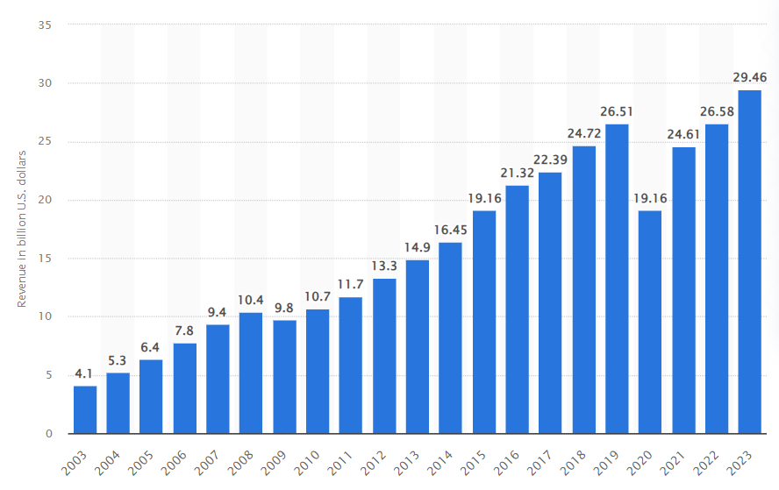
Figure 1: Increase in Revenue of Starbucks in 2023
(Source: Statista, 2024)
As identified in the study by Liopa et al. (2023), ethical commitment and contribution to society are the two significant factors that lead to the design of CSR initiatives. Starbucks has adopted different CSR programs in various countries. The research will thus focus on examining the CSR strategies incorporated by Starbucks in the international market.

1.2 Research Rationale

The concept of Corporate Social Responsibility has undergone significant transformation, evolving into a crucial aspect of strategic business management. This research defined CSR as economic, legal, ethical, and philanthropic responsibilities businesses must undertake. However, this study also emphasises that CRS has become a significant aspect of the business landscape. This research explores the implications of this evolution, focusing on how strategic CSR contributes to sustainable development. It will also focus on how CRS strategies enhance corporate citizenship and environmental stewardship. Mostepaniuk et al. (2022) said that sustainability and Corporate Social responsibility correlate. Further, this study will argue that CSR is mandatory for sustainable improvement by integrating some factors into business operations.
This study will show a pertinent example of successful CSR implementation in Starbucks, a global leader. Also, how it has effectively integrated some practices into its international operations has been stated. For instance, the C.A.F.E initiative ensures ethical procurement and sustainable coffee practices, benefiting both the environment and farmers (Starbucks, 2020). It can be comprehended that this research will analyse the CSR practices inculcated by Starbucks. Analysing how the brand strikes a balance between the stakeholder needs and ethics and sustainability will offer insights into how constructive CSR strategies will be adopted by other brands. Starbucks will take initiatives to reduce its carbon footprint, and its overall impact will be justified later in this study.

1.3 Research Aims and Objectives

The study aims to identify the factors that result in Starbucks's design of corporate social responsibility (CSR) initiatives in the international market.
The objectives are stated below:
- To investigate Starbucks's Corporate Social Responsibility strategies in the international market.
- To evaluate the effectiveness rate of Starbucks's Corporate Social Responsibility programs in the international market.
- To recommend strategies to improve Starbucks' Corporate Social Responsibility initiatives in the international market.

1.4 Research Questions

The questions that have been formulated in the study are stated below-
- What are Starbucks's different Corporate Social Responsibility strategies in the international market that must be investigated?
- What is the effectiveness of Starbucks' corporate social responsibility initiatives in the international market?
- What strategies can Starbucks suggest to improve its Corporate Social Responsibility initiatives in the international market?

1.5 Research Significance

This study justifies the correlation between CSR and sustainable development. The research demonstrates the significance of integrating social, economic, and ecological considerations by exploring how CSR initiatives contribute to long-term sustainability objectives. Starbucks will emphasise the concept of corporate citizenship in association with CSR. This research investigates how companies implement stewardship practices to mitigate environmental degradation and promote ecological restoration. Environmental stewardship involves the proactive management and protection of natural resources. This study’s examination of Starbucks’ CSR strategies, including environmental concerns, ethical sourcing, and community engagement, provides a model for other businesses. The research demonstrates the significance of integrating considerations into business practices. This study’s findings will offer a valuable framework for businesses to design and execute CSR approaches that support sustainable development objectives. This research significantly contributes to practical business knowledge and academic literature. It enriches the theoretical understanding of CSR and provides some valuable strategies. The findings will benefit scholars, policymakers, business leaders, and other stakeholders interested in promoting responsible and sustainable business practices. By advancing knowledge in these areas, the study supports the broader goal of fostering more sustainable, ethical, and socially responsible business practices globally.

1.6 Research Methodology

Incorporating the secondary data in the study would be the most suitable way to explore Starbucks' CSR strategies in the global market. Interpretivist philosophy will be employed to carry out the research in the proper direction. This philosophy focuses on subjective understanding and guides the researcher in synthesising qualitative data to generate new insights (Chowdhury, 2014). Apart from this, the inductive approach will also be considered in the study. In the context of the research design, the questions of the study will be explored in favour of the exploratory research design.
Secondary data will be collected from peer-reviewed journals, articles, Starbucks' CSR reports, and newspaper websites. The thematic analysis technique will be followed to identify and create themes relevant to the research. Based on these themes, the secondary data will be analysed. Moreover, the study will also follow specific ethics in terms of secondary research.

1.7 Research Structure

The research is divided into five chapters, which are structured below:
Introduction - A brief context of the study, along with the rationale, has been involved in the first chapter. Specific aims, objectives and research questions are also formulated in this chapter. The chapter also includes the study's significance and a proposed method.
Literature Review - This chapter critically reviews the existing papers and identifies gaps in the literature.
Methodology -The third chapter discusses the philosophy, approach, design, and data collection and analysis method. The timeline and ethics of the study are also discussed accordingly.
Findings, Analysis, and Discussion—This dissertation chapter analyses the collected data. The discussion chapter compares the secondary data with the literature review.
Conclusion and Recommendations -The research ends with this chapter, which includes a summary, future research, and recommendations for the study.

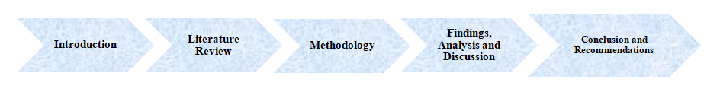
Figure 2: Research Structure
(Source: Self-developed)

Chapter 2: Literature Review

2.1 Chapter Introduction
The second chapter of this research is dedicated to analysing the previously published literature on Starbucks and its corporate social responsibility (CSR) in the international market. A thorough literature analysis will help this research understand key concepts and strategies related to Starbucks’ CSR initiatives. This will begin by analysing how Starbucks implements these strategies in the international market. Following this, a thorough analysis of Starbucks’ CSR strategies' effectiveness in promoting sustainability and its impact on the environment will be conducted. Furthermore, there will be a discussion of how Starbucks' CSR activities could be improved in the global marketplace. This chapter will then discuss the gaps in previous literature.

2.2 Overview of the Concepts Related to Corporate Social Responsibility

Concept of Corporate Social Responsibility
Carroll & Brown (2018) define CSR as the economic, legal, ethical, and philanthropic management responsibilities businesses have had to undertake. They elaborate that CSR extends a company’s responsibilities beyond earning profit and eradicating legal exigencies. The authors also provide an analysis of the further development of CSR, mentioning that CSR has become more significant in the company's strategic management and relation to the stakeholders. Some scholars assert that strategic CSR focuses on the humane consideration of social and environmental issues in business and management and the attainment of a balance between the various stakeholders ‘needs and efficiency and sustainability. From the study by Camilleri (2017), it is understood that CSR extends beyond mere compliance and economic obligations. In the study, it is also understood that this emphasises ethical behaviours about environmental stewardship and the welfare of society. However, it is also seen in this study that the critics argue that CSR is developed, and it is stated that CSR serves as a superficial marketing tool and underlying corporate malpractices.
On the other hand, in the study by Awuah et al. (2021), it is understood that there are many positive impacts of CSR, which is comprised of fostering community development with sustainable practices so that the companies project their profits from genuine social contributions rather than fake promises and products. From the study, it is understood that consistency and transparency in the brands are a must to ensure long-term societal benefits rather than transient public relations and profits. However, a research gap in the use of secondary data is seen in the study, which needs to be resolved further in the stages.
Sustainability
According to Mostepaniuk et al. (2022), CSR and sustainability are intermingled concepts. For this reason, Schultz and others assert that CSR is essential for attaining sustainable development objectives, where economic, social and ecological factors are integrated into business operations. In this context, the authors shed light on how CSR programmes help in achieving sustainable development in the long term, as demonstrated in the stewardship of resources, appropriate labour relations and involvement of the community (Mostepaniuk et al., 2022). They further posit that ideal CSR initiatives do not only respond to shareholders’ concerns in the present but also create organisational structures that are healthy over an extended period and benefit society and the environment concurrently. According to the study by Harangozo et al. (2018), sustainability is the subjective instance of the world that involves balancing economic growth with environmental protection to establish long-term viability in the business.
On the other hand, in the study by Jones (2019), greenwashing is also seen as based on the development of fraud rather than following authentic practices. From the study, it is also analysed that sustainability is the process by which researchers for future generations can be preserved. Sustainability has become an essential part of today’s businesses, and thus, it has efficiently produced ways by which the environment and society can be protected. Therefore, it is understood from the study that sustainability is a valuable implication for society, so better lives are expected.
Corporate Citizenship
According to Kruggel et al. (2020), corporate citizenship is a concept in proximity to CSR, in which the main emphasis is placed on the company's membership role in society. They define it as a corporation’s privilege, obligations, and societal associations. The authors link this with CSR since they involve activities beyond a firm’s legal obligations, aiming to generate positive social benefits. Thus, they found that CC entails such activities as philanthropy, community involvement, and business professionalism, which are all parts of CSR and the corporation’s established efforts to become an accepted member of society in areas where the company exercises operations. As per the study by Le (2023), it is understood that the company’s responsibility towards society is referred to as corporate citizenship, which can leverage strategic tools to enhance its reputation and reflect facts. The study also analyses that efficient corporate citizenship is enormous and comprises integrating ethical practices and fostering transparency in businesses. Thus, from the study, it is clear that authenticity is the main issue in every situation. This section also highlights that trust can only be developed with the authenticity of the practices.
Environmental Stewardship
According to the research of Bennett et al. (2018), environmental stewardship may be described as the proper handling and utilisation of the natural environment by exercising stewardship by using funds to maintain and improve the environment. They consider it a range of processes and activities related to the stewardship of ecosystems. The authors describe it as a process of preventing, controlling or remedying the deterioration of the environment by single persons or groups of people. He states that proper stewardship is not only passive protection and preservation of resources and environments but also restoration and enhancement of the resources and the creation of knowledge that can be used to manage the environment well (Bennett et al. 2018). This framework encompasses social, ecological and institutional aspects in the management of the environment. According to the study by Grubor and Milovanov (2017), it is stated that in the present era, environmental sustainability is the most effective practice that many companies do for the development of the community and the production of positive brand images. The study also explores the fact that protecting the environment and society is a common goal and has developed environmental awareness among the people. The study highlights that protecting the environment with natural resources is essential or that future generations must suffer. Thus, it is understood that environmental sustainability is a necessary implication of compliance, and this has to be followed for brand development and community building.

2.3 CSR Strategies that Starbucks Implements in its International Market
Starbucks is known for its strong commitment to CSR, which is seen across all its global organisational outlets (Kettunen, 2020). The organisation has strategically designed its CSR initiatives. They positively impact the environment, its essential stakeholders, and society. Furthermore, as the organisation is closely related to a diverse group of people with varied tastes and preferences, Starbucks has also adjusted its CSR initiatives (Bianco, 2020). The organisation can do this while also holding core values of sustainability and ethical standards. Studying previous literature published on Starbucks and its CSR initiatives, the following essential factors were highlighted:

2.3.1 Ethical Sourcing and Sustainable Coffee Practices
Starbucks is strongly dedicated towards ethical procurement. Research conducted by Eagle (2022) highlighted Starbucks’ C.A.F.E. (Coffee and Farmer Equity) initiative. With a strong emphasis on C.A.F.E., Starbucks ensures that the coffee it serves to its customers does not exploit any farmer or the environment (Starbucks, 2020). Starbucks's official website claims that 99% of its coffee is procured ethically. Research conducted by Susilo and Mendoza (2023) further confirms this and highlights that Starbucks highly emphasises fair labour standards and sustainable farming practices as a responsible business organisation.
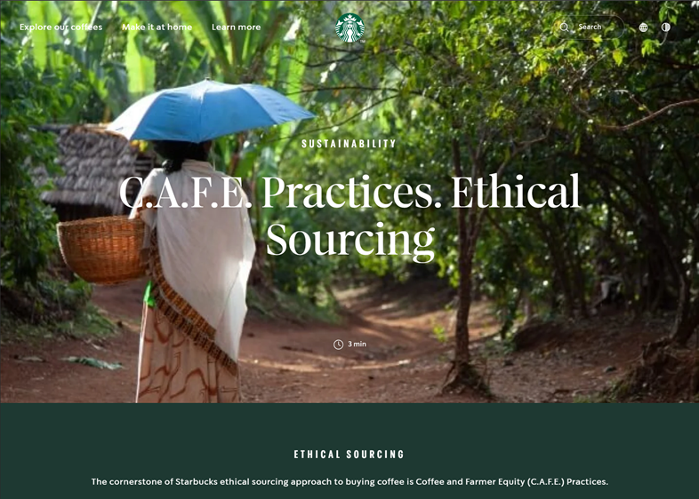
Figure 3: Starbuck’s C.A.F.E. Initiative
(Source: Starbucks, 2020)
Starbucks’ CSR initiative and ethical standards also align with those of other coffee producers like Nestlé and Lavazza. Renard (2022) and Niceforo (2023) research highlighted Nestlé’s Nescafé Plan and Lavazza with its ¡Tierra! Initiatives are promoting sustainability. However, Meilani and Ellitan (2024) highlighted that Starbucks can incorporate these initiatives into its global supply chain network. Thus, it can benefit individuals worldwide.
Furthermore, this research confirms that Starbucks’ initiative encompasses environmental stewardship and community involvement. According to the study by Civera et al. (2019), it is understood that coffee and farmer equity are the primary focus of the company that has developed ethical sourcing practices in coffee production. The study shows that social responsibility and economic accountability are the most critical parts of the scenario, and the process is focused on the ethical sourcing that represents the steps towards sustainable agriculture. Thus, it is understood that Starbucks's step toward sustainability has developed the concept of community farming by resolving society's gaps for sustainable development in these situations.

2.3.2. Environmental Stewardship and Sustainability Initiatives
Starbucks is intensely committed to reducing its carbon footprint. According to Azmi and Maksum (2022), the organisation stops there and has incorporated the circular economy principle into its organisational framework. The organisation also places significant importance towards reducing the quantity of its generated waste (Starbucks Stories, 2024). The report highlights that the organisation successfully reduced 20% of its greenhouse gas (GHG) emission per $ of revenue compared to the 2019 baseline. The organisation also uses 33% less water against the same baseline. Vollero et al. (2022) also highlighted Starbucks’ “Greener Stores” initiative. This focuses on developing eco-friendly store designs and business operations. From the study by Tikhonova et al. (2021), it is understood that the ecological footprints are reduced by environmental stewardship and sustainability initiatives so that the ecological footprints are reduced, and responsible resource management is developed. The practices are also focused on the reduction of carbon emissions with the management of wastes so that biodiversity protection is enforced in the process. The long-term ecological balance is the main requirement of environmental stewardship practices so that sustainable practices grow in businesses.

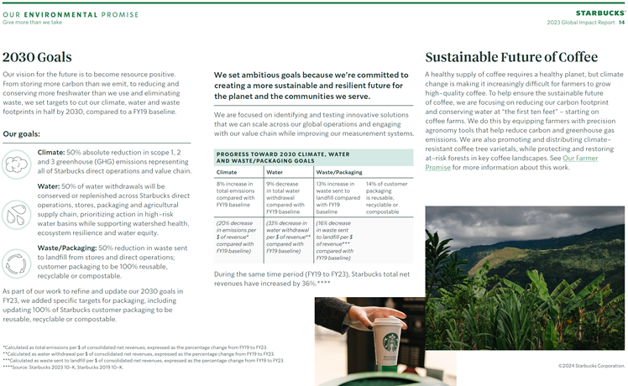
Figure 4: Starbuck’s 2023 Global Impact Report
(Source: Starbucks Stories, 2024)

2.3.3. Community Engagement and Social Impact
Hwang et al. (2020) research highlights that Starbucks actively engages the local community and runs several social impact campaigns. These include funding for regional development, encouraging diversity and inclusion and investing in local educational programs (Azriuddin et al., 2020). The organisation brings these initiatives under its Starbucks Foundation program (Starbucks, 2023). Since 2005, the organisation has spent 25 million US dollars to strengthen coffee- and tea-growing local communities. According to the study by Radyi et. al. (2019), community engagement is essential to sustainability and CSR development. The study shows that collective well-being is the main aim of the scenario in which efficient sustainability is projected with community development. The author has also stated that community engagement and society development comprise deep planning and transparent communication, so a beneficial outcome is projected from the study. Contradicting the statement by Questa et al. (2020), it is stated that with the authentic implication of community engagement, social change can be driven by the improved quality of life and the empowerment of the communities. It is understood that if there is a genuine implication, it is beneficial for society and the community. Otherwise, it needs to be guided by the complications to become genuine for the companies. This is shown by the company Starbucks by developing a community with high-quality coffee and sustainable practices.
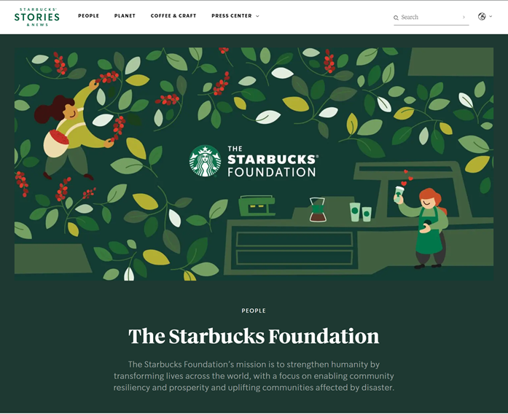
Figure 5: Starbucks Foundation Program
(Source: Starbucks, 2023)
Cold beverage companies like Coca-Cola also demonstrate a similar kind of initiative. According to Huse et al. (2022), Coca-Cola, with its five by 20 initiative, aims to empower 5 million female entrepreneurs by 2020. The organisation surpassed its goal and successfully empowered 6 million women across 100 countries (Coca-Cola, 2021). However, Starbucks’ approach is unique. Its success lies in including a community development program in its primary business operations (BusinessWire, 2019). Starbucks promote local employment and makes alliances with neighbourhood communities.

2.3.4. Employee Welfare and Diversity Inclusion
Starbucks is deeply committed to creating a diversified workplace that welcomes people from different backgrounds (Campbell, 2023). The organisation also places a high priority on the well-being of its employees. The organisation offers Healthcare Coverage, Stock Options, Parental Leave, Tuition Assistance, 401(k) Retirement Savings Plan and Paid Time Off (PTO) to its employees (Ayag, 2024). This creates a happy workplace for its employees. They know that Starbucks care for them. Starbucks also supports the LGBTQIA2+ community and wishes to achieve at least 30% ethnic and racial balance at the corporate level and a minimum of 40% at retail and manufacturing by 2025 (Starbucks Stories & News, 2024).
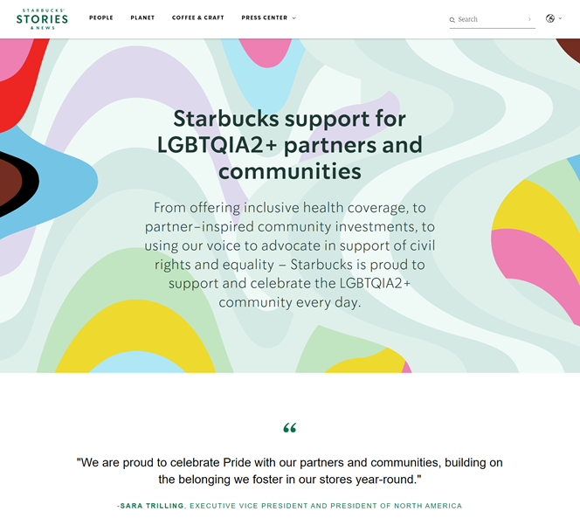
Figure 6: Starbucks’ Attitude Towards Cultural Inclusiveness
(Source: Starbucks Stories & News, 2024)

2.4 Effectiveness of the Corporate Social Responsibility Initiatives That are Planned and Incorporated by Starbucks on the Environment
With its CSR initiatives, Starbucks has made itself a prominent name for environmental sustainability (Li, 2022). With strategically developed CSR initiatives that promote sustainability, the organisation can reduce its ecological footprint. As this research aims to have a better understanding of the effectiveness of Starbucks’ CSR initiatives, the following could be highlighted:

2.4.1. Reduction of Carbon Footprint
Starbucks has made reducing its carbon footprint one of its primary objectives. Research conducted by Wang et al. (2022) highlighted that Starbucks has been able to make use of energy-efficient business practices. This significantly reduced its carbon footprint. This claim is further confirmed by the official report published by the organisation. According to Starbucks Stories (2024), Starbucks has successfully reduced 20% of GHG emissions per dollar of revenue. This is measured against the organisation’s 2019 baseline. This shows that Starbucks is determined to mitigate the negative impacts of global warming, and its initiatives are fruitful.
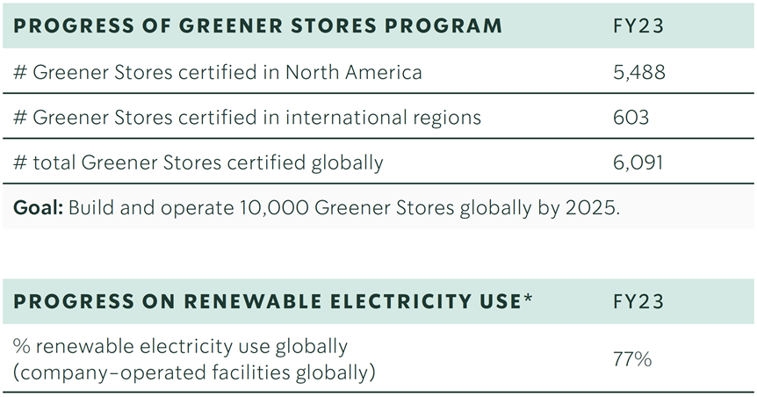
Figure 7: Starbucks’ Green Achievement
(Source: Starbucks Stories, 2024)
Similar to Starbucks, other popular international organisations like Amazon and McDonald's have made efforts to reduce their carbon footprint. 90% of electricity consumed by Amazon in 2022 was from renewable sources (Amazon, 2022). McDonald's also significantly improved in reducing its absolute scope 1 and 2 GHG emissions. The organisation has taken 2018 as its baseline year and wishes to reduce 50.4% of GHG emissions by 2030 (McDonald's, 2021). However, what sets Starbucks apart is that the organisation has incorporated its initiatives into the grassroots level of its organisational operations (Eilert and Nappier Cherup, 2020).

2.4.2. Water Conservation
Starbucks focuses on being carbon-zero and is committed to reducing its water usage. In its 2023 Global Impact report, Starbucks highlighted that it used 33% less water per $ of revenue generated than its 2019 baseline (Starbucks Stories, 2024). The organisation can achieve this remarkable difference by implementing water-saving technologies and encouraging its employees to participate in water conservation. The organisation uses high-blast nozzles in case of using running water. The organisation also uses low-flow valves at all its stores (Starbucks, 2024). Thus, it has helped Starbucks to promote sustainability and reduce the impact of the organisation’s daily activities on the planet. According to the study by Ingrid et al. (2022), Starbucks has done a lot for water preservation, focusing on reducing water usage and promoting sustainable water management activities. The study also examines the fact that the low-flow faucets and the fixtures in Starbucks stores have efficiently developed the water recycling strategy by which the company has minimised its water consumption.
On the other hand, in the study by Wang et al. (2022), it is stated clearly that the water recycling protocols are also developed by Starbucks, in which the reusing of water for coffee production is enforced. The authors also noted the water shade protection initiatives supported by Starbucks to improve water quality in the growing coffee regions. However, the company has done a great job in water preservation, enforcing more focus on the water reduction target, which can be significant for the sustainability initiatives. The initiatives that the company processes to preserve the water must continue to ensure efficient sustainability all around the company's businesses. This will develop compelling competitive advantages for the company to remain dominant in the coffee business.

2.4.3. Waste Reduction and Recycling
Starbucks has made significant decisions about its organisational operations and has incorporated the concept of circular economy into practice. The organisation is firmly determined to reduce the amount of waste it generates and promote recycling. Research conducted by Wijaya and Mursitama (2023) has highlighted Starbucks’ Greener Stores initiative. The organisation has partnered with the World Wildlife Fund (WWF) and SCS Global Services. The organisation has 6091 Greener Stores, and the buildings are made with recyclable and eco-friendly materials (Starbucks Stories, 2024b).
Furthermore, the organisation encourages its employees to follow in eco-friendly footsteps and reduce unnecessary use of resources. Moreover, Starbucks encourages its consumers to use reusable cups and offers discounts to boost their morale (Tsai, 2022). This reduced the amount of waste Starbucks used to send to landfills. The organisation has also banned using single-use plastics to carry their coffee mugs. The organisation also does not use single-use plastic straws. It offers straw-less lids that customers can use directly to sip their coffee (Moloney, 2020). Thus, the organisation has been able to cut down on the waste it sends to landfills. Starbucks’ 2023 Global Impact Report highlights a 16% decrease in waste sent to landfills per $ of revenue compared to the 2019 baseline (Starbucks Stories, 2024a).
Organisations like Unilever and Procter & Gamble (P&G) follow similar approaches. P&G is determined to make 100% of its packaging materials recyclable by 2030 (P&G, 2023). On the other hand, Unilever has decided to cut down 50% of its virgin plastic usage by 2025, against a 2019 baseline (Rachal, 2024). However, Starbucks can stand out in this instance as it influences consumer behaviour in its green CSR initiatives, creating a more significant environmental impact.

2.5 Strategies to Help Enhance the Corporate Social Responsibility Activities of Starbucks in the International Market
Starbucks has already made a significant impact on the natural world as a result of its CSR policies that aggressively prioritise sustainability. However, there is substantial scope for improvement in the international markets. They could be categorised as follows:

2.5.1. Enhancing Ethical Sourcing
With its C.A.F.E. initiative, Starbucks has become a global sensation in ethically procuring coffee beans and teas. However, research conducted by Gashema (2021) highlighted that Starbucks could expand its C.A.F.E. and similar initiatives and include more certification programs. The study highlighted incorporating blockchain technology for added transparency and certifications for more transparent coffee production. This will further improve Starbucks’ reputation. Another research conducted by Millard (2021) spoke similarly. This research highlighted that with Rainforest Alliance certification, Nestlé has been able to add credibility to its Nescafé Plan. Starbucks could follow a similar kind of approach.
Research conducted by Villena and Gioia (2020) highlighted another essential aspect. Their research believes that organisations like Starbucks could gain more benefits from transparent reporting. Starbucks must provide its audiences with detailed case studies and farmer testimonials to maximise benefits. This will make consumers aware of the impact of Starbucks’ ethical procurement.

2.5.2. Expanding Community Engagement
Starbucks Foundation is effective in providing support for its employees. Yusuf et. al. (2020) research highlighted that these initiatives benefit the neighbourhood communities. However, Starbucks needs to maximise the outreach of its community development programs. In this instance, research conducted by Abiddin et. al. (2022) highlighted that forming a collaboration with NGOs would be beneficial. As NGOs specifically focus on community development programs, they have specific information about the particular needs of communities (Seddiky et. al., 2020). This will enable Starbucks to develop tailored community development programs. Instead of a one-model-fits-all approach, McNamara et al. (2020) research highlighted that individuals could do better with tailored community development programs. According to the study by Kohl et al. (2022), it is analysed that the company also needs to collaborate with the local educational sector so that environmental initiatives are projected among those individuals. On the other hand, in the study by Musonera (2021), it is also said that Starbucks will serve several communities' needs efficiently with this strategy and can possess better businesses in the future. The store environment creation is also a dedicated factor that can be focused on sustainable practices and environmental protection awareness to generate better customer experiences with the understanding of CSR.

2.5.3. Improving Environmental Sustainability
Vollero et. al. (2022) and their research confirm that Starbucks has significantly impacted nature with its Greener Stores initiatives. However, there is still scope for improvement. Official publication from Starbucks Stories (2024b) highlights only 6091 Greener Stores. The organisation needs to invest in renewable energy sources for the rest of its store outlets. Starbucks has thousands of store outlets all across the globe, and according to Lu et. al. (2020), powering these outlets with renewable energy sources like Solar power will reduce the use of fossil fuels and GHG emissions. Furthermore, Starbucks could also replace traditional lights inside its stores with energy-efficient LEDs. Fakharuddin et. al. (2022) research highlighted the energy efficiency of Perovskite LEDs. These will reduce energy consumption to a great extent and make the organisation and its activities more energy efficient.

2.5.4. Advancing Waste Reduction Initiatives
Starbucks has reduced waste by promoting usable cups and eliminating plastic straws. However, research conducted by Accorsi et al. highlighted that there is still scope for Starbucks to make further improvements. Starbucks needs to design its products and their packaging in such a way that they can be reused and efficiently repaired and could be reused.
However, research by Jude et al. (2021) suggested a different Approach. Their study highlighted implementing intelligent technologies like AI in waste management. These AI could track which organisational activities generate the maximum amount of waste. Advanced Machine Learning (ML) software could understand Starbucks' usage pattern. This would help the organisation create solutions and help Starbucks reduce its waste.

2.6 Theoretical Framework
Stakeholder Theory
The Stakeholder Theory defines business as bearing responsibility for all the significant players influenced by the company’s operations rather than only shareholders (Freeman, 2023). This approach applies explicitly to the international dimension of Starbucks’ CSR because the company operates in numerous societies, cultures, and economies that represent various stakeholders. Employees, consumers, suppliers, local communities and governments, competitors, and coffee’s environmental groups form part of Starbucks’ stakeholder map while operating in various locations globally. The theory postulates that when these different groups’ wants and worries are met, firms can generate long-term wealth and keep their social permissions to operate (Kivits and Sawang, 2021). For Starbucks, this might encompass fair trade with coffee farmers, proper working conditions in its outlets worldwide, and active involvement in community projects in the countries it sources its products.
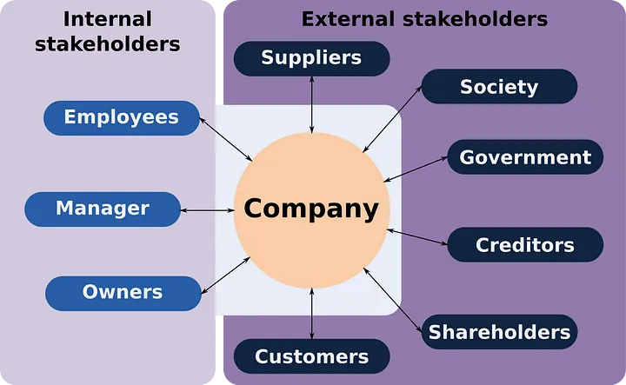
Figure 8: Stakeholder Theory Overview
(Source: Aweston 3, 2022)
Kivits and Sawang (2021) further stress that stakeholder relations are temporary; both parties are constantly changing, building, and maintaining those relationships. This is especially relevant to Starbucks as it operates in different cultural environments and has to use CSR initiatives relevant to various markets. Freeman (2023) also explains that stakeholder theory holds political consequences because it asserts that the business influences society's prevailing norms and practices. Thus, for Starbucks, this could mean using its position as the world’s largest coffee-selling company to popularise sustainable business and social responsibility models for the coffee industry and other sectors of the economy. From this theoretical perspective, Starbucks should strengthen its position as a company that implements international CSR practices based on Stakeholder Theory, thus avoiding or minimising various risks and focusing on win-win cooperation with stakeholders from all Starbucks global value chain countries.
Triple Bottom Line (TBL) Theory
According to Shim et al. (2021) and Ozanne et al. (2016), businesses can use the Triple Bottom Line (TBL) Theory to measure their performance besides the financial factors, including social and economic factors. The said strategy is valuable to Starbucks’ international CSR practice. The TBL framework encourages companies to balance three key areas: profit, people, and the planet. The three Ps of sustainability, more particularly, profit (economic), people (social), and the earth (environment) (Shim et al., 2021). For Starbucks, it could unlock, for example, maintaining solvency across stores worldwide and, at the same time, ensuring the fair treatment of workers and the application of sustainability throughout the supply chain.

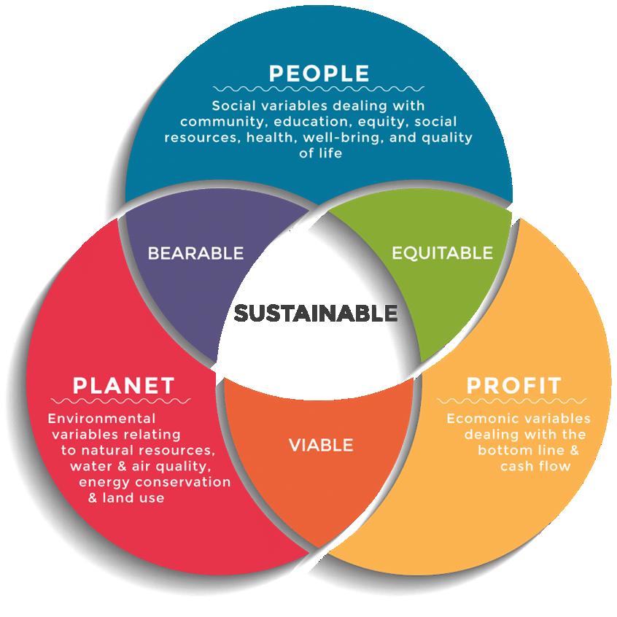
Figure 9: Triple Bottom Line Theory
(Source: Dalibozhko and Krakovetskaya, 2018)
Ozanne et al. (2016) also note that these three Responsibilities are frequently conflicting and represent paradoxical management objectives. The authors believe that it is possible to state that such tensions cannot be eliminated, and therefore, they should be considered and managed to support sustainability management. In Starbucks’ case, this could refer to the difficulties of achieving profitability while implementing resource-intensive but beneficial environmental measures or catering to society's culture while fulfilling global ethics standards. Thus, implementing a TBL approach can achieve a vision aligning with Starbucks’ strategy. Shim et al. (2021) identified the positive relationship between CSR practices and corporate value within the restaurant sector. Due to the systematic framework’s consistency with the multifaceted nature of performance management in external international environments, it holds the potential to help guide Starbucks toward the creation of sound and comprehensive CSR strategies.

2.7 Conceptual Framework
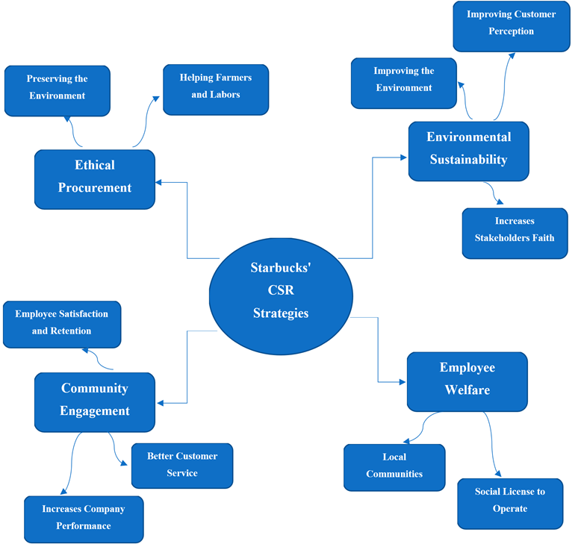
Figure 10: Conceptual Framework
(Source: Self-Created)

2.8 Literature Gap
After reviewing the past literature, official company reports, and other relevant research materials on Starbucks, it was found that extensive research has been conducted on these. However, there remains a void in the knowledge. Researchers have shown how Starbucks extensively works for the community (Meilani and Ellitan 2024; Hwang et. al. 2020). However, these researchers failed to provide any relevant information about the long-term impact of Starbucks’ community development programs. Many of these studies focus on short-term gains and effects on community development.
Furthermore, several researchers have skilfully and methodologically documented Starbucks' environmental efforts (Eagle 2022; Susilo and Mendoza 2023; Meilani and Ellitan 2024; Azmi and Maksum 2022; Vollero et. al. 2022). However, researchers should have provided more significant light on how these sustainability efforts impact its customers globally. This research was mainly regional-specific. Most of them focused on the UK, USA, and some Southeast Asian markets like Indonesia. They needed to provide knowledge about the rest of the globe. Finding relevant research material about the MENA region took a lot of work.
Furthermore, there is a lack of knowledge about how modern technologies might improve Starbucks’ CSR initiatives. Gashema (2021) highlighted blockchain technologies and AI models for the food and beverages industry. However, they were not Starbucks-specific.
Therefore, future studies need to fill these gaps. As these voids would be filled, it could provide a more detailed picture of Starbucks’ CSR initiative.

2.9 Chapter Summary
This literature review helped the researcher understand Starbucks' approaches to a multifaced CSR initiative. These initiatives aim to help society or the stakeholders, and Starbucks has strategically incorporated environmental sustainability into its CSR objectives. Several practices have become prominent, such as ethical procurement, sustainable and green coffee production, environmental stewardship, community engagement, employee welfare, and diversity inclusion. Furthermore, the Stakeholder Theory and Triple Bottom Line (TBL) Theory helped this research understand everything holistically.

Chapter 3: Methodology

3.1 Introduction
The reasonable move of this research is that it has applied the framework of Research Onion by Saunder. The Research Onion enables the investigation of the choices that result in selecting methodological techniques (Bianchi, 2021). The framework reflects the six layers of influence in the research approach. Starting with the research philosophy followed by the approach, strategy, and timescale and ending with the data collection and analysis techniques, the framework ensures that the study is going in the right direction.

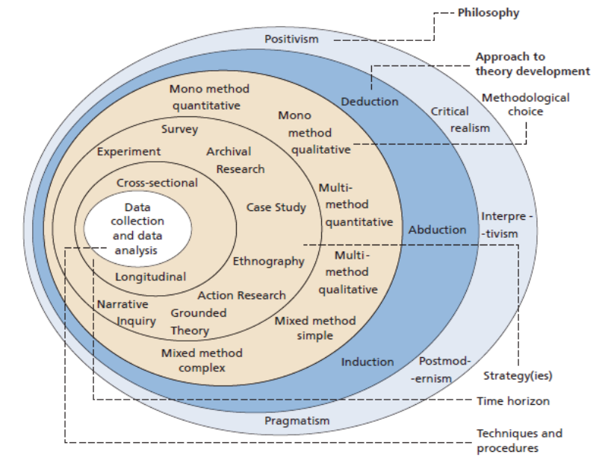
Figure 11: Research Onion by Saunder
(Source: Bianchi, 2021)

3.2 Research Philosophy

By following the interpretivist philosophy, the research began. Interpretivism is a necessary philosophical approach that strongly emphasises utilising qualitative methodologies that can lead to the analysis of a particular phenomenon (Acharya, 2024). It ensures exploring the subjective experiences of the individuals in a specific context. William (2024) outlined that the interpretivism philosophy allows the exploration of the truth and mitigates social interaction problems. By relying on this aspect, the interpretivist philosophy has been chosen to examine Starbucks' CSR strategies in the international market through qualitative data.
The difference between interpretivism and positivism philosophy is that interpretivism generates value by emphasising qualitative data and focusing intensely on the context (Nickerson, 2024). Positivism holds ontological beliefs that objective reality exists, and this paradigm ensures that hypothesis testing is done through statistical techniques (Saliya, 2023). Allmark and Machaczek (2018) outlined that the realism philosophy is a significant basis of mixed methods research. The quantitative or mixed data set has been eliminated from this research, and thus, the positivist and realism paradigms have been avoided.
Lawler and Waldner (2023) explained that interpretivism's paradigm comprises a methodological commitment to understanding a specific phenomenon within its deeply rooted meaning and context. The interpretivism paradigm is most applicable to exploring the effectiveness of Starbucks's different CSR programs in the international market.

3.3 Research Approach

The inductive research approach has been selected based on the second layer of the Research Onion framework. The research approach poses a significant implication for how the study is designed and the research techniques are selected (Bianchi, 2021). The inductive approach narrows down the scope of the research and is linked with the qualitative methods (Kumar and Ujire, 2024). On the contrary, the deductive approach tests the theory and is related to the quantitative approach. Okoli (2023) outlined that the inductive approach emphasises and drives a general from a specific case. The deductive approach, however, takes the general rule and concludes a particular case. The inductive approach broadly encourages a flexible approach towards the research by collecting qualitative data (Frank and Ejaz, 2024). This approach also enables a comprehensive exploration of the respective phenomena of the research. The deductive approach puts a strong emphasis on the use of empirical evidence to test the theories. The research has moved forward with applying qualitative data and rejected empirical testing. Thus, the inductive approach has been considered, followed by the rejection of the deductive approach.
According to Hoiruddin and Ulfa (2020), the inductive approach can help us understand the phenomenon's meaning by applying the qualitative technique. In this regard, the inductive approach has been chosen to identify Starbucks' CSR strategies and effectiveness in the international market.

3.4 Research Strategy

The selected methodological techniques in this study suit the qualitative research strategy. Yadav (2022) explained that the qualitative strategy comes from a distinct paradigmatic stance and demands specific criteria for evaluating good research. The quantitative research strategy emphasises the hypotheses of the research. The research has proceeded towards a suitable conclusion, with the qualitative approach preferred. Thus, regarding this fact, the qualitative research strategy has been included, and the quantitative strategy has been avoided.
Busetto et. al. (2020) contradicted this and stated that the nature of flexibility and responsivity makes the qualitative research strategy suitable for qualitative research. The research strategy facilitates significant decisions about planning the research design and data collection techniques. The present research has picked out qualitative data to investigate the efficiency rate of Starbucks' CSR programs. Thus, the qualitative research strategy has been considered appropriate in this study. The quantitative research strategy collects and interprets numerical data (Apuke, 2017). The research has not favoured any numerical data set, so the quantitative research strategy has not been used.

3.5 Research Design

The exploratory research design has been put into practice in the current research. Makri and Neely (2021) determined that the primary motive of this design was to seek new insights into a particular context. The exploratory design allowed the collection of qualitative data to evaluate the effectiveness of Starbucks's CSR practices in the international market. Olawale et. al (2023) stated that the exploratory design is flexible and well-known for contributing value to the research. This research design is also suitable for examining the research problem and gaining an in-depth understanding of the problem. Thus, to explore the research problem, this study design has proved to be worthy. The research has yet to consider using descriptive and explanatory research designs. Through the views of Makri and Neely (2021), it has been observed that explanatory design sets up the relationship between the variables in primary research. The quantitative nature of the descriptive research design allows its suitability in quantitative research and not in qualitative research (Ansari et. al, 2022). For these reasons, the descriptive and the explanatory designs have been rejected from this present research.
In addition, the exploratory research design enables an examination of various sources, such as published secondary data based on a specific phenomenon (Thomas and Lawal, 2020). This research has examined various secondary data sources to explore Starbucks' CSR strategies. Due to this, this research design has been chosen to carry out this research objective.

3.6 Data Collection

Sukmawati (2023) explained that data collection techniques must be implemented in the research to obtain valid information from the collected data. Based on the two categories of data collection methods, the secondary data collection method has been preferred in this research. The data set previously collected by an investigator can be obtained through secondary data collection (Martins et al. 2018). First-hand data is mainly the primary data that can be gathered through the primary data collection method.
Secondary data has several advantages, and it is applied in this research. Secondary data is previously collected by another researcher, saving time and money (Pérez-Sindín, 2017). In addition, secondary data allows us to seek new insights from the previous analysis. Primary data involves high costs and the potential for data collection bias. Thus, primary data is not preferred in this research.
This study's secondary data has been collected from academic journals, articles, newspaper websites, and Starbucks' CSR reports. The keywords followed in this search strategy are CSR, Starbucks, international market, and strategies. In addition, the data collected has been considered relevant to the research topic.

Inclusion and Exclusion Criteria

Updated and authentic papers have been used to collect suitable secondary data. The old papers are excluded from this current research. The research proceeded towards a specific conclusion by following the criteria for selecting papers from and after 2017. The documents issued before 2017 were excluded as they were old and could not help to obtain reliable information for the study. Papers in English are included, while documents in other languages have yet to be considered in the research. Another significant inclusion criterion is the selection of documents that contain information about Starbucks' CSR measures in the international market. Papers not involving this information have not been preferred in this respective study.

3.7 Data Analysis

The data analysis technique has the potential to unlock essential values by making specific facts and information transparent (Bhatia, 2017). Qualitative data has been used in this research; thus, the qualitative data analysis technique is preferred. Mezmir (2020) viewed the fact that the motive of the qualitative data analysis method is to describe a specific phenomenon in detail. This research has eliminated the numerical data for which the quantitative data analysis method has yet to be considered valid. Dunn et al. (2015) explained that secondary data analysis takes less time and resources and enables access to large data sets. Among the different categories of qualitative analysis, thematic analysis has been applied in this study. The other categories have yet to be used as they cannot identify and create themes to analyse the data most suitable for the research topic.
In qualitative research, thematic analysis is a valuable analytic tool that seeks insights into a phenomenon under investigation (Christou, 2022). It is mainly regarded as a flexible tool that offers a nuanced account of the collected data. Braun and Clarke (2023) opined that thematic analysis is applied in qualitative research due to its theoretical flexibility. The other methodological techniques are more flexible than thematic analysis. Therefore, it has been chosen to analyse the effectiveness of the different CSR practices employed by Starbucks in the international market. The six-step process of thematic analysis has been used to generate themes in the study. As Peel (2020) stated, in the first step, the data is collected, followed by engaging with the data. The third step involves coding the extracts from the data, while the codes are generated in the fourth step. The fifth step involves conceptualising the themes, followed by the final step, which comprises contextualising the findings. In this way, the themes of this research have been created.

3.8 Ethical Considerations

Ethics mainly deals with the moral problems linked to research practice (Mirza et al., 2023). To preserve the study's credibility, transparency has been maintained as a guiding principle in all the research steps. The various university regulations have been complied with to avoid ethical issues. The correct referencing format has been followed to prevent plagiarism. The data has been appropriately cited, and the authors have been acknowledged to avoid integrity issues. In addition, all the data are effectively handled and stored by following the Data Protection Act. Moreover, no party other than the investigator has access to the data.

3.9 Research Timeline

Research Activities | Week 1 | Week 2 | Week 3 | Week 4 | Week 5 | Week 6 | Week 7
Formulating the aims and objectives
Writing the literature review
Collection of secondary data
Data analysis
Conclusion and recommendations
Final review and submission
Table 1: Research Timeline
(Source: Self-developed)

3.10 Summary

The different research techniques have successfully investigated the factors leading to the design of CSR practices at Starbucks in the international market. The authentic secondary data aided in acquiring essential results for the study. By opting for the interpretivist philosophy, inductive approach, and exploratory design, the proper selection of data collection techniques and analysis has stood out as much as possible. The maintenance of the ethics mentioned above has also allowed the successful completion of the study without any ethical issues.

Chapter 4: Findings and Data Analysis

4.1 Thematic Table
Author’s name | Title | Methods used | Findings
Adams (2022) | Sustainability in large food and beverage companies and their supply chains: An investigation into key drivers and barriers affecting sustainability strategies | Secondary methods | The Food and Beverage Industry have substantial environmental and social impacts
Newman et al., (2020) | Corporate Social Responsibility in a Competitive Business Environment | Secondary methods | Due to huge competition in the business world, the adoption of CSR is impacted in many ways.
Mishra (2020) | How Starbucks Made An Alliance With TATA For The Indian Market? | Secondary methods | By collaborating with business leaders in India, Starbucks is extending its tea sustainable practices across stores.
Dudovskiy (2022) | Starbucks CSR: Corporate Social Responsibility - Research-Methodology | Secondary methods | Starbucks has looked after the welfare of the local communities.
Starbucks (2020) | C.A.F.E. Practices: Starbucks Approach to Ethically Sourcing Coffee | Secondary methods | Starbucks has set ethical sourcing standards to showcase they use sustainable practices.
Starbucks (2022) | The Starbucks Foundation Launches Global Community Impact Grants Initiative, Investing $30 Million by 2030 | Secondary methods | Starbucks has launched granting initiatives and committed to fulfil its projects by 2020.
Perry (2019) | Starbucks Organizational Structure & Culture A Starbucks Coffee Company case study | Secondary methods | Starbucks has introduced the concept of open forums so that employees can interact openly with its seniors and resolve queries.
Kang and Namkung, (2018) | The Effect of corporate social responsibility on brand equity and the moderating role of Ethical Consumerism: The Case of Starbucks | Secondary methods | The analysis of moderating effects revealed that consumers who are highly committed to ethical consumerism have a stronger connection between economic corporate social responsibility and positive brand equity for restaurants.
Richey and Ponte (2021) | Brand Aid and Coffee Value Chain Development Interventions  Is Starbucks Working Aid Out of Business? | Primary methods | We conclude that although Brand Aid types of VCDIs claim to eliminate the need for aid, they primarily benefit businesses and celebrities, with their real effects on the ground being limited and uncertain.
Bui et al. (2020) | Green marketing as showcase of sustainable coffee shop business | Primary methods | Additionally, the author successfully uses the concept to minimize environmental impacts and appeal to customers who share similar concerns. This study can also serve as a guide for other restaurants looking to operate sustainably, offering marketing strategies that result in more efficient business practices.
Hwang et al. (2020) | The importance of philanthropic corporate social responsibility and its impact on attitude and behavioural intentions: The moderating role of the barista disability status | Secondary methods | The data analysis results indicated that PCSR positively influences attitudes, which subsequently enhances intentions to use, word-of-mouth intentions, and the willingness to pay a premium. Additionally, the study identified the moderating effect of barista disability status. Based on these findings, the discussion covered both theoretical and managerial implications, including the promotion of hiring individuals with disabilities in coffee shops.
Maisuria (2023) | Case Study: How Starbucks India crossed Rs 1000 Crore in yearly revenue | Secondary methods | Starbucks has partnered with NGOs and local institutions to support skills and training program to the needful.
Mainwaring (2021) | Purpose At Work: How Starbucks Scales Impact By Listening To All The Stakeholders In Our Shared Future | Secondary methods | Starbucks has marked a record of 100% pay equity in the US workforce.
Singh and Rahman (2021) | Integrating corporate sustainability and sustainable development goals: towards a multi-stakeholder framework | Primary methods | CSR plays a significant role in shaping the business dimensions.
Ardiansyah and Alnoor (2024) | Integrating Corporate Social Responsibility into Business Strategy: Creating Sustainable Value | Secondary methods | Integrating CSR initiatives in the business operations helps in gaining brand trust and customer satisfaction.
Nirino (2019) | The impact of corporate social responsibility on firms’ financial performance, evidence from the food and beverage industry | Secondary methods | CSR directly impacts a firm’s financial situations in the food and beverage sector.
Bui et al. (2022) | Developing a food and beverage corporate sustainability performance structure in Indonesia: Enhancing the leadership role and tenet value from an ethical | Primary methods | This study adds to the corporate sustainability performance literature by presenting new theoretical perspectives as a hierarchical structure and detailing the causal relationships among the attributes. It also offers practical guidance to the Indonesian food and beverage industry, aiding in the development of reference data on firm performance and competitive advantage.
Nisa et al. (2022) | The Concept of Greenwashing and its Impact on Green Trust, Green Risk, and Green Consumer Confusion: A Review-Based Study | Secondary methods | The conclusion revealed that there were significant connectio
World Coffee (2022) | Starbucks allocates £1.4m funding for sustainable packaging projects in the UK | Secondary methods | Starbucks has invested huge capital in the UK for reducing carbon footprint and reduce waste.
Olobia (2023) | Environmental Sustainability Through Corporate Social Responsibility | Secondary methods | The findings of the paper indicated that Starbucks' report could enhance its sustainability initiatives, given the company's strong stance on climate change. To achieve corporate growth, the paper offers valuable insights into resilience and conservation for building a resilient community.
Kettunen (2020) | Corporate Activism–New Kid on the CSR Block: Perceptions of Social Justice in Starbucks' Corporate Activism Discourses | Secondary methods | The study essentially demonstrates that corporate activism is a fresh and enduring element of corporate social responsibility (CSR). For corporations to create a meaningful impact, they must critically evaluate their roles and privileges within society.
Abou-Sabe and Kaplan (2024) | Starbucks sued for allegedly using coffee from farms with rights abuses while touting its ‘ethical’ sourcing | Secondary methods | Starbucks has been charged for using coffee from farms with rights abuses and claiming 100% ethically sourced items.
Olobia (2023) | Environmental Sustainability Through Corporate Social Responsibility | Secondary methods | The paper's findings suggest that Starbucks' report has the potential to enhance its sustainability efforts, considering the company's strong commitment to climate change advocacy. To support corporate growth, the paper offers comprehensive insights into resilience and preservation for fostering a resilient community.
Agee (2023) | The effects of growing consumer green consciousness on corporate supply chain sustainability enhancement: American Fortune 500 | Primary method | The research emphasises the urgent need for businesses to align their operations with consumer priorities on sustainability. Additionally, examining managerial strategies and their effects on supply chain sustainability and resilience brings depth to discussions about corporate accountability.
Tsai et al. (2020) | Exploring the effect of Starbucks' green marketing on consumers' purchase decisions from consumers' perspective | Primary methods | This study's findings can be used as a guide for companies looking to enhance the measurable impact of their eco-friendly marketing strategies by encouraging consumers' buying intentions.
LeBaron et al. (2017) | Governing global supply chain sustainability through the ethical audit regime | Secondary methods | The article challenges the prevailing view of the audit regime as a neutral and benign tool of supply chain governance. It emphasizes its involvement in debates over the legitimacy and effectiveness of industry-led privatization of global governance.
Gozdan and Sudolska, (2019) | Exploring company's activities in the field of CSR: The case of Starbucks | Secondary methods | The paper presents research results indicating that Starbucks is involved in various activities supporting different communities and dedicated to environmental protection and climate change resistance.
Arkesteyn (2020) | Framing environmental movements: a multidisciplinary analysis of the anti-plastic straw movement | Primary methods | Although plastic straws may appear insignificant in terms of size and their impact on global waste, they are connected to larger environmental issues and complexities, making them a catalyst for important discussions.
Ginting and Tesselhof (2023) | How does Starbucks implement the blockchain system in supply chain management to maintain its product quality? | Secondary methods | The recommendations for Starbucks Indonesia to consider when exploring the implementation of blockchain technology in its supply chain management include Pilot Testing and Proof of Concept, Collaborating with suppliers and partners, Providing Training and Education, and Continuous evaluation and improvement.
Aminuddin et al. (2021) | Starbucks Coffee Company: coffee cafe company | Primary methods | In order for Starbucks to consistently generate strong revenues, they must actively innovate to cater to their customers. Accurately focusing on elements such as customer segments, value proposition, channels, key activities, and key partners in the business model will certainly bring them the success they desire
Table 2: Thematic table
(Source: Self-developed)

4.2 Coding Tree
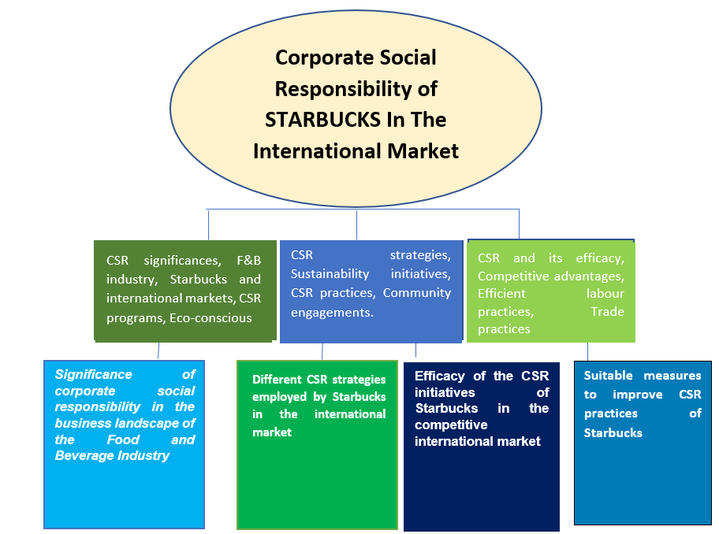
Figure 12: Coding Tree
(Source: Self-created)

4.3 Thematic Analysis

Theme 1: Significance of Corporate Social Responsibility in the Business Landscape of the Food and Beverage Industry

As Singh and Rahman (2021) claimed, corporate social responsibility (CSR) plays a significant role in shaping the business dynamics of an industry. The Food and Beverage (F&B) industry is driven by its distinctive environmental and consumer-facing natural influences. CSR programs in this context can help the industry mitigate ecological impact. As quoted by Adams (2022, p1), “The food and beverage industry and its associated agricultural supply chains have significant environmental and social impacts''. This implies that the F&B industry faces growing scrutiny over sustainability approaches, specifically regarding ethical sourcing and resource utilisation. With the help of CSR efforts, any industry, including the food and beverage industry, can resonate positively with consumers who are becoming eco-conscious and seek products aligned with their expectations and values.
On a similar note, Ardiansyah and Alnoor (2024) clarified that CSR, when businesses align their goals with social and environmental values, companies can contribute to a more sustainable and inclusive future not only for the organisation but also for the general public. Also, it can lead to many benefits for organisations that will provide new business opportunities. As Newman et al. (2020, p. 3) quoted, “Second, competition may have differential effects on CSR adoption and firm performance. If enterprises in competitive settings compete for socially responsible consumers, CSR activities may be boosted by market competition, improving overall industry efficiency”. In essence, the above statements mean that several competitions in the market are prevalent, which may act as catalysts for CSR adoption by incentivising organisations to tailor to specific socially responsible consumers. When organisations compete for socially responsible consumers, they are encouraged to improve their CSR practices and strategies. With the help of the right initiatives, companies can stay competitive in the food and beverage industry. The competition motivates them to invest and innovate in CSR practices to fulfil consumer preferences and comply with competitive tensions. Nirino (2019) opines that consumer trust and brand reputation increase when companies integrate the right CSR strategies. CSR will promote clarity and community engagement, which will help consumers respond to the brand's efforts. A brand like Starbucks has been integrating CSR strategies to attract more consumers and build trust to stay competitive in the food and beverage industry.
Bui et al. (2022) state that CSR is crucial in the food and beverage industry, reflecting the growing consumer demand for ethical practices. The study states that F&B companies must ensure that sustainable sourcing with fair labour practices is followed with environmental stewardship. It is also analysed from the research that the superficiality in the sustainability practices has been noticed to have been designed to enhance brand image rather than drive substantive changes in the genuine landscapes. From the study by Nisa et al. (2022), it is understood that public trust gets eroded by the fraudulent practices of greenwashing that have significantly declined the brand image of the companies. The study also effectively stated that significant CSR can develop substantial outcomes in the companies, such as improved supply chain sustainability and enhanced community well-being, which is necessary for sustainability principles. From the study, it is understood that applying these initiatives is challenging and is not merely performative but integrated into core business strategies for the business. In the study, the authors also stated, “Nevertheless, several corporations continue to take advantage of the "green trend" by publicising interesting information about their sustainability impact, when the actuality is quite the opposite. Greenwashing refers to companies that mislead consumers about the goods and services they offer” (Nisa et al. 2022, p 9). Thus, it is understood that meaningful CSR can differentiate companies in a competitive market to foster long-term loyalty with the contribution to further sustainability practices.

Theme 2: Different CSR Strategies Employed by Starbucks in the International Market

As Dudovskiy (2022) mentioned, Starbucks is a global leader in the coffeehouse sector, adopting a myriad of corporate social responsibility practices that cater to different regions and countries. With these initiatives, Starbucks has committed to sustainability, employee welfare, and community involvement. For instance, one of the significant CSR initiatives integrated by the coffeehouse brand is community engagement and philanthropy. On the other hand, Maisuria (2023) said that in countries like India, Starbucks has partnered with NGOs and local organisations to support skills and education training programs for needy children. Through such an initiative, it can be analysed that Starbucks prioritises recruiting from local regions and promotes diversity within its business. This ensures their initiatives align with their global dedication to inclusion and diversity. As Mishra (2020, p1) quoted, “TATA Starbucks Private Limited is a joint venture between TATA Consumer Products and Starbucks Corporation which brings unparalleled experience to Indian customers. Starbucks made an alliance with TATA for the Indian Market”. From the above statement, it can be analysed that Starbucks is forming partnerships with different countries and its renowned business leaders to promote sustainable tea practices. Collaboratively, they are working on improving a signature Indian tea blend that will be available in all Starbucks stores in India.
The author quoted, “The global coffeehouse chain runs a FoodShare food donation program in all company-operated stores in the US and Canada. 10.4 million and 1.2 million meals were donated in the US and Canada respectively in FY21” (Dudovskiy, 2022, p1). This demonstrates that Starbucks has taught the proper CSR practices by redistributing excess food to needy people, which has contributed positively to the welfare of the local communities. One of Starbucks's major CSR approaches is community engagement. In countries like the Philippines, the Starbucks Foundation has invested more than $3.2 million in grants to support the communities in the country and help build resilience to fight hunger issues (Dudovskiy, 2022). Initiating such practices reflects that the brand is dedicated to the people's overall welfare, especially those in need. On the other hand, World Coffee (2022) opined that Starbucks has committed to reducing its environmental footprint in the UK by introducing sustainable packaging projects. Even though the countries’ regulations are stringent, the brand has been dedicated to implementing sustainable practices, promoting recycling, and reducing waste.
On the other hand, Starbucks emphasises farmer support and ethical sourcing as a part of its CSR strategies for its global business. As quoted by Starbucks (2020, p2), “The cornerstone of our ethical sourcing approach to buying coffee is Coffee and Farmer Equity (C.A.F.E.) Practices, which was one of the coffee industry’s first set of ethical sourcing standards when it launched in 2004”. Starbucks works closely with local coffee farmers through its Coffee and Farmer Equity (C.A.F.E.) program. This initiative relies mainly on ensuring fair employee wages, sustainable farming approaches, and facilitating community development projects. With the help of these partnerships, the brand is ensuring that the proper training on agricultural practices is provided. Therefore, it helps enhance the livelihood of farmers and facilitates environmental impacts. On the contrary, Abou-Sabe and Kaplan (2024) mentioned that even though Starbucks claims it relies on 100% ethical or sustainable sourcing, it is not entirely true. This reflects that ethical commitments from big brands like Starbucks often have an outsize influence on the integrity of supply chains if they are backed up.
Hence, based on all the above CSR strategies implemented by Starbucks, the brand is committed to tailoring its initiatives to suit local requirements and priorities. It contributes to the environments where it functions and improves its brand image. Starbucks continues to set benchmarks by integrating good CSR practices within the global coffee industry.
According to Olobia (2023), it is proved that by focusing on ethical sourcing options, Starbucks has developed different environmental sustainability initiatives with community development for better CSR practices. The study also stated that Starbucks coffee and farmer engagements have ensured fair wages and sustainable farming, which is inconsistent across the different regions. According to the Agee study (2023), it is analysed that green building practices with ethical sourcing and community building have become essential for the company. Yet, these efforts often face scrutiny for not fully offsetting the company's environmental footprint, which causes the company to face challenges. The study ensures that the health programs and support for local education are the primary facts of community engagement that demonstrate a commitment to social welfare, which is why systematic solutions will be developed. However, the study also shows that Starbucks has had excellent results in promoting reusable cups and investing in renewable energy to encourage efficient CSR practices in society. The study also said, "Starbucks is switching to paper cups and offering promotions in American locations when bringing a reusable cup.
Additionally, “sustainable packaging is mentioned in all three selected sustainability reports” (Agee, 2023, p. 49). The author presented the knowledge effectively in his study; however, a lack of beneficial information was noticed, which is why a research gap was developed. There are a variety of effective CSR strategies, and if they are followed efficiently, the company will achieve long-term success.

Theme 3: Efficacy of the CSR Initiatives of Starbucks in the Competitive International Market

Starbucks has implemented various CSR initiatives to benefit its business and the general public. As opined by Perry (2019), Starbucks is very conscious about its employees and their welfare. The brand has significantly affected the international business landscape by setting high standards for corporate responsibility. Its commitment to employee welfare has enhanced job satisfaction and appeals to a loyal workforce. The author even said it has taught open forums for employees to ask questions and communicate openly with their seniors. The author Perry (2019, p. 3) quoted, “To address this issue, former Starbucks President Behar introduced open forums to encourage employees to ask questions and communicate with superiors. A culture of openness developed”. Such initiatives have proven that the coffeehouse chain has successfully driven innovation and increased market productivity with the collaborative efforts of the skilled workforce.
Similarly, Mainwaring (2021) stated that the brand has recorded 100% pay equity throughout the United States (US). This has motivated employees to work more diligently and with better commitment, aligning the brand’s values with theirs. Hence, based on both studies, it can be concluded that Starbucks’ employee welfare and benefits strategy has proven to be impactful throughout its operations on a global level.
On the other hand, another CSR initiative by Starbucks was community engagement. As quoted by Starbucks (2022, p. 1), “Grants will be awarded for causes aligned to The Starbucks Foundation’s community impact goals, including youth empowerment, inclusion & diversity, social services, hunger relief, economic opportunity, and coffee-, tea- and cocoa-growing communities”. This indicates that the Starbucks Foundation has invested $30 million in a project that will be implemented by 2030 (Starbucks, 2022). With such an initiative, the brand is trying to motivate people towards youth empowerment, hunger relief, and other social causes that can make the world a better place for everyone. Hence, it has empowered the individuals of the local regions and positively impacted the communities. Based on the above discussion, Starbucks’ community engagement practices have helped the brand reach new heights. The coffeehouse chain is gaining more consumer trust by applying such excellent CSR practices integrated at the core of its operations.
According to the study by Kang and Namkung (2018), Starbucks' CSR initiatives are essential and positively impact the international market. It is also understood from the study that the company has maintained ethical sourcing for a long time, which has developed equity for the farmers with a CAFE and the company so that the farmers stay satisfied. The authors have also stated that high-quality coffee is the company's signature and promotes fair wages, safe working conditions, and sustainable farming practices that have contributed to social responsibilities. It is understood from the study that Starbucks has enhanced its brand reputation by investing in sustainability practices and customer loyalty, which differentiates it from competitors who may not prioritise similar values. However, the author has yet to state the actual requirement of the CSR initiatives, and thus, a research gap is noticed in the study.
The study by Richey and Ponte (2021) shows that Starbucks provides numerous farmers with support for the development of centres and its Global Farmer Fund, which has developed more significant opportunities for the market. As per the study, the essential resources also become available with this strategy to improve training and financing with better crop quality and yield, fostering a more sustainable supply chain throughout the business landscapes. The authors have also said, “Under the guise of helping farmers in the global South, Starbucks partners with celebrities, traditional development implementers and consumers to test a new business model given catering to the shifting demands of elite coffee drinkers around the globe” (Richey and Ponte 2021, p .2). The authors have also stated that the long-term agricultural sustainability and economic stability for coffee-growing communities are ensured by this implication, which will have a future impact. However, due to secondary resources, the authors have developed a research gap that needs to be analysed.
The study by Olobia (2023) clearly states that Starbucks' appeal has become strong with sustainable practices to a growing segment of socially conscious consumers who like ecological awareness. Starbucks's sustainability options also impact customers' prioritisation of environmental and social responsibility in purchasing decisions. Brand loyalty is developed with these customer values but also attracts new customers who seek ethically produced products, the latest trend in the market.
The CSR initiatives of Starbucks in the competitive market have a mix of impacts, some positive and some negative. As per the study by Bui et al. (2020), it is considered that Starbucks's ethical sourcing practices and environmental sustainability efforts, such as promoting reusable cups and reducing carbon emissions, have garnered positive attention and consumer loyalty in the business. The study also specified that Starbucks is differentiated by these initiatives in a crowded market, appealing to increasingly eco-conscious consumers in society. In the study by Hwang et al. (2020), it is explored that Starbucks has also developed various community engagement programs, such as local educational and health initiatives, that demonstrate a commitment to social responsibility; however, their impact is unequal in every region. Thus, it is ensured that competitors with more localised and deeply integrated CSR strategies may express Starbucks in terms of authentic community impact and responsibilities in society. The author has described the data accurately but could have used the primary findings so that the research gap is not highlighted as it is done in the study for the secondary method and its uses. However, there are notable successes in Starbucks's CSR, with their true efficacy in a competitive market that depends on consistent and transparent impacts.

Theme 4: Suitable Measures to Improve CSR Practices of Starbucks

According to the study by Kettunen (2020), it is analysed that Starbucks' CSR practices need immediate improvement, which is essential to examine both its current initiatives and the areas where enhancement is required for the company. In the study, it is efficiently stated that sustainable sourcing becomes the most crucial effort of Starbucks with community involvement and environmental stewardship; however, some areas still need development in the sector. The authors have also said, "The findings ultimately show that Starbucks’ activism efforts are derived from the narrow and instrumental perspective of an advantaged group and fail to bring out the voices of those who are marginalised against and disadvantaged” (Kettunen, 2020, p. 1). The study by Tsai et. al. (2020) explores that, in the first case, fair trade practices must be developed in the company to create benefits in Starbucks’s marketing strategies. The study also ensures that the company needs to ensure that the coffee is sourced from ethical sources and that 100% of its coffee is certified by fair trade. This would further guarantee that all farmers receive fair compensation in this process. The study has also stated that not only will the farmers' livelihood be affected by these practices but also reinforce Starbucks' brand as a socially responsible leader in the coffee industry that is aware of farmers' well-being.
The study by LeBaron et. al. (2017) has stated the scenario well with the application of the statement that transparency in the supply chain of Starbucks is critical, and they could implement more rigorous third-party audits and publish detailed reports on the outcomes so that efficiency is developed in the transparency. The study also stated that consumers with this clear information could develop further loyalty to businesses knowing about the origins of their coffee and the conditions under which it was produced, fostering greater consumer trust and satisfaction. As per the study by Gozdan and Sudolska (2019), it is noticed that environmental sustainability is another important consideration that needs to be implemented in the company. However, it has been seen that Starbucks has made efforts to reduce its carbon footprint and promote recycling, which is a significant opportunity to lead the way in innovative, eco-friendly packaging solutions that will keep environmental values high.
From the study by Arkesteyn (2020), it is analysed that the reusable cup options and the biodegradable cups of Starbucks have showcased the concern and incentivised customers to utilise these alternatives that significantly reduce waste and set a precedent in the industry of coffee, apart from all the strategies Starbucks needs to focus on their efficient labour practices which the better performance efficiency will be developed. The study also stated that the company needs to implement essential benefits so that further improvements in working conditions, particularly regarding shift scheduling and workload management, would enhance employee satisfaction and productivity. The study also said, “For those that do, it’s not common for them to receive many in the recycling stream in the first place. Since plastic straws are often used in disposable beverage cups with many different parts (plastic lid, coated paper cup, liquid beverage), users often forget (or choose not) to recycle them” (Arkesteyn, 2020, p. 8). However, in the study, the author failed to create the settings for accurate data, and thus, a research gap was noticed. From the study, it is understood that flexible scheduling practices and ensuring adequate staffing levels would alleviate employee stress and foster a more positive work environment.
The study uses various strategies, which has simplified the fact that the company needs to adopt these strategies for enhanced competitive advantages in the market. According to the work by Ginting and Tesselhof (2023), the supply chain of Starbucks needs to be focused on the establishment of transparency and accountability. However, the study also states that the greenwashing acquisition needs to be resolved by efficiently following sustainable practices with regular audits to standardise the business model. In the study by Aminuddin et. al. (2021), it is explored that Starbucks has also efficiently supported the farmers and community so that the C.A.F.E of the company succeeds with effective CSR practices comprising fair wages and sustainable farming procedures. The study shows that the company needs to apply renewable energy to solidify its commitment to sustainability initiatives further. The study also said that the company needs to analyse community engagement efforts to address specific local needs more effectively and foster more profound and meaningful connections among stakeholders. The authors have also stated, "This sustainable Starbucks environment can make the customer do their things while enjoying the aromas for coffee lovers” (Aminuddin et al. 2021, p. 17). Thus, with the adaptation of these strategies, it is understood that Starbucks has reinforced the authenticity of its CSR initiatives that have fostered trust and loyalty among consumers while making a substantial, positive impact on the environment and communities worldwide. Thus, it is understood from the exploration of the studies that the CSR initiatives in Starbucks can be established with these establishment strategies to develop better business results.

4.4 Discussion

The first theme has emphasised the fact that CSR has a beneficial role in the business arena of the food and beverage sector. The CSR efforts of the organisations allow them to influence eco-friendly consumers positively. By aligning the business goals with social and environmental values, the organisations can contribute towards sustainability. This is similar to the second point of the literature review, which focused on the concepts associated with corporate social responsibility (CSR). Strategic CSR of the organisations strongly emphasises social and environmental issues and maintains a balance between the needs of the different stakeholders. Through the first theme, it has also been identified that with the appropriate CSR initiatives, businesses can achieve competition in the food and beverage sector. However, such an industry has yet to be reviewed in the literature review for which a difference has been identified. The first theme has further analysed that organisations can develop consumer trust and brand reputation by incorporating the appropriate CSR strategies. The fair labour practices and the negative impacts of the greenwashing techniques are also described in the first theme, which contradicts the literature that was used in the previous stages. In the theme, it is stated that greenwashing is a dangerous implication for industries in which fraudulent practices occur with the practices of sustainability. In the literature review, no such implication is shown; thus, it is proved that the study is efficient for future implications.
The second theme has shed light on Starbucks's various CSR strategies in the international market. The theme explains that community engagement is one of Starbucks' significant CSR strategies. Regarding its CSR strategy in India, the brand has partnered with NGOs to support the education of needy children. On the contrary, as a part of their CSR initiative, Starbucks has started a FoodShare food donation program, which provides 10.4 million meals to needy people. Through the analysis of the second theme, it has also been observed that in Plilipness, Starbucks has widely invested in the Starbucks Foundation to build resilience in addressing hunger issues. This has reflected the brand's dedication towards the well-being of human beings. Starbucks has also adopted the CSR initiative to reduce its environmental footprint through sustainable packaging projects. However, through the literature review, it has been reviewed that Starbucks has implemented the “Greener Stores” initiative, based on which the company has developed eco-friendly store designs to reduce its carbon footprint. This shows the distinction between the second theme and the literature review. Apart from this, it has also been found from the literature review that Starbucks has employed the Starbucks Foundation program. Based on this program, the company has invested 25 million US$, which can broadly strengthen the coffee-growing local communities. In addition, Starbucks has created a diversified workplace and supported the LGBTQIA2+ community to maintain the racial and ethical balance in the organisation's workplace. However, no such CSR initiatives of Starbucks have been analysed in the second theme of the research. This shows the difference between the literature review and Theme 2. The theme shows differences in facts based on community-building initiatives and coffee engagements with farmers. The company has shared efficient CSR practices that are also contradictory with the literature, and thus, in the study, this part is essential, which shows that Starbucks is involved in various strategies for community building and supporting a better way of business. Thus, from the theme, it is analysed that the company does a variety of positive activities for the well-being of society. Therefore, the company's CSR is high in the global circle.
The third theme of the study focuses on the efficacy of Starbucks' CSR initiatives in the competitive market. It has been analysed that the CSR programs of this brand in the corporate workplace have improved job satisfaction and appealed to a diverse array of talents. The brand also offers 100% pay equity to its employees, motivating them to give their best. However, the effectiveness of the CSR initiatives has yet to be mentioned in the literature review, reflecting the difference between the third theme and the literature review. In addition, the literature review signifies Starbucks' water conservation efforts. The brand uses low-flow valves in its stores to reduce water usage. The theme differs because it has yet to analyse any such Starbucks initiatives. The theme has denoted Starbucks' CSR initiative of offering support to farmers through the Global Farmer Fund. This has developed significant opportunities for the brand in the competitive market. The literature review, on the other hand, has shed light on the waste reduction initiative of Starbucks that promotes recycling, which has also developed the brand's reputation to a great extent. However, the theme has yet to analyse any such waste reduction initiative of the brand. In this context, a difference is found between the third theme and the literature review.
The final theme is suitable strategies to enhance Starbucks' CSR measures. It has come to light that a similarity has been identified between the literature review and the final theme. This concerns the sustainable sourcing strategy explained in the literature review and the theme, which can improve Starbucks' CSR practice. The theme analysed how Starbucks can improve its CSR practices by developing fair trade practices. The farmers, by receiving fair compensation, can improve their livelihood, and this can also instil improvement in the CSR practice of the brand. However, the literature review must include information on fair trade practices that reflect the difference between the fourth theme. The fourth theme of the study is crucial, as it states that adequate data is essential for future implications. The theme shows the best practices that Starbucks can follow to stay competitive in the market and efficiently adopt sustainability in the business. In the theme, the company's sustainability strategies are highlighted, which is essential and can be used for other companies to grow strategically in sustainability practices.
This theme is similar to the literature review explaining the strategy for improving environmental sustainability. The theme and the literature review show that Starbucks' focus on ecological sustainability can add value to its business practices. Eco-friendly packaging solutions are a beneficial strategy that can generate organisational value. The theme also analysed Starbucks' emphasis on developing its labour practices, which can be a valuable part of its CSR strategy. On the other hand, the literature review emphasises expanding community engagement as a strategy to improve Starbucks' CSR practices. However, the theme does not reflect any strategy that denotes the difference between the literature review and the final theme.

Linking with the Research Questions

Question 1: What are the different CSR strategies of Starbucks in the international market that must be investigated?

The research question based on the CSR strategies of Starbucks in the international market is explored in the second theme of the study, in which the efficient result is excavated. In the theme, Maisuria (2023) clearly states that Starbucks uses strategies like collaboration with NGOs to provide local skills and training for the children. The global deduction towards inclusiveness and diversity is the prime importance resolved by the quarry of this research. Therefore, it is understood that the research question is successfully answered in the theme.
Question 2: What is the effectiveness of CSR initiatives of Starbucks in the international market?

This research question is answered in the third theme of the study, in which the efficacy of CSR initiatives at Starbucks is described so that an accurate result can be obtained. The theme of concern for the company's labour practices is highlighted in the theme, which is the effective CSR practices of Starbucks. According to Perry (2019), employee welfare is considered the most essential part of a company's development of effectiveness in CSR practices. The theme also stated the effectiveness, like that of community development, by which it is analysed that the CSR initiatives of Starbucks are comprised of different implications, and the research question gets its answer transparently.

Question 3: What strategies can Starbucks consider to improve its CSR initiatives in the international market?

The research question is analysed in the fourth theme of the study by which it is clear that developing new strategies is possible to improve Starbucks's CSR objectives. The strategy is highlighted effectively in the fourth theme, which has more excellent value for future implications. Strategies like fair trade practices need to be established, as per the study by Tsai et. al. (2020). These strategies and their uses will improve the company's situation and develop beneficial results for the business.

Research Implication

The implication of the research is high as it has discovered facts related to the CSR practices of the companies. This research has values like this that can be used to develop CSR practices, which is the most important implication in the present era. The CSR initiative is a critical component with various corners that must be established carefully to obtain a beneficial outcome. However, in this research, the CSR applications are stated with very negligible confusion. By this research, a business can develop strategies by which the CSR objectives of the company will be met. This research also has value for educational implications and for Starbucks, which can accept the study and develop further CSR strategies.

Chapter 5: Conclusions and Recommendations

5.1 Linking with Research Objectives

First Objective
The study's first objective has been addressed through the data of the second theme. Starbucks has collaborated with NGOs to support educational programs for needy children. The brand operates in different countries and thus has promoted diversity in its business to embrace employee differences. Through the second theme, it was found that the company has also adopted the CSR initiative to redistribute excess food to needy people. Moreover, Starbucks has increased its commitment towards reducing its environmental footprint to promote sustainability in business. Ethical sourcing is also a CSR strategy Starbucks uses in the international market.
Second Objective
The third theme has helped address the second objective of the research. Through the analysis of the theme, it has been found that Starbucks' commitment to employee welfare has dramatically increased its employees' satisfaction. The brand's 100% pay equity has increased the motivational level of the employees. Starbucks' ethical sourcing has improved the brand's sustainability and increased brand awareness. The brand's support of the farmers has increased Starbucks' global opportunities, which has been analysed through the theme.
Third Objective
The information gathered through analysing the fourth theme has helped address the study's third objective. The company can develop fair trade practices that can benefit its marketing strategies. Starbucks must also increase transparency in its supply chain, which can improve the brand's CSR initiatives. The theme has indicated that Starbucks can incorporate eco-friendly packaging solutions, which can reduce the business's adverse effects on the environment.

5.2 Summary

Starbucks is a multinational coffee company; thus, effective CSR initiatives can increase the brand image and customer base. The research was carried out following the secondary qualitative data, through which the scholarly articles were analysed to address the study's objectives. The research findings have denoted that Starbucks has implemented several CSR initiatives, such as partnerships with NGOs to educate needy children about their needs and food. One of Starbucks' significant CSR initiatives is the embracement of diversity. This has facilitated inclusion and diversity within the organisation. It has been further identified through the study findings that Starbucks has emphasised employee welfare and considered the increasing environmental issues due to their business. Thus, they shifted their focus towards the reduction of ecological footprints. Starbucks is required to improve their CSR strategies further to exploit more opportunities in the global market. The company has implemented the green store initiative through which it has developed eco-friendly store designs. This has improved sustainability on a considerable scale.

5.3 Recommendations

As per the research findings, the importance of effective CSR strategy in competing in the international market has been understood. However, some recommendations can be considered that would be helpful for small business owners to improve their CSR strategies to enter the international market:
- Companies need to define a clear business goal and align it with sustainability objectives.
- According to Thanh et al. (2021), SMEs can enhance their CSR performance by prioritising the environment, community and employees. Therefore, it will influence Customers' Purchasing Intentions (CPI) and Corporate Reputation (CR) and maximise competitive advantages.
- It is also important to modify the CSR strategies according to customers' preferences. Considering customer needs, the company should focus on sustainability initiatives like recycled packaging and community engagement to improve its performance in the international market.

5.4 Limitations

One of the main limitations of this research is the use of secondary data only to achieve the study's valid outcomes. However, some articles could not be accessed while collecting secondary data due to the subscriptions. Due to the lack of access to some databases like Scopus, important and high-quality peer-reviewed journals on the corporate social responsibility of Starbucks could not be collected. Further, some crucial reports related to Starbucks' CSR must be made available in the public domain, limiting the analysis of Starbucks' corporate social responsibility in different national contexts. Apart from that, using limited data sources can also be considered a research limitation. Due to time constraints, such data could not be collected from the public domain for proper analysis to enrich the research outcomes. Another area for improvement is the extensive focus on Starbucks; the research should have considered other brands in the coffee retail or food and beverage industry adopting CSR strategies successfully in different countries. Only limiting the research to Starbucks has narrowed the scope of the study.

5.5 Future Scope

Based on the limitations of the current research study, some suggestions can be provided to broaden the scope of future research. The same topic can be investigated further using primary quantitative or qualitative data. A questionnaire survey with a large sample size can be beneficial in identifying different CSR approaches adopted by Starbucks and their impact on customers. Moreover, a semi-structured interview with the personnel of Starbucks can also help in a detailed understanding of how the brand has localised or modified its CSR strategies in different cultures and countries. It would be better to employ a statistical analysis to analyse the numerical data to obtain definite measures. Apart from this, future scholars can also focus on any competitors of Starbucks, such as Costa Coffee, McDonald's or others and adopt a comparative approach between them to showcase the effective CSR strategies of the brand in the international market.

References
Abiddin, N.Z., Ibrahim, I. and Abdul Aziz, S.A. (2022) Non-governmental organisations (NGOs) and their part towards sustainable community development. Sustainability, 14(8), p.4386. Available at: https://doi.org/10.3390/su14084386 (Accessed on: 20 May 2024)
Abou-Sabe, K. and Kaplan, A. (2024) Starbucks sued for allegedly using coffee from farms with rights abuses while touting its ‘ethical’ sourcing. NBC News. Available at: https://www.nbcnews.com/news/us-news/starbucks-sued-allegedly-using-coffee-farms-rights-abuses-touting-ethi-rcna130393. (Accessed on: 20 May 2024)
Accorsi, R., Baruffaldi, G. and Manzini, R. (2020) A closed-loop packaging network design model to foster infinitely reusable and recyclable containers in the food industry. Sustainable Production and Consumption, 24, pp.48-61. Available at: https://doi.org/10.1016/j.spc.2020.06.014 (Accessed on: 20 May 2024)
Acharya, R. (2024) Examining Interpretivism in Social Science Research. Education. Available at: https://www.skultech.com/examining-interpretivism-in-social-science-research/ (Accessed on: 25 May 2024)
Adams, D., Donovan, J. and Topple, C. (2022) Sustainability in large food and beverage companies and their supply chains: An investigation into key drivers and barriers affecting sustainability strategies. Business Strategy and the Environment, 32(4), pp.1451–1463. Available at: doi:https://doi.org/10.1002/bse.3198 (Accessed on: 25 May 2024)
Agee, C. (2023) The effects of growing consumer green consciousness on corporate supply chain sustainability enhancement: American Fortune 500. Available at: https://lutpub.lut.fi/handle/10024/166963 (Accessed on: 25 May 2024)
Allmark, P. and Machaczek, K. (2018) Realism and Pragmatism in a mixed methods study. Journal of Advanced Nursing, 74(6), pp.1301-1309. Available at: https://onlinelibrary.wiley.com/doi/abs/10.1111/jan.13523 (Accessed on: 27 May 2024)
Amazon (2022) Driving Climate Solutions. Sustainability (US). Available at:(https://sustainability.aboutamazon.com/climate-solutions (Accessed on 25 June 2024)
Aminuddin, M.A., Abdullah, N.F., Mazlan, N.A., Mohd Idris, A.A. and Mustafa, A.N. (2021) Starbucks Coffee Company: coffee cafe company. Available at: https://ir.uitm.edu.my/id/eprint/66898/ (Accessed on: 25 June 2024)
Ansari, R.M., Rahim, K., Bhoje, R., and Bhosale, S. (2022) A study on research design and its types. Available at: https://www.irjet.net/archives/V9/i7/IRJET-V9I7216.pdf (Accessed on: 25 June 2024)

Apuke, O.D. (2017) Quantitative research methods: A synopsis approach. الكويت الفصول العربية اليومية من مراجعة الأعمال, 33(5471)، pp.1-8. Available at: ‎https://platform.almanhal.com/Files/Articles/107965 (Accessed on: 25 June 2024)

Ardiansyah, M. and Alnoor, A. (2024) Integrating Corporate Social Responsibility into Business Strategy: Creating Sustainable Value. Involvement International Journal of Business, 1(1), pp.28–41. Available at: doi:https://doi.org/10.62569/iijb.v1i1.5 (Accessed on: 27 June 2024)
Arkesteyn, C. (2020) Framing environmental movements: a multidisciplinary analysis of the anti-plastic straw movement. Available at: https://conservancy.umn.edu/handle/11299/214864 (Accessed on: 27 June 2024)
Aweston 3 (2022) Stakeholder Theory, Available at: https://medium.com/@aweston3/stakeholder-theory-b8d61f27f7a7 (Accessed on: 25 June 2024)
Awuah, L.S., Amoako, K.O., Yeboah, S., Marfo, E.O. and Ansu-Mensah, P. (2021) Corporate Social Responsibility (CSR): motivations and challenges of a Multinational Enterprise (MNE) subsidiary’s engagement with host communities in Ghana. International Journal of Corporate Social Responsibility, 6, pp.1-13. Available at: https://link.springer.com/article/10.1186/s40991-021-00064-8 (Accessed on: 25 June 2024)
Ayag, J. (2024) 6 Starbucks Employee Benefits That Make A Difference: Why Employees Love Working Here — PerkUp. Available at: https://perkupapp.com/post/6-starbucks-employee-benefits-that-make-a-difference-why-employees-love-working-here (Accessed on: 25 June 2024)
Azmi, F. and Maksum, A. (2022) Green Marketing And Climate Change: The Case Of Starbucks Indonesia. Journal Ilmu Hubungan International, 5(1). Available at: https://www.researchgate.net/profile/Ali-Maksum-4/publication/365007233_Green_Marketing_And_Climate_Change_The_Case_Of_Starbucks_Indonesia/links/6421364092cfd54f8431c06d/Green-Marketing-And-Climate-Change-The-Case-Of-Starbucks-Indonesia.pdf (Accessed on: 27 June 2024)
Azriuddin, M., Kee, D.M.H., Hafizzudin, M., Fitri, M., Zakwan, M.A., AlSanousi, D., Kelpia, A. and Kurniawan, O. (2020) Becoming an international brand: A case study of Starbucks. Journal of The Community Development in Asia, 3(1), pp.33-43. Available at: https://doi.org/10.32535/jcda.v3i1.706 (Accessed on: 25 June 2024)
Bennett, N.J., Whitty, T.S., Finkbeiner, E., Pittman, J., Bassett, H., Gelcich, S. and Allison, E.H. (2018) Environmental stewardship: A conceptual review and analytical framework. Environmental management, 61, pp.597-614. Available at: https://link.springer.com/content/pdf/10.1007/s00267-017-0993-2.pdf (Accessed on: 25 June 2024)
Bhatia, M.K. (2017) Data analysis and its importance. International Research Journal of Advanced Engineering and Science, 2(1), pp.166-168. Available at: https://www.academia.edu/download/113671854/IRJAES-V2N1P58Y17.pdf (Accessed on: 25 June 2024)
Bianchi, L. (2021) Exploring ways of defining the relationship between research philosophy and research practice. Journal of Emergent Science, 20, pp.32-37. Available at: https://www.ase.org.uk/system/files/Bianchi.pdf (Accessed on: 25 June 2024)
Bianco, G.B. (2020) Climate change adaptation, coffee, and corporate social responsibility: challenges and opportunities. International Journal of Corporate Social Responsibility, 5(1), p.3 Available at: https://doi.org/10.1186/s40991-020-00048-0 (Accessed on: 25 June 2024)
Braun, V. and Clarke, V. (2023) Toward good practice in thematic analysis: Avoiding common problems and be (com) ing a knowing researcher. International Journal of Transgender Health, 24(1), pp.1-6. Available at: https://www.tandfonline.com/doi/abs/10.1080/26895269.2022.2129597 (Accessed on: 28 June 2024)
Bui, H. (20200 Green marketing as showcase of sustainable coffee shop business. Available at: https://www.theseus.fi/handle/10024/354797 (Accessed on: 28 June 2024)
Bui, T.D., Aminah, H., Wang, C.H., Tseng, M.L., Iranmanesh, M. and Lim, M.K. (2022) Developing a Food and beverage corporate sustainability performance structure in Indonesia: Enhancing the Leadership Role and tenet value from an ethical perspective. Sustainability, 14(6), p.3658. Available at: https://www.mdpi.com/2071-1050/14/6/3658 (Accessed on: 28 June 20240
Busetto, L., Wick, W. and Gumbinger, C. (2020) How to use and assess qualitative research methods. Neurological Research and Practice, 2(1), p.14. Available at: https://link.springer.com/article/10.1186/s42466-020-00059-z (Accessed on: 28 June 2024)
BusinessWire (2019) Starbucks Accelerates Commitment to Hiring 10,000 Opportunity Youth, Deepens Investments and Engagement in Diverse, Underrepresented Communities across the U.S. Available at: https://www.businesswire.com/news/home/20150716005704/en/Starbucks-Accelerates-Commitment-to-Hiring-10000-Opportunity-Youth-Deepens-Investments-and-Engagement-in-Diverse-Under-represented-Communities-across-the-U.S (Accessed on: 25 June 2024)
Camilleri, M.A. (2017) Corporate sustainability, social responsibility and environmental management. Cham, Switzerland: Springer International Publishing. Available at: https://link.springer.com/content/pdf/10.1007/978-3-319-46849-5.pdf (Accessed on: 25 June 2024)
Campbell, J. (2023) Identifying Select Diversity Best Practices in the United States Workplace: A Review of Key Success Factors in Workplace Diversity Practices that Can Prevent Diversity Crises in Organizations. The Pennsylvania State University. Available at: https://etda.libraries.psu.edu/files/final_submissions/27791 (Accessed on: 28 June 2024)
Carroll, A.B. and Brown, J.A. (2018) Corporate social responsibility: A review of current concepts, research, and issues. Corporate social responsibility, pp.39-69. Available at: https://www.researchgate.net/profile/Archie-Carroll/publication/353138749_Corporate_Social_Responsibility/links/61d07b8cda5d105e5511e360/Corporate-Social-Responsibility.pdf (Accessed on: 25 June 2025)
Chen, C.C., Khan, A., Hongsuchon, T., Ruangkanjanases, A., Chen, Y.T., Sivarak, O. and Chen, S.C. (2021) The role of corporate social responsibility and corporate image in times of crisis: The mediating role of customer trust. International journal of environmental research and public health, 18(16), p.8275. Available at: https://www.mdpi.com/1660-4601/18/16/8275 (Accessed on: 30 June 2024)
Chowdhury, M.F. (2014) Interpretivism in aiding our understanding of the contemporary social world. Open Journal of Philosophy, Available at: https://www.scirp.org/html/20-1650412_48986.htm (Accessed on: 30 June 2024)
Christou, P.A. (2022) How to use thematic analysis in qualitative research. Journal of Qualitative Research in Tourism, 3(2), pp.79-95. Available at: https://www.elgaronline.com/abstract/journals/jqrt/aop/article-10.4337-jqrt.2023.0006/article-10.4337-jqrt.2023.0006.xml (Accessed on: 30 June 2024)
Civera, C., De Colle, S. and Casalegno, C. (2019) Stakeholder engagement through empowerment: The case of coffee farmers. Business Ethics: A European Review, 28(2), pp.156-174. Available at: https://onlinelibrary.wiley.com/doi/abs/10.1111/beer.12208 (Accessed on: 30 June 2024)
Coca-Cola (2021). What is 5by20? Available at: https://www.coca-cola.com/pk/en/about-us/faq/what-is-5by20-0 (Accessed on: 25 June 2024)
Coelho, R., Jayantilal, S. and Ferreira, J.J. (2023) The impact of social responsibility on corporate financial performance: A systematic literature review. Corporate Social Responsibility and Environmental Management, 30(4), pp.1535-1560. Available at: https://onlinelibrary.wiley.com/doi/abs/10.1002/csr.2446 (Accessed on; 30 June 2024)
Dalibozhko, A. and Krakovetskaya, I. (2018) Youth entrepreneurial projects for the sustainable development of global community: evidence from Enactus program. In SHS Web of Conferences (Vol. 57, p. 01009). EDP Sciences. Available at: https://www.shs-conferences.org/articles/shsconf/pdf/2018/18/shsconf_infoglob2018_01009.pdf (Accessed on: 25 June 2024)
Dudovskiy, J. (2022) Starbucks CSR: Corporate Social Responsibility - Research-Methodology. Research-Methodology. Available at: https://research-methodology.net/starbucks-csr-corporate-social-responsibility/ (Accessed on: 25 May 2024)
Dunn, S.L., Arslanian-Engoren, C., DeKoekkoek, T., Jadack, R. and Scott, L.D. (2015) Secondary data analysis as an efficient and effective approach to nursing research. Western Journal of Nursing Research, 37(10), pp.1295-1307. Available at: https://journals.sagepub.com/doi/abs/10.1177/0193945915570042 (Accessed on: 10 June 2024)
Eagle, A. (2022) Green Is the New Black: Achieving Whole-System Sustainability in US Coffee via a Hybrid Certification Scheme. Ariz. St. LJ, 54, p.663. Available at: https://arizonastatelawjournal.org/wp-content/uploads/2022/12/Eagle_Publication.pdf (Accessed on: 10 June 2024)
Eilert, M. and Nappier Cherup, A. (2020) The activist company: Examining a company’s pursuit of societal change through corporate activism using an institutional theoretical lens. Journal of Public Policy & Marketing, 39(4), pp.461-476 Available at: https://doi.org/10.1177/0743915620947408 (Accessed on: 10 June 2024)
Fakharuddin, A., Gangishetty, M.K., Abdi-Jalebi, M., Chin, S.H., bin Mohd Yusoff, A.R., Congreve, D.N., Tress, W., Deschler, F., Vasilopoulou, M. and Bolink, H.J. (2022) Perovskite light-emitting diodes. Nature Electronics, 5(4), pp.203-216. Available at: https://doi.org/10.1038/s41928-022-00745-7 (Accessed on: 10 June 2024)
Frank, E. and Ejaz, U. (2024) A Comparative Analysis of Inductive and Deductive Approaches in Developing Spiritual Nursing Care Theory. Available at: https://www.researchgate.net/profile/Edwin-Frank/publication/379909961_A_Comparative_Analysis_of_Inductive_and_Deductive_Approaches_in_Developing_Spiritual_Nursing_Care_Theory/links/66217c9439e7641c0bd74049/A-Comparative-Analysis-of-Inductive-and-Deductive-Approaches-in-Developing-Spiritual-Nursing-Care-Theory.pdf (Accessed on: 10 June 2024)
Freeman, R.E. (2023) The politics of stakeholder theory: Some future directions. In R. Edward Freeman’s Selected Works on Stakeholder Theory and Business Ethics (pp. 119-132). Cham: Springer International Publishing. Available at: https://elib.unikom.ac.id/files/disk1/476/jbptunikompp-gdl-gunardiend-23777-13-thepoli-y.pdf (Accessed on: 10 June 2024)
Gashema, C. (2021) Blockchain and certification for more sustainable coffee production. Available at: https://stud.epsilon.slu.se/16859/1/gashema-c-210622.pdf (Accessed on: 10 June 2024)
Ginting, V.N.S. and Tesselhof, K. (2023) How Does Starbucks Implement The Blockchain System In Supply Chain Management To Maintain Its Product Quality? Diponegoro Journal of Accounting, 12(4). Available at: https://ejournal3.undip.ac.id/index.php/accounting/article/view/41643 (Accessed on: 10 June 2024)
Gozdan, E. and Sudolska, A. (2019) Exploring company’s activities in the field of CSR: The case of Starbucks. Journal of Corporate Responsibility and Leadership, 6(2), pp.29-47. Available at: https://apcz.umk.pl/JCRL/article/view/JCRL.2019.006 (Accessed on: 22 July 2024)
Gozdan, E. and Sudolska, A. (2019) Exploring company’s activities in the field of CSR: The case of Starbucks. Journal of Corporate Responsibility and Leadership, 6(2), pp.29-47. Available at: https://apcz.umk.pl/JCRL/article/view/JCRL.2019.006 (Accessed on: 22 July 2024)
Grubor, A. and Milovanov, O. (2017) Brand strategies in the era of sustainability. Interdisciplinary Description of Complex Systems: INDECS, 15(1), pp.78-88. Available at: https://hrcak.srce.hr/176227 (Accessed on: 22 July 2024)
Harangozo, G., Csutora, M. and Kocsis, T. (2018) How big is big enough? Toward a sustainable future by examining alternatives to the conventional economic growth paradigm. Sustainable Development, 26(2), pp.172-181. Available at: https://onlinelibrary.wiley.com/doi/abs/10.1002/sd.1728 (Accessed on:
Harshe, S. (2024) Starbucks CSR Activities in India. Available at: https://investmentdose.com/starbucks-csr-activities-in-india/ (Accessed on: 25 June 2024)
Hoiruddin, M. and Ulfa, S.M. (2020) Inductive Approach Used in Teaching Speaking Skill: A Content Analysis. Linguista: Jurnal Ilmiah Bahasa, Sastra, dan Pembelajarannya, 4(2), pp.105-113.Available at: https://e-journal.unipma.ac.id/index.php/linguista/article/view/7993 (Accessed on: 25 June 2024)
Hongdiyanto, C. (2016) The implementation of corporate social responsibility of Starbucks company. Available at: https://dspace.uc.ac.id/handle/123456789/798 (Accessed on: 25 June 2024)
Huse, O., Reeve, E., Bell, C., Sacks, G., Baker, P., Wood, B. and Backholer, K. (2022) Strategies used by the soft drink industry to grow and sustain sales: a case study of The Coca-Cola Company in East Asia. BMJ Global Health, 7(12), p.e010386. Available at: https://doi.org/10.1136/bmjgh-2022-010386 (Accessed on: 25 July 2024)
Hwang, J., Kim, J.J. and Lee, S. (2020) The importance of philanthropic, corporate social responsibility and its impact on attitude and behavioural intentions: The moderating role of the barista disability status. Sustainability, 12(15), p.6235. Available at: https://doi.org/10.3390/su12156235 (Accessed on: 25 July 2024)
Hwang, J., Kim, J.J. and Lee, S. (2020) The importance of philanthropic, corporate social responsibility and its impact on attitude and behavioural intentions: The moderating role of the barista disability status. Sustainability, 12(15), p.6235. Available at: https://www.mdpi.com/2071-1050/12/15/6235 (Accessed on: 25 July 2024)
Ingrid, R., Juned, M. and Afrimadona, A. (2022) Starbucks’ Efforts in Creating the Green Investment in Papua and West Papua. International Journal of Multicultural and Multireligious Understanding, 9(7), pp.390-405. Available at: https://ijmmu.com/index.php/ijmmu/article/view/4019 (Accessed on: 10 July 2024)
Jones, E. (2019) Rethinking greenwashing: Corporate discourse, unethical practice, and the unmet potential of ethical consumerism. Sociological Perspectives, 62(5), pp.728-754. Available at: https://journals.sagepub.com/doi/abs/10.1177/0731121419849095 (Accessed on: 10 July 2024)
Jude, A.B., Singh, D., Islam, S., Jameel, M., Srivastava, S., Prabha, B. and Kshirsagar, P.R., (2021) An artificial intelligence-based predictive approach for smart waste management. Wirel. Pers. Commun, 123456789. Available at: https://www.researchgate.net/profile/Deepmala-Singh-2/publication/353906640_An_Artificial_Intelligence_Based_Predictive_Approach_for_Smart_Waste_Management/links/62c3d716412e4c2aaeab2ca6/An-Artificial-Intelligence-Based-Predictive-Approach-for-Smart-Waste-Management.pdf (Accessed on: 10 July 2024)
Kettunen, S. (2020) Corporate Activism–New Kid on the CSR Block: Perceptions of Social Justice in Starbucks’ Corporate Activism Discourses (Master's Thesis). Available at: https://trepo.tuni.fi/handle/10024/121568 (Accessed on: 10 July 2024)
Kettunen, S. (2020) Corporate Activism–New Kid on the CSR Block: Perceptions of Social Justice in Starbucks’ Corporate Activism Discourses (Master's Thesis). Available at:https://trepo.tuni.fi/bitstream/handle/10024/121568/KettunenSalla.pdf?sequence=2&isAllowed=y (Accessed on: 10 July 2024)
Kivits, R., Sawang, S., Kivits, R. and Sawang, S. (2021) Stakeholder theory. The Dynamism of Stakeholder Engagement: A Case Study of the Aviation Industry, pp.1-8. Available at: https://scholarship.richmond.edu/cgi/viewcontent.cgi?article=1105&context=management-faculty-publications (Accessed on: 10 July 2024)
Kohl, K., Hopkins, C., Barth, M., Michelsen, G., Dlouhá, J., Razak, D.A., Abidin Bin Sanusi, Z. and Toman, I. (2022) A whole-institution approach towards sustainability: a crucial aspect of higher education’s individual and collective engagement with the SDGs and beyond. International Journal of Sustainability in Higher Education, 23(2), pp.218-236. Available at: https://www.emerald.com/insight/content/doi/10.1108/IJSHE-10-2020-0398/full/html (Accessed on: 16 July 2024)
Kruggel, A., Tiberius, V. and Fabro, M. (2020) Corporate citizenship: Structuring the research field. Sustainability, 12(13), p.5289. Available at: https://www.mdpi.com/2071-1050/12/13/5289/pdf (Accessed on: 16 July 2024)
Kumar, S. and Ujire, D.K. (2024) Inductive And Deductive Approaches To Qualitative Research. Available at: http://ijmer.s3.amazonaws.com/pdf/volume13/volume13-issue1(4)/9.pdf (Accessed on: 16 July 2024)
Lawler, J. and Waldner, D. (2023) Interpretivism versus Positivism in an Age of Causal Inference. The Oxford Handbook of Philosophy of Political Science, p.221. Available at: https://books.google.com/books?hl=en&lr=&id=B96mEAAAQBAJ&oi=fnd&pg=PA221&dq=interpretivism+research+philosophy&ots=ukpUaZ-DOb&sig=D7rVOEmWTGZZsUhevS2V8opj-Ag (Accessed on: 16 July 2024)
Le, T.T. (2023) Corporate social responsibility and SMEs' performance: the mediating role of corporate image, corporate reputation and customer loyalty. International Journal of Emerging Markets, 18(10), pp.4565-4590. Available at: https://www.emerald.com/insight/content/doi/10.1108/ijoem-07-2021-1164/full/html (Accessed on: 16 July 2024)
LeBaron, G., Lister, J. and Dauvergne, P. (2017) Governing global supply chain sustainability through the ethical audit regime. Globalisations, 14(6), pp.958-975. Available at: https://www.tandfonline.com/doi/abs/10.1080/14747731.2017.1304008 (Accessed on: 16 July 2024)
Li, X. (2022) The discursive construction of corporate identity in the corporate social responsibility reports: A case study of Starbucks. Frontiers in Psychology, 13, p.940541. Available at: https://doi.org/10.3389/fpsyg.2022.940541 (Accessed on: 16 July 2024)
Lindner, J. (2024) Corporate Social Responsibility Statistics: Latest Data & Summary. Available at: https://wifitalents.com/statistic/corporate-social-responsibility/ (Accessed on: 25 June 2024)
Liopa, M., Geitona, M. and Latsou, D. (2023) Factors Affecting the Implementation of Corporate Social Responsibility in the Health Technology Industry in Greece. Cureus, 15(6). Available at: https://www.ncbi.nlm.nih.gov/pmc/articles/PMC10319453/ (Accessed on: 16 July 2024)
Lu, Y., Khan, Z.A., Alvarez-Alvarado, M.S., Zhang, Y., Huang, Z. and Imran, M. (2020) A critical review of sustainable energy policies for the promotion of renewable energy sources. Sustainability, 12(12), p.5078. Available at: https://doi.org/10.3390/su12125078 (Accessed on: 10 July 2024)
Mainwaring, S. (2021) Purpose At Work: How Starbucks Scales Impact By Listening To All The Stakeholders In Our Shared Future. Forbes. Available at: https://www.forbes.com/sites/simonmainwaring/2021/07/07/purpose-at-work-how-starbucks-scales-impact-by-listening-to-all-the-stakeholders-in-our-shared-future/ (Accessed on: 8 July 2024)
Maisuria, C. (2023) Case Study: How Starbucks India crossed Rs 1000 Crore in yearly revenu. Growth Elements. Available at: https://www.thegrowthelements.com/p/starbucks-india-growth-case-study (Accessed on: 10 July 2024)
Makri, C. and Neely, A. (2021) Grounded theory: A guide for exploratory studies in management research. International Journal of Qualitative Methods, 20, p.16094069211013654. Available at: https://journals.sagepub.com/doi/abs/10.1177/16094069211013654 (Accessed on: 10 July 2024)
Martins, F.S., da Cunha, J.A.C. and Serra, F.A.R. (2018) Secondary data in research–uses and opportunities. PODIUM Sport, leisure and tourism review, 7(3), pp. I-IV. Available at: https://periodicos.uninove.br/podium/article/view/12908 (Accessed on: 10 July 2024)
McDonald's (2021) Climate Action. corporate.mcdonalds.com. Available at: https://corporate.mcdonalds.com/corpmcd/our-purpose-and-impact/our-planet/climate-action.html (Accessed on: 25 June 2024)
McNamara, K.E., Clissold, R., Westoby, R., Piggott-McKellar, A.E., Kumar, R., Clarke, T., Namoumou, F., Areki, F., Joseph, E., Warrick, O. and Nunn, P.D. (2020) An assessment of community-based adaptation initiatives in the Pacific Islands. Nature Climate Change, 10(7), pp.628-639. Available at: https://doi.org/10.1038/s41558-020-0813-1 (Accessed on: 10 July 2024)
Meilani, T. and Ellitan, L. (2024) Supply Chain Management Processes and Competitive Advantage: The Case of Starbucks. Available at: http://ijmrap.com/wp-content/uploads/2024/01/IJMRAP-V6N7P198Y24.pdf (Accessed on: 10 July 2024)
Mezmir, E.A. (2020) Qualitative data analysis: An overview of data reduction, data display, and interpretation. Research on humanities and social sciences, 10(21), pp.15-27. Available at: https://core.ac.uk/download/pdf/356684456.pdf (Accessed on: 16 July 2024)
Millard, E. (2021) How Fair Trade can stay strong as companies scale up their social and environmental programmes. Journal of Fair Trade, 3(1), pp.54-63. Available at: https://doi.org/10.13169/jfairtrade.3.1.0054 (Accessed on: 16 July 2024)
Mirza, H., Mirza, C. and Bellalem, F. (2023) Ethical considerations in qualitative research: Summary guidelines for novice social science researchers. Social Studies and Research Journal, 11(1), pp.441-449. Available at: https://www.researchgate.net/profile/Fouzi-Bellalem/publication/370838199_Ethical_Considerations_in_Qualitative_Research_Summary_Guidelines_for_Novice_Social_Science_Researchers/links/646545267020266316541da5/Ethical-Considerations-in-Qualitative-Research-Summary-Guidelines-for-Novice-Social-Science-Researchers.pdf (Accessed on: 10 July 2024)
Mishra, S. (2020) How Starbucks Made An Alliance With TATA For The Indian Market? Available at: https://sanketmishra24.medium.com/how-starbucks-made-an-alliance-with-tata-for-the-indian-market-6d84ec0c1aae (Accessed on: 16 July 2024)
Moloney, M. (2020) Flawlessly Strawless? Fordham Envtl. L. Rev., 31, p.107. Available at: https://ir.lawnet.fordham.edu/cgi/viewcontent.cgi?article=1824&context=elr (Accessed on: 16 July 2024)
Mostepaniuk, A., Nasr, E., Awwad, R.I., Hamdan, S. and Aljuhmani, H.Y. (2022) Managing a Relationship between Corporate Social Responsibility and Sustainability: A Systematic Review. Sustainability, 14(18), p.11203. Available at: https://www.mdpi.com/2071-1050/14/18/11203/pdf (Accessed on: 25 July 2024)
Musonera, E. (2021) Strategic marketing case analysis: Starbucks. Journal of Business and Social Science Review, 2(11), pp.12-22. Available at: https://jbssrnet.com/wp-content/uploads/2021/12/2.pdf (Accessed on: 10 July 2024)
Newman, C., Rand, J., Tarp, F. and Trifkovic, N. (2020) Corporate Social Responsibility in a Competitive Business Environment. The Journal of Development Studies, [online] 56(8), pp.1455–1472. Available at: https://doi.org/10.1080/00220388.2019.1694144 (Accessed on: 16 July 2024)
Niceforo, M. (2023) Eco-friendly language, sustainability claims, and power relations in green advertising discourse. Lingue e Linguaggi, 58, pp.173-196. Available at: https://doi.org/10.1285/i22390359v58p173 (Accessed on: 10 July 2024)
Nickerson, C. (2024) Interpretivism Paradigm & Research Philosophy. Available at: https://www.simplypsychology.org/interpretivism-paradigm.html (Accessed on: 10 July 2024)

Nirino, N., Miglietta, N. and Salvi, A. (2019) The impact of corporate social responsibility on firms’ financial performance, evidence from the food and beverage industry. British Food Journal, [online] 122(1), pp.1–13. Available at: https://doi.org/10.1108/bfj-07-2019-0503 (Accessed on: 10 July 2024)
Nisa, N.U., Mendoza, S.A.J. and Shamsuddinova, S. (2022) The Concept of Greenwashing and its Impact on Green Trust, Green Risk, and Green Consumer Confusion: A Review-Based Study. JABS, 8(3), pp.1-18. Available at: http://www.tafpublications.com/gip_content/paper/jabs-8.3.1.pdf (Accessed on: 10 July 2024)
Olawale, S.R., Chinagozi, O.G. and Joe, O.N. (2023) Exploratory research design in management science: A review of literature on conduct and application. International Journal of Research and Innovation in Social Science, 7(4), pp.1384-1395. Available at: https://www.researchgate.net/profile/Rahmon-Saka/publication/370960798_Exploratory_Research_Design_in_Management_Science_A_Review_of_Literature_on_Conduct_and_Application/links/663bc00708aa54017aee05c9/Exploratory-Research-Design-in-Management-Science-A-Review-of-Literature-on-Conduct-and-Application.pdf (Accessed on: 10 July 2024)
Olobia, L.P. (2023) Environmental Sustainability Through Corporate Social Responsibility. American Journal of Development Studies, 1(2), pp.1-4. Available at: https://journals.e-palli.com/home/index.php/ajds/article/view/1424 (Accessed on: 10 July 2024)
Olobia, L.P. (2023) Environmental Sustainability Through Corporate Social Responsibility. American Journal of Development Studies, 1(2), pp.1-4. Available at: https://journals.e-palli.com/home/index.php/ajds/article/view/1424 (Accessed on: 10 July 2024)
Ozanne, L.K., Phipps, M., Weaver, T., Carrington, M., Luchs, M., Catlin, J., Gupta, S., Santos, N., Scott, K. and Williams, J. (2016) Managing the tensions at the intersection of the triple bottom line: A paradox theory approach to sustainability management. Journal of Public Policy & Marketing, 35(2), pp. 249-261. Available at: https://epublications.marquette.edu/cgi/viewcontent.cgi?article=1205&context=market_fac (Accessed on: 25 June 2024)
P&G (2023) Global Recycling Day: P&G Accelerates Towards 2030 Plastic Reduction Goals. [online] P&G. Available at: https://us.pg.com/blogs/global-recycling-day-2030-plastic-reduction-goals/ (Accessed on: 25 June 2024)
Peel, K.L. (2020) A beginner’s guide to applied educational research using thematic analysis. Practical Assessment Research and Evaluation, 25(1). Available at: https://research.usq.edu.au/item/q59y5/a-beginner-s-guide-to-applied-educational-research-using-thematic-analysis (Accessed on: 25 June 2024)
Pérez-Sindín, X. (2017) Secondary Data sources: advantages and disadvantages. The SAGE Encyclopedia of Communication Research Methods, pp.1578-1579. Available at: https://www.researchgate.net/publication/304794138_Secondary_Data_sources_advantages_and_disadvantages (Accessed on: 25 June 2024)
Perry, P. (2019) Starbucks Organizational Structure & Culture A Starbucks Coffee Company case study. www.academia.edu. Available at: https://www.academia.edu/41361478/Starbucks_Organizational_Structure_and_Culture_A_Starbucks_Coffee_Company_case_study (Accessed on: 25 June 2024)
Questa, K., Das, M., King, R., Everitt, M., Rassi, C., Cartwright, C., Ferdous, T., Barua, D., Putnis, N., Snell, A.C. and Huque, R. (2020) Community engagement interventions for communicable disease control in low-and lower-middle-income countries: evidence from a review of systematic reviews. International journal for equity in health, 19, pp.1-20. Available at: https://link.springer.com/article/10.1186/s12939-020-01169-5 (Accessed on: 25 June 2025)
Rachal, M. (2024) Unilever reality-checked its 2025 plastic packaging targets. Will more companies do the same? [online] Packaging Dive. Available at: https://www.packagingdive.com/news/changing-2025-plastic-packaging-goals-unilever/714063/ (Accessed on: 25 June 2024)
Radyi, S.A.M., Yaacob, M.R. and Abdullah, A. (2019) Community engagement: an integral component of CSR for local development and sustainability of palm oil industry. Academy of Strategic Management Journal, 18(3), pp.1-6. Available at: https://www.researchgate.net/profile/Siti-Amaliya-Mohd-Radyi/publication/350447516_community_engagement_an_integral_component_of_csr_for_local_development_and_sustainability_of_palm_oil_industry/links/606002a3a6fdccbfea0f5dde/community-engagement-an-integral-component-of-csr-for-local-development-and-sustainability-of-palm-oil-industry.pdf (Accessed on: 25 June 2024)
Renard, M.C. (2022) Values and the making of standards in ‘sustainable ’ coffee networks: The case of 4C and Nestlé in México. International Sociology, 37(6), pp.758-776. Available at: https://doi.org/10.1177/02685809221119289 (Accessed on: 25 June 2024)
Richey, L.A. and Ponte, S. (2021) Brand Aid and coffee value chain development interventions: Is Starbucks working aid out of business? World Development, 143, p.105193. Available at: https://www.sciencedirect.com/science/article/pii/S0305750X2030320X (Accessed at: 25 June 2024)
Saliya, C.A. (2023) Research Philosophy: Paradigms, world views, perspectives, and theories. In Social Research Methodology and Publishing Results: A Guide to Non-Native English Speakers (pp. 35-51). IGI Global. Available at: https://www.igi-global.com/chapter/research-philosophy/320209 (Accessed on: 10 July 2024)
Seddiky, M.A., Giggins, H. and Gajendran, T. (2020) International principles of disaster risk reduction informing NGOs strategies for community-based DRR mainstreaming: The Bangladesh context. International journal of disaster risk reduction, 48, p.101580. Available at: https://doi.org/10.1016/j.ijdrr.2020.101580 (Accessed on: 10 July 2024)
Shim, J., Moon, J., Lee, W.S. and Chung, N. (2021) The impact of CSR on the corporate value of restaurant businesses using triple bottom line theory. Sustainability, 13(4), p.2131. Available at: https://www.mdpi.com/2071-1050/13/4/2131/pdf (Accessed on: 15 July 2024)
Singh, A.P. and Rahman, Z. (2021) Integrating corporate sustainability and sustainable development goals: towards a multi-stakeholder framework. Cogent Business & Management, [online] 8(1). Available at:https://doi.org/10.1080/23311975.2021.1985686 (Accessed on: 10 July 2024)
Starbucks (2020) C.A.F.E. Practices | Starbucks® At Home. [online] Starbucks® At Home. Available at: https://www.starbucksathome.com/sg/story/cafe-practices-ethical-sourcing (Accessed on: 25 June 2024)
Starbucks (2020) C.A.F.E. Practices: Starbucks Approach to Ethically Sourcing Coffee. Available at: https://stories.starbucks.com/press/2020/cafe-practices-starbucks-approach-to-ethically-sourcing-coffee/ (Accessed on: 25 June 2024)
Starbucks (2022) The Starbucks Foundation Launches Global Community Impact Grants Initiative, Investing $30 Million by 2030. Available at: https://stories.starbucks.com/press/2022/the-starbucks-foundation-launches-global-community-impact-grants-initiative/ (Accessed on: 25 June 2024)
Starbucks (2023) The Starbucks Foundation. Available at: https://stories.starbucks.com/stories/the-starbucks-foundation/ (Accessed on: 25 June 2024)
Starbucks (2024) Building Greener Stores. Available at: https://www.starbucks.co.id/environment/green-building (Accessed on: 25 June 2024)
Starbucks Stories & News (2024). Starbucks Support for LGBTQIA2+ Partners and Communities. Available at: https://stories.starbucks.com/pride/ (Accessed on: 25 Jun 2024)
Starbucks Stories (2024a) F I S C A L 2 0 2 3 Starbucks Global report. Available at: https://stories.starbucks.com/uploads/2024/02/2023-Starbucks-Global-Impact-Report.pdf (Accessed on: 25 June 2024)
Starbucks Stories (2024b) Starbucks Announces 6,000 Greener Stores Worldwide. Available at: https://stories.starbucks.com/press/2024/starbucks-announces-6000-greener-stores-worldwide/ (Accessed on: 25 June 2024)
Starbucks. (2020) GLOBAL ENVIRONMENTAL & SOCIAL IMPACT REPORT. Available at: https://stories.starbucks.com/uploads/2021/04/Starbucks-2020-Global-Environmental-and-Social-Impact-Report.pdf (Accessed on: 25 June 2024)
Statista. (2024) Net revenue of Starbucks worldwide from 2003 to 2023. Available at: https://www.statista.com/statistics/266466/net-revenue-of-the-starbucks-corporation-worldwide/ (Accessed on: 25 June 2024)
Sukmawati, S. (2023) Development of quality instruments and data collection techniques. Jurnal Pendidikan Dan Pengajaran Guru Sekolah Dasar (JPPGuseda), 6(1), pp.119-124. Available at: https://journal.unpak.ac.id/index.php/JPPGuseda/article/view/7527/0 (Accessed on: 25 June 2024)
Susilo, D. and Mendoza, C.M.T. (2023) Marketing Model Of Starbucks: A Sustainability Monetization. Journal Ekonomi, 12(02), pp.1182-1190. Available at: https://ejournal.seaninstitute.or.id/index.php/Ekonomi/article/view/1862/1483 (Accessed on: 25 June 2024)
Thanh, T.L., Huan, N.Q. and Hong, T.T.T. (2021) Effects of corporate social responsibility on SMEs’ performance in emerging market. Cogent Business & Management, 8(1), p.1878978. Available at: https://www.tandfonline.com/doi/pdf/10.1080/23311975.2021.1878978 (Accessed on: 10 July 2024)
Thomas, O.O. and Lawal, O.R. (2020) Exploratory Research Design in Management Sciences: An X-Ray of Literature. Annals of the University Dunarea de Jos of Galati: Fascicle: I, Economics & Applied Informatics, 26(2). Available at: https://search.ebscohost.com/login.aspx?direct=true&profile=ehost&scope=site&authtype=crawler&jrnl=15840409&AN=145741888&h=Hd8tW8kTDrBJctXRqSdb9XTm8NfPn%2BlcoFca6U4TsyKkE6CRcKWnkCR%2FETDmMp6fsJ%2F0KYFO6v31vYz8i9j2Vg%3D%3D&crl=c (Accessed on: 10 July 2024)
Tikhonova, I., Guseva, T., Averochkin, E. and Shchelchkov, K. (2021) Best available techniques and best environmental management practices: collaboration between industries and regions. Procedia Environmental Science, Engineering and Management, 8(2), pp.495-505. Available at:http://ecoline.ru/wp-content/uploads/bat-and-bemp-collaboration-between-industries-and-regions.pdf (Accessed on: 10 July 2024)
Tsai, C.H., Su, C.H., Lin, L.C. and Brown, E.A. (2022) Keep CUP the good work! Is sustainable consumption a promise or all talk? Journal of Teaching in Travel & Tourism, 22(4), pp.415-424. Available at: https://doi.org/10.1080/15313220.2022.2056562 (Accessed on: 10 July 2024)
Tsai, P.H., Lin, G.Y., Zheng, Y.L., Chen, Y.C., Chen, P.Z. and Su, Z.C. (2020) Exploring the effect of Starbucks' green marketing on consumers' purchase decisions from consumers’ perspective. Journal of Retailing and Consumer Services, 56, p.102162. Available at: https://www.sciencedirect.com/science/article/pii/S0969698920303313 (Accessed on: 25 July 2024)
Villena, V.H. and Gioia, D.A. (2020) A more sustainable supply chain. Harvard Business Review, 98(2), pp.84-93. Available at: https://www.researchgate.net/profile/Veronica-Villena/publication/339486951_A_More_Sustainable_Supply_Chain/links/61869b4a3068c54fa5b5d59e/A-More-Sustainable-Supply-Chain.pdf (Accessed on: 25 June 2024)
Vollero, A., Siano, A. and Bertolini, A. (2022) Ex-ante assessment of sustainable marketing investments. Italian Journal of Marketing, 2022(3), pp.271-287. Available at: https://doi.org/10.1007/s43039-022-00052-1 (Accessed on: 25 June 2024)
Wang, Y., Dargusch, P. and Hill, G. (2022) How do world-renowned coffee companies manage carbon emissions? A case study of Starbucks. Advances in Environmental and Engineering Research, 3(2). Available at: https://doi.org/10.21926/aeer.2202015 (Accessed on: 25 June 2024)
Wang, Y., Dargusch, P. and Hill, G. (2022) How do world-renowned coffee companies manage carbon emissions? A case study of Starbucks. Advances in Environmental and Engineering Research, 3(2). Available at: https://research.monash.edu/en/publications/how-do-world-renowned-coffee-companies-manage-carbon-emissions-a- (Accessed on: 10 July 2024)
Wijaya, S.A. and Mursitama, T.N. (2023) The Implementation of Triple Bottom Line on CSR Effort Toward Sustainable Development: Case Study Starbucks Greener Nusantara. In E3S Web of Conferences (Vol. 388, p. 03018). EDP Sciences. Available at: https://doi.org/10.1051/e3sconf/202338803018 (Accessed on: 10 July 2024)
William, F.K.A. (2024) Interpretivism or Constructivism: Navigating Research Paradigms in Social Science Research. Interpretivism or Constructivism: Navigating Research Paradigms in Social Science Research, 143(1), pp.5-5. Available at: https://www.researchgate.net/profile/Arthur-William-Fodouop-Kouam/publication/378396560_Interpretivism_or_Constructivism_Navigating_Research_Paradigms_in_Social_Science_Research/links/65d7e90dc3b52a1170ecfe70/Interpretivism-or-Constructivism-Navigating-Research-Paradigms-in-Social-Science-Research.pdf (Accessed on: 25 June 2024)
Wirba, A.V. (2023) Corporate social responsibility (CSR): The role of government in promoting CSR. Journal of the Knowledge Economy, pp.1-27. Available at: https://link.springer.com/article/10.1007/s13132-023-01185-0 (Accessed on: 10 July 2024)
World Coffee, P. (2022) Starbucks allocates £1.4m funding for sustainable packaging projects in the UK. Available at: https://www.worldcoffeeportal.com/Latest/News/2022/October/Starbucks-funds-six-businesses-in-the-UK-to-limit#:~:text=The%20Seattle-based%20coffee%20chain%20has%20allocated%20%C2%A31.4m%20%28%241.6m%29 (Accessed on:10 July 2024)
Yadav, D. (2022) Criteria for good qualitative research: A comprehensive review. The Asia-Pacific Education Researcher, 31(6), pp.679-689. Available at: https://link.springer.com/article/10.1007/s40299-021-00619-0 (Accessed on: 10 July 2024)
Yusuf, O.J., Adekunmi, A.O. and Ayanda, I.F. (2020) Community participation and sustainability of the community and social development projects in Kwara State, Nigeria. Journal of Agricultural Extension, 24(1), pp.138-147. Available at: https://doi.org/10.4314/jae.v24i1.14 (Accessed on: 10 July 2024)

