

Student name: AMINA NOOR
Student ID:2421445
Module: Introduction to Health and Social Care
Assignment title: portfolio-two task
Module code: LCHS4003
Lecturer: Mumtaz Ghoolam

Table of Contents
Title page………………………………………………………………………………………………………………………………………………………………………………………………………………… 1
Task 1: community mental health services
Introduction 3
Explanation of the service 3
Brief history of the service…………………………………………………………………………………………………………………………………………………………………………………………. .3
Current function of CMHS……………………………………………………………………………………………………………………………………………………………………………………………4
Challenges faced by CMHS 4
Conclusion 4
Task 2: community Antenatal midwifery services

Introduction 5
Origins and historical context 5
Critical Evaluation of current service functioning 5
Significance for enhancing quality of life 5
Conclusion 5
References 6

Community Mental Health Services (TASK 1)

https://www.anxiousminds.co.uk/community-mental-health-teams/
INTRODUCTION
Community Mental Health Services (CMHS) support individuals with mental health needs and help them stay independent in their communities. These services emphasize early intervention, recovery, and personalized care. CMHS brings together professionals such as nurses, social workers, and psychologists to provide comprehensive support. Their goal is to decrease hospital admissions and ensure people get prompt, proper care (NHS England, 2024).

Brief history of the service
Community Mental Health Services in the UK appeared during the 1950s and 1960s, marking a shift from large psychiatric institutions to support that is person-centred care delivered in the community. This transition, referred to as deinstitutionalisation, sought to enhance, diminish stigma, and aimed to improve personal autonomy elevate overall quality of life.
The Health and Social Care Act 2012 marked a major shift in CMHS by promoting joined-up care, increasing patient choice, and strengthening the involvement of local councils in mental health service planning (Health and Social Care Act, 2012).This legislation promoted closer cooperation among the NHS, social care, and voluntary organizations, ensuring that mental health assistance became more coordinated and focused on the community.
The NHS Long Term Plan 2019–2024 expanded CMHS by improving access to therapy services, crisis teams, and personalised community-based support (NHS England, 2024). It has also highlighted the importance of early intervention and recovery-focused care.
According to the World Health Organization (WHO), community-based mental health care promotes recovery, reduces stigma, and encourages inclusion (WHO, 2022). This global perspective is consistent with the UK's strategy for contemporary mental health treatment.
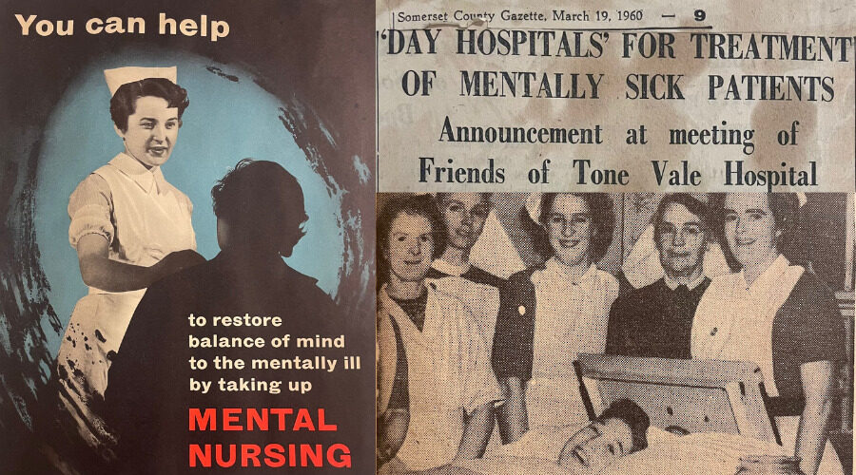
Explanation of the Service
CMHS provides customized assessments, therapeutic strategies, and ongoing support for those dealing with issues such as depression, anxiety, schizophrenia, bipolar disorder, and personality disorders. These services are delivered within local communities, allowing individuals to receive care close to home rather than relying solely on hospital-based services.
CMHS adopt a person-centred approach, meaning that care plans are tailored to meet everyone’s specific needs, strengths, and personal goals. This approach supports people in keeping independence, managing symptoms, and taking part in everyday activities.
NICE states that community mental health care should be based on evidence, informed by trauma, and focused on long-term well-being (NICE, 2024). CMHS also collaborates closely with GPs, social workers, and voluntary organizations to ensure individuals receive coordinated support. By providing flexible and accessible care, CMHS helps reduce isolation, prevent hospital admissions, and promote long-term recovery.
© Somerset NHS Foundation Trust 2025
Flow chart of current functioning of CMHS
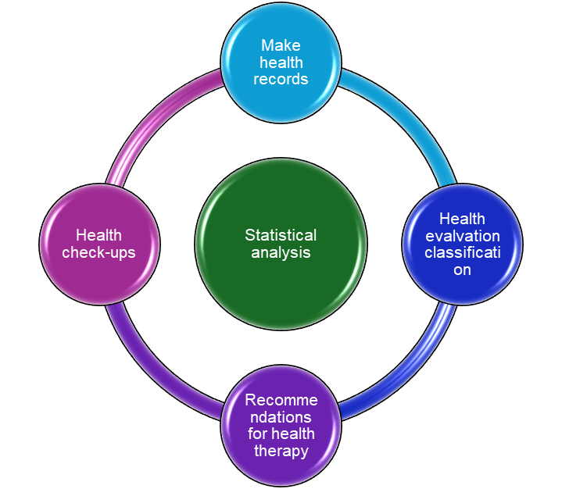
Current Functioning of CMHS
Contemporary Community Mental Health Services function through a network of interdisciplinary teams that deliver adaptable, individualized help. Community Mental Health Teams (CMHTs) aid adults with moderate to severe mental health challenges by providing evaluations, therapy, medication assessments, and social support (Rethink Mental Illness, 2024).
Crisis Resolution and Home Treatment Teams offer intensive help to those facing a mental health crisis, easing care at home to prevent the need for hospitalization. These teams are available around the clock in many regions and are crucial in avoiding unnecessary hospital admissions.
Early Intervention in Psychosis (EIP) Teams help young individuals meeting their first episode of psychosis, promoting swift recovery while helping them continue their education or support employment.
Talking Therapies (IAPT) services deliver research-backed psychological treatments like Cognitive Behavioural Therapy (CBT) to address anxiety and depression (NHS, 2024).
CMHS provides recovery-oriented support, which includes peer support, job help, housing aid, and wellbeing initiatives. These services empower individuals to enhance their confidence, cultivate coping mechanisms, and achieve independence.
This comprehensive approach guarantees that mental health services are obtainable, holistic, and attuned to the unique needs of each person.

challenges face by CMHS
Despite their importance, Community Mental Health Services face several challenges. One major issue is the rising demand. Mental health needs in the UK have increased significantly, especially after the COVID-19 pandemic. CMHS often struggle with long waiting lists, staff shortages, and high caseloads. These factors can delay access to support (NHS England, 2024).
Another challenge is stigma and barriers to access. Some individuals hesitate to seek help because they fear judgement face culture stigma or lack of awareness are available services. Some communities encounter extra obstacles like language difficulties, internet access issues or mistrust of healthcare systems (Mind,2019)
These challenges can keep people from getting early intervention. Which is vital for recovery, tackling these problems needs more funding, better staffing and stronger community outreach to make sure mental health support is accessible to everyone.


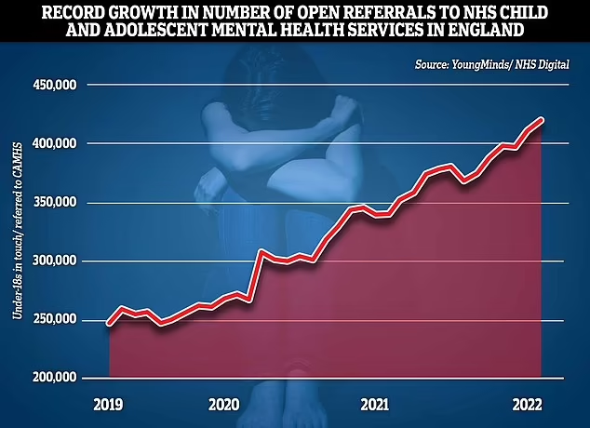

mindthrivetherapy.com
Conclusion
Community Mental Health Services serve persons with mental health problems in a flexible, community-based format. Their development indicates a trend towards more inclusive and person-centred care, highlighting the significance of collaborative aid. Although CMHS faces obstacles such as increased demand and stigma, improving these services will ensure that patients receive timely, complete therapy that enhances their well-being and quality of life.
Openmimds.org.au

COMMUNITY ANTENATAL MIDWIFERY SERVICES (TASK 2)
Historical Development, Contemporary Practice and Impact on Quality of life
Introduction
Community antenatal midwifery services are a fundamental aspect of maternity care in the UK, offering crucial support that contributes to the well-being of both mothers and infants. The evolution of these services has been shaped by significant public health reforms, regulatory measures within the profession, and the creation of the NHS. Gaining insight into this history aids in understanding the current functionality of the service and highlights its importance in improving health outcomes. This assignment examines the historical roots of community antenatal midwifery, assesses its present-day operations, and explores its role in enhancing the quality of life for those who use the services.
Origins and historical context
The history of community antenatal midwifery services goes back to the early 20th century. At that time, high maternal mortality rates reflected a lack of regulation in maternity care. The Midwives Act 1902 introduced mandatory training and registration, laying the groundwork for professional midwifery practice (NMC, 2023). This reform aimed to improve safety and reduce preventable deaths among mothers and infants.
The establishment of the NHS in 1948 was a significant turning point. It provided universal access to maternity care and integrated midwives into community settings (NHS England, 2023). Over the years, national policy continued to influence the service. The Better Births review highlighted the need for personalized care, consistency, and better outcomes. It reinforced the importance of support based in the community (Department of Health, 2017). These changes helped shape the current model of community midwifery, which focuses on accessible care based on relationships and provided close to home.
Critical evaluation of current service functioning
Today, community antenatal midwifery services work within a structured NHS framework guided by the NICE Antenatal Care Guideline NG201. This guideline outlines evidence-based standards for screening, monitoring, and health promotion (NICE, 2021). Midwives carry out routine assessments, safeguarding checks, emotional support, and referrals to specialist services. They collaborate with GPs, health visitors, and hospital teams. Key strengths of the service include:
- Continuity of care, which improves communication, trust, and maternal satisfaction (NHS England, 2023).
- Holistic assessment, addressing physical, emotional, and social needs, including mental health and domestic abuse.
- Accessibility of community clinics, which reduces barriers for vulnerable groups.
- Health promotion activities that support smoking cessation, nutrition, breastfeeding, and safe infant care.
However, the service faces significant challenges. The Royal College of Midwives (2023) points out national workforce shortages that increase caseloads and reduce appointment time. Rising obesity, diabetes, and mental health issues have made pregnancies more complex, placing added pressure on community teams. Persistent inequalities also exist, with MBRRACE-UK (2023) reporting higher risks of poor outcomes for Black and Asian women. These issues highlight the need for ongoing investment, better staffing, and focused support for disadvantaged groups.
Significance for enhancing quality of life
Community antenatal midwifery services are essential for improving the quality of life for women, babies, and families. Identifying risks early allows for timely intervention, which reduces complications and leads to better birth outcomes. Midwives also offer emotional support, helping to ease anxiety and encourage good mental health during pregnancy.
The service empowers women by providing personalized information and supporting informed decision-making about birth plans and care options. Midwives have an important role in safeguarding, identifying issues like domestic abuse or substance misuse, and connecting families to additional support services. Health promotion activities help long-term well-being by encouraging healthy behaviours and supporting infant development. Overall, community antenatal midwifery services strengthen family relationships, boost maternal confidence, and lead to healthier pregnancies and safer births.
Conclusion
Community antenatal midwifery services have developed from early public health reforms into a key part of today’s maternity care. Despite challenges like workforce shortages and ongoing inequalities, the service still offers vital, comprehensive support that improves the well-being of women and families. Its role in early intervention, emotional support, safeguarding, and health promotion shows how important it is for enhancing quality of life and achieving positive maternity outcomes.

List of references task 1
Mind (2019). Information & Support | Mind, the Mental Health Charity - Help for Mental Health Problems. [online] Mind.org.uk. Available at: https://www.mind.org.uk/information-support/ (Accessed: 25 January 2026).

Mind Thrive Therapy (n.d.) Programs. Available at: https://www.mindthrivetherapy.com/programs/ (Accessed: 09 February 2026).

National Institute for Health and Care Excellence (2024). NICE Guidance. Available at: https://www.nice.org.uk/guidance (Accessed: 25 January 2026).
NHS England (2024). NHS England Community Mental Health Services. [online] England.nhs.uk. Available at: https://www.england.nhs.uk/mental-health/adults/cmhs/ (Accessed: 27 January 2026).
Open Minds (2024). What we do. [online] Openminds.org.au. Available at: https://openminds.org.au/what-we-do/
(Accessed: 09 February 2026).
Rethink Mental Illness (2024) Advice and information. Available at: https://www.rethink.org/advice-and-information/(Accessed: 27 January 2026).
The Recovery Centre USA (n.d.) How Community Mental Health Can Support. Available at: https://www.therecoverycenterusa.com/
(Accessed: 06 February 2026).
Somerset NHS Foundation Trust (2023) The evolution of mental health care over 75 years. Available at: https://www.somersetft.nhs.uk/?news=the-evolution-of-mental-health-care-over-75-year (Accessed: 09 February 2026).
UK Government (2012). Health and Social Care Act 2012. [online] legislation.gov.uk. Available at: https://www.legislation.gov.uk/ukpga/2012/7/contents (Accessed: 30 January 2026).
World Health Organization (2022). Mental health. [online] www.who.int. Available at: https://www.who.int/health-topics/mental-health (Accessed :01 February 2026).
Young Minds (n.d.) Record growth in number of open referrals to NHS child and adolescent mental health services in England. Available at: https://www.youngminds.org.uk/ (Accessed: 03 February 2026).

List of reference task 2

Department of Health (2017) Better Births: Improving Outcomes of Maternity Services in England. London: Department of Health.
MBRRACE-UK (2023) Mothers and Babies: Reducing Risk Through Audits and Confidential Enquiries. Oxford: University of Oxford.
NHS England (2023) Maternity and Neonatal Programme. London: NHS England.
NICE (2021) Antenatal Care: Clinical Guideline NG201. London: National Institute for Health and Care Excellence.
Nursing and Midwifery Council (2023) History of Midwifery Regulation. London: NMC.
Royal College of Midwives (2023) State of Maternity Services Report. London: RCM.

