Decisions in Python 2 (if…elif…else)

Sometimes a decision is not binary (if…else…) , there may be more two pathways required.

To do this, we use the if…elif…elif…else

if (condition):
do something 1
elif (condition):
do something 2
else:
do something 3

print("End program")

In the example above, Python will first look at if(condition) If this condition is satisfied, it will run do something 1 Then it will jump straight on to print("End program") and will not look at the elif or the else.

If the first condition is not satisfied, Python will continue on to elif(condition) and so on down the line.

As soon as Python has executed one of the conditions, it will exit the statement.(ie it will never execute both an if and an elif)

Code Example:

Let's look at this through an example. Here I am giving the user a choice of drinks:

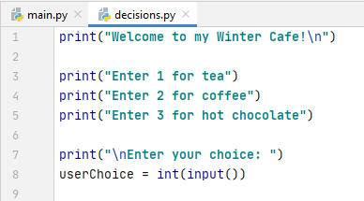

I will carry on with the program and make a comment on their choice (there are 3 possible "decisions" 1, 2 or 3

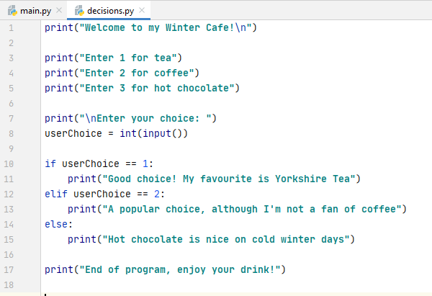

As you can see above, Python will first check for the user entering 1. If they did, it will print the message about Yorkshire Tea (line 11). It will then exit the statement to line 17 "End of program"

If the user didn't enter 1, Python moves on to the elif and checks to see if they entered 2.
If they did, it prints the message about coffee (line 13) and then exits to line 17.

If they didn't enter 2, Python will go to the else which will execute for anything else entered.

Note: we NEVER put a condition on an else. The else picks up anything not covered in previous conditions.
Let's see it in action:

User enters 1:
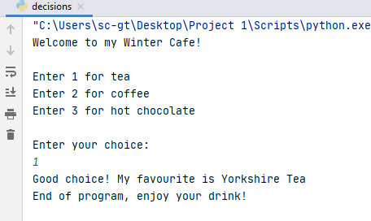

User enters 2:
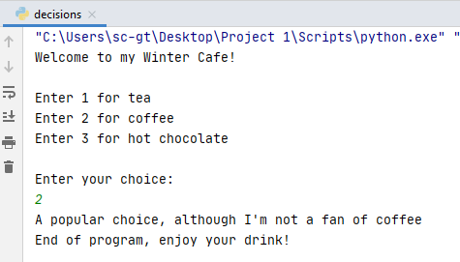

User enters 3:

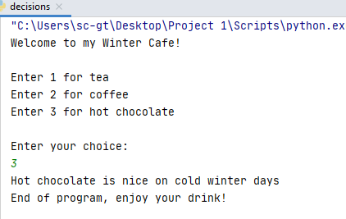

This program works well, although we must be careful to anticipate everything the user might do. In fact, the else part covers anything that isn't 1 or 2 so if the user entered something out of range, the program would still give the message about hot chocolate:

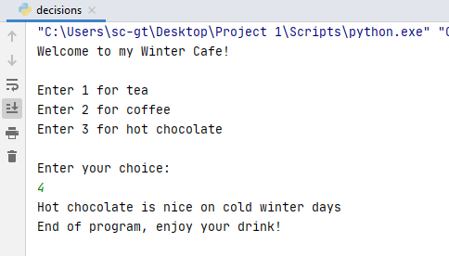
An unexpected input!

To improve this, I could adapt the code as follows (two elif s!)

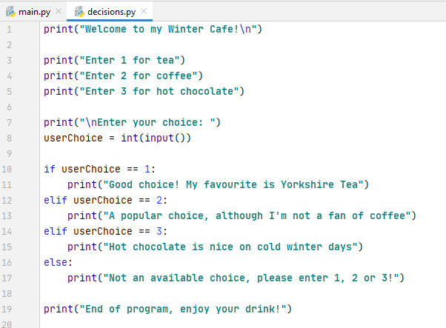

This time, I have conditions for input of 1, 2 and 3, and else will catch any other input.
Example with greater than (>)

Let's look at another example, this time using greater than (>).

Suppose a user was going to enter their exam mark and we wanted to write a program to tell them whether they had achieved a Distinction (70%), Merit (60%) Pass (40%). Here there are at least 3 decisions (possibly more if we want to tell them they've failed, or the mark entered was out of range)

We might write something like this:

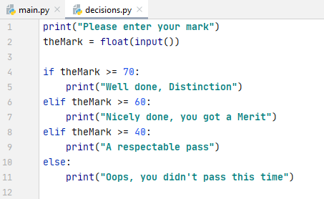

Sometimes programmers will write

elif theMark >= 60 and theMark<70:

But it is not necessary in this example. Remember that Python will move through the conditions in order. If the mark is not above 70, everything above 70 is eliminated.
if theMark >= 70:
print("Well done, Distinction")
elif theMark >= 60:
print("Nicely done, you got a Merit")
elif theMark >= 40:
print("A respectable pass")
else:
print("Oops, you didn't pass this time")

0 | 10 | 20 | 30 | 40 | 50 | 60 | 70 | 80 | 90 | 100

If the first condition is not met, when we get to the first elif we are left only with everything 60 and below:

0 | 10 | 20 | 30 | 40 | 50 | 60

Then for second elif only these are left:

0 | 10 | 20 | 30 | 40 | 50

And finally the last else:
0 |  | 10 | 20 | 30

Therefore it is redundant to write in a second condition elif theMark >= 60 and theMark<70

