Strategic Management and Sustainability of Tesla in the UK market

Component 1: Coursework: Written Report

Student Name: Andrei Zaharia
Student Number: 2311195

Module: Strategic Management and Sustainability
Module code: LCBB6015
Programme: BA (Hons) Business Management

Lecturer Name: Abdi Rahman
Date: 07/03/2026

Table of Contents
1 Executive Summary 3
2 Introduction 3
3 Strategy Analysis 4
3.1 PESTLE External analysis 4
3.1.1 Political 4
3.1.2 Economic Factors 4
3.1.3 Social Factors 4
3.1.4 Technology 5
3.1.5 Environmental Factors 5
3.1.6 Legal 5
3.2 Internal analysis - VRIO 6
3.3 SWOT Analysis 6
3.3.1 Strengths 6
3.3.2 Weaknesses 7
3.3.3 Opportunities 7
3.3.4 Threats 8
4 Strategy Formulation 8
5 Conclusion & recommendations 9
6 References 10

Executive Summary
This report analyses Tesla’s strategic position in the UK automotive market. The zero-emission electric vehicle mandate now requires every automotive company to shift from manufacturing traditional diesel or petroleum-powered models to zero-emission vehicles. The external market plays a significant role in exerting much pressure on the UK market manufacturers to transition before 2035. Such regulatory pressures affect Tesla’s current strategy to scale up its efforts. Specifically, the report analyses external market factors using PESTLE to understand Tesla's strategic position in the external market. Moreover, the report analyses the strategic choice to gain insights concerning the internal VRIO framework and SWOT synthesis. The strategic formulation proposes a single strategy to respond to current market opportunities.

Introduction
Strategic management is inherent in almost every company. However, its application differs because of varying strategic positions, choices, and actions taken by management to create a strong competitive advantage. According to Johnson et al (2017), strategic management refers to the importance of managers in respect to a strategy. In any company, a strategy integrates managers who make decisions and implement them (Hitt, 2017). Managers use strategic management to decide how to leverage resources, respond to external markets, and create sustainable competitive advantage (Barney, 1991). Every manager concerned with managing resources and building a long-lasting company must understand a company's strategic position in its sector, the strategic choices available, and the best strategy for competing with other firms.
Tesla is a multinational manufacturer and distributor of electric vehicles. With its main headquarters in the US, Tesla also operates through subsidiaries located in other regional markets (Tesla UK Limited, 2025). Currently, Tesla operates a subsidiary brand in the UK market. Its purposes involve selling, offering services, and energy storage. Its purpose in the UK automotive industry is to import and sell its own electric vehicles and accessories manufactured in the US market. The financial statement also outlines that its principal activities focus on the distribution of heating and plumbing supplies.
Tesla uses one mission and vision across the global markets where it operates. The mission is to ensure that it continues to accelerate the transition towards sustainable energy. Moreover, the company’s vision is to create compelling cars for the 21st century. It seeks to drive the world to transition more quickly to electric vehicles. Tesla relies on its three major objectives – expand adoption of EV, scale storage of energy, and the sale of solar products, as well as ensuring improvement of its manufacturing sustainability.

Strategy Analysis

PESTLE External Analysis

Political
The government supports automotive sector players by funding research and development initiatives to accelerate transition to zero emission electric vehicles. The country’s ZEV mandate by 2035 targets enforcement among automotive makers and sellers to sell EV vehicles. This now implies that such market forces compress competitive differentiation (Johnson et al., 2017). Besides, the government support lowers barriers for companies such as Tesla to achieve EV transition by 2035 (Roychowdhury, Chattopadhyaya, and Tripathi, 2023). Besides, the current trade frictions causes negative implications to the company supply chains and flexibility in its pricing strategies. Tesla has no option but to develop strategies that fasten its adoption rate that competitors such as Toyota, Hyundai, Nissan, Ford, Volkswagen, Suzuki, and Honda (SMMT, 2025).

Economic Factors
UK automotive sector experiences three factors that affects strategies of companies such as Tesla. High inflation rate and cost of living on customers is a major impact on customers who want low-cost EV vehicles. Moreover, the UK market experiences high upfront costs of buying EV vehicles (SMMT, 2024). Such costs work together with other market factors increasing buyer price sensitivity. Third, the market also experiences volatile energy prices. Additionally, high economic uncertainties act as barriers limiting the mass market to adopt the product (Department for Business & Trade, 2018). Moreover, high-cost pressures is a challenge to Tesla’s premium positioning.

Social Factors
There is high increased awareness among the UK households about environment conservation initiatives (SMMT, 2024). A majority of customers also want to build strong trust, expectation of receiving high level personalized services, and positive brand perception. Besides, lack of charging convenience for many customers with EV complain about anxiety travelling long distances before finding the right charging location. Sustainability values drive customer interest. However, practical usability drives more purchases. Additionally, service quality and experience serve as important indicators of loyalty. Therefore, players such as Tesla must ensure that products meet high customer expectations to avoid bad reputation and scrutiny.

Technology
The UK market continues to accelerate battery innovation with a major target on total EVs by the year 2035. Venture capitalists have managed to raise over £2.7 billion since 2018 (Department for Business & Trade, 2018). Currently, the UK market is in position 4 in the global market. The market is also transitioning at a faster rate to software-defined vehicles to enhanced updates on features, performance, and safety during the entire period of a vehicle. Many players are taking part in the charging infrastructure. Tesla must develop strategies that support technology leadership as part of everyday consumer value.

Environmental Factors
Automakers and importers to achieve ZEV guidelines by 2035. The dates indicated in the figure cover the cars and vans with varying percentages. Automotive companies that sell and manufacture cars and vans must achieve 100% by the year 2035 (Benson et al., 2025). The current and future battery technology is likely to ensure that companies decarbonize their vehicles. However, companies such as Tesla must increase their investment level in the manufacturing of carbon-hydrogen batteries. This also places greater pressure to source and put in place mechanisms for measuring sustainability efforts.

Figure 1: The UK ZEV mandate target dates
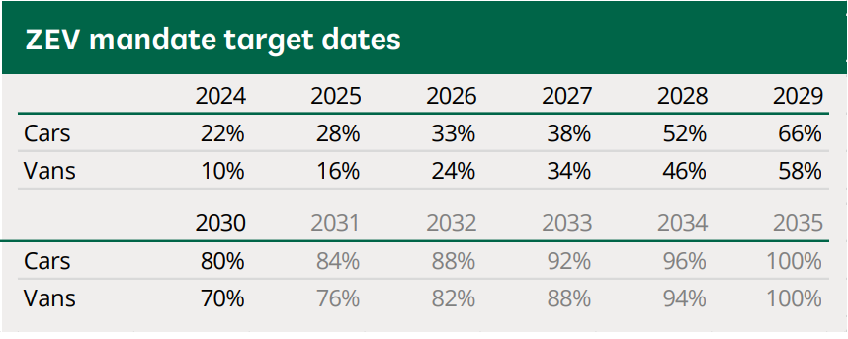
Source: Benson et al. (2025).

Legal
Major legal issues affecting automotive companies include meeting safety standards and adopting consumer protection and data protection policies (Benson et al., 2025). As companies focus on achieving net zero by 2035, there is a need to regulate the use of software when collecting user data. However, regulatory compliance could raise more costs and complexity in operations (Department for Business & Trade, 2018). Regulations on software and data protection might limit numerous autonomous features with much legal scrutiny increasing reputational risks.

Internal analysis - VRIO
The figure below presents an assessment of Tesla's resources and capabilities to draw insights into whether it can create a sustained competitive advantage (Grant, 1991). All available resources generate value for the customers and Tesla itself. However, it is surprising that some are not rare, thereby exposing themselves to imitation by competing firms (Barney, 1991). Despite having financial, technology, and facilities, such resources cannot create sustained competitive advantage (Johnson et al., 2017). Entrants in the market increases intensity of competition (Reuters, 2025). Premium sellers include Volkswagen, enjoying the highest-ranking competitor.

Figure 2: Tesla VRIO assessment
Resources/Capability | Valuable | Rare | Imitable | Organised | Competitive Advantage
Financial | Yes | No | Yes | Yes | Temporary
Physical | Yes | No | Yes | No | Disadvantage
Human | Yes | Yes | No | Yes | Sustained
Technological | Yes | No | Yes | Yes | Temporary
Reputation | Yes | Yes | No | Yes | Sustained
Organisational | Yes | Yes | No | Yes | Sustained

SWOT Analysis

Strengths
Tesla enjoys large economies of scale in manufacturing and distribution of different vehicle models through imports from the U.S. market. It is able to serve the needs of customers from different market segments. Tesla also imports variations of cars in the markets making it easier to sell to customers. While other automakers struggle to transition to full EV models, Tesla’s cars are full EV making it easier to meet the 2035 government mandate.

Weaknesses
The market experiences limited number of charging locations for a majority of customers with EV vehicles. Lower market share means Tesla struggles with meeting market demand dominated by high-ranking companies. High administrative expenses and interest payable contribute to lower profit for the year. This also lowers the capability for Tesla to raise more funds and manage its cash flows, creditors, and debtors. Tesla products face high upfront costs due to import duties from the USA market. This limits customer demand for those who switch to competing models. Tesla relies more on the sale of heating and plumbing supplies, limiting its ability to scale into automobiles. Tesla uses U.S manufacturing facility to export to UK market.

Opportunities
The UK government funds automotive sector. It funded 500 million pounds to enhance R&D projects and core activities of EVs manufacturing (Department for Business & Trade, 2018). Tesla can leverage this opportunity by transitioning to ultra-low and zero-emission cars. The government also intends to fund the development of a working lifetime National Battery. Battery electric vehicles (BEVs) and plug-in hybrid EVs are expected to increase in production by 2035 (See Figure below, panel 1) (Advanced Propulsion Centre UK, 2025). The government also seeks to help ramp up the installation of charging points nationwide. Tesla could leverage this opportunity to increase car imports.

Figure 3: Production for passenger cars and commercial vehicles is expected to increase by 2035 (%)
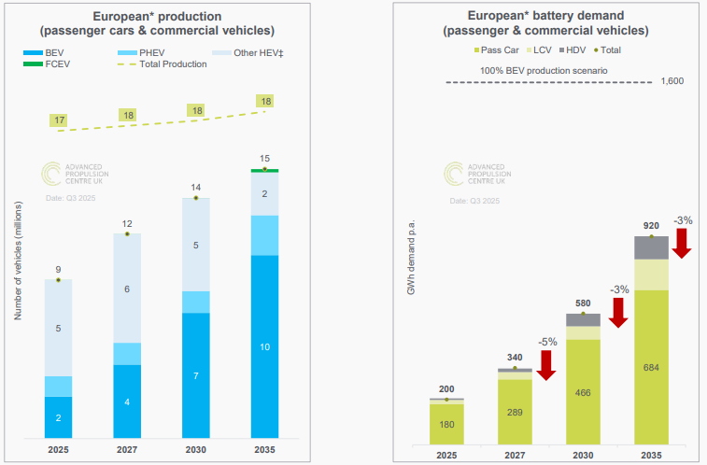
Source: Advanced Propulsion Centre UK, 2025

Threats
The UK market faces intense competition from both small and large automotive makers (SMMT. 2025). They compete on value and car models. The current market share ranking includes Volkswagen with more than 8%, followed by BMW, Ford, Kia, and Audi. Lower switching cost from Tesla premium cars to competitors remains lower. The company could lose more customers who value pricing and quality (Reuters, 2025). Second, the market's high cost of production might continue to keep Tesla away from setting up a manufacturing plant in the UK. Third, high pressure from government agencies to achieve full ZEV by 2035 poses a major threat to Tesla's products. A majority of automakers face the challenge of lowering upfront costs, which limits many customers from buying. Besides, a majority of customers are likely to switch their preferences to mini models.

Strategy Formulation
Install more supercharger networks in the market to gain the first slot as a leader in this infrastructure. Currently, the market continues to have a limited number of charging points for most EVs. Strategic action should cover investment in supercharging points that charge Tesla brands and those sold by competitors. Tesla need to now position itself as a key manufacturer of charging stations. The move will help the company to offer such services not only to customers that own Tesla EVs but also those who own other brands of EVs sold by competitors. Such a diversification move would help Tesla to generate more revenues beyond its current performance.
International expansion leaders should consider setting up a local manufacturing facility in the UK. By importing all models manufactured in the US market, this makes the company miss out on appealing to the market's rising demand. Tesla can overcome high competition from low-cost models by manufacturing low-cost models that meet local demands from low to middle-income customer segments (Acar, 2024). Local facilities would help the company to cut down on importation duties and high upfront costs. The market expects to experience higher demand for low cost of used EVs (SMMT, 2025). Tesla must now begin use its human resources and financing to support local manufacturing centre in the UK.
Management should also consider implementing ecosystem strategy. Management should implement this by integrating both financing and energy storage. The company could leverage on energy division to bundle together powerwall or solar solutions with EV investment. The strategic move could help the company to create “unique sustainable energy”. The strategy seeks to ensure that Tesla creates resources and capability that differentiates itself from traditional manufacturers (Barney, 1995). They will find it difficult to copy hence, generating more loyalty and sustainable lifestyle solution targeted at meeting the 2035 guidelines.

Conclusion & recommendations
The strategic analysis of Tesla reveals lack of market integration to achieve full scale operation. Currently, Tesla’s core objective includes distribution of heating and plumbing supplies. Importation of high premium EV cars from the US market positions Tesla at a disadvantage than competitors. Analysis of resources shows Tesla lacks the needed capability to create sustained competitive advantage.
The study recommends that management focus on three strategic implementations. Invest heavily in superchargers across the market, set up a local manufacturing facility in the UK to produce low-cost EV models for the local markets. Moreover, Tesla should use ecosystem strategy to integrate energy storage solutions and proper financing. Bundling of solar solutions with EV financing would help create sustainable energy for the local consumers.

References
Acar, S., 2024. A Review of Porter’s Generic Strategies: Strategy Examples in International Firms. International Social Sciences Studies Journal, 10(11), pp.1902-1918. Available at: https://sssjournal.com/files/sssjournal/e5935340-8b65-4cf6-a1c1-cf266026257d.pdf (Accessed on 6 February 2026).
Advanced Propulsion Centre UK. 2025. Automotive industry demand forecast: Q3 2025. Available at: https://www.apcuk.co.uk/wp-content/uploads/2025/12/Q3-2025-Quarterly-Demand-Report-December.pdf (Accessed on 5 February 2026)
Barney, J. B. 1991. Firm resources and sustained competitive advantage. Journal of Management, 17(1): 99-120
Barney, J. B. 1995. Looking Inside for Competitive Advantage. Academy of Management Executive 9(4): 49-61
Benson, M., Stewart, I., Hutton, G., and Tyers, R. 2025. Electric Vehicle and Infrastructure. Available at: https://researchbriefings.files.parliament.uk/documents/CBP-7480/CBP-7480.pdf. (Accessed on 6 February 2026)
Department for Business & Trade. 2018. Policy paper Industrial Strategy: Automotive Sector Deal (HTML). Available at: https://www.gov.uk/government/publications/automotive-sector-deal/auto (Accessed on 7 February 2026)
Grant, R. 1991. The Resource-Based Theory of Competitive Advantage’ California Management Review 33(3): 114-135
Hitt M. A. 2017. Strategic Management: Competitiveness & Globalisation: Concepts and Cases 12th Ed., Boston, MA: Cengage, Chapter 3
Johnson, G., Whittington, R., Scholes, K., Angwin, D. and Regner, P. 2017. Exploring Strategy Text and Cases. 11th ed. UK: Pearson Education Ltd. Chapter 4: pp.96-131
Reuters. 2025. Tesla UK sales plunge in January as Chinese rivals race ahead, New Automotive data shows. Available at: https://www.reuters.com/business/autos-transportation/tesla-uk-sales-plunge-january-chinese-rivals-race-ahead-new-automotive-data-2026-02-04/ (Accessed on 6 February 2026)
Roychowdhury, A., Chattopadhyaya, V. and Tripathi, M., 2023. Policy brief on Zero emission vehicle (ZEV) mandate policy: Scaling up electric vehicle markets. Centre for Science and Environment, New Delhi. Available at: https://www.researchgate.net/profile/Anumita-Roychowdhury/publication/383910054_ZERO_EMISSION_VEHICLE_ZEV_MANDATE_POLICY_Scaling_up_Electric_Vehicle_Markets/links/66e040e164f7bf7b19a5af66/ZERO-EMISSION-VEHICLE-ZEV-MANDATE-POLICY-Scaling-up-Electric-Vehicle-Markets.pdf (Accessed on 6 February 2026)
SMMT. 2024. Motor Industry Facts 2024. Available at: https://www.smmt.co.uk/smmt-motor-industry-facts-2024/ (Accessed on 7 February 2026)
SMMT. 2025. The UK’s Small Volume Automotive Manufacturers. Available at: https://www.smmt.co.uk/the-uks-small-volume-automotive-manufacturers/ (Accessed on 5 February 2026)
SMMT. 2025. Used EV market enjoys record uptake as one in 25 buyers switches over the summer. Available at: https://www.smmt.co.uk/used-ev-market-enjoys-record-uptake-as-one-in-25-buyers-switch-over-summer/ (Accessed on 6 February 2026)
Tesla UK Limited. 2025. Annual report and financial statements for the year ended 31 December 2024. Available at: https://find-and-update.company-information.service.gov.uk/company/06081188/filing-history (Accessed on 5 February 2026).

