Title Page

Title of Report

Workplace Culture and its impact on Organisational Efficiency

Name/Number of author

Muhammad Sujon / 1706581

Name of Host Organisation

UWTSD

Date of Report Publication

5TH April 2019

Executive Summary

Contents Page

Content Page No.

- 1.0 Introduction 1

- 2.0 Findings 3-15

- 4.0 Conclusion 16

- 5.0 Recommendations 17

- Reference

- Introduction

2.0 Findings

2.1 The researcher using two tools PESTLE and SWOT to analysis the environment of an organisation.
The organisation the researcher is analysing is Virgin Group.
PESTLE analyse is a tools used to monitor and analyse the macro-environment factors and the impact on an organisation. The result then can be used in SWOT analysis to identify treat and weaknesses of that organisation.

PESTEL stands for:
- P – Political
- E – Economic
- S – Social
- T – Technological
- E – Environmental
- L – Legal
PESTLE looks at each of these macro-environmental factors in turn:


(Professional Academy, 2019, accessed: 28th March 2019)

2.2 PESTLE (table below) analysis and evaluate how different aspect of the surrounding business may affect the operation of Virgin Group.

 | Eternal factors to consider | Factors affected within Industry | Important to organisation
POLITICAL | Virgin Group can be affected by various political factors, such as labour laws, taxation policies and trade restriction imposed by government.  Virgin Group is UK based company, has spread operation into foreign country such as Australia and USA, external challenge includes Licensing bureaucracies set by the foreign governments, increase regulations, tariff and custom imposed by government and political instabilities in some countries.  (essaywriting, 2019, accessed: 31st March 2019) | Brexit, UK leaving EU.  UK government imposed new restriction on the air transport; this may have negative impact on the operation of Virgin Airlines.  Virgin group also faced threats from terrorist attacks.  (essaywriting, 2019, accessed: 31st March 2019) | Medium
ECONOMIC | High cost of production, such as labour cost, capital and land.  Globalization and liberation of the consumer market  (Soffels 2011) | Brexit uncertainty.  Pound exchange rate remains volatile.  High cost of fuel.  (Capon 2010) | High  Medium  Medium
SOCIAL | Over sea air traffic control strikes and social unrest.  Discrimination and reduce poverty.  Grade fixer, 2018, Analysis of Virgin Atlantic Airline  Environmental factor growing. | Culture diversity, gender discrimination (gender equality), ending LDBT  (virgin.com, 2016, Investment about social impact)  Launch of Virgin Bio-diesel train. | Medium  Medium
TECHNOLOGY | Artificial intelligent, security and innovation  Upgrade, social networking | Virgin group policy is to change according to trend and customer interest.  Update internet service, wireless technology, software and technical knowledge, to serve customers.  (UKessay, 2018, SWOT, PEST and Porter’s 5 Forces Analysis of Virgin) | Medium  Medium
LEGAL | Employment law,  Working condition  Air traffic control legislation.  Local labour law.  Common law.  Health and safety regulation.  Gender and pay equality | Pay above minimum wage. Flexible working hours and healthy work environment.  Pay gap between male and female, published  (payscale, 2019, Average Virgin Atlantic Airways Ltd Salary) | High  Medium
ENVIROMENTAL | Sustainable resources CSR (corporation social responsibility)  Transportation.  Environmental restriction imposed by the government countries | Creating sustainable virgin trains , reducing C02 emission by 4% at each station  (Virgintrain.com, 2019, environment) | Medium

2.3 The researcher has used SWOT analysing techniques to understand the Strength and Weaknesses of Virgin Group, also to Identify Opportunities open to Virgin Group and the Threat faced by the organisation.
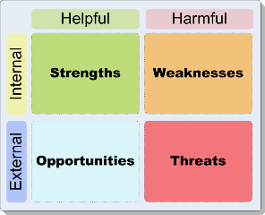

SWOT analysis is reality check for the organisation, to check on the Strengths, advantage the organisation have and what they can do then their competitors.
To identify what Virgin weaknesses, what they can do to improve and what they should avoid.
What good opportunities can be spotted and interesting trends the organisational aware of, and what threat Virgin face, and what are the competitors doing.
(Mindtools, 2019, SWOT analysis)

Strengths
Virgin group has lot of strengths; the group is one of the largest corporations in United Kingdom. The Virgin logo is visible in many different brands around the world; the corporation has stake in many variety sectors, such as music, finance, cosmetic, publishing, mobile phone, train, plane, space tourism and many more.
(Cayenneapps 2016, the SWOT analysis of virgin group)
Te companies staff is strength for the organisation, their highly motivated staff, with flat and unique management style culture, minimal hierarchy level and flexible working hours, makes it desired place to work. Happy employee means happy customers. Richard Branson, the founder of Virgin group believes, motivated staff is an asset for his organisation.
(Sadq, 2016, p. 78-83)

Weaknesses
Too loose supervision, sluggish communication and pessimistic attitude towards change.
Funding is one of the other weaknesses for the group, Virgin group never had enough fund available to buy out.
(Honeycutt, 2010, pp. 34-278)

Opportunities
Virgin group policy is to change according to trend and customer interest.
Update internet service, wireless technology, software and technical knowledge, to serve customers.
Opportunities exist for virgin group in new markets such as China, India and Far East. The Airline can compete with other Airline and create impact in its low pricing strategy.
(Marketing Doctrines, 2012)
Threat
Brexit, UK leaving EU, volatile exchange rate, pound dropping against dollar and euro, high fuel cost.
UK government imposed new restriction on the air transport; this may have negative impact on the operation of Virgin Airlines.
Environmental restriction imposed by the government countries Virgin operate in.
One of the biggest threats to the organisation is the founder, Richard Branson himself, he does not like justifying himself to anyone and uncertainty over who will replace Branson.
Not introduction new innovations.

2.4 To analysis structure and culture of Virgin Group, the researcher applied two models to Virgin Group:
- The Cultural Web
- Deal and Kennedy
The Cultural web is one of the widely recognized models:
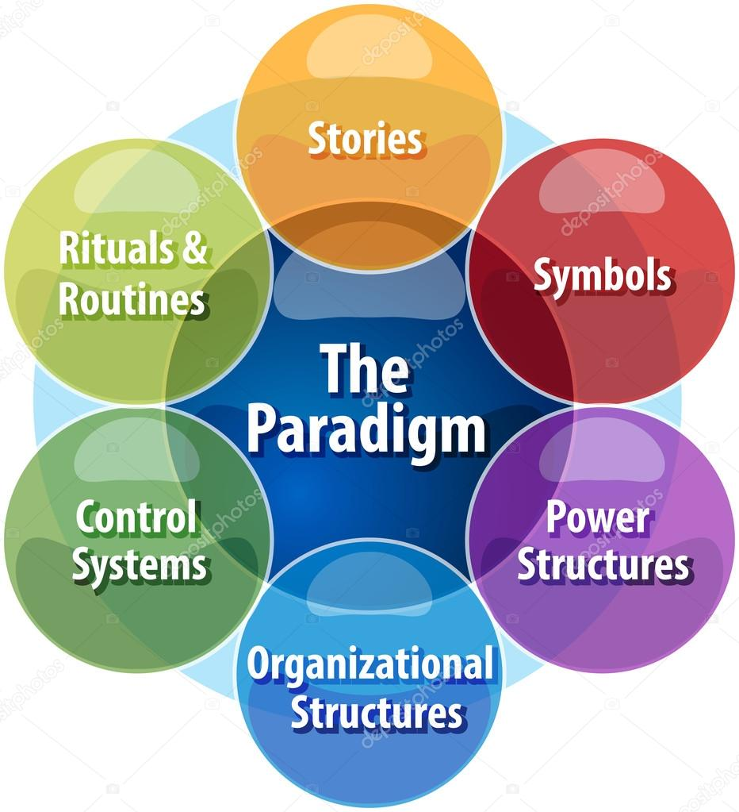

(Mindtools,2019,The cultural Web)

- Story

Virgin group has established a multinational worldwide organisation with over 400companies in 30 different countries and employing more than 69,000 people worldwide.
Virgin group has stake in many different sectors including, telephone, media, music & entertainment, financial service, health & wellbeing and many more, with global annual revenue over £16.6 billion and growing.
Virgin group has over 37 million social media followers.

(Virgin.com, 2019, about us)

- Rituals and Routines

Virgin group gives their employees flexibility hours, which help staff better balance between private life and workplace.
The organisation with Keiretsu structure, own share in other organisations.
In order to cope with environmental change, the organisation needs to be organic and promote flexibility.

(UKessays.com, 2016, The Virgin Group An insight into the organizational structure and culture)

Virgin staff do not work in traditional corporation culture, staff do not wear formal business attire and does not work strictly 9am to 5.30pm shift, instead employee work freely with access to work internet, music and flexible working hours. Also Virgin Group provides staff with unlimited staff holiday.

(hrsolutions, 2019, Sir Richard Branson recently led a ‘Corporate Day’ at the Virgin Management offices to highlight the ‘horrible experience’ of corporate culture)

- Symbols

Logo is an important identity of the organisation. Logo is more than visual identity. Hand written Virgin marks with red and white, is one of the most recognizable logo in the world, with many different sub-brand.

(Logo design love, 2009, Stretching the Virgin logo)

- Organisation Structure

The founder Richard Branson, personal believes and influence on workplace culture to create decentralization structure, to reduce bureaucracy.
Virgin Group does not have hierarchy management system instead have flat structure.

- Control System

Virgin group has never done business as usual; they believe “tried and tested” is not always the best path to success. They always encourage workers not to follow rational procedures, but think of their own ideas.
Virgin does not believe in hierarchy management system, Branson believe in flat organisation.
Virgin distributes authority from one to many, make the criteria for business success as part of every ones roll.
(McCrory, 2015)
Flattering structure is not just about tearing up the organisation, but is about communication with everyone and allows all the employees to feel they are part of the organisation
(McCrory, 2015)

- Power Structure

Virgin group do not believe in hierarchy structure, they have flat structure. All Important decision about the organisation is made by Richard Branson himself

2.5 Deal and Kennedy’s model:
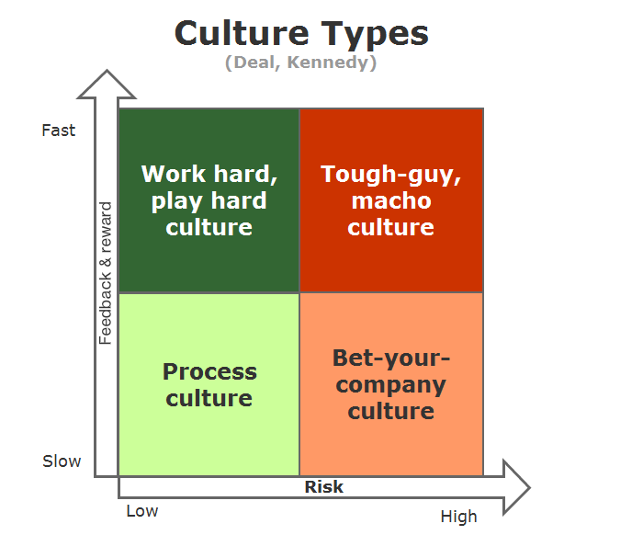

Deal and Kennedy model have six elements:
- History
- Value and believe
- Rituals and Ceremonies
- Stories
- Heroic figures
- The culture network

According to Deal and Kennedy Models virgin group best reflects Kennedy’s value and belief element because their written value are ignored but the real value ‘behaviour and skills they care most’.
Also Virgin group reflects Kennedy Heroic figures element, as Virgin encourage workers not always to follow rational procedures, but think of their own ideas and credible judgement to make decision.
(Virgin.com, 2019, about us)
Virgin Group has many different companies in different sectors; different organisation has different culture type and risk.
Although virgin group is recognised as single business entity, but this is not the case, virgin each brand company operate as a separate business entity.
Organizational culture play important role in an organization. Although most people have different understanding of organization culture it’s a universal concept difficult to divine precisely.
(Mullins,2007, p.721)
Deal and Kennedy (2000) explain as the dominant value exposed by an organization. Were as Bower (1966) simply described it as ‘the way things are done around here’. Despite there has not been a unanimous accepted definition. The common theme within Bowers (1966) and Deal and Kennedy (2000) describes simply as ‘referred system shared and meaning’.
“The collection of traditions, values, policies, beliefs and attitudes that constitute a pervasive context for everything we do and think in an organization.”
(Mclean and Marshall, 1993 cited in Mullins, 2007)

2.6 Virgin Group good business ethic, Virgin believes “an ethical business and being successful one are not opposite; they are two side of the same coin”.
Building new alliance for change can make real difference, reducing inequality and safeguarding environment for next generation means building a growth for further markets.
(Branson, 2016, good business ethics)

Virgin group is trying to implement their ethical policy and encourage other entrepreneurs to follow. Virgin is successfully branding for ethical entrepreneurs. Helping Company to reduce excessive carbon footprint, Virgin encourage organisation to take an ethical and sustainable approach to cloth manufacturing.
Virgin ethical policy is to treat all employees as equal, reducing gender pay gap, Culture diversity, gender discrimination (gender equality), ending LDBT.
Employees are allowed to work flexible hours, helping employees to more balance work and family life.
Flat management structure, to managed the organisation and give more freedom to employees to implement their ideas and make decisions.
Virgin train is reducing carbon by 4% in every station to honour their environmental commitments.
(McGuire, 2016, branding success for ethical entrepreneurs)

2.7 Virgin Groups Value, belief and attitude, is highly appreciated by their employees, good working conditions, their flexible working hours, unlimited holiday, flat management structure; equal opportunities for everyone, people from different race, religion or gender are given same right and commitment for cleaner and sustainable environment.
Virgin Group work culture is a role model for 21st century organisation business culture and the environment employees prefer to work in.

2.8 The researcher has compared Virgin Group workplace culture with another large British corporation, British Telecommunication (BT).
BT use power of communication to get together best people, technology and network and make the world better place for all their stakeholders.
Creating new possibilities and making connection helps BT, as an organisation to grow, employees customers get more out of life.
BT employees feel engaged and inspired to be the best they can be, high performing and helps organisation to thrive.
Leaders are challenging but supportive, BT’s value guide their employees decision making and behaviour.
Opportunities are diverse and rewarding for employee who embraces to new ideas. BT put people first and combines healthy view on work life balance.
(BT, 2019, career)
BT change to employee needs, more and more employee wants soft skill, they want their boss to serve more as a coach or mentor, BT believes this drives the quality of relationships in trust, it drive performance and engagement. Regular feedback helps employees to know what they need to do to become successful.
(BT,2017, working together)
BT has a different workplace culture than Virgin Group. BT has hierarchy structure, where managers are monitoring their employees.
Unlike Virgin employees are required to dress professional and maintain working hours. BT has more strict roles, employees must follow and maintain.
But some aspect of BT’s workplace culture cab be beneficial for Virgin group, such as ‘soft skills’ this helps employees to learn from their boss, and give them chance to increase their knowledge, boss acting as mentor help pass on knowledge and experience to their employees. Also regular feedback will help and guide employees to make change and improvement.

3.0 Conclusion
3.1 In conclusion the PESTLE analysis shows the external political factor of Virgin Group can be affected by many different factors, as Virgin Group operate in many different countries; they need to follow local rules and regulations, labour law, taxation policy and traffic regulation.
Internal factors also face challenges due to Brexit, UK leaving Europe; this can course uncertainty for the organisation.
Economic factors of the organisation are at risk due to high production cost and labour cost.
Some of the Virgin technology equipments are aging will require renew/replacement.
As Virgin Group operate overseas and have stakes in many different organisations, legal policy, employment law, good working condition and health and safety at work is important for organisation to maintain these policies and protect the image of the company worldwide.
Virgin environmental policy has created sustainable Virgin train with reduces CO2 emission by 4%.
SWOT analysis indicates that Virgin group strength is that they are one of the largest corporations in the UK and have stakes in many different sectors. As a large organisation Virgin has a big influence over their suppliers.
Virgin Weaknesses is the organisation has too loose supervision and pessimistic attitude towards change.
Opportunities are software and technological knowledge, with vast information from their different sectors.
Virgin biggest threat is Brexit; it brings uncertainty and volatile exchange rate.
The cultural Web indicates that Virgin Group employees enjoys flexible working hours, unlimited holidays, which help employees to better balance work and personal life.
They have a flat management structure and their symbol is most recognized logo in the world.
Virgin has good ethical policy in place, including treating all employees as equal and reducing gender pay gap.
Comparing Virgin Group working culture with BT shows Virgin has more freedom and relax work place culture than BT, but some of the BT work culture can be beneficial for Virgin group, such as ‘soft skills’ as indicated on SWOT analysis Virgin has sluggish communication and too loose supervision.

4.0 Recommendations

5.0 Reference

Branson, R (2016) good business ethics.
Available at: https://www.virgin.com/richard-branson/good-business-ethic
(Accessed: 1st April 2019)

BT(2017) working together.
Available at:https://www.btplc.com/Thegroup/Ourcompany/Ourcodesofethics/index.htm
(Accessed:4th April 2019)

BT (2019) career.
Available at: https://www.btplc.com/Careercentre/lifeatbt/ourculture/index.htm
(Accessed :4th April 2019)

Professional academy (2019) Marketing theories-PESTLE analysis.
Available at: https://www.professionalacademy.com/blogs-and-advice/marketing-theories---pestel-analysis
(Accessed: 28th March 2019)

Cayenneapps (2016) the SWOT analysis of Virgin group.
Available at: https://www.cayenneapps.com/blog/2016/02/10/the-swot-analysis-of-richard-bransons-virgin-group/
(Accessed: 3rd April 2019)

The Cultural Web Model
www.canstockphoto.com
Accessed 5th March 2019
HRsolutons (2019) Sir Richard Branson recently led a ‘Corporate Day’ at the Virgin Management offices to highlight the ‘horrible experience’ of corporate culture.
Available at: https://www.hrsolutions-uk.com/virgin-highlights-corporate-culture-horror/
(Accessed: 27th March 2019)

Logo Design love (2009) Stretching the Virgin logo.
Available at: https://www.logodesignlove.com/stretching-the-virgin-logo
(Accessed: 31st March 2019)

Mullins (200), p.721

Marketing Doctrines (2012) Grow your business. (Mclean and Marshall, 1993 cited in Mullins, 2007)

Available at: http://marketingdoctrines.blogspot.com/2012/07/marketing-strategies-of-virgin-group.html
(Accessed: 3rd April 2019)

McGuire, L (2016) branding success for ethical entrepreneurs.
Available at: https://www.virgin.com/entrepreneur/branding-success-ethical-entrepreneurs
(Accessed: 29th March 2019)

Essay writing (2019) Custom PESTLE Analysis for Virgin Group Essay.
Available at: https://essayswriters.com/essays/Analysis/pestle-analysis-for-virgin-group.html
(Accessed: 31st March 2019)

Grade fixer (2018) Analysis of Virgin Atlantic Airline.
Available at: https://gradesfixer.com/free-essay-examples/analysis-of-virgin-atlantic-airline/
(Accessed: 1st April 2019)

Honeycutt, E. A (2010) ‘Virgin Company analysis’, pp 34-278.
Available at: http://www.researchomatic.com/Virgin-Company-Analysis-4671.html#buytopicstep
(Accessed: 3rd April 2019)

McCrory, K (2015) Tearing up the organizational chart.
Available at: https://www.virgin.com/virgin-unite/business-innovation/tearing-up-the-organisational-chart
(Accessed: 4th April 2019)

Mindtools (2019) SWOT analysis.
Available at: https://www.mindtools.com/pages/article/newTMC_05.htm
(Accessed: 3rd April 2019)

Mindtools (2019) The Cultural Web.
Available at: https://www.mindtools.com/pages/article/newSTR_90.htm
(Accessed: 3rd April 2019)

Payscale, (2019) Average Virgin Atlantic Airways Ltd Salary.

Available at: https://www.payscale.com/research/UK/Employer=Virgin_Atlantic_Airways_Ltd/Salary

(Accessed: 2nd April 2019)

Sadq, Z. (2016) ‘Virgin Group Success Businesses: Diversification, and Key Strengths’, 1(1), pp. 78-83.

UKessay (2018) SWOT, PEST and Porter’s 5 Forces Analysis of Virgin.
Available at: https://www.ukessays.com/essays/marketing/strategic-development-of-virgin-company-marketing-essay.php
(Accessed: 2nd April 2019)

UKessay (2016) The Virgin Group An insight into the organizational structure and culture.
Available at: https://www.ukessays.com/essays/business/the-virgin-group-an-insight-into-organizational-structure-and-culture-business-essay.php
Accessed: 28th March 2019)

Virgin.com (2016) Investment about social impact.
Available at: https://www.virgin.com/entrepreneur/richard-branson-how-talk-investors-about-social-impact
(Accessed: 1st April 2019)

Virgintrain.com (2019) environment.
Available at: https://www.virgintrains.co.uk/about/social-responsibility/environment
(Accessed: 2nd April 2019)

Virgin.com (2019) About us.
Available at: https://www.virgin.com/virgingroup/content/about-us
(Accessed: 28th March 2019)

