Referencing practice activity answers
Here you will find the correctly formatted citations and references.
Make sure you do plenty of practice before attempting your actual portfolio reference assignment.

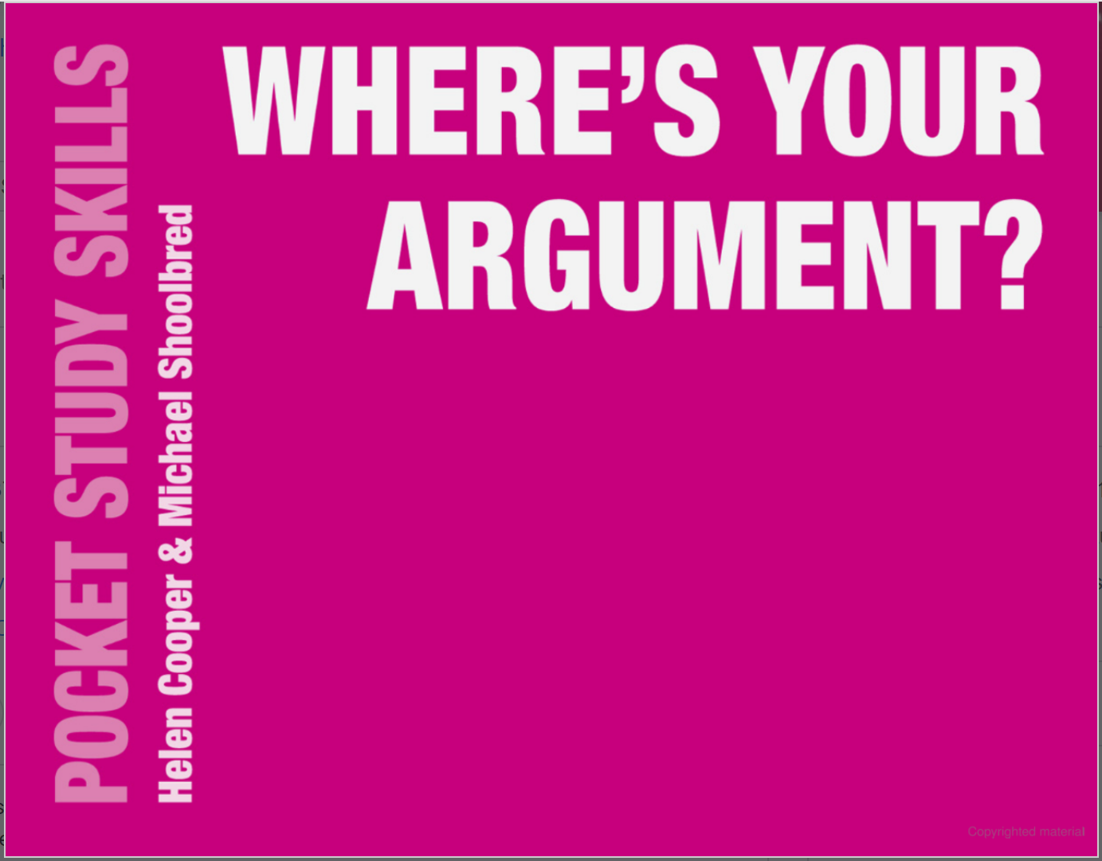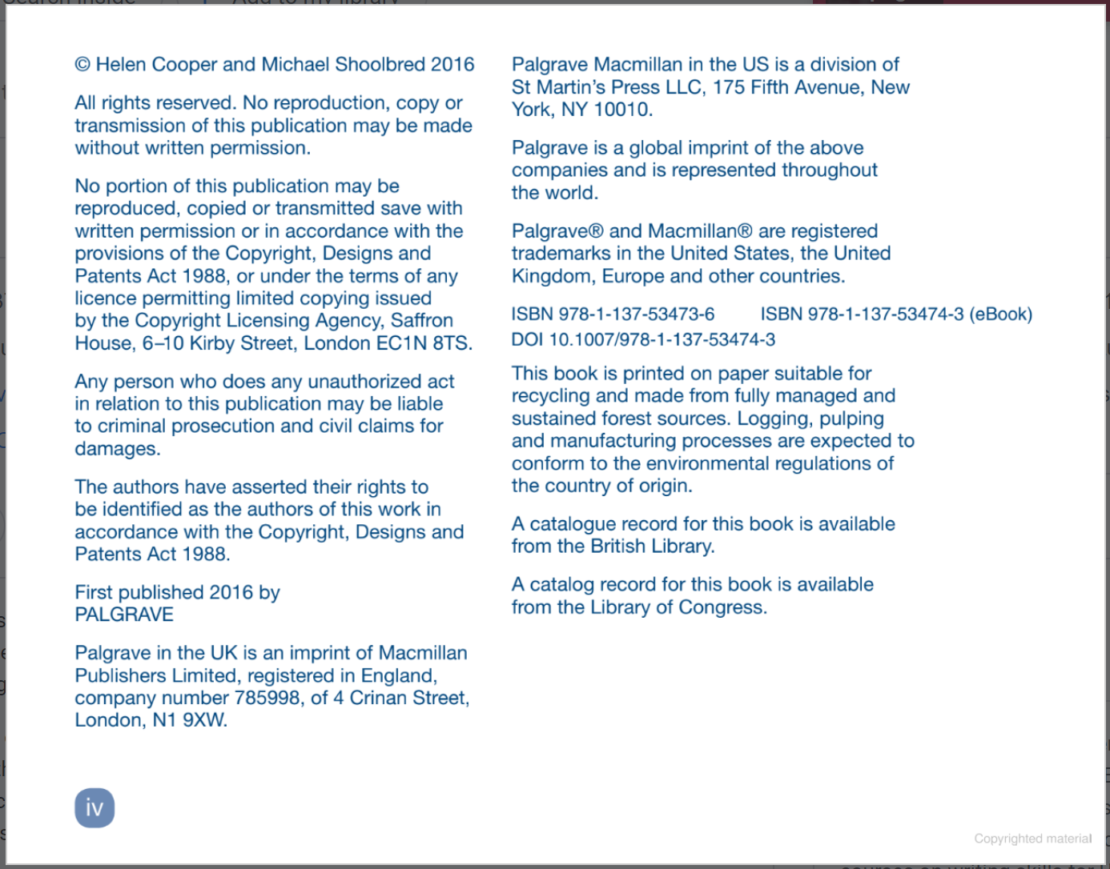

Citation: (Cooper and Shoolbred, 2016) or Cooper and Shoolbred (2016)
Reference: Cooper, H. and Shoolbred, M. (2016) Where’s your argument? London: Palgrave Macmillan.
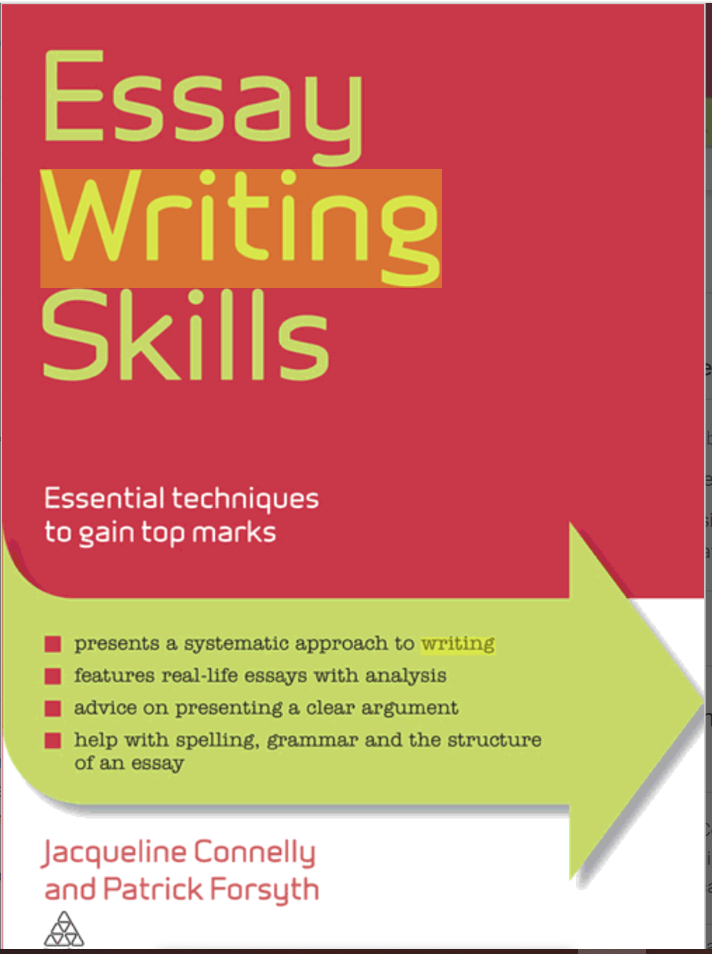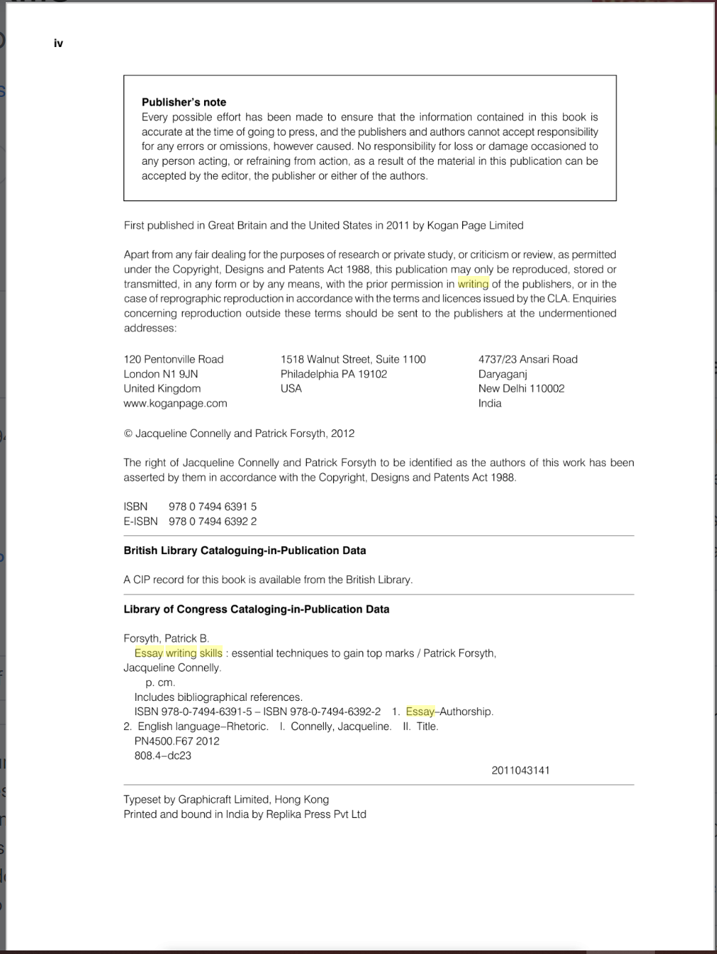
Citation: (Connelly and Forsyth, 2012) or Connelly and Forsyth (2012)
Reference: Connelly, J. and Forsyth, P. (2012) Essay Writing Skills: Essential techniques to gain top marks. London: Kogan Page Limited.

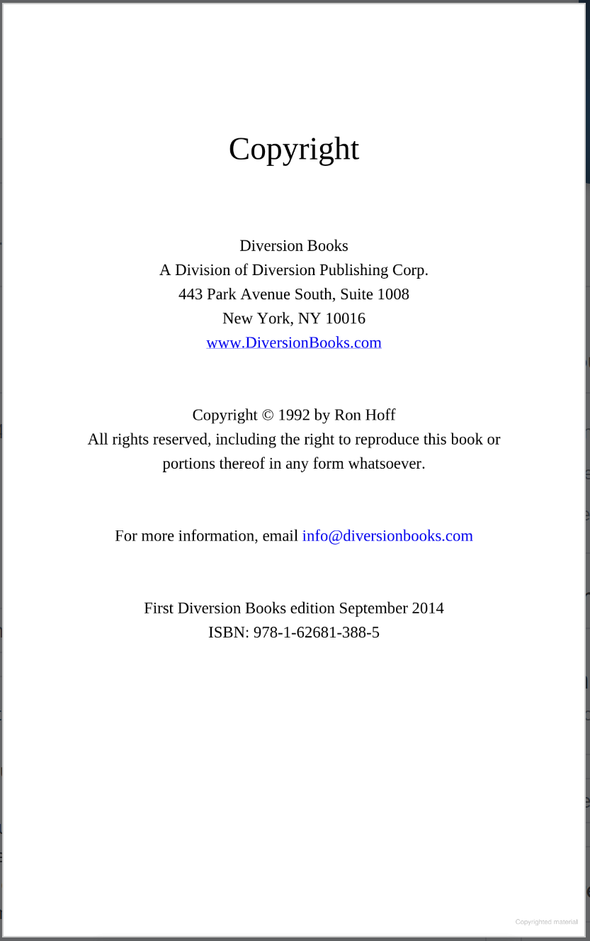
Citation: (Hoff, 2014) or Hoff (2014)
Reference: Hoff, R. (2014) I Can See You Naked: A fearless guide to making great presentations. New York: Diversion Books.
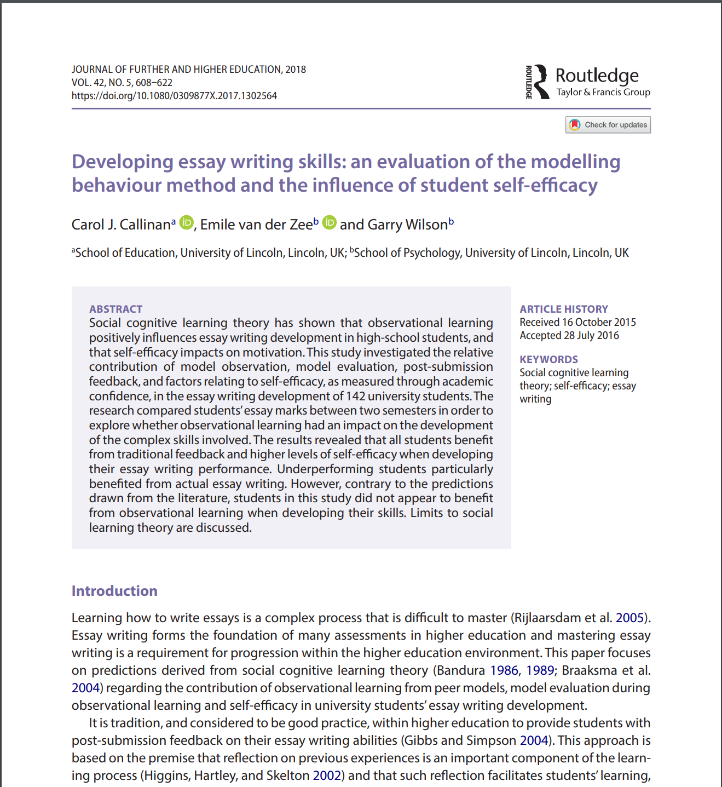
Citation: (Callinan, Van der Zee and Wilson, 2018) or Callinan, Van der Zee and Wilson (2018)
Reference: Callinan, C. J., Van der Zee, E. and Wilson, G. (2018) ‘Developing essay writing skills: an evaluation of the modelling behaviour method and the influence of student self-efficacy’, Journal of Further and Higher Education, 42(5), pp. 608-622. Available at: https://doi.org/10.1080/0309877X.2017.1302564.

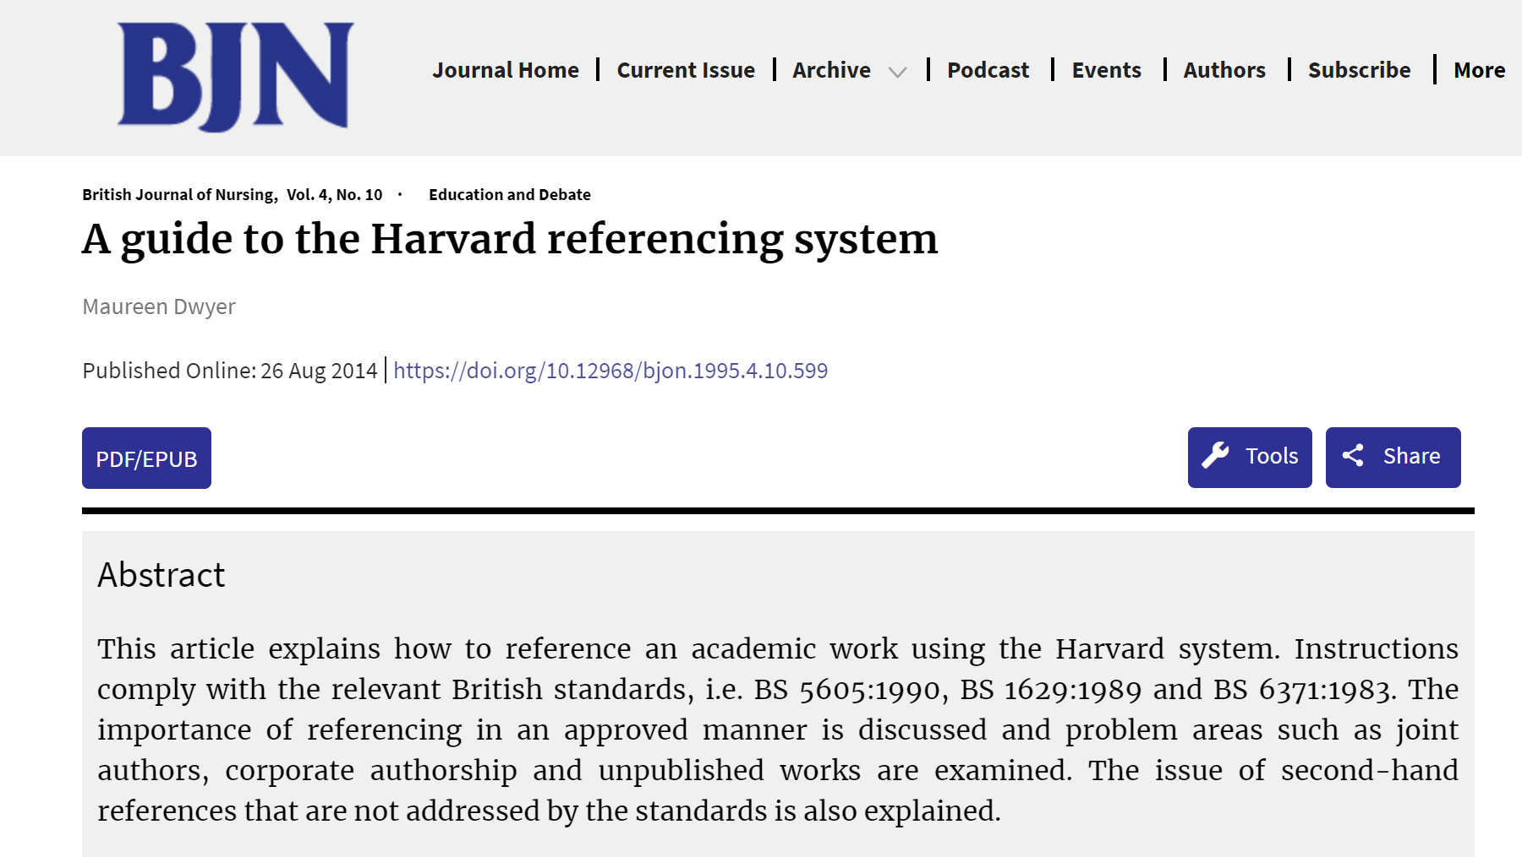
Citation: (Dwyer, 2014) or Dwyer (2014)
Reference: Dwyer, M. (2014) ‘A guide to the Harvard referencing system’, British Journal of Nursing, 4(10). Available at: https://doi.org/10.12968/gjon.1995.4.10.599.
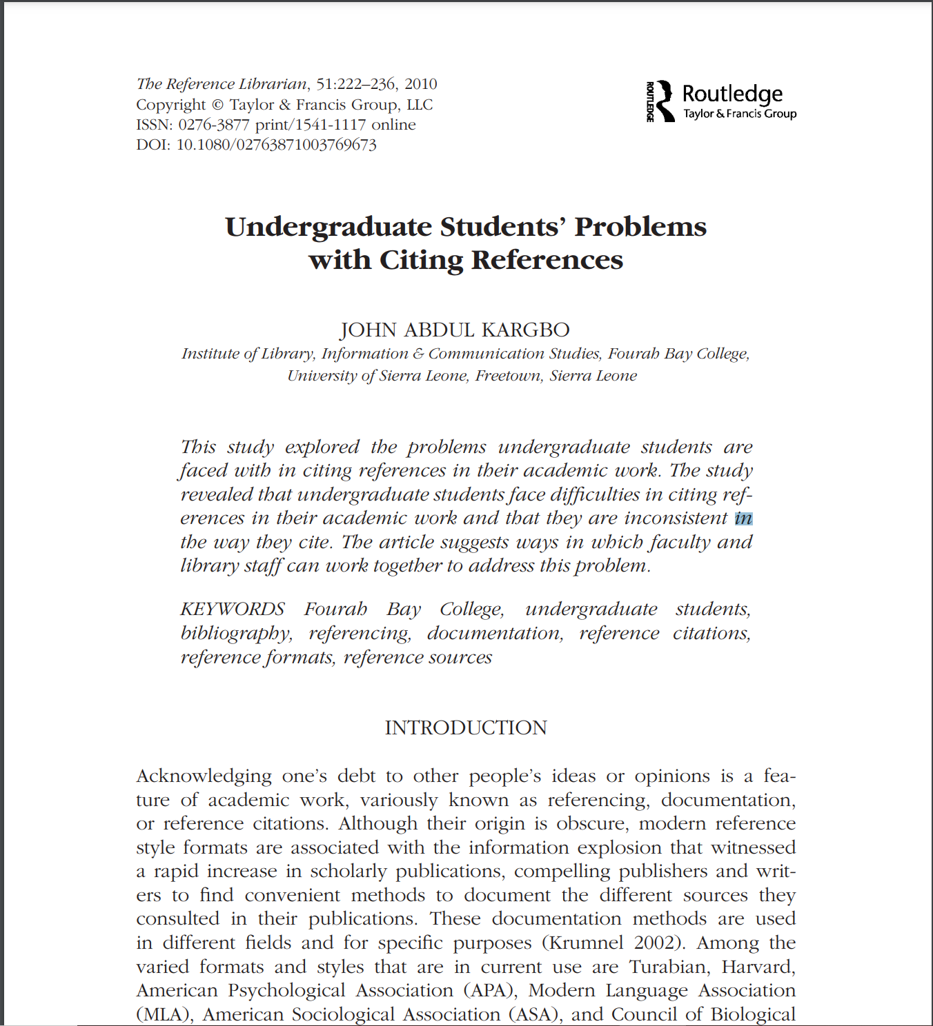
Citation: (Kargbo, 2010) or Kargbo (2010)
Reference: Kargbo, J. A. (2010) ‘Undergraduate Students’ Problems with Citing References’, The Reference Librarian, 51, pp. 222-236. Available at: 10.1080/02763871003769673.
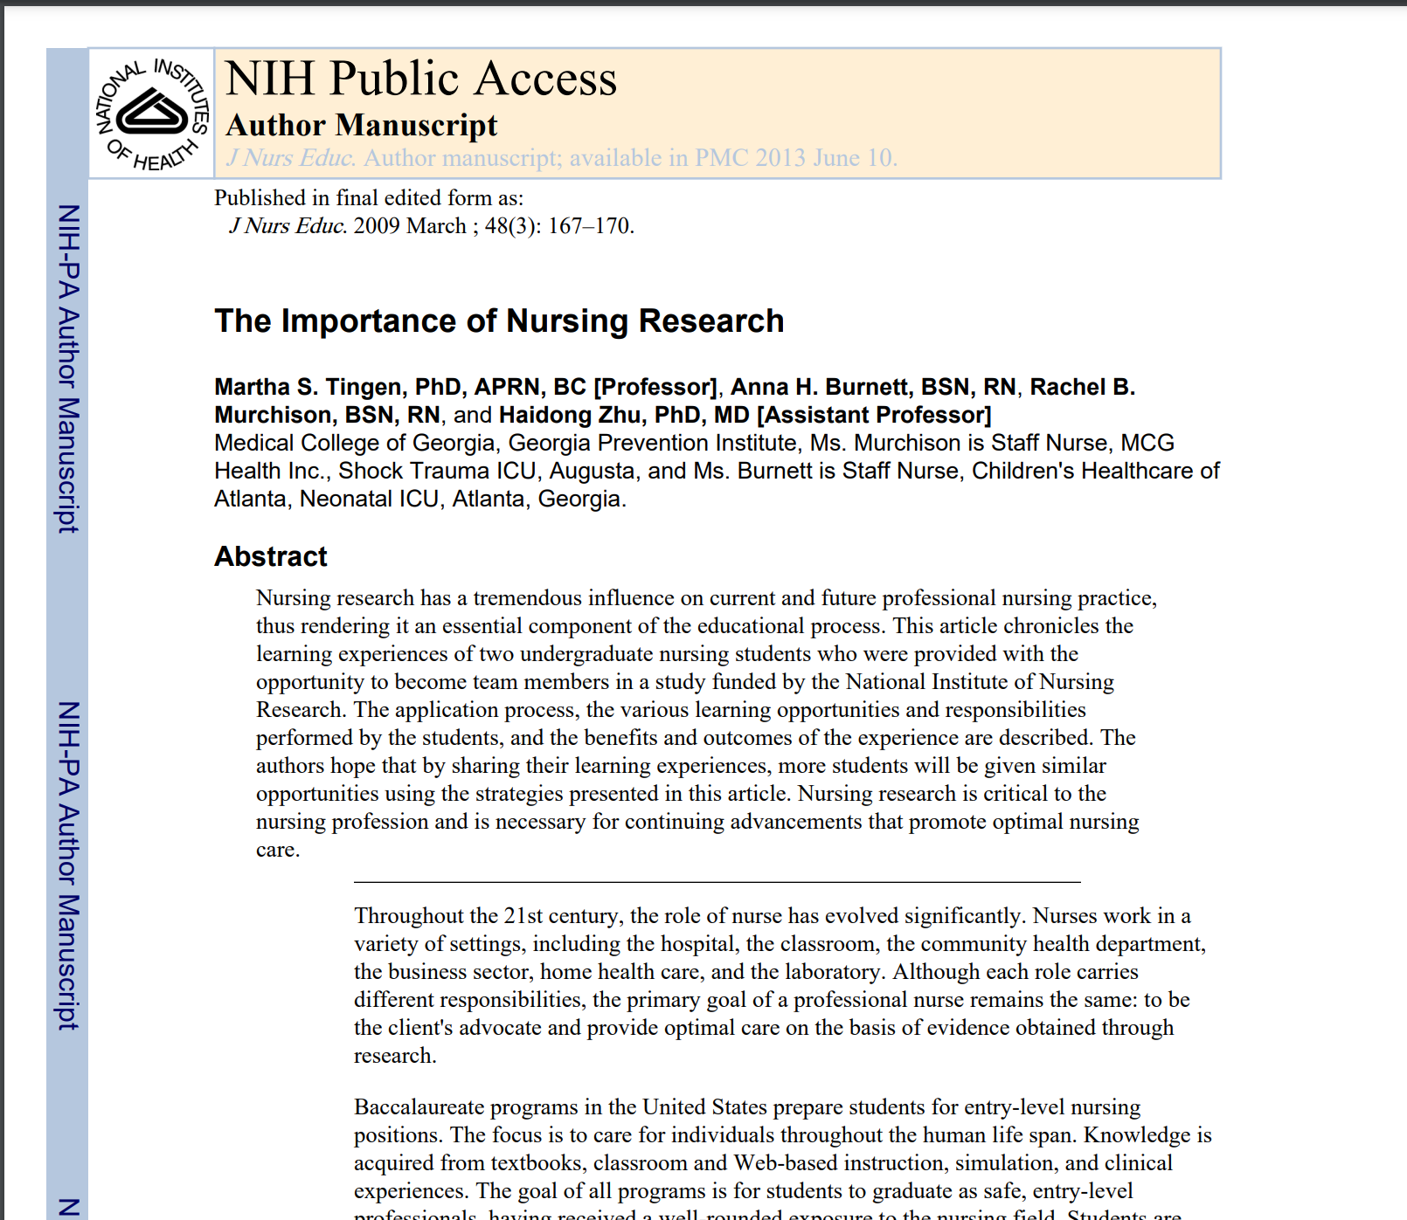

Citation: (Tingen et al, 2013) or Tingen et al (2013)
Reference: Tingen, M. S., Burnett, A. H., Murchison, R. B. and Zhu, H. (2013) ‘The importance of nursing research’, Journal of Nurse Education, 48(3), pp. 167-170.
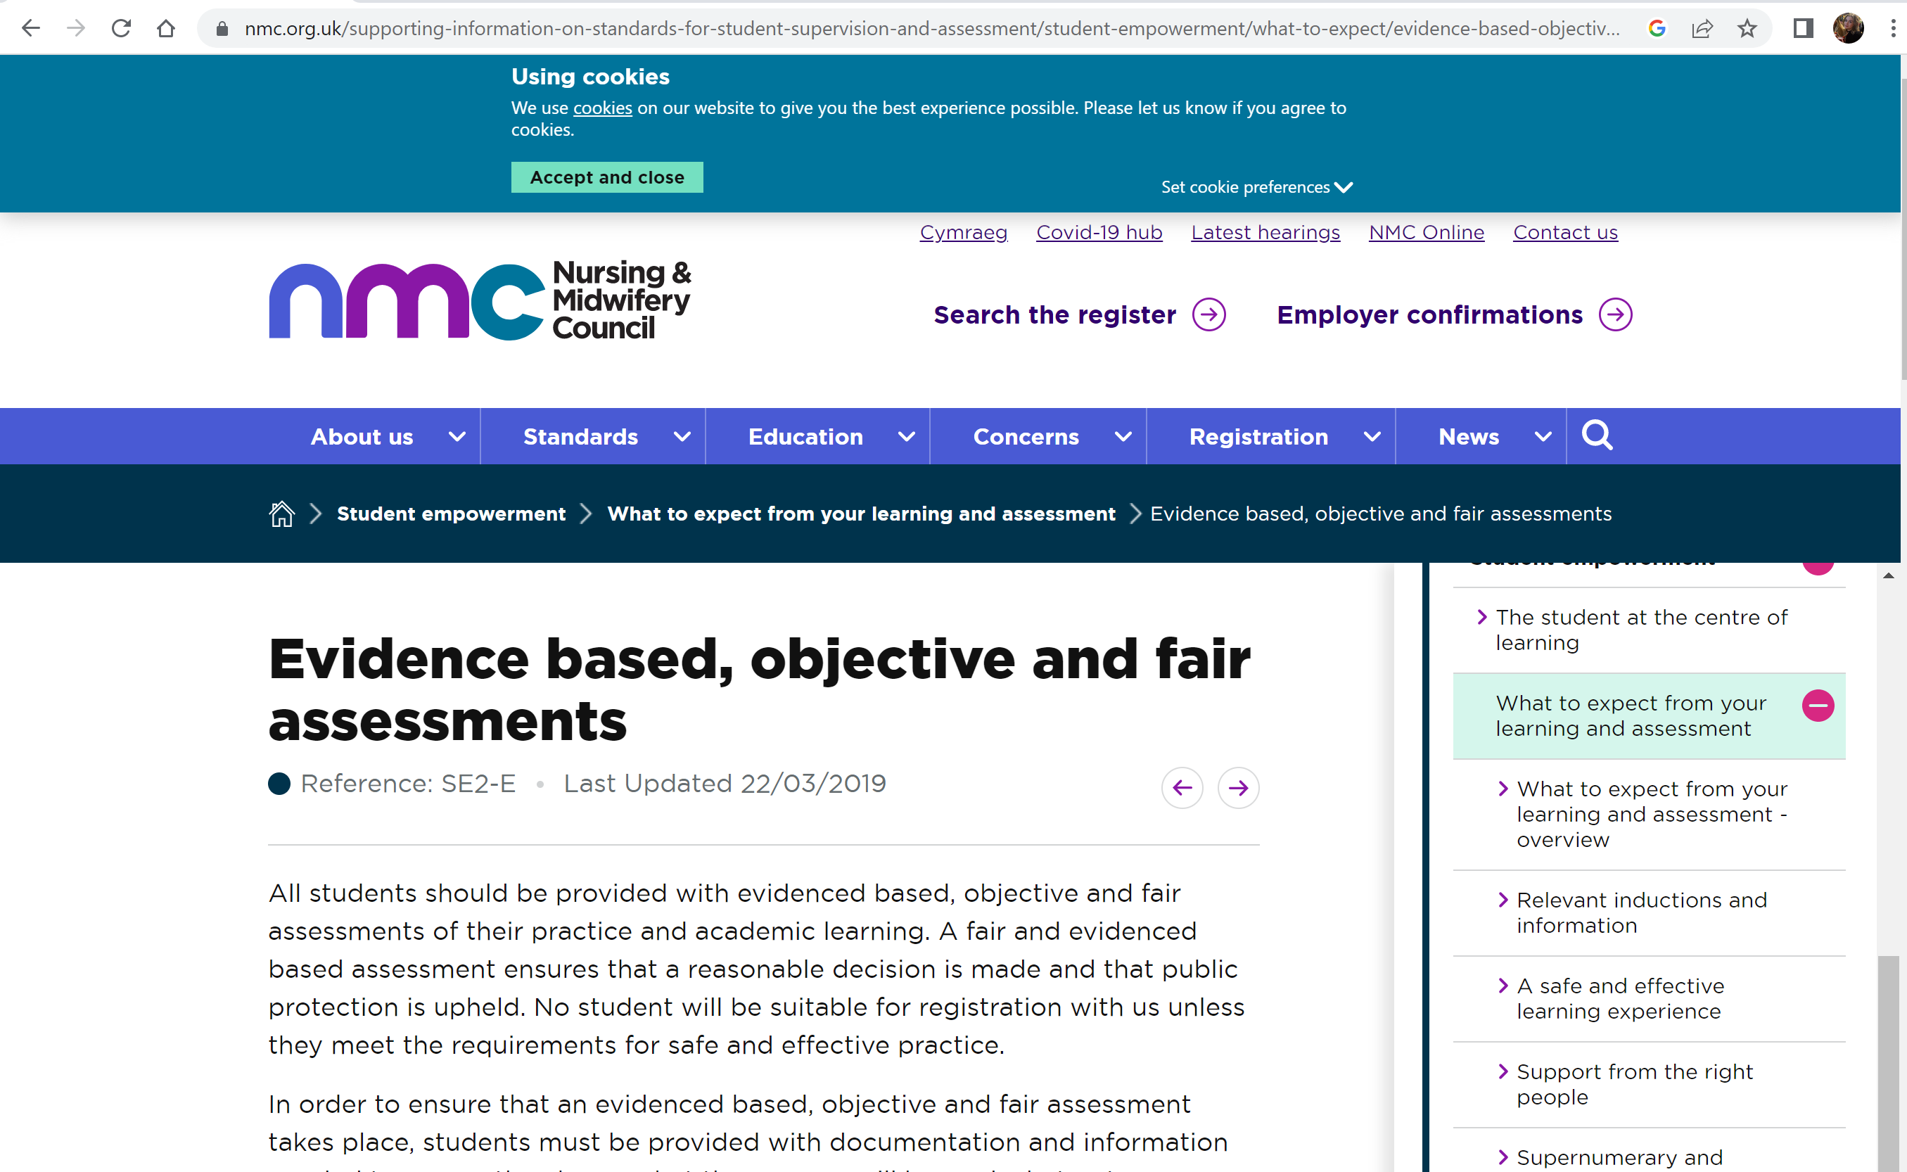
Citation: (Nursing and Midwifery Council, 2019) or Nursing and Midwifery Council (2019)
Reference: Nursing and Midwifery Council (2019) Evidence based, objective and fair assessments. Available at: https://www.nmc.org.uk/supporting-information-on-standards-for-student-supervision-and-assessment/student-empowerment/what-to-expect/evidence-based-objective-and-fair-assessments/ (Accessed: 24th October 2023).

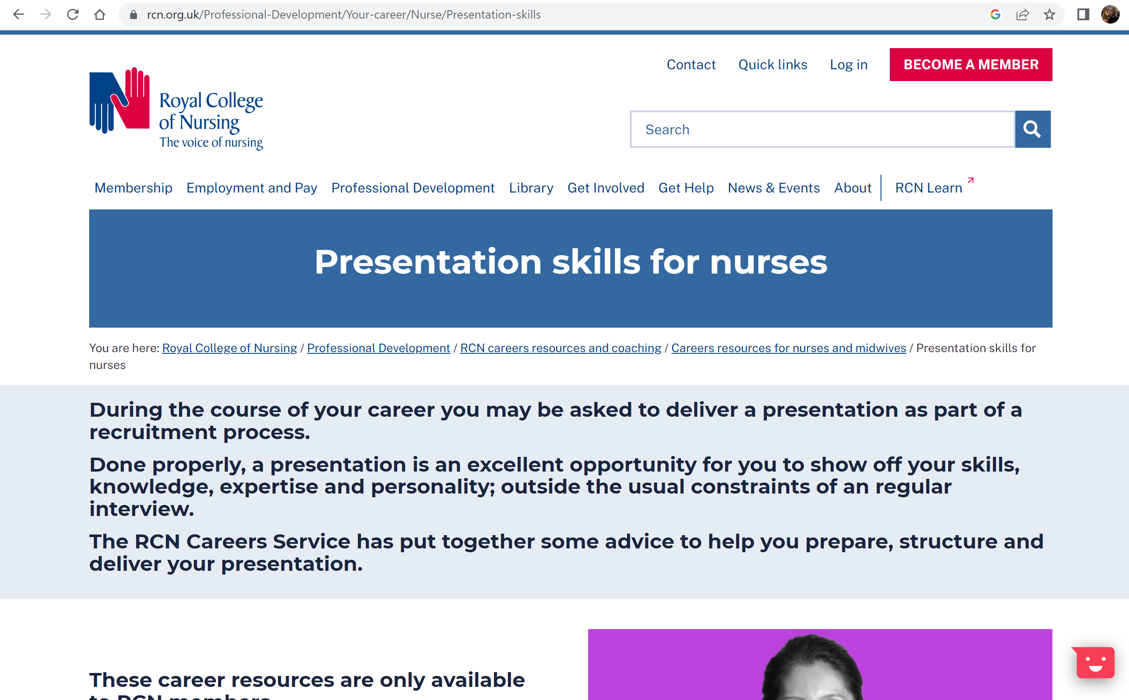
Citation: (Royal College of Nursing, 2023) of Royal College of Nursing (2023)
Reference: Royal College of Nursing (2023) Presentation skills for nurses. Available at: https://www.rcn.org.uk/Professional-Development/Your-career/Nurse/Presentation-skills. (Accessed: 24th October 2023)

